1. Consider the network of following figure

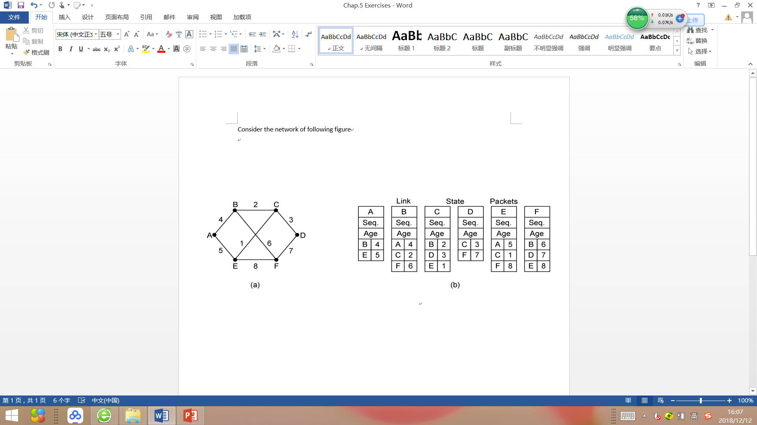

Distance vector routing is used, and the following vectors have just come in to router C: from B(5,0,8,12,6,2); from D(16,12,6,0,9,10); and from E(7,6,3,9,0,4). The cost of the links from C to B, D, and E are 6, 3, and 5, respectively. What is C’s new routing table? Give both the outgoing line to use and the cost.

CB 延迟 6 CD 延迟3 CE 延迟 5

**C的路由表：**

到 延迟 线路

A 11 B CB+BA = 11 CD+DA=19 CE+EA=12

B 6 B

C 0 -

D 3 D

E 5 E

F 8 B CB+BF= 8 CD+DF=13 CE+EF=9

1. A network on the Internet has a subnet mask of 255.255.240.0. What is the maximum number of hosts it can handle?

255.255.240.0. 化为二进制为

11111111 111111111 11110000 00000000

前缀长度20位

2^12 = 4096

最多可以有个主机台4096-2=4094台主机（去除全0全1IP）

1. A router has just received the following new IP addresses: 57.6.96.0/21, 57.6.104.0/21, 57.6.112.0/21 and 57.6.120.0/21. If all of them use the same outgoing line, can they be aggregated? If so, to what? If not, why not?

可以将上述IP化为二进制形式:

00111001 00000110 **011 00000** 00000000

00111001 00000110 **011 01000** 00000000

00111001 00000110 **011 10000** 00000000

00111001 00000110 **011 11000** 00000000

可以看到这四个地址的前19位相同，所以可以被聚集到统一个地址上：

57.6.96.0/19