WEB页面端

分配账号即注册（POST）

api/account/adminregis

String id; //工号

String account; //手机号

String password;

String sex;

String name;

返回值：字符串："admin regis success"

获取全部职工列表（GET）

api/account/admingetallworkers

返回值：

List<AllWorkersOutput>

String id; //工号

String account; //手机号

String auth; //1为职工 2为经理主管 3为你自己超级用户不用显示 “”空为新账号没有权限

String sex; //1为男 0为女

String name;

String status; //0为空闲 1为工作中 “”空为新账号

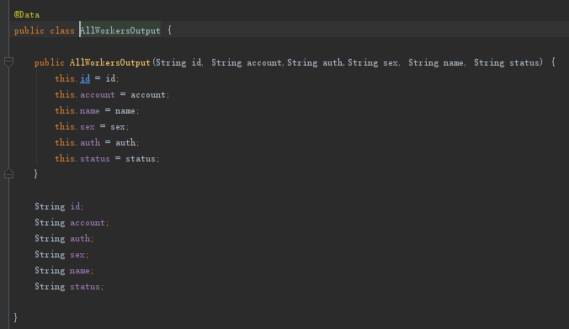

权限修改（POST）

api/account/adminauthconfrim

String id;

String auth;

返回值："success"

APP端

点名：

获取secret（GET）

api/statistic/getsigninsecret

{

"code": 0,

"codeInfo": "OK",

"data": "y4UDY7uH"

}

扫码记录（POST）

api/statistic/signin

String secret;

{

"code": 0,

"codeInfo": "OK",

"data": "cyf"

}

统计名单（POST）

api/statistic/getSigninNames

String secret;

返回

List<String>

获取统计数据（GET）

<http://localhost:8080/api/statistic/getData>

返回值

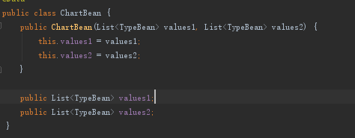

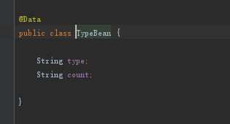

{

"code": 0,

"codeInfo": "OK",

"data": {

"values1": [

{

"type": "其他",

"count": "1"

},

{

"type": "教室故障",

"count": "3"

},

{

"type": "水电",

"count": "1"

},

{

"type": "物业",

"count": "2"

}

],

"values2": [

{

"type": "其他",

"count": "1"

},

{

"type": "教室故障",

"count": "3"

},

{

"type": "水电",

"count": "2"

},

{

"type": "物业",

"count": "2"

}

]

}

}

获取工人列表（GET）

http://localhost:8080/api/mission/getWorkers

返回为

String account;

String name;

指派工人（POST）

http://localhost:8080/api/mission/assign

String questionId;

String workerid;

{

"code": 0,

"codeInfo": "OK",

"data": "cyf"

}

任务确认完成（POST）

http://localhost:8080/api/mission/missionComplete

String questionId;

{

"code": 0,

"codeInfo": "OK",

"data": "cyf"

}

提交评价（POST）

<http://localhost:8080/api/mission/setcomment>

String id;

String comment;

{

"code": 0,

"codeInfo": "OK",

"data": "cyf"

}

获取任务详情（POST）

http://localhost:8080/api/mission/getMyMissionDescription

String questionId;

{

"code": 0,

"codeInfo": "OK",

"data": {

"QuestionPerson": {

"name": "赵衍琛",

"phoneNumber": "18340018831"

},

"SolvePerson": {

"name": null,

"phoneNumber": null

},

"QuestionType": "教室故障",

"QuestionAddress": "当饭吃穿多大的",

"QuestionText": "地方呀任覅咕咕咕换个词广发银行重复的复古风地方呀观后感好幸福",

"Comment": null,

"comment": null,

"questionType": "教室故障",

"questionText": "地方呀任覅咕咕咕换个词广发银行重复的复古风地方呀观后感好幸福",

"solvePerson": {

"name": null,

"phoneNumber": null

},

"questionAddress": "当饭吃穿多大的",

"questionPerson": {

"name": "赵衍琛",

"phoneNumber": "18340018831"

}

}

}

获取任务列表（POST）

http://localhost:8080/api/mission/getMyMissions

String status; (待处理，处理中，已处理)

{

"code": 0,

"codeInfo": "OK",

"data": [

{

"id": "9wGswNnK",

"type": "教室故障",

"address": "山东大学",

"starttime": "2018-09-21",

"status": "待处理"

}

]

}

发布任务(POST)

http://localhost:8080/api/mission/upload

String type;

String address;

String question;

MultipartFile file;

{

"code": 0,

"codeInfo": "OK",

"data": "cyf"

}

注：任务图片名为 18340018831mission.jpg 即账号加mission.jpg 接口可以用下面的获取用户头像

获取用户头像（GET）

<http://localhost:8080/api/image/getuserheadphoto?name=18945678923head.jpg>

byte[] data

设置用户头像

http://localhost:8080/api/image/setuserheadphoto

MultipartFile file

{

"code": 0,

"codeInfo": "OK",

"data": "cyf"

}

注：头像名为 18340018831head.jpg 即账号加head.jpg

注册（仅为学生注册）

http://localhost:8080/api/account/register

String account;

String password;

String sex;

String name;

String schoolnumber;

{

"code": 0,

"codeInfo": "OK",

"data": {

"id": "YghbcEpw",

“account”:”18340018831”

"name": "赵衍琛",

"sex": "1",

"schoolnumber": "201600301315"

“auth”:”0” (0是学生 1是工人 2是管理)

}

}

登录

http://localhost:8080/api/account/login

String account;

String password;

注：

1. 普通学生用户的Bean

{

"code": 0,

"codeInfo": "OK",

"data": {

"id": "YghbcEpw",

“account”:”18340018831”

"name": "赵衍琛",

"sex": "1",

"schoolnumber": "201600301315"

“auth”:”0” (0是学生 1是工人 2是管理)

}

}

1. 职工用户的bean

String id;

String account; （account是电话号码 id是后台自己生成的）

String auth; (0是学生 1是工人 2是管理)

String sex;

String name;

错误信息：

{

"code": 100,

"codeInfo": "AccountNotExists",

"data": ""

}

{

"code": 102,

"codeInfo": "PasswordError",

"data": ""

}