**SUPPLEMENTAL MATERIAL**

|  |  |  |  |
| --- | --- | --- | --- |
| **Supplemental Table 1. Plaque Progression Metrics KETO-CTA vs Other Cohorts.** | | | |
| **Study** | **Baseline PAV** | **ΔPAV(%/year)** | **Notes** |
| KETO-CTA | 1.6 (0.5 – 4.9) | 0.8 (0.3 – 1.73) | n = 100 |
| KETO-CTACACbl = 0 | 0.6 (0.2 – 1.2) | 0.5 (0.3 – 1.0) | n = 57 |
| KETO-CTA10yCVDrisk > 5% | 4.5 (1.1 – 9.4) | 1.4 (0.5 – 2.7) | n = 28 |
| KETO-CTACACbl > 100 | 9.6 (7.2 – 12.2) | 2.4 (1.4 – 3.4) | n = 17 |
| Nakanishi et al.(1) | 7.64 (2.0 – 13.7) § | 0.7 (0.0 – 1.1)§ | Non-DM group |
| Won et al. (2) | 1.6 (0.0 – 6.1) | 0.3 (0.0 – 0.9) | Low TyG tertile |
| Won et al.(2) | 9.4 (1.4 – 27.7) | 0.5 (0.1 – 1.4) | High TyG tertile |
| Han et al.(3) | NA | 0.5 (0.1 – 1.1)* | Low 10-year CVD risk group |
| Han et al.(3) | NA | 1.0 (0.1 – 2.2)* | High 10-year CVD risk group |
| vanRosendael et al.(4) | 4.7 (1.3 – 10.8) | 0.8 (0.4 – 1.2) | PARADIGM cohort |
| Nurmohamed et al.(5) | 2.5 (0.7 – 8.1) | 0.4 (0.1 – 0.9) | Annualized over 10 years |

*Values are medians and 25th-75th percentiles. PAV=Percentage Atheroma Volume. * = Estimated from SD in Supplemental Table 1.* § = *estimated from follow-up total volume and vessel volume follow-up values. Apart from KETO-CTA (present study), all values are annualized.*

|  |  |  |
| --- | --- | --- |
| **Supplemental Table 2. Baseline characteristics of Participants with High Adherence.** | | |
| Sex (Male) | 48.2 % | |
| **Ethnicity** | | |
| Asian | 10.7 % | |
| Hispanic | 5.4 % | |
| White | 83.9 % | |
|  | **Mean ± SD** | **Median (Q1 – Q3)** |
| Age (years) | 57.0 ±8.7 | 58.0 (52.8 - 63.0) |
| Ketogenic Diet Duration (days) | 1731.2 ±1050.6 | 1427 (990 – 1970) |
| Body Mass Index (kg/m2) | 22.3 ±2.9 | 22.0 (20.0 - 24.1) |
| Systolic Blood Pressure (mmHg) | 120.1 ±24.8 | 120 (107 – 136) |
| Total Cholesterol (mg/dL) | 361.4 ±102.1 | 357 (296 – 406.3) |
| LDL-C (mg/dL) | 255.9 ±95.7 | 234.5 (197.5 – 309.5) |
| HDL-C (mg/dL) | 89.3 ±18.6 | 90 (76 – 101.2) |
| Triglycerides (mg/dL) | 70.4 ±36.8 | 63.5 (49 – 80) |
| ApoB (mg/dL) | 192.3 ±55.6 | 185 (150.3 – 226.3) |
| Non-Calcified Plaque Volume (mm3) | 69.7 ±90.5 | 32.5 (12.7 – 93.5) |
| Coronary Artery Calcium Score | 45.2 ±104.1 | 0 (0 – 22.5) |
| Percentage Atheroma Volume | 2.85 ± 3.7 | 1.3 (0.5 – 3.6) |
| Total Plaque Score | 1.59 ± 2.7 | 0 (0 – 2.0) |
| 10-year CVD Risk (MESAETH-CAC, %) | 5.3 ±5.8 | 3.4 (2.0 – 6.0) |

*n = 56. BMI = Body Mass Index, SBP= Systolic Blood Pressure;* ***10-year CVD Risk*** *= Based on Risk Equation from the Multi-Ethnic Study of Atherosclerosis with Ethnicity and CAC Inputs.*

|  |  |  |
| --- | --- | --- |
| **Supplemental Table 3. Diet Composition in Participants with High Adherence.** | | |
| **N = 56** | **Mean ±** **SD** | **Median (Q1 - Q3)** |
| Carbohydrates (g/day) | 34.4 ± 26.0 | 30.8 (12.6 – 51.1) |
| Fat (g/day) | 120.4 ± 47.6 | 113.1 (89.8 – 139.3) |
| Saturated Fat (g/day) | 43.5 ± 14.4 | 39.4 (29.9 – 52.6) |
| Sugar (g/day) | 15.4 ± 13.9 | 11.1 (6.3 – 22.2) |
| Fiber (g/day) | 7.6 ± 7.3 | 6.86 (1.3 – 11.3) |
| Sodium (mg/day) | 3073.6 ± 1169.7 | 2931.4 (2217 – 3625.7) |

*n = 56. Pooled data from all available dietary records.*

|  |  |  |  |  |  |
| --- | --- | --- | --- | --- | --- |
| **Supplemental Table 4. Model Results in Participants with High Adherence.** | | | | | |
|  | | **β** | **P-value** | **R2** | **BF** |
| **LDL-C exposure** |  | | | | |
| NCPVfinal ~ LDL-Cexp | | 0.00 | 0.92 | -0.02 | (01) 7.66 |
| PAVfinal ~ LDL-Cexp | | 0.00 | 0.96 | -0.02 | (01) 7.69 |
| **ApoB** | | | | | |
| ΔNCPV ~ ΔApoB | | 0.04 | 0.63 | -0.01 | (01) 6.90 |
| ΔNCPV ~ ApoBbl | | 0.06 | 0.09 | -0.04 | (01) 1.83 |
| **Plaque Metrics** | | | | | |
| ΔNCPV ~ CACbl | | 0.20 | <0.001 | 0.39 | *(10) >10.0 |
| ΔNCPV ~ NCPVbl | | 0.28 | <0.001 | 0.60 | *(10) >10.0 |
| ΔNCPV ~ PAVbl | | 6.84 | <0.001 | 0.55 | *(10) >10.0 |
| ΔNCPV ~ TPSbl | | 7.74 | <0.001 | 0.39 | *(10) >10.0 |
| ΔNCPV ~ CACbl* ΔApoB | |  |  |  |  |
| CACbl | | 0.17 | <0.001 | 0.41 | N/A |
| ΔApoB | | 0.08 | 0.08 | N/A | N/A |
| CACbl : ΔApoB | | -0.00 | 0.12 | N/A | N/A |
| **Saturated Fat** | | | | | |
| ΔNCPV ~ Saturated Fat Intake | | 0.25 | 0.34 | -0.00 | (01) 5.0 |
| ApoB ~ Saturated Fat Intake | | -0.06 | 0.88 | -0.02 | (01) 7.62 |
| **Age Mediation Analyses** | | | | | |
| NCPVfinal ~ Age | | 3.48 | 0.06 | 0.05 | (01) 1.34 |
| NCPVfinal ~ Age + Life-LDL-Cexp | | 2.81|0.00 | 0.21|0.61 | 0.03 | (01) 1.34 / 2.54 |
| NCPVfinal ~ Age + Life-LDL-Cexp + CACbl | | 0.1|0.0 |0.8 | 0.96|0.24|<0.001 | 0.45 | (01) 1.34|2.54|>10.0* |

*n = 56.* ***ApoB*** *= ApoB on a Ketogenic Diet;* ***ΔApoB*** *= ApoB change during the study;* ***BF*** *= Bayes Factor.* ***CACbl****= CAC at baseline;* ***LDL-Cexp*** *= LDL-C exposure while on a Ketogenic Diet (mean 5.7 years); Life-****LDL-Cexp*** *= LDL-Cexposure over life course to date;* ***NCPVfinal*** *= Non-Calcified Plaque Volume at the end of the study,* ***TPSfinal*** *= Total Plaque Score at the end of the study.* ***ΔNCPV*** *= Change in Non-Calcified Plaque Volume,* ***ΔTPS*** *= Change in Total Plaque Score. β = Estimate (slope magnitude), R2 = Squared correlation coefficient (explained variability). *Models on CAC are provided for the alternative hypothesis (10). All other models are provided for the null hypothesis (01).*

|  |  |  |  |  |
| --- | --- | --- | --- | --- |
| **Supplemental Table 5. Model Results in Participants with High CVD Risk.** | | | | |
|  | **β** | **P-value** | **R2** | **BF** |
| **LDL-C exposure** | | | | |
| NCPVfinal ~ LDL-Cexp | -0.01 | 0.57 | -0.03 | (01) 4.79 |
| PAVfinal ~ LDL-Cexp | -0.00 | 0.81 | -0.04 | (01) 5.43 |
| **ApoB** | | | | |
| ΔNCPV ~ ΔApoB | 0.10 | 0.57 | -0.03 | (01) 4.76 |
| ΔNCPV ~ ApoBbl | 0.11 | 0.52 | -0.02 | (01) 4.57 |
| **Plaque Metrics** | | | | |
| ΔNCPV ~ CACbl | 0.17 | 0.002 | 0.29 | *(10) >10.0 |
| ΔNCPV ~ NCPVbl | 0.28 | <0.001 | 0.56 | *(10) >10.0 |
| ΔNCPV ~ PAVbl | 5.47 | 0.003 | 0.37 | *(10) >10.0 |
| ΔNCPV ~ TPSbl | 7.84 | 0.004 | 0.37 | *(10) >10.0 |
| ΔNCPV ~ CACbl* ΔApoB |  |  |  |  |
| CACbl | 0.16 | 0.004 | 0.30 | N/A |
| ΔapoB | 0.24 | 0.16 | N/A | N/A |
| CACbl : ΔApoB | -0.00 | 0.19 | N/A | N/A |
| **Saturated Fat** | | | | |
| ΔNCPV ~ Saturated Fat Intake | -0.08 | 0.84 | -0.04 | (01) 5.48 |
| ApoB ~ Saturated Fat Intake | -0.58 | 0.25 | 0.01 | (01) 2.97 |
| **Age Mediation Analysis** | | | | |
| NCPVfinal ~ Age | 3.40 | 0.48 | -0.02 | (01) 4.39 |
| NCPVfinal ~ Age + Life-LDL-Cexp | 4.11|-0.02 | 0.50|0.84 | -0.06 | (01) 0.18 / 0.22 |
| NCPVfinal ~ Age + Life-LDL-Cexp + CACbl | -1.70|0.0 |0.7 | 0.74|0.91|0.006 | 0.33 | (01) 0.18|0.22|>10.0* |

*n = 28.* ***ApoB*** *= ApoB on a Ketogenic Diet;* ***ΔApoB*** *= ApoB change during the study;* ***BF*** *= Bayes Factor.* ***CACbl****= CAC at baseline;* ***LDL-Cexp*** *= LDL-C exposure while on a Ketogenic Diet (mean 5.7 years); Life-****LDL-Cexp*** *= LDL-Cexposure over life course to date;* ***NCPVfinal*** *= Non-Calcified Plaque Volume at the end of the study,* ***TPSfinal*** *= Total Plaque Score at the end of the study.* ***ΔNCPV*** *= Change in Non-Calcified Plaque Volume,* ***ΔTPS*** *= Change in Total Plaque Score.*  *β = Estimate (slope magnitude), R2 = Squared correlation coefficient (explained variability). *Models on CAC are provided for the alternative hypothesis (10). All other models are provided for the null hypothesis (01).*

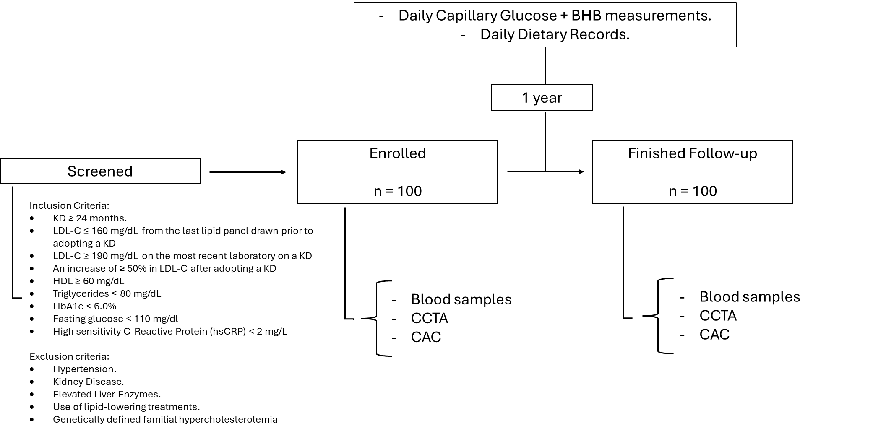

**Supplemental Figure 1. Participant Flow-Chart**.**REFERENCES**

1. Nakanishi R, Ceponiene I, Osawa K, Luo Y, Kanisawa M, Megowan N, Nezarat N, Rahmani S, Broersen A, Kitslaar PH, et al. Plaque progression assessed by a novel semi-automated quantitative plaque software on coronary computed tomography angiography between diabetes and non-diabetes patients: A propensity-score matching study. Atherosclerosis Elsevier Ireland Ltd; 2016;255:73–9.

2. Won KB, Lee BK, Park HB, Heo R, Lee SE, Rizvi A, Lin FY, Kumar A, Hadamitzky M, Kim YJ, et al. Quantitative assessment of coronary plaque volume change related to triglyceride glucose index: The Progression of AtheRosclerotic PlAque DetermIned by Computed TomoGraphic Angiography IMaging (PARADIGM) registry. Cardiovasc Diabetol [Internet] BioMed Central; 2020 [cited 2024 Sep 18];19:1–10. Available from: https://cardiab.biomedcentral.com/articles/10.1186/s12933-020-01081-w

3. Han D, Berman DS, Miller RJH, Andreini D, Budoff MJ, Cademartiri F, Chinnaiyan K, Choi JH, Conte E, Marques H, et al. Association of Cardiovascular Disease Risk Factor Burden With Progression of Coronary Atherosclerosis Assessed by Serial Coronary Computed Tomographic Angiography. JAMA Netw Open [Internet] American Medical Association; 2020 [cited 2024 Sep 17];3:e2011444–e2011444. Available from: https://jamanetwork.com/journals/jamanetworkopen/fullarticle/2768616

4. van Rosendael SE, van den Hoogen IJ, Lin FY, Andreini D, Al-Mallah MH, Budoff MJ, Cademartiri F, Chinnaiyan K, Choi JH, Conte E, et al. Clinical and Coronary Plaque Predictors of Atherosclerotic Nonresponse to Statin Therapy. JACC Cardiovasc Imaging Elsevier; 2023;16:495–504.

5. Nurmohamed N, Bom MJ, Ibrahim S, Gaillard EL, De Groot RJ, Jukema RA, Van Diemen PA, De Winter RW, Min JK, Earls JP, et al. The natural history and prediction of 10-year plaque progression on serial coronary CT angiography. [cited 2024 Sep 24]; Available from: https://academic.oup.com/eurheartj/article/44/Supplement_2/ehad655.152/7392901