**Operating System assignement**

**Compiler:** gcc

**Compile environment:** Linux Terminal

**newproc-posix.c**

**Command line used to compile:** gcc newproc-posix.c -o newproc

**Summary:** Creation of a child process by using the system call fork(), then the parent process does a print and wait until the child process finish its execution. The child process does a print and execute the function ls and finish its execution. The parent process print “Child Complete” and finish its execution.

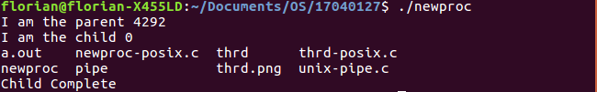

**unix-pipe.c**

**Command line used to compile:** gcc unix-pipe.c -o pipe

**Summary:** Creation of a child process with the system call fork(). The parent process will close the READ_END, write the message in the buffer and close the WRITE_END. After that the child process will close the WRITE_END, read the message in the buffer, print that message and close the READ_END.

**thrd-posix.c**

**Command line used to compile:** gcc thrd-posix -o thrd -lpthread

**Summary:** Initialization of attr with pthread_attr_init(&attr) (thread’s attributes will have the default value). Creation of a thread and execution of the function runner which sum all the number from 1 to n. Wait for the end of the thread execution and print the result returned by the thread.