???Title name???

-2D platformer

-you are a spacehip

-the game is level based

-each level will have unique layout

-the further the player gets the levels get harder (more obstacles, different types of enemies[faster, more HP])

-pixel graphics (aseprite?)

-fun mechanics (try to code unique movement of spaceship, move it and shoot with mouse?)

-later maybe implement dash, power-ups, flying meteoroids, boss fights

-old school platformer music (bosca ceoil?, your piano?)

-particle and sound effects

-moving background with particles flying so it’s not so static

-animations

What to do first?

-basic movement and mechanics

-graphics

….

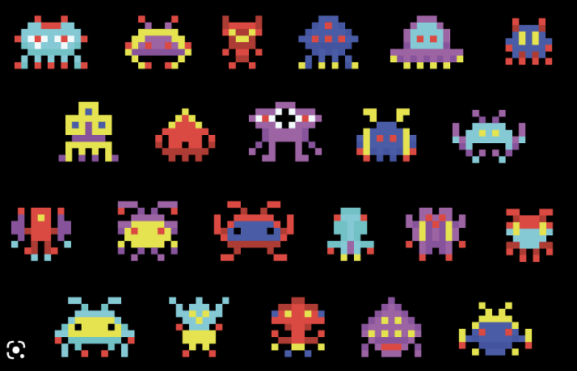Graphics?

