IRIS411

LTE/WCDMA/TD-SCDMA/HSPA/EDGE/GPRS/GSM Radio Frequency Transceiver for User Equipment

Features

* A monolithic RF transceiver for LTEI/E-UTRA FDD and TDD with 17 RF inputs and 8 RF outputs
* Support FDD band WCDMA/HSPA, HSDPA 64-QAM, HSUPA 16-QAM and above
* TD-SCDMA/TD-HSPA in TDD band, 64-QAM in TD-HSDPA, 16-QAM and above in TD-HSUPA
* Supporting four-band GSM, GRPS, and EDGE
* LTE FDD/WCDMA Rx and Tx paths do not require SAW filters
* LTE TDD/TD-SCDMA Rx and Tx paths do not require SAW filters
* GSM/GPRS/EDGE Tx path does not need SAW filter
* Support up to 39 GPRS/EDGE and GGE PA climbing
* Fully integrated frequency synthesis with loop filter
* In-chip 26MHz DCXO
* AFCDAC supports AFC for 19.2, 26, 38.4, or 52 MHz off-chip TCXO
* Including two Rx ADC, Tx DAC, digital front-end and auxiliary ADC
* Integrated LDO Linear Regulator
* MIPI RFFE control interface, 12 GPOs
* Serial peripheral device control interface
* DIRF v1.12 Interface for GGE
* DigRF V4 control and data interface (LS, HS1x, two Rx channels)

application

E-UTRA band 1-14, 17-21, 23-25, 33-41 in 4G (E-UTRA), 3G (UTRA) and 2G (GGE) user equipment, such as mobile phones and data modems.

General description

IR1S411 is a monolithic RF transceiver for LTE/E-UTRA FDD/TDD applications (4G). It also provides traditional support for WCDMA/TD-SCDMA (3G) and GSM/GPRS/EDGE (2G).

In 4G and 3G modes, high sensitivity, low EVM and high linearity are one of the significant features of the receiver. These features ensure the best performance of QPSK, 16-QAM and 64-QAM, thus improving the increasing data throughput of smartphones and data modems. For 4G/3G TDD, IRIS411 supports a unique SAW-less configuration to eliminate the cost and sensitivity loss of Rx SAW filters. For 4G/3G FDD, IRIS411 does not need an inter-stage SAW filter in the receiving path, which makes the 4G/3G RF subsystem unprecedented integration level and lower complexity.

The transmitter provides low EVM to support 16-QAM for high throughput and maintains low spurious emission to eliminate the RF subsystem of SAW filters common in 4G/3G transmitters. In the mode of GSM/EDGE, the receiver has the advantages of low noise and high linearity. The transmitter provides hyperspectral purity, which again meets the stringent stray emission requirements without the need for interstage SAW filters.

IRIS411 satisfies the advanced multi-mode multi-band RF subsystem by providing a total of 17 RF inputs and 8 RF outputs. Placing IRIS411 in the center of complex RF subsystem can achieve very compact PCB package, because it is fully integrated with synthesizer, Rx ADC, Tx DAG, DCXO, LDO regulator, MIPI RFFE control interface and high-speed DigRF V4 control and data interface.

ordering information

|  |  |  |  |  |
| --- | --- | --- | --- | --- |
| Model number | Name | | | |
| IRIS411 | | IRIS411 |  | | |
| Catalog | |  | |  | |

Structural drawing

Figure 1: IRIS411 (power pin omitted)

Pin assignment

Name

PIN

# Explain

RXBLOW1

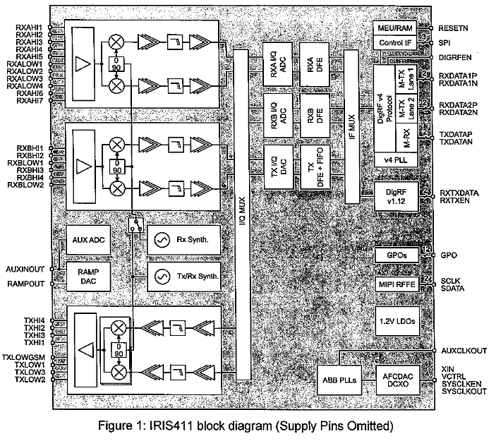

Rx Input Low Frequency Band

# RXBHI2

| A2 | Rx Input High Frequency FDD/TDD | RXBHI1 |
| --- | --- | --- |
| A3 | Rx Input High Frequency FDD/TDD | RXAHI7 |
| A4 | Rx input high frequency TDD | RXAHI6 |
| A5 | Rx input high frequency TDD | RXALOW4 |
| A6 | Rx Input Low Frequency Band | RXALOW3 |
| A7 | Rx Input Low Frequency Band | RXALOW2 |
| A8 | Rx Input Low Frequency Band | RXALOW1 |
| A9 | Rx Input Low Frequency Band | RXAHI5 |
| A10 | Rx Input High Frequency FDD | RXAHI4 |
| A11 | Rx Input High Frequency FDD | RXAHI3 |
| A12 | Rx Input High Frequency FDD | RXAHI2 |
| A13 | Rx Input High Frequency FDD | RXBHI3 |
| B1 | Rx Input High Frequency FDD/TDD | RXAHI1 |
| B13 | Rx Input High Frequency FDD | RXBHI4 |
| C1 | Rx Input High Frequency FDD/TDD | NC |
| C3 | Connectionless | RAMPOUT |
| C10 | GSM PA Slope Signal of Ramp DAC | VDD3RS |
| C11 | Rx synthesizer 2.85V power supply | RXBLOW2 |
| D1 | Rx Input Low Frequency Band | NC |
| D3 | Connectionless | LDORSIN |
| D11 | Rx synthesizer LDO input (1.6V) | TXHI4 |
| D13 | Tx output (>2.3GHz) | NC |
| E3 | Connectionless | VIO |
| E11 | MIPI RFFE Power Supply (Provided Internally or Externally) Tx Output High Frequency Band | TXHI2 |
| E13 | Tx Output High Frequency Band | SPIDIO |
| F1 | SPI Data Signal (DigRF v1.12 Protocol) | NC |
| F2 | Connectionless | NC |
| F3 | Connectionless | SDATA |
| F11 | MIPI RFFE data | TXHI3 |
| F13 | Tx Output High Frequency Band | NC |
| G1 | Connectionless | NC |
| G2 | Connectionless | NC |
| G3 | Connectionless | SCLK |
| G11 | MIPI RFFE clock | TXHI1 |
| G13 | Tx Output High Frequency Band | NC |
| H1 | Connectionless | NC |
| H2 | Connectionless | NC |
| H3 | Connectionless | RXTXEN |
| H11 | DIGRF v1.12 Enabled Signal | TXLOWGSM |
| H13 | Tx Output Low Frequency Band GSM | VDD3INTF |
| J1 | 2.85V power supply | SPICLK |
| J2 | SPI clock signal (DigRF V1.12 protocol) | NC |
| J3 | Connectionless | AUXINOUT |
| J11 | Auxiliary ADC Input/Slope DAC Auxiliary Output | TXLOW1 |
| J13 | Tx Output Low Frequency Band | LDODIGIN |
| K1 | 2.85V Power Supply for Digital LDO and MIPI RFFE LDO | NC |
| K2 | Connectionless | NC |
| K3 | Connectionless | NC |
| K11 | Connectionless | TXLOW3 |
| K13 | Tx Output Low Frequency Band | VCTRL |
| L1 | Control Voltage of VCTCXO | AUXCLKOUT |
| L2 | Auxiliary clock output (19.2 MHz, 26 MHz, 38.4 MHz, 52 MHz, 30.72 MHz) | GPO[11] |
| L3 | GPO data | GPO[10] |
| L4 | GPO data | GPO[8] |
| L5 | GPO data | GPO[6] |
| L6 | GPO data | GPO[4] |
| L7 | GPO data | GPO[2] |
| L8 | GPO data | GPO[0] |
| L9 | GPO data | SPIEN |
| L10 | SPI enabled signal (DigRF v1.12 protocol) | RESETN |
| L11 | Global Reset (Low Activation) | TXLOW2 |
| L13 | Tx Output Low Frequency Band | XIN |
| M1 | Crystal input or system docking input | SYSCLKOUT |
| M2 | System clock output | RXTXDATA |
| M3 | DigRF v1.12 data | NC |
| M4 | Connectionless | GPO[9] |
| M5 | GPO data | GPO[7] |
| M6 | GPO data | GPO[5] |
| M7 | GPO data | GPO[3] |
| M8 | GPO data | GPO[1] |
| M9 | GPO data | SYSCLKEN |
| M10 | Enable System Clock Output SYSCLKOUT | VDD3TS |
| M11 | Tx synthesizer 2.85V power supply | VDDD |
| N1 | Digital Core 1.2V Power Supply (Provided Internally) | VDDIO |
| N2 | Digital I/O 1.2V-1.8V Power Supply (Externally Provided) | RXDATA2P |
| N3 | DigRF V4 Rx2 interface positive node | RXDATA2N |
| N4 | DigRF V4 Rx2 interface negative node | RXDATA1P |
| N5 | DigRF V4 Rx1 interface positive node | RXDATA1N |
| N6 | DigRF V4 Rx1 interface negative node | TXDATAP |
| N7 | DigRF V4 Tx interface positive node | TXDATAN |
| N8 | DigRF V4 Tx interface negative node | NC |
| N9 | Connectionless | DIGRFEN |
| N10 | DigRF V4 enabled signal | LDOTSIN |
| N11 | Tx synthesizer LDO input (1.6V) | LDOMAININ |
| N12 | Main LDO input (1.6V) | LDOTXIN |
| N13 | Tx LDO input (1.6V) |  |
| All other pins: global universal or dedicated grounding |  |  |
|  |  |  |

AC Electrical Characteristics

Receiver

In general, unless otherwise specified: 1.5V < VLDOIN < 3.0V, 2.7V < VDD3 < 3.0V, 1.14V < VDDIO < 2.0V, and -30 ~C < Tamb < 85 ~C. Typical values are VLDOIN = 1.6V, VDD3 = 2.85V, VDDIO = 1.8V, Tamb = 25 degree C. The minimum and maximum values are applicable to all frequency bands, including process, voltage and temperature changes. All parameters refer to the input of Rx matching network and are applied to an RX output (RXA/RXB).

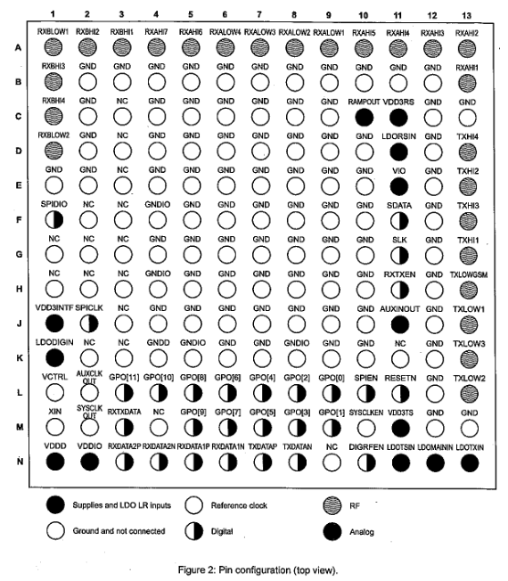

数字

电源和LDO LR输入

接地和无连接

图2：引脚 配置（俯视图）

类比

射频

参考时钟

parameter

SYM

state

# minimum value

Model

Maximum value

## Company

|  |  |  |  |  |  |  |  |  |
| --- | --- | --- | --- | --- | --- | --- | --- | --- |
| 1. Overall characteristics | Receiving frequency range | GSM-850 | |  | | 894 | MHz |  |
| DCS 1800 | | | | | | | | |
| 1805 |  |  | |  | | PCS 1900 | 1930 |  |
| 1990 |  | NF | |  | |  |  | DB |
| Error vector size | EVMrx |  | |  | | DEG |  |  |
| 8-PSK RMS EVM |  |  | | 2. Gain and PC Characteristics | | Maximum voltage gain | GRrx, Max | Tamb=+25 degrees C |
|  | 94 | DB | | Grx, min | | Tamb=+25 degrees C |  |  |
|  | DB | Channel Selectivity of Adjacent Signals | | 0.2MHz offset GMSK signal | |  |  |  |
| DB |  | 0.4MHz offset GMSK signal | | 38 | |  |  |  |
| 0.6MHz offset CW signal | | | | | | | | |
|  |  | |  | Synthesizer switching time | | Tsyn, RX |  |  |
| 100 | Mu s | |  | parameter | | SYM | state | minimum value |
| 1880 | | | | | | | | |
|  | 2400 | NF | | | Tamb=+25 degree C (band A/E/F) |  | 3.8 |  |
| DB | Error vector size |  | | |  |  |  | 2. Gain and PC Characteristics |
| Maximum voltage gain | Grx, Max | 94 | | |  | DB | Minimum voltage gain | Grx, min |
| To an I/Q output, Tamb=+25 degree C |  | DB | | | 3. Rx synthesizer characteristics | Synthesizer switching time | Tsyn, RX |  |
| state | | | | | | | | |
| minimum value | Model | Company | | Receiving Frequency Range (Central Frequency) | | Frx | Band 1 (High Frequency) | 2112.4 |

## 2167.6

|  |  |  |  |  |  |  |  |
| --- | --- | --- | --- | --- | --- | --- | --- |
| MHz |  | Band 2 (High Frequency) | | 1932.4 |  | 1987.6 |  |
|  | | | | | | | |
|  | Band 4 (High Frequency) | 2152.6 | |  |  | Band 5 (Low Frequency) | 871.4 |
|  | 891.6 |  | |  | Band 6 (Low Frequency) | 877.4 |  |
| 882.6 |  |  | | Band 8 (Low Frequency) | 927.4 |  | 957.6 |
|  | | | | | | | |
|  | Band 10 (High Frequency) | | 2112.4 |  | 2167.6 |  |  |
|  |  | |  |  |  | Noise figure | NF |
| Pin's QPSK signal=-60 dBm | | | | | | | |
|  |  |  | | 2. Gain and PC Characteristics | Maximum voltage gain | Grx, Max | To an I/Q output, Tamb=+25 degree C |

## 94

|  |  |  |  |  |  |  |  |
| --- | --- | --- | --- | --- | --- | --- | --- |
|  | DB | Grx, min | | To an I/Q output, Tamb=+25 degree C |  |  |  |
|  | | | | | | | |
| Mu s |  | parameter | | SYM | state | minimum value | Model |
| Maximum value | Company | Receiving Frequency Range (band limitation defined by 3GPP in TS 36.101) | | Frx | High Frequency > 2.3GHz: | FDD:7 | TDD: 38, 40, 41 |
| 2300 |  | MHz | | Receiving Frequency Range (band limitation defined by 3GPP in TS 36.101) |  | High Frequency > 2.3GHz: | FDD:7 |
| TDD: 38, 40, 41 |  |  | |  | Receiving Frequency Range (band limitation defined by 3GPP in TS 36.101) |  | High Frequency > 2.3GHz: |
| FDD:7 | TDD: 38, 40, 41 |  | |  |  | Receiving Frequency Range (band limitation defined by 3GPP in TS 36.101) |  |
| High frequency < 2.2GHz: | FDD: 1, 2, 3, 4, 9, 10, 11, 21, 23, 24, 25 | 1805 | |  | 2200 |  |  |
|  | High frequency < 2.2GHz: | TDD: 33, 34, 35, 36, 37, 39 | |  |  |  |  |
|  |  | FDD: 1, 2, 3, 4, 9, 10, 11, 21, 23, 24, 25 | | TDD: 33, 34, 35, 36, 37, 39 |  |  |  |
|  |  | High frequency < 2.2GHz: | | FDD: 1, 2, 3, 4, 9, 10, 11, 21, 23, 24, 25 | TDD: 33, 34, 35, 36, 37, 39 |  |  |
|  |  |  | | Low frequency: | FDD: 5, 6, 8, 12, 13, 14, 17, 18, 19, 20 | TDD: Not applicable | 728 |
|  | 960 |  | |  | Low frequency: | FDD: 5, 6, 8, 12, 13, 14, 17, 18, 19, 20 | TDD: Not applicable |
|  |  |  | |  |  | Low frequency: | FDD: 5, 6, 8, 12, 13, 14, 17, 18, 19, 20 |
| Tamb=+25 degrees C | | | | | | | |
|  |  | | DB | Error vector size | EVMrx | Pin's QPSK signal=-60 dBm |  |
|  |  | | 2. Gain and PC Characteristics | Maximum voltage gain | Grx, Max | To an I/Q output, Tamb=+25 degree C |  |
|  | | | | | | | |
|  | DB | Synthesizer switching time | | Tsyn, RX |  |  | 100 |

## Mu s

|  |  |  |  |  |  |  |  |
| --- | --- | --- | --- | --- | --- | --- | --- |
|  | Launcher | GSM/GPRS/EDGE Transmitting Mode | | parameter | SYM | state | minimum value |
| 824 | | | | | | | |
| DBc | 849 | DBm  Modulation Spectrum Measurement Around Carrier Frequency in 30 kHz Resolution BW  ModSp | | 915 |  |  |  |
| 1710 | 1850 |  | 1910 |  |
| Output Power of GSMK Mode | 200 kHz, 30 kHz BW |  | -35 |  |
| Modulation Spectrum Measurement Around Carrier Frequency in 30 kHz Resolution BW | DBm  Modulation Spectrum Measurement Around Carrier Frequency in 30 kHz Resolution BW | | Modulation Spectrum Measurement Around Carrier Frequency in 30 kHz Resolution BW |  | 400 kHz, 30 kHz BW |  |
| -62 |  |  | modulation accuracy | ModAcc | RMS of phase error |
|  | 2.5 | 10 |  | DB | 3. PSK mode |
| Maximum output power | PoutGMax | ModSp | 200 kHz, 30 kHz BW |  | -35 |
|  | DBc | 4. Tx synthesizer characteristics  Establishment time of synthesizer  Tsyn, RX | |  | Modulation Spectrum Measurement Around Carrier Frequency in 30 kHz Resolution BW |  | 400 kHz, 30 kHz BW |
|  | -60 |  |  | modulation accuracy | EVMRMS |
| RMS EVM |  |  |  | 100 |  |
| Mu s |  | parameter | | SYM | state | minimum value | Model |
| Maximum value | Company | Transmitting Frequency Range | | Frx | Band 34 (F), 39 (A) and 40 (E) | 1880 |  |
|  | | | | | | | |
| DBm | ACLR | | Pout = - 40dBm.. 0.5dBm | Pout <-40dBm |  | -43 | -80 |
|  | DBm | | Adjacent Channel Leakage Rate +3.2MHz Migration | AltCLR | Pout = 30 dBm.. 0.5 dBm |  | -60 |
|  | | | | | | | |
| DBm | Error vector size | Pout = 37dBm.. Pout, Max | |  |  |  |  |

2. Gain and PC Characteristics

## Programmable gain range

GRtx

|  |  |  |  |  |  |  |  |  |  |  |  |  |  |
| --- | --- | --- | --- | --- | --- | --- | --- | --- | --- | --- | --- | --- | --- |
| 85 | | DB | |  | | | |  | | DB | BB filter passband edge | | FC |
| Synthesizer switching time | | | | | | | | | | | | | |
|  | | 100 | | WCDMA/HSUPA transmission mode | | | | SYM | | state | Model | | Maximum value |
| 1. Overall characteristics | | Frx | | 1977.6 | | | |  | |  | 1852.4 | |  |
|  | |  | | 1782.6 | | | |  | |  | 1712.4 | |  |
|  | |  | | 846.6 | | | |  | |  | 832.4 | |  |
|  | | | | | | | | | | | | | |
|  | | |  | | | |  | |  | | | 0.5 | |
| DB | Pout = - 40dBm.. 0.5dBm | | | | -43 | | |  | | DBc | Neighboring Channel Leakage Rate (+10MHz) | | deviation |
|  | | | | deviation | | | Pout< -40dBm | |  |  | | DBm |
|  | | | | 2. Gain and PC Characteristics | | | GRtx | |  | 85 | |  |
|  | | | | BB filter passband edge | | | | | FC |  | | 2.5 |
| 100 | parameter | | | | |  | | 4. Tx synthesizer characteristics | | Synthesizer switching time |  | |  |
| state | | Model | | Maximum value | 1. Overall characteristics | | Transmitting Frequency Range (band limitation defined by 3GPP in TS 36.101) |
|  | | | | | | | | | | | | | |
|  | | Transmitting Frequency Range (band limitation defined by 3GPP in TS 36.101) | | TDD: 38, 40, 41 | | | |  | |  | Transmitting Frequency Range (band limitation defined by 3GPP in TS 36.101) | |  |
|  |  | | | |  | | | High frequency < 2.2GHz: | | FDD: 1, 2, 3, 4, 9, 10, 11, 21, 23, 24, 25 |  | |  |
| High frequency < 2.2GHz: | | | |  | | |  | |  |  | | High frequency < 2.2GHz: |
|  | | | |  | | | FDD: 5, 6, 8, 12, 13, 14, 17, 18, 19, 20 | | 699 | 915 | |  |
|  | | | |  | | | | | Low frequency: |  | |  |
|  |  | | | | |  | | Neighboring Channel Leakage Rate (+20MHz) | | ACLR | Pout <-40dBm | |  |
| AltCLR | | | | | | | | | | | | | |
|  | |  | | Pout = 37dBm.. Pout, Max | | | |  | |  | 2. Gain and PC Characteristics | | Programmable gain range |

GRtx

|  |  |  |  |  |  |  |  |  |
| --- | --- | --- | --- | --- | --- | --- | --- | --- |
|  | 85 | DB | | GStx | |  |  | 0.125 |
|  | | | | | | | | |
| MHz | Stopband attenuation of BB filter | Fin=25MHz | | 25 | |  | DB | 4. Rx synthesizer characteristics |
| Synthesizer switching time | Tsyn, RX |  | |  | | Mu s |  | Package shape |
|  |  | minimum value  Model | | Company | | 0.83 | 0.93 | 1.03  Mm |
| Mm |  |  | | A2 | |  | 0.71 |  |
|  | 0.50 | | Mm | |  |  | 0.50 |
|  | Mm |  | |  | |  |  | REF |
| Mm | | | | | | | | |
| D1 | 6.0 | |  |  | |  | 7.0 |  |
| Mm |  | | 6.0 | Mm | |  |  | 0.30 |
| Definition | | | | | | | | |
| 5.1 List of Abbreviations | ABB | Maximum power reduction | | | ACLR | Adjacent channel leakage ratio | Na | Not applicable / not available |
| AFC | Automatic frequency control circuit | ASM | | | Antenna switch module | PA | Power amplifier | BB |
| Channel | | | | | | | | |
| PGC | Programmable gain control | Continuous wave, single-tone sine | | Radio-frequency | | DBB | Digital baseband | RFFE |

RF front-end

## DFE

|  |  |  |  |  |  |  |  |  |
| --- | --- | --- | --- | --- | --- | --- | --- | --- |
| Digital front-end | RMS | DL | | Rx | | Receiver | E-UTRA | Evolved UTRA (LTE) |
| TCXO | | | | | | | | |
| Temp. -compensated crystal oscillator | HS1P | TDD | | HS2S | | High speed 2 secondary | VFBGA | Very thin-profile fine-pitch ball grid array |
| IC | Integrated Circuit | Transmitter | | Low speed | | UL | Uplink | LSB |
| Least significant bit | UTRA | MIP1 | |  | |  | MSB | Most significant bit |
|  |  |  | | 1712.4 | |  | 1752.6 |  |
|  |  | 波段5 | | 826.4 | |  | 846.6 |  |
|  |  | 波段6 | | 832.4 | |  | 837.6 |  |
|  |  | 波段8 | | 882.4 | |  | 912.6 |  |
|  |  | 波段9 | | 1752.4 | |  | 1782.4 |  |
|  |  | 波段10 | | 1712.4 | |  | 1767.6 |  |
| 最大输出功率 | Pout,max |  | |  | | 0.5 |  | dBm |
| 邻通道泄漏率±5MHz | ACLR | Pout =-40dBm..0.5dBm  Pout <-40dBm | |  | | -43  -80 |  | dBc  dBm |
| 邻通道泄漏率±10MHz  偏移 | AltCLR | Pout = -40dBm .. 0.5dBm | |  | | -60 |  | dBc |
| Pout< -40dBm | |  | | -80 |  | dBm |
| 误差矢量大小 | EVMrx | Pout = -37dBm .. Pout,max | |  | | 4 |  | % |
| **2. 增益和PGC特性** | | | | | | | | |
| 程控增益范围 | GRtx | |  |  | | 85 |  | dB |
| 可编程增益阶跃分辨率 | GStx | |  |  | | 0.125 |  | dB |
| **3. 基带特性** | | | | | | | | |
| BB滤波器通带边缘 | fc |  | | |  | 2.5 |  | MHz |
| BB滤波器阻带衰减 |  | fin=20MHz | | |  | 50 |  | dB |
| **4. Tx合成器特性** | | | | | | | | |
| 合成器切换时间 | Tsyn, tx |  | |  | | 100 |  | μs |

## TDD/FDD LTE发射模式

|  |  |  |  |  |  |  |  |  |
| --- | --- | --- | --- | --- | --- | --- | --- | --- |
| **参数** | **SYM** | **状态** | | **最小值** | | **型号** | **最大值** | **单位** |
| **1．总体特性** | | | | | | | | |
| 发射频率范围（根据TS 36.101中3GPP定义的波段限制） | frx | 高频>2.3GHz：  FDD：7  TDD：38, 40, 41 | | 2300 | |  | 2690 | MHz |
|  |  | |  |  |  |
|  |  | |  |  |  |
|  | 高频< 2.2GHz：  FDD：1,2,3,4,9,10,11,21,23,24,25  TDD：33,34,35,36,37,39 | | 1710 | |  | 2025 |  |
|  |  |  | |  |  |  |
|  |  |  | |  |  |  |
|  |  |  | |  |  |  |
|  |  | 低频：  FDD：5,6,8,12,13,14,17,18,19,20 | | 699 | |  | 915 |  |
|  |  |  | |  |  |  |
|  |  |  | |  |  |  |
| 最大输出功率 | Pout,max |  | |  | | 0.5 |  | dBm |
| 邻通道泄漏率±20MHz | ACLR | Pout =-40dBm..0.5dBm  Pout <-40dBm | |  | | -41  -80 |  | dBc  dBm |
| 邻通道泄漏率±40MHz偏移 | AltCLR | Pout = -35dBm .. 0.5dBm | |  | | -45 |  | dBc |
| Pout< -35dBm | |  | | -80 |  | dBm |
| 误差矢量大小 | EVMrx | Pout = -37dBm .. Pout,max | |  | | 4 |  | % |
| **2. 增益和PGC特性** | | | | | | | | |
| 程控增益范围 | GRtx | |  |  | | 85 |  | dB |
| 可编程增益阶跃分辨率 | GStx | |  |  | | 0.125 |  | dB |
| **3. 基带特性** | | | | | | | | |
| BB滤波器通带边缘 | fc |  | | |  | 12.5 |  | MHz |
| BB滤波器阻带衰减 |  | fin=25MHz | | |  | 25 |  | dB |
| **4. Rx合成器特性** | | | | | | | | |
| 合成器切换时间 | Tsyn, rx |  | |  | | 100 |  | μs |

# 封装外形

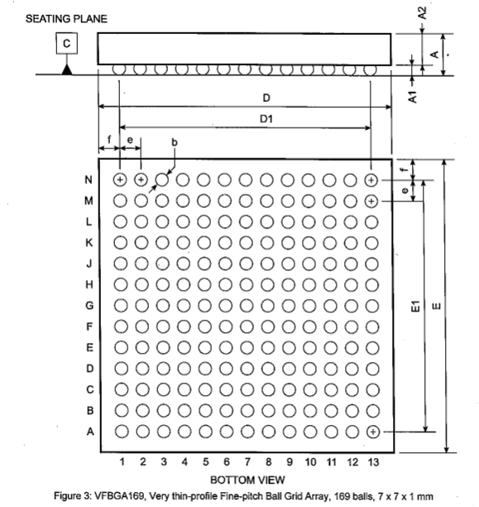

底座平面

底视图

图3：VFBGA169，薄型细间距BGA，169个球，7x7x1 mm

表1：封装直径，见图3

|  |  |  |  |  |
| --- | --- | --- | --- | --- |
| **REF** | **最小值** | **型号** | **最大值** | **单位** |
| A | 0.83 | 0.93 | 1.03 | mm |
| A1 |  | 0.22 |  | mm |
| A2 |  | 0.71 |  | mm |
| e |  | 0.50 |  | mm |
| f |  | 0.50 |  | mm |
|  |  |  |  |  |

|  |  |  |  |  |
| --- | --- | --- | --- | --- |
| **REF** | **最小值** | **型号** | **最大值** | **单位** |
| D |  | 7.0 |  | mm |
| D1 |  | 6.0 |  | mm |
| E |  | 7.0 |  | mm |
| E1 |  | 6.0 |  | mm |
| b |  | 0.30 |  | mm |
|  |  |  |  |  |

# 定义

## 5.1 缩写列表

|  |  |  |  |
| --- | --- | --- | --- |
| ABB | 模拟基频（Analog baseband） | MPR | 最大功率降低（Maximum power reduction） |
| ACLR | 邻信道泄漏功率比（Adjacent channel leakage ratio） | na | 不适用（not applicable / not available） |
| AFC | 自动频率控制电路（Automatic frequency control） | n. c. | 无连接（not connected） |
| ASM | 天线开关模块（Antenna switch module） | PA | 功放（Power amplifier） |
| BB | 基带（Baseband） | PMU | 电源管理单元（Power management unit） |
| BW | 带宽（Bandwidth） | RBW | 解析带宽（Resolution bandwidth） |
| ch. | 通道（Channel） | PGC | 可编程增益控制（Programmable gain control） |
| CW | 连续波，单音正弦（Continuous wave, single-tone sine） | RF | 射频（Radio-frequency） |
| DBB | 数字基带（Digital baseband） | RFFE | 射频前端（RF front-end） |
| DFE | 数字前端（Digital front-end） | RMS | 均方根（Root-mean-square） |
| DL | 下行链路（Downlink） | Rx | 接收器（Receiver） |
| E-UTRA | Evolved UTRA (LTE) | sig. | 信号（Signal） |
| FDD | 频分双工（Frequency division duplex） | SPI | 串行外围设备接口（Serial peripheral interface） |
| HS | 高速（High speed） | TCXO | 温补晶振（Temp.-compensated crystal oscillator） |
| HS1P | High speed 1 primary | TDD | 时分双工（Time division duplex） |
| HS2S | High speed 2 secondary | VFBGA | 薄型细间距BGA（Very thin-profile fine-pitch ball grid array） |
| IC | 集成电路（Integrated circuit） | Tx | 发射器（Transmitter） |
| LS | 低速（Low speed） | UL | 上行链路（Uplink） |
| LSB | 最低有效位（Least significant bit） | UTRA | 通用地面无线接入（Universal Terrestrial Radio Access） |
| MIP1 | 移动行业处理器接口（Mobile industry processor interface） |  |  |
| MSB | 最高有效位（Most significant bit） |  |  |