**系统2.0优化建议**

Suggestions for System 2.0 Optimization

系统2.0取得了如下工作和效果：

System 2.0 achieves the following work and results:

1. 编辑器渲染优化，基本无卡顿

Editor rendering optimization, basically no carton

1. 对接语料库

Docking corpus

1. 保持原文格式做到了80%

80% of the original format is maintained.

1. 密码找回和个人信息完善

Password Retrieval and Personal Information Improvement

1. 表格和图片处理

Table and Image Processing

1. 英文QA检查， 包括拼写和语法检查，性能不输Word.

English QA checks, including spelling and grammar checks, do not lose the performance of Word.

1. 貌似这些编号，都被误译了，是否跟语料匹配有关系？

It seems that these numbers have been misinterpreted. Does it have anything to do with corpus matching?

注：我看了下原文中的编号是人工输入的，不是自动的项目编号

Note: I have seen that the numbering in the original text is manual input, not automatic project numbering.

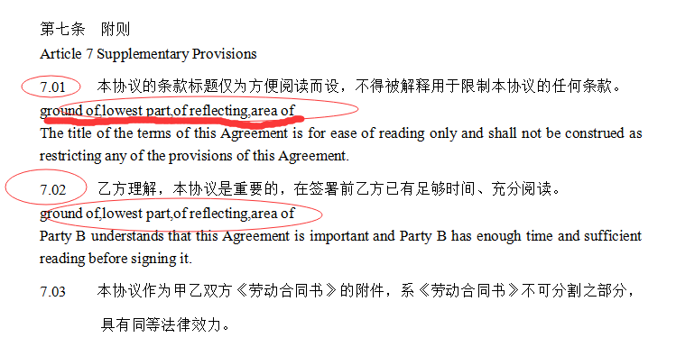

2、QA检查可以显示红色字体，能否将鼠标放上去之后给个错误提示

2. QA check can show the red font, can you put the mouse up and give an error prompt?



1. QA检查能否加个Button，让译员随时可以来一遍QA检查

QA check can add a Button, so that the interpreter can come to QA check at any time

4、语料匹配提示，匹配数量

4. Matching Tips and Number of Matches

5、如三人讨论，进入编译界面后，如果机器翻译还在进行，有个提示条提示一下

5. As discussed by three people, after entering the compiler interface, if machine translation is still in progress, there is a prompt bar to prompt you.

6、现在渲染速度确实很好了，但发现如果编译器如果有一会没操作，就会卡顿

6. The rendering speed is really good now, but it is found that if the compiler fails to operate for a while, it will get stuck.

3.0工作

3 work

1. 修订模式

Revision mode

1. 接入OCR识别

Access OCR Recognition