Suggestions for System 2.0 Optimization

System 2.0 achieves the following work and results:

1. Editor rendering optimization, basically no carton
2. Docking corpus
3. 80% of the original format is maintained.
4. Password Retrieval and Personal Information Improvement
5. Table and Image Processing
6. English QA checks, including spelling and grammar checks, do not lose the performance of Word.
7. It seems that these numbers have been misinterpreted. Does it have anything to do with corpus matching?

Note: I have seen that the numbering in the original text is manual input, not automatic project numbering.

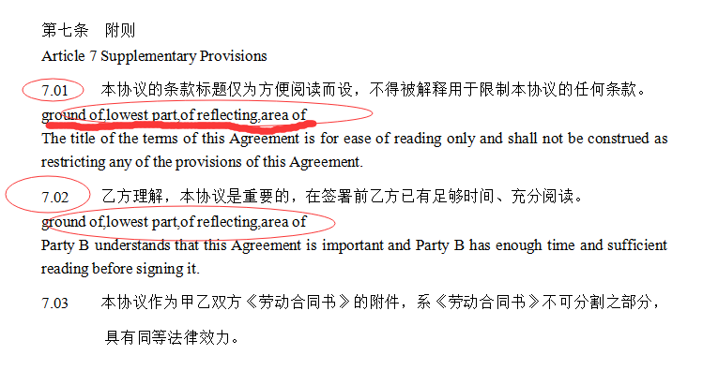

2. QA check can show the red font, can you put the mouse up and give an error prompt?



1. QA check can add a Button, so that the interpreter can come to QA check at any time

4. Matching Tips and Number of Matches

5. As discussed by three people, after entering the compiler interface, if machine translation is still in progress, there is a prompt bar to prompt you.

6. The rendering speed is really good now, but it is found that if the compiler fails to operate for a while, it will get stuck.

3 work

1. Revision mode
2. Access OCR Recognition