ABCDEFA,HAFIC,KDLL,INNDOH,FHNH,QLHIRH,LSNH,FDT,AB,AFH,IVICWBCHW,KINHFBSRH,CHIN,AFH,QBLDZH,RAIADBC,KFHNH,AFH,QNBAHRRDBCIL,IRRIRRDC,NHHRH,FDNHW,KDLL,HLDTDCIAH,FDT,ABTBNNBC,RFH,KDLL,EB,AB,AFH,KINHFBSRH,ICW,VHZBBH,AFH,ADNRA,QHNRBC,AB,WDRZBOHN,FDR,ZBNQRH,KDAE,F,RANBCE,ILDVH,AFHRH,QBLDZH,BYYDZHNR,IVRBLSAHLP,ZIC,CBA,INNHRA,FHN

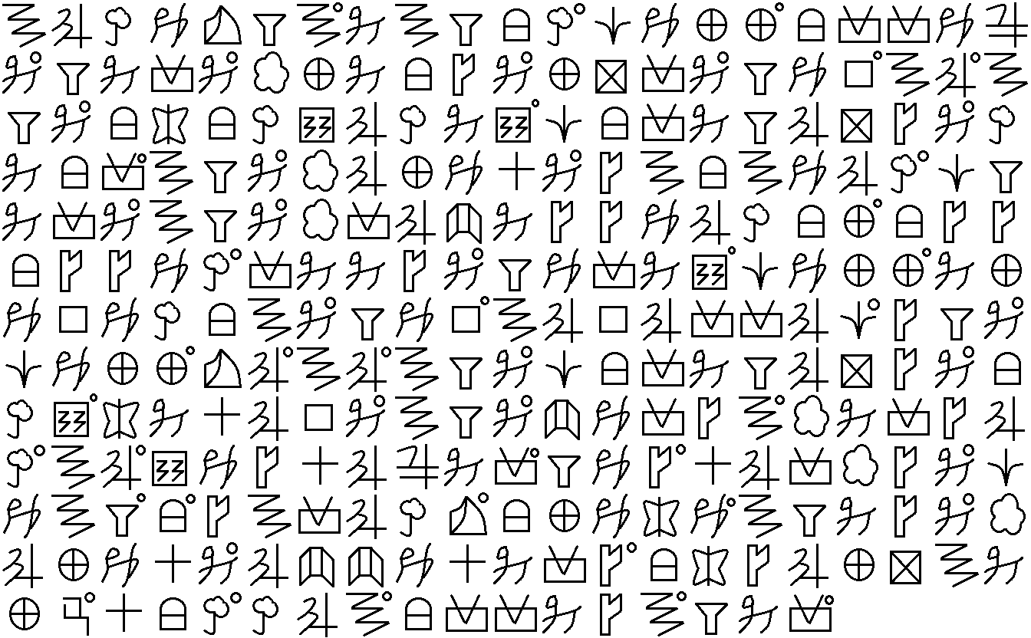

ABCDEFA,HAFIC,KDLL,INNDHH,FHNH,QLHIRH,LSNH,FDT,AB,AFH,IVICWBCHW,KINHFBSRH,CHIN,AFH,QBLDZH,RAIADBC,KFHNH,AFH,QNBAHRRDBCIL,IRRIRRDC,NHHRH,FDNHW,KDLL,HLDBDCIAH,FDT,ABBBNNBC,RFH,KDLL,EB,AB,AFH,KINHFBSRH,ICW,VHZBBH,AFH,ADNRA,QHNRBC,AB,WDRZBHHN,FDD,ZBNQRH,KDAE,F,RANBCA,ILDVH,AFHRH,QBLDZH,BAADZHND,IVRBLSAHLI,ZIC,CBA,INNHRA,FHN