# LABORATORY EXERCISE 7

# FILE UPLOADS (COURSE MATERIALS)

**Learning Objectives**

By the end of this laboratory exercise, students should be able to:

* Design and implement a database schema for managing file uploads related to courses.
* Utilize CodeIgniter's File Uploading Library to handle file uploads securely.
* Create an administrative interface for uploading and managing course materials.
* Implement access control to ensure only enrolled students can download materials.
* Enhance the user interface with Bootstrap for a clean and functional file management system.

**Prerequisite student experiences and knowledge**

Before starting this exercise, students should have:

* Completed Laboratory Exercise 6 (Course Enrollment System).
* A solid understanding of CodeIgniter's MVC structure and database operations.
* Experience with HTML forms and Bootstrap styling.
* Basic knowledge of handling file inputs in HTML.
* Familiarity with user authentication and session management in CodeIgniter.

**Background**

A core feature of any Learning Management System (LMS) is the distribution of learning resources. This involves allowing instructors to upload various file types (such as PDFs, PowerPoint presentations, and documents) and making them available to enrolled students. CodeIgniter provides a robust File Uploading Library that simplifies the process of validating, uploading, and securing files. This exercise will integrate this functionality into the LMS, ensuring that file management is seamless and secure.

**Materials/Resources**

* **Personal Computer with Internet Access**
* **XAMPP/WAMP/LAMP server installed**
* **CodeIgniter Framework (latest version)**
* **Visual Studio Code or any code editor**
* **Git and GitHub Account**
* **Web Browser (Chrome, Firefox, etc.)**

**Laboratory Activity**

**Step 1: Create a Database Migration for Materials Table**

1. Create a new migration file for the materials table.

Run: **php spark make:migration CreateMaterialsTable**

1. Open the newly created file in **app/Database/Migrations/**.
2. In the **up() method**, define the table with the following fields:

* id (Primary Key, Auto-Increment)
* course_id (INT, Foreign Key referencing the `courses` table)
* file_name (VARCHAR(255)) to store the original filename
* file_path (VARCHAR(255)) to store the path to the uploaded file
* created_at (DATETIME)

1. In the **down() method**, define how to drop the table.

Run the migration: php spark migrate

**Step 2: Create a Model for Materials**

1. Navigate to app/Models/ and create a file named **MaterialModel.php**.
2. Create a model class with methods to:

* **insertMaterial($data)** Insert a new material record.
* **getMaterialsByCourse($course_id)** Get all materials for a specific course.

**Step 3: Create or Modify a Controller for Materials**

1. You can create a new Materials.php controller or add methods to an existing admin controller.
2. Add the following methods:

* **upload($course_id)** Displays the file upload form and handles the file upload process.
* **delete($material_id)** Handles the deletion of a material record and the associated file.
* **download($material_id)** Handles the file download for enrolled students.

**Step 4: Implement File Upload Functionality**

1. In the **upload($course_id**) method, check for a POST request.
2. Load CodeIgniter's File Uploading Library and Validation Library.
3. Configure the upload preferences (upload path, allowed file types, maximum file size).
4. Perform the file upload. If successful, prepare data (course_id, file_name, file_path) and save it to the database using the **MaterialModel**.
5. Set a flash message indicating success or failure and redirect back to the course management page.

**Step 5: Create the File Upload View**

1. Create a view file.
2. The view should contain a form with the **enctype="multipart/form-data"** attribute and a file input field.
3. Style the form using Bootstrap classes.

**Step 6: Display Downloadable Materials for Students**

1. In the student dashboard or a dedicated course view, use the **MaterialModel** to fetch materials for the courses the student is enrolled in.
2. Create a view that lists these materials, displaying the file name and a download button/link for each.
3. The download link should point to the **download($material_id)** method in your controller.

**Step 7: Implement the Download Method**

1. In the **download($material_id)** method:

* Check if the current user is logged in and enrolled in the course associated with the material.
* Retrieve the file path from the database using the `$material_id`.
* Use CodeIgniter's download() helper function or the Response class to force the file download securely.

**Step 8: Update Routes**

1. Update app/Config/Routes.php to include routes for the new functionalities.

**$routes->get('/admin/course/(:num)/upload', 'Materials::upload/$1');**

**$routes->post('/admin/course/(:num)/upload', 'Materials::upload/$1');**

**$routes->get('/materials/delete/(:num)', 'Materials::delete/$1');**

**$routes->get('/materials/download/(:num)', 'Materials::download/$1');**

**Step 9: Test the Application**

1. Run the application and test the complete flow:

* Log in as an admin/instructor.
* Navigate to a course and upload a file (PDF, PPT).
* Verify the file is saved in the designated folder and a record is added to the `materials` table.
* Log in as a student enrolled in the course.
* Navigate to the course page and verify the material is listed.
* Test the download functionality.
* Test accessing the download link while not enrolled (it should be restricted).

**Step 9: Push to GitHub**

1. Add, commit, and push your changes to your GitHub repository.

Output / Results

* Screenshot of the **materials** table schema from your database (phpMyAdmin or equivalent).
* Screenshots of the file upload form (admin side) and the student view showing the list of downloadable materials.
* Screenshot of the server's file system (upload directory) showing the uploaded file.
* A screenshot of the GitHub repository with the latest commit for this exercise.

**QUESTIONS:**

1. **What are the security risks associated with file uploads, and how did you mitigate them using CodeIgniter's File Uploading Library?**

The security risks in file uploads include harmful files that can damage the system, people trying to access files outside the upload folder, files with the same name replacing others, users who are not allowed to see the files, and very big or unsafe files. In Lab 7, these problems were fixed by using CodeIgniter’s file upload tools like getFile(), isValid(), hasMoved(), and move() to handle uploads safely. Files are saved with random names using $file->getRandomName() so no one can guess or replace them. The system also checks user permission in the download($id) function before giving access, and only safe file types and sizes are allowed to upload.

1. **Explain the purpose of the enctype="multipart/form-data" attribute in the form tag for file uploads.**

In my LMS, I used enctype="multipart/form-data" in the form tag so the browser can send files correctly to the server. Without this, the file would not upload, and request->getFile('file') in CodeIgniter would not work.

1. **Why is it important to check if a student is enrolled in a course before allowing them to download a material? How does this enforce application security?.**

I made sure to check if a student is enrolled before downloading materials. This keeps the files safe so only enrolled students also teachers, and admins can download them. I did this in the Materials::download($id) function, where it checks with EnrollmentModel::isAlreadyEnrolled(userId, courseId). This stops users who are not part of the class from opening or guessing file links.

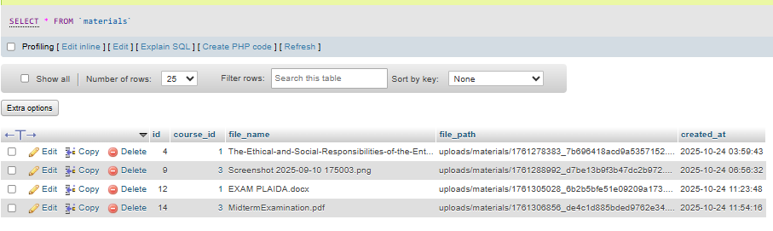**Output / Results**

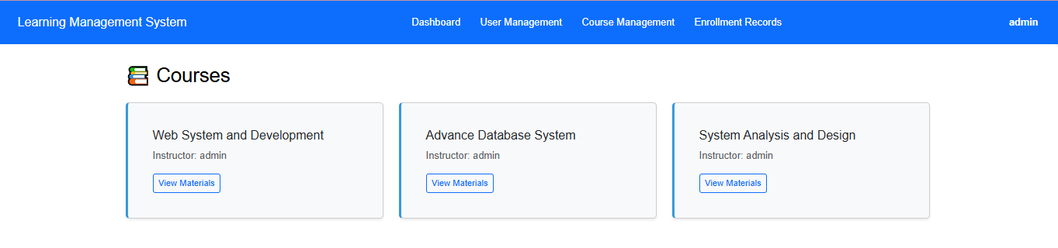

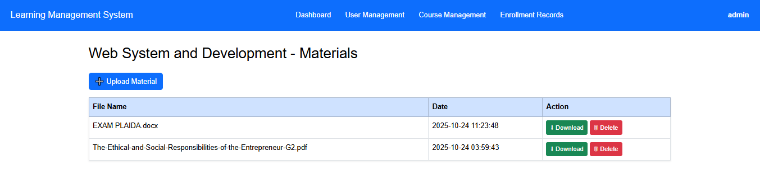

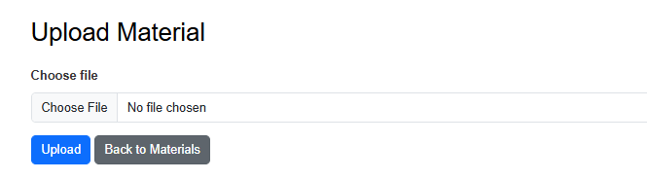

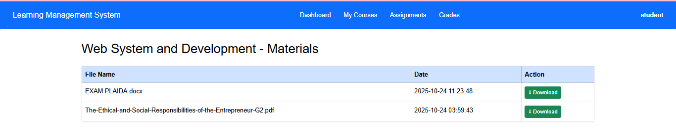

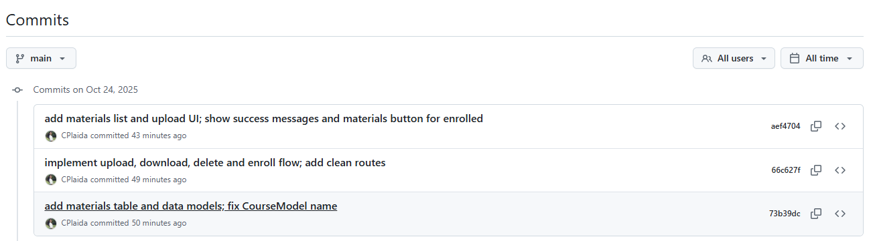

**Conclusion**

In conclusion, while creating my LMS, I learned that handling file uploads safely is very important. Using CodeIgniter’s upload tools helped protect the system from harmful files and wrong access. Adding enctype="multipart/form-data" made sure files were uploaded correctly, and checking student enrollment before downloads kept the materials secure. These steps made my LMS safer and more reliable for both teachers and students.