Andrew Hernandez

February 14, 2021

Foundations of Programming (Python)

Assignment 05

Professor Dirk Biesinger

**List of Dictionaries**

*Keywords: Dictionaries, 2-dimension lists, User input, While-loop, if-elif-else statement, Import libraries, saving data, append lists, deleting data, reading file data*

**Introduction**

In this assignment, we were tasked to convert last week’s assignment of a 2-dimensional list into a list of dictionaries. The purpose of this paper is to discuss the method and techniques used to accomplish this assignment. Furthermore, we were asked to read in data from a file, update the CD inventory from the data in a file, search specific data to delete by using the Key and append the list with new data. Similar to last weeks assignment, I was a little off guard with the tasks being asked because I didn’t know if we had to start with a baseline inventory and add, delete and update that data or if we needed to create an empty list and start fresh. I chose to create an empty list of dictionaries assuming that we were expecting users to enter their own data into the program.

One of the differences between this assignment and the previous assignments was that we were provided some starter code. Working from someone else code base can be a little difficult because you first must review the code, variables, functions and logic to understand how you are going to add new functionality. At work, I’ve had to peer-review several developers SQL and C# code and I’ve also had to modify existing code to add more functionality to the application. Both are a tricky to do but you do get a good understanding on how to approach problems and often you end up learning a lot from the solutions provided.

For this assignment, there were sections that were completed such as the closing of the application and the else condition of an invalid option was selected. At first glance, I didn’t know where to start in converting this from a 2 dimensional list to a list of dictionaries. I chose to work on the displaying of the list since the for loop used for that would provide the basis for the other user options. For displaying the list of dictionaries, I added a nested if statement to check if the list was empty and return a message to the user. If the list was not empty, I displayed the current list. This portion of the assignment took me a while because I wasn’t able to display the dictionaries with out “” and showing 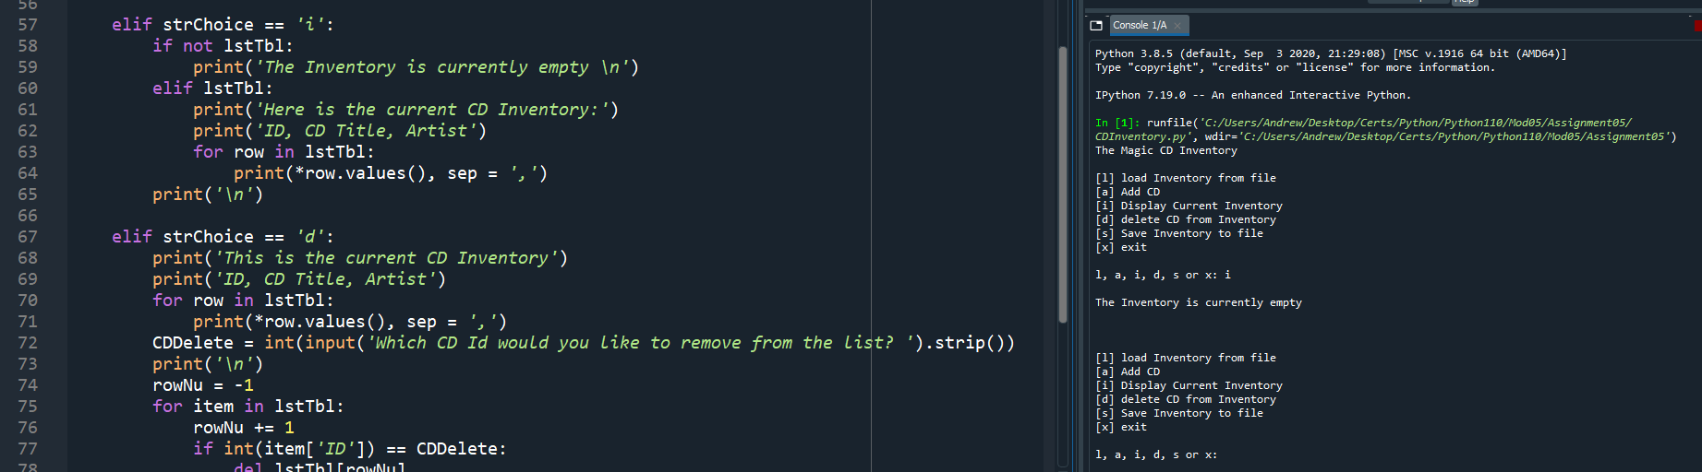the key.

Figure :Display CD Inventory

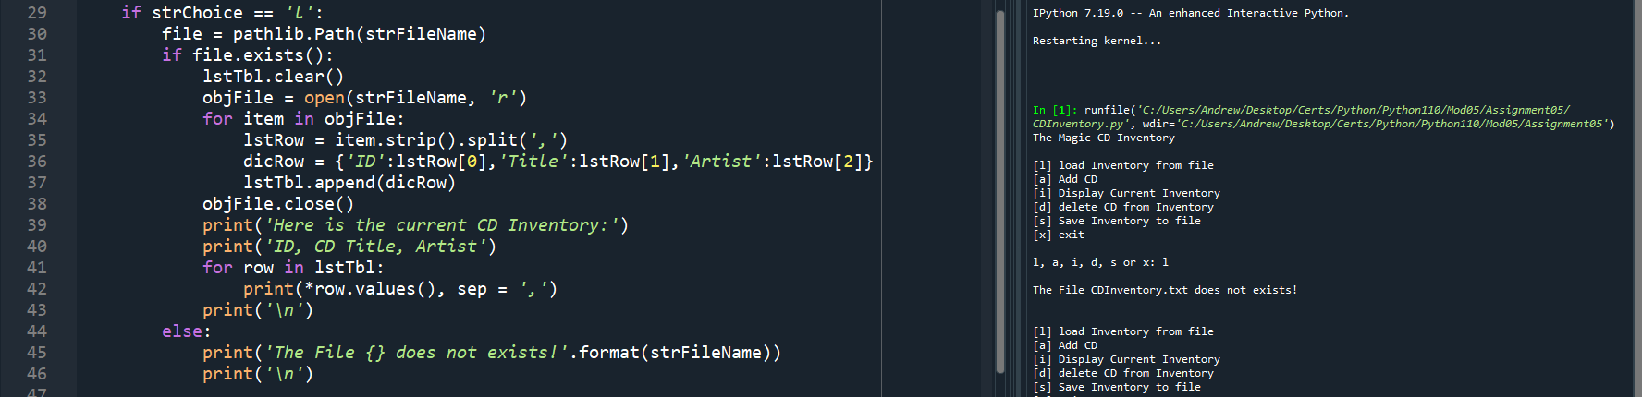 The second section that I worked on completing was loading a list from a text file. For this task, we used the strip() and split() functions. The strip() removes white space characters from the data being imported. The split() function is used to parse data by a delimiter such as a comma. While I was working on this section, I found that if a user tries to load data from a file and the file doesn’t exist the program will crash. I decided to add another nested if statement to check if the file exists. In order to accomplish this, I imported the pathlib[1] library so I could confirm if the file were there or not.

The next section that I completed was saving the dictionary to a file. For this part I reused the code that I wrote in the display list section because it was similar. I also used some code that was demonstrated in class because I was not sure how to remove the trailing comma at the end of the list. This part didn’t cause me too many issues; however, we did use the addition assignment for variables and the .values() function for the rows in the list table. The addition assignment is the same as in other programming languages, where it adds the value of the right operand to the variable then assigns the results to the variable[2].

Figure 2:Loading List from File

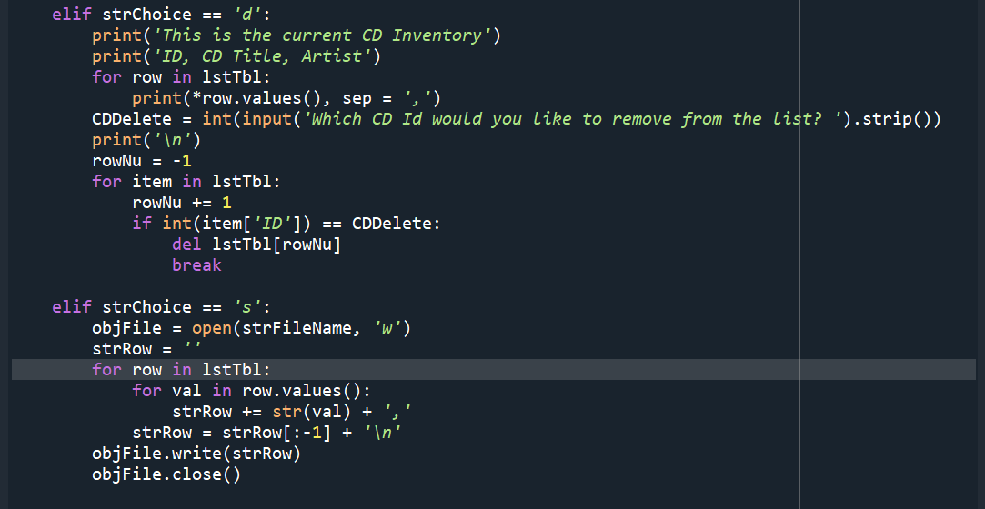The final section, deleting a dictionary from a list was the area that caused me the most difficulty only because I was not able to get a match on the user input value and the ID of the dictionary. After spending hours trying everything including casting the user input. I realized that I needed to cast the ID to an int. After casting the ID to an int I was able to delete with no issue. This was, however, the most consuming part of the assignment for me and I wonder if it was because I was starting at the code for too long. My usual routine is to only get stuck on code for a max of 2 hours then I will take a break and try to decompose the issue going through scenarios in my head. This usually does one of two things. The first being to understand the logic or issue that I’m having and create a logical solution. The second is to be able to formulate a question to post on Stack Overflow.

Figure 3:Deleting record from list of dictionaries

**Conclusion**

Overall, I found this assignment to be very enjoyable and challenging. It allowed us to apply all of the python techniques we have learned so far and create a single program using them all. Furthermore, getting more experience working and adding to someone else’s code was a good learning experience because it showed me a different solution to the previous assignment and it also reinforced those techniques because I had to review the code and the logic. I like how we had to add the code to GitHub because it will allow use to get familiar with source control software. Here is my GitHub link for this assignment. <https://github.com/Slugdrew/Assignment05_python>

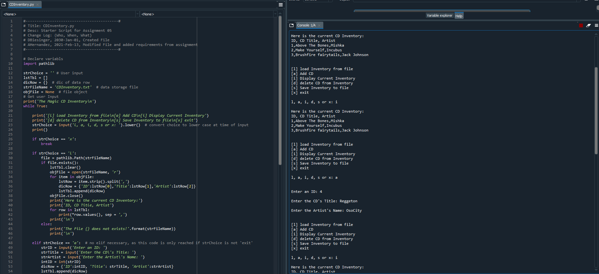

Figure 4: Program Executed in Spyder

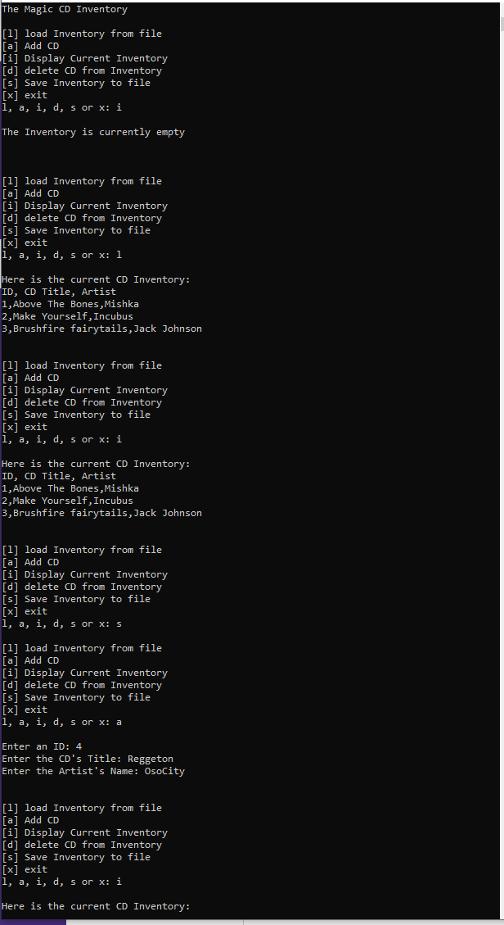

Figure :Program executed in CLI

1. <https://www.guru99.com/python-check-if-file-exists.html#:~:text=Python%20exists()%20method%20is,with%20os%20module%20and%20os>. Accessed 14 Feb 2021
2. <https://developer.mozilla.org/en-US/docs/Web/JavaScript/Reference/Operators/Addition_assignment> accessed 14 Feb 2021