Andrew Hernandez

February 21, 2021

Foundations of Programming (Python)

Assignment 06

Professor Dirk Biesinger

**Functions and SoC**

*Keywords: Custom Functions, Separation of Concern, Classes, Docstrings, Dictionaries, 2-*

*dimension lists, User input, While-loop, if-elif-else statement,*

**Introduction**

The purpose of this assignment was to work with code from the previous assignment and refactor the code to follow the Separation of Concern (SoC) design principle. Furthermore, we were tasked with understanding how to work with functions and classes. This assignment was a very important assignment in the field of programming. There were many things that we did in this assignment that resembled real-life programming tasks. The first was working from existing code and refactoring it to follow the Separation of Concern (SoC) design principle. The second was working with custom functions, classes and methods. There were some concerns that I had in this assignment as I was not too sure if I was applying the proper best practices in my code.

**Separation of Concern (SoC)**

Separation of Concern (SoC) design principle is a very common programming principle that helps developers organize their code into logical sections. “SoC is a design principle for separating a computer program into distinct sections such that each section addresses a separate area of concern”[1]. For this program we separated the application into three sections, presentation, Data, and Processing. The Presentation section is where you would put all input and output code. The Data is where all the global variables would be placed. The processing is where the logic of the program would be placed. All these sections would be called from a main class that starts the program. I like to think of Pythons SoC like a C# MVC program where the Data is the Model, the presentation is the view, and the processing is the controller of the application. Looking at a Pythons SoC in this way I was able to logically understand how the program should be separated. My assumption would be that these areas would be separated 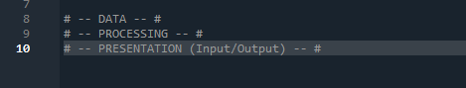into different .py files and we would need to import them in order to use them in the project.

Figure : Separation of Concern (SoC) Structure

**Functions and Classes**

Our goal for this assignment was to examine the code base that was provided and refactor the code structure. We were tasked with taking specific code blocks out of the main program and placing them into custom functions. We were also tasked with creating our own custom functions that took in variables and/or returned variables to be used in other areas of concern. When I first saw the starter code, I was a little caught off guard because the program executed and worked as intended; however, the structure of the code was not separated into different areas.

The starter code already had functions created into different SoCs and we needed to move the pieces, so they followed the correct logic. I approached this assignment as I would an MVC project. I started working with the Data area first since this was the smallest section to work with and it only contained variables that would be used for the other sections. 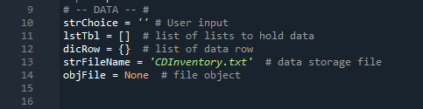

Figure : Data SoC

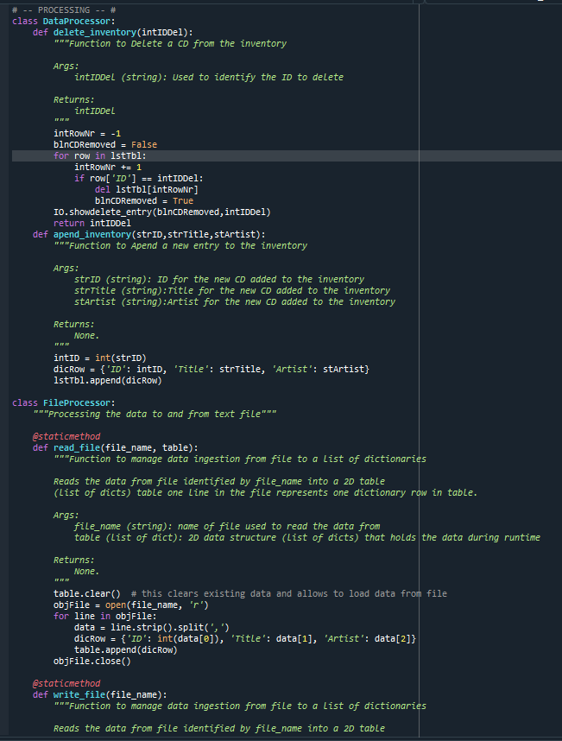The next section that I refactored was the Processing section. This section took a little time to work through because it contained several input and output code. I had to write down how I was going to logically separate this area and how variables would flow back and forth. This section also contained two different classes. One that handled the data processing and the other that dealt with the file processing. When creating or modifying the functions, we also had to create a Docstring which describes the function, its arguments and any return value.

Figure : Processing SoC

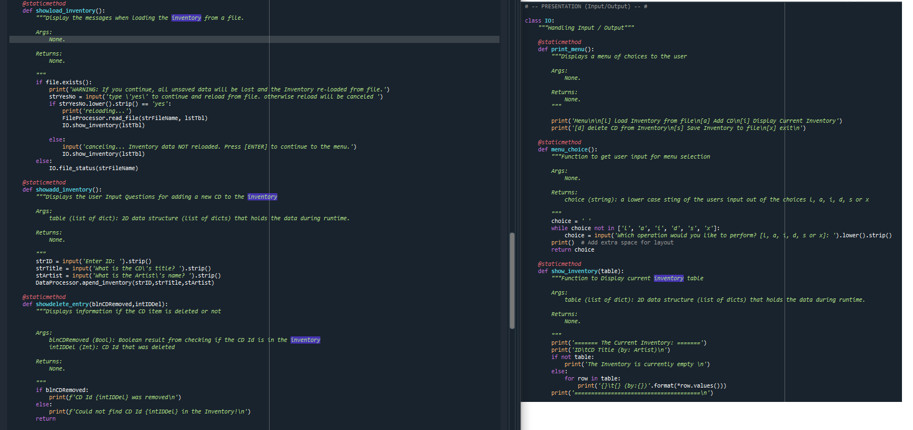 The final SoC that I worked with was the Presentation area. I purposely worked on this last because I wanted to make sure that my logic was correct and that it was passing the correct data for display. I also realized that I wanted to add a little more to the presentation of the application so I wanted to make sure the main tasks were completed then I would proceed with the additional items such as checking if a list was empty, checking if the file existed in the directory, listing the record that was being removed, and adding some built-in functions to the existing source code. In the IO class of the presentation area, I wasn’t too sure if all IO functions such as one liners should be moved into their own custom function. To me it seemed a little overkill to do this since you would be writing several more lines for a one-line IO function. However, I do realize, after it was mentioned in class, that if we were doing any type of input validation that would wrap the IO in try-except blocks then we should create a function for those sections. Furthermore, I really wasn’t sure if I was passing or returning the correct arguments in the function and this is one area that I would really like some feedback on.

Figure :Presentation SoC

**Summary**

Overall, I really enjoyed this assignment because it allowed us to see how a larger application would be organized and structured. Also, it made me realize that I really need to work harder and understand how functions, classes and methods work when they contain arguments. The program that I created functions how it is supposed to, but I fear that I did not implement the functions the way there were supposed to be implemented. I feel as if there is something that I am missing in the program. I created a new repository in GitHub and the source code can be found at the following URL: <https://github.com/Slugdrew/Assignment_06.git>

1. <https://en.wikipedia.org/wiki/Separation_of_concerns>, accessed 21-Feb-2021