# Lab 5.C – Study of Pointers & Linked Data Structures at the Architecture Level

## DESCRIPTION

The goal of this lab is to introduce the concepts of pointer types and linked data structures at the architecture level.

Construct a memory image of Figure 7.1. Load A5 with the address $0074B0 (do **not** do this in the code, do this before you run your program). Insert the following code which establishes pointers to e2 and e3:

|  |  |  |  |
| --- | --- | --- | --- |
|  | LEA | $0074A8,A6 | .A6 points to e1 |
|  | MOVE.L | 4(A6),A1 | .A1 points to e2 |
|  | MOVE.L | 4(A1),A2 | .A2 points to e3 |

    LEA.L   $000074B0,A5

     MOVE.L  A2,4(A5)

     MOVE.L  A5,4(A1)

Insert the element that A5 points to between those two elements. You must turn in a copy of the linked list (memory display) prior to and after inserting the new element. You are also required to turn in a copy of your instructions for this operation.

**Address Contents**

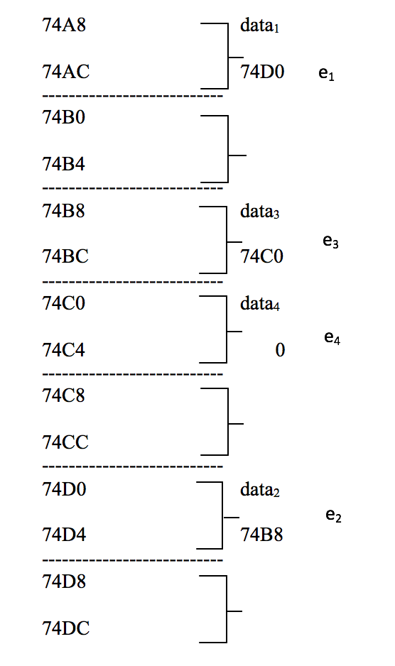

74A8 data1

74AC 74D0 e1

74B0

74B4

74B8 data3

74BC 74C0 e3

74C0 data4

74C4 0 e4

74C8

74CC

74D0 data2

74D4 74B8 e2

74D8

74DC

Figure 7.1 shows the address and its contents

|  |  |
| --- | --- |
| **Address** | **Data** |
| $74A8 | 41414141 |
| $74AC | 000074D0 |
| $74B0 | 00000000 |
| $74B4 | 00000000 |
| $74B8 | 43434343 |
| $74BC | 000074C0 |
| $74C0 | 44444444 |
| $74C4 | 00000000 |
| $74C8 | 00000000 |
| $74CC | 00000000 |
| $74D0 | 42424242 |
| $74D4 | 000074B8 |