DIABETES PREDICTION USING AN ARTIFICIAL NEURAL NETWORK WITH A CALIBRATED, EXPLAINABLE ENSEMBLE
A Project Report
Submitted by
Padmanaban (RA2411026050113)
Kishor A (RA2411026050085)
Shakithyan (RA2411026050090)
Department of Artificial Intelligence and Machine Learning (AIML), SRM Institute of Science and Technology
Faculty guide: Bhuvaneswari Amma N G | Academic year 2026-2027
October 2026

Abstract
Diabetes mellitus is a chronic metabolic condition whose early identification depends on routinely collected measurements such as plasma glucose, body mass index and age. Machine learning offers a way to convert these measurements into a risk score, but published studies on the small Pima Indians Diabetes benchmark are often difficult to compare because they differ in preprocessing, data partitioning and the way performance is selected and reported. This project builds a transparent and reproducible workflow around an artificial neural network (ANN) and evaluates it honestly against four established learners, a no-skill baseline and an ensemble.
The dataset contains 768 records with eight numeric predictors and a binary Outcome label (500 negative, 268 positive). The records are split once, with a fixed seed and stratification, into 460 training, 154 validation and 154 test rows. Physiologically impossible zero values in glucose, blood pressure, skin thickness, insulin and BMI are treated as missing, and median imputation with missingness indicators, standardisation and ANOVA feature selection are fitted inside every cross-validation fold so that no information leaks from held-out data. Three feature representations (original, engineered and five selected features) are compared by five-fold cross-validation. Six randomised hyperparameter configurations are searched for each of five models: logistic regression, random forest, histogram gradient boosting, an RBF support vector machine and a multilayer perceptron with one hidden layer of 32 ReLU units, a sigmoid output, the Adam optimiser, L2 regularisation and early stopping.
The five tuned models are combined by equal-weight soft voting, the averaged probability is passed through an out-of-fold sigmoid calibrator, and a decision threshold of 0.33 is chosen on the validation set by maximising the F1 score. The frozen model is evaluated exactly once on the held-out test set. The calibrated ensemble reaches ROC-AUC 0.811 (bootstrap 95% interval 0.736 to 0.876), accuracy 71.4%, recall 70.4%, specificity 72.0% and F1 0.633. Gradient boosting obtains a slightly higher test AUC of 0.822, and sigmoid calibration lowers the binned expected calibration error from 0.125 to 0.086 while the Brier score rises marginally from 0.1709 to 0.1746; both results are reported without adjustment. An exact interventional Shapley analysis of the complete deployed pipeline, permutation importance and what-if curves show that glucose is the dominant driver, followed by BMI and age. A local web application exposes the frozen model with explanations and uncertainty notes.
The study contributes a leakage-controlled benchmark, a full ablation of representation, model, ensemble and calibration choices, a comparison against the literature and an explicit statement of limitations, including the small test set, heavy missingness in insulin and skin thickness, and the absence of external validation. The system is an educational demonstrator and not a clinical diagnostic tool.
Keywords: diabetes prediction, artificial neural network, Pima Indians dataset, soft-voting ensemble, probability calibration, Shapley explanations.

1. Introduction
1.1 Background and motivation
Diabetes mellitus is a group of metabolic disorders characterised by persistently elevated blood glucose. Left undetected it contributes to cardiovascular disease, kidney failure, neuropathy and retinopathy, and the World Health Organization and the International Diabetes Federation both describe its prevalence as rising worldwide [1], [2]. Because many people remain undiagnosed for years, inexpensive screening aids that use measurements already collected in primary care are of practical interest. A model that ranks individuals by estimated risk could help prioritise confirmatory laboratory testing, although it can never replace a clinical diagnosis.
Supervised machine learning is a natural tool for this task. Given a table of measurements and a recorded outcome, a learner estimates a function that maps new measurements to a probability of the positive class. Artificial neural networks are attractive because they can represent non-linear interactions between predictors, but on small tabular datasets they are often matched or beaten by simpler models. A responsible study therefore has to compare the network with strong baselines under identical conditions rather than reporting it in isolation.
1.2 Problem statement
The task addressed here is binary classification of the historical Outcome label in the Pima Indians Diabetes Database from eight numeric inputs. The label is an existing dataset annotation. The project does not forecast future disease onset, and its predictions are not diagnoses. The challenge is to obtain reliable estimates of generalisation on only 768 records, to cope with measurements that are recorded as zero when they are actually missing, and to report both discrimination and the quality of the predicted probabilities.
1.3 Objectives
• To audit the data, quantify missing and invalid values and explore the relationship between each predictor and the outcome using training data only.
• To design a leakage-controlled pipeline in which imputation, scaling and feature selection are learned only from training folds.
• To train and tune an ANN and compare it with logistic regression, random forest, gradient boosting, a support vector machine and a no-skill dummy classifier.
• To combine the models into a soft-voting ensemble, calibrate its probabilities and choose a decision threshold on a separate validation set.
• To evaluate the frozen model once on an untouched test set with confidence intervals and a paired statistical comparison.
• To perform ablation studies of representation, model, ensembling, calibration and threshold, and to compare the results with published work.
• To explain predictions with exact Shapley values, permutation importance and what-if analysis, and to deliver a local application.
1.4 Contributions
The reporting follows the spirit of the TRIPOD guideline for prediction-model studies [35]. The study does not propose a new learning algorithm. Its contribution is the careful integration of established techniques into one reproducible protocol, an ablation that isolates the effect of each design decision, and an honest report of the outcome, including the cases in which the more elaborate choice did not help: engineered features did not win the cross-validation ablation, gradient boosting obtained a higher test AUC than the deployed ensemble, and calibration worsened the Brier score even though it reduced binned calibration error.
1.5 Organisation of the report
Section 2 surveys related work with a comparison table. Section 3 presents the proposed methodology with a block schematic, equations and algorithms. Section 4 describes the dataset, the experimental setup and the results with output figures. Section 5 reports the ablation study and a comparison with the state of the art. Section 6 concludes, and the references follow.

2. Literature Survey
The Pima Indians Diabetes Database is one of the most frequently used small benchmarks in medical machine learning. It was assembled by the National Institute of Diabetes and Digestive and Kidney Diseases and was already used in the late 1980s to evaluate the ADAP neural-style learning algorithm for forecasting the onset of diabetes [3]. Since then dozens of studies have applied classical classifiers, ensembles and neural networks to it. This section reviews work on diabetes prediction and the methodological literature on which the present design relies.
2.1 Diabetes prediction with classical learners
Sisodia and Sisodia compared decision trees, support vector machines and Naive Bayes on the Pima data using 10-fold cross-validation and reported Naive Bayes as best with about 76.3% accuracy [4]. Their work shows that simple probabilistic models are competitive, but it reports a single accuracy figure and does not examine calibration or threshold choice. Zou et al. applied decision trees, random forest and a neural network to hospital physical-examination data from Luzhou, China, and to the Pima data, using principal component analysis and minimum redundancy maximum relevance for dimensionality reduction; random forest performed best on their hospital data [5]. Sneha and Gangil studied feature selection for early diabetes prediction and found that choosing an optimal feature subset improved several classifiers, with Naive Bayes and a decision tree among the strongest [6]. Kavakiotis et al. surveyed machine learning and data mining methods in diabetes research and observed that supervised classification, and particularly support vector machines, dominates the literature while validation practices vary widely [7].
2.2 Ensembles, boosting and neural networks
Breiman's random forests average many decorrelated decision trees and are robust on small tabular data [8]. Friedman's gradient boosting builds an additive model stage by stage by fitting the negative gradient of a loss, and modern histogram-based variants make it fast and accurate [9], [10]. Support vector machines maximise the margin of a separating surface and use kernels for non-linearity [11]. Multilayer perceptrons trained by back-propagation [12] with the Adam optimiser [13] and rectified linear units [14] are the standard feed-forward networks. Regularisation by weight decay, dropout and early stopping limits over-fitting on small samples [15]. Grinsztajn et al. showed that tree-based models still frequently outperform deep networks on medium-sized tabular data, which motivates comparing the ANN against forests and boosting rather than assuming its superiority [16].
2.3 Probability calibration and decision thresholds
A classifier that ranks well can still output poorly calibrated probabilities. Platt scaling fits a sigmoid to classifier scores [17], and Niculescu-Mizil and Caruana compared calibration methods across learners [18]. Guo et al. showed that modern neural networks can be over-confident and examined temperature scaling and expected calibration error [19]. The Brier score, introduced for probability forecasts in meteorology, is a proper scoring rule that rewards both discrimination and calibration [20], whereas binned expected calibration error depends on the number of bins, so the two can disagree. Choosing a decision threshold on data separate from the test set is important because the default 0.5 rarely matches the desired balance of sensitivity and specificity, particularly with a 35% positive prevalence [21].
2.4 Explainability in diabetes prediction
Lundberg and Lee unified several attribution methods as SHapley Additive exPlanations, which assign each feature its average marginal contribution over all feature coalitions [22]. Ribeiro et al. proposed LIME, which fits local linear surrogates [23]. Tasin et al. combined ensemble classifiers with SHAP and LIME for diabetes prediction and built an application around them [24]. Hasan et al. combined automated machine learning with explainable AI and a Streamlit interface for transparent diabetes prediction [25]. Permutation importance, introduced for forests by Breiman and generalised later, offers a model-agnostic global view [8], [26]. These studies motivate explaining the complete deployed pipeline, including preprocessing and calibration, rather than an isolated surrogate model.
2.5 Evaluation methodology
Evaluation on small datasets is vulnerable to optimistic bias. Information leakage from preprocessing performed before splitting, repeated tuning on the same folds and selection of the best-looking model on the test set all inflate reported performance. Varma and Simon demonstrated the bias of non-nested cross-validation when it is used for model selection [27], and Cawley and Talbot made the same point for hyperparameter tuning [28]. Efron's bootstrap provides interval estimates for test metrics [29], and McNemar's test compares paired classifier errors [30]. Saito and Rehmsmeier argued that precision-recall measures are more informative than ROC curves on imbalanced data [31]. This project applies these recommendations: a held-out test set that is evaluated once, fold-local preprocessing, bootstrap intervals and a prespecified paired comparison.
2.6 Comparison of related work
Table 1. Comparison of the surveyed studies with the present work.
Ref. | Data | Methods | Validation | Reported result | Limitation addressed here
[3] Smith 1988 | Pima | ADAP neural-style learner | Train / test split | About 76% (as commonly cited) | Early work; no calibration or explanation
[4] Sisodia 2018 | Pima | DT, SVM, Naive Bayes | 10-fold CV | NB accuracy 76.3% | Single metric; no threshold or calibration study
[5] Zou 2018 | Luzhou hospital + Pima | RF, DT, NN; PCA, mRMR | Cross-validation | RF best on hospital data | Feature reduction chosen on full data
[6] Sneha 2019 | Diabetes records | Feature selection + classifiers | Hold-out / CV | Selection improved accuracy | No probability quality or explanation
[7] Kavakiotis 2017 | Review | SVM and others | Various | Qualitative survey | Highlights inconsistent validation
[24] Tasin 2023 | Pima + private | Ensembles, SHAP, LIME | Hold-out | High accuracy after resampling | Synthetic resampling; no frozen threshold
[25] Hasan 2025 | Pima | AutoML, XAI, Streamlit | Hold-out | AutoML best model | No separate threshold set; no ablation
[16] Grinsztajn 2022 | Tabular benchmarks | Trees vs deep nets | Large benchmark | Trees often better | Not diabetes-specific
[19] Guo 2017 | Image / text | Temperature scaling | Hold-out | Deep nets over-confident | Not tabular medical data
This work | Pima (768) | ANN + 4 learners + calibrated ensemble | Train / val / test, 5-fold CV, bootstrap | AUC 0.811, recall 0.704 | Reports negative findings and limitations

Table 1 shows that earlier studies usually emphasise a single accuracy number, seldom separate the data used for tuning from the data used for threshold selection, and rarely examine calibration or explain the complete pipeline. Reported accuracies cannot be ranked directly against each other because they depend on partitions, preprocessing and sometimes on synthetic resampling.
2.7 Research gap
The reviewed work leaves three gaps that this project addresses. First, the effect of each individual design decision (representation, model family, ensembling, calibration and threshold) is rarely isolated under a fixed protocol. Second, probability quality is seldom reported next to discrimination. Third, explanations are usually produced for a stand-alone classifier rather than for the entire deployed pipeline, so they may not match what the application actually computes.

3. Proposed Methodology
3.1 System overview and block schematic
The workflow separates three roles for data. The training set (460 rows) is used for exploratory analysis, representation selection, hyperparameter tuning, calibration and final fitting. The validation set (154 rows) is used only to choose the decision threshold. The test set (154 rows) is used once, after the deployment bundle is frozen. Figure 1 shows the complete block schematic.
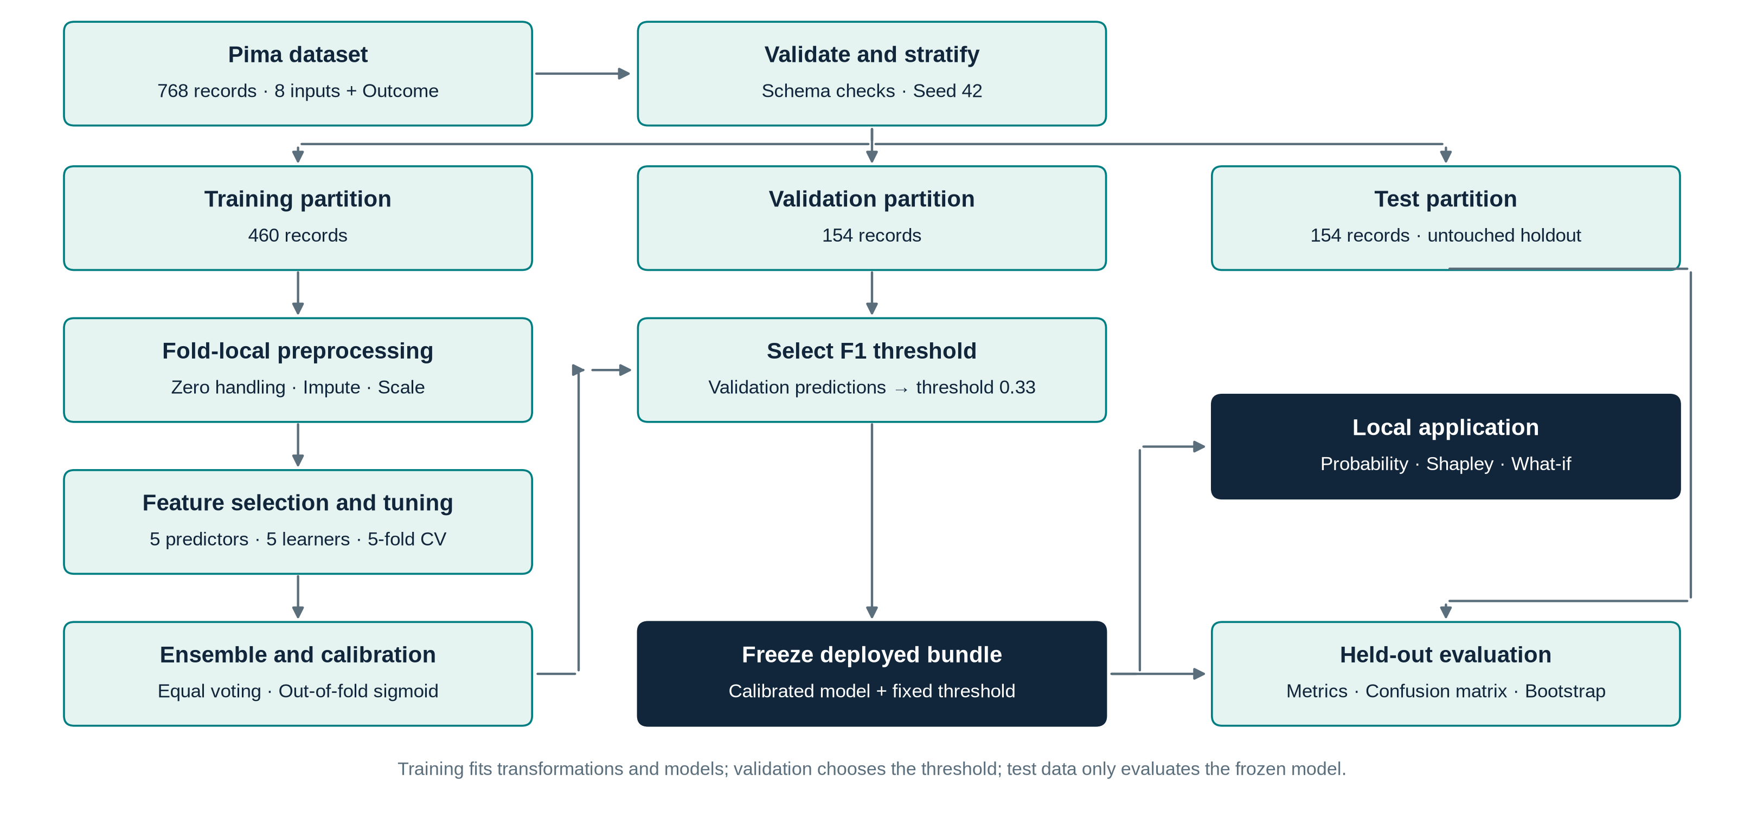
Figure 1. Block schematic of the proposed methodology.
In the schematic the raw CSV is checked for schema and duplicates, split with stratification, and the training branch feeds the feature ablation, the model search, the ensemble and the calibrator. The validation branch consumes the calibrated probabilities to select a threshold. The frozen bundle is then scored on the test branch and also drives the local application, which adds Shapley explanations, model-disagreement notes and what-if curves.
3.2 Data preparation and leakage control
Numeric coercion, binary-label checks and rejection of negative, infinite or duplicate feature records precede splitting, so that duplicates cannot straddle partitions. The split is a seeded (seed 42) stratified 60/20/20 partition. A zero in Glucose, BloodPressure, SkinThickness, Insulin or BMI is physiologically impossible and is replaced by a missing value, while a zero in Pregnancies is valid and retained. Median imputation, standardisation and feature selection are learned on the training portion of each fold. For a feature value x with fold-training median m, mean μ and standard deviation σ, the transformed value is
z = (x̃ − μ) / σ, x̃ = x if observed, otherwise m (1)
A binary missingness indicator is appended for each feature that contains missing values so that the model can learn from the pattern of missingness, which is not assumed to be random. Outliers identified by the 1.5×IQR rule are counted and retained because extreme clinical values are not automatically errors. No synthetic oversampling is used; class weighting is offered as a tuning option for logistic regression, random forest and SVM.
3.3 Feature representations and selection
Three representations are compared. The original representation uses all eight predictors with the indicators. The engineered representation adds log(1+Insulin), log(1+DiabetesPedigreeFunction) and the interaction Glucose×BMI/100. The selected representation keeps the k = 5 features with the largest ANOVA F score computed on training folds. For feature j the F statistic compares between-class and within-class variance:
F_j = [ Σ_c n_c (ȳ_{jc} − ȳ_j)² / (C − 1) ] / [ Σ_c Σ_i (x_{ij} − ȳ_{jc})² / (N − C) ] (2)
where C = 2 is the number of classes, n_c the class size and ȳ denotes means. The representation with the highest mean cross-validated AUC across a fixed logistic and a fixed ANN learner is used for all models.
3.4 Artificial neural network
The ANN is a multilayer perceptron with one hidden layer. For input vector x the hidden activations h and the output probability p are
h = ReLU(W₁ x + b₁), ReLU(u) = max(0, u) (3)
p = σ(W₂ h + b₂) = 1 / (1 + exp(−(W₂ h + b₂))) (4)
Training minimises the L2-regularised binary cross-entropy over N training examples:
L(θ) = −(1/N) Σ_i [ y_i log p_i + (1 − y_i) log(1 − p_i) ] + (α / 2N) ||θ||² (5)
Parameters are updated by Adam [13], which keeps exponential moving averages of the gradient g_t and of its square:
m_t = β₁ m_{t−1} + (1 − β₁) g_t, v_t = β₂ v_{t−1} + (1 − β₂) g_t² (6)
θ_t = θ_{t−1} − η · m̂_t / (√v̂_t + ε) (7)
where m̂ and v̂ are bias-corrected moments and η is the learning rate. Early stopping holds out an internal validation fraction of the training data and stops when its score stops improving. The search selected 32 hidden units, η = 0.003 and α = 0.001.
3.5 Comparison models
Logistic regression models the log-odds linearly and is fitted with L2 regularisation of strength 1/C. The random forest averages bootstrap-trained trees with limited depth and leaf size. Histogram gradient boosting builds an additive model F_m(x) = F_{m−1}(x) + ν h_m(x), where each tree h_m fits the negative gradient of the log-loss and ν is the learning rate [9], [10]. The support vector machine uses the radial basis kernel
K(x, x′) = exp(−γ ||x − x′||²) (8)
with probabilities obtained through internal calibration. A dummy classifier predicting the training prevalence exposes the performance achievable without information from the features.
3.6 Hyperparameter search
For each model, six random configurations are evaluated by stratified five-fold cross-validation on the training set with ROC-AUC as the criterion. The ANN with the best cross-validated AUC is fixed in advance as the comparator for the statistical test. Because the same folds are used for selecting representation and parameters, the best cross-validation scores are optimistically biased; this is acknowledged and the untouched test set provides the independent estimate.
Table 2. Selected hyperparameters from the randomised search.
Model | Selected hyperparameters | CV AUC (mean ± sd) | Train AUC
Logistic regression | class_weight=balanced, C=0.05 | 0.821 ± 0.016 | 0.840
Random forest | min_samples_leaf=10, max_features=sqrt, max_depth=5, class_weight=balanced | 0.815 ± 0.024 | 0.901
Gradient boosting | max_leaf_nodes=7, max_iter=80, learning_rate=0.04, l2_regularization=1 | 0.814 ± 0.019 | 0.920
RBF SVM | gamma=0.03, class_weight=None, C=5 | 0.819 ± 0.024 | 0.859
ANN (MLP) | learning_rate_init=0.003, hidden_layer_sizes=[32], alpha=0.001 | 0.821 ± 0.023 | 0.843

3.7 Soft-voting ensemble and calibration
The five tuned pipelines produce positive-class probabilities p_k(x). With equal weights fixed beforehand, the raw ensemble probability is
p_ens(x) = (1/5) Σ_{k=1}^{5} p_k(x) (9)
Out-of-fold ensemble probabilities on the training data are then used to fit a Platt sigmoid [17]:
p_cal(x) = 1 / (1 + exp(A · s(x) + B)) (10)
where s(x) is the ensemble score and A and B are fitted by maximum likelihood. Because the sigmoid is monotonic it cannot change the ranking of examples, so ROC-AUC is unchanged while the probability values, Brier score and calibration error may change. The expected calibration error over M = 10 equal-width bins is
ECE = Σ_{m=1}^{M} (|B_m| / N) · | acc(B_m) − conf(B_m) | (11)
3.8 Threshold selection and evaluation metrics
The decision threshold τ is chosen on the validation set from 0.10 to 0.90 in steps of 0.01 to maximise F1, with ties resolved toward 0.50. A case is predicted positive when p_cal(x) ≥ τ. With TP, TN, FP and FN the counts of a confusion matrix, the reported metrics are
Accuracy = (TP + TN)/N, Precision = TP/(TP + FP), Recall = TP/(TP + FN) (12)
Specificity = TN/(TN + FP), F1 = 2PR/(P + R) (13)
Brier = (1/N) Σ_i (p_i − y_i)², LogLoss = −(1/N) Σ_i [y_i log p_i + (1 − y_i) log(1 − p_i)] (14)
ROC-AUC [33] is the probability that a random positive is scored above a random negative, and PR-AUC is reported as average precision. Metrics are reported both at a common threshold of 0.50 and at each model's own validation-selected threshold, because comparisons at different operating points are not comparable.
3.9 Statistical analysis
Uncertainty of the deployed ensemble on the test set is described by 1,000 stratified bootstrap resamples with the model and threshold held fixed. A single prespecified paired comparison between the calibrated ensemble and the ANN comparator uses the exact McNemar test on discordant predictions at threshold 0.50 and a paired bootstrap of the AUC difference. With b and c the numbers of examples that only one model classifies correctly, the exact two-sided p-value is
p = min(1, 2 · Σ_{i=0}^{min(b,c)} C(b + c, i) / 2^{b+c}) (15)
3.10 Explainability
For an input x with M = 8 raw features the Shapley value [34] of feature j is
φ_j = Σ_{S ⊆ F\{j}} [ |S|! (M − |S| − 1)! / M! ] · [ v(S ∪ {j}) − v(S) ] (16)
where v(S) is the expected model output when the features in S are fixed to the values of x and the remaining features are jointly replaced by a row from a background sample of 24 training records. Since M = 8 there are only 256 coalitions, so the sum is evaluated exactly. The explained function includes feature construction, imputation, selection, the five models, the ensemble and the calibrator, so the explanation refers to the deployed pipeline. The additivity property Φ₀ + Σφ_j = p(x) is verified numerically; the largest error was 2.2×10⁻¹⁶. Permutation importance measures the mean drop in test AUC when one feature is randomly shuffled.
3.11 Algorithms
Algorithm 1. End-to-end training and evaluation protocol
Input: dataset D (N = 768), seed s, candidates per model = 6, folds K = 5
1. Validate D; split D into Train, Val, Test (60/20/20, stratified, seed s)
2. For each representation r in {original, engineered, selected_5}:
r_score = mean CV-AUC of {logistic, ANN} on Train (K folds)
3. r* = argmax r_score
4. For each model m in {LR, RF, GB, SVM, ANN}:
sample 6 configurations; score each by K-fold CV-AUC on Train
keep best configuration; refit on all of Train
5. Comparator = model with best CV-AUC (ANN)
6. Ensemble = equal-weight mean of the five probabilities
7. Fit sigmoid calibrator on out-of-fold Train probabilities
8. tau = argmax over {0.10, ..., 0.90} of F1 on Val
9. Freeze (ensemble, calibrator, tau); save bundle
10. Evaluate once on Test: metrics, bootstrap CI, paired tests
Output: frozen model, metrics, explanations

Algorithm 2. Fold-local preprocessing and ANN training
for each CV fold (train_idx, held_idx):
X_tr = replace zeros by NaN in invalid columns
fit median imputer, scaler, SelectKBest on X_tr only
transform X_tr and X_held with the fitted objects
initialise W1, b1, W2, b2; hold out 10% of X_tr for early stopping
repeat until no improvement for n_iter_no_change epochs:
for each mini-batch: forward pass (eq. 3-4); loss (eq. 5)
back-propagate; Adam update (eq. 6-7)
score held fold with ROC-AUC

Algorithm 3. Exact interventional Shapley explanation
Input: instance x, background B (24 rows), model f
for each coalition S in all 2^8 subsets of the 8 features:
for each background row b in B:
z = x on features in S, b elsewhere
collect f(z)
v(S) = mean of collected f(z)
phi_j = weighted sum of v(S + j) - v(S) with weights from eq. 16
check: v(empty) + sum_j phi_j == f(x)

3.12 Local application
A standard-library HTTP server binds to the local machine, loads the frozen bundle and validates all inputs for type, finiteness, non-negativity and the age scope of the dataset. Blank or zero laboratory values follow the training preprocessing. The interface shows the calibrated probability, the validation-selected threshold, the five component probabilities, Shapley contributions, notes on missing or extrapolated values and what-if comparisons. Cross-origin posts and oversized bodies are rejected and inputs are not stored.

4. Experimental Results and Discussion
4.1 Dataset details
The dataset is the preserved headerless Pima Indians Diabetes CSV from a public mirror, with original ownership attributed to the National Institute of Diabetes and Digestive and Kidney Diseases. It holds 768 women aged 21 years or more of Pima heritage. The SHA-256 checksum of the bundled file is recorded in the results file so that the exact data can be verified. The partition sizes and class counts are listed in Table 3 and the features in Table 4.
Table 3. Stratified data partitions (seed 42).
Partition | Rows | Positive (Outcome = 1) | Prevalence | Purpose
Training | 460 | 160 | 34.8% | EDA, CV, tuning, calibration, fitting
Validation | 154 | 54 | 35.1% | Threshold selection only
Test | 154 | 54 | 35.1% | Single final evaluation
Total | 768 | 268 | 34.9% | 500 negative, 268 positive

Table 4. Features of the Pima dataset.
Feature | Meaning (unit) | Preprocessing
Pregnancies | Number of pregnancies | Zero valid
Glucose | 2-hour OGTT plasma glucose (mg/dL) | Zero = missing
BloodPressure | Diastolic blood pressure (mmHg) | Zero = missing
SkinThickness | Triceps skinfold thickness (mm) | Zero = missing
Insulin | 2-hour serum insulin (µU/mL) | Zero = missing
BMI | Body mass index (kg/m²) | Zero = missing
DiabetesPedigreeFunction | Dataset-specific pedigree score | Numeric
Age | Age in years (≥ 21) | Numeric
Outcome | Historical binary class label | Target only

Table 5. Training-set data quality summary.
Feature | Zero / missing | Missing % | IQR outliers | Min | Median | Max
Pregnancies | 0 | 0.0 | 1 | 0.0 | 3.0 | 14.0
Glucose | 4 | 0.9 | 0 | 56.0 | 117.0 | 197.0
BloodPressure | 18 | 3.9 | 12 | 24.0 | 72.0 | 114.0
SkinThickness | 131 | 28.5 | 2 | 7.0 | 30.0 | 99.0
Insulin | 215 | 46.7 | 12 | 16.0 | 125.0 | 744.0
BMI | 6 | 1.3 | 6 | 18.2 | 32.4 | 67.1
DiabetesPedigreeFunction | 0 | 0.0 | 16 | 0.084 | 0.389 | 2.329
Age | 0 | 0.0 | 11 | 21.0 | 29.0 | 81.0

Table 5 shows that insulin is missing in 46.7% and skin thickness in 28.5% of training rows, which strongly limits the information they can contribute, whereas glucose, BMI and blood pressure are missing in fewer than 4%. Pedigree function, insulin and blood pressure have the most IQR outliers; these were retained.
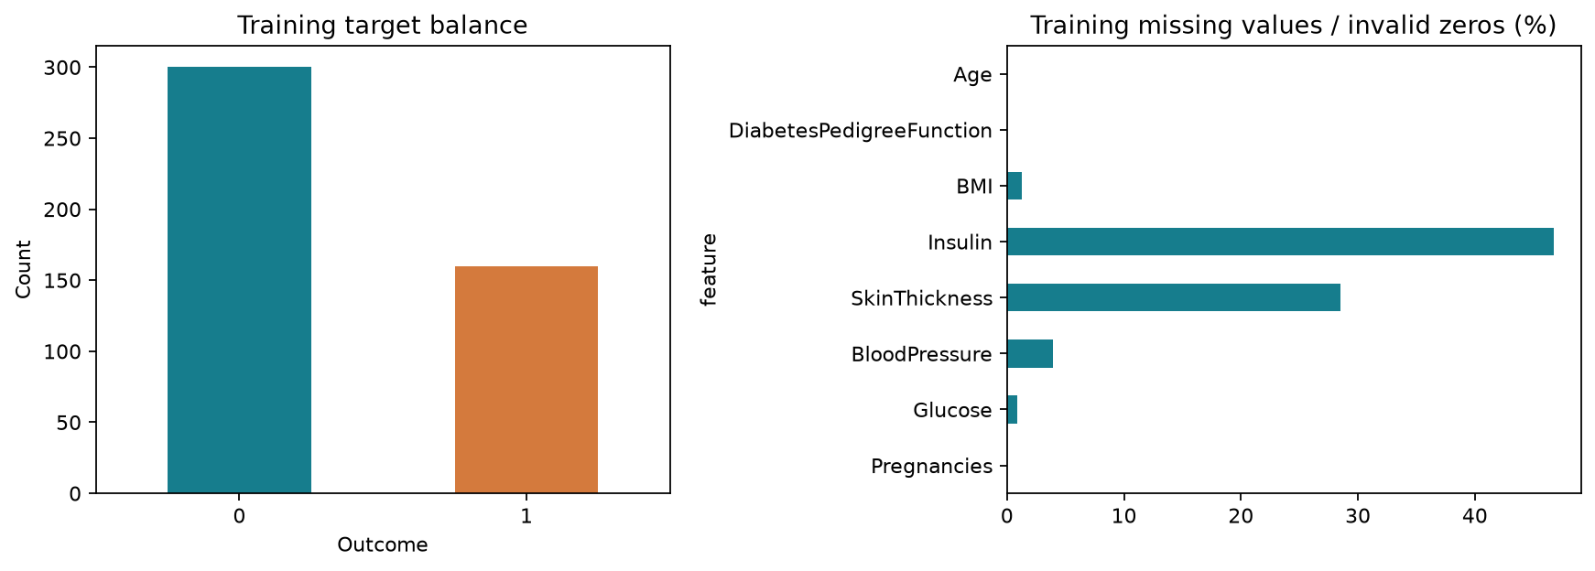
Figure 2. Missing-value rates and class balance in the training set.
Figure 2 confirms that the target is moderately imbalanced, with about 35% positives, which is why accuracy alone is misleading: the dummy prior classifier already reaches 64.9% accuracy by predicting every case negative while having zero recall.
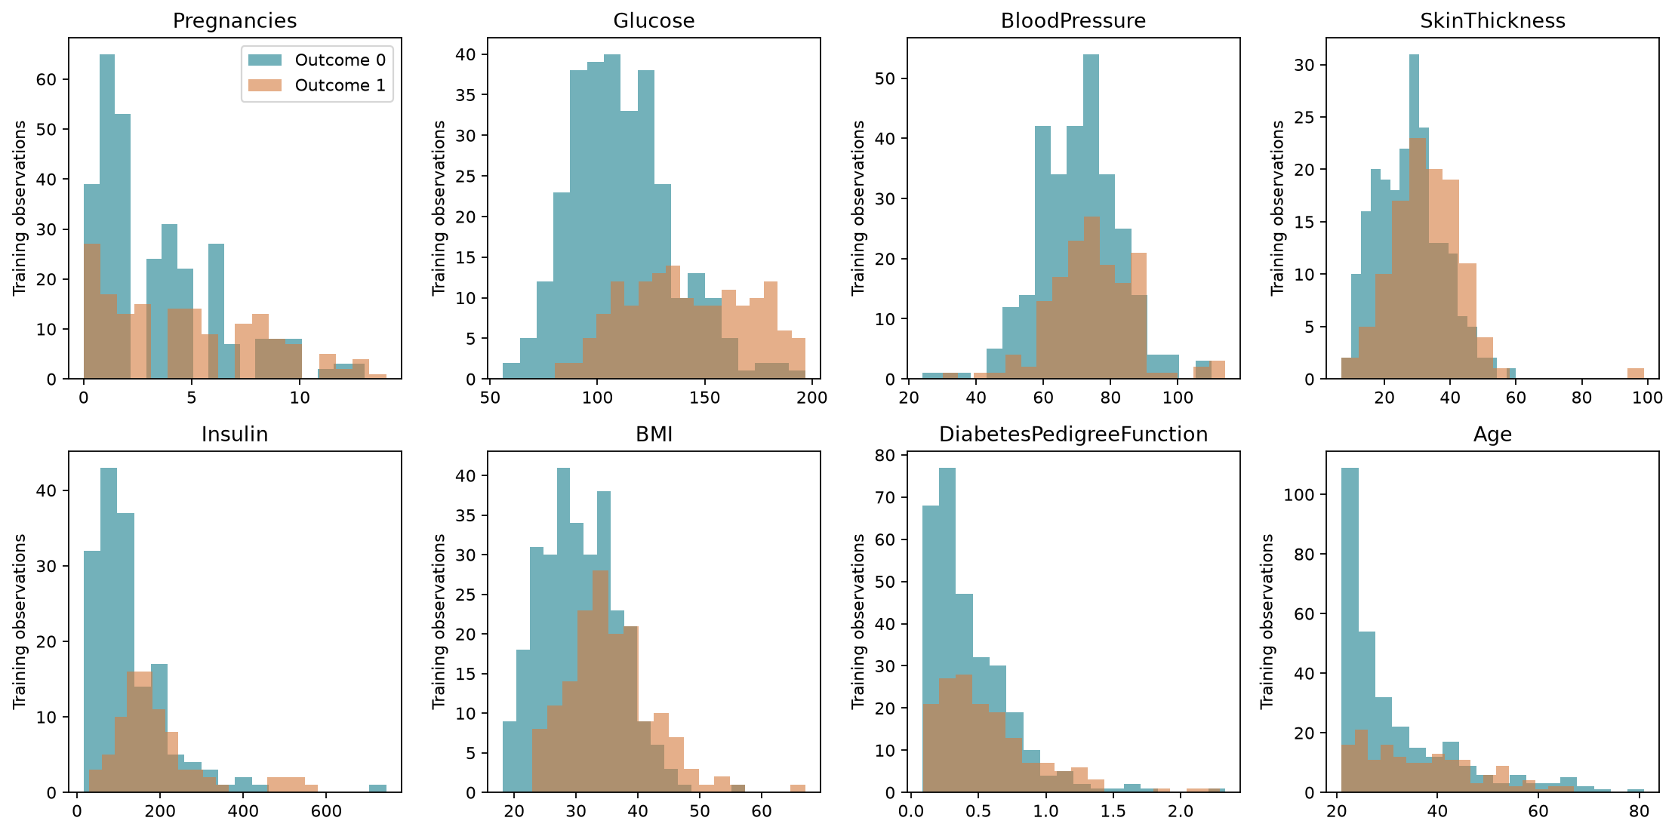
Figure 3. Training-set feature distributions by outcome class.
Figure 3 shows that glucose separates the classes most clearly: the positive class is shifted toward higher glucose. Insulin and pedigree function are right-skewed, which motivated the log transforms tested in the ablation. Age and pregnancies are also shifted upward for the positive class.
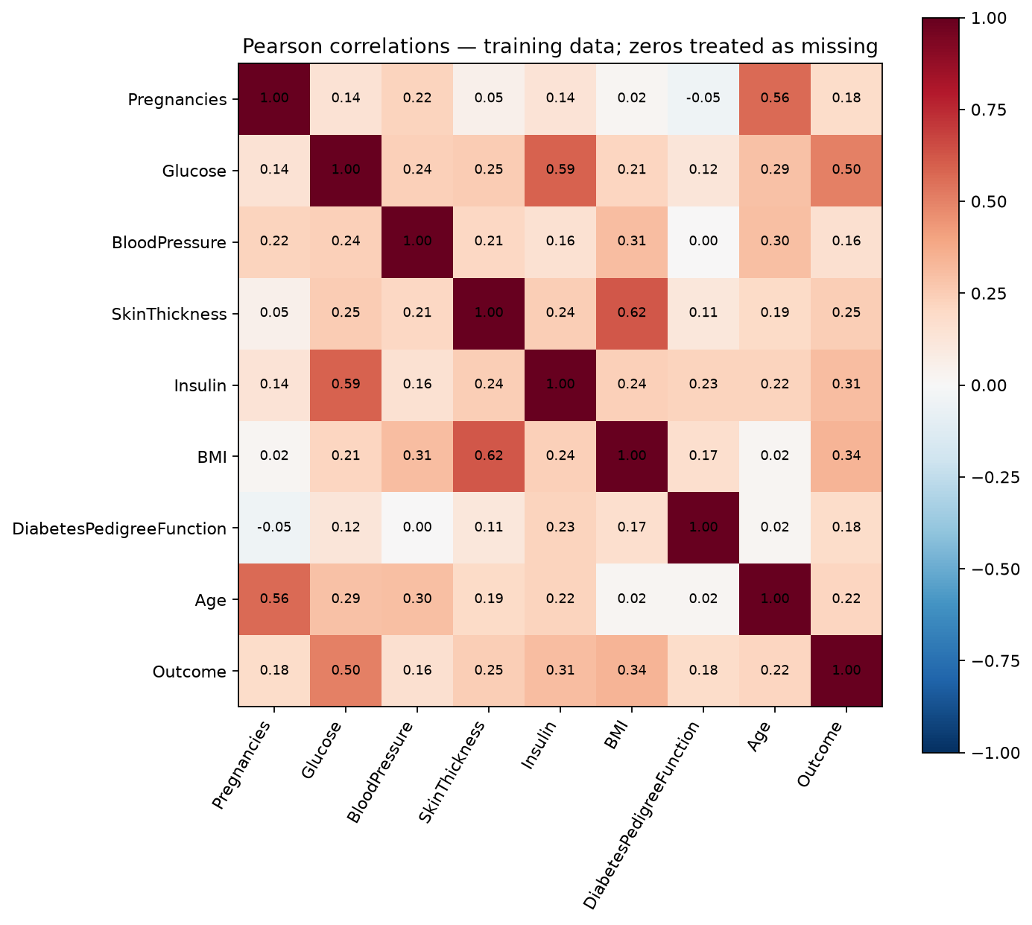
Figure 4. Pearson correlation matrix of the training features and outcome.
The strongest correlations with Outcome are glucose (r = 0.501), BMI (r = 0.337), insulin (r = 0.311), skin thickness (r = 0.246) and age (r = 0.216). Pregnancies and age are strongly correlated with each other (r = 0.564), as are skin thickness and BMI (r = 0.622) and glucose and insulin (r = 0.588), which explains why feature selection can discard some variables with little loss. Correlation is not causation, and pairwise missingness affects these estimates.
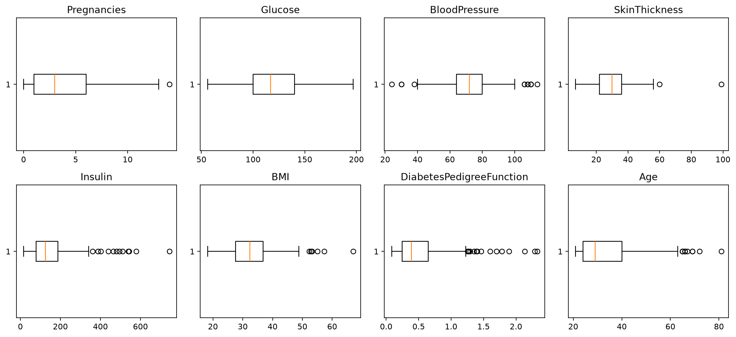
Figure 5. IQR outlier inspection of training features.
4.2 Experimental setup
All experiments were run in Python 3.14 with scikit-learn [32], using seed 42 throughout. The complete training run, including 150 cross-validation fits for the search, 1,000 bootstrap resamples and exact Shapley enumeration, took about 68 seconds on a CPU. The exact package versions, partitions, search tables and warnings are stored with the results so that the experiment can be repeated. No test labels influenced training, tuning, calibration or threshold selection.
4.3 Feature-representation results
Table 6. Representation comparison on identical five-fold training partitions.
Learner | Representation | Mean CV AUC | SD | Mean CV F1 | Mean CV Brier
LogisticRegression | original | 0.826 | 0.021 | 0.647 | 0.157
LogisticRegression | engineered | 0.825 | 0.019 | 0.641 | 0.157
LogisticRegression | selected_5 | 0.821 | 0.018 | 0.623 | 0.162
ANN | original | 0.795 | 0.027 | 0.588 | 0.174
ANN | engineered | 0.756 | 0.115 | 0.570 | 0.182
ANN | selected_5 | 0.808 | 0.037 | 0.581 | 0.169

Logistic regression was nearly indifferent to the representation (AUC 0.826, 0.825 and 0.821), whereas the ANN benefited from selection (0.808 with five features against 0.795 with all features) and was damaged by the engineered features (0.756 with a large standard deviation of 0.115, indicating instability in at least one fold). The mean over the two learners therefore selected the five-feature representation, a decision made on training data only.
4.4 Hyperparameter search results
Table 2 (Section 3.6) lists the selected configurations. Cross-validated AUC values lie in a narrow band from 0.814 to 0.821, and the standard deviations of 0.016 to 0.024 are larger than the differences between models, so the training folds cannot reliably separate them. The ANN had the highest value (0.8214) and was therefore fixed as the comparator. Tree-based models show larger gaps between training AUC (0.90 and 0.92) and cross-validated AUC (0.815 and 0.814), a sign of more over-fitting than for the ANN (0.843 versus 0.821) or logistic regression (0.840 versus 0.821).
4.5 Test-set performance at the common threshold 0.50
Table 7. Held-out test metrics at threshold 0.50 (n = 154).
Model | Acc. | Prec. | Recall | Spec. | F1 | ROC-AUC | PR-AUC | Brier | ECE
Logistic regression | 0.695 | 0.557 | 0.630 | 0.730 | 0.591 | 0.783 | 0.613 | 0.191 | 0.120
Random forest | 0.740 | 0.600 | 0.778 | 0.720 | 0.677 | 0.821 | 0.678 | 0.172 | 0.091
Gradient boosting | 0.740 | 0.635 | 0.611 | 0.810 | 0.623 | 0.822 | 0.677 | 0.164 | 0.064
RBF SVM | 0.708 | 0.605 | 0.481 | 0.830 | 0.536 | 0.800 | 0.666 | 0.177 | 0.101
ANN (MLP) | 0.727 | 0.625 | 0.556 | 0.820 | 0.588 | 0.796 | 0.655 | 0.180 | 0.085
Dummy prior | 0.649 | 0.000 | 0.000 | 1.000 | 0.000 | 0.500 | 0.351 | 0.228 | 0.003
Raw ensemble | 0.727 | 0.607 | 0.630 | 0.780 | 0.618 | 0.811 | 0.671 | 0.171 | 0.125
Calibrated ensemble | 0.727 | 0.625 | 0.556 | 0.820 | 0.588 | 0.811 | 0.671 | 0.175 | 0.086

At threshold 0.50 all learned models clearly beat the dummy classifier (ROC-AUC 0.5). Gradient boosting and random forest reach the highest AUC (0.822 and 0.821), followed by the ensemble (0.811), SVM (0.800), the ANN (0.796) and logistic regression (0.783). The ANN's recall of 0.556 and the SVM's recall of 0.481 are low at this threshold, meaning that many positive cases are missed, which is the reason a validated threshold is used for deployment.
4.6 Test-set performance at validation-selected thresholds
Table 8. Held-out test metrics at each model's validation-selected threshold.
Model | τ | Acc. | Prec. | Recall | Spec. | F1 | TN | FP | FN | TP
Logistic regression | 0.60 | 0.727 | 0.615 | 0.593 | 0.800 | 0.604 | 80 | 20 | 22 | 32
Random forest | 0.56 | 0.740 | 0.617 | 0.685 | 0.770 | 0.649 | 77 | 23 | 17 | 37
Gradient boosting | 0.28 | 0.740 | 0.592 | 0.833 | 0.690 | 0.692 | 69 | 31 | 9 | 45
RBF SVM | 0.30 | 0.714 | 0.571 | 0.741 | 0.700 | 0.645 | 70 | 30 | 14 | 40
ANN (MLP) | 0.39 | 0.701 | 0.567 | 0.630 | 0.740 | 0.596 | 74 | 26 | 20 | 34
Dummy prior | 0.34 | 0.351 | 0.351 | 1.000 | 0.000 | 0.519 | 0 | 100 | 0 | 54
Raw ensemble | 0.40 | 0.708 | 0.567 | 0.704 | 0.710 | 0.628 | 71 | 29 | 16 | 38
Calibrated ensemble | 0.33 | 0.714 | 0.576 | 0.704 | 0.720 | 0.633 | 72 | 28 | 16 | 38

Moving each model to its own threshold changes the balance between sensitivity and specificity. For the calibrated ensemble the threshold 0.33 raises recall from 0.556 to 0.704 while specificity falls from 0.820 to 0.720, and F1 improves from 0.588 to 0.633. Gradient boosting at τ = 0.28 obtains the highest recall (0.833) but the lowest precision among the strong models (0.592), and the ANN at τ = 0.39 reaches F1 0.596. The dummy classifier at its “threshold” simply predicts everyone positive (recall 1.0, specificity 0), which shows why recall must be read together with specificity.
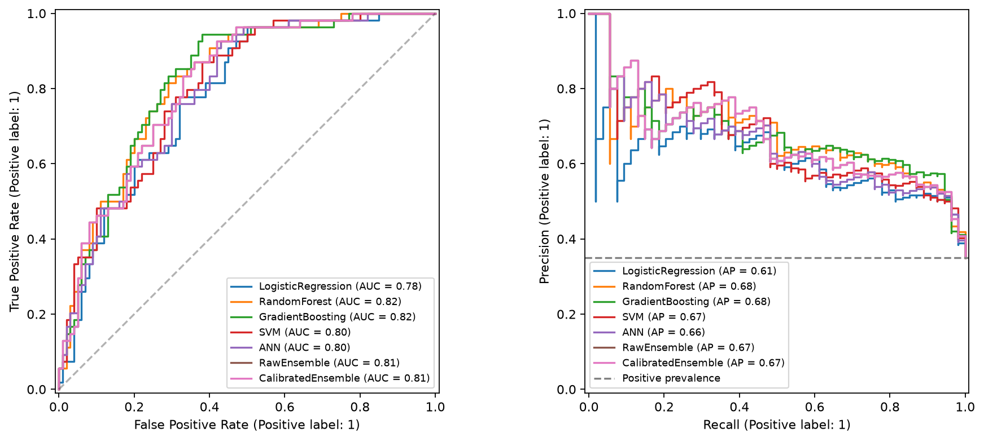
Figure 6. Test ROC curves (left) and precision-recall curves (right) for all models.
In the ROC panel all curves lie well above the diagonal and are close to each other, with gradient boosting slightly ahead in the region of low false-positive rate. In the precision-recall panel the models stay above the prevalence baseline of 0.35 over the whole recall range and the average precision values range from 0.61 (logistic regression) to 0.68 (random forest and gradient boosting). The overlap of the curves is consistent with the wide confidence intervals reported below: with 154 test rows, differences of about 0.01 in AUC should not be over-interpreted.
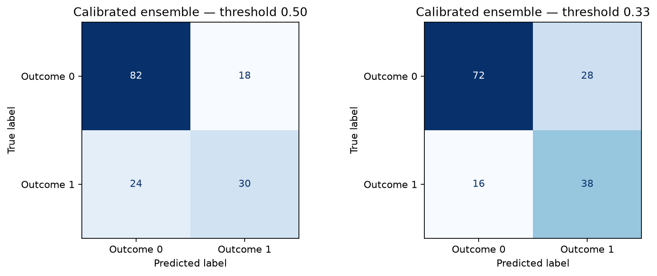
Figure 7. Confusion matrices on the test set.
For the deployed calibrated ensemble at τ = 0.33 the confusion matrix is TN = 72, FP = 28, FN = 16 and TP = 38. Sixteen of 54 diabetic cases are missed and 28 of 100 non-diabetic cases are flagged, so the error rates are far too high for diagnostic use, although they are acceptable for a demonstration of a screening-style prioritisation.
4.7 Uncertainty and statistical comparison
Table 9. Bootstrap intervals for the deployed calibrated ensemble (1,000 resamples).
Metric | Point estimate | 95% bootstrap interval
Accuracy | 0.714 | 0.643 to 0.786
Precision | 0.576 | 0.493 to 0.672
Recall | 0.704 | 0.574 to 0.815
Specificity | 0.720 | 0.630 to 0.810
F1 | 0.633 | 0.543 to 0.719
ROC-AUC | 0.811 | 0.736 to 0.876
PR-AUC | 0.671 | 0.575 to 0.788
Brier | 0.175 | 0.142 to 0.210

The intervals are wide: accuracy could plausibly lie anywhere between 0.64 and 0.79 and ROC-AUC between 0.74 and 0.88. They characterise sampling variation of the test set for a fixed model and do not include variation due to training or tuning. The paired comparison between the calibrated ensemble and the ANN comparator gave an exact McNemar p-value of 1.000 at τ = 0.50, with two examples correct only for the ensemble and two correct only for the ANN. The paired bootstrap AUC difference was +0.0152 with a 95% interval of 0.0006 to 0.0320. The two tests answer different questions: the prediction errors at a fixed threshold are indistinguishable, whereas the ranking advantage of the ensemble is small but its interval narrowly excludes zero. Neither result proves clinical superiority.
4.8 Calibration
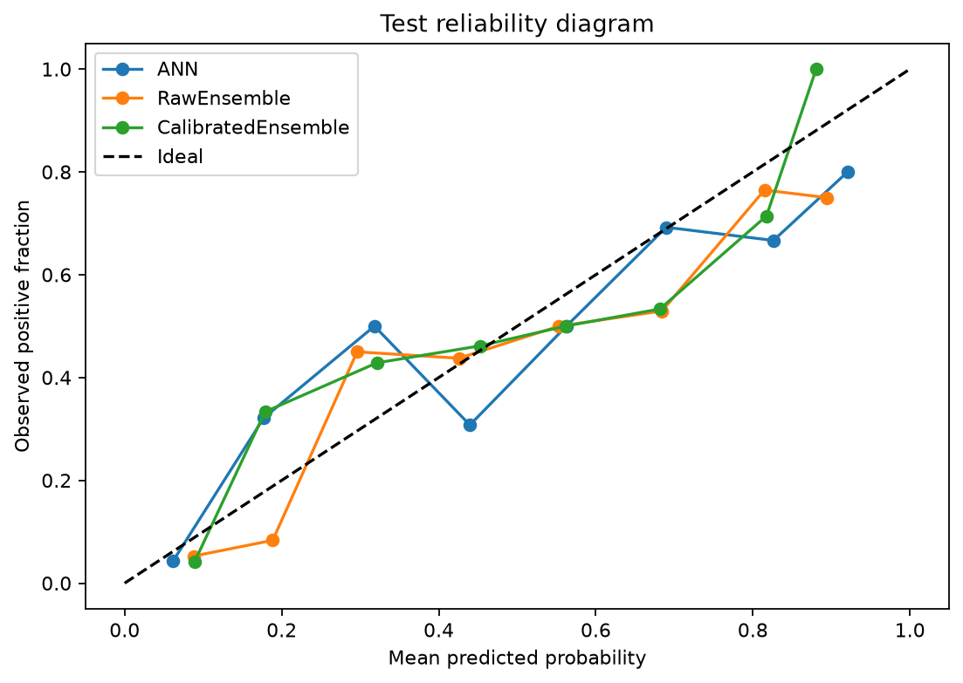
Figure 8. Test reliability diagram for the ANN, raw ensemble and calibrated ensemble.
The reliability diagram compares predicted probability with the observed positive fraction in ten bins. The ANN curve is the most irregular, falling well below the diagonal near a predicted probability of 0.45. The raw ensemble under-predicts in the 0.2 to 0.3 range, and the calibrated ensemble follows the diagonal more closely at low and middle probabilities but is noisy at high probabilities because few test examples fall there. Quantitatively, calibration reduced the binned ECE from 0.1245 to 0.0863, but the Brier score changed from 0.1709 to 0.1746 and log loss from 0.5076 to 0.5161, both slightly worse. This disagreement arises because ECE depends on the binning and ignores sharpness, while the Brier score penalises the loss of sharpness caused by the sigmoid fit. The honest conclusion is that calibration produced mixed evidence, not a clear improvement.
4.9 Explainability results
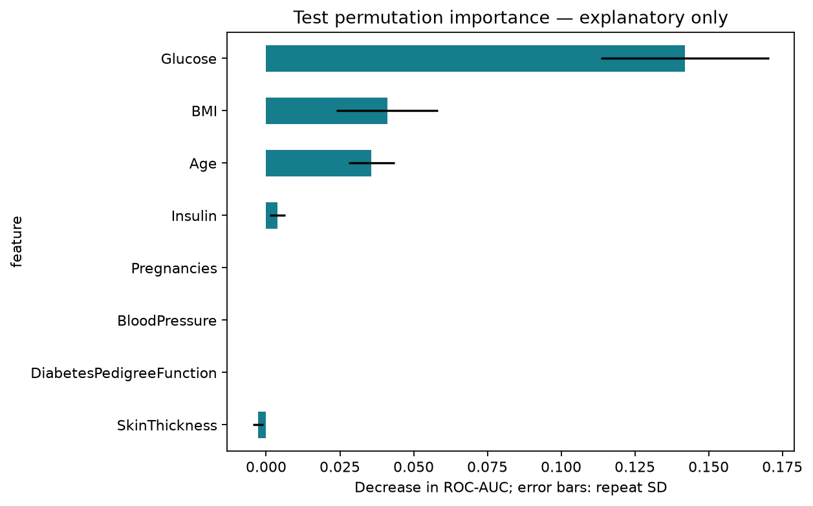
Figure 9. Permutation importance (drop in test ROC-AUC).
Permuting glucose reduces the test AUC by 0.142, far more than BMI (0.041) or age (0.036). Insulin contributes only 0.0038, and pregnancies, blood pressure and pedigree function have zero effect, consistent with their removal by the ANOVA selection (their Shapley contributions are also exactly zero); skin thickness shows a slightly negative value, which is noise around zero. Glucose dominates the model's behaviour in agreement with the clinical role of glucose and with the correlation analysis.
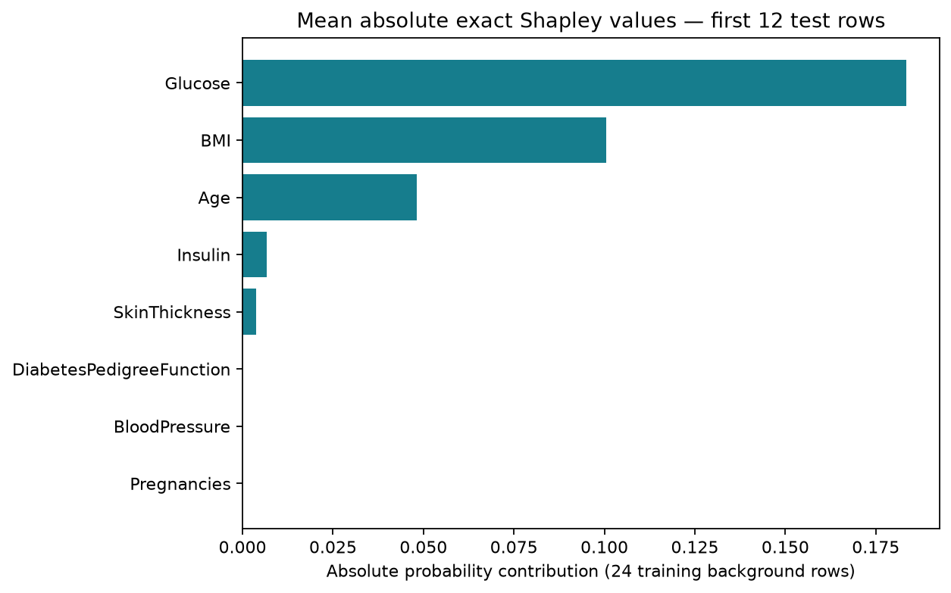
Figure 10. Mean absolute Shapley contribution for 12 fixed test cases.
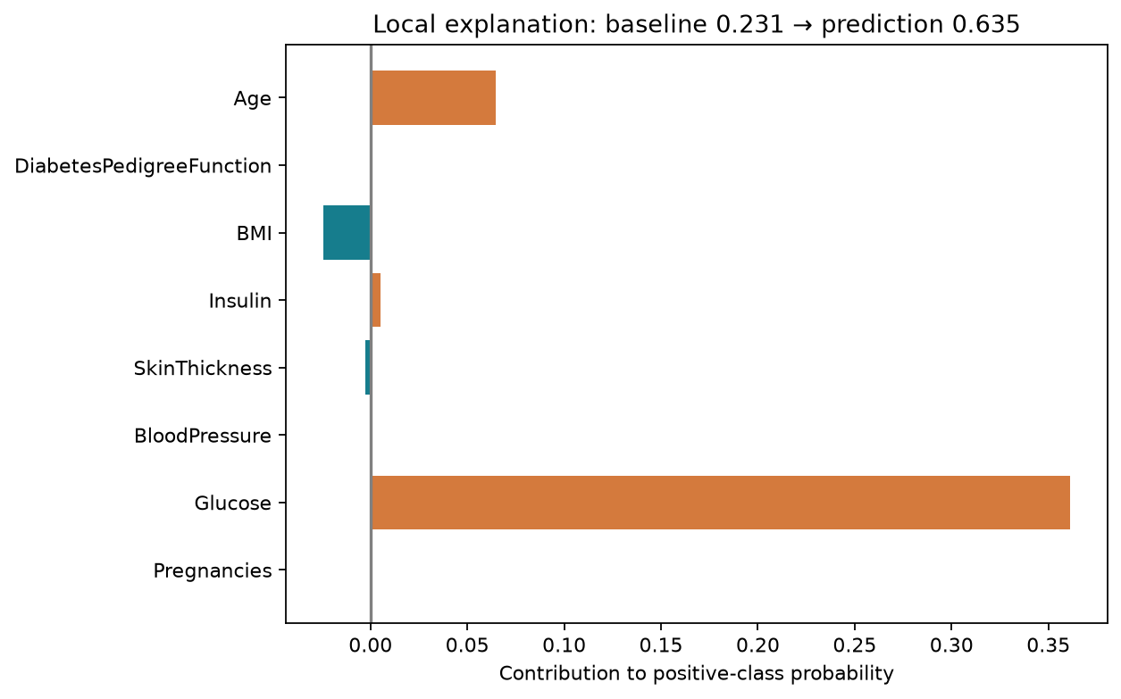
Figure 11. Exact Shapley explanation of an individual test prediction.
For the first illustrative test case (a 40-year-old with glucose 159 mg/dL, BMI 27.4 and no recorded insulin or skin thickness) the model predicts a probability of 0.635 against a baseline of 0.231. Glucose contributes +0.361, age +0.065 and BMI −0.024, while features removed by selection contribute exactly zero. The additivity check holds to machine precision (largest error 2.2×10⁻¹⁶). For a second case with glucose far below the average, glucose contributes −0.179 and the predicted probability is only 0.119. The Shapley summary over only 12 cases is illustrative and not a population-level ranking, and interventional substitution can create unrealistic feature combinations; the values describe model behaviour, not causes.
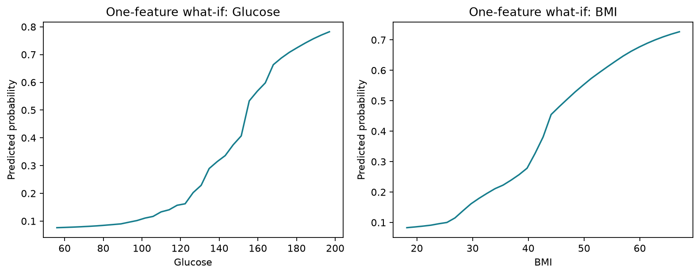
Figure 12. What-if curves: predicted probability when one measurement is varied.
The what-if curves vary a single measurement across its training range with the other inputs fixed. The predicted probability increases monotonically and steeply with glucose, from about 0.08 at 56 mg/dL, and the BMI curve also rises from about 0.08 to 0.73 across its range, so both measurements move the predicted risk substantially when varied alone. These curves show model associations and must not be read as estimates of the benefit of changing a patient's measurements.
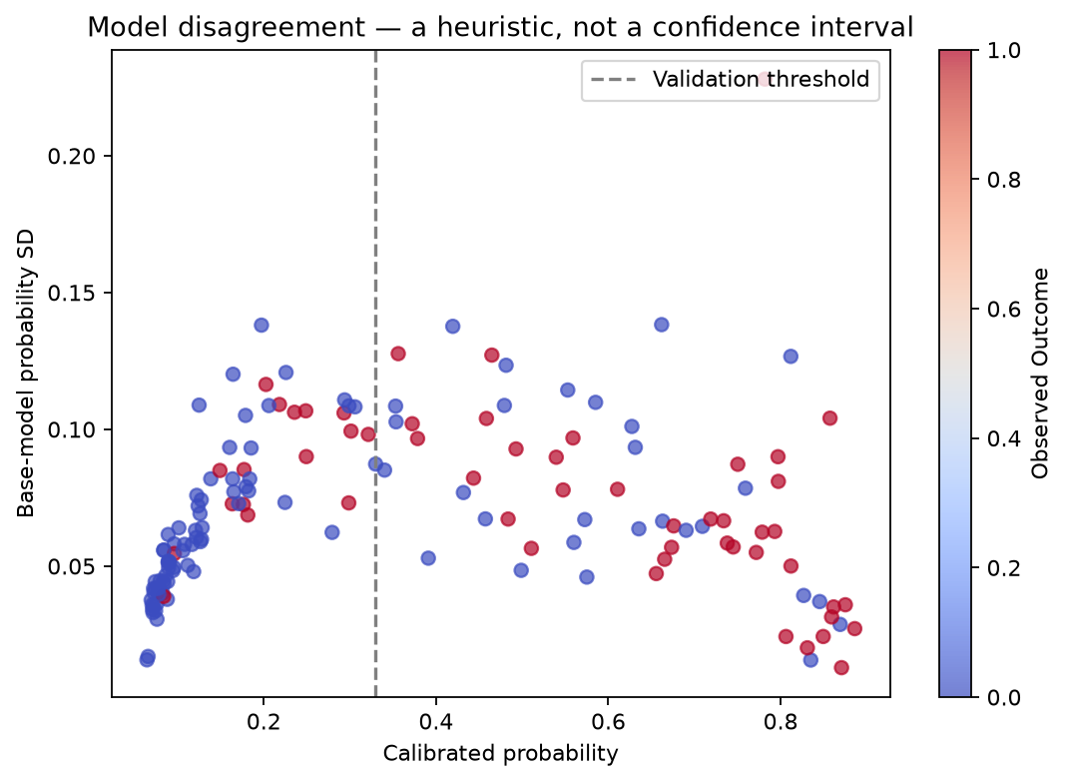
Figure 13. Disagreement among the five component models versus absolute error.
The standard deviation of the five component probabilities is used as a descriptive measure of model disagreement. Disagreement is largest for intermediate predicted probabilities (roughly 0.2 to 0.5, where the SD reaches about 0.10 to 0.14) and smallest at the extremes, but it is not a calibrated confidence interval and offers no coverage guarantee.
4.10 Application output
The local application loads the frozen model and returns, for any valid input, the calibrated probability, the threshold decision, the component predictions, the Shapley contributions and warnings about missing or out-of-range values. Its outputs are generated by the same code used in the experiments, so the values in Figures 10 to 12 can be reproduced interactively. The application is shown to demonstrate the workflow only and carries a disclaimer that it is not a diagnostic device.
4.11 Discussion
Three observations follow from the results. First, the choice of model family matters less than expected on this dataset: the five learners span only 0.783 to 0.822 in test AUC and the cross-validated differences are within one standard deviation. Second, the ANN is competitive but not superior; it achieves the best cross-validated AUC yet a lower test AUC than the tree ensembles, which is typical of small tabular problems and agrees with the literature [16]. Third, the operating point has a larger effect on clinically relevant behaviour than the model: moving the threshold changes recall by more than 15 percentage points. A validated threshold and an explicit report of both operating points are therefore more informative than a single accuracy figure.

5. Ablation Study and State-of-the-Art Analysis
5.1 Ablation study
The ablation isolates the effect of each design decision by changing one component at a time while keeping the rest of the protocol fixed. All numbers come from the saved experiment: the representation ablation from five-fold training cross-validation (Table 6), and the remaining ablations from the held-out test set.
5.1.1 Feature representation
Table 6 shows that engineered features did not help either learner. For the ANN they reduced the mean AUC by 0.039 relative to the original representation and increased instability; for logistic regression the difference was negligible (−0.001). Five-feature selection reduced the AUC of logistic regression by 0.006 but improved the ANN by 0.014, and it halved the number of inputs. The selection criterion (average over both learners) therefore favoured five-feature selection.
5.1.2 Model family
Table 10. Ablation of model components on the test set at validation thresholds.
Component removed / replaced | Test ROC-AUC | Recall at τ | F1 at τ | Brier
Dummy prior (no features) | 0.500 | 1.000 | 0.519 | 0.228
Logistic regression only | 0.783 | 0.593 | 0.604 | 0.191
ANN only | 0.796 | 0.630 | 0.596 | 0.180
SVM only | 0.800 | 0.741 | 0.645 | 0.177
Random forest only | 0.821 | 0.685 | 0.649 | 0.172
Gradient boosting only | 0.822 | 0.833 | 0.692 | 0.164
Raw ensemble (no calibration) | 0.811 | 0.704 | 0.628 | 0.171
Calibrated ensemble (proposed) | 0.811 | 0.704 | 0.633 | 0.175

The dummy baseline confirms that every model extracts real signal. Logistic regression is the weakest informative model (AUC 0.783), SVM and the ANN are in the middle, and the tree ensembles are best by AUC. The ensemble sits between the strongest and the weakest members (0.811), so it is more robust than choosing the wrong single model but does not exceed the best member on this test set. This is the expected behaviour of averaging when the members are highly correlated and when one is clearly stronger.
5.1.3 Calibration and threshold
Table 11. Ablation of calibration and decision threshold for the ensemble.
Configuration | ROC-AUC | Brier | Log loss | ECE (10 bins) | Recall | Specificity | F1
Raw ensemble, τ = 0.50 | 0.811 | 0.171 | 0.508 | 0.125 | 0.630 | 0.780 | 0.618
Calibrated, τ = 0.50 | 0.811 | 0.175 | 0.516 | 0.086 | 0.556 | 0.820 | 0.588
Raw, τ = 0.40 (validation) | 0.811 | 0.171 | 0.508 | 0.125 | 0.704 | 0.710 | 0.628
Calibrated, τ = 0.33 (validation) | 0.811 | 0.175 | 0.516 | 0.086 | 0.704 | 0.720 | 0.633

Calibration leaves the AUC unchanged (0.811) as expected for a monotonic mapping, reduces ECE by 31% (0.1245 to 0.0863) and slightly worsens Brier score and log loss. The threshold has the larger practical effect: at τ = 0.50 the calibrated ensemble catches only 55.6% of positives, while the validated τ = 0.33 catches 70.4% at the cost of 10 points of specificity. Interestingly, at each ensemble's own validation threshold the calibrated and raw ensembles are within 0.005 of each other in F1 (0.633 versus 0.628), so calibration is chiefly valuable for interpreting the probability, not for classification accuracy.
5.1.4 Feature importance ablation
Permutation importance (Figure 9) is a post-hoc feature ablation: removing the information in glucose reduces AUC by 0.142, while removing BMI or age costs about 0.04 each and removing insulin costs 0.004. This ordering is consistent with the correlation analysis and with the Shapley explanations, and it justifies selecting five rather than eight predictors.
5.2 Comparison with the state of the art
Direct comparison with published accuracies is difficult because studies differ in partitioning, preprocessing, use of synthetic resampling and whether the reported score was selected on the test data. With that caveat, Table 12 positions this project among representative Pima studies. The published figures are the values stated by the cited authors or reported in secondary summaries and were not reproduced here.
Table 12. Positioning against representative Pima studies.
Study | Method | Reported accuracy | Protocol notes
Smith et al. 1988 [3] | ADAP learning algorithm | ≈ 76% (commonly cited) | Early benchmark
Sisodia & Sisodia 2018 [4] | Naive Bayes (best of DT, SVM, NB) | 76.3% | 10-fold CV
Alam et al. (as summarised in a 2023 review) | ANN (vs. RF, k-means) | 75.7% | Reported in secondary source
Gradient-boosting study (same review) | Gradient boosting | 81.8% | Protocol differs; not reproduced
This work: ANN only, τ = 0.50 | MLP, 32 ReLU units | 72.7% | Held-out test, n = 154
This work: gradient boosting, τ = 0.50 | HistGradientBoosting | 74.0% | Held-out test, n = 154
This work: calibrated ensemble, τ = 0.33 | Soft voting + sigmoid | 71.4% | Held-out test; recall 70.4%

The accuracy of this project (71.4% to 74.0%) is lower than several published figures of 76% to 82%, and the reason is mainly methodological rather than a sign of a weaker model. Published numbers are frequently obtained by cross-validation on all 768 records after preprocessing and selection performed on the same data, which is known to be optimistic [27], [28]. Here the test set was used once, 154 examples are scored by a model that had never seen them, and the cross-validated AUC of 0.82 on the training portion is consistent with the 0.81 to 0.82 obtained on the held-out test set. The AUC values are also in line with the typical range for this dataset. A fair statement is that the proposed pipeline matches the performance level of established approaches under a stricter protocol, and adds calibrated probabilities, a validated threshold and complete explanations that most earlier work does not report.
5.3 Strengths, limitations and threats to validity
The principal strength is the evaluation protocol: fold-local preprocessing, a validation set reserved for the threshold, one-shot test evaluation, bootstrap intervals and the retention of negative results. The limitations are equally important. The test set has only 154 rows and 54 positives, so the intervals are wide. Insulin and skin thickness are missing in about 47% and 28% of rows. Hyperparameters and representation were chosen on the same training folds, so cross-validated scores are optimistic and nested cross-validation was not used. The population is historical, restricted to Pima women aged 21 or more, and there is no external cohort. The Shapley analysis uses a small background sample and only 12 cases. Finally, the label is a dataset annotation, and glucose is a two-hour OGTT value rather than a fasting measurement, so modern clinical cut-offs must not be applied. For these reasons the system must not be used for diagnosis.

6. Conclusion
This project developed and evaluated an artificial neural network for predicting the diabetes label in the Pima Indians dataset inside a leakage-controlled, reproducible workflow. The 768 records were split once into training, validation and test partitions, with imputation, scaling and feature selection learned only from training folds. Three feature representations, five model families and a calibrated soft-voting ensemble were compared, and every choice was made on training or validation data before the test set was touched exactly once.
The tuned ANN, with one hidden layer of 32 ReLU units, obtained the highest cross-validated AUC (0.821) but a test AUC of 0.796, while gradient boosting and random forest reached 0.822 and 0.821. The deployed calibrated ensemble reached a test ROC-AUC of 0.811 (95% interval 0.736 to 0.876), and at the validation-selected threshold of 0.33 it achieved accuracy 71.4%, recall 70.4%, specificity 72.0% and F1 0.633. A paired comparison showed no difference in prediction errors between the ensemble and the ANN (McNemar p = 1.0) and only a small ranking advantage (AUC difference 0.015). These results confirm that on a small tabular dataset the ANN is competitive but not superior to tree-based and linear alternatives, and that the ensemble offers robustness rather than a higher peak score.
The ablation study produced several clear findings. Engineered features did not improve the models and destabilised the ANN, whereas selecting five features helped the ANN. Sigmoid calibration lowered the binned calibration error by about 31% but slightly worsened the Brier score and log loss, so the evidence for calibration benefit is mixed. The decision threshold had the largest practical effect, raising recall from 55.6% to 70.4% at the cost of specificity. Explanations from exact Shapley values, permutation importance and what-if curves agreed that glucose is the dominant predictor, followed by BMI and age, which is consistent with clinical knowledge and with the correlation analysis.
Compared with the literature, the absolute accuracy of this work is lower than some published values, but the protocol is considerably stricter, and the study adds validated thresholds, calibrated probabilities, confidence intervals and full-pipeline explanations. The limitations are clear: a small test set with wide intervals, heavy missingness in insulin and skin thickness, selection bias in cross-validated scores, a single historical population and no external validation. Consequently the application is an educational demonstrator and not a clinical tool.
Future work should include nested cross-validation or repeated cross-validation to reduce the variance of the comparison, external validation on an independent cohort, multiple imputation and models that treat missingness explicitly, fairness and subgroup analysis, comparison with additional learners such as regularised gradient-boosting libraries, larger Shapley background samples and a prospective study of how a validated screening aid could fit into a clinical workflow under appropriate regulatory and ethical oversight.

References
[1] World Health Organization, “Global report on diabetes,” WHO, Geneva, Switzerland, 2016.
[2] International Diabetes Federation, IDF Diabetes Atlas, 10th ed. Brussels, Belgium: IDF, 2021.
[3] J. W. Smith, J. E. Everhart, W. C. Dickson, W. C. Knowler, and R. S. Johannes, “Using the ADAP learning algorithm to forecast the onset of diabetes mellitus,” in Proc. Symp. Computer Applications in Medical Care, 1988, pp. 261–265.
[4] D. Sisodia and D. S. Sisodia, “Prediction of diabetes using classification algorithms,” Procedia Computer Science, vol. 132, pp. 1578–1585, 2018.
[5] Q. Zou, K. Qu, Y. Luo, D. Yin, Y. Ju, and H. Tang, “Predicting diabetes mellitus with machine learning techniques,” Frontiers in Genetics, vol. 9, art. 515, 2018.
[6] N. Sneha and T. Gangil, “Analysis of diabetes mellitus for early prediction using optimal features selection,” Journal of Big Data, vol. 6, art. 13, 2019.
[7] I. Kavakiotis, O. Tsave, A. Salifoglou, N. Maglaveras, I. Vlahavas, and I. Chouvarda, “Machine learning and data mining methods in diabetes research,” Computational and Structural Biotechnology Journal, vol. 15, pp. 104–116, 2017.
[8] L. Breiman, “Random forests,” Machine Learning, vol. 45, no. 1, pp. 5–32, 2001.
[9] J. H. Friedman, “Greedy function approximation: A gradient boosting machine,” Annals of Statistics, vol. 29, no. 5, pp. 1189–1232, 2001.
[10] G. Ke et al., “LightGBM: A highly efficient gradient boosting decision tree,” in Advances in Neural Information Processing Systems 30, 2017, pp. 3146–3154.
[11] C. Cortes and V. Vapnik, “Support-vector networks,” Machine Learning, vol. 20, no. 3, pp. 273–297, 1995.
[12] D. E. Rumelhart, G. E. Hinton, and R. J. Williams, “Learning representations by back-propagating errors,” Nature, vol. 323, pp. 533–536, 1986.
[13] D. P. Kingma and J. Ba, “Adam: A method for stochastic optimization,” in Proc. Int. Conf. Learning Representations (ICLR), 2015.
[14] V. Nair and G. E. Hinton, “Rectified linear units improve restricted Boltzmann machines,” in Proc. 27th Int. Conf. Machine Learning (ICML), 2010, pp. 807–814.
[15] N. Srivastava, G. Hinton, A. Krizhevsky, I. Sutskever, and R. Salakhutdinov, “Dropout: A simple way to prevent neural networks from overfitting,” Journal of Machine Learning Research, vol. 15, pp. 1929–1958, 2014.
[16] L. Grinsztajn, E. Oyallon, and G. Varoquaux, “Why do tree-based models still outperform deep learning on typical tabular data?,” in Advances in Neural Information Processing Systems 35 (Datasets and Benchmarks), 2022.
[17] J. Platt, “Probabilistic outputs for support vector machines and comparisons to regularized likelihood methods,” in Advances in Large Margin Classifiers, MIT Press, 1999, pp. 61–74.
[18] A. Niculescu-Mizil and R. Caruana, “Predicting good probabilities with supervised learning,” in Proc. 22nd Int. Conf. Machine Learning (ICML), 2005, pp. 625–632.
[19] C. Guo, G. Pleiss, Y. Sun, and K. Q. Weinberger, “On calibration of modern neural networks,” in Proc. 34th Int. Conf. Machine Learning (ICML), PMLR vol. 70, 2017, pp. 1321–1330.
[20] G. W. Brier, “Verification of forecasts expressed in terms of probability,” Monthly Weather Review, vol. 78, no. 1, pp. 1–3, 1950.
[21] A. J. Vickers and E. B. Elkin, “Decision curve analysis: A novel method for evaluating prediction models,” Medical Decision Making, vol. 26, no. 6, pp. 565–574, 2006.
[22] S. M. Lundberg and S.-I. Lee, “A unified approach to interpreting model predictions,” in Advances in Neural Information Processing Systems 30, 2017, pp. 4765–4774.
[23] M. T. Ribeiro, S. Singh, and C. Guestrin, “‘Why should I trust you?’ Explaining the predictions of any classifier,” in Proc. 22nd ACM SIGKDD Int. Conf. Knowledge Discovery and Data Mining, 2016, pp. 1135–1144.
[24] I. Tasin et al., “Diabetes prediction using machine learning and explainable AI techniques,” Healthcare Technology Letters, vol. 10, no. 1–2, pp. 1–10, 2023.
[25] Hasan et al., “Towards transparent diabetes prediction: Combining AutoML and explainable AI for improved clinical insights,” Information, vol. 16, no. 1, art. 7, 2025.
[26] A. Fisher, C. Rudin, and F. Dominici, “All models are wrong, but many are useful: Learning a variable's importance by studying an entire class of prediction models simultaneously,” Journal of Machine Learning Research, vol. 20, no. 177, pp. 1–81, 2019.
[27] S. Varma and R. Simon, “Bias in error estimation when using cross-validation for model selection,” BMC Bioinformatics, vol. 7, art. 91, 2006.
[28] G. C. Cawley and N. L. C. Talbot, “On over-fitting in model selection and subsequent selection bias in performance evaluation,” Journal of Machine Learning Research, vol. 11, pp. 2079–2107, 2010.
[29] B. Efron and R. J. Tibshirani, An Introduction to the Bootstrap. New York, NY, USA: Chapman and Hall, 1993.
[30] Q. McNemar, “Note on the sampling error of the difference between correlated proportions or percentages,” Psychometrika, vol. 12, no. 2, pp. 153–157, 1947.
[31] T. Saito and M. Rehmsmeier, “The precision-recall plot is more informative than the ROC plot when evaluating binary classifiers on imbalanced datasets,” PLOS ONE, vol. 10, no. 3, art. e0118432, 2015.
[32] F. Pedregosa et al., “Scikit-learn: Machine learning in Python,” Journal of Machine Learning Research, vol. 12, pp. 2825–2830, 2011.
[33] T. Fawcett, “An introduction to ROC analysis,” Pattern Recognition Letters, vol. 27, no. 8, pp. 861–874, 2006.
[34] L. S. Shapley, “A value for n-person games,” in Contributions to the Theory of Games, vol. II, Princeton University Press, 1953, pp. 307–317.
[35] G. S. Collins, J. B. Reitsma, D. G. Altman, and K. G. M. Moons, “Transparent reporting of a multivariable prediction model for individual prognosis or diagnosis (TRIPOD),” BMJ, vol. 350, art. g7594, 2015.

