Увод в алгоритмите – Домашна работа 3

Стоян Лупов F82264

#include<iomanip>

#include<fstream>

using namespace std;

double calculate_pi(int iterations, ofstream& of)

{

double sum = 0.0;

int sign = 1;

for (int i = 0; i < iterations; i++)

{

sum += sign / (2.0 * i + 1.0);

sign *= -1;

if (i % 200 == 0)

{

of << left << setw(4) << "it: " << setw(5) << i;

of << setw(5) << " pi: " << setprecision(15) << left << setw(15)

<< fixed << sum * 4 << endl;

}

}

sum = sum * 4;

of << "it: " << iterations << " pi: " << setprecision(15) << fixed << sum << endl;

return sum;

}

int main()

{

int iterations = 10000;

ofstream of;

of.open("output.txt");

double pi = calculate_pi(10000, of);

of.close();

return 0;

}

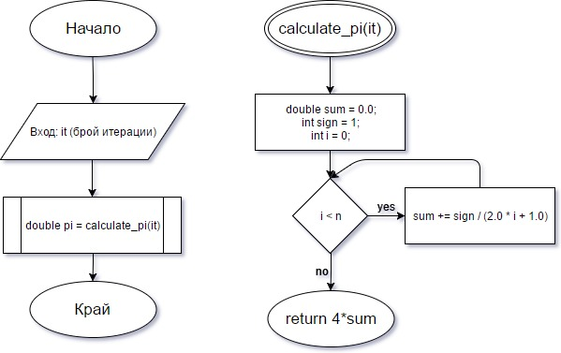Блок схема:

(По метода на Тейлър)

Изход от програмата:

it: 0 pi: 4.000000000000000

it: 200 pi: 3.146567747182956

it: 400 pi: 3.144086415298761

it: 600 pi: 3.143256545948974

it: 800 pi: 3.142841092554028

it: 1000 pi: 3.142591654339544

it: 1200 pi: 3.142425292912591

it: 1400 pi: 3.142306429373255

it: 1600 pi: 3.142217263147860

it: 1800 pi: 3.142147900631949

it: 2000 pi: 3.142092403683526

it: 2200 pi: 3.142046992503194

it: 2400 pi: 3.142009146699595

it: 2600 pi: 3.141977121088081

it: 2800 pi: 3.141949668930079

it: 3000 pi: 3.141925875839790

it: 3200 pi: 3.141905055956430

it: 3400 pi: 3.141886684750745

it: 3600 pi: 3.141870354223156

it: 3800 pi: 3.141855742246124

it: 4000 pi: 3.141842591101516

it: 4200 pi: 3.141830692148672

it: 4400 pi: 3.141819874672979

it: 4600 pi: 3.141809997642868

it: 4800 pi: 3.141800943527130

it: 5000 pi: 3.141792613595791

it: 5200 pi: 3.141784924305186

it: 5400 pi: 3.141777804486189

it: 5600 pi: 3.141771193134878

it: 5800 pi: 3.141765037660222

it: 6000 pi: 3.141759292482148

it: 6200 pi: 3.141753917900947

it: 6400 pi: 3.141748879178585

it: 6600 pi: 3.141744145787069

it: 6800 pi: 3.141739690789404

it: 7000 pi: 3.141735490326666

it: 7200 pi: 3.141731523190563

it: 7400 pi: 3.141727770465268

it: 7600 pi: 3.141724215225843

it: 7800 pi: 3.141720842283015

it: 8000 pi: 3.141717637966245

it: 8200 pi: 3.141714589938549

it: 8400 pi: 3.141711687037752

it: 8600 pi: 3.141708919139901

it: 8800 pi: 3.141706277041293

it: 9000 pi: 3.141703752356238

it: 9200 pi: 3.141701337428174

it: 9400 pi: 3.141699025252072

it: 9600 pi: 3.141696809406606

it: 9800 pi: 3.141694683994580

it: 10000 pi: 3.141492653590034