#include<iostream>

using namespace std;

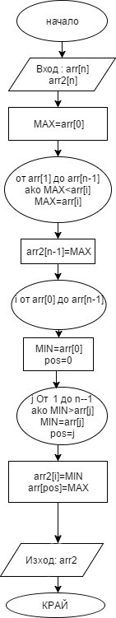

//sorting array inside another array

int main()

{

int n;

cin >> n;

int\* arr = new int[n];

int\* arr2 = new int[n];

for (int i = 0; i < n; i++)

{

cin >> arr[i];

}

int max = arr[0];

for (int i = 1; i < n; i++)

{

//update max

if (max < arr[i])

{

max = arr[i];

}

}

//make current max last in arr2

arr2[n - 1] = max;

int min;

int minPos;

for (int i = 0; i < n - 1; i++)

{

min = arr[0];

minPos = 0;

//find min (prev min got "destroyed")

for (int j = 1; j < n; j++)

{

if (min > arr[j])

{

//update min

min = arr[j];

minPos = j;

}

}

arr2[i] = min;

//"destroying" the min element in original array

arr[minPos] = max;

}

for (int i = 0; i < n; i++)

{

cout << arr2[i] << " ";

}

return 0;

}