FitTrack - Documentation Report

Application Outline
FitTrack is a fitness tracking web application that enables users to log, manage, and analyse their workout activities. Users can register an account, log in securely, and record workouts with details including type, duration, calories burned, and distance covered.
The application provides a personal dashboard displaying aggregated statistics and recent activity. A search feature allows filtering workouts by name, type, and date range. An analytics page visualises workout trends through interactive charts.
Key functionality includes:
- User authentication with secure password hashing and session management
- Workout CRUD operations for adding, viewing, and deleting fitness entries
- Search and filtering across the workout database
- Data visualisation showing workout patterns over time
- CSV export for external data analysis
- REST API providing JSON endpoints for programmatic access
The application uses audit logging to track authentication attempts for security monitoring.
Test credentials: username gold, password smiths

High-Level Architecture

The application follows a three-tier architecture consisting of a client layer, application tier, and data tier.
The client browser sits at the top of the architecture and communicates with the application tier through HTTP or HTTPS connections.
The application tier runs on Node.js with the Express.js framework, which handles HTTP requests, routing, and business logic. The EJS templating engine renders dynamic HTML views, while Express provides session management, input validation, and security features.
The data tier consists of a MySQL relational database that stores all persistent data including user accounts, workout records, workout types, and audit logs. The application connects to the database via the mysql2 package using parameterized queries, communicating through the MySQL protocol.

Data Model

The database contains four tables.
The users table stores account credentials and profile information. It has a primary key of id.
The workout_types table is a reference table containing five exercise categories, which are Cardio, Strength, Flexibility, HIIT, and Sports. It also has a primary key of id.
The workouts table is the main data table linking users to their logged activities with metrics. It has a primary key of id and contains two foreign keys: user_id references the users table, and workout_type_id references the workout_types table.
The audit_log table is a security table that records login attempts. It has a primary key of id and operates independently of the other tables.
The relationships between tables are as follows. Each user can have many workouts, creating a one-to-many relationship between users and workouts. Each workout belongs to exactly one workout type, creating a one-to-many relationship between workout_types and workouts.

User-Facing Functionality

Home Page
The landing page welcomes users and provides navigation links to all application features including login, registration, search, and about pages.

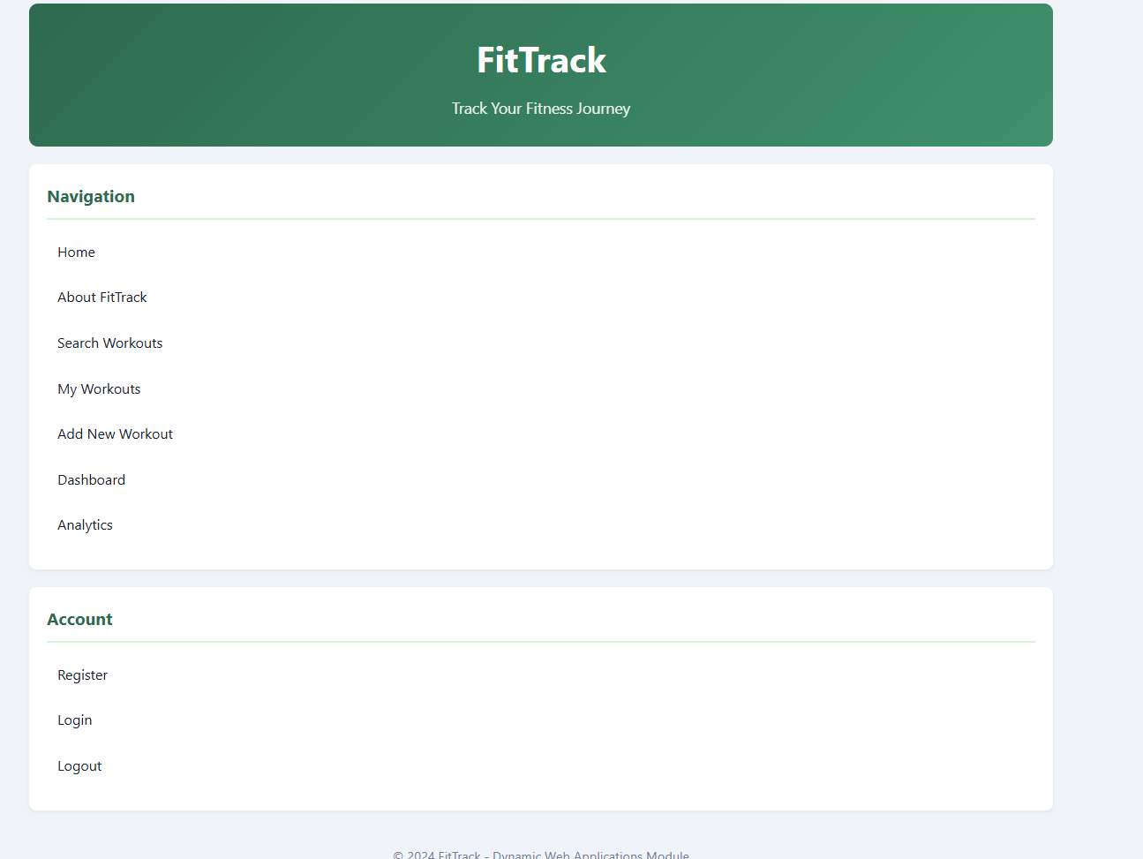

### Registration and Login
New users register by providing username, email, first name, last name, and password. The registration form validates input (email format, username 5-20 characters, password minimum 8 characters). Returning users log in with username and password credentials.

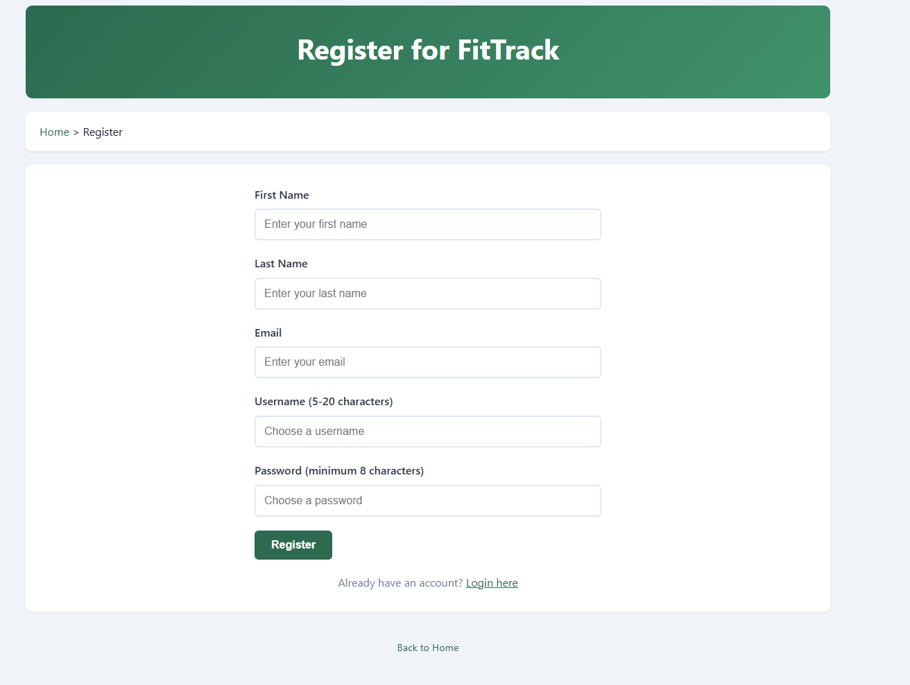
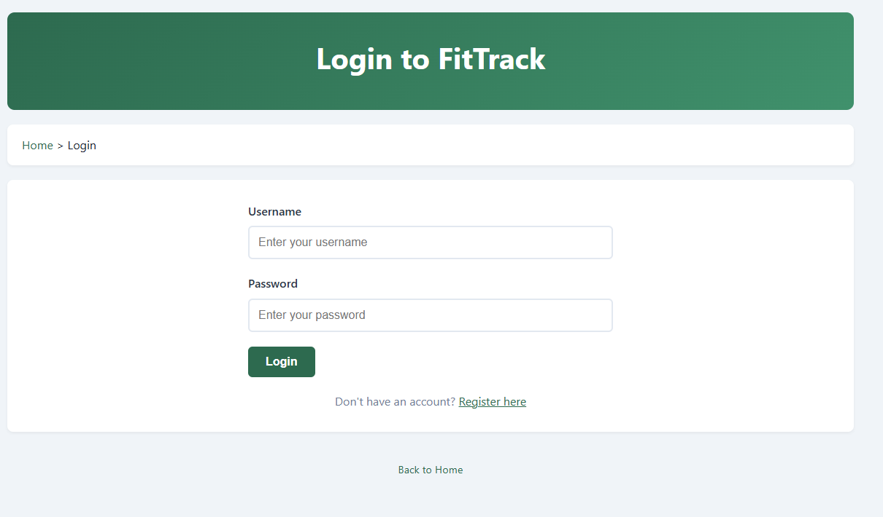

Dashboard
After logging in, users see their personal dashboard displaying:
- Total workout count
- Total minutes exercised
- Total calories burned
- Total distance covered
- Recent workout history
- Quick action buttons for adding workouts and viewing analytics

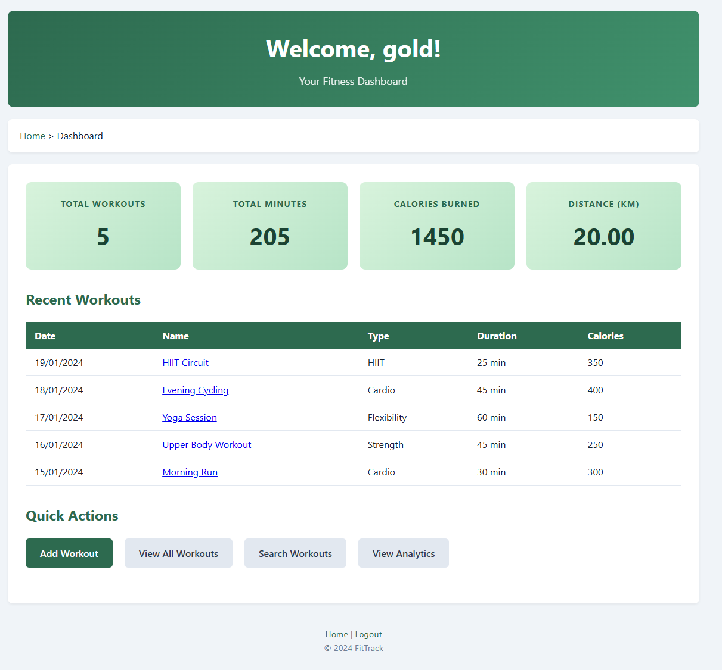

Add Workout
Users add new workouts through a form specifying:
- Workout name
- Type (dropdown selection)
- Date performed
- Duration in minutes
- Calories burned
- Distance in kilometres
- Optional notes

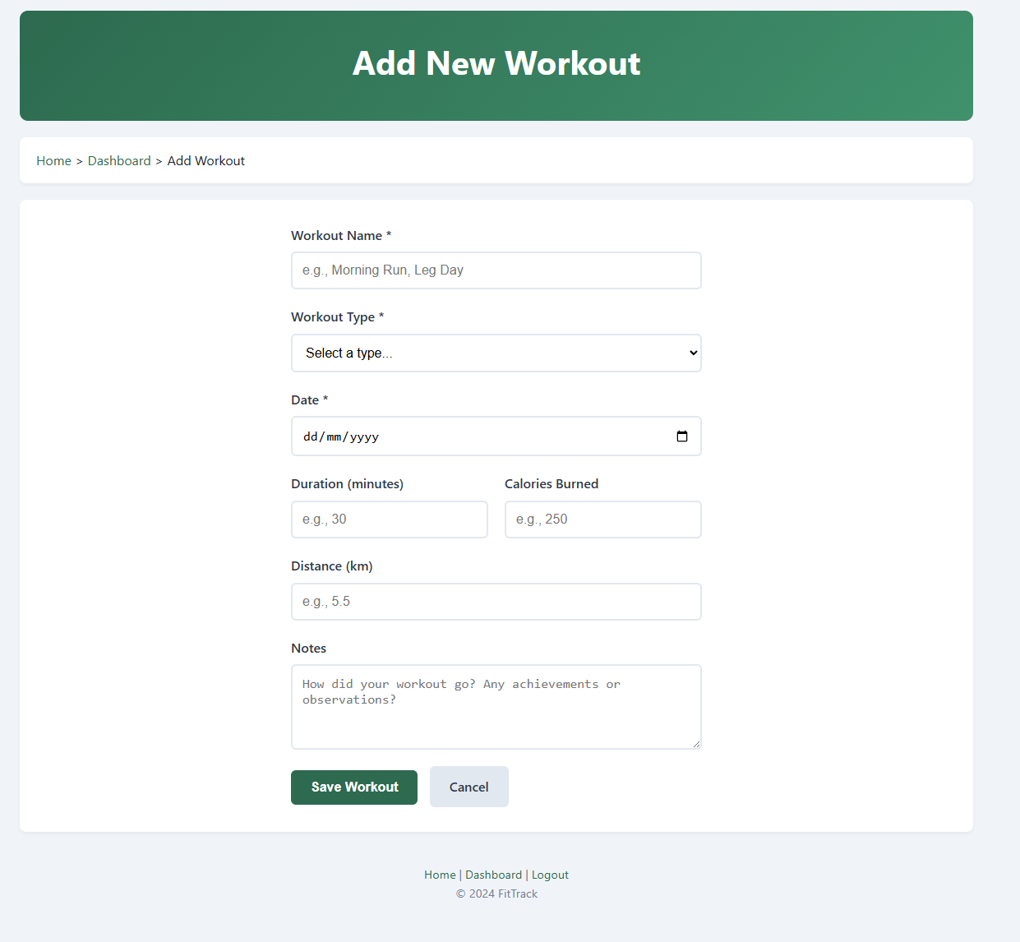

Search
The search page allows users to find workouts by:
- Keyword search (partial name matching)
- Workout type filter
- Date range filter

Results display matching workouts from all users in the system.

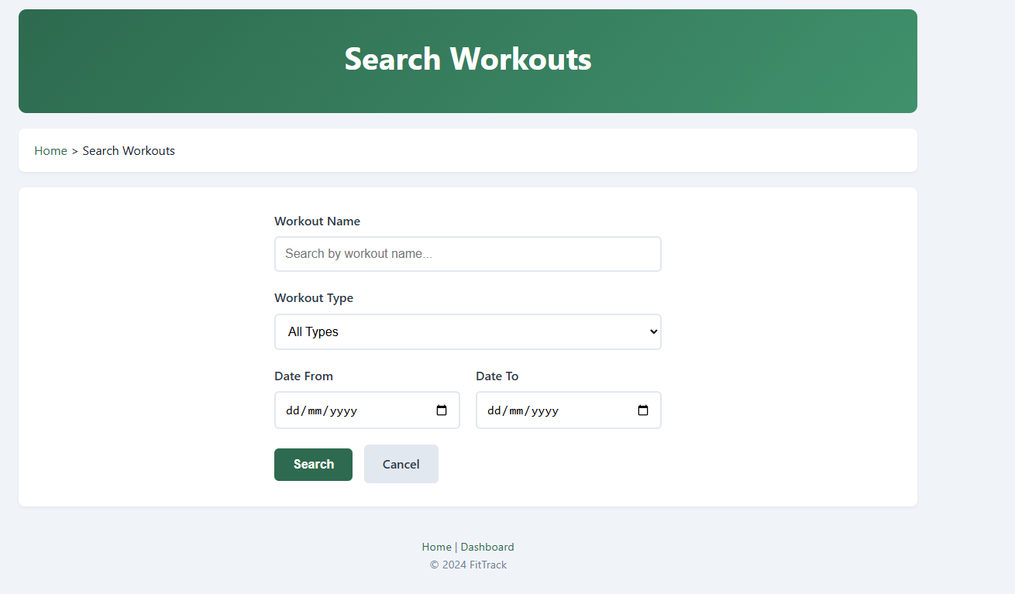
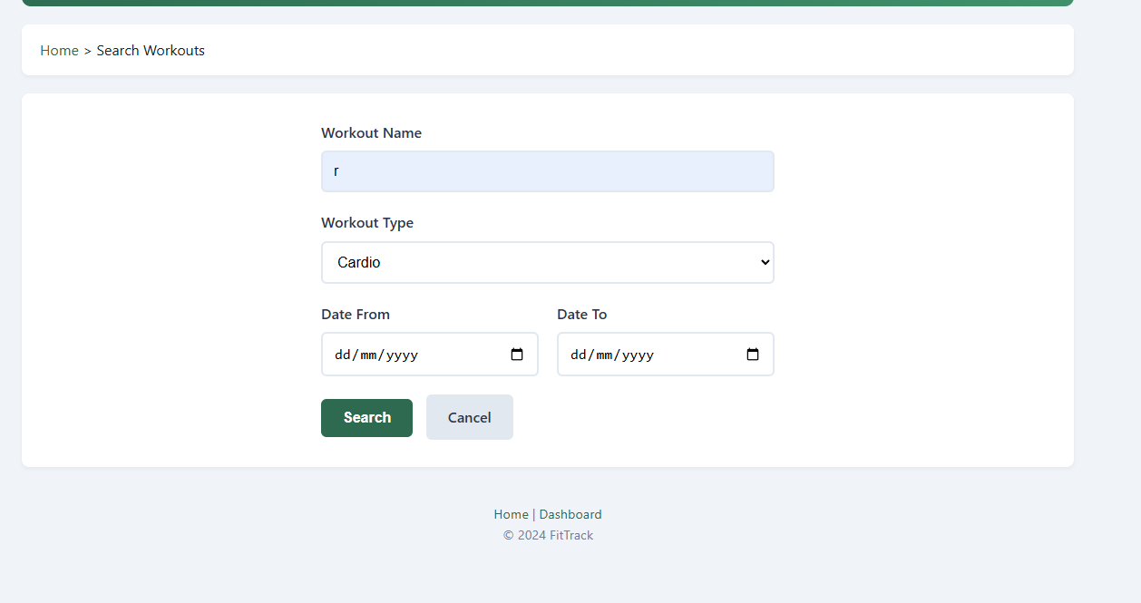

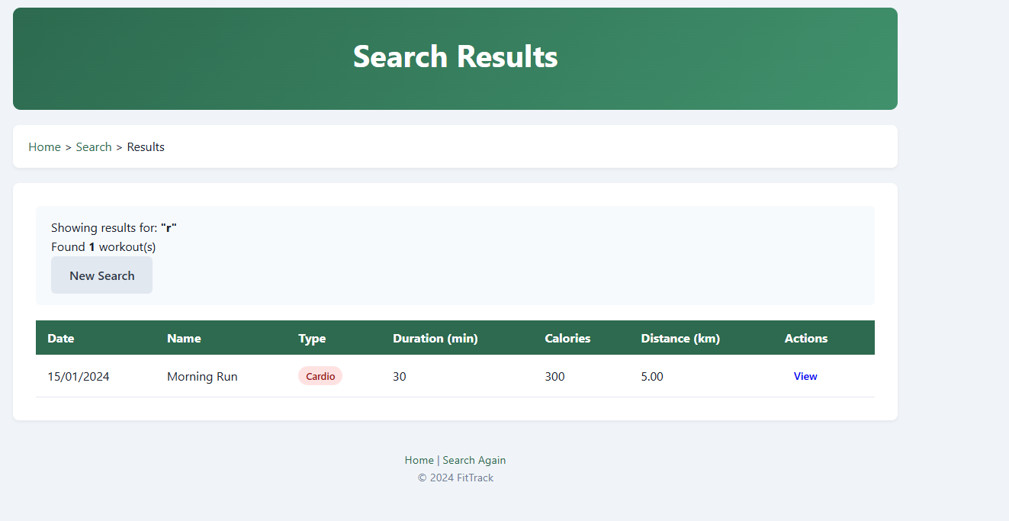

Analytics
An interactive analytics page displays four charts:
- Workout distribution by type (doughnut chart)
- Calories by workout type (bar chart)
- Monthly activity trends (line chart)
- Weekly workout frequency (bar chart)

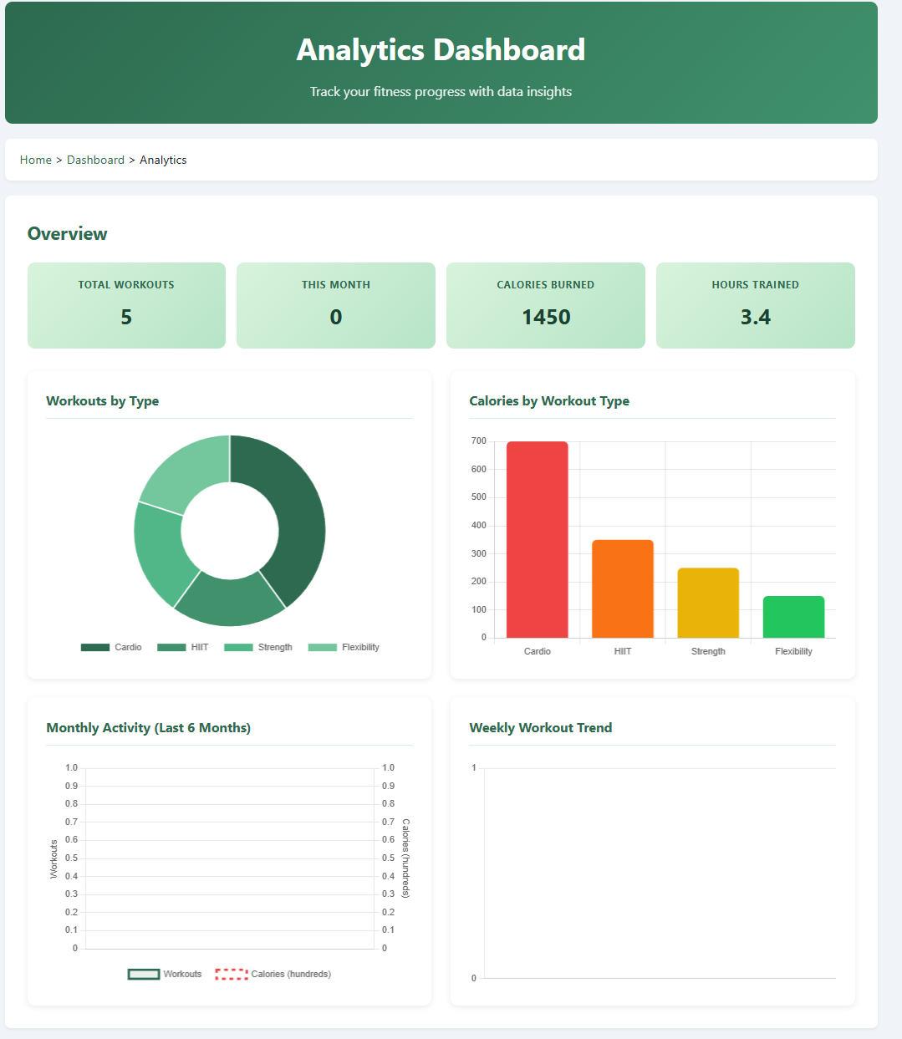

About Page
Provides information about the application, its features, and technology stack.

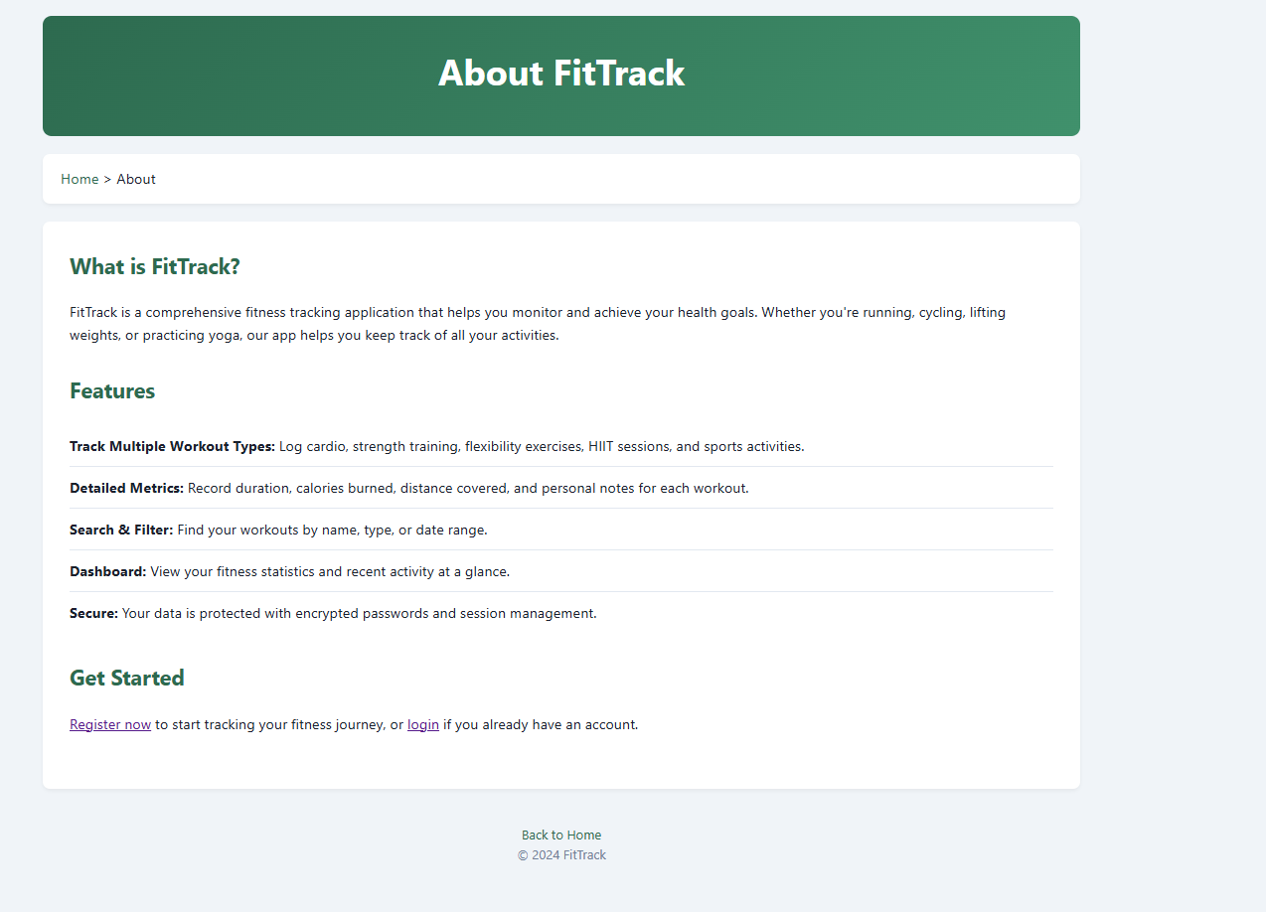

---

Advanced Techniques

1. Interactive Analytics with Chart.js and Fetch API

The analytics dashboard demonstrates client-side JavaScript fetching data from multiple API endpoints simultaneously using `Promise.all()`:

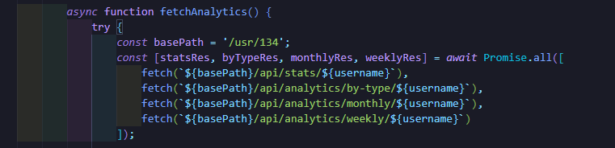
This parallel fetching improves performance compared to sequential requests. The data is then rendered using Chart.js to create interactive visualisations including a dual-axis line chart for tracking trends.

2. Complex SQL Aggregation Queries
The analytics API endpoints use advanced SQL features including GROUP BY, date functions, and aggregations:
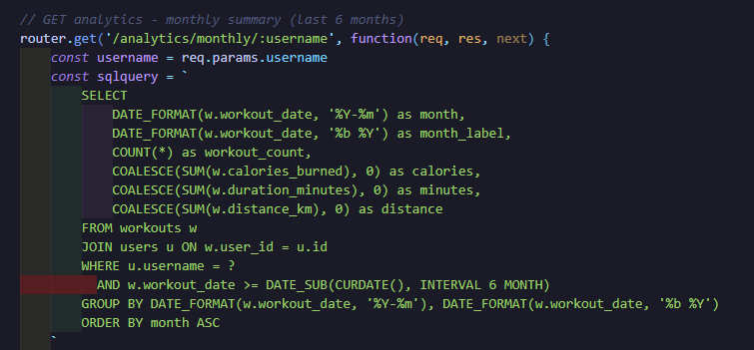

3. CSV Data Export
Users can export workout data as CSV files with proper escaping and HTTP headers:

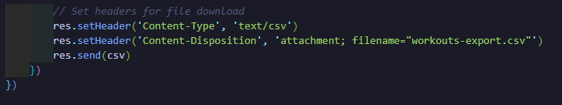

4. Authorisation-Protected Deletion
Delete operations verify workout ownership before execution:
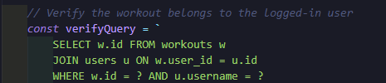

5. Custom Error Handling Middleware
Express middleware provides user-friendly 404 and 500 error pages:
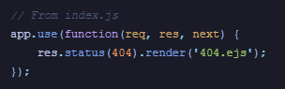

AI DECLARATION

I have used AI to help ensure that the structure and hierarchy of code paths are correct. I also used it to correct any punctuation and grammar inside the report to ensure the correct level of professionalism was used. I also used AI to explain different code snippets as well as teach me a few concepts that were required to complete the assignment.

