**NAPIER UNIVERSITY  
KENNETH BROWN - 40090523  
Group ProjecT 2021  
SELF-EVAULATION**

**Team 14 – Penetration Testing Scenario  
  
Project Manager: Kenneth Brown  
PM Support/ Server Administrator: Davide Pisanu  
Security Team Manager: Tom Neil  
Security Team: Luis Loaysa  
Web Team Manager/ Back-End Developer: Connor Grattan  
Web Team / Front-End Developer: Jake Salt**

**Project Client: Robert Ludwiniak**

**Project Sponsor: Andrew Partridge**

Contents

**Section 1** - Introduction 2

**Section 2** – Teamwork 3

**Section 3 –** Project Management 5

**Section 4 –** Drive for Results 7

**Section 5 -** Conclusion 9

**Appendix** 10

**1.0** **-** Teamwork – Evidence 10

1.1 10

1.2 10

1.3 11

1.4 11

**2.0** - Project Management - Evidence 12

2.1 12

2.2 12

2.3 13

2.4 13

2.5 13

**3.0** - Drive for Results – Evidence 14

# **Section 1** - Introduction

This report is for the purpose of conducting a personal self-evaluation and critical reflection on my actions and their results throughout my recently completed Group Project. To do this I will be using the STARL format as outlined by the module. My team consists of six members whose names and roles can be found on the cover page to this document. My own role within the team was as the project manager and our client was Napier’s own Digital Forensics lecturer, Robert Ludwiniak.

The previously mentioned STARL structure requires that I highlight three specific events within the project which clearly show demonstrations of key behavioural indicators, relating to certain categories. These categories are Teamwork, Project Management and Drive for Results. These make up the various sections in this report and the behavioural indicators which correspond to each will be clearly listed at the beginning of each section and referenced in their conclusions. Evidence which directly relates to these situations can be found in the Appendix section.

My project’s goal was to deploy a virtual security penetration testing scenario, to be used later for developing fourth year Cybersecurity labs. Inside the scenario Robert asked us to include a server and an E-commerce website which was vulnerable to web-based malicious attacks such as SQL injections and Cross-Site Scripting. He also asked that we not rely on any legacy OS versions or known exploits from before 2012 so that he could attempt to maintain a sense of realism within the scenario and to make improvements on some of the current labs, which still often demonstrate modern pen-testing techniques on relatively outdated operating systems such as Windows Server 2003.

At its conclusion, the project was quite successful, which is reflected in the overall satisfaction ratings taken by myself from both my team and client for the final weeks Project Health Register. My team was able to develop a scenario to most of Robert’s specifications and deployed five different successful penetration tests against this virtual network and its E-commerce site. Robert has asked that the team remain contactable regarding any future developments and expressed a great deal of satisfaction with the quality of work that went into our final product.

Our success did not come without its obstacles and this self-evaluation will focus on some specific events within the project where I was presented with challenging situations and, as the project manager, had to overcome them to make effective progress. It should also be noted that despite being quite successful overall, the project did not manage to achieve all its desired MOSCOW requirements. There are numerous layers of essential security removed from the network and many legacy features which would not commonly be found on an E-commerce network such as un-sanitized SQL product search bars. This is something I hope to return to later and make improvements upon both to improve my own security skillset and to provide Robert with a dynamic and quality product.

# **Section 2** – Teamwork

**Behavioural Indicators demonstrated in this section: -**

* **Exemplary -** Works to resolve conflicts by showing respect for others’ opinions and working toward mutually agreeable solutions.
* **Positive -** Listens to others and works to reach a compromise.
* **Positive -** Openly and diplomatically addresses conflicts as they arise.

One of Robert’s main requirements for the project was that the team produce an E-Commerce website hosted on a server. Despite the security focussed nature of this project, it meant that the team also needed members who were skilled in web development. Our web team consisted of two members, Connor Grattan, and Jake Salt. Connor was the web team lead and responsible for the back-end development whilst Jake was responsible for developing the front-end to the site and exploring potential web exploits within the scenario. Both members have strong web-dev skillsets but an issue that arose in the early stages of the project was that neither member had much prior experience in developing websites as part of a team.

I had deployed several GitHub repositories for the team to use for documentation and source code. Both members of the web team were working off the same source code and were expected to communicate amongst one another regarding important live updates to the site. It was brought to my attention through an online group chat in Discord that Jake was not communicating as as actively as he should be and was pushing changes to the site which were rendering Connor’s work obsolete. The issue was not voiced by Connor to me directly at the time, but it was clear from the conversation that this was inconvenient and needed to be addressed to avoid a potential conflict later in the project. (**Appendix 1.1**) After noticing this, I contacted Connor to see if anything had changed, address any possible concerns, and offer my own subsequent input into this situation (**Appendix 1.2**).

Connor told me that things had not yet reached a problematic stage at this point but if the matter were left unchecked then it potentially could (**Appendix 1.2**). I decided that instead of addressing Jake privately and asking him to produce the work as soon as possible that I would instead make the issue slightly more public and address it through our web development Discord channel (**Appendix 1.3**). The purpose of this was to possibly allow Connor’s input into the conversation as I felt it was essential that the two teammates start communicating with one another.

After asking Jake in the group chat when he would be able the deliver to work, he responded quickly and made great efforts the same day to deliver what was required of him. Connor did not have any input on this occasion and was able to complete his changes to the back end of the site. I took this opportunity to address every member of the group individually to remind them of the subsequent tasks they were now to complete. By doing this I hoped to not single Jake out in any way but make him realize that he was being counted on by the rest of his team to complete future tasks more promptly (**Appendix 1.4**). This was also a means of including everybody into the conversation to encourage future teamwork via Discord. This was particularly important to me as it was my main method of communication with the rest of the team within lockdown restrictions.

This was ultimately the first and only situation I was involved in that involved a breakdown in teamwork and communication. Connor was able to begin effectively communicating what he was doing or needed via the public discord (**Appendix 1.4**) and there were no further incidents involving the contributions from Jake or any other member of the group. By focussing quickly on navigating the issue without the need for any conflict, I was able to create a greater bond amongst the teammates, which I feel was beneficial to our overall outcome. I was able to effectively listen to what others had to say whilst still taking into consideration the opinions of my teammates. By openly and diplomatically addressing this issue in our public group chats, without singling anybody out, I sought to elevate our overall potential levels of efficiency. From this situation I learned a great deal about coordinating efficient teamwork efforts, conflict prevention and project management. These are experiences that I hope to draw knowledge from in my future projects.

# **Section 3 –** Project Management

**Behavioural Indicators demonstrated in this section: -**

* **Positive -** Keeps others informed of progress and outstanding issues**.**
* **Positive -** Spends time up-front planning an approach and develops reasoned and feasible work plans.
* **Positive –** Takes account for other people’s competing priorities.

In the early weeks of the project, it was made known to me through the regular module classes that my group was expected to be keeping track of weekly/overall team contributions. A spreadsheet was provided for measuring this, with the weekly totals to be averaged for an overall contribution score after the full 12 weeks of the module. The obstacle that I personally encountered here was being tasked with the creation and fair management of this system. The other members of the team were extremely busy with the set-up for the scenario whilst I was just conducting research for them at this point. My main issue was that I am a non-confrontational person and keeping track of the individual members contributions to the project felt like there was a high potential for confrontation if it was not done fairly for everyone involved. I did not like the idea early on that I may potentially have to single somebody out that I was unfamiliar with and make academic demands of them. Given that everyone has been working remotely this year and having not met the other team members in person, this sense of unease surrounding a potential conflict was further heightened.

The main task that was required of me here was to develop a system which would accurately recognise and reflect if a group member had made significant contributions that week, whilst simultaneously not singling out individual members publicly if they had not met their weekly requirements. A further issue that this posed for me was, how then to measure the negative effects accurately without directly addressing members about their lack of contribution that week? I wanted this system to motivate my team members to work hard but did not want it to change the teams’ dynamics negatively.

The way in which I developed my final system for measuring was done in the fairest way I could think of. My initial plan was to implement a group voting system where each person voted for someone else in the group to name a contribution that they had made for the week. Receiving a vote would give that member a 10% boost to their weekly score. I also told members that they should submit a vote for themselves which would award them with a 5% boost. This was so I could help my team mates to become more self-reflective about the work that they were carrying out through the week. Every member began with an equal split of the weekly contributions which was 16.7% (**Appendix 2.1**). This system was not effective using the original planned voting amounts, however.

After the first week of trying to use this system, I quickly found that awarding 10% and 5% boosts created an enormous discrepancy between the members final totals. If a member did not happen to receive any votes it was entirely possibly that they would find themselves with a final contribution of under 10% whilst member who received more than one could potentially reach 40-50%. This directly opposed my wish for this system to be fair and felt that using it this way would open the doors for future conflict within the group. To counter this issue, I decided to try the same system with smaller numbers, awarding 4% for all types of vote. This would also result in every member not involved in a particular vote would see a penalty of 2% to compensate the difference. I explained this new system to the group, and it was approved for use (**Appendix 2.2**).

Whilst this system was ultimately successful in achieving what I set out for it to do there were still some issues left unaccounted for. If a member had made a significant contribution for the week but did not receive a vote, then this could still result in them seeing negative results. To avoid this, I made it clear to the group that these numbers were not finalised after voting. If any member had any issues with their totals, then I told them they were welcome to speak out either publicly or privately to myself (**Appendix 2.3**). There were three weeks when this system was changed slightly to accommodate such requests. In week 3 myself and Connor both received many votes, bringing our weekly contributions to over 28% each. I did not feel that either of us had worked hard enough to merit this large discrepancy over the rest of the group and asked Connor if he would be happy to give up one vote along with myself so I could spread it amongst the rest of the team. Connor was not happy with this however as it would bring his overall contribution down, which was already amongst the groups lowest at this point (**Appendix 2.4**). Instead of taking this approach I instead decided to deduct 6% from my own score and award 3% to both lowest scoring members that week. Weeks 9 and 12 I decided not to ask for votes but instead arranged one group vote to keep the weekly contributions at an equal 16.7%. This was done because on both weeks I felt that my team had all performed exceptionally well and there was no need to debate as to who had done more or less than the other. The group voted in favour of using this method on both occasions (**Appendix 2.5**).

This system was used for the duration of the project and was ultimately without too much issue. I learned new skills in project management such as ways of effectively avoiding conflict whilst still taking the project goals into consideration. I learned how peoples competing priorities can be utilised in a positive way to encourage friendly competitiveness within the team. I enjoyed the process of spending time to plan and then put that plan into action to analyse my own performances. Using this system to nominate other people was also good for team bonding as it helped me and the other members recognise more effectively the hard work that was going into the project by our teammates.

# **Section 4 –** Drive for Results

**Behavioural Indicators demonstrated in this section: -**

* **Exemplary -** Readily tackles demanding tasks.
* **Positive -** Demonstrates motivation and commitment to achieving project outcomes.
* **Negative -** Over-complicates processes.

After conducting extensive security research through the planning stages of the project I had asked each team member to thoroughly document their methods and findings within the virtual environment. In total there were five different reports submitted, each of varying length and complexity.

One of the challenges I faced as the project manager in this situation was a language barrier that existed partially within our group. This barrier did not affect our internal communications in any way and only ever presented itself within the individually written pieces of documentation. The research and practical work that was carried out in all members' cases was done so to a very high standard, however, the written work was not always reflective of this and could often be confusing from the reader's perspective. Whilst this is not a criticism of the team members responsible it was still an issue that had to be addressed.

Having worked closely with each member of the team and keeping an ongoing, invested interest in their outcomes for the project, I knew each component of our pen-testing scenario extremely well. As the project manager, I felt that it was my responsibility to ensure that the final copy of any work that was submitted should be reflective of the level of effort that had been put in by the responsible member of my team.

My main task was to produce a final document for Robert which he could easily read and understand using a normal document structure (i.e., dynamic table of contents, page numbering, etc). This document also had to be used as the main point of reference for our final report as supporting evidence for the completion of the MOSCOW requirements, set at the beginning of the project. As a failure on my part as the project manager, I had not specified any format that each group member should submit their exploit documents in. This resulted in some cases of creative freedom coming before the reader's practicality. I did not feel it would appear to be professional to the client if I presented these documents as they were in a variety of different states.

The previously mentioned language barrier meant that in some cases, extensive editing was needed to convey the message clearly for our client. Because I was so familiar with each exploit, I already knew what the writer was trying to convey. This meant that I could rewrite relatively large sections of reports to correct things such as sentence structure and grammatical errors to make it clearer for our final product, whilst still maintaining the validity of information in the report itself.

What was originally anticipated to be a relatively quick task became a full days’ work. The smallest report was two pages long whilst the longest was ten pages. Every document had to be converted from a PDF into a word document and then have its contents copy/pasted into the new final document. Font and Heading styles had to be corrected for the dynamic contents page and the sections had to be organised to present a logical exploit path structure for the reader. Entire sections had to be reworded to convey the proper meanings to its reader. The final document which was submitted was 41 pages long and over 8000 words cumulatively across the whole groups work.

This was a valuable learning experience for me for several reasons. To focus on a negative side of things, the behavioural indicator of ‘*over complicating processes’* was demonstrated here in my lack of ability to pre-empt the situation where all of the reports would arrive with different formatting. This complicated the process of handing in work to the client by requiring me to construct the new document from scratch when the time could have potentially been spent working on our presentation. I learned how to effectively manage my time better and decided that in future projects I would ensure that a document template was provided in advance for any required team documentation.

From a positive perspective I feel that this situation allowed me to focus on my project management skills and develop them further. I also feel that this demonstrated the behavioural indicators motivation, commitment, and a willingness to readily tackle challenging tasks. I learned a great deal from carrying out this task regarding documentation management & presentation. This is the first time I have had to collate a large amount of work from other people together into one space and managing this task helped me to challenge myself to produce work and exceed expectations.

The evidence provided shows a single excerpt from the group’s documentation. The first shown is prior to editing for the final submission and includes examples of the grammatical errors that were found throughout. The second shows the same area of text after I had finished editing the final document (**Appendix - 3.0**). The full document, as well as the individual team document contributions, can be found at the GitHub repository linked in the appendix for a full review. The main document in question is called *‘Penetration Testing Scenario – Exploit Documentation.pdf’* and is found in the parent directory. The individual documents can be found within each team members named folder.

# **Section 5 -** Conclusion

My performance throughout this project has been good as seen in the team satisfaction register where I scored in the region of 80 – 90% overall satisfaction for my project management. It has not been without challenges, as shown in this self-evaluation, but I feel that these challenges were overcome and provided me with excellent learning experiences. Some of the skills I would like to develop moving forwards are my ability to more pro-actively approach team confrontations. This was something I actively avoided throughout the duration and thankfully there were not many major arguments for me to intervene in. This could have been different however and it would be a useful skill to be given an opportunity to develop later.

In conclusion this project has been a very positive experience for me. Facing the challenge of working remotely this year was greatly relieved by having the opportunity to work closely with other students. The teammates I worked with were all highly motivated and enthusiastic individuals that made managing the project an enjoyable experience. Through developing my core skills in Teamwork, Project Management, and the Drive for Results I feel confident that I can carry these over to the next student project and hopefully my future career.

# **Appendix**

## **-** Teamwork – Evidence

### 1.1



---Irrelevant to self-evaluation---

**Discord Chat Log** – Public Group Messages on Team Web-Dev Channel (22/02/2021)

### 1.2

**Discord Chat Log** – Private Message between Myself and Connor (24/02/2021)

### 1.3

**Discord Chat Log** – Public Group Messages on Team Web-Dev Channel (24/02/2021)

### 1.4

**Discord Chat Log** – Public Group Messages on Team Web-Dev Channel (24/02/2021)

## **2.0** - Project Management - Evidence

### 2.1

**Discord Chat Log** – Public Group Messages on Contributions Channel (01/02/2021)

### 2.2

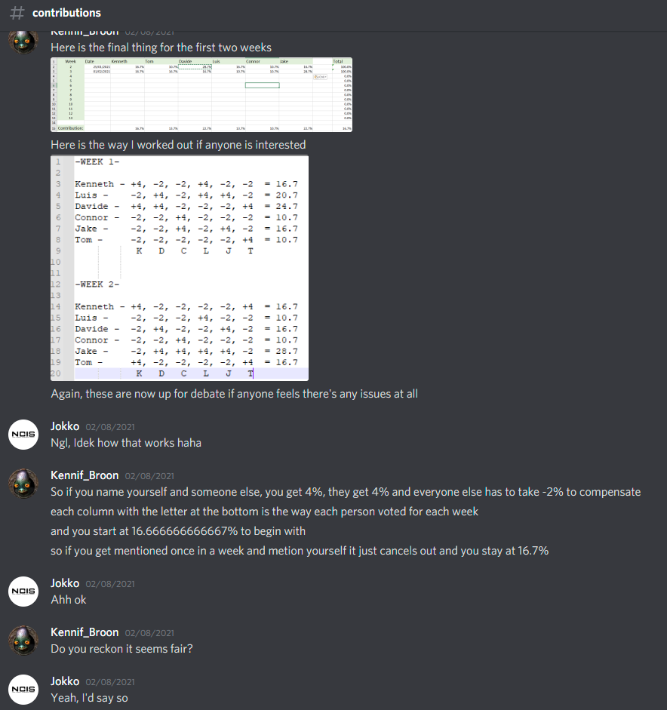

**Discord Chat Log** – Public Group Messages on Contributions Channel (08/02/2021)

### 2.3

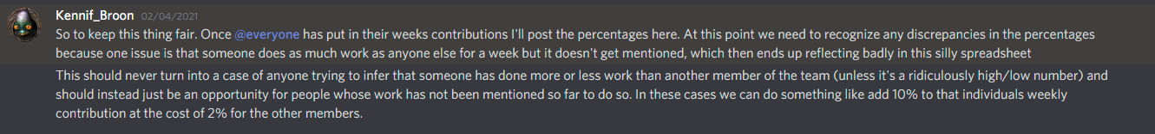

**Discord Chat Log** – Public Group Messages on Contributions Channel (04/02/2021)

### 2.4

**Discord Chat Log** – Public Group Messages on Contributions Channel (22/02/2021)

### 2.5

**Weekly Contribution Calculations** – Original Document & Spreadsheet @ https://github.com/Sly-Lamp/GRP14_PMIS

## **3.0** - Drive for Results – Evidence

**Original Documents Available at -** https://github.com/Sly-Lamp/GRP14_PMIS



Figure - Report Section Before Editing

Figure - Report Section after Editing