SlyLED User Manual — 3D Volumetric Lighting System (v1.0)

Table of Contents
- Getting Started
- Walkthrough: First Show in 30 Minutes
- Platform Guide
- Fixture Setup
- Stage Layout
- Stage Objects
- Creating Spatial Effects
- Track Action
- Building a Timeline
- Baking & Playback
- Show Preview Emulator
- DMX Fixture Profiles
- Preset Shows
- Camera Nodes
- Firmware & OTA Updates
- System Limits
- Troubleshooting
- Examples
- API Quick Reference
- Glossary
- Appendix A — Camera Calibration Pipeline (DRAFT)
- Appendix B — Moving-Head Calibration Pipeline (DRAFT)
- Appendix C — Documentation Maintenance
────────────────────────────────────────

1. Getting Started
SlyLED is a three-tier LED and DMX lighting control system:
- Orchestrator (Windows/Mac desktop app or Android app) — design shows and control playback
- Performers (ESP32/D1 Mini) — run LED effects on hardware
- DMX Bridge (Giga R1 WiFi) — output Art-Net/sACN to DMX fixtures

Quick Start
- Launch the desktop app: powershell -File desktop\windows\run.ps1 (Windows) or bash desktop/mac/run.sh (Mac)
- Open the browser at http://localhost:8080
- Go to Setup tab, click Discover to find performers on your network
- Go to Layout tab to position fixtures on the stage
- Go to Runtime tab, load a Preset Show, click Bake & Start
────────────────────────────────────────

2. Walkthrough: First Show in 30 Minutes
This walkthrough builds a complete DMX moving-head show from scratch — hardware discovery, fixture setup, layout, camera registration, actions, timeline, and playback. Every step was validated end-to-end during QA testing (issue #533). Follow in order; each step builds on the last.
What you need:
- SlyLED orchestrator running on Windows or Mac
- At least one DMX moving head connected via Art-Net/sACN bridge (e.g. Enttec ODE Mk3)
- At least one USB camera node on the network (Orange Pi or Raspberry Pi)
- All devices on the same LAN subnet as the orchestrator
────────────────────────────────────────

Step 1 — Launch and Create a New Project
Start the orchestrator:
powershell -File desktop\windows\run.ps1
Open http://localhost:8080 in Chrome or Edge. The SPA loads on the Dashboard tab.
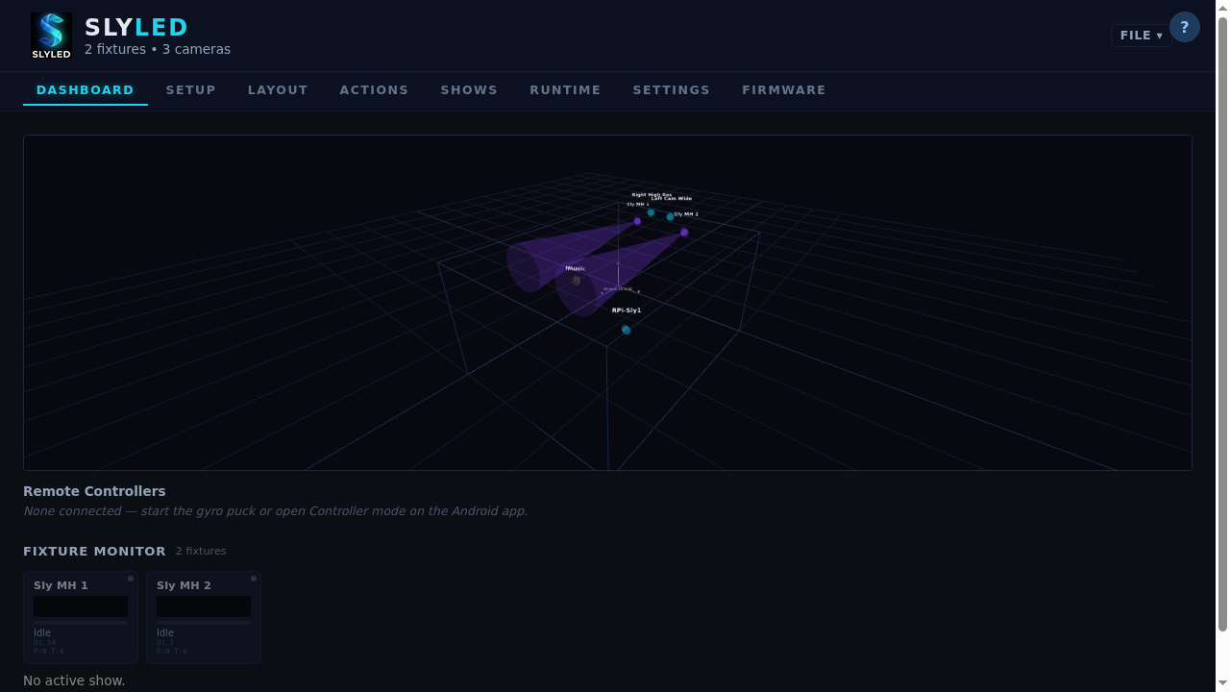
SPA at launch showing Dashboard tab
Go to Settings tab → Project → click New Project, then name it (e.g. "Walkthrough Show").
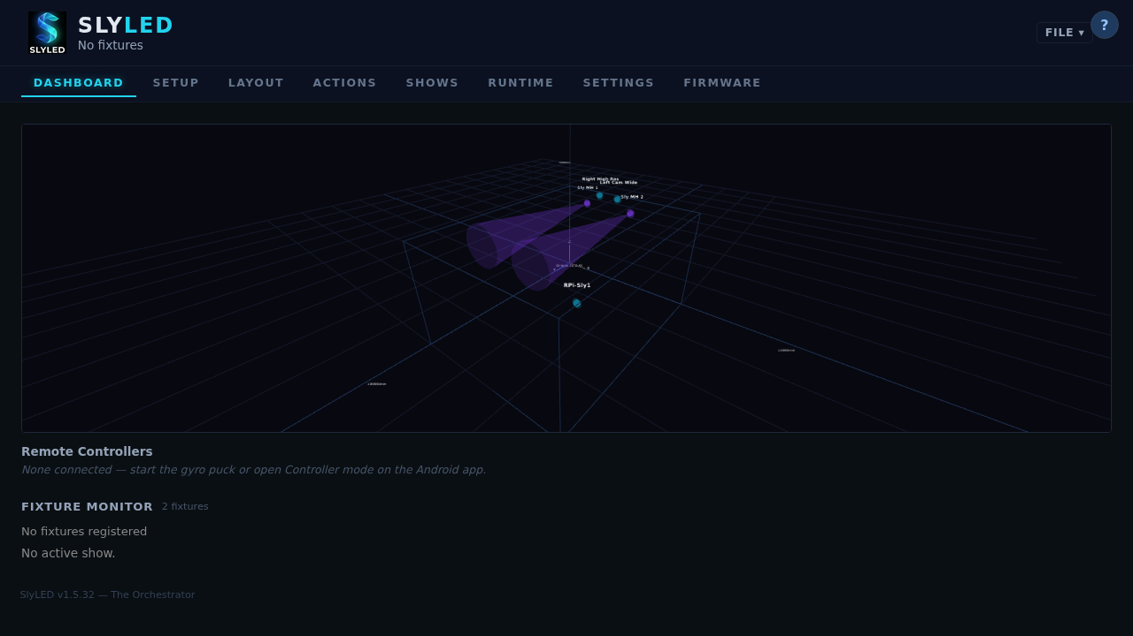
New project dialog
────────────────────────────────────────

Step 2 — Set Stage Dimensions
In Settings → Stage, enter the dimensions of your performance area:
- Width: 6000 mm (6 m)
- Height: 3000 mm (3 m)
- Depth: 4000 mm (4 m)
Click Save. The layout canvas will resize to match these dimensions.
────────────────────────────────────────

Step 3a — Discover DMX Hardware
Go to the Setup tab. In the DMX Nodes section, click Discover Nodes. SlyLED broadcasts an ArtPoll packet; Art-Net bridges on the network reply within 3 seconds.
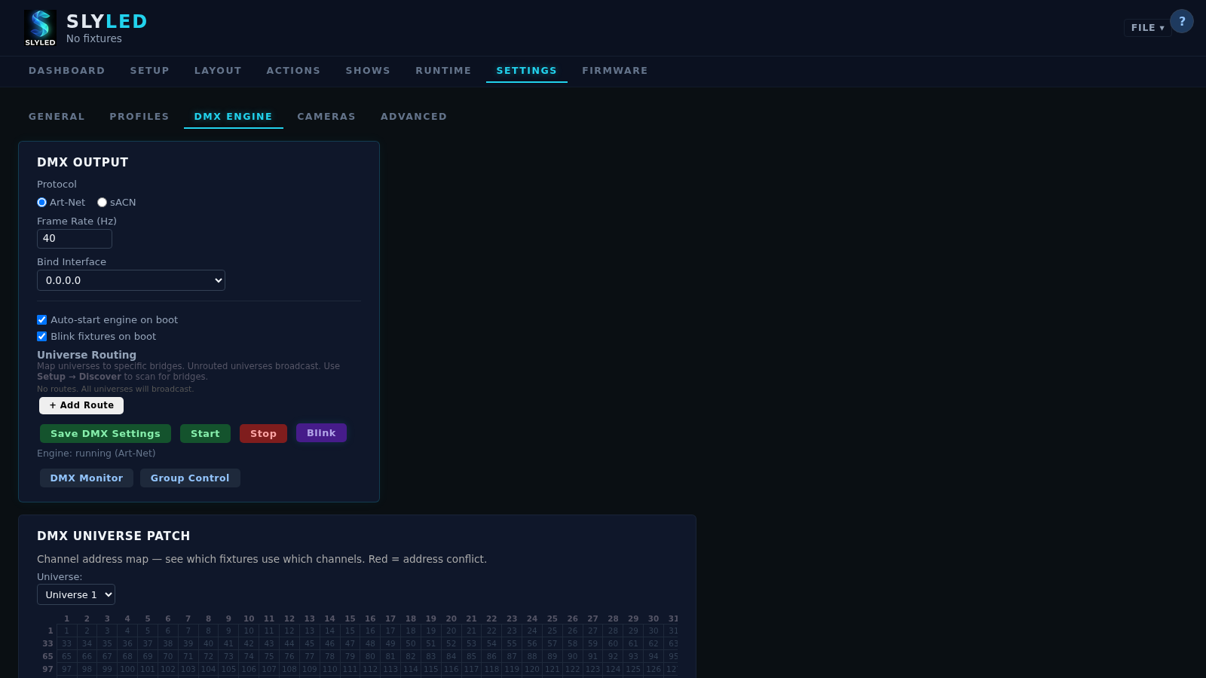
Setup tab after hardware discovery — Art-Net node shown
Any discovered nodes appear in the list with their IP, port, and universe count. If your bridge is not found:
- Confirm it is powered and on the same LAN subnet
- Check that UDP port 6454 is not blocked by a local firewall
- Some bridges require the Art-Net source IP to match their configured subnet
────────────────────────────────────────

Step 3b — Configure and Start the DMX Engine
Go to Settings → DMX:
- Universe Routing: Set Universe 1 → your Art-Net node IP (or leave as broadcast 255.255.255.255 to reach all nodes on the subnet).
- Click Start Engine. The status indicator turns green ("Running").
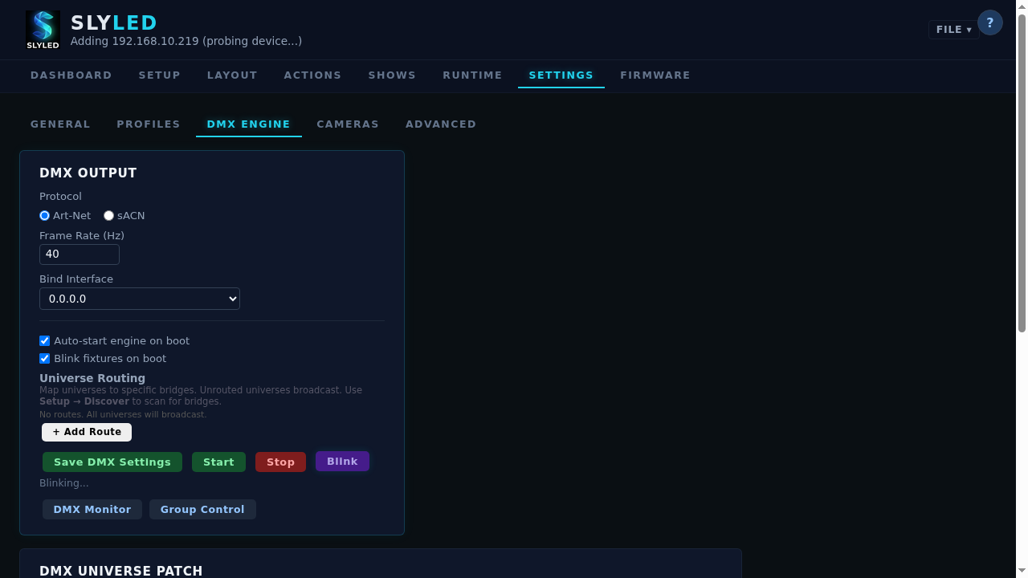
DMX engine configuration — universe routing and start
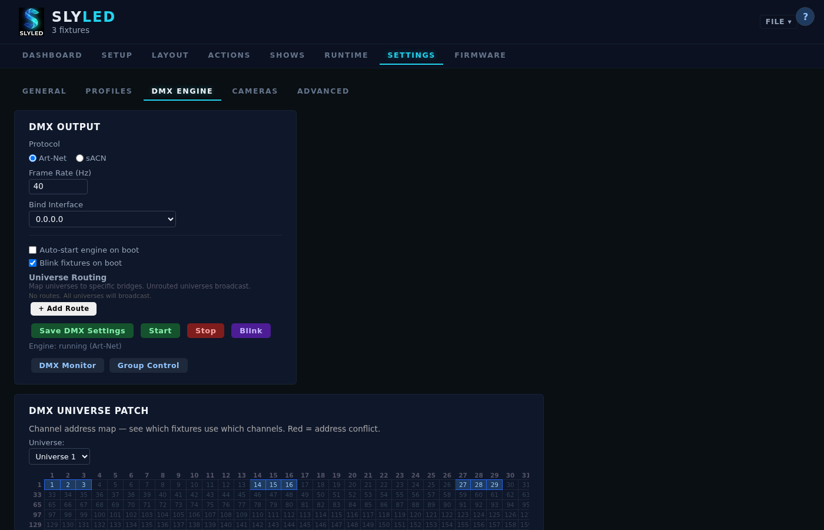
DMX routing — universe 1 assigned to bridge
Important: The engine must be running before adding DMX fixtures or running calibration. If you stop and restart the orchestrator, re-start the engine here.
────────────────────────────────────────

Step 4 — Add DMX Moving Head Fixtures
Go to the Setup tab → click + DMX Fixture. The fixture wizard opens.
Finding the right profile:
- In the Search box, type your fixture's name (e.g. "Sly Moving Head Super Mini")
- Results show Local profiles first, then Community (from the shared library), then OFL (Open Fixture Library)
- If a community profile download fails ("imported: 0"), it may contain unsupported channel types — fall back to a local generic profile or search OFL directly
- For a generic 16-channel moving head with no exact match, search OFL for "moving head" and import the closest match
Fixture 1 (stage left):
- Name: MH1 SL
- Universe: 1, Start Address: 1
- Profile: your moving head profile
- Click Create Fixture
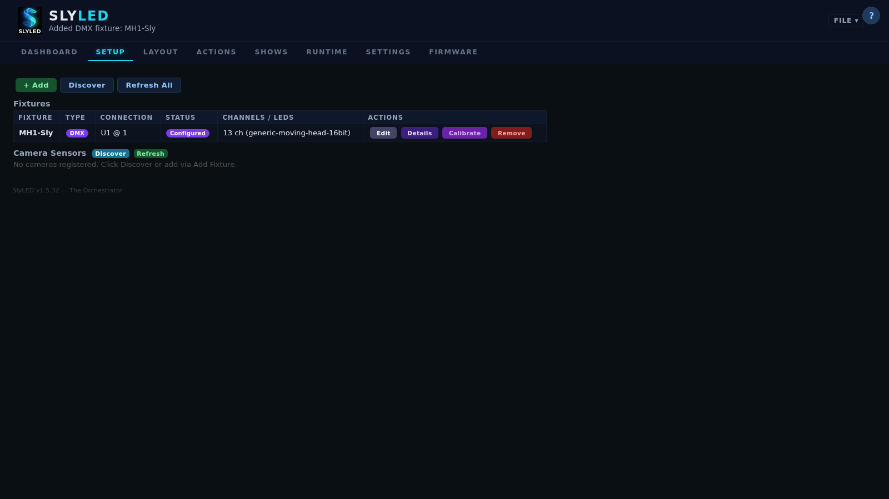
Moving head 1 added to Setup tab
Fixture 2 (stage right):
- Name: MH2 SR
- Universe: 1, Start Address: 17
- Profile: same profile
- Click Create Fixture
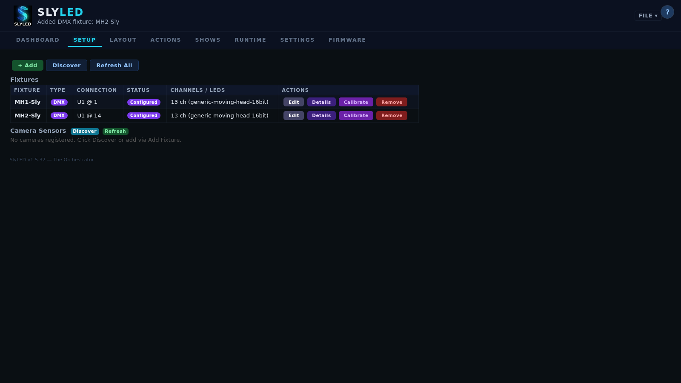
Moving head 2 added to Setup tab
────────────────────────────────────────

Step 5 — Add a Wash or Spot Fixture
Add any additional fixtures (e.g. a 350W wash spot):
- Name: Spot C
- Universe: 1, Start Address: 33
- Profile: your spot/wash profile
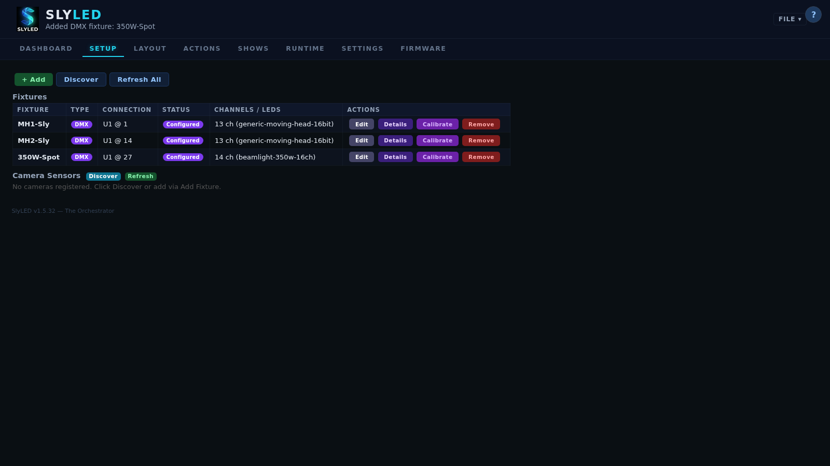
350W spot added to Setup tab
────────────────────────────────────────

Step 6 — Register Camera Nodes
Still on the Setup tab, scroll to the Camera Nodes section. Click Discover Cameras. Camera nodes running slyled-cam respond to the same UDP broadcast as performers.
Alternatively, enter the camera's IP manually and click Add.
Camera 1 (left):
- IP: your camera's IP (e.g. 192.168.10.50)
- Name: Cam Left
Camera 2 (right):
- IP: your second camera's IP
- Name: Cam Right
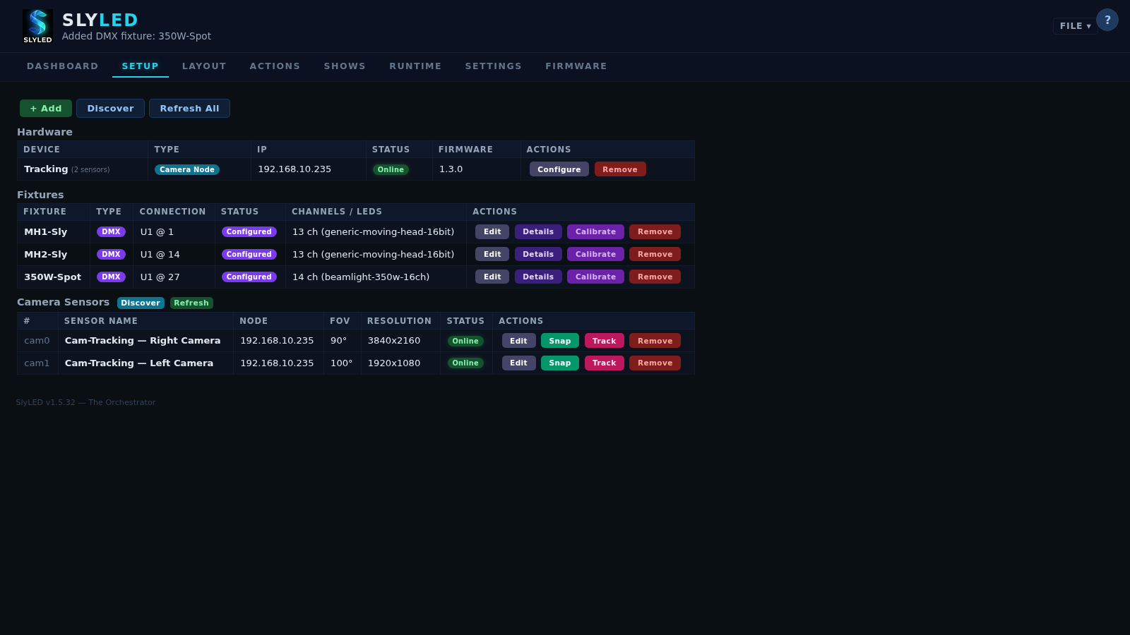
Two cameras added to Setup tab
Each camera appears with online/offline status. Click Snap to verify the live feed.
[Image: screenshots/walkthrough-533/06-cam1_left_hires.png — not found]
[Image: screenshots/walkthrough-533/06-cam2_right.png — not found]
Note: Camera discover sometimes returns 0 nodes on the first broadcast due to UDP timing. If no cameras are found, wait 3 seconds and click Discover again. This is a known intermittency (#542) being addressed in a future release.
────────────────────────────────────────

Step 7 — Position All Fixtures on the Layout
Switch to the Layout tab. All added fixtures appear in the left sidebar as "unplaced."
Place and position each fixture:
- Click a fixture in the sidebar to select it
- Click on the canvas to place it, or drag from the sidebar
- Double-click the placed fixture to open the edit dialog and enter exact coordinates
Fixture | X (mm) | Y (mm) | Z (mm)
MH1 SL | 1500 | 3000 | 500
MH2 SR | 4500 | 3000 | 500
Spot C | 3000 | 3000 | 500
Cam Left | 0 | 2500 | 0
Cam Right | 6000 | 2500 | 0
Click Save after entering coordinates for each fixture.
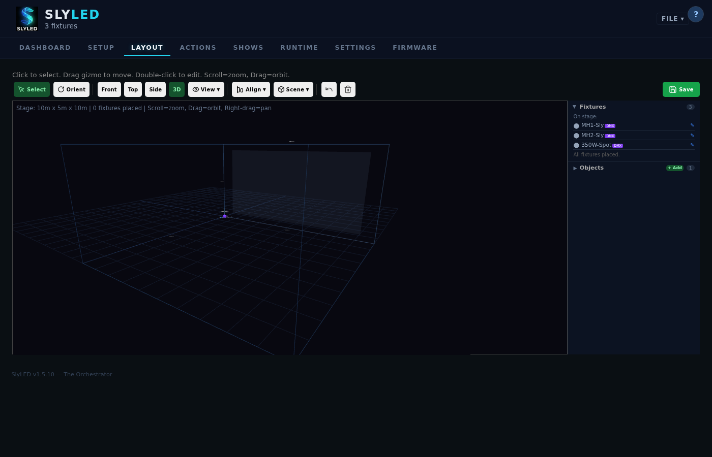
Layout tab — fixtures placed at initial positions
[Image: screenshots/walkthrough-533/04d-layout-positions.png — not found]
[Image: screenshots/walkthrough-533/06c-cameras-positioned.png — not found]
Tip: Use 3D view (toggle in the layout toolbar) to visually verify that movers are elevated on the truss and aimed downward toward the stage floor.
────────────────────────────────────────

Step 8 — Add a Stage Object
Go to the Layout tab → click + Object in the toolbar.
- Name: Music Stand
- Type: Prop (moving — trackable by movers)
- Position: X: 3000, Y: 0, Z: 2000 (center stage, at floor level, mid-depth)
- Size: 300 × 1200 × 300 mm
Click Save. The object appears as a labeled rectangle on the canvas.
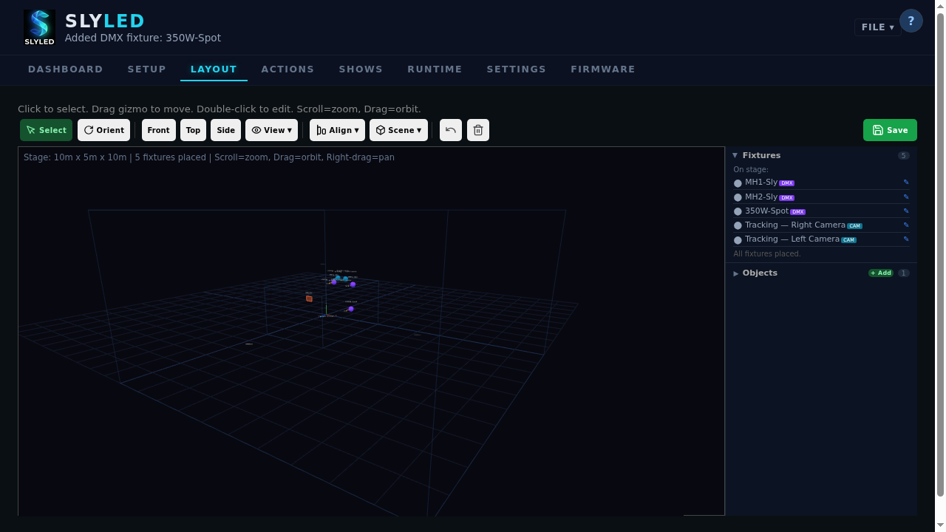
Music stand object on layout
────────────────────────────────────────

Step 9 — Run Mover Calibration
Before the moving heads can accurately track positions, calibrate each one. This step requires the camera nodes to be positioned on the layout (Step 7) and the DMX engine running (Step 3b).
In the Layout tab, double-click MH1 SL. Click Calibrate.

Calibration buttons in fixture edit dialog
[Image: screenshots/walkthrough-533/07-calibrate-ui.png — not found]
- Select Green as the beam color (good contrast on dark floors)
- Click Start Calibration
- The wizard runs automatically through eight phases: warmup → discovery → blink-confirm → mapping/convergence → grid build → verification sweep → model fit → held-out parametric gate → save
- Repeat for MH2 SR
Calibration typically takes 2–4 minutes per head. For the complete phase-by-phase reference — what each phase does, how long it should take, what fallbacks exist, and what to check when a phase stalls — see Appendix B — Moving-Head Calibration Pipeline.
────────────────────────────────────────

Step 10 — Create Actions
Go to the Actions tab. You'll create two actions: a static aim and a figure-eight sweep.
Action 1: Aim Red (static spotlight)
- Click + New Action
- Name: Aim Red
- Type: DMX Scene
- Colour: Red (255, 0, 0)
- Dimmer: 255
- Click Save Action
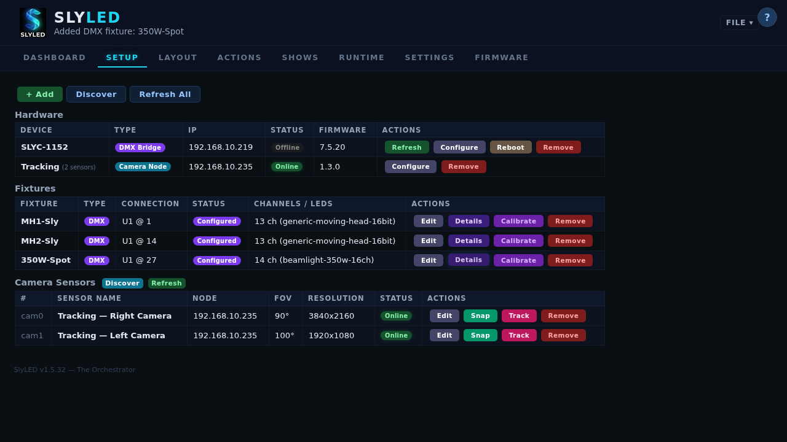
Aim Red action — aimed at stage center
Action 2: Figure Eight (dynamic sweep)
- Click + New Action
- Name: Figure Eight
- Type: Track
- Target Objects: leave empty (track all moving objects)
- Cycle Time: 4000 ms
- Click Save Action
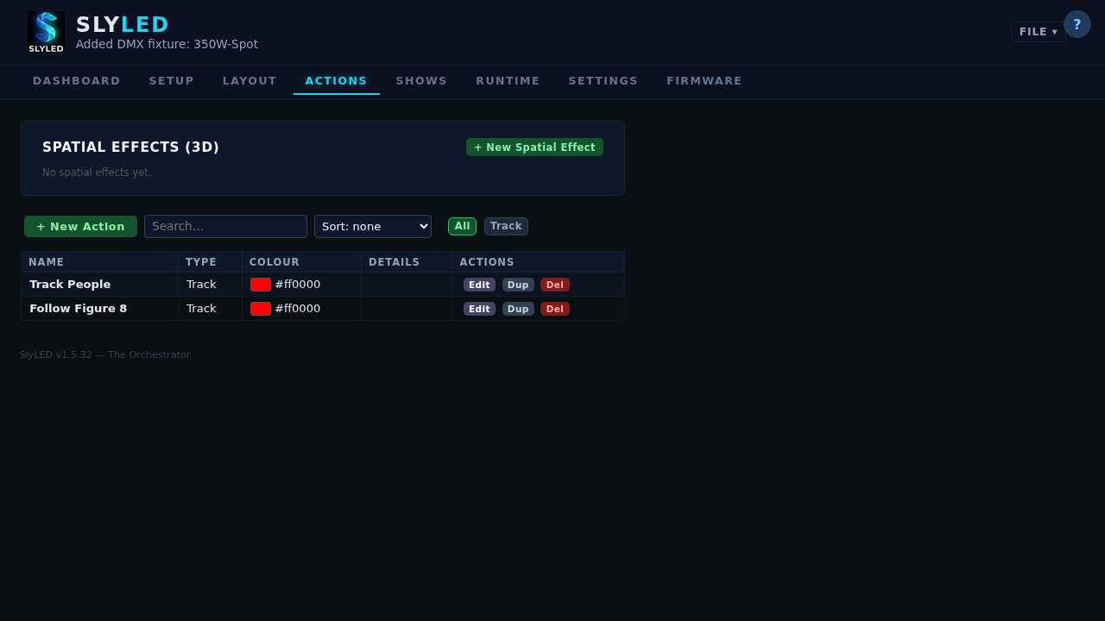
Figure Eight track action
────────────────────────────────────────

Step 11 — Build a Timeline
Go to the Runtime tab (labeled Shows in some versions). Click + New Timeline.
A dialog prompts for the name — enter Walkthrough Show. A second dialog prompts for duration — enter 120 (seconds). Click OK.
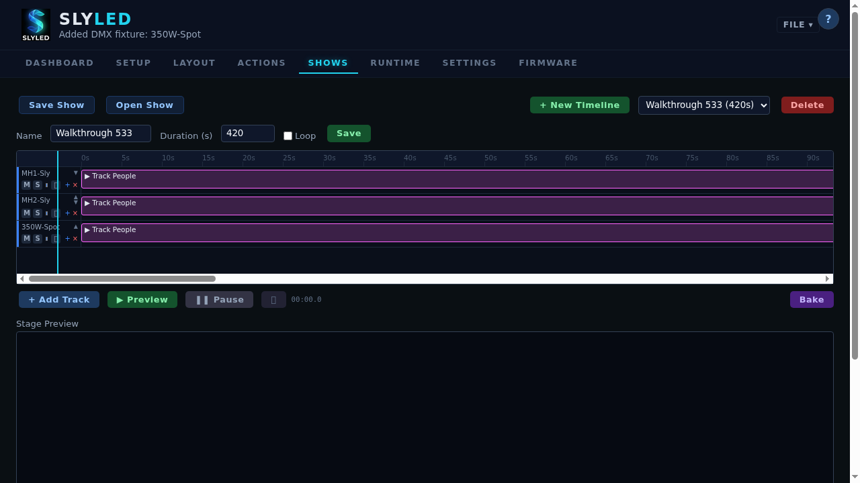
Timeline editor with tracks
Add tracks:
For each fixture or group, click + Add Track:
- Track for MH1 SL — add clip: Aim Red at 0s, duration 10s
- Track for MH1 SL — add clip: Figure Eight at 10s, duration 110s
- Track for MH2 SR — add clip: Figure Eight at 0s, duration 120s
- Track for All Performers — add clip with ambient wash color
The Track action (type 18) evaluates in real-time during playback and doesn't need to be baked per-frame — it reads live object positions at 40 Hz.
────────────────────────────────────────

Step 12 — Bake and Start Playback
- Click Bake — the engine compiles the timeline into per-fixture action sequences. Progress shows frame count.
- Click Start — NTP-synchronized playback begins.
Watch the Runtime view:
- Beam cones animate in 3D as the timeline plays
- The figure-eight pattern moves through the stage space
- DMX output is sent via Art-Net to the physical fixtures
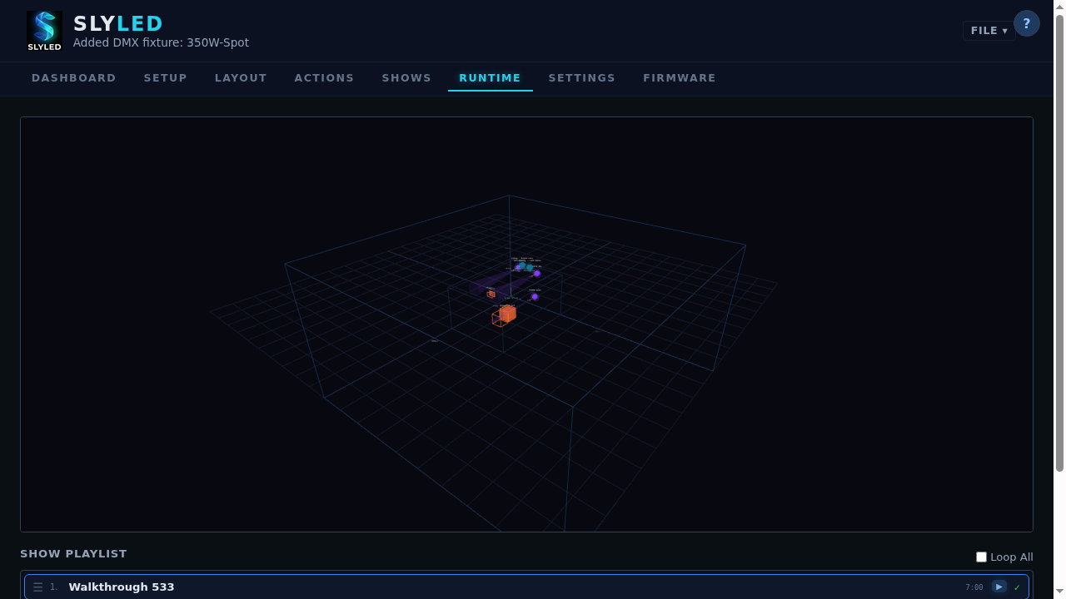
Runtime view with animated beam cones
To test a blackout:
- Click Stop, then fire a Blackout action from the Settings → Group Control panel
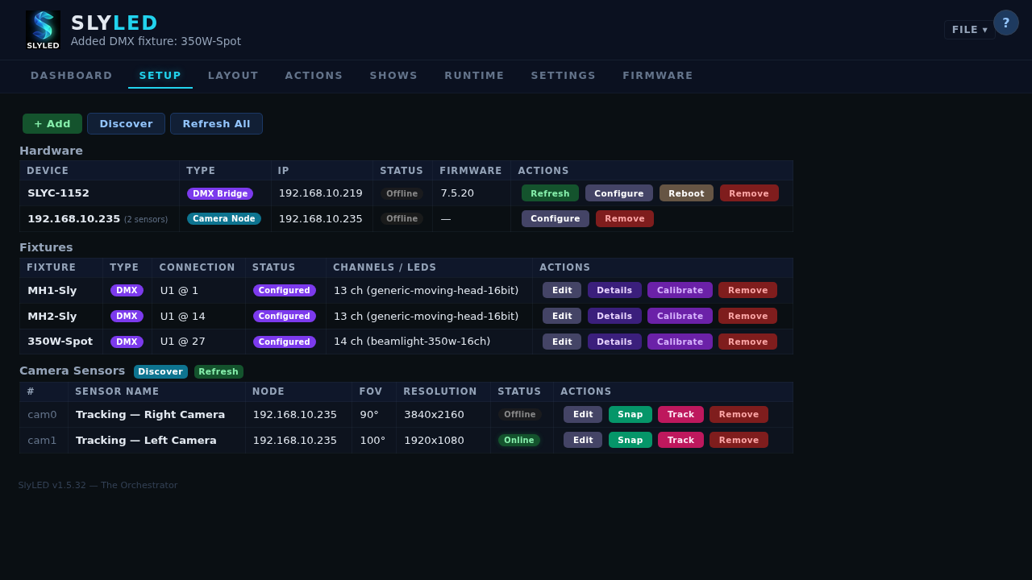
Blackout state — all beams off
────────────────────────────────────────

Step 13 — Save the Project
Go to Settings → Project → click Export. A .slyshow file is downloaded containing all fixtures, layout positions, objects, camera registrations, calibration data, actions, and timelines.
To reload: Settings → Project → Import → select the .slyshow file.
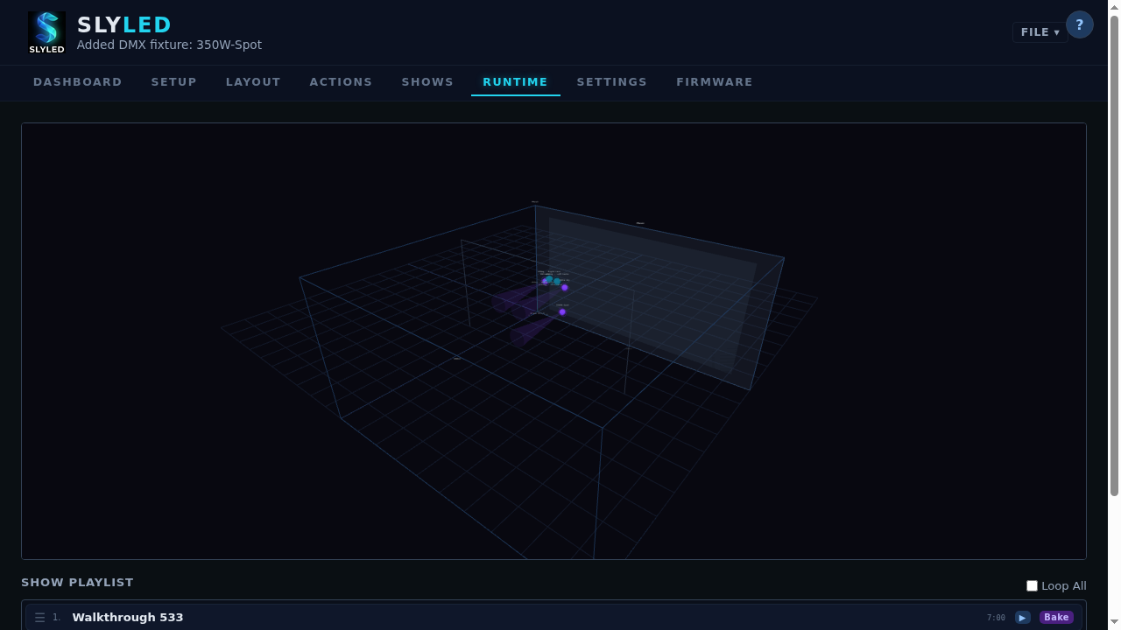
Project saved — all state bundled in .slyshow file
────────────────────────────────────────

Walkthrough Troubleshooting
Problem | Solution
No Art-Net nodes discovered | Confirm bridge is on the same subnet; UDP port 6454 not blocked
DMX engine won't start | Check Settings → DMX → verify universe routing is configured
Community profile download fails | Profile has unsupported channel types — use local or OFL profile instead
Fixture position resets to 0,0,0 | Ensure saveFixture() completes before switching tabs; use the edit dialog Save button
Camera discover returns 0 | Wait 3s and retry — first broadcast may arrive before socket is bound (#542)
Calibration fails to detect beam | Dim ambient light, verify beam color contrasts with floor, check camera can see the beam
Figure Eight doesn't move heads | Verify Track action has no trackFixtureIds restriction; confirm engine is running
Timeline tracks missing after create | Add tracks manually after timeline creation — they are not auto-created
────────────────────────────────────────

3. Platform Guide

Windows Desktop (SPA)
The primary design and control interface. Full-featured 7-tab SPA with 2D/3D layout, timeline editor, spatial effects, DMX profiles, and firmware management.
Launch: powershell -File desktop\windows\run.ps1 or run SlyLED.exe Install: Run SlyLED-Setup.exe (includes system tray icon)

Android App
Live operator tool for running shows from your phone. Connects to the desktop server over WiFi.
Install: Transfer SlyLED-debug.apk to your phone and install. Connect: Scan the QR code on the desktop Settings tab, or enter the server IP and port manually.
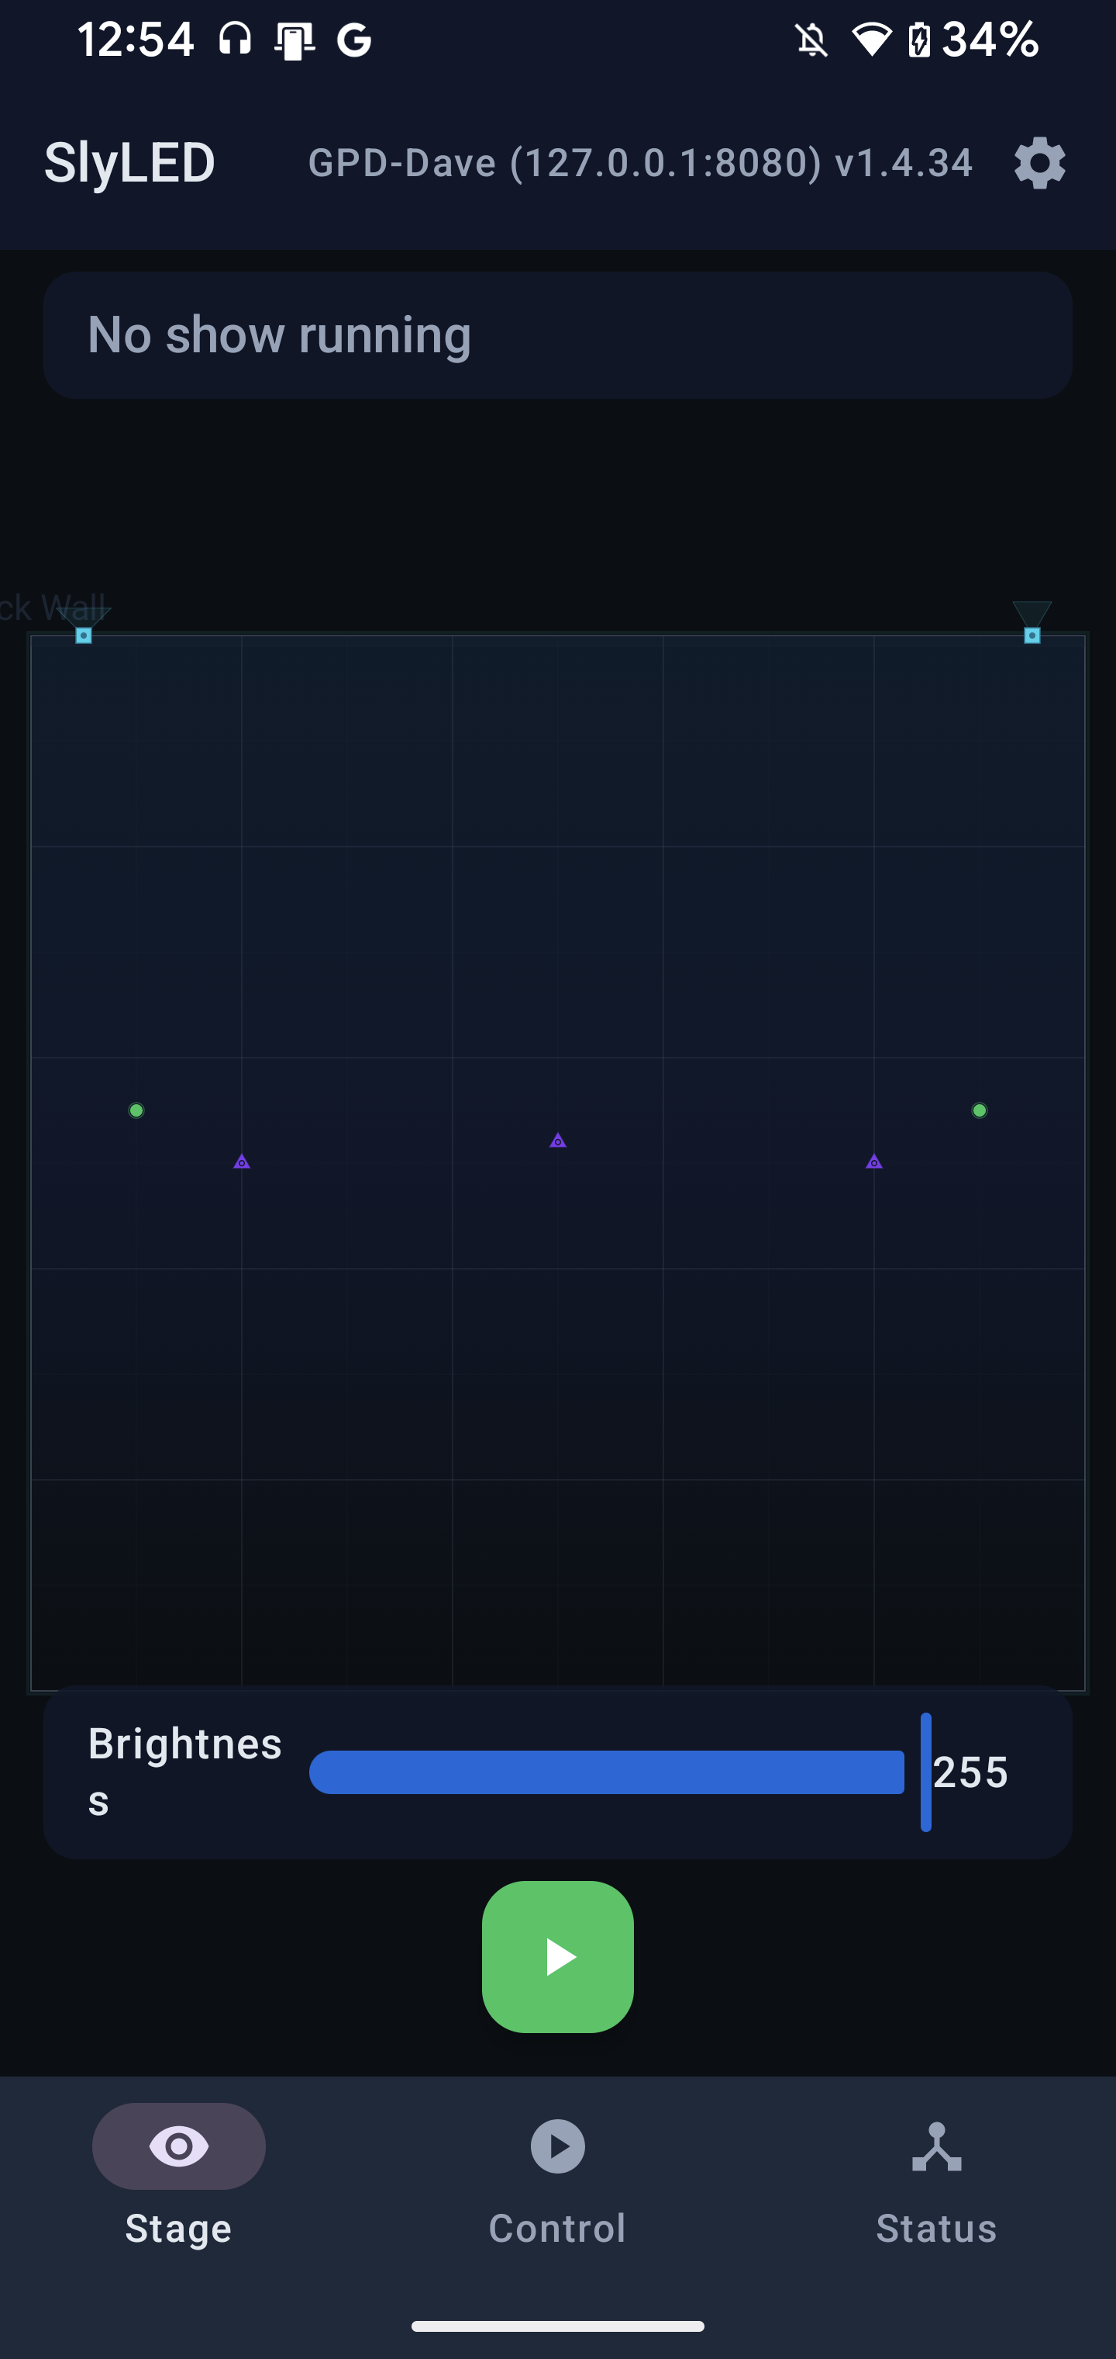
Android Stage View
Android Screens:
- Stage — live viewport showing all fixtures (LED, DMX, cameras) with beam cones, tracked object markers, and grid floor. Pinch-to-zoom and drag-to-pan. HUD shows current show status. Play/Stop button and brightness slider at bottom.
- Control — one-tap timeline start, playlist with loop toggle, global brightness slider, and Pointer Mode for aiming DMX moving heads with your phone's gyroscope.
- Status — device monitoring (performers online/offline, RSSI, firmware), camera nodes with Track button to start/stop person tracking, and Art-Net/DMX engine status.
- Settings — server name, stage dimensions, dark mode, config export/import, disconnect.
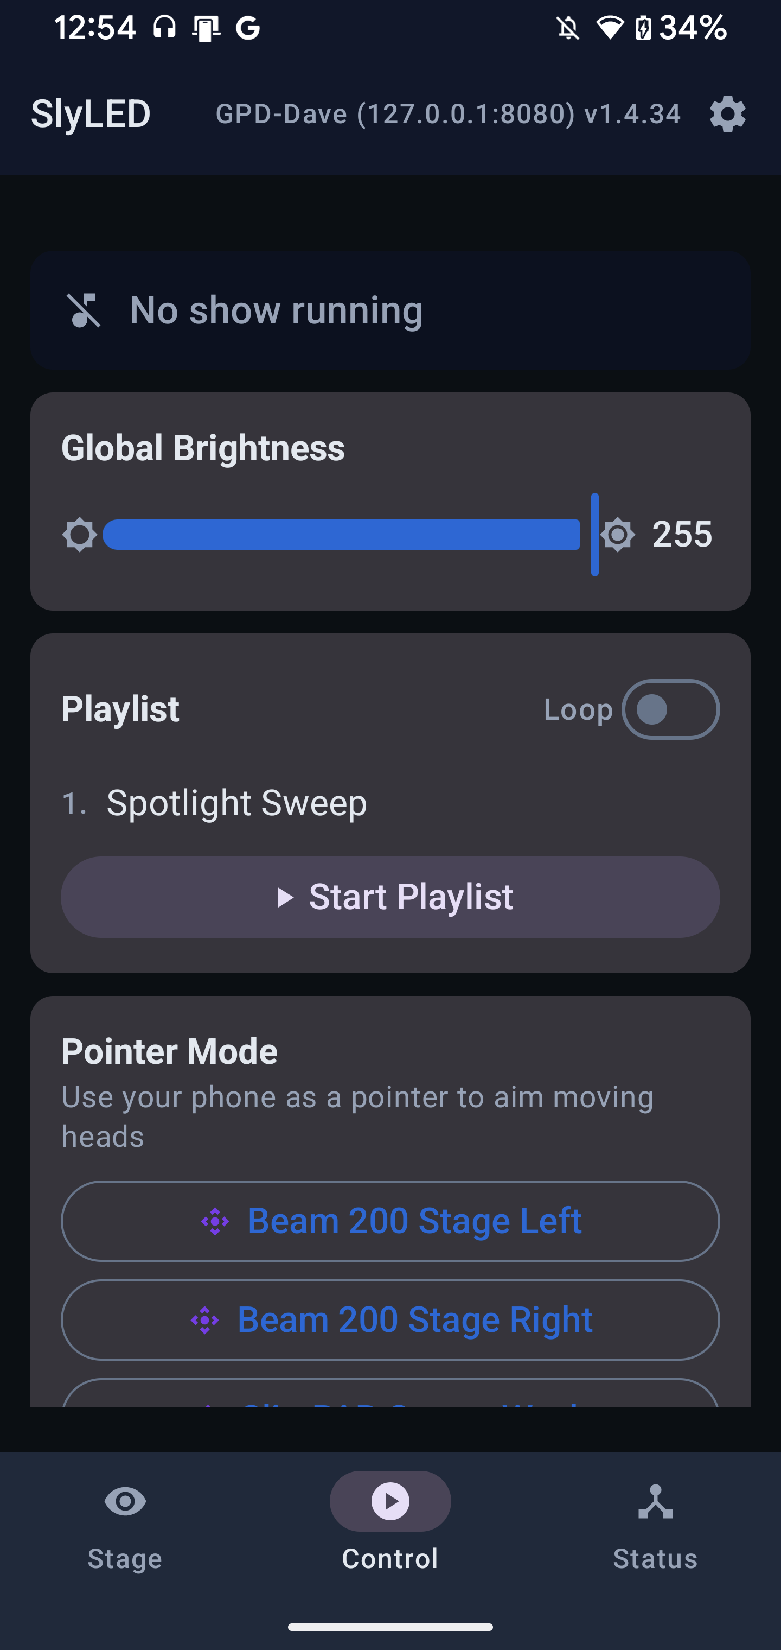
Android Control
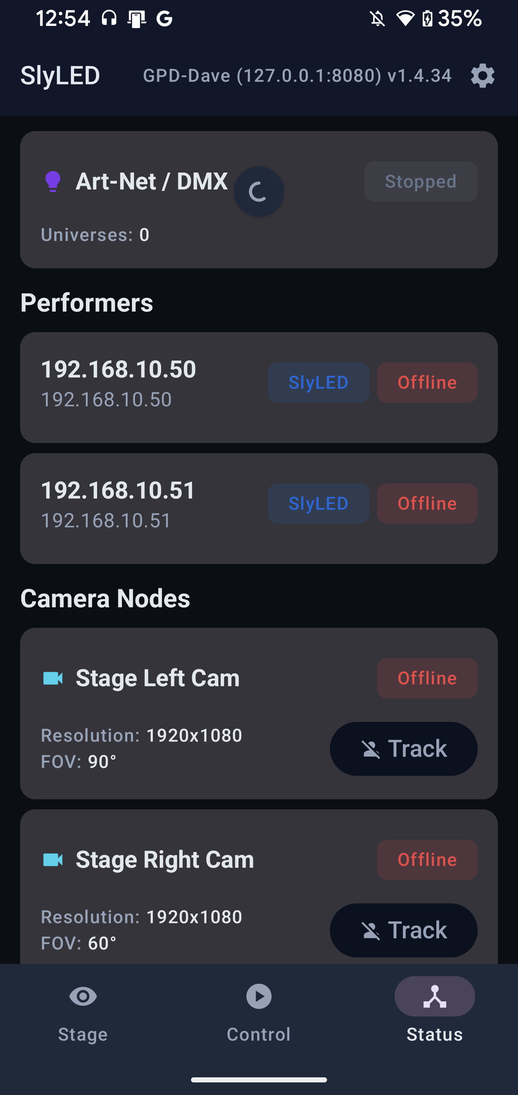
Android Status
Pointer Mode: Select a DMX moving head on the Control tab and tap its name under Pointer Mode. Hold your phone and point where you want the light — the fixture's pan/tilt follows your phone orientation in real-time at 20 Hz. Tap Recenter to calibrate, X to exit.

Firmware Config (ESP32/D1 Mini)
Each performer serves a 3-tab config page at http://<device-ip>/config:
- Dashboard — hostname, firmware version, active action status
- Settings — device name, description, string count
- Config — per-string LED count, length, direction, GPIO pin (ESP32)
────────────────────────────────────────

4. Fixture Setup

What Are Fixtures?
A fixture is the primary entity on the stage. It wraps physical hardware and adds stage-level attributes:
- LED fixtures — linked to a performer child, with LED strings
- DMX fixtures — linked to a DMX universe/address, with a profile and aim point

Adding LED Fixtures
- Go to Setup tab, click Discover to find performers
- Click Add Fixture → select "LED" type
- Link to a performer and configure strings (LED count, length, direction)

Adding DMX Fixtures (Wizard)
Click + DMX Fixture on the Setup tab to launch the 3-step wizard:
- Choose Fixture: Search the Open Fixture Library (700+ fixtures) or create a custom fixture
- Set Address: Universe, start address, and name — with real-time conflict detection
- Confirm: Review all settings, click "Create Fixture"

DMX Monitor
Settings → DMX → DMX Monitor opens a real-time 512-channel grid per universe. Click any cell to set a value. Color-coded by intensity.

Fixture Group Control
Settings → DMX → Group Control opens a control panel for fixture groups. Master dimmer slider, R/G/B sliders, and quick color preset buttons (Warm, Cool, Red, Off).

Testing DMX Channels
On the Setup tab, click Details on any DMX fixture to open the channel test panel:
- Sliders for every channel with live DMX output
- Quick buttons: All On, Blackout, White, Red, Green, Blue
- Capability labels show what each value range does (e.g., "Strobe slow→fast")
- Changes take effect immediately on the physical fixture via Art-Net/sACN

Fixture Types
Type | Description
Linear | LED strip. Pixels along a path.
Point | DMX light source with beam cone.
Group | Collection of fixtures targeted as one.
────────────────────────────────────────

5. Stage Layout

2D Canvas
The Layout tab shows a 2D front view of the stage. Stage dimensions (width × height) are set in Settings.
The layout toolbar provides: Save, 2D/3D mode toggle (shows current mode as text), Recenter, Top view, Front view, Auto-arrange DMX, Show/hide LED strings. Active toggles highlight in green.
Use the ?tab= URL parameter for deep-linking directly to any tab (e.g., ?tab=layout).
Action | Desktop | Android
Place fixture | Drag from sidebar | Tap fixture then tap canvas
Move fixture | Drag on canvas | Drag on canvas
Remove fixture | Double-click → Remove | Tap → Edit → Remove
Zoom | Scroll wheel | Pinch gesture
Pan | — | Two-finger drag
Edit coordinates | Double-click | Tap placed fixture
Edit object | Double-click | Tap object in list
What's rendered:
- Grid lines at 1-meter spacing
- Stage dimension labels
- LED fixtures: Green nodes with colored string lines (direction arrows)
- DMX fixtures: Purple nodes with beam cone triangles toward aim point
- Objects: Semi-transparent rectangles with name labels (clipped to stage)
- Aim dots: Red circles at DMX aim points

3D Viewport (Desktop Only)
Toggle to 3D mode for an interactive Three.js scene:
- Orbit camera with mouse drag
- Beam cones as 3D geometry
- Draggable aim spheres for DMX fixtures
- Object planes/boxes with transparency

Move / Rotate Mode
The layout canvas has two interaction modes, toggled with keyboard shortcuts or the toolbar button (which displays M or R to show the active mode):
Key | Mode | Description
M | Move | Drag any placed fixture to reposition it (default mode)
R | Rotate | Click a DMX fixture or camera fixture to show a compass ring; drag around the ring to aim the fixture
Rotate mode details:
- A compass ring appears around the selected fixture when you enter Rotate mode
- Drag clockwise or counter-clockwise to set the horizontal aim direction
- The beam cone updates in real-time as you drag
- In 3D viewport, Rotate mode activates Three.js TransformControls in rotate mode — drag the colored arcs to rotate on any axis
- Press Ctrl+Z to undo the last move or rotation
Typical workflow: Place all fixtures in Move mode, then switch to Rotate mode to aim DMX moving heads and cameras toward their intended focus areas before running calibration.

Coordinate System
- aimPoint[0] = X (horizontal position, mm)
- aimPoint[1] = Y (height from floor, mm) — used for 2D canvas vertical axis
- aimPoint[2] = Z (depth, mm) — used in 3D viewport only
- canvasW = stage width × 1000 (mm)
- canvasH = stage height × 1000 (mm)
────────────────────────────────────────

6. Stage Objects
Objects represent physical elements on the stage — walls, floors, trusses, screens, and props/performers.

Object Types
Type | Default Mobility | Description
Wall | Static | Back wall, stage-locked to stage width x height
Floor | Static | Stage floor, stage-locked to stage width x (depth + 1m)
Truss | Static | Lighting truss bar
Screen | Static | Projection surface
Prop | Moving | Performer, set piece, or mobile element
Custom | Moving | User-defined object

Stage-Locked Objects
Wall and floor objects can be locked to stage dimensions. When you change the stage size in Settings, locked objects automatically resize.

Mobility
- Static: Fixed position. Cannot be tracked by moving heads.
- Moving: Position can change at runtime. Trackable by DMX moving heads via Track action.

Patrol Motion
Moving objects can patrol (oscillate) back and forth during playback:
- Axis: Side-to-side (X), front-to-back (Z), or diagonal (X+Z)
- Speed presets: Slow (20s cycle), Medium (10s), Fast (5s), or Custom
- Range: Start/end percentage of stage dimension (default 10%--90%)
- Easing: Smooth (sine) or Linear
Patrol is evaluated at 40Hz in the DMX playback loop, before Track actions read object positions.

Temporal Objects
External systems can create short-lived objects via POST /api/objects/temporal:
- Always in-memory (never saved to disk)
- Require ttl > 0 (time-to-live in seconds)
- Auto-expire when TTL elapses
- Position updates refresh the TTL
- Shown in runtime viewer with dashed outline and countdown badge
- Useful for camera tracking integration
────────────────────────────────────────

7. Creating Spatial Effects

Spatial Effects vs Classic Actions
- Classic Actions (Solid, Chase, Rainbow, etc.): Run locally on each performer. Pattern based on pixel index. When assigned to DMX fixtures, classic actions are automatically converted to DMX Scene segments with appropriate dimmer, pan/tilt defaults.
- DMX Actions: Control DMX-specific features directly:
- DMX Scene — Set exact values for dimmer, pan, tilt, strobe, gobo, color wheel, prism
- Pan/Tilt Move — Animate pan/tilt from start to end position over time
- Gobo Select — Select a gobo wheel position
- Color Wheel — Select a color wheel position
- Track (Type 18) — Make moving heads follow moving objects in real-time (see Track Action)
- Spatial Effects: Operate in 3D space. A sphere of light sweeping across the stage illuminates different fixtures at different times.
SlyLED supports 19 action types in total: 14 classic LED actions plus 5 DMX/spatial actions (DMX Scene, Pan/Tilt Move, Gobo Select, Color Wheel, Track).

Creating a Spatial Effect
Navigate to Actions tab → + New Spatial Effect.
Field | Description
Shape | Sphere, Plane, or Box
Color | RGB color applied to pixels inside the field
Size | Radius (sphere), thickness (plane), or dimensions (box)
Motion Start/End | 3D positions in millimeters
Duration | Travel time from start to end
Easing | Linear, ease-in, ease-out, ease-in-out
Blend | Replace, Add, Multiply, Screen
────────────────────────────────────────

8. Track Action

Track Action (Type 18)
Makes DMX moving heads follow moving objects in real-time during playback.
How it works:
- Create moving objects (props/performers) on the Layout tab
- Create a Track action on the Actions tab
- Select target objects and configure assignment
- During playback, the 40Hz loop computes pan/tilt for each head
Assignment algorithm:
- Equal heads and objects: 1:1 mapping
- More heads than objects: Spread evenly across objects
- More objects than heads (cycling mode): Cycle through objects (default 2s per target)
- More objects than heads (fixed mode): Each head locks to one target, extras ignored
Fields:
Field | Description
trackObjectIds | Target object IDs (empty = all moving objects, including camera-detected people)
trackCycleMs | Cycle time when cycling (default 2000ms)
trackOffset | Global [x,y,z] offset in mm
trackFixtureIds | Specific fixture IDs (empty = all moving heads)
trackFixtureOffsets | Per-fixture [x,y,z] overrides
trackAutoSpread | Spread multiple heads across object width
trackFixedAssignment | Fixed 1:1 assignment — each head gets one target, extra targets ignored
────────────────────────────────────────

9. Building a Timeline
- Go to Runtime tab → + New Timeline
- Set name and duration
- + Add Track for each fixture (or "All Performers")
- + Add Clip to assign effects with start time and duration
- Clips can overlap — they blend according to their effect's blend mode
────────────────────────────────────────

10. Baking & Playback

Bake
Compiles a timeline into minimal action instructions per performer:
- Click Bake → progress shows frame count and segments
- Click Sync to push instructions to performers via UDP
- Click Start for synchronized NTP-timed playback

Output
- Action segments: Sequences of the 19 action types (14 classic + 5 DMX/spatial)
- LSQ files: Raw per-pixel RGB data at 40Hz (downloadable as ZIP)
- Preview data: 1 color per string per second for emulator
────────────────────────────────────────

11. Show Preview Emulator
Both desktop and Android include a real-time show preview:

Dashboard Preview
When a show is running, the Dashboard tab shows a live stage preview canvas alongside the performer status table and playback progress bar.

Desktop SPA
The emulator canvas appears on the Runtime tab below the timeline. Shows:
- LED fixtures: Colored dots along string paths with glow effects
- DMX fixtures: Beam cone triangles with preview-driven colors
- Aim dots: Red circles at aim points
- Fixture labels: Names below each node
- Time counter: MM:SS elapsed / total

Android App
The ShowEmulatorCanvas card shows:
- Same LED string dots and DMX beam cones as desktop
- Objects rendered as background rectangles
- Preview colors update every second during playback

Spatial Field Visualization
During show playback, the runtime emulator renders the active spatial effects moving across the stage:
- Sphere: translucent colored circle moving along the motion path
- Plane: translucent horizontal or vertical band sweeping across the stage
- Box: translucent rectangle at the effect's current position
- Effect names shown as labels at their current position
- Updates every frame, synced to playback elapsed time

DMX-Only Rigs
The emulator correctly renders DMX-only setups (no LED performers). Static purple beam cones always visible, with live colors when a show is running.
────────────────────────────────────────

12. DMX Fixture Profiles

Built-in Profiles
Profile | Channels | Features
Generic RGB | 3 | Red, Green, Blue
Generic RGBW | 5 | Red, Green, Blue, White, Dimmer
Generic Dimmer | 1 | Intensity only
Moving Head 16-bit | 16 | Pan, Tilt, Dimmer, Color, Gobo, Prism

Profile Editor — Step-by-Step (#527)
The fixture profile editor maps a DMX channel to what it does — this red channel here, that pan channel there — and records any behaviour the fixture firmware expects on each channel (gobo slot ranges, strobe rate curves, colour-wheel slots). Once a profile exists the whole orchestrator can drive that fixture with semantic calls like "set colour to red" or "aim at stage (1150, 2100)" instead of raw DMX.

1. Where to find it
Settings tab → Profiles sub-section. The list view shows every built-in and custom profile, filterable by category (par / wash / spot / moving-head / laser / effect). Each row has:
- Edit — opens the editor on the selected profile (disabled for
built-in profiles; clone first if you want to diverge from one).
- Clone — copy a built-in or community profile into your local
library under a new id; the copy is editable.
- Share — upload a custom profile to the community server
(requires an internet connection, rate-limited per IP).
- Delete — remove a custom profile (built-in profiles cannot be
deleted).
Click New Profile to start a fresh editor on a blank profile. You can also reach the editor from any DMX fixture card by clicking the profile name under the fixture's Edit Profile button.

2. Top-level fields
- Name — operator-visible label shown in fixture cards + the
profile picker.
- Manufacturer — free text; used for grouping in the Community
browser and for dedup matching.
- Category — par, wash, spot, moving-head, laser,
effect, other. Drives the preset-show generator.
- Channel count — total DMX slots the fixture uses. Auto-updated
as you add channels; can also be set explicitly.
- Colour mode — rgb, cmy, rgbw, rgba, single (monochrome
dimmer), or color-wheel-only. Drives how the show engine resolves a requested colour.
- Pan range / Tilt range — maximum mechanical sweep in
degrees. Used by mover calibration to normalise DMX→angle.
- Beam width — degrees of the beam cone. Used for 3D beam-cone
rendering and for marker-coverage prediction.

3. Channels
Every channel has:
- Offset — 0-based channel number within the fixture's address
range (not the universe). A 16-channel fixture has offsets 0..15.
- Name — operator-facing label. Matches the fixture's
documentation.
- Type — the semantic role. Common types:
pan, pan-fine, tilt, tilt-fine, dimmer, red, green, blue, white, amber, uv, color-wheel, gobo, prism, focus, zoom, frost, strobe, macro, reset. The type is what downstream code reads when it wants to control "the dimmer" — you can rename the channel but the type is the contract.
- Bits — 8 (one DMX slot) or 16 (two slots, coarse at this
offset + fine at offset+1). Use 16-bit for pan and tilt if the fixture supports it; everything else is typically 8-bit.
- Default — the value the engine writes when no effect is
overriding the channel. Leave blank for "set to 0 at idle." Use a non-zero default for channels the fixture needs lit to function (e.g. a lamp-on macro, shutter-open slot).

4. Capabilities
Each channel can carry a list of capabilities that describe what DMX value ranges mean to the fixture:
- WheelSlot — colour or gobo wheel position. Range [min, max],
label ("Red", "Open", "Pattern 3"), and — for colour wheels — an optional `color` hex like #FF0000. The orchestrator's RGB→slot resolver (used by show bake and mover calibration) picks the closest-matching slot by Euclidean distance in RGB space, so every colour-labelled slot needs the hex filled in. Without the hex the RGB pipeline silently falls through to slot 0 (white/open), which is the #624 footgun.
- WheelRotation — rotating-wheel range for cycle effects
("CW cycle fast-slow", "CCW cycle slow-fast").
- WheelShake — jitter ranges on gobo wheels.
- ShutterStrobe — a range with a shutterEffect of "Open",
"Closed", or "Strobe". The orchestrator's "open the shutter during calibration" helper walks these caps to find the right DMX value.
- Prism, PrismRotation, Effect, NoFunction — same
pattern: range, label, optional type-specific fields.
Each capability row lets you pick the type from a dropdown, set min/max, add a label, and (for WheelSlot on colour wheels) a colour hex swatch.

5. Saving + sharing
- Save persists the profile to desktop/shared/data/dmx_profiles/
(gitignored per-install) and updates the SPA list.
- Share to Community uploads the profile JSON to the electricrv.ca
server. The server dedups by channel-hash, so submitting a profile someone else already uploaded produces a "this fixture is already covered" response with a link to the existing entry.
- Export downloads every custom profile as a single JSON bundle.
Use this to transfer a profile library between installs without going through the community server.

6. When to create your own vs import from OFL
- Import from OFL first — 700+ fixtures are already there, and
importing is one click. The Open Fixture Library volunteers have spent years curating the capability lists.
- Clone and edit if the fixture is close to an OFL profile but a
channel or two differs (firmware update, mode variant).
- Create from scratch only when the fixture is genuinely not in
OFL and not in the community. When you're done, share it so nobody else has to.

Legacy quick-reference
Settings tab → Profiles → New Profile or Edit:
- Define channels with name, type (red/green/blue/dimmer/pan/tilt/etc.), default value
- Set beam width, pan/tilt range for moving heads
- Import from Open Fixture Library (OFL) JSON format

Browsing the Open Fixture Library
Click Search OFL in Settings → Profiles to access 700+ fixtures from the Open Fixture Library:
Search: Type a fixture name, manufacturer, or keyword → results show with Import buttons.
Browse by Manufacturer: Click Manufacturers to see all brands with fixture counts. Click a manufacturer to see all their fixtures. Click Import All to import every fixture from that manufacturer at once.
Bulk Import: From search results, click Import All to import all matching fixtures. From a manufacturer page, click Import All for the entire brand catalog.
Multi-mode fixtures create one SlyLED profile per mode automatically.

Community Fixture Library
Share and discover profiles with other SlyLED users:
- Browse: Click Community in Settings > Profiles to search, view recent, or popular
- Download: Click Download — imported to your local library immediately
- Share: Click Share on any custom profile to upload to the community
- Dedup: Server detects duplicates by channel fingerprint (same channels = same fixture)
- Unified search: When adding a DMX fixture, search queries Local + Community + OFL at once
Community server: https://electricrv.ca/api/profiles/

Import/Export
- Community: Share/download profiles with other users
- Search OFL: Browse, search, and bulk import from the Open Fixture Library
- Paste OFL: Paste raw OFL JSON for offline fixtures
- Import Bundle: Load previously exported profile pack
- Export: Download all custom profiles as JSON
- Built-in profiles cannot be edited or deleted
────────────────────────────────────────

13. Preset Shows
14 pre-built shows available from Runtime tab → Load Show → Presets:
Preset | Description
Rainbow Up | Rainbow plane rising floor to ceiling
Rainbow Across | Rainbow sphere sweeping left to right
Slow Fire | Warm fire effect on all fixtures
Disco | Pastel twinkle sparkles
Ocean Wave | Blue wave sweep with teal wash
Sunset Glow | Warm breathe with golden sweep
Police Lights | Red strobe with blue flash sweep
Starfield | White sparkles on dark background
Aurora Borealis | Green curtain with purple shimmer
Spotlight Sweep | Warm orb — moving heads track it
Concert Wash | Magenta flood + amber tracking spot
Figure Eight | Crossing orbs — heads trace X paths
Thunderstorm | Lightning strikes — heads chase bolts
Dance Floor | Fast orbiting spots — rapid tracking
────────────────────────────────────────

14. Camera Nodes
Camera nodes are Orange Pi or Raspberry Pi single-board computers with USB cameras. They provide live snapshots and AI-powered object detection for stage setup.
Note: Only USB cameras are supported. Pi CSI ribbon cameras (e.g. Pi Camera Module, Freenove FNK0056) are not supported in v1.x. Use USB webcams instead.

Adding a Camera Node
- Flash an Orange Pi with the supported OS image
- Connect it to the same WiFi network as the orchestrator
- In the Firmware tab, configure SSH credentials (default: root / orangepi)
- Click Scan for Boards to find the device on the network
- Click Install to deploy the camera firmware via SSH+SCP

Camera Config Page
Each camera node serves a local web interface at http://<camera-ip>:5000/config:
- Dashboard — board info, per-camera cards with live capture and detection
- Settings — device name, reboot, factory reset

Snapshots
Click Capture Frame on any camera card to take a JPEG snapshot. Uses OpenCV for fast capture with fswebcam fallback.

Object Detection
Click Detect Objects (purple button) to run YOLOv8n AI detection on the current camera frame:
- Bounding boxes with labels and confidence percentages are drawn on a canvas overlay
- Threshold slider (0.1–0.9) — filter by detection confidence
- Resolution (320/640) — lower is faster, higher is more accurate
- Auto checkbox — continuously detect every 3 seconds
- Typical latency: ~500ms capture + ~500ms inference on Orange Pi 4A
Detection requires the YOLOv8n ONNX model (models/yolov8n.onnx, 12 MB), which is uploaded automatically during firmware deployment.

Camera Deploy
The deploy process (from the Firmware tab) uploads all camera files via SCP:
- camera_server.py, detector.py, requirements.txt, slyled-cam.service
- models/yolov8n.onnx (detection model)
- Installs system packages (python3-opencv, python3-numpy, v4l-utils)
- Installs Python packages (flask, zeroconf, onnxruntime)
- Sets up the slyled-cam systemd service for auto-start on boot
- Shows version comparison and supports force-reinstall

Multi-Camera Support
Each node can host multiple USB cameras. The firmware auto-detects connected cameras and filters out internal SoC video nodes. Each camera gets its own card in the config page with independent capture and detection controls.

Environment Scanning
The Scan Environment button on the Layout toolbar captures a 3D point cloud of the physical space:
- Each positioned camera captures a frame and runs depth estimation
- Pixels are back-projected to 3D using camera FOV and depth
- Point clouds from all cameras are merged into stage coordinates
- Surface analysis identifies floor, walls, and obstacles (pillars, furniture)
- Detected surfaces can be automatically created as named stage objects
The point cloud can be viewed as colored dots in the 3D viewport (toggle with the point cloud button). This gives a visual map of the physical environment that the lights will illuminate.

Per-Camera Fixtures
Each USB camera sensor on a camera node registers as a separate fixture in the layout. A node with 2 cameras creates 2 fixtures, each with:
- Its own position on the stage (independently placeable)
- Its own FOV and resolution
- Its own rest direction vector (cyan arrow)

Tracking Configuration
Each camera fixture has per-camera tracking settings accessible from the Edit dialog on the Setup tab. These control what the camera detects and how it behaves during live tracking.
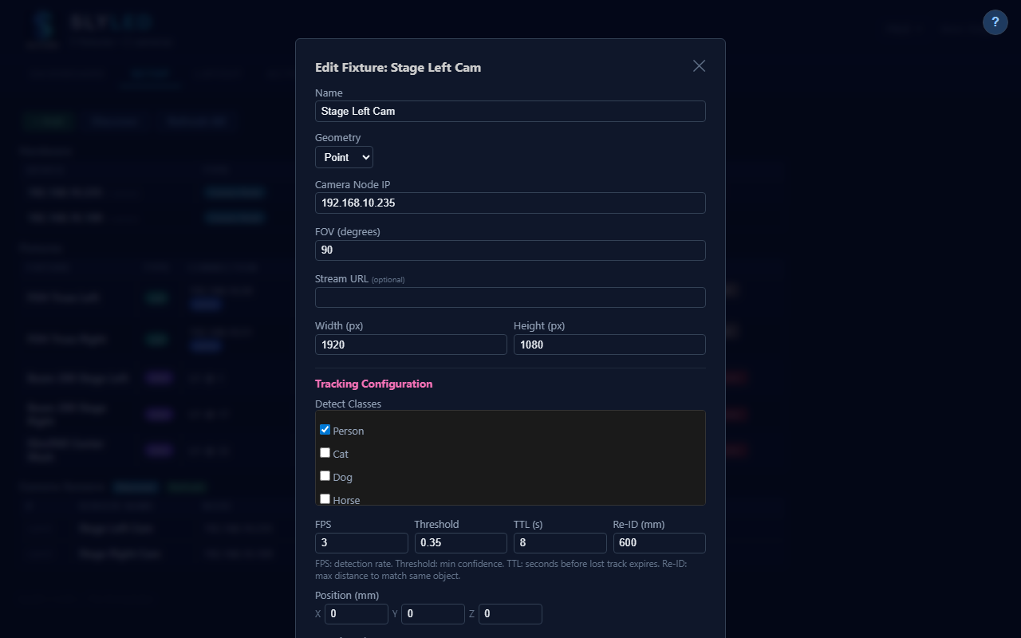
Camera edit with tracking config
Detect Classes — Multi-select the object types to track. The YOLOv8n model supports 80 COCO classes; 16 stage-relevant classes are available:
Category | Classes
People | Person
Animals | Cat, Dog, Horse
Props | Chair, Backpack, Suitcase, Sports Ball, Bottle, Cup, Umbrella, Teddy Bear
Vehicles | Bicycle, Skateboard, Car, Truck
By default only Person is selected. Adding more classes has zero performance impact — YOLO always evaluates all classes in one pass and filters afterward.
Parameters:
Parameter | Default | Range | Description
FPS | 2 | 0.5–10 | Detection frames per second. Higher = more responsive but more CPU on the camera node.
Threshold | 0.4 | 0.1–0.95 | Minimum confidence to accept a detection. Lower = more sensitive but more false positives.
TTL (s) | 5 | 1–60 | Seconds before a lost track expires and its stage marker is removed.
Re-ID (mm) | 500 | 50–5000 | Maximum distance to match a new detection to an existing tracked object.
Starting tracking: Click the Track button on the Setup tab (next to Snap) or in the fixture edit modal on the Layout tab. The camera node begins continuous detection using your configured classes and parameters. Detected objects appear as labeled markers in the 3D viewport.

Mover Calibration
The mover calibration wizard builds an interpolation grid that maps every stage position to the exact pan/tilt angles required for a DMX moving head. A positioned camera node is required.
Prerequisites:
- At least one camera node positioned on the Layout tab
- Art-Net engine running (POST /api/dmx/start)
- Moving head fixture placed on the layout with its profile configured
Starting calibration:
- Go to the Layout tab and double-click a DMX moving head fixture
- Click the Calibrate button in the fixture edit dialog
- Choose a beam color — options are Green, Magenta, Red, Blue (pick one that contrasts with your stage)
- Click Start Calibration — the wizard takes over automatically
What happens automatically:
- Discover — the head sweeps through a coarse pan/tilt grid; the camera detects where the beam lands on the stage floor
- Map visible region — the pan/tilt range that keeps the beam within the camera's field of view is identified
- Build interpolation grid — the head systematically samples points across the visible region; at each point the camera records the exact stage coordinates
Progress: A real-time progress panel shows the current phase, percentage complete, and a live thumbnail from the camera.
Result: The interpolation grid is saved to the fixture and used automatically by the Track action and any Pan/Tilt Move actions to convert stage-space coordinates into hardware pan/tilt values.
Tip: Run calibration in dim ambient lighting so the beam is clearly visible to the camera. Use the Beam Color option that gives the highest contrast against your floor surface.

Fixture Orientation Test
Before running full calibration, use the orientation test to confirm pan and tilt are wired in the expected directions. Incorrect orientation causes calibration to converge on wrong positions.
Running the test:
- Double-click a DMX moving head on the Layout tab to open the fixture edit dialog
- Click Orientation Test (below the channel map)
- The fixture moves through four probe positions: pan left, pan right, tilt up, tilt down
- Watch the physical beam and compare with the on-screen arrows showing expected direction
Interpreting results:
Observation | Action
Beam matches arrows | Orientation is correct — proceed to calibration
Pan moves opposite direction | Enable Invert Pan in the fixture settings
Tilt moves opposite direction | Enable Invert Tilt in the fixture settings
Pan and tilt axes are swapped | Enable Swap Pan/Tilt in the fixture settings
Saving: After adjusting orientation flags, click Save in the fixture edit dialog. The flags are stored with the fixture and applied automatically during all subsequent calibration and playback.
────────────────────────────────────────

15. Firmware & OTA Updates

USB Flash
- Go to Firmware tab
- Select COM port and firmware binary
- Click Flash — progress shows percentage

OTA (Over-the-Air)
- Set WiFi credentials on the Firmware tab
- Click Check for Updates — shows per-device version comparison
- Click Update on any outdated performer
- Device reboots automatically after flash

Firmware Registry
firmware/registry.json lists available binaries with board type and version. The OTA system compares the registry version against each performer's reported firmware.
────────────────────────────────────────

16. System Limits
Resource | Tested | Recommended Max
DMX fixtures | 120 | 500+
LED performers | 12 | 50
Total fixtures | 132 | 500+
Universes | 4 | 32,768 (Art-Net)
LEDs per string | 65535 | uint16 addressing
Strings per child | 8 | Protocol constant
Timeline clips | 50 | 200+
Preset shows | 14 | Built-in (expandable)
API response (132 fixtures) | < 1ms | Sub-millisecond
Memory (132 fixtures) | 46 MB | Flat scaling
Network (132 fixtures) | 221 KB | Per test cycle
See docs/STRESS_TEST.md for full benchmark data.
────────────────────────────────────────

17. Troubleshooting
Problem | Solution
Runtime view empty | Check fixtures are positioned in Layout. DMX-only rigs now render (v8.1 fix).
Beam cone wrong direction | aimPoint[1] is height (Y), not depth (Z). Check aim point values.
Android JSON crash | Update to v8.1 — aimPoint changed from Int to Double. Factory reset: now requires confirm header.
Save Show error | Update to v8.1 — /api/show/export endpoint was missing.
Firmware check fails | Update to v8.1 — registry.json UTF-8 BOM and dict iteration bugs fixed.
3D viewport not rendering | Use Chrome/Firefox/Edge with WebGL support.
Performers not syncing | Check all devices on same WiFi network. Refresh in Setup tab.
Canvas wrong size | Stage dimensions (Settings) drive canvas size: canvasW = stage.w × 1000.
────────────────────────────────────────

18. Examples

Example A: Camera Tracking — Moving Heads Follow a Person (#376)
Make DMX moving heads automatically follow people detected by a camera.
Prerequisites:
- At least one camera node online (Firmware tab → deploy + verify)
- At least one DMX moving head fixture placed on the Layout tab
- Moving head profile configured with pan/tilt range
- Art-Net/sACN engine running (Settings → DMX → Start)
- Mover calibration completed (see Example C) for accurate aiming
Steps:
- Verify hardware — Open the Setup tab. Confirm your movers show green status and camera nodes show online. If cameras are offline, check WiFi and deploy firmware from the Firmware tab.
- Start camera tracking — Click the Track button on the Setup tab (next to Snap), or go to the Layout tab, click a camera fixture, and click the Track button in the edit modal. The camera node begins running YOLO detection using the classes and parameters configured in the camera's tracking settings (see Tracking Configuration). Detected objects appear as labeled markers in the 3D viewport.
- Create a Track action — Go to the Actions tab. Click + New Action.
- Name: Person Follow
- Type: Track (last option in the dropdown)
- Colour: Pick the beam color (e.g. red for a spotlight)
- Leave Target Objects empty — this means "follow ALL detected people"
- Cycle Time: 2000 ms (how fast heads switch if cycling)
- Check Fixed assignment if you want strict 1:1 (head 1 = person 1, extras ignored)
- Click Save Action
- Create a timeline — Go to the Shows tab. Click + New Timeline, name it "Person Tracking", set duration to 600s, enable Loop. The timeline can be empty — Track actions evaluate globally during any playback.
- Start playback — Click Bake, then Start. The 40 Hz DMX playback loop begins. The Track action reads all moving temporal objects (detected people), computes pan/tilt for each head, sets dimmer and color, and sends Art-Net packets to the bridge.
- Test — Walk in front of the camera. Within 2 seconds a pink person marker appears in the 3D viewport. The moving heads should light up in your chosen color and aim at you.
Assignment behavior:
People in view | With 2 moving heads
1 person | Both heads aim at the same person
2 people | One head per person (1:1)
3+ people (cycling) | Heads cycle through people every 2s
3+ people (fixed) | First 2 tracked, 3rd ignored
Troubleshooting:
Problem | Solution
No person markers in 3D | Check camera node status — is tracking running? Try a manual Scan to verify detection works.
Person detected but heads don't move | Check Art-Net engine is running. Check mover calibration. Verify timeline playback is active.
Heads light up but aim at wrong position | Run mover calibration (Example C). Without calibration, the system uses geometric estimates which may be inaccurate.
Heads respond with delay | Normal — detection runs at 2 fps with ~1s capture latency. Temporal objects have 5s TTL.
────────────────────────────────────────

Example B: Mover Tracking with Spatial Effects (#379)
Make moving heads follow a virtual object sweeping across the stage — no camera required. This example walks through the complete workflow from stage setup to live 3D preview with animated beam cones.
Prerequisites:
- SlyLED orchestrator running (Windows or Mac)
- No physical hardware required — this example runs entirely in the emulator
Part 1 — Stage and Fixture Setup
- Set stage dimensions — Open the Settings tab. Under Stage, enter the dimensions of your performance area:
- Width: 6000 mm (6 m)
- Height: 3000 mm (3 m)
- Depth: 4000 mm (4 m)
- Click Save. The 3D viewport will resize to match these dimensions.
- Create a DMX profile — Go to Settings → Profiles → click New Profile. This defines the channel layout of your moving head:
- Name: Narrow Spot
- Beam Width: 8 (degrees — narrow beam for visible tracking)
- Pan Range: 540, Tilt Range: 270
- Channels: Add 6 channels in this order:
- Ch 0: Pan (16-bit) — pan coarse
- Ch 1: Pan Fine — pan fine (auto-linked)
- Ch 2: Tilt (16-bit) — tilt coarse
- Ch 3: Tilt Fine — tilt fine (auto-linked)
- Ch 4: Dimmer
- Ch 5: Red, Ch 6: Green, Ch 7: Blue
- Click Save Profile
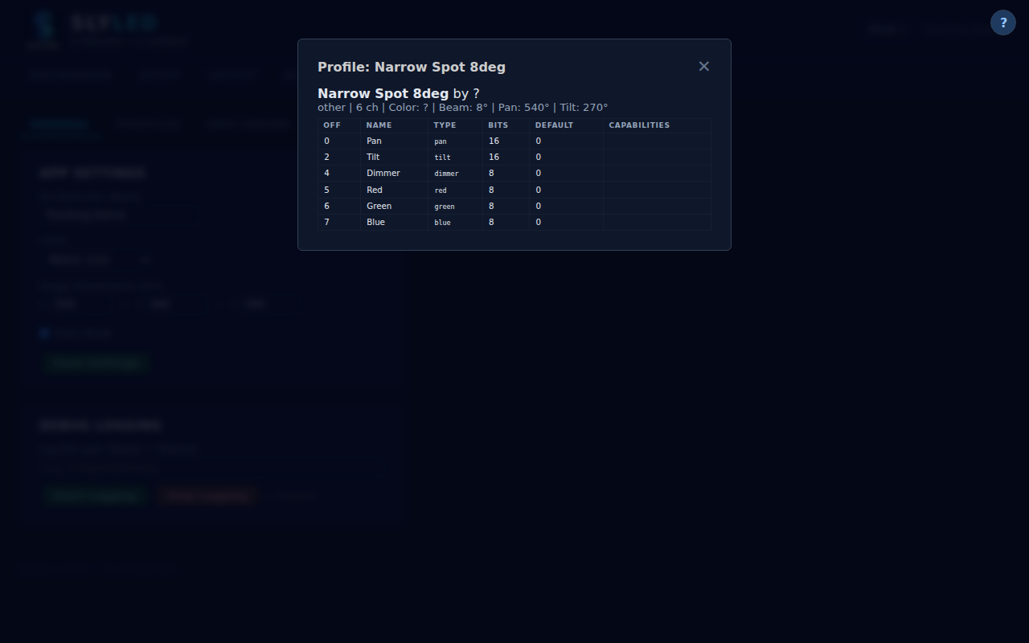
Profile editor with narrow spot configuration
- Add two movers — Go to the Setup tab. Click + Add Fixture twice to create two DMX moving heads:
- Fixture 1: Name: Mover SL (Stage Left), Universe: 1, Start Address: 1, Profile: Narrow Spot
- Fixture 2: Name: Mover SR (Stage Right), Universe: 1, Start Address: 14, Profile: Narrow Spot
Both fixtures appear in the Setup table with purple "DMX" badges and the profile name.
Part 2 — 3D Layout and Spatial Effect
- Position movers on the truss — Switch to the Layout tab. In the sidebar, you'll see both movers listed as "unplaced." Drag each one into the 3D viewport:
- Mover SL: Position at X: 1500, Y: 0, Z: 2800 (stage left, on truss). Set rotation to tilt: -30, pan: -15.
- Mover SR: Position at X: 4500, Y: 0, Z: 2800 (stage right, on truss). Set rotation to tilt: -30, pan: 15.
Switch to 3D view to confirm both movers are elevated on the truss and aimed downward toward the stage floor. The beam cones should be visible as translucent triangles.
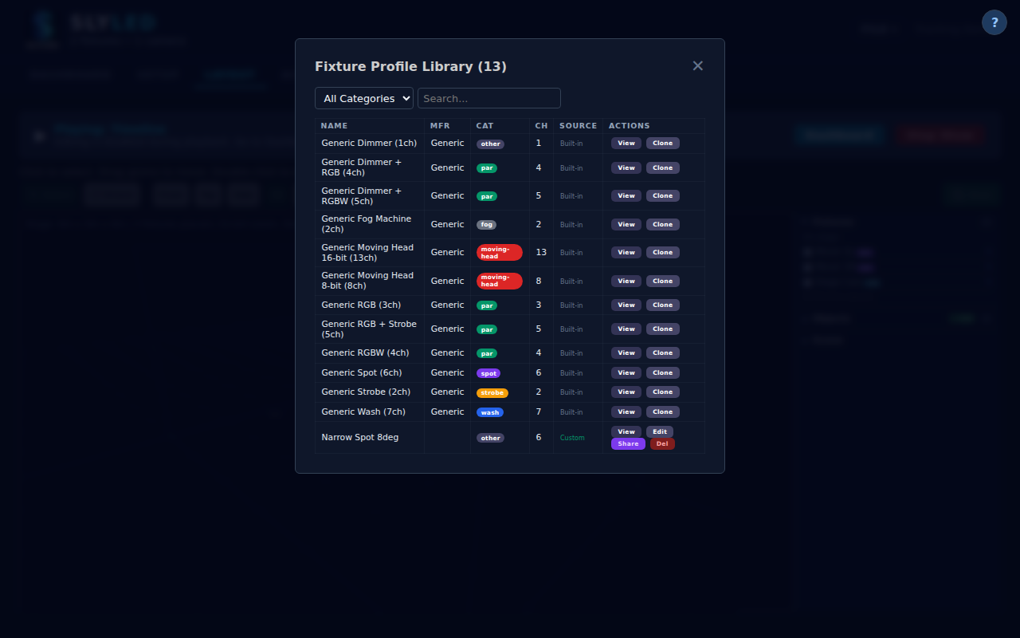
Layout tab — 3D view with two movers positioned on truss
- Create a spatial effect — Go to the Actions tab. Click + New Action:
- Name: Sweep Green
- Type: Spatial Effect
- Shape: Sphere
- Radius: 800 mm
- Color: Green (0, 255, 0)
- Motion Start: X: 1000, Y: 2000, Z: 0 (stage left, mid-depth, floor level)
- Motion End: X: 5000, Y: 2000, Z: 0 (stage right, same depth and height)
- Duration: 8 seconds
- Easing: Linear
- Click Save Action
This creates a green sphere of light that sweeps from stage left to stage right over 8 seconds. When applied to moving heads, they will track the sphere's center position.
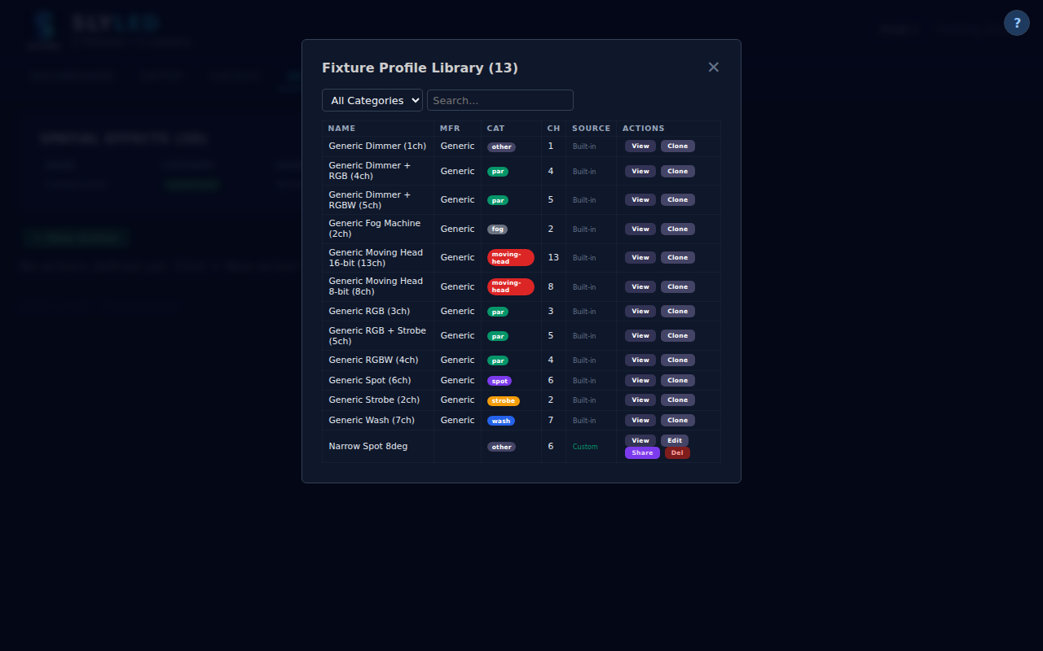
Actions tab with Sweep Green spatial effect configured
Part 3 — Timeline, Bake, and Playback
- Create a timeline — Go to the Shows tab. Click + New Timeline:
- Name: Mover Tracking Demo
- Duration: 20 seconds
- Loop: Enabled
- Add a track targeting All Performers
- Add a clip referencing the Sweep Green effect, starting at 0s with 8s duration
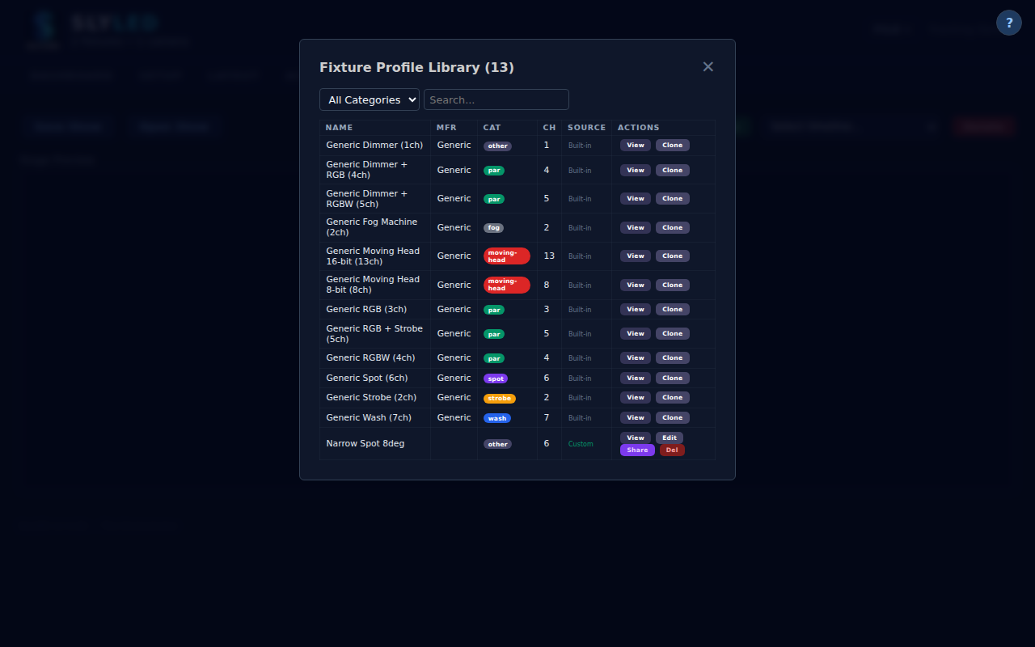
Shows tab with timeline containing the spatial effect clip
- Bake the timeline — Click the Bake button. The bake engine computes per-fixture pan/tilt angles for each time slice:
- For each 25ms frame, it calculates the sphere's position along the motion path
- For each mover, it computes the pan/tilt angles needed to aim at that position
- Dimmer is set to 255 and color channels are set to green
- Wait for "Bake complete" confirmation (typically < 1 second)
- Start playback and verify — Switch to the Runtime tab. Click Start:
- The 3D viewport shows both beam cones animated in real-time
- At T=0s, both beams aim at the starting position (stage left)
- As the effect sweeps, the beams track the green sphere across the stage
- At T=8s, both beams have followed the sphere to stage right
- The timeline loops, and the sweep restarts
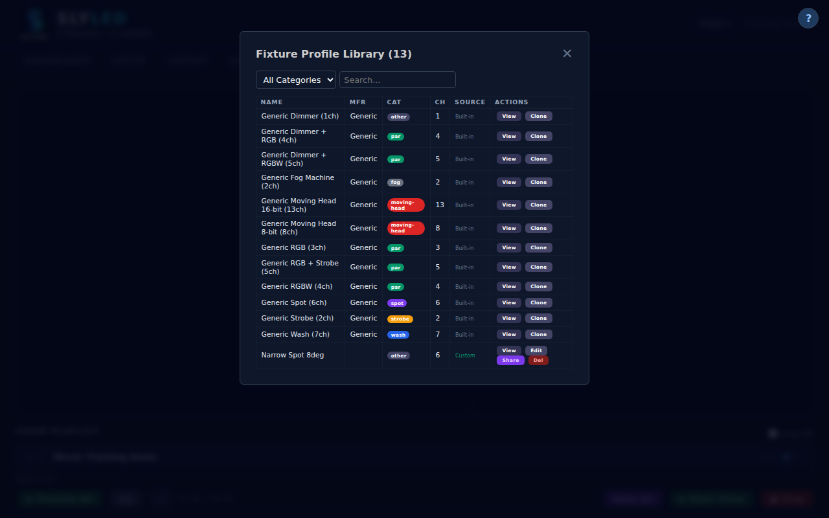
Runtime — beam cones at start position (T=0s)

Runtime — beams tracking mid-sweep (T=5s)

Runtime — beams at end position (T=10s)
What to look for:
- Both beam cones should be green (matching the effect color)
- The cones should move smoothly from left to right
- The beam intensity (opacity) should be > 0 during the sweep, indicating active output
- If beam cones don't appear, ensure fixtures are positioned in the Layout tab and the timeline is baked
Variations:
- Change the spatial effect shape to Plane for a wall of light sweeping across
- Add a second effect on a separate track with different timing for crossing patterns
- Try the Figure Eight preset show (Runtime → Load Show) for a ready-made crossing pattern
────────────────────────────────────────

Example C: Manual Mover Calibration (#381)
Calibrate a moving head so the system knows exactly where its beam lands for any pan/tilt position. This two-part process first discovers the beam's visible range (pan/tilt grid) and then builds a light map that maps every pan/tilt position to real stage coordinates.
Prerequisites:
- At least one camera node online and positioned on the Layout tab
- Camera calibration complete — the camera must have a valid stage map (see Example D)
- Moving head fixture added in Setup and positioned on the Layout tab
- Art-Net/sACN engine running (Settings → DMX → Start)
- Dim ambient lighting — the beam must be clearly visible to the camera against the floor
- The beam should be aimed at the floor within the camera's field of view, not directly at the camera
Part 1 — Pan/Tilt Discovery and Grid Calibration
- Open the calibration panel — Go to the Layout tab. Double-click the moving head fixture you want to calibrate. In the edit dialog, click the Calibrate button. The calibration wizard opens showing the fixture name, current calibration status (if any), and available calibration modes.
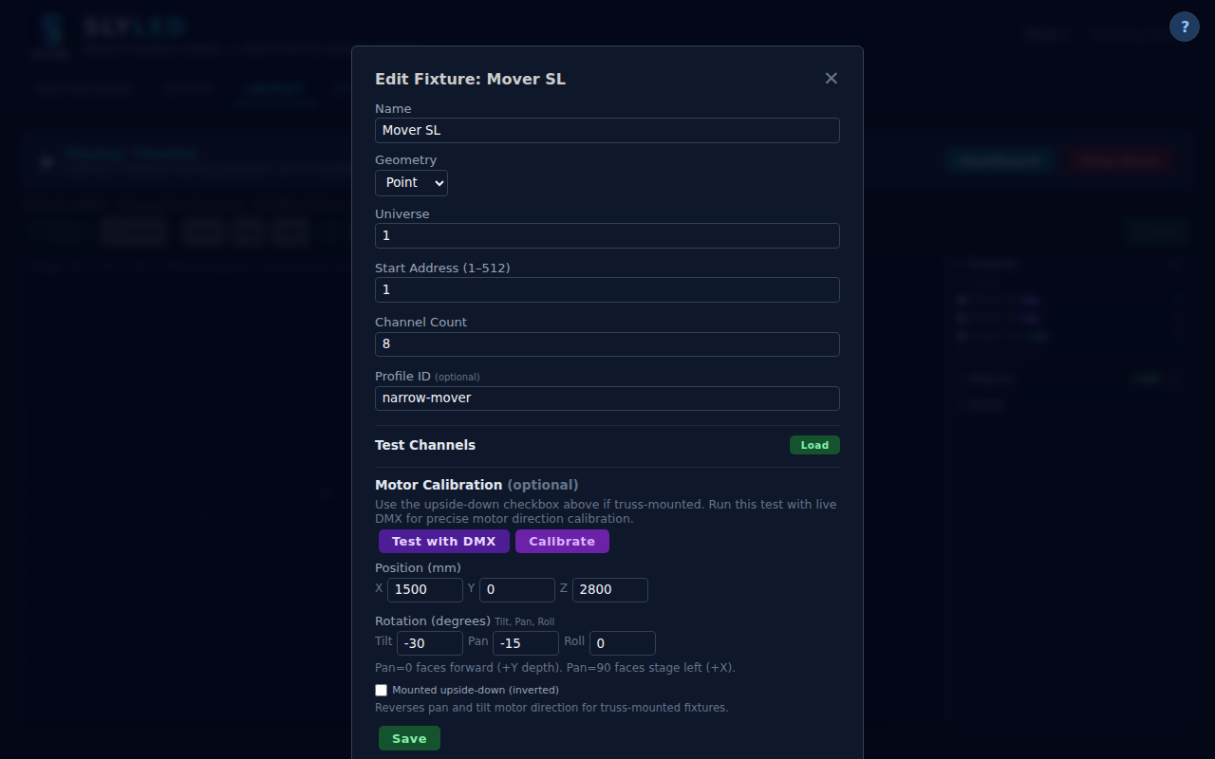
Calibration panel before starting — shows fixture name and calibration options
- Choose beam color — Select a color that contrasts well with your floor surface:
- Green works best on dark floors (wood, dark carpet)
- Magenta works best on light floors (white, concrete)
- Red or Blue are alternatives if the default choices blend with your environment
- The color matters because the camera uses color filtering to isolate the beam from ambient light
- Run discovery — Click Start Calibration. The system runs an automatic discovery sequence:
- Phase 1 — Coarse grid scan: The fixture sweeps through ~40 pan/tilt positions (8 columns x 5 rows) across its full range. The camera watches for the beam appearing on the floor after each move.
- Phase 2 — Fine refinement: Once the beam is found, the system spirals outward from that position to refine the exact center of the visible region.
- Discovery typically completes in 30-60 seconds. The progress indicator shows "Discovering..." with the current scan position.

Discovery in progress — coarse grid scan with camera watching for beam
- BFS mapping — After discovery, the system automatically maps the full visible region:
- Starting from the discovered beam position, it steps in 4 directions (up/down/left/right in pan/tilt space)
- At each position, the camera captures a frame and detects the beam centroid
- The system records the beam's pixel position and converts it to stage millimeters using the camera's homography
- Mapping stops at boundaries where the beam leaves the camera's field of view or falls off the stage
- Collects up to 60 sample positions, typically completing in 2-3 minutes
- The system uses adaptive settle times (0.8-2.5s) per move and double-capture verification to ensure the beam has stopped before recording
- Grid build and review — The collected samples are compiled into a bilinear interpolation grid:
- The calibration summary displays:
- Sample count: Number of successfully detected positions (aim for 30+)
- Pan range: Normalized range (e.g., 0.15-0.85 means the beam is visible across 70% of pan range)
- Tilt range: Normalized range
- Grid density: How finely the grid was sampled
- The grid enables fast forward lookup: given a (pan, tilt) value, compute the stage (X, Y) where the beam lands

Grid calibration complete — summary showing sample count, pan/tilt range, and grid density
Part 2 — Light Map Calibration (stage coordinates to pan/tilt lookup)
- Build the light map — Click Build Light Map. This extends the calibration by sweeping a systematic 20x15 grid across the discovered visible region:
- For each grid position, the fixture moves to the pan/tilt value
- The camera detects the beam and records the exact stage X/Y/Z where it lands
- This builds a comprehensive (pan, tilt) → (stageX, stageY, stageZ) lookup table
- Progress shows as "Building light map... N/300" with real-time updates
- Typical completion time: 5-10 minutes for a full 20x15 grid

Light map build in progress — systematic sweep with stage coordinate mapping
- Verify inverse lookup — After the light map is built, use the Aim button to test the inverse mapping:
- Enter a target stage position (e.g., center stage: X=3000, Y=2000, Z=0)
- Click Aim — the system uses inverse-distance weighted interpolation of the 4 nearest light map samples to compute the exact pan/tilt values
- The fixture moves to the computed position
- Verify visually that the beam lands on (or very near) the target point on stage
- Try 3-4 different targets across the stage to confirm accuracy
- Good calibration should place the beam within 100-200mm of the target at typical stage distances

Aim verification — beam aimed at target stage position using calibrated light map
- Save calibration — Calibration data is automatically saved with the fixture. The light map and grid data persist across sessions and are included in project file exports (.slyshow).
- Track actions use the light map to aim at detected people
- Pan/Tilt Move actions use it for smooth interpolated sweeps
- The 3D viewport uses it to render accurate beam cone directions
Manual calibration (alternative — no camera required):
If automated calibration isn't available (no camera, or camera can't see the beam), use the manual calibration wizard:
- Layout tab → double-click mover → click Manual Calibrate
- Define marker positions — Add 4-6 physical markers at known stage positions. Enter each marker's X, Y, Z coordinates (in mm). Spread markers across the stage: front-left, front-right, back-center at minimum.
- Jog to each marker — For each marker, use the pan/tilt sliders to manually aim the beam until it lands exactly on the physical marker. Click Record to save the (pan, tilt) → (stageX, stageY, stageZ) sample.
- Add at least 4 samples spread across the stage for a good affine fit. More samples (6+) improve accuracy, especially at stage edges.
- Click Compute — the system fits a 3D affine transform from your samples:
- pan = a1*stageX + b1*stageY + c1*stageZ + d1
- tilt = a2*stageX + b2*stageY + c2*stageZ + d2
- The affine transform extrapolates beyond calibrated points for full-stage coverage
When to re-calibrate:
- Fixture physically moved to a new position or angle
- Venue change (different stage dimensions or floor surface)
- After firmware update that changes pan/tilt range or motor behavior
- If aim accuracy degrades over time (motor drift)
- After changing the fixture's mounting orientation (upright vs. inverted)
────────────────────────────────────────

Example D: Camera Calibration with ArUco Markers (#380)
Calibrate a camera so pixel coordinates can be mapped to real stage positions. This is a prerequisite for beam detection, person tracking, and mover calibration — without it, the system cannot convert what the camera sees into real-world stage millimeters.
Prerequisites:
- Camera node online and reachable on the network (deploy firmware from the Firmware tab if needed)
- Camera fixture registered in the system (Setup tab → Discover, or Settings → Cameras → add manually)
- Camera fixture placed on the Layout tab at its physical position
- A printer to print the ArUco marker sheet (standard A4/Letter paper)
- A tape measure to record marker positions on stage
- The camera must have a clear view of the stage floor where markers will be placed
Part 1 — Prepare and Place ArUco Markers
- Print ArUco markers — Go to Settings → Cameras. Click the Print ArUco Markers button. A modal opens with 6 printable ArUco 4x4 markers (IDs 0-5), each 150mm x 150mm:
- Click Download or use the browser's print dialog to print the marker sheet
- Print at 100% scale (no scaling/fit-to-page) — the physical size must match the expected 150mm for accurate calibration
- Markers can be printed on regular white paper, but card stock is more durable
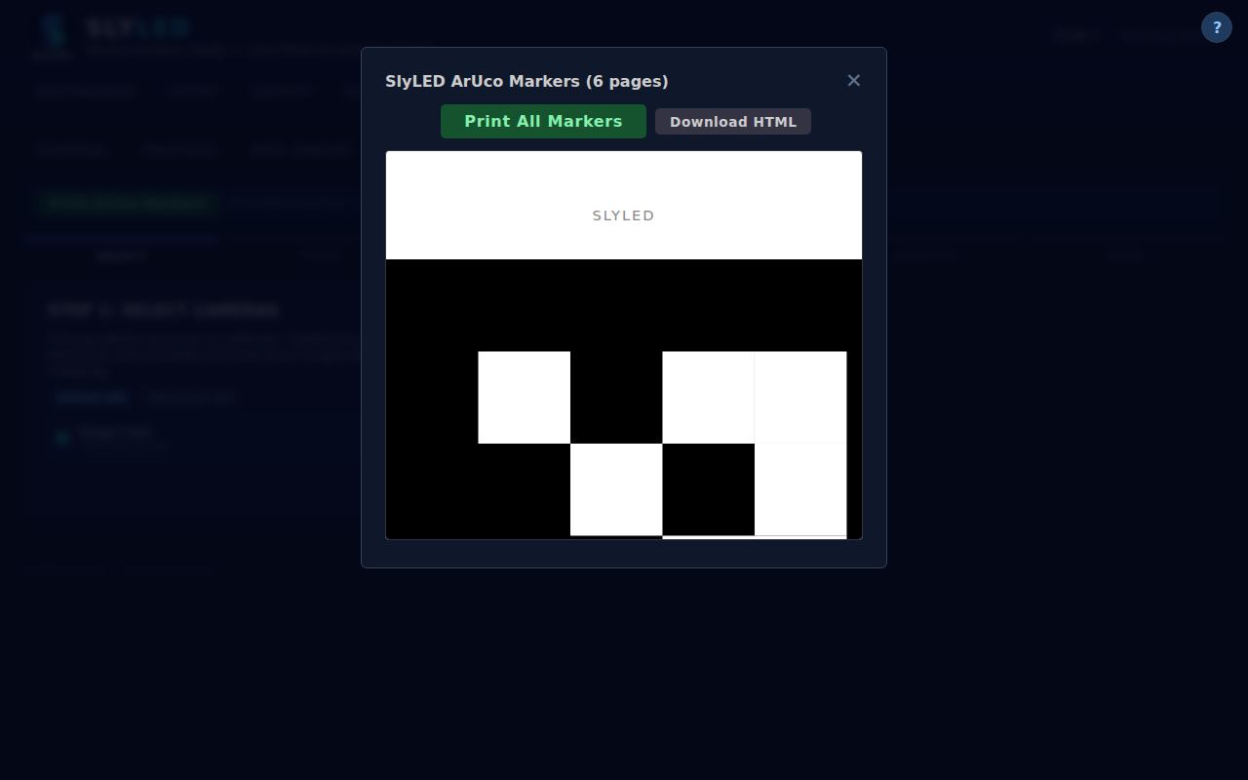
ArUco marker print dialog — 6 markers ready to print
- Place markers on the stage floor — Position the printed markers at known locations on the stage:
- Minimum: 3 markers (enough for a basic homography)
- Recommended: 4-6 markers for better accuracy
- Placement strategy:
- Spread markers across the entire camera's field of view
- Place at least one marker near each corner of the visible area
- Place markers flat on the floor — tilted markers reduce accuracy
- Measure each marker's position from the stage origin (back-right corner at floor level):
- X = distance from stage right (mm)
- Y = distance from back wall (mm)
- Z = 0 (floor level)
- Record the marker ID and its (X, Y) coordinates — you'll enter these in step 5
Part 2 — Register and Position the Camera
- Register the camera — If the camera node is not already registered:
- Go to the Setup tab and click Discover — camera nodes respond to UDP broadcast
- Or go to Settings → Cameras → enter the camera's IP address manually
- Each USB camera sensor on the node appears as a separate fixture
- Verify the camera is online: its status should show "Online" with a green indicator
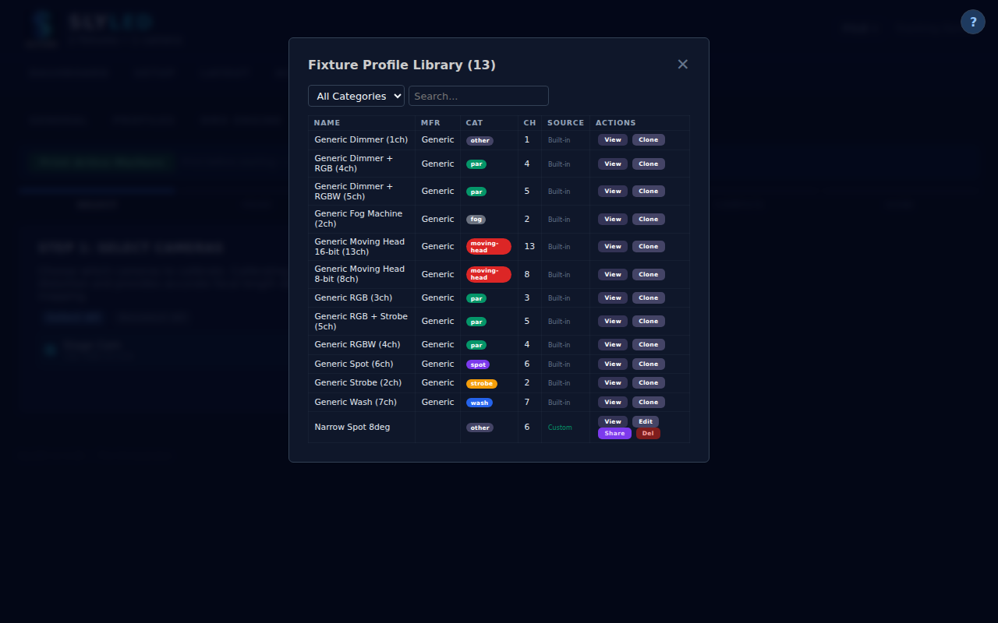
Camera configuration panel in Settings — camera list with IP, status, and calibration badges
- Position the camera in 3D — Switch to the Layout tab:
- Find the camera fixture in the sidebar (listed as "unplaced" if new)
- Drag it into the 3D viewport at the camera's real physical position
- Set the rotation to match the camera's actual aim direction:
- A camera mounted on a wall at 2m height, aimed down at 30 degrees would have rotation Z=2000, tilt=-30
- In 3D view, the camera appears as a frustum (pyramid) showing its field of view
- Verify the frustum covers the area where you placed the ArUco markers
Part 3 — Run Calibration and Verify
- Run ArUco calibration — In the Layout tab, click on the camera fixture to select it. Click the Calibrate button:
- The wizard opens and fetches a live snapshot from the camera
- The system automatically detects all visible ArUco markers and highlights them with green overlays
- For each detected marker:
- The marker ID is shown on the overlay
- Enter the marker's real-world stage coordinates (X, Y in mm) that you measured in step 2
- Click Record to save the pixel-to-stage mapping for this marker
- After recording all markers, click Compute — the system builds a homography matrix that maps any pixel coordinate to stage floor coordinates

Camera snapshot with ArUco markers detected — green overlays showing marker IDs
- Review calibration results — The calibration summary shows:
- Reprojection error: How accurately the computed homography matches the recorded points. Lower is better:
- < 10mm: Excellent — suitable for precision tracking
- 10-20mm: Good — adequate for most use cases
- 20-50mm: Fair — consider adding more markers or re-measuring positions
- > 50mm: Poor — re-check marker measurements and try again
- Reference points: Number of markers used (should match what you recorded)
- Coverage area: The stage area covered by the calibration (larger is better)

Calibration complete — reprojection error, reference points, and coverage summary
- Save and apply — Click Save to persist the calibration:
- The camera fixture badge updates to show a green "Cal" checkmark
- All features that depend on pixel-to-stage conversion now use this calibration:
- Person tracking: Detected bounding boxes are converted to stage positions
- Beam detection: Beam centroids become stage coordinates for mover calibration
- Mover calibration: The entire mover calibration wizard (Example C) requires this
- Calibration data is included in project file exports (.slyshow) for portability
Tips for accurate calibration:
- Marker size matters: Use the 150mm markers at standard print size. Smaller markers are harder to detect at distance.
- Flat placement is critical: Even a slight tilt (marker on a crumpled surface) can shift the detected center by 10-20mm.
- Cover the edges: The homography is most accurate within the convex hull of your reference markers. Place markers at the extremes of the camera's view, not just the center.
- Lighting conditions: ArUco detection works in most lighting, but avoid direct glare on the printed markers (glossy paper under bright lights).
- Re-calibrate when:
- The camera is physically moved (even slightly)
- The camera lens is changed or zoom is adjusted
- Stage dimensions change (markers would be at different positions)
- Accuracy of tracking or beam detection degrades
────────────────────────────────────────

Example E: Spotlight Follow Person — Live Tracking Preset (#382)
Use the built-in Spotlight: Follow Person preset to make moving heads automatically follow people detected by a camera in real-time.
Prerequisites:
- At least one camera node online with person detection working (verify with a manual Scan first)
- At least one DMX moving head fixture placed on the Layout tab
- Camera calibration complete (see Example D) for accurate stage positioning
- Mover calibration complete (see Example C) for accurate pan/tilt aiming
- Art-Net/sACN engine running
Steps:
- Load the preset — Go to the Runtime tab. Click Load Show (or the preset dropdown). Select Spotlight: Follow Person from the preset list.
- If no camera node is registered, a warning appears: "No camera node registered — person detection will not work"
- If no moving heads are configured, a warning appears about missing movers
- The preset loads even with warnings — you can add the missing hardware later
- What it creates — The preset automatically configures:
- A Track action (type 18) on every available moving head, targeting objectType: "person"
- A warm spotlight color (255, 240, 200) at full dimmer for the beam
- A dim blue ambient wash (10, 5, 30) on all LED fixtures for atmospheric framing
- A 10-minute looping timeline that keeps the DMX playback loop running
- Start camera tracking — Click the Track button on the Setup tab or in the camera fixture edit modal. The camera node begins running detection using the configured tracking classes and parameters (see Tracking Configuration). Detected objects appear as labeled markers in the 3D viewport.
- Start playback — Click Bake, then Start. The 40 Hz DMX playback loop begins. The Track action reads all temporal person objects and computes pan/tilt for each head in real-time.
- Walk on stage — Within 2 seconds of entering the camera's view, a pink person marker appears. Moving heads light up with the warm spotlight color and aim at you. As you move, the beams follow.
Behavior with multiple people:
- 1 person, 2 heads: Both heads aim at the same person
- 2 people, 2 heads: One head per person (auto-spread)
- 3+ people, 2 heads: Heads cycle through people every 2 seconds
When no one is detected:
- Heads dim to 0 (blackout) and hold their last position
- As soon as a person is detected again, heads immediately re-aim and light up
Tips:
- Use a narrow beam profile (8-15 degrees) for a dramatic spotlight effect
- Ensure the room is dim enough for the camera to distinguish the beam from ambient light
- If tracking seems jittery, increase the camera's capture FPS or reduce the confidence threshold
- The Track action works alongside other timeline effects — you can add spatial color washes on lower-priority tracks
────────────────────────────────────────

19. API Quick Reference

Stage & Layout
Method | Endpoint | Description
GET/POST | /api/layout | Layout with fixtures and positions
GET/POST | /api/stage | Stage dimensions (w, h, d meters)
GET/POST | /api/objects | Stage objects (walls, floors, trusses, props)
POST | /api/objects/temporal | Create temporal objects (TTL-based)

Fixtures
Method | Endpoint | Description
GET/POST | /api/fixtures | List / create
GET/PUT/DELETE | /api/fixtures/:id | CRUD
PUT | /api/fixtures/:id/aim | Set aim point

Shows & Timelines
Method | Endpoint | Description
GET/POST | /api/timelines | List / create
POST | /api/timelines/:id/bake | Start baking
POST | /api/timelines/:id/start | Start playback
GET | /api/show/presets | List preset shows
GET/POST | /api/show/export, /api/show/import | Save/load show file

DMX
Method | Endpoint | Description
GET | /api/dmx-profiles | List profiles
GET | /api/dmx/patch | Universe address map
POST | /api/dmx/start, /api/dmx/stop | Engine control

Cameras
Method | Endpoint | Description
GET | /api/cameras | List registered camera fixtures
POST | /api/cameras | Register a camera node as fixture
DELETE | /api/cameras/:id | Remove camera fixture
GET | /api/cameras/:id/snapshot | Proxy JPEG snapshot
GET | /api/cameras/:id/status | Live status from camera node
POST | /api/cameras/:id/scan | Object detection (proxy to node /scan)
GET | /api/cameras/discover | Find camera nodes on network
GET/POST | /api/cameras/ssh | SSH credentials for deployment
POST | /api/cameras/deploy | Deploy firmware to camera node via SSH+SCP
GET | /api/cameras/deploy/status | Poll deploy progress

Camera Node Local API (port 5000)
Method | Endpoint | Description
GET | /status | Node status, capabilities, camera list
GET | /config | HTML config page with detection UI
GET | /snapshot?cam=N | JPEG snapshot from camera N
POST | /scan | Object detection (JSON: cam, threshold, resolution, classes)
GET | /health | Health check
────────────────────────────────────────

20. Glossary
SlyLED touches lighting, networking, computer vision, and embedded firmware — which means a lot of acronyms and jargon. This section expands every acronym used elsewhere in the manual and defines the domain terms that don't have a literal expansion ("baking", "universe", "blink-confirm", etc.).
Entries are alphabetised on the Term column. For acronyms that cluster around a common concept (e.g. RX / RY / RZ) the cluster appears under the first member.
Term | Expansion | Plain-language definition | Where it shows up
API | Application Programming Interface | The set of HTTP endpoints a program exposes for other programs to call. | §19 API Quick Reference; /api/* routes throughout.
ARM | Advanced RISC Machine | CPU architecture used by the Giga R1, Raspberry Pi, and Orange Pi. "Slow on ARM" in the manual means these boards. | §14 Camera Nodes (depth-estimation runtimes).
Art-Net | — | DMX-over-Ethernet protocol by Artistic Licence. The orchestrator sends ArtDMX packets to an Art-Net bridge, which relays them to DMX fixtures. | §2 Walkthrough Step 3b; §12 DMX Profiles.
ArtDMX | Art-Net DMX packet | One 512-channel Art-Net data packet. | §2 Walkthrough Step 3b.
ArtPoll | Art-Net discovery packet | The Art-Net discovery broadcast used to find bridges. | §2 Walkthrough Step 3a.
baking | — | Compiling a timeline into a pre-computed DMX scene stream so playback doesn't need to recompute effects on every frame. | §10 Baking & Playback.
battleship search | — | Calibration-discovery strategy that probes a coarse grid across the full pan/tilt range before refining — faster than a dense scan when the beam's reachable region is small. | Appendix B §B.3 Discovery.
BFS | Breadth-First Search | Graph-traversal algorithm that explores outward from a seed point one ring at a time. Used in mover calibration to map the visible-region boundary from a first detected beam position. | Appendix B §B.3 Mapping.
blink-confirm | — | Reflection-rejection check: after detecting a candidate beam pixel, nudge pan and tilt slightly and verify the detected pixel actually moves. A reflection stays put; a real beam moves. | Appendix B §B.3; issue #658.
CPU | Central Processing Unit | The main processor. | §14 Camera Nodes.
CRGB | Color RGB | FastLED's C++ struct for a single RGB pixel. | Firmware modules (GigaLED.h).
CRUD | Create, Read, Update, Delete | Shorthand for "all four basic database-style operations." | §4 Fixture Setup; §12 DMX Profiles.
CSI | Camera Serial Interface | Raspberry Pi's native ribbon-cable camera port (not supported in SlyLED v1.x — use USB cameras). | §14 Camera Nodes.
dark reference | — | Snapshot captured with all calibration beams off, subtracted from subsequent frames so beam detection isn't fooled by ambient lighting. | Appendix A §A.5; issue #651.
DHCP | Dynamic Host Configuration Protocol | How devices on a network get an IP address. The board's hostname shows up in DHCP so routers list it by name. | §14 Camera Nodes deployment.
DMX | Digital Multiplex | Industry-standard lighting-control protocol — 512 channels per universe, carried over a twisted-pair cable or over Ethernet (Art-Net / sACN). | §2 Walkthrough; §12 DMX Profiles; Appendix B.
DOF | Degrees of Freedom | Independent axes a system can move along. SlyLED's parametric mover model has 6 DOF (yaw, pitch, roll, pan offset, tilt offset, plus scale). | Appendix B §B.3 Model fit.
ESP32 | — | Espressif microcontroller family used for LED-performer nodes (WiFi + dual-core, up to 8 LED strings). | §4 Fixture Setup; §15 Firmware.
extrinsic | — | A camera's pose (position + rotation) in stage/world space. The solvePnP output. Pair with intrinsic. | Appendix A §A.4.
FastLED | — | Arduino library for driving WS2812B-style addressable LED strips. Used on ESP32 and D1 Mini; not reliable on the Giga R1 (custom PWM path instead). | §15 Firmware; CLAUDE.md hardware quirks.
fixture | — | Any addressable lighting device — an LED strip, a DMX wash, a moving head, or a camera (which registers as a placeable "fixture" so it has a layout position). | §4 Fixture Setup; throughout.
FOV | Field of View | The angular width a camera or lens sees. Stored as fovDeg + fovType (horizontal/vertical/diagonal). Used as an intrinsic fallback when true calibrated intrinsics aren't available. | Appendix A §A.3.
FPS | Frames Per Second | Update rate for live playback or emulation. | §11 Show Preview Emulator.
FQBN | Fully Qualified Board Name | The arduino-cli identifier for a board target, e.g. arduino:mbed_giga:giga. | §15 Firmware.
GET / POST / PUT / DELETE | — | HTTP methods. GET reads, POST creates/triggers, PUT updates, DELETE removes. | §19 API Quick Reference.
GPIO | General-Purpose Input/Output | A configurable pin on a microcontroller — used for LED data lines on the ESP32. | §4 Fixture Setup (ESP32 only).
homography | — | A 3×3 matrix that maps points on one plane to points on another via projective transform. SlyLED uses a pixel↔floor homography as a fast alternative to full 3D extrinsics during calibration. | Appendix A §A.4.
HSV | Hue, Saturation, Value | A colour representation used for colour-filter beam detection (hue bands identify "the green beam" regardless of brightness). | Appendix A §A.8 Beam detection.
HTML | HyperText Markup Language | The markup the SPA is built from. | §3 Platform Guide.
HUD | Heads-Up Display | An overlay showing live state (used in the 3D viewport). | §5 Stage Layout.
ID | Identifier | Any short key that uniquely names something (fixture ID, ArUco marker ID, etc.). | Throughout.
IK | Inverse Kinematics | Given a target point, compute the pan/tilt values that aim the beam there. The parametric mover model provides IK once calibration completes. | Appendix B §B.3 Model fit.
intrinsic | — | A camera's internal optical parameters: focal length (fx, fy), principal point (cx, cy), and lens distortion. Independent of where the camera is — that's the extrinsic. | Appendix A §A.3.
IP | Internet Protocol | Addressing scheme for networked devices (192.168.x.y). | §14 Camera Nodes.
JPEG | Joint Photographic Experts Group | Compressed image format used for camera snapshots. | §14 Camera Nodes.
JSON | JavaScript Object Notation | The text format used for API request/response bodies and persisted data files. | §19 API Quick Reference.
kinematic model | — | Mathematical model that describes how a fixture's motors translate pan/tilt DMX values into an aim direction in stage space. SlyLED fits a 6-DOF kinematic model per calibrated moving head. | Appendix B §B.3.
LAN | Local Area Network | The physical/WiFi network the orchestrator and performers share. | §2 Walkthrough.
LED | Light-Emitting Diode | Addressable RGB LEDs (WS2812B and similar) are the primary fixture type. | §4 Fixture Setup.
LM | Levenberg–Marquardt | Nonlinear least-squares solver used to fit the parametric mover model to calibration samples. | Appendix B §B.3 Model fit.
LSQ | Least-Squares | The fitting technique LM refines. When calibration falls back to "median-based" fitting, it's because LSQ wouldn't converge. | Appendix A §A.6.
Mbed OS | — | The real-time operating system running on the Arduino Giga R1. Explains why analogWrite() and some libraries behave differently on the Giga. | CLAUDE.md hardware quirks.
mDNS | Multicast DNS | Zero-config DNS over multicast — how "SLYC-1234.local" resolves on the LAN without a DNS server. | §14 Camera Nodes deployment.
NTP | Network Time Protocol | How performers sync their clocks so runner start times are coordinated. | Protocol (Globals.cpp).
NVS | Non-Volatile Storage | ESP32 flash-backed key/value store. SlyLED uses the "slyled" namespace. Equivalent to EEPROM on the D1 Mini. | §4 Fixture Setup.
ONNX | Open Neural Network Exchange | Portable neural-network file format. YOLOv8n and Depth-Anything-V2 ship as ONNX files so they run via onnxruntime on ARM. | §14 Camera Nodes.
OFL | Open Fixture Library | Community-maintained DMX-fixture profile database. SlyLED can import OFL JSON. | §12 DMX Profiles.
orchestrator | — | The desktop (Windows/Mac) or Giga-parent Flask server that hosts the SPA, designs shows, and drives performers and cameras. One of the three tiers. | §1 Getting Started.
OS | Operating System | — | CLAUDE.md hardware.
OTA | Over-the-Air | Firmware update pushed over WiFi instead of via USB. | §15 Firmware & OTA Updates.
PDF | Portable Document Format | The packaged manual format. Generated by tests/build_manual.py. | Appendix C.
performer | — | An ESP32, D1 Mini, or Giga-child LED execution node. One of the three tiers. | §1 Getting Started.
PnP / solvePnP | Perspective-n-Point | OpenCV algorithm that computes a camera's 3D pose from ≥3 known 2D↔3D point correspondences. SOLVEPNP_SQPNP is the preferred solver; SOLVEPNP_ITERATIVE is the fallback. | Appendix A §A.4.
PNG | Portable Network Graphics | Lossless image format used for screenshots. | §2 Walkthrough.
PR | Pull Request | Git/GitHub workflow — a proposed change on a branch, reviewed before merge. | Appendix C §C.4.
PWM | Pulse-Width Modulation | Dimming technique where the LED is switched on and off fast. On the Giga R1 this is implemented in software because analogWrite() is banned on the onboard RGB pins. | CLAUDE.md hardware quirks.
QA | Quality Assurance | Testing role — in SlyLED's workflow, QA runs the Playwright + test suites and files issues rather than patching source. | Appendix C.
QR | Quick Response (code) | 2D barcode. Not the same as an ArUco marker — ArUco is designed for solvePnP, QR for data payloads. | —
RANSAC | Random Sample Consensus | Robust plane-fitting algorithm — samples random small subsets, finds the model with the most inliers. SlyLED uses it to detect floor and wall planes in noisy point clouds. | Appendix A §A.7.
reprojection RMS | — | After solvePnP, project the 3D points back through the solved pose and measure the pixel distance to the detected corners. Reported as root-mean-square across all points. <2 px is excellent, 2–5 px is usable, >5 px means something is wrong. | Appendix A §A.4.
RGB / RGBW | Red, Green, Blue [, White] | Standard LED colour models. RGBW adds a dedicated white LED for purer whites. | §4 Fixture Setup.
RMS | Root-Mean-Square | Quadratic-mean aggregation of errors (sqrt(mean(x²))). More sensitive to outliers than a plain mean — which is why it's used as a calibration quality metric. | Appendix A §A.4.
Rodrigues | — | Mathematical conversion between a rotation vector (rvec from solvePnP) and a 3×3 rotation matrix. cv2.Rodrigues(). | Appendix A §A.4.
RSSI | Received Signal Strength Indicator | How strong a WiFi signal a performer is hearing. Reported in dBm; the orchestrator stores it as an unsigned magnitude so "69" means "−69 dBm". | UDP protocol PONG payload.
RTOS | Real-Time Operating System | An OS with deterministic timing guarantees. Mbed OS on the Giga is an RTOS. | CLAUDE.md hardware.
runner | — | A step sequencer loaded into a performer. Each step is an action (colour, pattern, LED range) with a duration; the runner loops the step list in sync with the orchestrator. | §4 Fixture Setup; §13 Preset Shows.
RX / RY / RZ | — | Rotations about the X, Y, Z axes of the stage frame, in degrees. In schema v2: rx = pitch, ry = roll, rz = yaw/pan. Never read rotation[1] or rotation[2] directly — always go through rotation_from_layout(). | Appendix A §A.9.
sACN | Streaming ACN | DMX-over-Ethernet alternative to Art-Net, defined by RFC 7724. SlyLED speaks both. | §12 DMX Profiles.
SCP | Secure Copy Protocol | File transfer over SSH. How camera firmware reaches the Orange Pi / Raspberry Pi. | §15 Firmware → Camera deploy.
solvePnP | — | See PnP. | Appendix A §A.4.
SPA | Single-Page Application | The desktop orchestrator UI is one HTML page that loads JavaScript modules instead of navigating between pages. | §3 Platform Guide.
SQPNP | — | A specific solvePnP algorithm variant (cv2.SOLVEPNP_SQPNP) chosen because it tolerates fewer correspondences than the iterative solver. | Appendix A §A.4.
SRAM | Static Random-Access Memory | The fast, volatile RAM on a microcontroller. Tight budget on the D1 Mini — the manual warns against String objects and heap allocation. | CLAUDE.md performance rules.
SSH | Secure Shell | Encrypted remote-login protocol. How the orchestrator reaches camera-node shells for firmware deployment. | §15 Firmware → Camera deploy.
SVG | Scalable Vector Graphics | Vector image format used by diagram exporters. | Appendix C.
TCP | Transmission Control Protocol | Reliable, connection-based networking. HTTP traffic (config pages, API calls) rides on TCP. | UDP protocol discussion.
tiling | — | Sliced-Aided Hyper-Inference (SAHI)-style detection: break a large image into overlapping patches, run the detector on each, stitch results. Improves small-object detection accuracy at the cost of runtime. Controlled by the tile option on /scan. | §14 Camera Nodes.
TTL | Time-To-Live | A timeout after which a resource (e.g. a mover claim) auto-expires. Mover-control claims have a 15 s TTL. | Appendix B §B.7.
UDP | User Datagram Protocol | Connectionless, best-effort networking. Used for all orchestrator↔performer traffic (discovery, actions, runner control) because it's low-latency and the wire protocol tolerates occasional packet loss. | Wire protocol; CLAUDE.md §UDP binary protocol.
UI | User Interface | — | Throughout.
universe | — | A DMX addressing space — 1–512 channels. A show typically spans multiple universes; Art-Net addresses them as net.subnet.universe. | §12 DMX Profiles.
URL | Uniform Resource Locator | Web address. | §14 Camera Nodes.
USB | Universal Serial Bus | — | §15 Firmware USB flash.
V4L2 | Video for Linux 2 | The kernel video-capture API used by camera nodes (cv2.VideoCapture on Orange Pi / Raspberry Pi). SoC ISP video nodes like sunxi-vin and bcm2835-isp are filtered out — only regular USB cameras register. | §14 Camera Nodes.
WiFi | — | 802.11 wireless networking. Performers and camera nodes join the orchestrator's LAN over WiFi. | §2 Walkthrough.
WLED | — | Popular open-source firmware for ESP32/8266-based LED controllers. SlyLED includes a bridge so WLED devices can appear as performers. | §4 Fixture Setup; desktop/shared/wled_bridge.py.
WS2812B | — | Common addressable-RGB LED chip (aka "NeoPixel"). The ESP32 RMT peripheral drives it in hardware; the D1 Mini bit-bangs it in software. | §4 Fixture Setup.
YOLO | You Only Look Once | Single-pass object-detection neural network. SlyLED camera nodes run YOLOv8n via ONNX Runtime for person/object detection on POST /scan. | §14 Camera Nodes.
ZIP | — | Archive file format, used for the release bundle. | §15 Firmware Registry.
Not sure what something means? If a term appears in the manual but isn't in this table, that's a bug in the glossary — open an issue or PR against #663.
────────────────────────────────────────

Appendix A — Camera Calibration Pipeline (DRAFT)
⚠ DRAFT — assumes all in-flight work is merged. This appendix describes the camera-calibration pipeline under the assumption that issues #610, #651–#661, and #357 are fully implemented. Some features documented below are partially merged today (notably full intrinsic calibration of every camera, dark-reference integration into the mover pipeline per #651, and the floor-view polygon target filter per #659). See docs/DOCS_MAINTENANCE.md for the current merge status and the criteria for removing this banner. Issue #662.
Camera calibration runs as a one-time setup per camera node and must be repeated whenever a camera is physically moved or re-aimed. It produces, per camera: an intrinsic matrix K (focal length + principal point + distortion), an extrinsic pose (stage-space position + rotation), and — for stages that will run point-cloud scans — a depth-anchor fit that corrects monocular depth to stage metric.

A.1 Pipeline overview
[Mermaid diagram — see docs/diagrams/ for rendered source]
%%{init: {'theme':'neutral'}}%%
flowchart TD
Start([Register camera node]) --> Deploy[Deploy firmware via SSH+SCP]
Deploy --> Intrinsic{1 — Intrinsic calibration}
Intrinsic -->|Checkerboard path| CBCap[Capture 15-30 checkerboard frames<br/>~500ms/frame]
Intrinsic -->|ArUco path| ArCap[Capture 5-10 ArUco snapshots]
CBCap --> CBCompute[cv2.calibrateCamera<br/>~2s for 3 frames]
ArCap --> ArCompute[cv2.calibrateCamera<br/>a few seconds]
CBCompute --> Saved[Save intrinsic_camN.json on camera]
ArCompute --> Saved
Intrinsic -.->|skip| FOV[Fall back to FOV-derived K<br/>intrinsic_source = fov-estimate]
Saved --> Survey[2 — ArUco marker survey]
FOV --> Survey
Survey --> MarkerReg[POST /api/aruco/markers<br/>id, size, x/y/z, rx/ry/rz, label]
MarkerReg --> Coverage[GET /api/aruco/markers/coverage]
Coverage --> Enough{>= 3 markers<br/>visible per camera?}
Enough -->|no| AddMarker[Add marker at<br/>recommendation pin]
AddMarker --> Coverage
Enough -->|yes| DarkRef[3 — Dark-reference capture<br/>~100ms/cam]
DarkRef --> StageMap[4 — Extrinsic solve<br/>~5-10s multi-snapshot]
StageMap --> PnP[cv2.solvePnP SQPNP<br/>best-per-ID corners]
PnP --> StoreExt[Store rotation rx/ry/rz + position<br/>rotationSchemaVersion: 2]
StoreExt --> Scan[5 — Optional: space scan]
Scan --> PointCloud[/point-cloud per cam<br/>~6.5s/cam metric model]
PointCloud --> Anchor[Depth anchor fit<br/>scale + offset]
Anchor --> Merge[space_mapper<br/>cross-cam filter + floor normalize]
Merge --> Surfaces[surface_analyzer RANSAC<br/>floor + walls + obstacles]
Surfaces --> Done([Stage geometry ready])
Scan -.->|skip| Done
StageMap -.->|RMS > 5px or too few markers| Error[Calibration error]
PnP -.->|no convergence| Error
Error --> Retry[Add markers or increase snapshots]
Retry --> Coverage

A.2 ArUco marker surveying
Physical ArUco markers mounted on the stage floor, walls, or rigging define the ground-truth geometry that every subsequent camera-calibration step references.
Registry schema — each marker is stored with:
Field | Type | Notes
id | int (0–49) | ID within the CV2_DICT_4X4_50 dictionary
size | float mm (≥1) | Physical edge length; default 100 mm
x, y, z | float mm | Stage-space position; usually z=0 for floor markers
rx, ry, rz | float deg | Marker orientation — see §A.9 for axis convention
label | string (≤60 chars) | Operator annotation, e.g. north-entrance
Endpoints
Method | Path | Purpose
GET | /api/aruco/markers | Full registry (dictId, markers[])
POST | /api/aruco/markers | Upsert one or more markers by ID
DELETE | /api/aruco/markers/<id> | Remove a marker by ID
GET | /api/aruco/markers/coverage | Per-camera visible-ID report with a placement recommendation
Coverage pre-flight — before starting the extrinsic solve, run GET /api/aruco/markers/coverage. The response lists which IDs each camera currently sees, the stage-space hull covered by the registered markers, and a recommendation object indicating which camera has the weakest coverage and where the operator should place the next marker.
Expected timing — marker registration is instant (JSON write). Coverage check takes one snapshot per registered camera, typically 50–200 ms per camera.
Fallback — none. Without surveyed markers there is no extrinsic solve; the camera defaults to identity rotation and (0, 0, 0) position.

A.3 Intrinsic calibration
Intrinsic calibration produces the camera's K matrix (fx, fy, cx, cy) and distortion coefficients. It is a per-lens, per-resolution, one-time step. Two independent paths are supported:
Path A — Checkerboard (camera-side)
Method | Path | Purpose
POST | /calibrate/intrinsic/capture | Grab one frame, find ≤10 checkerboards (4×9, 25 mm squares default), accumulate corners
POST | /calibrate/intrinsic/compute | Run cv2.calibrateCamera on accumulated frames; save to /opt/slyled/calib/intrinsic_camN.json
GET | /calibrate/intrinsic?cam=N | Retrieve the saved calibration
DELETE | /calibrate/intrinsic | Remove saved calibration
POST | /calibrate/intrinsic/reset | Clear accumulated frames (does not touch saved file)
Expected timing — ~500 ms per frame capture, 2–5 s compute with the minimum three frames. Targets for a usable calibration: 15–30 frames, RMS < 0.3 pixels.
Path B — ArUco (orchestrator-side)
Method | Path | Purpose
POST | /api/cameras/<fid>/aruco/capture | Snapshot + ArUco detection, accumulate per-fixture corners
POST | /api/cameras/<fid>/aruco/compute | Pool corners across frames, cv2.calibrateCamera, POST result to camera node for persistence
POST | /api/cameras/<fid>/aruco/reset | Clear accumulated frames
GET | /api/cameras/<fid>/intrinsic | Proxy GET to the camera node
DELETE | /api/cameras/<fid>/intrinsic | Proxy DELETE to the camera node
POST | /api/cameras/<fid>/intrinsic/reset | Proxy POST to the camera node
Expected timing — 5–10 captures × a few hundred ms each, compute in a few seconds.
Fallback — if no calibration file is available, the orchestrator falls back to an FOV-derived K on the fly: fx = (w/2) / tan(h_fov/2), fy = fx, cx = w/2, cy = h/2, distortion zero. The /stage-map response reports intrinsic_source: "fov-estimate" when this path is used. Accuracy drops to roughly ±15% of true focal length.
Persistence — saved to the camera node at /opt/slyled/calib/intrinsic_camN.json; survives reboots.

A.4 Extrinsic solve (solvePnP)
Given surveyed markers in stage space and their detected pixel corners, the orchestrator computes each camera's pose via cv2.solvePnP (see PnP, RANSAC is not used here — PnP is a direct algebraic solve, not a consensus method).
[Mermaid diagram — see docs/diagrams/ for rendered source]
%%{init: {'theme':'neutral'}}%%
sequenceDiagram
actor Op as Operator
participant SPA as SPA (calibration.js)
participant Orch as Orchestrator
participant Cam as Camera node
Op->>SPA: Click Solve
SPA->>Orch: POST /api/cameras/fid/stage-map
Note over Orch,Cam: Multi-snapshot aggregation
loop maxSnapshots (default 6)
Orch->>Cam: GET /snapshot?cam=N
Cam-->>Orch: JPEG
Orch->>Orch: detectMarkers + keep best per ID
end
Orch->>Cam: GET /calibrate/intrinsic?cam=N
Cam-->>Orch: K or 404
alt K available
Orch->>Orch: intrinsic_source=calibrated
else fallback
Orch->>Orch: intrinsic_source=fov-estimate
end
Orch->>Orch: cv2.solvePnP SQPNP
alt convergence
Orch->>Orch: projectPoints RMS check
Orch->>Orch: Rodrigues -> tilt/pan/roll
Orch-->>SPA: ok, reprojectionRmsPx
else RMS > 5 or no convergence
Orch->>Orch: try SOLVEPNP_ITERATIVE
alt still fails
Orch-->>SPA: error
end
end
Endpoint — POST /api/cameras/<fid>/stage-map with {cam, markers, markerSize, maxSnapshots}.
Preconditions — ≥3 surveyed markers registered (or ≥2 if all floor-coplanar), each visible in at least one snapshot. Multi-snapshot aggregation handles frame-to-frame transients; six snapshots is a good default.
Algorithm — for each snapshot, the orchestrator detects markers and keeps the single detection with the largest perimeter per ID (largest = closest = best sub-pixel corners). Correspondences from each detected corner to the surveyed 3D point feed into cv2.solvePnP(..., flags=SOLVEPNP_SQPNP), with SOLVEPNP_ITERATIVE as a fallback solver.
Expected timing — one multi-snapshot run: 5–10 s (dominated by snapshot capture).
Output — tvec (stage mm) → camera position; rvec → Rodrigues → tilt/pan/roll → stored in camera.rotation using schema v2 (§A.9). Also reports reprojectionRmsPx.
Fallbacks
Failure | Behaviour | Operator action
Fewer than 3 markers matched across all snapshots | Error; pose not updated | Add markers or reposition camera
SQPNP does not converge | Retry with SOLVEPNP_ITERATIVE | None automatic
Reprojection RMS > 5 px | Pose stored but flagged | Verify surveyed marker positions and markerSize; recapture intrinsics
No intrinsics on camera | Fall back to FOV-derived K, report intrinsic_source: "fov-estimate" | Run §A.3 for better accuracy

A.5 Dark-reference capture (#651)
A dark-reference frame is a snapshot taken with all calibration beams off so that beam detection in subsequent calibration steps can subtract ambient lighting.
Endpoint — POST /dark-reference on the camera node, body {cam: -1} (all cameras) or {cam: N}.
Behaviour — captures one frame per camera, stores in the BeamDetector in-memory buffer (not persisted across reboots).
Expected timing — ~100 ms per camera (V4L2 frame grab).
When it runs — automatically at the start of each mover calibration run (see Appendix B §B.3). Can also be triggered manually before running beam-detect calls.
Fallback — if the beam detector module is not available on the node, the endpoint returns 503 and the caller proceeds without dark-reference subtraction. Beam detection still works but is more sensitive to ambient light.

A.6 Point cloud + multi-camera merge
Point-cloud generation produces a 3D representation of the stage from monocular depth plus camera pose. It is optional — only needed for features that reason about stage surfaces (mover-calibration target filtering, tracking, spatial effects on arbitrary geometry).
Camera-side endpoint — POST /point-cloud with {cam, maxPoints, maxDepthMm}. Returns {points: [[x,y,z,r,g,b], ...], pointCount, inferenceMs, calibrated, fovDeg}.
Depth models
Model | File | Output | Typical inference on ARM
Metric (Depth-Anything-V2 Metric Indoor Small) | /opt/slyled/models/depth_anything_v2_metric_indoor.onnx | Depth in mm directly | ~6.5 s / frame
Disparity (Depth-Anything-V2 Small, fallback) | /opt/slyled/models/depth_anything_v2_small.onnx | Normalized [0,1]; caller scales by maxDepthMm | ~6.5 s / frame
The camera selects the metric model by default; the disparity model is a fallback when the metric file is absent. Preference file: /opt/slyled/models/active_depth_model.
Multi-camera merge — POST /api/space/scan on the orchestrator runs, in order:
- Fetch per-camera point clouds (try /point-cloud on the node; orchestrator-side depth if camera path unavailable).
- Per-camera depth anchor (#581) — two-parameter scale + offset least-squares fit so monocular depth agrees with stage geometry. Reject outliers >2σ, refit. If RMS > 2000 mm, fall back to a median-based coarse fit.
- Transform to stage coordinates using the camera's stored rotation + position.
- Cross-camera consistency filter (#582) — if ≥2 cameras are present, reject points that appear in only one camera's view where another camera should have seen them (filters monocular hallucinations).
- Floor normalization — compute 5th-percentile Z per camera, shift cloud so the average floor lands at Z=0; fall back to RANSAC floor detection if the camera-anchored method fails.
- Z-marker alignment (#599) — if any registered marker has z < 50 mm and zero rotation, treat it as ground truth and shift the cloud so those markers sit at Z=0.
Expected timing — 30–60 s end-to-end for a typical two-camera setup; dominated by per-camera depth inference.
Anchor quality classification in the response (depthAnchor.quality): "ok" (RMS ≤ 500 mm), "degraded" (500–2000 mm), "fallback" (>2000 mm, median fit used). Degraded or fallback quality means downstream features (surface fitting, tracking) may be inaccurate.

A.7 Surface analysis (RANSAC)
After a merged point cloud is available, desktop/shared/surface_analyzer.py extracts structural surfaces so the orchestrator can reason about them (obstacle-aware target picking, beam-surface intersection for mover calibration).
Surface | Algorithm | Expected runtime | Failure mode
Floor | RANSAC up to 200 trials, sample 3 points, plane fit, require vertical normal (dot-z > 0.95), ≥5% inlier share | 100–500 ms | Too few inliers → no floor reported
Walls | RANSAC on non-floor points, 2-point vertical-plane fit, ≥50 inliers or ≥5%, max 4 walls | 500 ms–2 s total | Silent; fewer walls reported
Obstacles | 300 mm XY grid + flood-fill, cluster size ≥20 points, classify as pillar if tall+thin else obstacle | 100–500 ms | Silent; sparse clusters rejected
Ray-cast intersection — beam_surface_check() answers "which surface does a beam ray hit first?" Used by mover calibration to interpret detected-beam pixels as stage points when the beam lands on a wall or pillar rather than the floor (see #585/#260). Typical runtime 10–50 ms.

A.8 Beam detection (interface used by mover calibration)
Beam detection is documented here because it is how the camera pipeline feeds moving-head calibration (Appendix B). The endpoints live on the camera node.
Method | Path | Purpose | Typical runtime
POST | /beam-detect | Single-frame detection; color filter + brightness + saturation + compactness | <100 ms
POST | /beam-detect/flash | Capture ON frame → wait offDelayMs → capture OFF → diff; immune to ambient shifts | <100 ms + offDelayMs
POST | /beam-detect/center | Multi-beam fixture: detect N beams, return cluster centre | <150 ms
Color filtering uses HSV hue ranges (beam_detector.py): red [0,60] ∪ [168,180], green [35,85], blue [100,130], magenta [140,170]; white falls back to brightness only.
Validation checks per contour: mean-V ≥ 160 (brightness); mean-S ≥ 80 for colored beams (saturation); aspect ≤ 5 (compactness).

A.9 Rotation schema v2 (axis convention)
Camera and DMX fixture rotations share a unified convention (issues #586, #600). fixture.rotation is a list [rx, ry, rz] in degrees, axis-letter-matched to the Z-up stage frame:
[Mermaid diagram — see docs/diagrams/ for rendered source]
%%{init: {'theme':'neutral'}}%%
flowchart LR
subgraph Stage["Stage coordinate frame (Z-up)"]
X["+X — stage-left"]
Y["+Y — downstage forward"]
Z["+Z — up"]
end
subgraph Rotation["rotation = [rx, ry, rz] (deg)"]
RX["rx = pitch<br/>about X<br/>rx > 0 aims DOWN"]
RY["ry = roll<br/>about Y (stage-forward)<br/>ry > 0 rotates image clockwise<br/>(viewed from behind the camera)"]
RZ["rz = yaw / pan<br/>about Z (stage-up)<br/>rz > 0 aims toward +X"]
end
Stage --> Rotation
Canonical read path — always route through:
- Python: desktop/shared/camera_math.py::rotation_from_layout(rot) → (tilt, pan, roll), then build_camera_to_stage(tilt, pan, roll) for the 3×3 matrix.
- SPA: rotationFromLayout(rot) in spa/js/app.js.
Never read `rotation[1]` or `rotation[2]` directly — those indices swap between v1 and v2 files.
Schema migration — imported project files carrying layout.rotationSchemaVersion < 2 (or missing) have ry and rz swapped on load (v1 used ry=pan, rz=roll; v2 uses ry=roll, rz=pan). Current exports always write rotationSchemaVersion: 2.

A.10 Failure modes & operator expectations
Phase | Symptom | Probable cause | Operator action
Marker survey | Coverage recommendation persists after adding markers | Marker outside every camera's FOV | Move marker toward the recommended pin, or reposition camera
Intrinsic capture | "Board not found" | Lighting too low, angle too oblique, printout wavy | Flatten print, reposition, add light
Intrinsic compute | RMS > 1.0 px | Too few frames, poor angle variety | Capture 10+ more frames from diverse angles
Extrinsic solve | markersMatched < 3 | Markers not visible in any snapshot | Increase maxSnapshots, reposition camera, add markers
Extrinsic solve | reprojectionRmsPx > 5 | Bad intrinsics or wrong markerSize | Run §A.3; verify physical marker size matches registry
Extrinsic solve | intrinsic_source: fov-estimate | Camera has no saved intrinsic calibration | Optional: run §A.3 for ±2–5 px accuracy instead of ±10–20 px
Dark reference | 503 response | Beam detector module missing on camera | Redeploy firmware from the Firmware tab
Depth estimate | "model unavailable" | ONNX file not deployed | Deploy via Firmware → Camera tab
Anchor fit | quality: fallback | Monocular depth disagrees strongly with stage geometry | Verify stage bounds and camera pose; may be a solvePnP error upstream
Surface analysis | No floor reported | Cloud too sparse or noisy, camera aimed too high | Add cameras, aim lower, verify depth model

A.11 File locations & persistence
Data | Location | Format | Notes
ArUco registry | desktop/shared/data/aruco_markers.json | JSON list | Persisted on every marker POST/DELETE
Camera fixtures | desktop/shared/data/fixtures.json | JSON list | Includes stored pose + rotation
Layout positions | desktop/shared/data/layout.json | JSON | Must carry rotationSchemaVersion: 2
Intrinsic calibration (camera-side) | /opt/slyled/calib/intrinsic_camN.json | JSON | fx, fy, cx, cy, distCoeffs, imageSize, rmsError, frameCount
Point cloud cache | desktop/shared/data/pointcloud.json | JSON | From last /api/space/scan run
────────────────────────────────────────

Appendix B — Moving-Head Calibration Pipeline (DRAFT)
⚠ DRAFT — assumes all in-flight work is merged. This appendix describes the moving-head-calibration pipeline as if issues #610, #651–#661, #653–#655, #658–#661, and #357 are fully implemented. Some features documented below are partially merged today (notably global per-phase time budgets per #653, full held-out parametric gating of the moverCalibrated flag per #654, adaptive battleship density scaling per #661, and the floor-view polygon target filter per #659). See docs/DOCS_MAINTENANCE.md for the current merge status and the criteria for removing this banner. Issue #662.
Moving-head calibration runs per DMX moving-head fixture after the camera(s) covering its reachable region have been calibrated (Appendix A). It produces a sample set + parametric 6-DOF kinematic model that lets the orchestrator translate stage-space targets into exact pan/tilt DMX values, enabling IK (inverse kinematics) for the Track action and spatial effects.

B.1 Pipeline overview
[Mermaid diagram — see docs/diagrams/ for rendered source]
%%{init: {'theme':'neutral'}}%%
flowchart TD
Start([Start Calibration]) --> Claim[Claim mover<br/>15s TTL]
Claim --> Warmup[1 — Warmup<br/>~30s]
Warmup --> Discovery{2 — Discovery<br/>45-55s}
Discovery -->|Battleship path| BS[Battleship 4x4 grid<br/>+ blink-confirm nudge<br/>~10-15s]
Discovery -->|Legacy path| Coarse[Coarse 10x7 scan<br/>+ fine spiral fallback<br/>~45-55s]
BS --> MapConv[3 — Mapping / Convergence<br/>35-50s]
Coarse --> MapConv
MapConv --> Grid[4 — Grid build<br/>&lt;1s]
Grid --> Verify[5 — Verification sweep<br/>3-5s advisory]
Verify --> Fit[6 — LM model fit<br/>4 sign combos + verify_signs<br/>&lt;1s]
Fit --> HoldOut{7 — Held-out<br/>parametric gate<br/>#654}
HoldOut -->|pass| Save[8 — Save +<br/>moverCalibrated=true]
HoldOut -->|fail| OperatorRetry[Accept / Retry prompt]
OperatorRetry -->|Retry| Discovery
OperatorRetry -->|Accept| Save
Save --> Release[Release claim + blackout]
Release --> Done([Complete])
Discovery -.->|no beam after 80 probes| Error
MapConv -.->|fewer than 6 samples| Error
Fit -.->|no sign combo fits| Error
Error[Phase error] --> Blackout[_cal_blackout<br/>512 zeros + release claim]

B.2 Phase reference
# | Phase | Status string | Typical duration | Progress % | Fallback on failure
1 | Warmup | warmup | 30 s (configurable via warmupSeconds) | 2–8 | Log warning, continue without warmup
2 | Discovery (legacy) | discovery | 45–55 s | 10–30 | Abort with error status after 80 probes
2′ | Discovery (battleship) | battleship → confirming | 10–15 s | 10–25 | Abort with error; can fall back to legacy discovery
3 | Mapping (legacy BFS) | mapping | 35–50 s | 35–70 | Abort if <6 samples
3′ | Convergence (v2) | sampling | 30–60 s (N targets × ~1 s each) | 30–70 | Abort if convergence fails on multiple targets
4 | Grid build | grid | <1 s | ~80 | Abort if sample spread insufficient
5 | Verification sweep | verification | 3–5 s (3 held-out points) | ~90 | Advisory only — does not block save
6 | Model fit (LM) | fitting | <1 s | 85–95 | Abort if all 4 sign combos fail
7 | Held-out parametric gate (#654) | holdout | 2–5 s (N unseen targets) | 95–98 | Surface Accept/Retry prompt
8 | Save | complete | <1 s | 100 | Write error logged but does not affect moverCalibrated flag
Additional top-level statuses: cancelled, error, done.
[Mermaid diagram — see docs/diagrams/ for rendered source]
%%{init: {'theme':'neutral'}}%%
stateDiagram-v2
[*] --> Idle
Idle --> Claimed: POST /claim
Claimed --> Warmup: start
Warmup --> Discovery
Discovery --> Confirming: candidate found<br/>(battleship path)
Confirming --> Discovery: nudge fails<br/>(#658 reflection)
Confirming --> Mapping: nudge confirms
Discovery --> Mapping: beam found<br/>(legacy path)
Mapping --> Grid: samples >= 6
Grid --> Verification
Verification --> Fitting: advisory pass or skip
Fitting --> HeldOut: LM converged
HeldOut --> Complete: within tolerance
HeldOut --> Idle: retry (operator)
Complete --> Idle: released
Discovery --> Error: 80 probes exhausted
Mapping --> Error: insufficient spread
Fitting --> Error: no sign combo fits
Error --> Blackout
Warmup --> Cancelled: operator cancel
Discovery --> Cancelled: operator cancel
Mapping --> Cancelled: operator cancel
Confirming --> Cancelled: operator cancel
Cancelled --> Blackout
Warmup --> TimedOut: phase budget #653
Discovery --> TimedOut: phase budget #653
Mapping --> TimedOut: phase budget #653
TimedOut --> Blackout
Blackout --> Idle: claim released

B.3 Phase-by-phase detail
[Mermaid diagram — see docs/diagrams/ for rendered source]
%%{init: {'theme':'neutral'}}%%
sequenceDiagram
actor Op as Operator
participant SPA as SPA (calibration.js)
participant Orch as Orchestrator<br/>(mover_calibrator.py)
participant DMX as Art-Net bridge
participant Cam as Camera node
Op->>SPA: Click Start Calibration
SPA->>Orch: POST /api/calibration/mover/fid/start
Orch->>Orch: _set_calibrating(fid, True)
Note over Orch,DMX: Warmup (~30s)
loop warmup sweep steps
Orch->>DMX: _hold_dmx(pan,tilt,colour)
end
Note over Orch,Cam: Discovery (~45-55s or ~10-15s battleship)
loop battleship grid or coarse 10x7
Orch->>DMX: set pan,tilt
Orch->>Cam: POST /beam-detect
Cam-->>Orch: pixel or null
end
opt battleship hit — blink-confirm (#658)
Orch->>DMX: pan + nudge
Orch->>Cam: /beam-detect
Orch->>DMX: tilt + nudge
Orch->>Cam: /beam-detect
end
Note over Orch,Cam: Mapping / Convergence (~35-50s)
loop BFS or per-target converge
Orch->>DMX: set pan,tilt
Orch->>Cam: /beam-detect (dual-capture #655)
end
Note over Orch: Grid build (<1s, sync)
Note over Orch,Cam: Verification sweep (3-5s)
Note over Orch: LM fit — 4 sign combos + verify_signs
Note over Orch,Cam: Held-out parametric gate (#654)
alt within tolerance
Orch->>Orch: fixture.moverCalibrated=true
else too high
Orch-->>SPA: prompt Accept/Retry
end
Orch->>DMX: blackout
Orch->>Orch: _set_calibrating(fid, False)
SPA-->>Op: complete

1. Warmup
- Purpose — cycle the fixture through full pan/tilt range so motor belts are thermally and mechanically settled before measurements start. Reduces backlash artifacts in early samples.
- Preconditions — valid DMX profile on fixture; Art-Net engine running; calibration lock engaged.
- Expected duration — 30 s by default (warmupSeconds parameter). Six sub-sweeps (pan±, tilt±, two diagonals) × 20 steps each, ~0.25 s per step.
- Operator expectation — beam sweeps visibly across the stage; progress bar creeps from 2% to 8%.
- Fallback — if warmup raises an exception, log warning and skip; calibration continues.
- Cancel — _check_cancel() inside each _hold_dmx loop raises CalibrationAborted.

2. Discovery
Two code paths exist. The battleship path is preferred when camera homography is reliable; legacy path is the fallback when homography is unavailable (e.g. no surveyed markers visible).
Battleship (preferred, `battleship` + `confirming` status):
- Coarse 4×4 grid at pan/tilt bin centres {0.125, 0.375, 0.625, 0.875}² — 16 probes. Per #661, grid density scales with pan range and expected beam width; defaults to 4×4 but can reduce to 3×3 or expand to 5×5 for wide-pan fixtures.
- On the first detected pixel candidate, run the blink-confirm routine (#658): nudge pan by confirm_nudge_delta (≈ 0.02 of full range) and verify the detected pixel moves; nudge tilt likewise. If both pixel deltas exceed min_delta, the candidate is confirmed. Otherwise it was a reflection and is rejected — discovery resumes.
- Expected duration 10–15 s (16 probes × 0.6 s settle, plus 4 nudges × 0.6 s when a candidate hits).
- Fallback on failure — fall through to the legacy coarse+spiral path, or abort to error.
Legacy (`discovery` status):
- Initial probe at the warmstart aim (model prediction or geometric estimate from camera FOV).
- Coarse 10×7 grid: pan bins 0.02 + 0.96·i/9, tilt bins 0.1 + 0.85·j/6 — 70 probes. Per-probe settle SETTLE = 0.6 s (legacy discovery uses the fixed constant; the #655 adaptive-settle machinery documented in the mapping phase does not apply here).
- If the coarse sweep misses, spiral outward from the warmstart aim in rectangular shells at STEP = 0.05, up to MAX_PROBES = 80 total.
- Expected duration — 45–55 s worst-case.
- Fallback on failure — abort with error; call _cal_blackout().
Operator expectations — beam sweeps through a visible grid of positions. If the beam is clearly landing where the camera can see it but detection fails, check §A.5 dark-reference and §A.8 color filter config.

3. Mapping (legacy BFS) / Convergence (v2)
Legacy BFS (`mapping` status):
- BFS from the discovered (pan, tilt, pixel) seed. Each step detects the beam and, on success, enqueues four neighbours (up/down/left/right by STEP). Beam loss marks the current cell as a visible-region boundary; stale detections (where the pixel barely moves despite a large pan/tilt delta) are rejected as noise.
- Adaptive settle (#655) scales per-probe settle time by movement distance, with escalation levels [0.4, 0.8, 1.5] s. Dual-capture with a 0.2 s verify gap and a 30-pixel drift threshold filters mid-move frames; median filtering across the capture pair rejects outliers.
- Targets — _map_target = 50 samples (hard minimum 6; bounded by MAX_SAMPLES = 80).
- Expected duration — 35–50 s.
v2 Convergence (`sampling` status):
- For each target from pick_calibration_targets (filtered through the camera floor-view polygon per #659), converge the beam on the target pixel via converge_on_target_pixel.
- Bracket-and-retry refine (#660) — initial bracket_step = 0.08. When the beam is lost, halve the step and walk back toward the best-known-good offset in the error direction. Bracket floor BRACKET_FLOOR = 0.002. Reset bracket_step to 0.08 on beam re-acquisition. Typical convergence: 5–10 iterations; max 25.
- Expected duration — 30–60 s (N targets × ~1 s each).
Fallback — if fewer than 6 samples are collected, abort with error.

4. Grid build
- Pure compute: extract unique pan/tilt values from samples, sort, nearest-neighbour fill for missing cells.
- Expected duration — <100 ms, no I/O.
- Fallback — if sample spread insufficient to form a grid, abort with error.

5. Verification sweep
- Pick 3 random targets inside the grid bounds, avoiding fit samples by ≥0.05 pan/tilt margin, with a 10% interior shrink to dodge weak-interpolation edges.
- For each: predict pixel via grid lookup, detect actual beam, compute pixel error.
- Expected duration — 3–5 s (3 × ~1 s settle+detect).
- Advisory only — logs a warning if any point fails; does not block the save.

6. Model fit (parametric, Levenberg-Marquardt)
- Try all four sign combinations (pan_sign, tilt_sign) ∈ {±1}². For each combo, run scipy.optimize.least_squares with soft_l1 loss (f_scale=0.05) over five continuous parameters (mount yaw/pitch/roll + pan/tilt offsets); up to 120 iterations.
- Sort candidates by RMS error; pick the best. If the top two candidates agree to within 0.2°, log a mirror-ambiguity warning.
- Sign verification (§8.1) — after fit, nudge pan by +0.02 and detect the pixel shift; nudge tilt +0.02 and do the same. Compute the sign of Δpx · pan_axis_sign_in_frame (default +1) → pan_sign; and Δpy · tilt_axis_sign_in_frame (default -1) → tilt_sign. Re-fit with force_signs=(pan_sign, tilt_sign) to resolve the mirror.
- Expected duration — <1 s including verify_signs probes.
- Fallback — if all 4 combos fail to converge, raise RuntimeError; caller aborts with error.

7. Held-out parametric gate (#654)
- After fit, drive the fixture to 2–3 unseen targets (not used in discovery, mapping, or verification) and measure pixel-level residual against model prediction.
- If residual is within tolerance, set fixture["moverCalibrated"] = True.
- If residual exceeds tolerance, return the result to the SPA as an Accept/Retry prompt: operator may accept (flag still set, marked as degraded) or retry calibration from discovery.
- Expected duration — 2–5 s.

8. Save + release
- Persist samples, model dict, fitQuality metrics, and per-phase metadata to desktop/shared/data/fixtures.json.
- Set fixture["moverCalibrated"] = True (if not already).
- Release the calibration lock via _set_calibrating(fid, False) — the mover-follow engine resumes writing pan/tilt.
- Blackout the fixture.

B.4 Time budget + blackout-on-timeout (#653)
Each phase has a per-phase wall-clock budget. If exceeded, the phase raises PhaseTimeout, caught by the top-level calibration thread, which then:
- Calls _cal_blackout() — sends 512 zeros to the fixture's universe for 0.3 s.
- Releases the calibration lock.
- Sets job["status"] = "error", job["phase"] = "<phase>_timeout".
- Flags tier-2 handoff in the status dict so the SPA can suggest the next diagnostic tier.
Default budgets (can be overridden per fixture via calibrationBudgets in settings):
Phase | Default budget
Warmup | 60 s
Discovery | 120 s
Mapping / Convergence | 180 s
Grid build | 10 s
Verification sweep | 30 s
Model fit | 15 s
Held-out gate | 30 s
Total default budget: ~7.5 min, well above the typical 2–4 min runtime.

B.5 Abort path
Cancellation can originate from three sources: operator (POST /api/calibration/mover/<fid>/cancel), phase timeout (§B.4), or an unhandled exception. All three converge on the same cleanup:
- Foreground immediate blackout (operator-initiated only): on the /cancel request, the orchestrator zeroes the fixture's channel window on the running Art-Net engine buffer in the foreground, so the next 25 ms frame carries zeros to the bridge — the operator sees the light go off immediately.
- Background unwind: the calibration thread sets _cancel_event, which _check_cancel() inside _hold_dmx picks up and raises CalibrationAborted. The exception propagates to _mover_cal_thread, which catches it, calls _cal_blackout() (512 zeros + release), sets status = "cancelled", phase = "cancelled".
- Lock release — _set_calibrating(fid, False) is always called in the cleanup, regardless of which path triggered the cancel.

B.6 Failure modes & operator diagnostics
Symptom | Probable cause | What to check / try
Discovery completes 80 probes without finding beam | Beam too dim, camera can't see it, wrong colour, mover not actually on | Verify fixture is powered and responding; increase threshold; run Fixture Orientation Test (§14); check §A.8 colour configuration; dim room lights
Discovery finds beam immediately but blink-confirm always rejects | Reflective surface (mirror, glass, polished floor) being detected instead of beam | Add diffuse material over the reflector; pick a different beam colour; move the mover's warmstart aim away from the reflector
Mapping / convergence aborts with "fewer than 6 samples" | BFS boundary is too narrow — camera sees only a small slice of the pan/tilt range | Reposition camera to see more of the floor; increase camera count; verify mover's position in layout matches reality
moverCalibrated flag never sets | Held-out gate is failing | Check the Accept/Retry prompt; if residual is reported, an Accept keeps the flag but marks it degraded; a full Retry restarts from discovery
Sign verification logs mirror ambiguity | Fit sees two equally good sign combos | Check physical mover pan/tilt direction against §14 Fixture Orientation Test; may need to toggle Invert Pan/Tilt or Swap Pan/Tilt flags
Calibration "hangs" at a phase | Phase budget (#653) not yet triggered; or Art-Net engine stopped mid-run | Wait up to the phase budget; check engine is running (POST /api/dmx/start if not); if still stuck, cancel and check orchestrator log
Light flashes momentarily then stops, status stays running | Foreground cancel happened but background thread is still unwinding | Normal; background cleanup completes within 1–2 s

B.7 Tuning-parameter reference
Constants in desktop/shared/mover_calibrator.py:
Constant | Default | Role
SETTLE (legacy) | 0.6 s | Per-probe settle before detection
SETTLE_BASE (#655) | 0.4 s | Adaptive-settle base before escalation
SETTLE_ESCALATION | [0.4, 0.8, 1.5] s | Escalation tiers on pixel-drift retry
SETTLE_VERIFY_GAP | 0.2 s | Dual-capture spacing for median filter
SETTLE_PIXEL_THRESH | 30 px | Inter-capture drift threshold for "settled"
STEP | 0.05 | Fine spiral step size (normalized pan/tilt)
MAX_SAMPLES | 80 | Hard cap on BFS samples
COARSE_PAN | 10 | Legacy coarse grid pan bins
COARSE_TILT | 7 | Legacy coarse grid tilt bins
BRACKET_FLOOR | 0.002 | Convergence refine floor (~1° on 540° pan)
Constants in desktop/shared/mover_control.py:
Constant | Default | Role
Claim TTL | 15 s | Auto-release if claim not refreshed

B.8 Related features
- Unified mover control — see CLAUDE.md §"Unified mover control (gyro + Android)". Calibration must complete and moverCalibrated must be set before manual mover-control (gyro/phone) will use the parametric model; without it, the control layer falls back to raw DMX pan/tilt passthrough.
- Fixture Orientation Test — §14 "Fixture Orientation Test". Run this first if the pan/tilt axes in the physical fixture don't match expectations.
- Track Action — §8 "Track Action". Consumes the interpolation grid + parametric model to aim at moving subjects.
────────────────────────────────────────

Appendix C — Documentation Maintenance
This appendix describes the contract between the calibration appendices above and the source code that implements them. It exists for issue #662 and is kept short — full details are in docs/DOCS_MAINTENANCE.md.

C.1 Source-of-truth files
Any PR that changes calibration behaviour in one of these files is expected to include an Appendix A or B review in the same PR:
Mover calibration: desktop/shared/mover_calibrator.py, mover_control.py, parametric_mover.py, desktop/shared/spa/js/calibration.js, desktop/shared/parent_server.py (routes /api/calibration/mover/*).
Camera calibration: firmware/orangepi/camera_server.py, beam_detector.py, depth_estimator.py, desktop/shared/space_mapper.py, surface_analyzer.py, camera_math.py, desktop/shared/parent_server.py (routes /api/aruco/markers*, /api/cameras/<fid>/stage-map, /api/cameras/<fid>/aruco/*, /api/cameras/<fid>/intrinsic*, /api/cameras/<fid>/beam-detect, /api/space/scan).

C.2 Reviewer checklist (short form)
On a calibration-touching PR, confirm:
- Phase names in mover_calibrator.py match the Appendix B §B.2 table
- Timeout constants in the §B.7 table still match code
- Endpoint paths + request/response shapes in Appendix A match Flask route signatures
- Rotation-schema v2 (§A.9) still matches camera_math.py::rotation_from_layout
- Status strings written to the calibration-status dict match the state machine diagram
The full checklist, including render verification for the Mermaid diagrams under docs/diagrams/ and the DRAFT-banner removal criteria, is in docs/DOCS_MAINTENANCE.md.

C.3 Regenerating the manual
- Canonical source: docs/USER_MANUAL.md (this file).
- docs/SlyLED_User_Manual.docx + .pdf are built separately by tests/build_manual.py, which constructs the document from scratch rather than parsing this markdown. The docx/PDF path does not yet include these appendices — follow-up work.
- Diagram sources live in docs/diagrams/*.mmd. Mermaid blocks are embedded inline in the markdown so GitHub renders them directly; external renderers like Kroki can generate SVG/PNG from the standalone files for PDF inclusion.

C.4 Enforcement
No automatic drift-check is wired up yet. Proposed options, in order of cost:
- PR-template checkbox (.github/pull_request_template.md)
- GitHub Actions grep: fail PRs that touch the source-of-truth list without touching docs/USER_MANUAL.md, with a skip-override label
- Scheduled drift agent (weekly)
These require .github/ changes and are tracked as follow-ups under #662.

C.5 DRAFT banner removal
The DRAFT banners on Appendix A and B should be removed once the in-flight items listed in docs/DOCS_MAINTENANCE.md §"When to bump the DRAFT banner" are all confirmed merged. At the time this appendix was drafted (2026-04-23), the following are known to be partial or not yet in code: #653 time budgets, #654 held-out parametric gate, #655 full median oversample, #658 blink-confirm on non-battleship path, #659 floor-view polygon target filter, #661 adaptive battleship density.

