SlyLED User Manual
3D Volumetric Lighting System — v7.6

Complete guide to designing, programming, and running LED + DMX lighting shows with the SlyLED orchestrator, performers, and DMX bridge.

Table of Contents
- 1. Getting Started with 3D Stage Design
- 2. Fixture Setup
- 3. Creating Spatial Effects
- 4. Building a Timeline
- 5. Baking & Playback
- 6. Show Preview Emulator
- 7. Preset Shows
- 8. DMX Fixture Profiles
- 9. Settings & Configuration
- 10. System Limits
- 11. Troubleshooting
- 12. API Quick Reference

1. Getting Started with 3D Stage Design

Overview
SlyLED is a three-tier lighting system: the Orchestrator (Windows/Mac desktop app) designs and controls shows, Performers (ESP32/D1 Mini boards with LED strings) execute lighting effects, and DMX Bridges (Giga R1 boards) drive professional DMX fixtures over Art-Net.
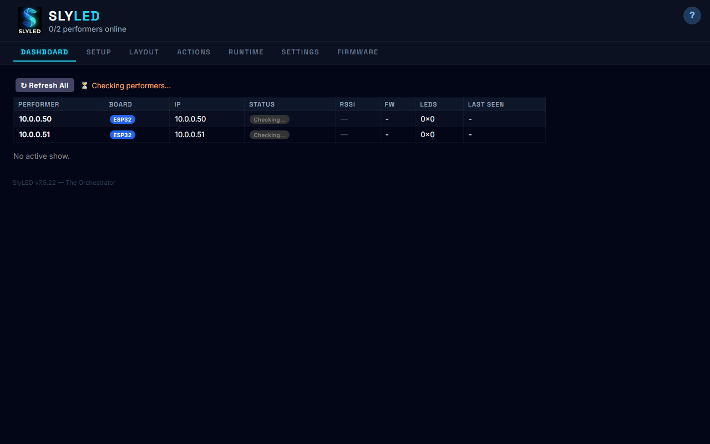
Dashboard — live performer status overview

Switching Between 2D and 3D
The Layout tab offers two views:
- 2D Canvas: Flat top-down layout for simple setups
- 3D Viewport: Interactive Three.js scene for complex multi-level installations
Both views share the same position data. Switching is instant and non-destructive.
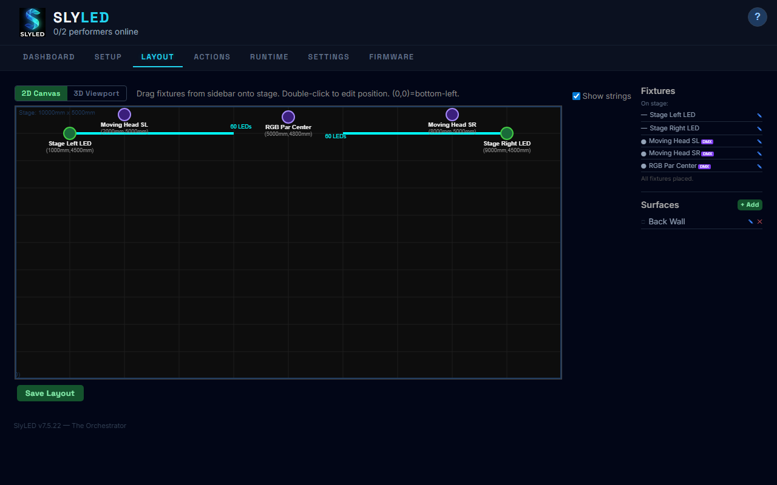
Layout tab — 2D Canvas with placed fixtures
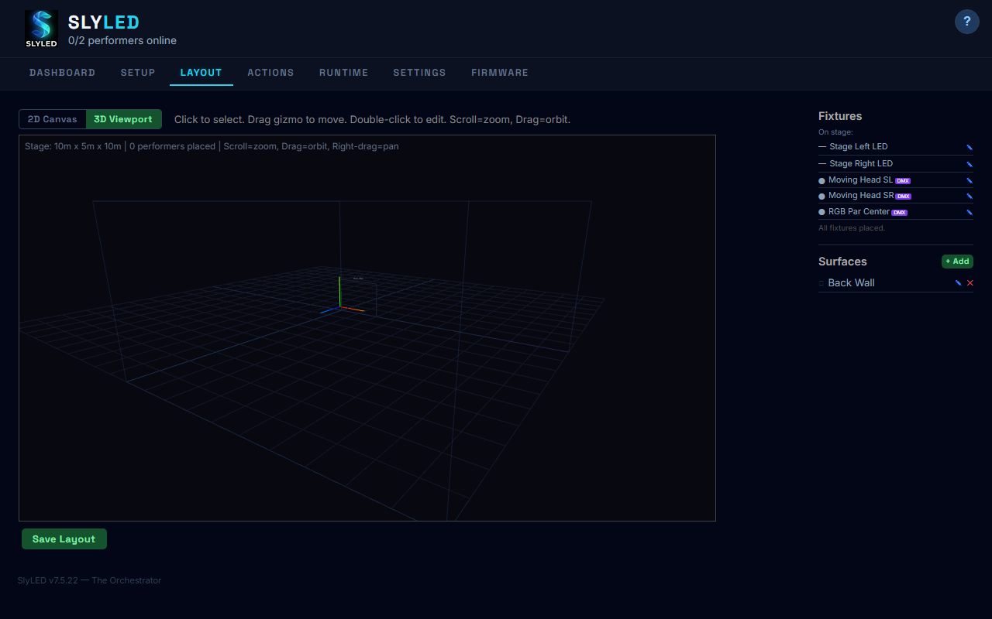
Layout tab — 3D Viewport with stage wireframe, fixtures, and surfaces

Navigating the 3D Viewport
Action | Control
Orbit (rotate) | Left-click + drag
Zoom | Scroll wheel
Pan (shift view) | Right-click + drag
Select fixture | Left-click on node
Move fixture | Drag the colored arrows
Edit fixture | Double-click on node
Place from sidebar | Drag unplaced fixture into viewport

Coordinate System
- X-axis (red): Width — left to right
- Y-axis (green): Height — ground to ceiling
- Z-axis (blue): Depth — front to back
- Origin: Bottom-left-front corner of the stage
- Units: Internally millimeters; displayed in Settings-chosen unit

2. Fixture Setup

What Are Fixtures?
A fixture is the primary entity on the 3D stage. It wraps physical hardware and adds stage-level attributes like position, rotation, and aim point.
- LED Performers: Auto-created when hardware is registered via Setup tab
- DMX Fixtures: Created manually with universe, address, and profile assignment
- Fixtures can override child attributes (e.g., rotate a horizontal string to vertical)
- The baking engine uses the fixture's position and rotation, not the child's raw config
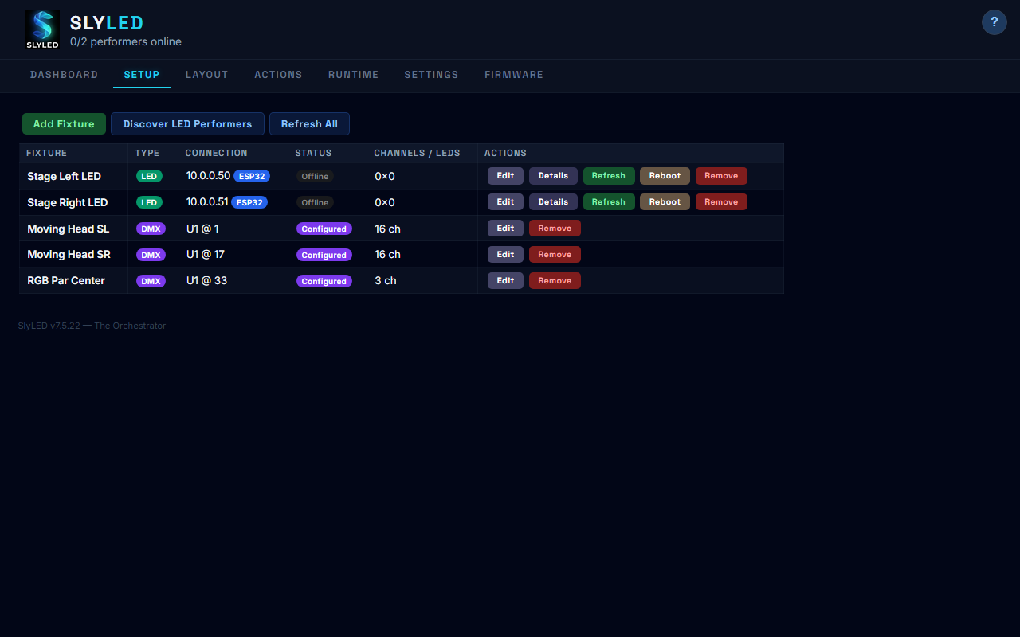
Setup tab — LED and DMX fixtures with type badges and status

Adding an LED Performer
Click Add Fixture, select "SlyLED Performer (LED)", and enter the device IP address. The system probes the device via UDP PING and HTTP, registers it as a child, and auto-creates a linked fixture.
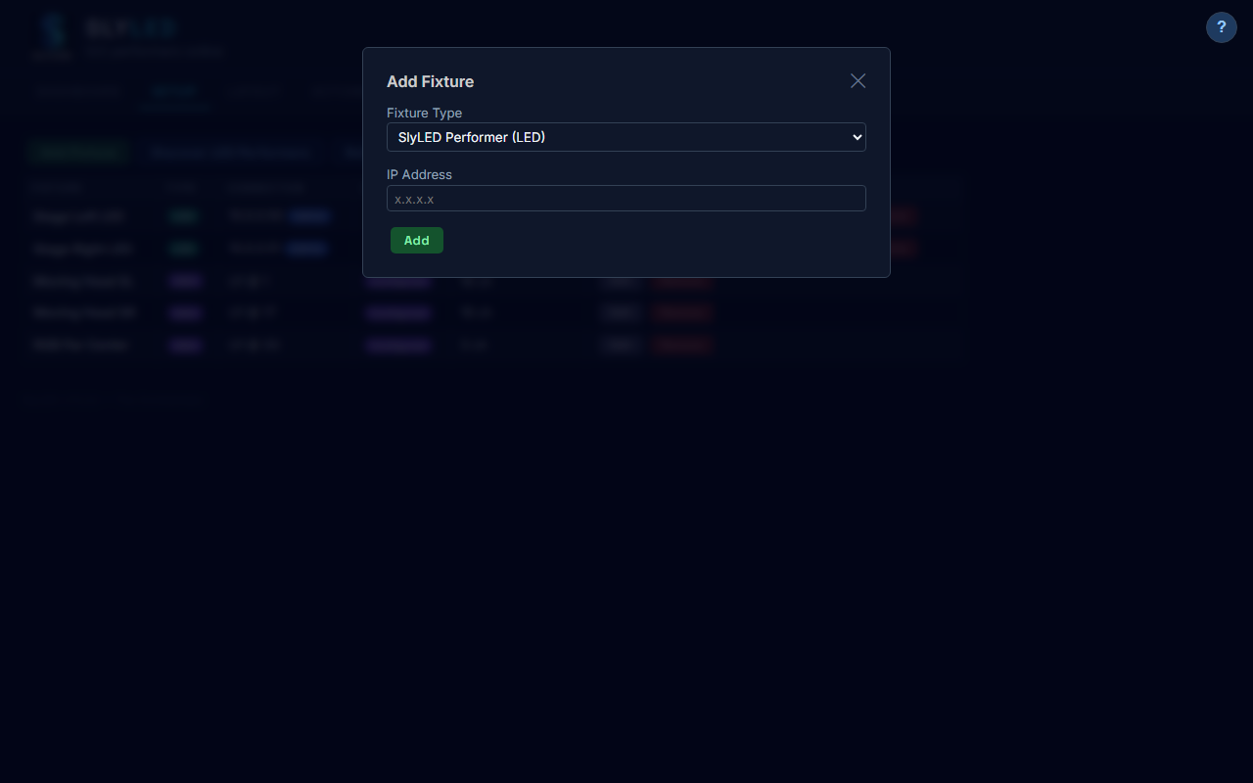
Add Fixture — LED performer flow with IP address entry

Adding a DMX Fixture
Click Add Fixture, select "DMX Fixture", and configure:
- Name: Descriptive label
- Universe: DMX universe number (1+)
- Start Address: DMX start channel (1-512)
- Channel Count: Number of channels the fixture uses
- Profile: Select from the built-in library or import from Open Fixture Library
DMX fixtures appear in the setup table with purple "DMX" badges.
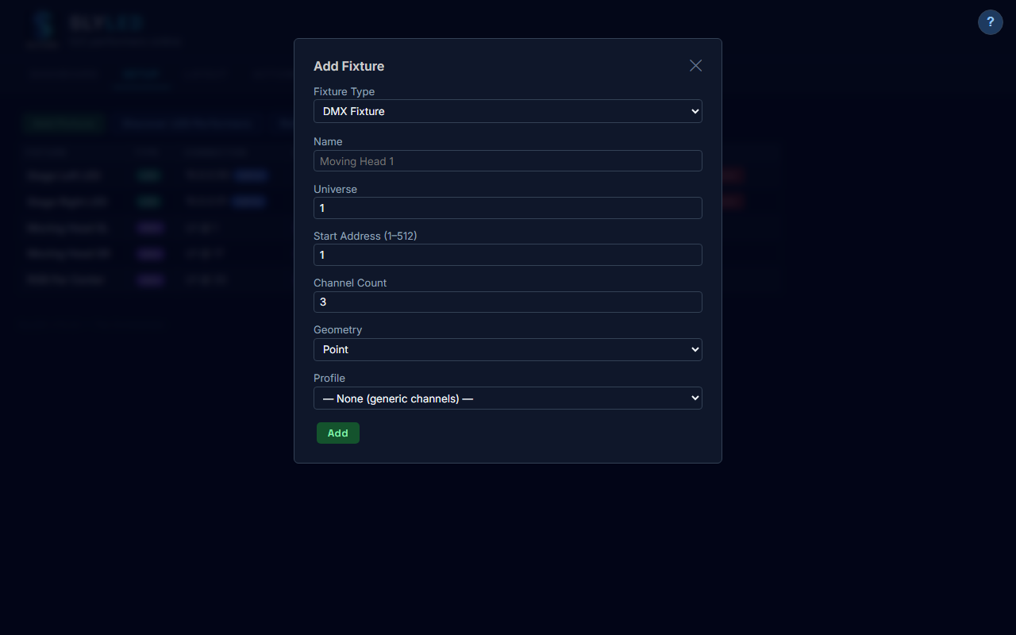
Add Fixture — DMX fixture with profile dropdown

Editing DMX Fixtures
Click Edit on a DMX fixture to modify its properties. The edit modal shows:
- Universe, Start Address, Channel Count
- Profile ID (for channel name/type mapping)
- Aim Point (X, Y, Z in mm) — where the beam points for moving heads
- Test Channels — interactive sliders to control each DMX channel live
- Rotation Override (degrees)
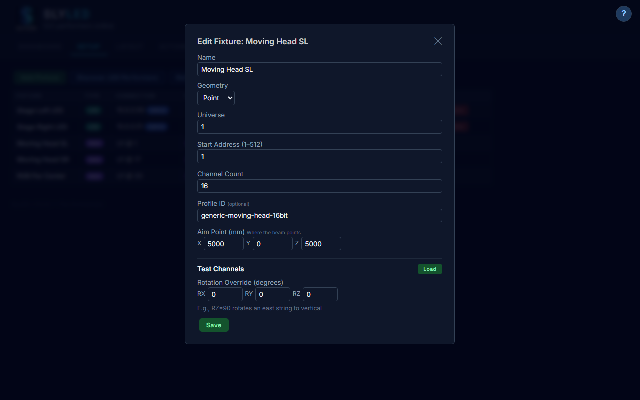
Edit DMX fixture — aim point, profile, and test channels

Fixture Types
Type | Description | Use Case
Linear | LED strip/string with pixels along a path | LED performers
Point | Single light source with area of effect | DMX pars, spots, moving heads
Surface | 3D mesh as a projection target | Walls, screens
Group | Named collection of fixtures | Zones, grouped control

3. Creating Spatial Effects
Spatial effects operate in 3D space. A sphere of colored light sweeping across the stage illuminates different fixtures at different times based on their physical position. For DMX moving heads, the effect center becomes the aim target — heads track the effect as it moves.
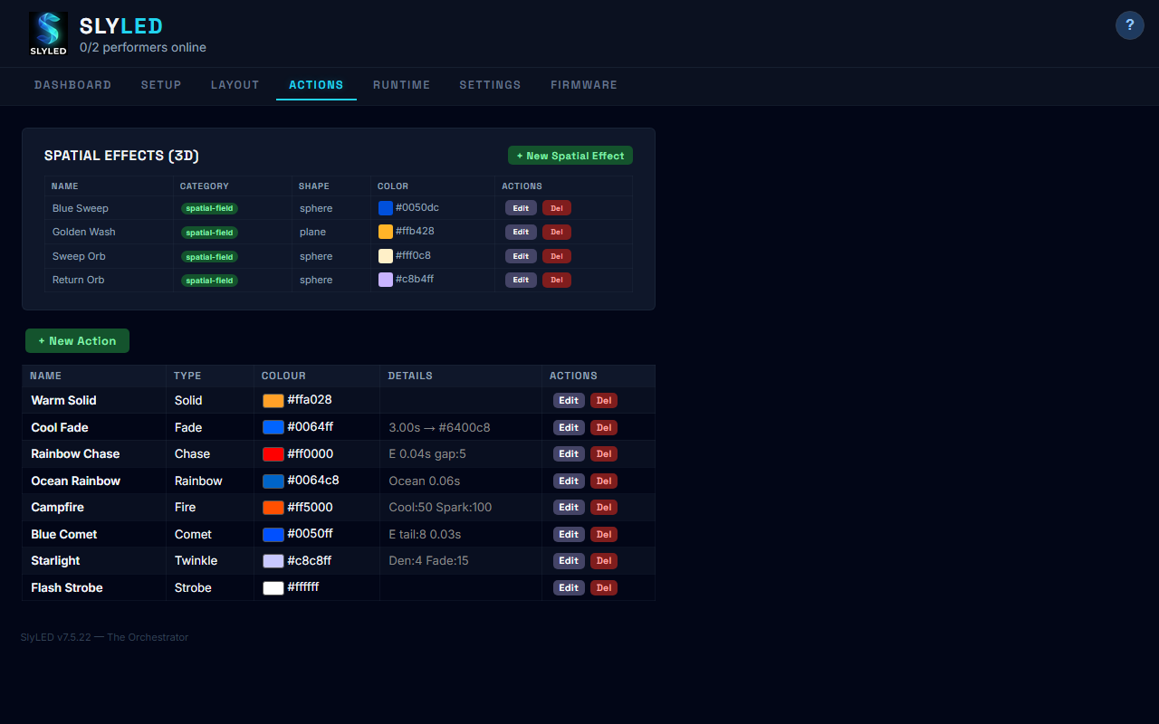
Actions tab — spatial effects and classic action library

Spatial Fields
Field | Description
Shape | Sphere, Plane, or Box
Color | RGB color applied to pixels inside the field
Size | Radius (sphere), thickness (plane), or W/H/D (box)
Motion Start | Starting position [x, y, z] in mm
Motion End | Ending position [x, y, z] in mm
Duration | Travel time from start to end
Easing | Linear, ease-in, ease-out, ease-in-out
Blend | Replace, Add, Multiply, or Screen

Moving Heads + Spatial Effects
When a spatial effect is applied to a DMX moving head fixture:
- The effect's center position becomes the aim target
- Pan/tilt angles are computed from fixture position to aim point
- Color is applied from the effect's RGB values
- Moving effects produce time-sliced segments that track the motion
- 3D viewport shows beam cones pointing at the effect center

4. Building a Timeline
Timelines are multi-track, overlapping effect sequences with precise timing. Use the Runtime tab to create and edit timelines.
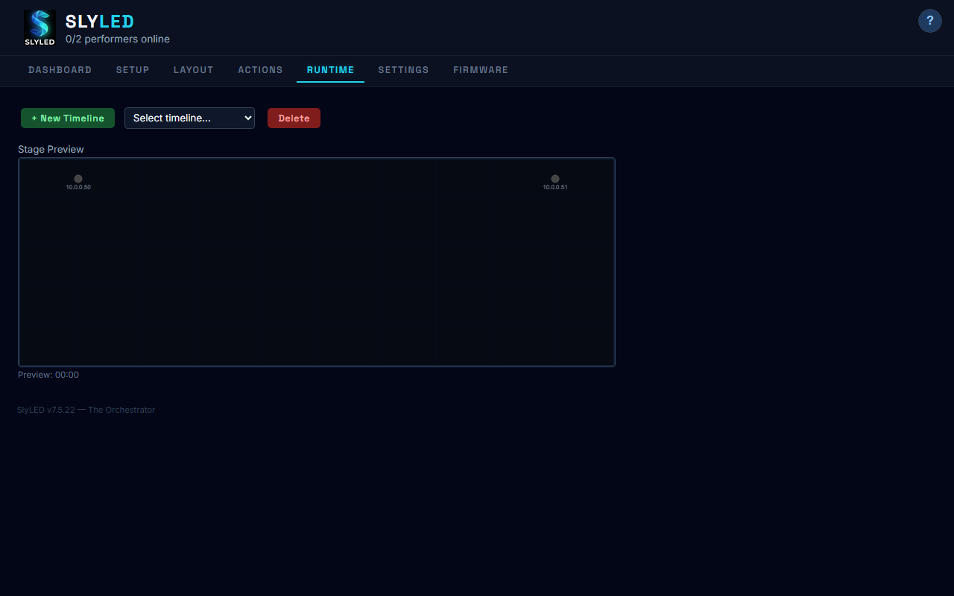
Runtime tab — timeline editor

Creating a Timeline
1. Click "+ New Timeline" and enter name and duration
2. Select the timeline from the dropdown
3. Add tracks (one per fixture or "All Performers")
4. Add clips referencing spatial effects or classic actions
5. Adjust clip timing by editing start time and duration

5. Baking & Playback

What Is Baking?
Baking compiles a timeline into minimal action instructions for each performer. The smart bake engine analyzes each clip's spatial geometry directly and computes per-string sweep patterns, directions, and speeds.
For DMX fixtures, baking also computes:
- Pan/tilt angles from spatial effect motion paths
- Color values from the effect's intersection with the fixture position
- Dimmer values (auto 255 when color is active)
- Time-sliced segments for smooth moving head tracking

Playback
After baking and syncing:
- LED performers receive action steps via UDP and execute locally
- DMX fixtures are driven by a 40Hz playback loop sending Art-Net/sACN packets
- All channels (RGB, pan, tilt, dimmer, strobe, gobo) are sent per profile
- 16-bit channels (pan/tilt) are split into coarse + fine bytes automatically

6. Show Preview Emulator
The emulator shows a real-time preview of your show on the Runtime tab.
- LED fixtures: Colored dots along string directions, animated per-pixel
- DMX fixtures: Beam triangles from fixture position toward aim point
- Beam color and alpha reflect the fixture's current DMX state
- Time counter shows elapsed position

7. Preset Shows
14 pre-built shows are available from Settings or the Runtime tab:
Preset | Type | Description
Rainbow Up | Spatial plane | Rainbow from floor to ceiling
Rainbow Across | Spatial sphere | Rainbow sweeping left to right
Slow Fire | Classic action | Warm fire effect on all fixtures
Disco | Classic action | Pastel twinkle sparkles
Ocean Wave | Spatial (2 effects) | Blue wave sweep with teal wash
Sunset Glow | Mixed | Warm breathe with golden plane sweep
Police Lights | Mixed | Red strobe with blue box flash sweep
Starfield | Classic action | White sparkles on dark background
Aurora Borealis | Spatial (2 effects) | Green curtain with purple shimmer
Spotlight Sweep | Spatial (moving heads) | Warm orb sweeps stage — heads track it
Concert Wash | Mixed (moving heads) | Magenta flood + amber tracking spot
Figure Eight | Spatial (moving heads) | Crossing orbs — heads trace X paths
Thunderstorm | Mixed (moving heads) | Lightning strikes — heads chase bolts
Dance Floor | Mixed (moving heads) | Fast orbiting spots — rapid tracking

8. DMX Fixture Profiles
Profiles define the channel layout and capabilities of DMX fixtures. Each channel maps a DMX offset to a function (pan, tilt, red, green, blue, etc.) with capability ranges that describe what each DMX value range does.
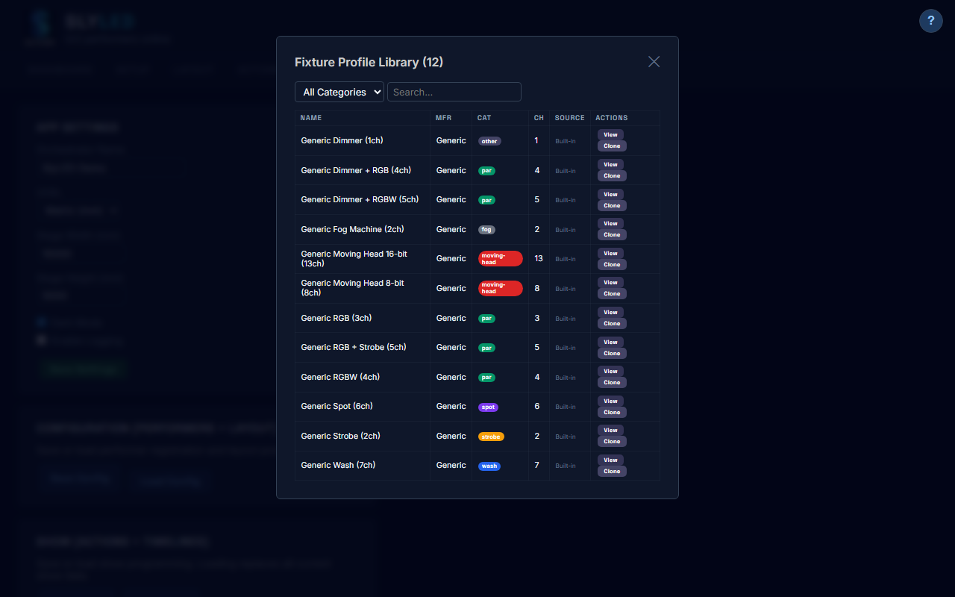
Fixture Profile Library — 12 built-in profiles

Viewing a Profile
Click View on any profile to see the full channel table with capabilities. Moving head profiles show pan/tilt ranges, beam width, and color mode.
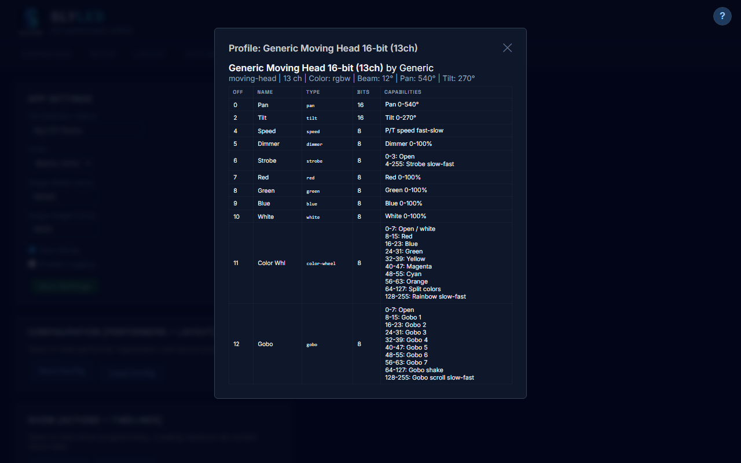
Moving Head 16-bit profile with 13 channels and capability ranges

Creating Custom Profiles
Click "New Profile" to open the editor. Define channels with type, name, bits (8/16), and capability ranges. Click the capabilities button on each channel to define what DMX value ranges do (e.g., gobo positions, strobe speeds, color wheel slots).
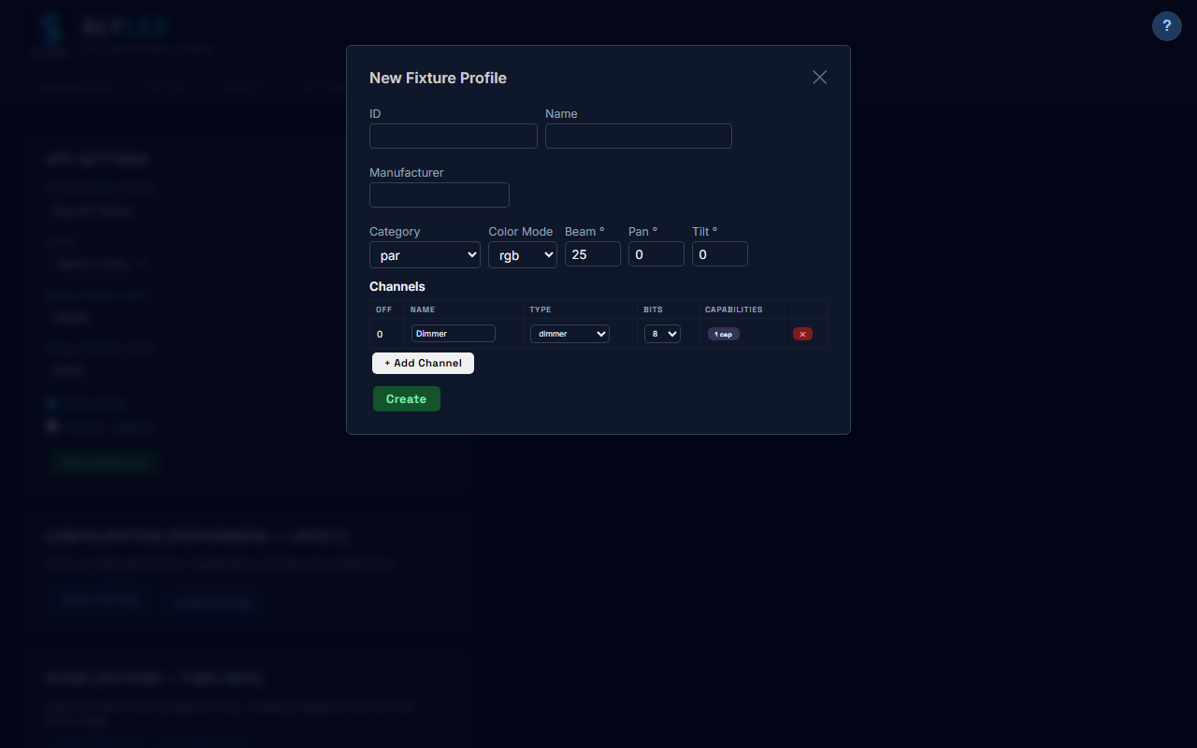
Profile editor — channel table with type dropdowns
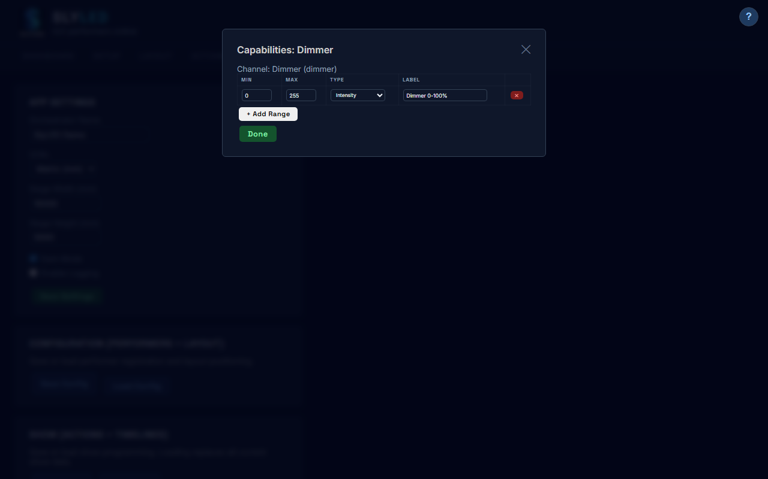
Capability range editor for a channel

Importing from Open Fixture Library
Click "Import OFL" to paste fixture JSON from open-fixture-library.org. The importer converts OFL's capability model to SlyLED format, handling multi-mode fixtures, 16-bit channels, and color detection automatically.
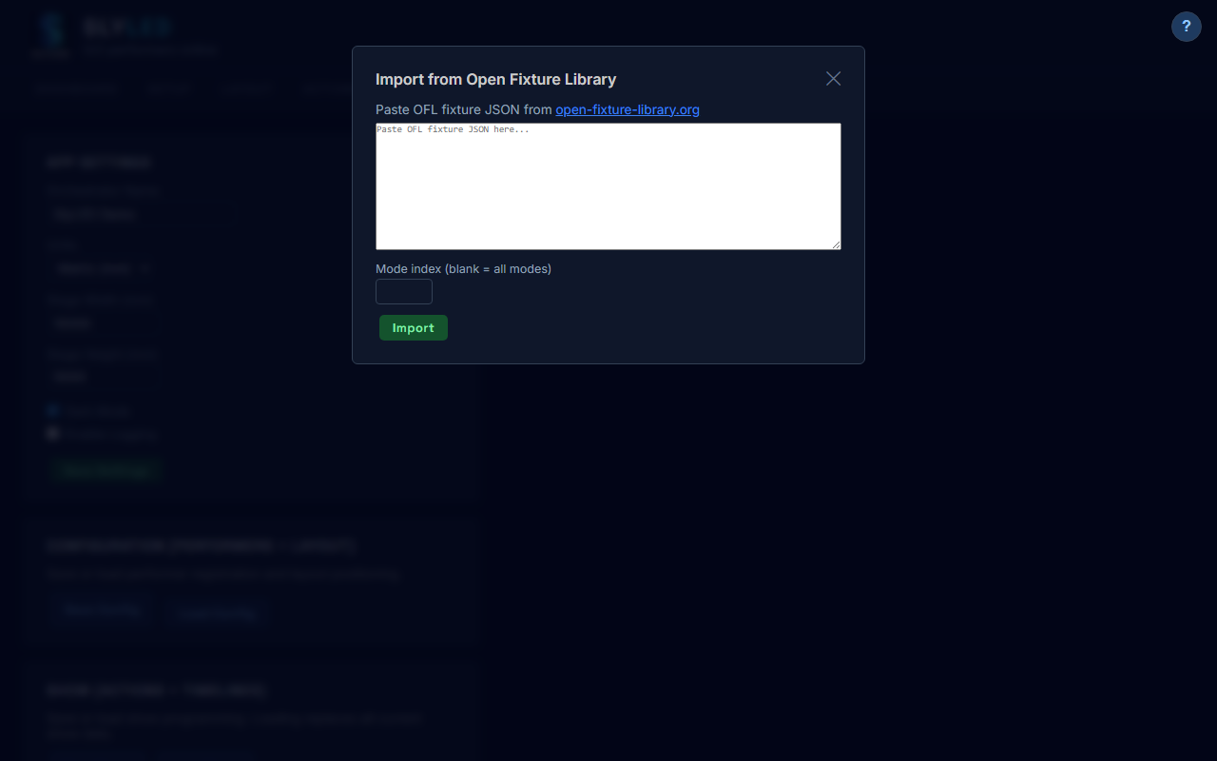
Open Fixture Library import modal

Import/Export Bundles
Export your custom profiles as a JSON bundle file for backup or sharing. Import bundles to add profiles from other installations.

9. Settings & Configuration
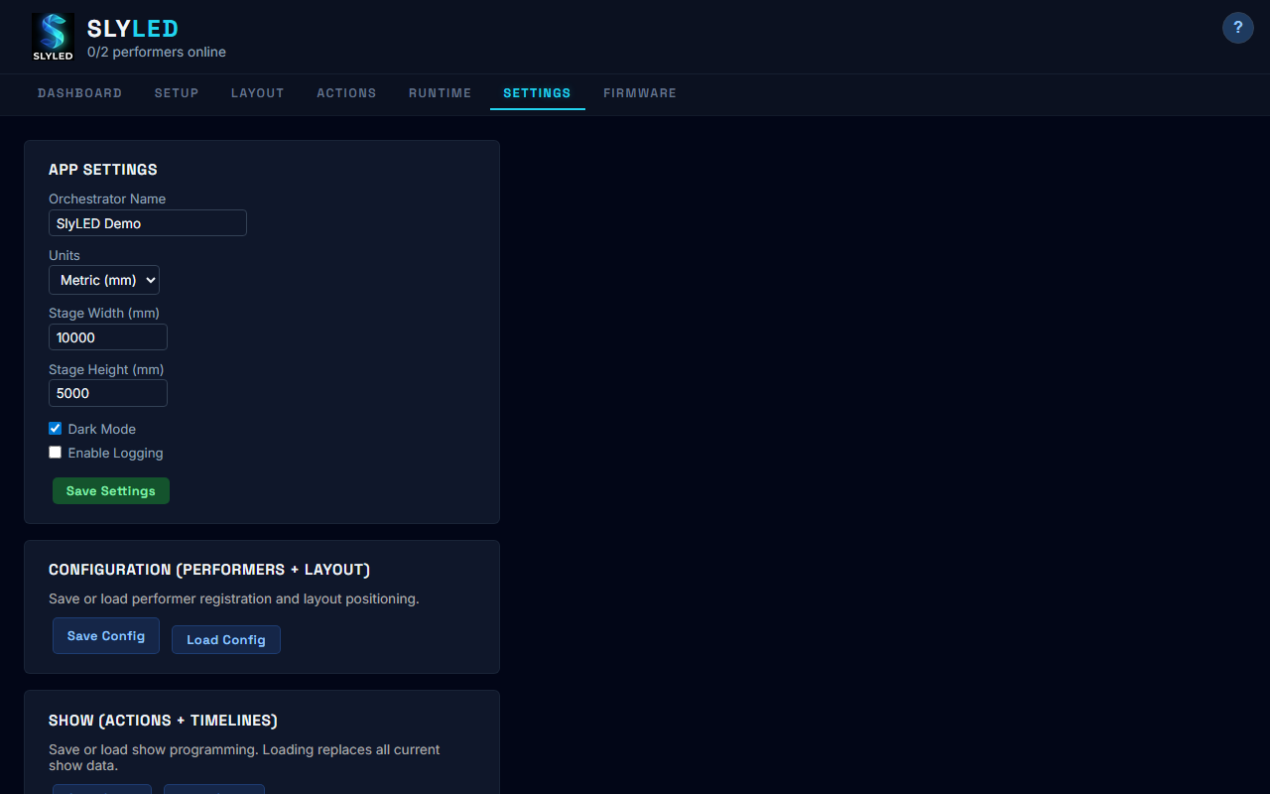
Settings tab — app configuration and DMX output
The Settings tab contains:
- Orchestrator name and units
- Stage dimensions
- Dark mode toggle
- Logging control
- Configuration export/import
- Show export/import
- DMX output settings (Art-Net/sACN, frame rate, universe routing)
- Fixture Profile Library
- Factory reset

Firmware
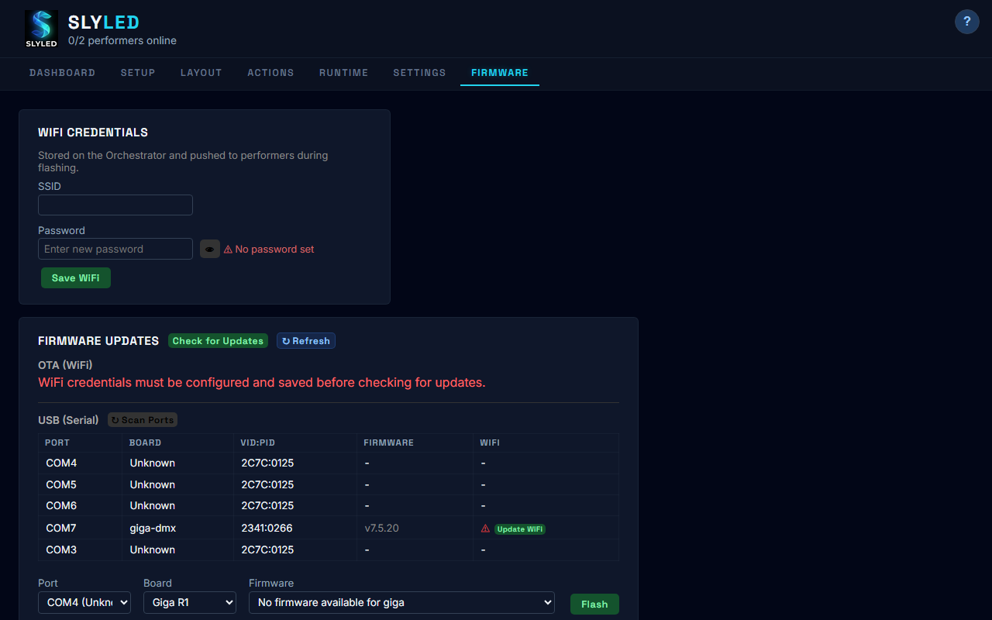
Firmware tab — board detection and flash controls
The Firmware tab provides:
- COM port detection with board type identification
- Serial version query
- WiFi credential management
- One-click firmware flashing for ESP32, D1 Mini, and Giga R1 boards

10. System Limits
Resource | Limit | Notes
Children (performers) | 8 max | Protocol constant
Strings per child | 8 max | ESP32 supports up to 8 GPIO pins
LEDs per string | 65535 max | uint16_t addressing (protocol v4)
Steps per runner | 16 max | LoadStepPayload array limit
Bake segments per fixture | 16 max | Fits runner step limit
Bake frame rate | 40 Hz | Art-Net output rate
DMX universes | Unlimited | One Art-Net packet per universe
DMX channels per universe | 512 | DMX-512 standard
Pan/tilt resolution | 8 or 16 bit | Per profile channel definition
Preview resolution | 1 fps | 1 color per string per second
NTP sync offset | 5 seconds | GO command sent with future epoch

11. Troubleshooting

3D Viewport Not Rendering
Browser doesn't support WebGL. Use Chrome, Firefox, or Edge.

Performers Not Syncing
Children offline or on different network. Check Setup tab status.

Bake Error: "No fixtures"
Add and position fixtures in Layout before baking.

DMX Not Outputting
Check Art-Net engine is started (Settings → DMX Output → Start). Verify universe routing matches your bridge address.

Moving Heads Not Tracking
Verify fixture has a profile with panRange/tiltRange > 0. Check aimPoint is set (Edit fixture → Aim Point fields).

Preview Shows No DMX Beams
Bake the timeline first. DMX preview requires baked data.

Factory Reset
Settings → Factory Reset clears ALL data including fixtures, effects, timelines, and profiles.

12. API Quick Reference
All endpoints are served from the Orchestrator at http://localhost:8080.

Fixtures
Method | Endpoint | Description
GET/POST | /api/fixtures | List / create
GET/PUT/DELETE | /api/fixtures/:id | CRUD
PUT | /api/fixtures/:id/aim | Set DMX aim point
POST | /api/fixtures/:id/resolve | Compute pixel positions

DMX Profiles
Method | Endpoint | Description
GET/POST | /api/dmx-profiles | List / create
GET/PUT/DELETE | /api/dmx-profiles/:id | CRUD
GET | /api/dmx-profiles/export | Export bundle
POST | /api/dmx-profiles/import | Import bundle
POST | /api/dmx-profiles/ofl/import-json | Import OFL fixture

Timelines
Method | Endpoint | Description
GET/POST | /api/timelines | List / create
POST | /api/timelines/:id/bake | Start baking
POST | /api/timelines/:id/start | Start playback
POST | /api/timelines/:id/stop | Stop playback

DMX Output
Method | Endpoint | Description
GET | /api/dmx/status | Engine status
POST | /api/dmx/start | Start engine
POST | /api/dmx/stop | Stop engine
GET | /api/dmx/fixture/:id/channels | Fixture channels with values

