

Form Information

|  |  |
| --- | --- |
|  |  |
| Form Name: | **Work Order Form** |
| Submitter Name: | Nicolaus Lawson (nicolaus.lawson) |
| Submission Date: | Feb 15, 2017 4:52:06 PM COT |
| Server Receive Date: | Feb 15, 2017 4:52:16 PM COT |
| Reference Number: | 20170215-1855374075 |
| Location: | Leinster Rd, Kingston, Jamaica  Feb 15, 2017 4:51:59 PM COT [ [View Map](http://maps.google.com/maps?q=17.99033991822416,-76.78467583004878) ] |
|  |  |

Work Order

|  |  |  |
| --- | --- | --- |
| Date |  | Feb 15, 2017 |

|  |  |  |
| --- | --- | --- |
| Supervisor |  | Franklyn Saunders |

|  |  |  |
| --- | --- | --- |
| Crew |  | MO2 (Mona team #2) |

|  |  |  |
| --- | --- | --- |
| Zone office |  | Mona |

|  |  |  |
| --- | --- | --- |
| Road |  | Leinster Rd, Kingston, Jamaica  Feb 15, 2017 4:50:01 PM COT [ [View Map](http://maps.google.com/maps?q=17.990365163255817,-76.78471816440404) ] |

|  |  |  |
| --- | --- | --- |
| Property # |  | 34 elm |

|  |  |  |
| --- | --- | --- |
| Meter # |  | 1232 |

|  |  |  |
| --- | --- | --- |
| Leak status |  | Leak found |

|  |  |  |
| --- | --- | --- |
| Excavation required? |  | Yes |

Before Excavation

|  |  |  |
| --- | --- | --- |
| Is the leak visible? |  | Yes |

|  |  |  |
| --- | --- | --- |
| Observation |  | Street |

After Excavation

|  |  |  |
| --- | --- | --- |
| Origin of the leak |  | Main |

|  |
| --- |
| Pre-repair photos |

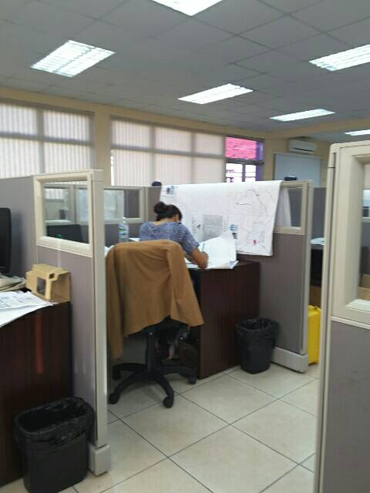

|  |
| --- |
| Pre-repair sketch photos |

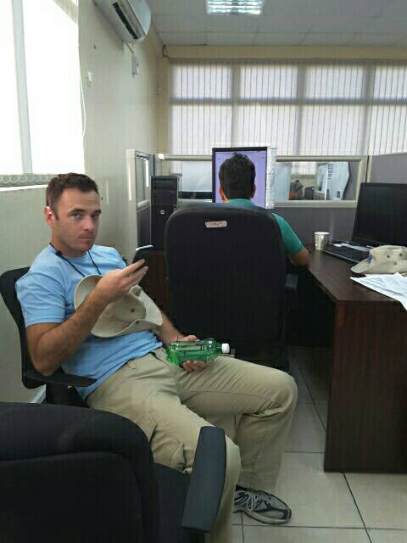

Leak Survey (Main)

|  |  |  |
| --- | --- | --- |
| Failure type (pipe) |  | Pin hole |

|  |  |  |
| --- | --- | --- |
| Failure type (fittings) |  | Elbow |

|  |  |  |
| --- | --- | --- |
| Cause of leak |  | Corrosion  Poor instalation  Soil settlement  Tree roots |

|  |  |  |
| --- | --- | --- |
| Pipe material |  | DI |

|  |  |  |
| --- | --- | --- |
| Pipe size (inch/mm) |  | 26 |

|  |  |  |
| --- | --- | --- |
| Pipe circumference (mm) |  | 355 |

|  |  |  |
| --- | --- | --- |
| OD (mm) |  | 113.00 |

|  |  |  |
| --- | --- | --- |
| OD (inch) |  | 4.45 |

Saddle

|  |  |  |
| --- | --- | --- |
| Saddle |  | 4x1-1/2 |

|  |  |  |
| --- | --- | --- |
| Description: |  | 4"x1-1/2" BSPT Brass Single Strap Saddle 3846BSPT C900 4.80 |

|  |  |  |
| --- | --- | --- |
| Quantity |  | 4 |

Ball Valve

|  |  |  |
| --- | --- | --- |
| Ball valve (at saddle) |  | Ball Valve DZR. 1"F X 1"M |

|  |  |  |
| --- | --- | --- |
| Description: |  | Ball Valve DZR. 1"F X 1"M |

|  |  |  |
| --- | --- | --- |
| Quantity |  | 2 |

Elbow 90º

|  |  |  |
| --- | --- | --- |
| Elbow 90º (at saddle) |  | Elbow 90 DZR. Male x Female 1"X1" |

|  |  |  |
| --- | --- | --- |
| Description: |  | Elbow 90 DZR. Male x Female 1"X1" |

|  |  |  |
| --- | --- | --- |
| Quantity |  | 3 |

ISIFLO Coupling Straight

|  |  |  |
| --- | --- | --- |
| Quantity |  | 0 |

ISIFLO Coupling Elbow 90º

|  |  |  |
| --- | --- | --- |
| Quantity |  | 0 |

Insert for PEX

|  |  |  |
| --- | --- | --- |
| Quantity |  | 0 |

PEX Pipe

|  |  |  |
| --- | --- | --- |
| Length (cm) |  | 0 |

Meter Valve

|  |  |  |
| --- | --- | --- |
| Quantity |  | 0 |

Manifold

|  |  |  |
| --- | --- | --- |
| Quantity |  | 0 |

Cap for Manifold

|  |  |  |
| --- | --- | --- |
| Quantity |  | 0 |

Clamp

|  |  |  |
| --- | --- | --- |
| Quantity |  | 0 |

Flex Adaptor

|  |  |  |
| --- | --- | --- |
| Quantity |  | 0 |

Detection Tape

|  |  |  |
| --- | --- | --- |
| Detection tape |  | 67T06W-Detecto Tape |

|  |  |  |
| --- | --- | --- |
| Description: |  | Detecto Tape Water |

|  |  |  |
| --- | --- | --- |
| Length (cm) |  | 33 |

Reinstatement

|  |  |  |
| --- | --- | --- |
| Bedding |  | Yes |

|  |  |  |
| --- | --- | --- |
| Back filling |  | Yes |

|  |  |  |
| --- | --- | --- |
| Compaction |  | No |

|  |
| --- |
| Outstanding ground works |

|  |  |  |
| --- | --- | --- |
| Asphalt works |  | Yes |

|  |  |  |
| --- | --- | --- |
| Concrete works |  | Yes |

|  |  |  |
| --- | --- | --- |
| Sidewalk works |  | Yes |

|  |  |  |
| --- | --- | --- |
| Sidewalk curb works |  | Yes |

After Repair Photos/Remarks

|  |
| --- |
| Post Repair Photos |



|  |  |  |
| --- | --- | --- |
| Remarks |  | thanks |

Job Closed

|  |
| --- |
| I verify that the above information is complete and accurate. |

|  |
| --- |
| Site supervisor signature (Miya) |

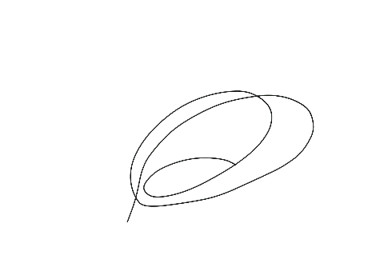

|  |
| --- |
| Team leader signature (NWC) |

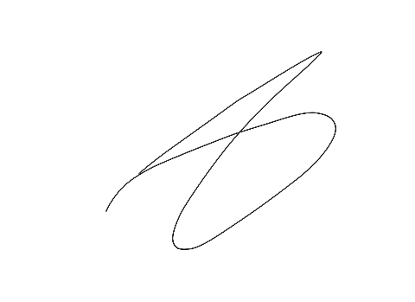

|  |  |  |
| --- | --- | --- |
| Date/Time |  | Feb 15, 2017 4:51:55 PM COT |

|  |  |  |
| --- | --- | --- |
| Remarks |  | worlcome |