

Form Information

|  |  |
| --- | --- |
|  |  |
| Form Name: | **Work Order Form** |
| Submitter Name: | Nicolaus Lawson (nicolaus.lawson) |
| Submission Date: | Feb 15, 2017 5:30:02 PM COT |
| Server Receive Date: | Feb 15, 2017 5:30:09 PM COT |
| Reference Number: | 20170215-1855376318 |
| Location: | Leinster Rd, Kingston, Jamaica  Feb 15, 2017 5:30:00 PM COT [ [View Map](http://maps.google.com/maps?q=17.990310308818525,-76.78466645958451) ] |
|  |  |

Work Order

|  |  |  |
| --- | --- | --- |
| Date |  | Feb 15, 2017 |

|  |  |  |
| --- | --- | --- |
| Supervisor |  | Franklyn Saunders |

|  |  |  |
| --- | --- | --- |
| Crew |  | VA2 (Valve team #2) |

|  |  |  |
| --- | --- | --- |
| Zone office |  | Rock Point |

|  |  |  |
| --- | --- | --- |
| Road |  | Leinster Rd, Kingston, Jamaica  Feb 15, 2017 5:02:38 PM COT [ [View Map](http://maps.google.com/maps?q=17.990355662802134,-76.78471222221319) ] |

|  |  |  |
| --- | --- | --- |
| Leak status |  | Leak found |

|  |  |  |
| --- | --- | --- |
| Excavation required? |  | No |

Before Repair

|  |  |  |
| --- | --- | --- |
| Is the leak visible? |  | Yes |

|  |  |  |
| --- | --- | --- |
| Observation |  | Pedestrian area  Service connection |

|  |  |  |
| --- | --- | --- |
| Origin of the leak |  | Valve |

Leak Survey (Valve)

|  |  |  |
| --- | --- | --- |
| Type of valve |  | Butterfly valve |

|  |  |  |
| --- | --- | --- |
| Location of leak (valve) |  | Stem |

|  |  |  |
| --- | --- | --- |
| Cause of leak (valve) |  | Normal wear  Corrosion  Poor installation |

|  |  |  |
| --- | --- | --- |
| Pipe size (inch/mm) |  | 226 |

|  |  |  |
| --- | --- | --- |
| Pipe material |  | CI |

|  |  |  |
| --- | --- | --- |
| Pipe circumference (mm) |  | 335 |

|  |  |  |
| --- | --- | --- |
| OD (mm) |  | 106.63 |

|  |  |  |
| --- | --- | --- |
| OD (inch) |  | 4.20 |

Saddle

|  |  |  |
| --- | --- | --- |
| Saddle |  | 4x3/4 |

|  |  |  |
| --- | --- | --- |
| Description: |  | 4"x3/4" BSPT Brass w/SS Single Strp Sadle 3846BSPT C900 4.80 |

|  |  |  |
| --- | --- | --- |
| Quantity |  | 1 |

Ball Valve

|  |  |  |
| --- | --- | --- |
| Quantity |  | 0 |

Elbow 90º

|  |  |  |
| --- | --- | --- |
| Quantity |  | 0 |

ISIFLO Coupling Straight

|  |  |  |
| --- | --- | --- |
| Quantity |  | 0 |

ISIFLO Coupling Elbow 90º

|  |  |  |
| --- | --- | --- |
| Quantity |  | 0 |

Insert for PEX

|  |  |  |
| --- | --- | --- |
| Quantity |  | 0 |

PEX Pipe

|  |  |  |
| --- | --- | --- |
| Length (cm) |  | 0 |

Meter Valve

|  |  |  |
| --- | --- | --- |
| Quantity |  | 0 |

Manifold

|  |  |  |
| --- | --- | --- |
| Quantity |  | 0 |

Cap for Manifold

|  |  |  |
| --- | --- | --- |
| Quantity |  | 0 |

Clamp

|  |  |  |
| --- | --- | --- |
| Quantity |  | 0 |

Flex Adaptor

|  |  |  |
| --- | --- | --- |
| Quantity |  | 0 |

Detection Tape

|  |  |  |
| --- | --- | --- |
| Detection tape |  | 67T06W-Detecto Tape |

|  |  |  |
| --- | --- | --- |
| Description: |  | Detecto Tape Water |

|  |  |  |
| --- | --- | --- |
| Length (cm) |  | 15 |

Reinstatement

|  |  |  |
| --- | --- | --- |
| Bedding |  | Yes |

|  |  |  |
| --- | --- | --- |
| Back filling |  | Yes |

|  |  |  |
| --- | --- | --- |
| Compaction |  | No |

|  |
| --- |
| Outstanding ground works |

|  |  |  |
| --- | --- | --- |
| Asphalt works |  | Yes |

|  |  |  |
| --- | --- | --- |
| Concrete works |  | Yes |

|  |  |  |
| --- | --- | --- |
| Sidewalk works |  | Yes |

|  |  |  |
| --- | --- | --- |
| Sidewalk curb works |  | Yes |

Job Closed

|  |
| --- |
| I verify that the above information is complete and accurate. |

|  |
| --- |
| Site supervisor signature (Miya) |

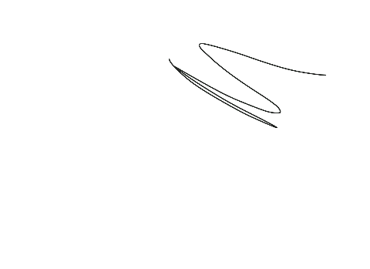

|  |
| --- |
| Team leader signature (NWC) |

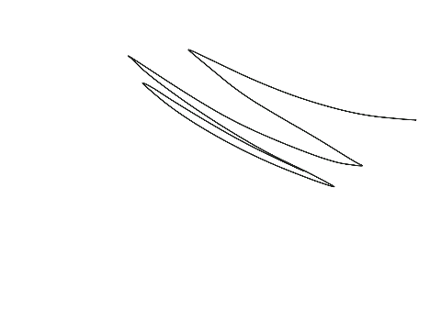

|  |  |  |
| --- | --- | --- |
| Date/Time |  | Feb 15, 2017 5:29:55 PM COT |