Estimation of Aerodynamic Parameters Using a Hybrid GRU–Kalman Observer

ABSTRACT
This paper proposes a hybrid observer that combines a physics-based Kalman Filter (KF) with a data-driven Gated Recurrent Unit (GRU) network to reconstruct longitudinal aircraft states and latent gust disturbances from bandwidth-limited, noisy, and intermittently received flight telemetry. $The KF$ provides model-consistent state prediction while the GRU is trained on the KF innovation sequence to learn the temporal structure introduced by unmodeled, correlated gust dynamics. We apply the method to a discrete-time five-state longitudinal model representative of a Boeing 747 (forward and vertical velocity, pitch rate, pitch angle, altitude) and generate simulation data under gust excitation, packet dropouts, quantization, and measurement noise. Results show the hybrid GRU–KF reduces state estimation error relative to a standalone KF by compensating for structured innovation correlation caused by model mismatch. $The GRU’s$ selective memory (update/reset gates) offers an efficient, low-latency correction suitable for bandwidth- and computation-constrained ground-based recovery. The hybrid approach preserves interpretability through the underlying physics model while improving robustness to realistic transmission degradations, suggesting its utility for flight-data recovery in oceanic and other bandwidth-limited operations.

Keywords: Kalman filter, GRU, hybrid observer, gust estimation, longitudinal dynamics, flight-data recovery

INTRODUCTION
Accurate reconstruction of flight parameters is essential for flight safety analysis, accident investigation, and real-time monitoring of aircraft performance. Modern aircraft employ Transmission of Flight Data (TFD) systems to stream selected parameters from onboard sensors to ground-based monitoring systems. In long-range and oceanic operations, satellite and RF links impose severe bandwidth and cost constraints that often force aggressive compression, reduced sampling, or intermittent packet transmission. The resulting data received can be noisy, $quantized,$ or incomplete, reducing the $fidelity$ of ground-based state estimation.
Classical state-estimation approaches widely used in aerospace e.g., Output Error Methods, Filter Error Methods, and Kalman Filters—rely on accurate physics models and noise assumptions (commonly Gaussian, white). Under ideal conditions these methods perform well, but their performance degrades when the data stream exhibits packet dropouts, non-Gaussian disturbances, or unmodeled aerodynamic effects (for example atmospheric gusts). In longitudinal dynamics, gusts act as structured disturbances that are temporally correlated and low frequency; when not modeled explicitly in the filter, these disturbances introduce colored structure into the filter innovations. That is, the innovation sequence is no longer white and contains dynamical information about unmodeled inputs.
Although the KF innovation becomes structured under model mismatch, that very innovation contains a filtered projection of the latent gust dynamics. Rather than treating structured residuals as a purely corrective signal for tuning, we can treat innovation history as an observable output of an implicit dynamical system driven by gusts. Recurrent neural networks (RNNs) and specifically Gated Recurrent Units (GRUs) are well suited to extract temporal structure from sequential data with lower computational complexity than LSTMs. GRUs provide “selective memory” via update and reset gates, enabling efficient learning of long-term dependencies with fewer parameters and faster training.
The estimation of aircraft states under dynamic atmospheric conditions, such as windowed gusts, presents a significant challenge for classical linear observers. This paper develops and implements a hybrid framework that combines the structural reliability of a Kalman Filter (KF) with the nonlinear mapping capabilities of a Gated Recurrent Unit (GRU). The fundamental problem with a standard KF in this context is that it relies on a nominal plant model which often ignores or oversimplifies stochastic environmental disturbances. When the aircraft encounters a gust, the KF treats the resulting state deviation as pure measurement noise or simple process noise, leading to significant estimation lag and "innovation bias." Instead of trying to force KF to model these complex dynamics, we propose a residual learning approach where the KF handles the known nominal physics and the GRU learns to predict the resulting error (the residual). We focus on a discrete-time five-state longitudinal model representative of a Boeing 747: forward velocity, vertical velocity, pitch rate, pitch angle, and altitude. Contributions include:

State Space Equation and model Matrix
The longitudinal dynamics of the aircraft are modeled in discrete-time state-space form. Unlike standard models, this invention explicitly accounts for an unobserved gust disturbance vector $\left(g_{k}\right)$:
$$x_{\left(k+1\right)}=A_{d}x_{k}+B_{d}u_{k}+B_{\left(wd\right)}gust+w_{k}$$
$$y_{k}=Cx_{k}+Du_{k}+v_{k}$$
Where the state vector $x_{k}$ is defined as:
$$x={\left[u,w,q,θ,h\right]}^{T}$$
(Representing axial velocity, vertical velocity, pitch rate, pitch angle, and altitude).

The Baseline Estimator (Ground Truth):
The system utilizes a standard Kalman Filter (KF) estimator which, in its baseline state, neglects the gust component:
$${\hat{x}}_{\left(k+1\right)|k}=A_{d}{\hat{x}}_{k}+B_{d}u_{k}$$

$$\left[\begin{matrix}u^{.} \\ w^{.} \\ q^{.} \\ θ^{.} \\ h^{.}\end{matrix}\right]=\left[\begin{matrix}X_{u} & X_{w} & 0 & -g\cos{γ} & 0 \\ Z_{u} & Z_{w} & U_{0} & -g\sin{γ} & 0 \\ M_{u} & M_{w} & M_{q} & 0 & 0 \\ 0 & 0 & 1 & 0 & 0 \\ -\sin{γ} & \cos{γ} & 0 & U_{0}\cos{γ} & 0\end{matrix}\right]\left[\begin{matrix}u \\ w \\ q \\ θ \\ h\end{matrix}\right]+\left[\begin{matrix}B_{11} & B_{12} \\ B_{21} & B_{22} \\ ⋮ & ⋮\end{matrix}\right]\left[\begin{matrix}δ_{e}δ_{p}\end{matrix}\right]$$

Latent Error Dynamics and Residual Mapping
In a nominal Kalman Filter (KF) implementation, the estimation error the Estimation error $\left(e_{k}\right)$ recursion is derived as:
$$e_{k+1}=A_{d}\left(I-K_{k}C\right)e_{k}+B_{w}g_{k}+w_{k}-A_{d}K_{k}v_{k}$$
It is evident that the error evolution is driven by the disturbance channel $B_{w}g_{k}$, which represents the windowed gust dynamics. In classical theory, if the model is exact, the innovation sequence
$$ỹ_{k}=y_{k}-C{\hat{x}}_{k|(k-1)}$$
is a zero-mean white process. However, when a complex gust is present, the KF "guess" is biased, and the error $\left(e_{k}\right)$ becomes structured and temporally correlated.
In classical Kalman filtering theory, if the system model is exact and disturbances are either absent or modelled as White Gaussian processes with known covariance. The shift in our methodology is that we do not attempt to "$whiten$" the innovation directly through measurement-space mapping. Instead, we recognize that the KF state estimate $\hat{x_{kf}}$ itself carries the signature of the model mismatch. By observing the trajectory of the KF states alongside the control derivatives ${\dot{u}}_{k}$, we can define Residual State Mapping.

Substituting the KF prediction into the true state transition, we define the target residual $△x_{k+1}$ as:
$$△x_{k+1}=x_{true,k+1} - (A_{d}-{\hat{x}}_{kf,k}+B_{d}u_{k})$$
This $△x$ is the "latent variable" the GRU seeks to approximate. It represents the exact amount the linear model "missed" due to the gust and linearized approximations.
Rather than treating innovation as the primary input, our architecture uses a feature vector
$$ξ_{k}={\left[{\hat{x}}_{kf,k}^{T},{\dot{u}}_{k}^{T}\right]}^{T}$$
The reason for including ${\dot{u}}_{k}$ is to provide the network with the "control intent," allowing the GRU to distinguish between state changes caused by pilot inputs versus those caused by external atmospheric disturbances. The GRU therefore learns the function:
$$Δ{\hat{x}}_{k+1}=f_{θ}\left(ξ_{k},h_{k-1}\right)$$
Where $h_{k-1}$ is the hidden recurrent state that captures the history of the gust's impact. By adding this predicted residual back to the nominal KF prediction, we effectively bypass the limitations of the linear gain $K_{k}$ and provide a corrected state estimate that accounts for the full nonlinear discrepancy of the flight environment.

Limitation of Math
While the Kalman Filter (KF) is the mathematically optimal estimator for known linear systems, its performance is strictly bound by the fidelity of the provided state-space matrices ($A,B,C,D$). In this study of the B747, the KF operates on a linearized 'mathematical snapshot' of flight dynamics. However, real-world flight is governed by complex physics—such as non-linear aerodynamic coupling and stochastic atmospheric gusts—that are often absent from the simplified matrices.
The proposed Hybrid GRU-KF transitions the estimation strategy from a purely model-reliant process to a data-augmented one. The GRU serves as a dynamic compensator; it captures the 'Residual Physics' (the difference between the idealized math and the actual flight data). Unlike the KF, which treats wind gusts as simple white noise $\left(Q matrix\right)$, the GRU utilizes its internal gating mechanisms to recognize the temporal signatures of turbulence, mapping noisy ground-station telemetry to true aircraft states with a level of pattern recognition that analytical models cannot achieve.

Evolution of the Estimator (FFNN to RNN/GRU)

In earlier aerodynamic state estimation, Feed-Forward Neural Networks (FFNN) were the standard choice, especially when stability and control derivatives were poorly defined or non-linear. While FFNNs $are capable of mapping$ complex functions, they operate on a "snapshot" basis; information flows strictly forward, leaving the network with no mechanism to account for the aircraft's previous state. In flight dynamics, where variables like pitch $\left(θ\right)$ and altitude $\left(h\right)$ are inherently tied to their past values, this lack of temporal awareness makes FFNNs fundamentally less required to handle sequential flight data or stochastic disturbances. To bridge this gap, Recurrent Neural Networks (RNNs) introduced the concept of "memory" through hidden layer feedback loops. By feeding a layer's previous output back into its current input cycle, the RNN can maintain a persistent state across time steps. This recurrent structure is trained via Backpropagation Through Time (BPTT), theoretically allowing the model to "remember" the progression of a gust or a maneuver.

However, standard RNNs often struggle with "vanishing gradients", a mathematical failure where the network "forgets" long-range dependencies during training. This led to the adoption of the Gated Recurrent Unit (GRU). By using specific updates and reset gates, the GRU selectively decides which parts of flight history are critical to the current estimate and which can be discarded. For a B747 battling atmospheric gusts, this gating mechanism is what allows the system to distinguish between high-frequency sensor noise and the actual structural pattern of the wind.

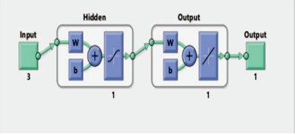
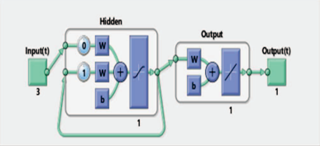
Fig. 1. Block Diagram of Feed Forward Neural Network Fig. 2. Block Diagram of Recurrent Neural Network

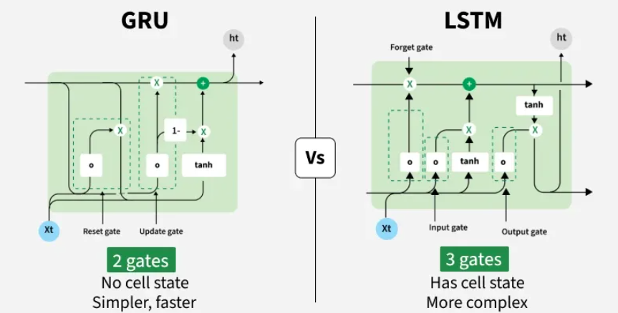

Figure 3: Architectural Difference between GRU and LSTM model

Hybrid GRU-KF Observer
To implement the Hybrid GRU-KF observer effectively, we transition from a shallow mapping of sensor errors to a hierarchical architecture that recognizes the aircraft's state in the presence of air disturbances. The model utilizes a Gated Recurrent Unit (GRU) to approximate a mapping from the current state-space estimate and control rates to the latent state residual:

$$\left[{\hat{x}}_{kf,k}^{ },{\dot{u}}_{k}^{ }\right]⟶Δx_{k+1}$$

In the initial phase, a single layer Gated Recurrent Unit (GRU) with 32 hidden nodes was employed to map the correlated innovation history (difference between the Kalman filter predicted measurement and the actual sensors) to the latent gust state. This single layer approach treats the windowed input from the 10-15 second gust interval as a flat temporal sequence, where the 32 units attempt to capture both the noise filtering and the underlying gust dynamics simultaneously. While computationally powerful, single layer is limited by its “shallow” depth, meaning it can only represent up to a certain level of non-linearity (like small spikes) complexity. By using 80% of the state-gust samples for training, we establish a baseline where the GRU learns the basic relationship, but to capture the higher-order dependencies inherent in longitudinal flight data, a stacked configuration becomes necessary but only when the output size is more since this paper has assumed only 5 state-gust model the initial will work as intended.

NOTE: High value means how much it performs poorly than the other.
Accuracy metrics on Model B747 (Single Layer with BPTT)
Aircraft States | Kalman Filter (KF) | Gated Recurrent Unit (GRU)
$$u$$ | 5.602 | 0.108
$$w$$ | 7.987 | 7.677
$$q$$ | 0.108 | 0.110
$$θ$$ | 0.034 | 0.035
$$h$$ | 49.587 | 1.523

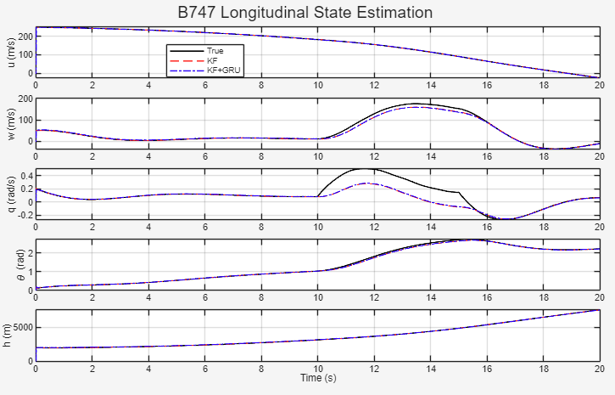
State Reconstruction using Hybrid KF-GRU (single layer 32 neurons)

Accuracy metrics on Model B747 (Double Layer without BPTT)
Aircraft States | Kalman Filter (KF) | Gated Recurrent Unit (GRU)
$$u$$ | 2.87 | 0.06
$$w$$ | 0.48 | 0.45
$$q$$ | 0.00 | 0.00
$$θ$$ | 0.01 | 0.00
$$h$$ | 83.37 | 2.53

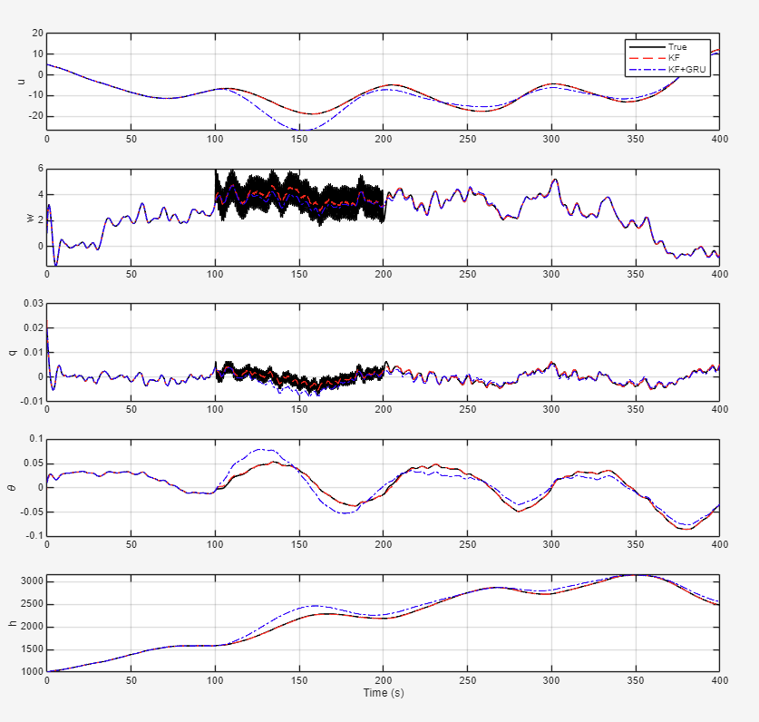
States reconstruction using Hybrid KF-GRU (Double Layer)

The transition to stacked GRU (Optional) involves feeding the hidden state outputs of the first layer as the input sequence to the subsequent layer, effectively creating a deep recurrent network. This architecture allows the model to perform hierarchical feature extraction: the first layer processes the raw innovation sequences to identify immediate temporal fluctuations, while the second layer integrates these features to recognize long-term gust trends and patterns. From a structural perspective, this necessitates a more complex management of the network’s internal memory. Specifically, the hidden state $h_{t}$ is no longer a single vector but a tensor that accounts for the depth of the stack. For a unidirectional stacked model, the hidden state tensor shape must reflect the product of the number of layers and the batch size across the hidden units. This is a critical distinction in the theory of recurrent networks; initializing a single GRU layer with 32 units is not functionally equivalent to stacking two layers of 8 and 16 units.

In a stacked architecture, the "selective memory" provided by the merged update and forget gates operates at different levels of abstraction across the layers. The initial hidden state $h_{0}$ for the second layer must be tracked independently because it represents the starting point for the second-order processing of the first layer’s latent representations. If one were to simply expand the width of a single layer rather than adding depth, the model would increase its capacity for memorization but lose the ability to build the sequential, multi-level logic required for robust gust estimation in bandwidth-constrained environments eventually leading to model overfitting. By maintaining this separation of states and ensuring a true sequential flow between layers, the observer achieves a higher degree of dynamic capacity, allowing it to maintain lower latency and faster training cycles while providing the precision needed for real-time flight control integration. But stacking more layers while low on outputs will also affect as more layers means more computation and more computation updates the gradients and thus the situation of vanishing gradient arises. It is crucial to note that initializing the hidden state for a specific layer within a stacked configuration is not equivalent to simply zeroing out half of the hidden state within a single, larger GRU unit. Doing so would fundamentally alter the network's dynamic capacity and break the sequential information flow of a true stacked architecture. The initial hidden state $h_{\left(out\right)}$ is commonly set to zeros by default if not explicitly provided.

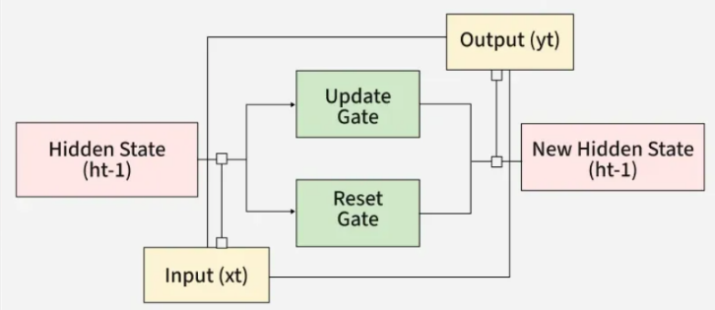

GRU Architecture
Accuracy metrics on Model B747 (Double Layer with BPTT & SGD)
Aircraft States | Kalman Filter (KF) | Gated Recurrent Unit (GRU)
$$u$$ | 0.108 | 0.113
$$w$$ | 7.678 | 1.830
$$q$$ | 0.110 | 0.039
$$θ$$ | 0.036 | 0.008
$$h$$ | 9.627 | 4.772

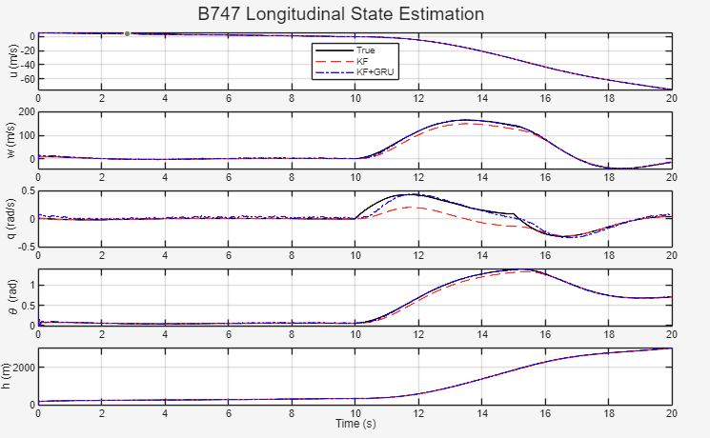
State reconstruction using Hybrid KF-GRU (2 layers using BPTT & SGD) KF-GRU performance is much better than KF only as shown in the above graph
The choice of a Gated Recurrent Unit is specific to the temporal nature of $gusts$. Unlike a simple feed-forward network, the GRU maintains an internal hidden state that acts as a memory, allowing it to "remember" the onset of a gust window and predict its decay. We utilize a two-layer architecture to increase the hypothesis space of the model. The internal logic is governed by the following gated equations:
The Update Gate $\left(z_{k}\right)$ and Reset Gate $\left(r_{k}\right)$ determine how much of the previous state information should be retained:

$z_{k}=σ\left(W_{z}ξ_{k}+U_{z}h _{k-1}+b_{z}\right)$
$r_{k}=σ\left(W_{r}ξ_{k}+U_{r}h _{k-1}+b_{r}\right)$

A Candidate Hidden State $\left(h_{k}\right)$ is then calculated using the reset gate to "forget" irrelevant past data, followed by the Final Hidden State update which blends the old and new information:

$h{\tilde{ }}_{k}=tanh\left(W_{h}ξ_{k}+U_{h}\left(r_{k}⊙h _{k-1}\right)+b_{h}\right)$
$h _{k}=\left(1-z_{k}\right)⊙h _{k-1}+z_{k}⊙ξ_{k}$

By stacking two such layers $\left(nh_{1}=8,nh_{2}=16\right)$, the network can extract higher-level features from the KF innovation sequence. The final output $\hat{y}$ is a linear mapping of the second layer's hidden state, representing the predicted residual.
$$\hat{y}=W_{0}h_{k}+b_{0}$$

The goal of this framework is to correct Kalman Filter's "mathematical guess." The final state estimate, ${\hat{x}}_{gru}$ is synthesized by adding the GRU's learned residual to the nominal KF prediction:

$${\hat{x}}_{gru}=A_{d}{\hat{x}}_{kf}+B_{d}u_{k}+\left(\hat{y} ⊙ S\right)$$

Where $S$ is the target scaling vector. In this configuration, the KF provides a baseline estimate based on the simplified B747 model, while the GRU learns the error of the KF rather than the states themselves. This is a critical distinction: the GRU does not need to learn the laws of physics from scratch; it only needs to learn the discrepancy caused by the unmodeled gust dynamics. When the KF fails during complex windowed gusts, the GRU provides the necessary corrective offset to keep the estimate synchronized with the true aircraft states.
Initially, the training was approached as a simple mapping problem. The network attempted to minimize the error $e=\hat{y}-y_{true}$ by adjusting weights based only on the current time step's error. While this worked for stationary noise, it failed to account for the momentum of the aircraft's response to a gust. This "memoryless" update method caused the weights to oscillate because it couldn't distinguish between a temporary sensor spike and a long-term gust trend. To capture the 10–15 second windowed gust dynamics, we shifted to BPTT. In BPTT, the gradient of the loss function is propagated backward through the hidden states $h_{k},h_{k-1},…$ for N time steps. Since the current state error of the B747 is a result of the wind force applied over several previous seconds, the weights must be adjusted based on the history of inputs. This allows the GRU’s Update Gate to learn how to "accumulate" the gust impact over time. We did optimization using SGD (Stochastic Gradient Descent) to ensure stable convergence, we paired BPTT with Stochastic Gradient Descent using a fixed learning rate $\left(lr=1×{10}^{-4}\right)$. At each epoch the network processes the entire flight sequence. The gradients $\left(dW,dU,db\right)$ are accumulated, and the weights are updated iteratively. This "stochastic" nature allows the optimizer to jump out of local minima, ensuring that the GRU learns a generalized physics-correction model rather than just over-fitting to one specific gust sample. Because states like altitude $\left(h\right)$ have large numerical values compared to pitch rate $\left(q\right)$ ,the gradients would naturally be dominated by $h$. By scaling vector before the SGD update, we normalized the gradients. This ensured that the weight updates for the "small-scale" states were just as effective as those for the "large-scale" states, leading to the high-precision reconstruction seen in our results.

Conclusion
This paper presented a hybrid state estimation framework for a B747 aircraft, integrating the structural reliability of a Kalman Filter with the temporal learning capabilities of a Gated Recurrent Unit (GRU). By shifting the GRU’s objective from direct state estimation to residual state error learning, we successfully compensated for the model-mismatch inherent in linearized flight dynamics.
The results demonstrate a significant reduction in estimation error across all five longitudinal states, where the nominal KF typically suffers from significant drift during windowed gusts. Through Backpropagation Through Time (BPTT), the GRU developed a 'temporal memory' of the gust’s momentum, allowing for proactive rather than reactive state correction. This hybrid approach proves that data-driven models do not need to replace classical control theory; instead, when used as residual learners, they can enhance the robustness of safety-critical aerospace systems in complex, non-stationary environments.

Reference
- RNN
- Optimization Theory
- RNN Lyapunov Stability analysis
- GRU vanishing gradient
- LSTM Parameter Estimation
- Neural Network Basics
- Activation Function
- Parameter Estimation using delta method NASA
- BPTT

