Evaluating Flight Behavior: Modeling for the Future of Aircraft Data Transmission

Abstract
The timely detection, tracking, and retrieval of flight data are critical to improving search-and-rescue operations and accident investigations. This study develops a modular simulation framework that evaluates transmission of flight data (TFD) trade-offs under realistic communication constraints (limited bandwidth, latency, packet loss) and on-board resource limits (storage, processing). Using an open-domain Boeing 747 longitudinal model implemented in MATLAB/Simulink, we couple an In-Air model (true dynamics with autopilot and injected faults) to an On-Ground model (state estimator and anomaly detector). Telemetry is compressed with a 7-bit linear quantizer and bit-packed into 32-bit words; transmission channels emulate variable data rates, packet loss, and latency. On the ground, an Adaptive Kalman Filter (AKF) reconstructs states and generates residuals for anomaly detection. We conduct parametric simulations varying quantization levels, compression ratios, packet loss, and reporting intervals to quantify effects on estimation accuracy and fault detectability. Results show the AKF can reliably reconstruct key longitudinal states (forward/vertical velocity, pitch rate, pitch angle, altitude) and detect gust and actuator faults under moderate quantization and intermittent connectivity. However, extreme compression and high packet loss degrade detection latency and increase state estimation mean squared error. The framework enables systematic evaluation of TFD schemes and informs operational trade-offs between bandwidth usage and data fidelity prior to validation in higher-fidelity simulators.

Keywords: flight-data transmission, Kalman filter, quantization, anomaly detection, simulation

Introduction
Modern aircraft produce dense telemetry from high-frequency sensors (e.g., IMUs, air data). Continuous or timely transmission of flight data supports faster SAR initiation and earlier access for accident investigators, but real-world communication (satellite, HF, VHF) imposes bandwidth, latency, and cost constraints. Existing approaches often rely on heavy down sampling, aggressive lossy compression, or on-board processing that may mask subtle transient signatures of faults (sensor drift, actuator degradation, gust-induced anomalies). There is a need for a ground-based estimation approach that maximizes information-per-bit under constrained links while preserving detectability of critical anomalies. This paper objective is to develop a simulation framework coupling an In-Air aircraft model to an On-Ground estimator and communications emulator, evaluating how parameter selection (which states to transmit), quantization (7-bit linear mapping), compression/bit-packing, and channel impairments affect state reconstruction and anomaly detection and demonstrating the use of an Adaptive Kalman Filter (AKF) and residual-based detection to infer gusts and actuator/sensor faults from compressed, intermittent telemetry.

Methodology and System Design
The research utilized a high-fidelity simulation environment developed within the MATLAB/Simulink ecosystem. The core of the simulation was an open-domain Boeing 747 (B747) longitudinal flight model, represented through a linear state-space architecture. To ensure operational realism, the model was integrated with standardized autopilot modules and a dedicated communications channel emulator to simulate data transmission constraints.
System Architecture
The experimental setup was organized into two synchronized instances designed to replicate real-time flight operations and ground-based monitoring:
- In-Air Segment: This instance functioned as the primary aircraft plant. It incorporated autopilot control laws, a fault injection engine used to introduce controlled anomalies, and a telemetry encoder for data transmission.
- On-Ground Segment: This instance served as the diagnostic hub. It consisted of a data decoder, an Augmented Kalman Filter (AKF) for state estimation, and a model-difference detector designed to identify deviations between the expected and received aircraft states.

Aircraft State-Space Model
The longitudinal dynamics of the Boeing 747 (B747) are modeled using a continuous-time state-space representation. The system is governed by the following equations:
$$\dot{x}\left(t\right)=Ax\left(t\right)+Bu\left(t\right)+ω\left(t\right)$$
$$y\left(t\right)=Cx\left(t\right)+Du\left(t\right)+υ\left(t\right)$$
Where the state vector is defined as $x={\left[u,w,q,θ\right]}^{T}$, representing axial velocity, normal velocity, pitch rate, and pitch angle, respectively $ω(t) \& υ(t)$ represent process and $measurement$ noise. Matrices A and B are derived from the aerodynamic stability derivatives of the B747. Specifically, the pitching moment due to elevator deflection $\left(M_{δe}\right)$ is a critical negative coefficient, necessitating specific gain considerations in the controller design.

$$\left[\begin{matrix}m & 0 & 0 & 0 \\ 0 & m-Z_{.w} & 0 & 0 \\ 0 & -M_{.w} & I_{yy} & 0 \\ 0 & 0 & 0 & 1\end{matrix}\right]\left[\begin{matrix}u \\ w \\ q \\ θ\end{matrix}\right]=\left[\begin{matrix}X_{u} & X_{w} & 0 & -mg\cos{Θ_{0}} \\ Z_{u} & Z_{w} & Z_{q+mU_{0}} & -mg\sin{Θ_{0}} \\ M_{u} & M_{w} & M_{q} & 0 \\ 0 & 0 & 1 & 0\end{matrix}\right]\left[\begin{matrix}u \\ w \\ q \\ θ\end{matrix}\right]+\left[\begin{matrix}X_{δe} & X_{δp} \\ Z_{δe} & Z_{δp} \\ M_{δe} & M_{δp} \\ 0 & 0\end{matrix}\right]\left[\begin{matrix}δ_{e}δ_{p}\end{matrix}\right]$$

$u,w$: Longitudinal and vertical body velocities.
$q,θ$: Pitch rate and pitch angle.
$m,I_{\left(yy\right)}$: Aircraft mass and pitch moment of inertia.
$X,Z,M$: Aerodynamic stability derivatives (force and moment).
$δ_{e},δ_{p}$: Elevator deflection and power/thrust control inputs.
Autopilot Architecture and Control Law
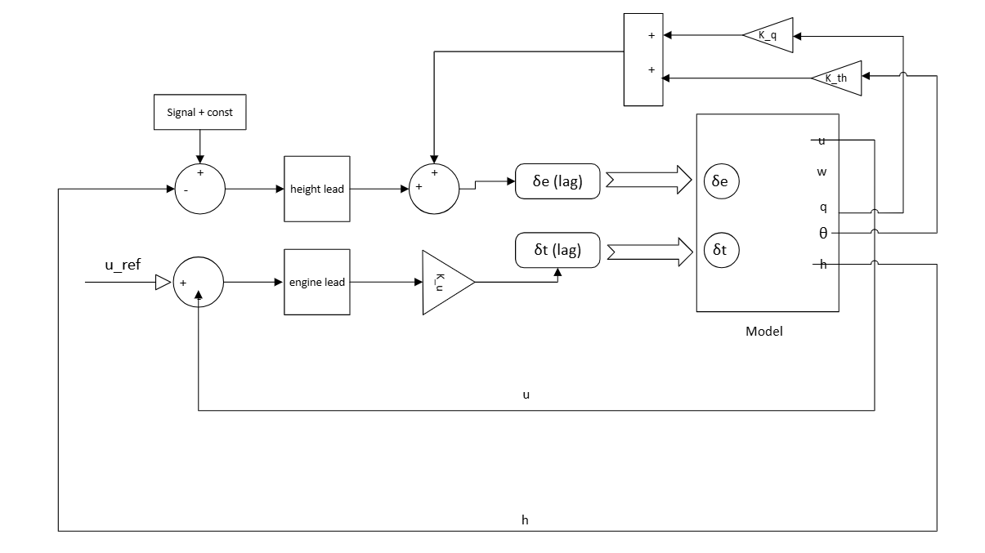
Schematic of Autopilot holding logic for ($θ,u,w,h)$
The autopilot system is designed to track a reference pitch angle $θ_{\left(ref\right)}$ using a Proportional-Integral-Derivative (PID) control law. For highly dynamic systems like the B747, a standard proportional controller is insufficient due to the inherent steady-state error (offset) that prevents the system from reaching the desired setpoint.

Controller Formulation and Stability
To ensure precise tracking, the control signal $δ_{e}$ (elevator deflection) is calculated as:
$$u\left(t\right)=K_{p}e\left(t\right)+K_{i}\int{e\left(t\right)}dt+K_{d}\frac{de\left(t\right)}{dt}$$
- Inner Loop (pitch) PID:
$$δ_{e}\left(t\right)=K_{p}\left(θ_{ref}-θ\left(t\right)\right)+K_{i}\int_{0}^{t}{\left(θ_{ref}-θ\left(τ\right)\right)dτ}+K_{d}\dot{θ}\left(t\right)$$
- Throttle (Velocity) (P or PI):
$$δ_{t}\left(t\right)=K_{tp}\left(u_{ref}-u\left(t\right)\right)+K_{ti}\int{\left(u_{ref}-u\right)dt}$$

The selection of gain polarity is critical for closed-loop stability. In the B747 longitudinal model, the pitching moment derivative with respect to elevator deflection $\left(M_{δe}\right)$ is negative ${(M}_{δe} ≈ -1.444)$. This physical characteristic implies that a positive elevator deflection produces a downward (negative) pitching moment.
To counteract this and ensure negative feedback, negative gains for $K_{p}$ $and$ $K_{i}$ must be utilized. If positive gains were applied, the system would experience positive feedback, causing the pitch angle to diverge rather than converge to the reference $R\left(s\right)$.

- Integral Action $\left(K_{i}\right)$: Eliminates the steady state offset, allowing the plant to settle exactly at the reference.
- Derivative Action $\left(K_{d}\right):$ Applied to the pitch rate $\left(q\right)$, providing the necessary aerodynamic damping to suppress oscillations during rapid transitions.
- Proportional Action $\left(K_{p}\right)$: Establishes the primary control sensitivity by generating a corrective response proportional to the magnitude of the tracking error. This action reduces the rise time and ensures the system initiates a rapid corrective maneuver to minimize deviations from the desired flight path.
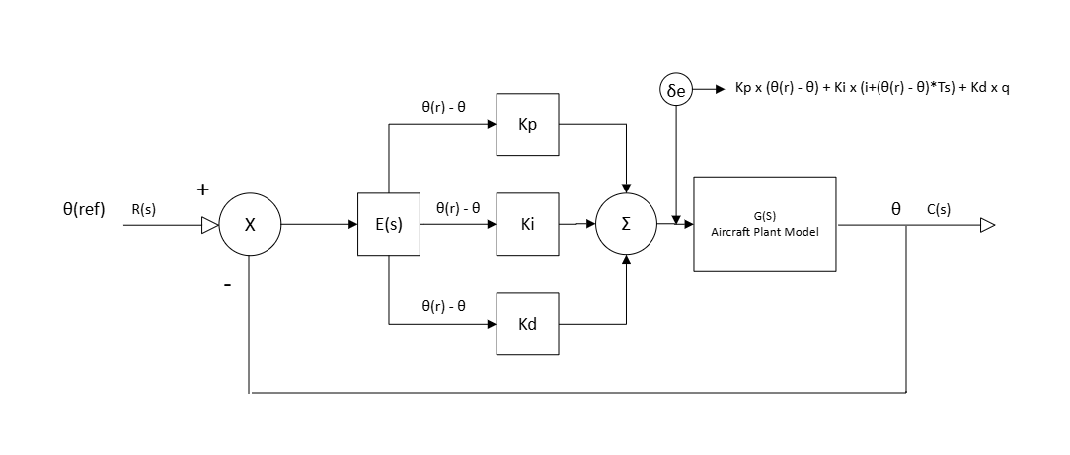
Autopilot without altitude case

Fault Injection and Data Quantization Architecture
To evaluate the robustness of the estimator, a dual-model framework is employed. This architecture consists of two synchronized instances: an In-Air model (representing the remote aircraft) and an On-Ground model (serving as the reference observer).
- Fault Modeling
To simulate realistic flight conditions, faults are introduced into the In-Air system as additive or multiplicative biases. These are categorized into:
- Sensor Degradation: Modeled as drift or bias in the output states $\left(θ,q\right)$, simulating IMU (Inertial Measurement Unit) inaccuracies.
- Actuator Failure: Modeled as anomalies in the control inputs $\left(δ_{e},δ_{p}\right)$, representing mechanical sticking or hydraulic pressure loss in the elevator or thrust systems.

- Bit-Packing and Quantization Theory
To address the challenges of limited downlink bandwidth, the high-rate state vector $x_{\left(air\right)}$ undergoes a lossy compression process. The continuous state values are mapped to a discrete space using a 7-bit linear quantization scheme.
Mathematically, the quantized value $x_{q}$ is derived from the continuous value by:

$$x_{q}=round\left(\frac{x-x_{\left(min\right)}}{Δ}\right)$$

Where $Δ$ is the quantization step size determined by the range of the parameter. By assigning 7 bits per parameter, we achieve a resolution of $2^{7} = 128$ discrete levels. These values are then bit-packed into a 32-bit word format, significantly reducing the transmission footprint. This process introduces "quantization noise," which the ground-based estimator must filter out to reconstruct the original state.

- Residual Generation and Dequantization
At the ground station, the 32-bit word is unpacked and dequantized. The resulting signal, ${\hat{x}}_{\left(dequant\right)}$, is compared against the expected state from the reference model. The difference, or residual, serves as the innovation sequence for the filtering stage. A significant or abrupt increase in this residual indicates that the In-Air model has deviated from nominal behavior due to an injected fault.

On-ground estimator and anomaly detector
Adaptive Kalman Filtering for Anomaly Detection
The diagnostic core utilized an Adaptive Kalman Filter (AKF) to estimate the aircraft’s state while mitigating quantization noise and injected anomalies. The estimation process followed a standard recursive cycle. The prediction phase utilized the discrete transition matrix $\left(ϕ\right)$ and control input matrix $\left(Γ\right)$:
$${\hat{x}}_{k}^{-}=ϕ{\hat{x}}_{k-1}^{+}+Γu_{k-1}$$
During the update phase, the Kalman gain $\left(K_{k}\right)$ was calculated to weigh the reliability of the model predictions against incoming telemetry:
$$K_{k}=P_{k}^{-}C^{T}{\left(CP_{k}^{-}C^{T}+R\right)}^{-1}$$
To account for dynamic channel conditions, the measurement noise covariance $\left(R_{k}\right)$ was updated via a convex combination: $R_{k}=αR_{k-1}+\left(1-α\right)….$, where $α$ represents a smoothing factor as illustrated in the system flow chart below:

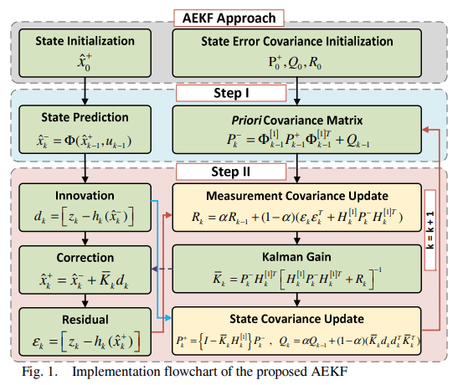

Stochastic Tuning and Anomaly Detection
The filter was characterized by strategic stochastic tuning of the process noise covariance $\left(Q\right)$ and measurement noise covariance $\left(R\right)$. By scaling $R$ to maintain high filter "inertia," the estimator was biased toward internal model predictions. This design choice ensured that during an anomaly, the filter would not immediately track the faulty data, thereby creating a measurable "gap" between the estimated trajectory and the actual faulty state curves.
The system performed real-time detection by monitoring the residual generation $\left(r_{k}\right)$:
$$r_{k}=y_{decoded,k}-H{\hat{x}}_{k}^{-}$$
Detection logic was applied to these residuals using a defined threshold or a likelihood ratio test. Significant deviations between the reconstructed behavior and the expected model triggered an anomaly flag. Furthermore, the Kalman Gain $\left(K\right)$ served as a secondary diagnostic tool; as the filter attempted to correct discrepancies caused by hindrances, the resulting spikes in the gain trajectory identified the exact onset of faults.
For efficient computation, Cholesky Decomposition is utilized rather than standard LU decomposition. Since the covariance matrix $R$ is symmetric and positive definite, it can be factorized as $R=LL^{T}$. This is particularly effective for Monte Carlo simulations and solving linear systems, as it ensures numerical stability when generating noise vectors $\left(z=L∙randn\right)$. For future non-linear expansions, an Extended Kalman Filter (EKF) is proposed, utilizing Jacobian matrices to linearize the system at each time step.

Response to Doublet Command Signals
The controller was tested using a doublet signal as the reference input $R\left(s\right)$ for $θ$. Through iterative tuning, the gains were set to $K_{p}=-1,{ K}_{i}=-0.9, K_{d}=0.5$. As shown in the simulation results, these parameters allow the output $θ$ to follow the doublet command with minimal overshoot. Although a high sampling rate (12,000 samples) was used to visualize the fine details of the rise and settling times, the controller remains robust even at lower sampling frequencies, which is essential for bandwidth-constrained environments.

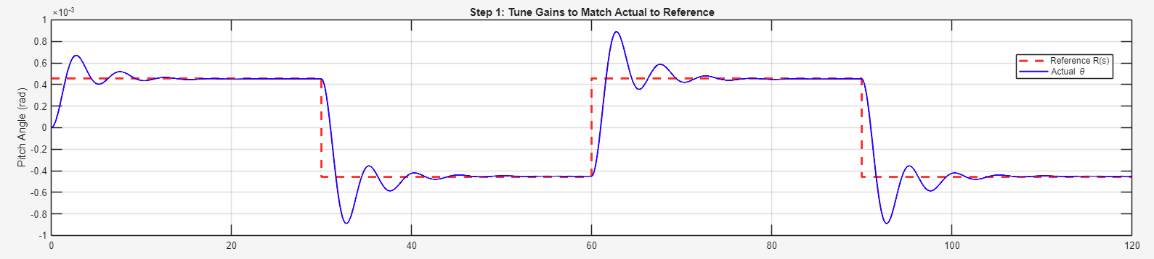
Pitch Hold Curve [Y: Pitch Angle and X: time]
Analysis of Velocity Perturbations and State Coupling
The longitudinal flight dynamics exhibit strong coupling between the pitch angle $\left(θ\right)$ and the perturbation velocities: forward velocity $\left(u\right)$and $vertical$ velocity $\left(w\right)$.
Observation of the simulation data reveals that during the interval where the pitch angle decreases (e.g., $t = 30 to 60 seconds)$, there is a corresponding exchange of kinetic and potential energy:
- Forward Velocity $(u)$: Increases as the aircraft pitches down, reflecting the conversion of altitude/potential energy into speed.
- Vertical Velocity $\left(w\right)$: Exhibits a simultaneous decrease.
These disturbances are expected in a high-fidelity model. The ability of the controller to maintain a stable pitch angle despite these velocity fluctuations demonstrates the efficacy of the PID loop in managing the aircraft’s multi-variable dynamics. While the velocities fluctuate, they remain bounded, confirming that the system maintains dynamic equilibrium throughout the doublet maneuver. Signal below snippet from 30-60 seconds.
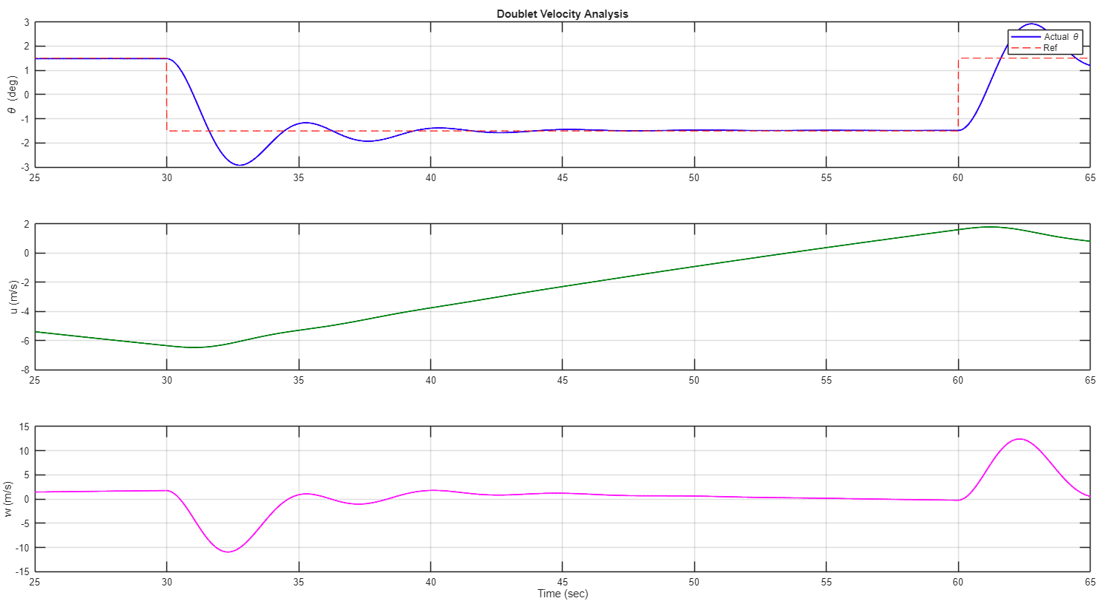
Fig1: (x: time, y: $θ$), Fig2: (x: time, y: $u$), Fig3: (x: time, y: $w$)
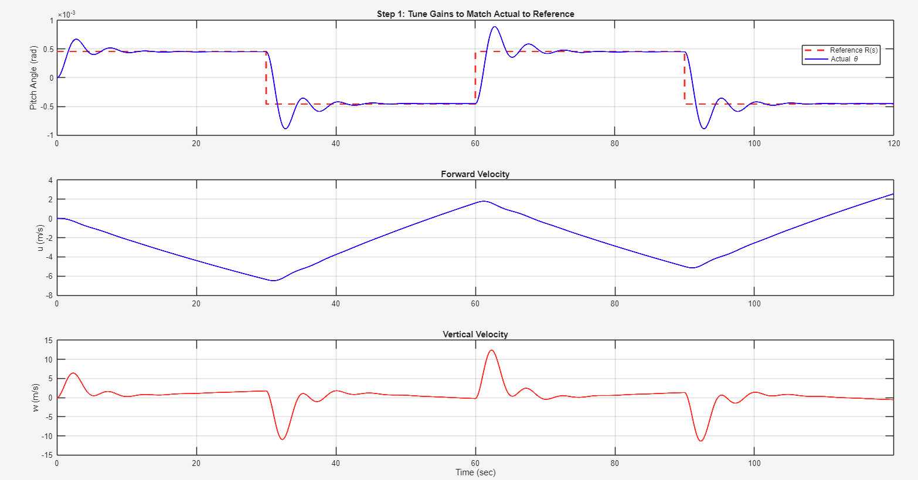
Figure: Full spectrum analyzed for all 3 signals

Atmospheric Modeling and Enhanced Flight Control
- Modeling Non-Linear Stochastic Perturbations (Wind Gusts)
In realistic flight envelopes, aircraft are subjected to continuous atmospheric turbulence and discrete gusts. To simulate these conditions, the nominal state-space representation is augmented to account for the relative motion between the aircraft and the atmosphere.
Aerodynamic forces are a function of the relative velocity $\left(v_{\left(rel\right)}=v_{\left(air\right)}-v_{\left(gust\right)}\right)$. Consequently, the linearized longitudinal equations of motion must be modified to include the gust velocity vector $w_{g}={\left[u_{g},w_{g},q_{g}\right]}^{T}$. The augmented state-space equation is defined as:

$${\dot{x}}_{air}=A_{d}x_{air}+B_{d}u_{vec}+B_{wg}w_{gust}$$

Where $B_{\left(wg\right)}$ represents the wind gust disturbance matrix. The rotary gusts $\left(p_{g},q_{g}\right)$ are treated as spatial variations of the vertical gust field, specifically where the pitch rate gust is defined by the gradient $q_{g}=\frac{∂y}{∂x}$. This ensures that the model accounts for the aircraft's posture changes during turbulence in the cruise phase.

- Wind Shear and Altitude Coupling

Wind shear presents a critical challenge during low-altitude maneuvers. It is modeled as a localized change in horizontal and vertical velocities relative to altitude $\left(h\right)$. The relationship is governed by the shear gradient $\frac{du}{dh}$. The rate of change of altitude is coupled to the state vector via:

$$\dot{h}=U_{0}\left(θ-α\right)$$

This introduces a two-way dynamic coupling:
- State-Dependent Forcing: Variations in altitude $\left(h\right)$ alter the effective gust velocity acting on the airframe.
- Aero-Elastic Impact: Aerodynamic forces modify the flight path, subsequently impacting $θ and α$, creating a closed-loop dependency between altitude and longitudinal stability.

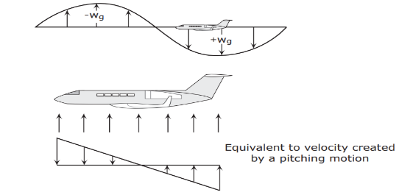
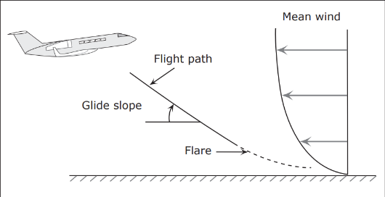

- Augmented State-Space Matrix (Altitude Integration)

To facilitate altitude hold, the state vector is expanded to $x={\left[u,w,q,θ,h\right]}^{T}.$ The resulting $5 x 5$ system matrix incorporates the kinematic relationship of altitude:

$$\left[\begin{matrix}u^{.} \\ w^{.} \\ q^{.} \\ θ^{.} \\ h^{.}\end{matrix}\right]=\left[\begin{matrix}X_{u} & X_{w} & 0 & -g\cos{γ} & 0 \\ Z_{u} & Z_{w} & U_{0} & -g\sin{γ} & 0 \\ M_{u} & M_{w} & M_{q} & 0 & 0 \\ 0 & 0 & 1 & 0 & 0 \\ -\sin{γ} & \cos{γ} & 0 & U_{0}\cos{γ} & 0\end{matrix}\right]\left[\begin{matrix}u \\ w \\ q \\ θ \\ h\end{matrix}\right]+\left[\begin{matrix}B_{11} & B_{12} \\ B_{21} & B_{22} \\ ⋮ & ⋮\end{matrix}\right]\left[\begin{matrix}δ_{e}δ_{p}\end{matrix}\right] + \left[B_{\left(wd\right)}\right]\left[\begin{matrix}u_{g} \\ w_{g} \\ q_{g} \\ \end{matrix}\right]$$

Pitch-Angle ($θ$) Hold
A PID loop is implemented to track a doublet command signal. Despite the injection of periodic sine-wave vertical gusts $\left(w_{g}\right)$, the controller maintains a stable $θ$ orientation.
Gains: $K_{p}=-2,K_{i}=-0.8,K_{d}=0.5$.
The negative gain logic compensates for the $M_{\left(δe\right)}$ pitching moment, ensuring the output converges to reference even under stochastic oscillation.

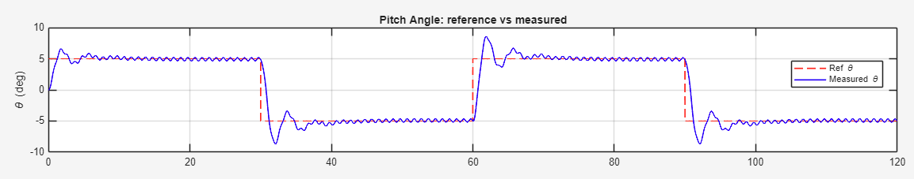
Theta ($θ)$ holding plot [Y: $θ$, X: time]

Forward Velocity and Thrust Regulation
Forward velocity $\left(u\right)$ is regulated through a feedback loop controlling the thrust command $\left(δ_{p}\right)$. While a PI controller provides zero steady-state errors, it may introduce undesirable oscillations in the thrust setpoint. A simplified Proportional (P) controller, or a PI with a negligible integral gain$\left(K_{i}≈{10}^{\left(-9\right)}\right)$, was found to provide superior stability in the presence of gust-induced disturbances, effectively "holding" the velocity during turbulence.
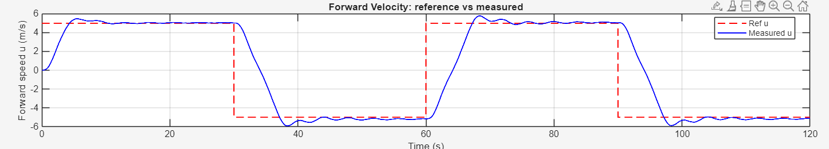
Velocity hold curve [Y: forward speed (u), X: time]
Altitude Hold (Outer Loop)
The altitude hold system represents the outer control loop. Because altitude is influenced by both vertical gust $\left(w_{g}\right)$ and forward velocity $\left(u\right)$, the response is inherently non-smooth.
Gains: $K_{p}=0.005,K_{i}={10}^{\left(-6\right)}$
The system demonstrates a gradual reconstruction of the desired altitude, proving that the low-gain PI approach successfully filters high-frequency vertical disturbances while maintaining long-term reference tracking.
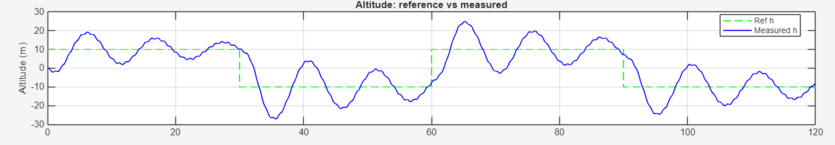

Integrated Thrust and Velocity Regulation
The final component of the In-Air autopilot is the auto-throttle system. By utilizing thrust $\left(δ_{p}\right)$ as a secondary actuator, the aircraft can maintain forward velocity $\left(u\right)$ independently of pitch maneuvers.
Initial testing with a PI controller $\left(K_{p}=0.1,K_{i}=0.05\right)$ successfully held the velocity setpoint but introduced minor oscillations in the thrust command.
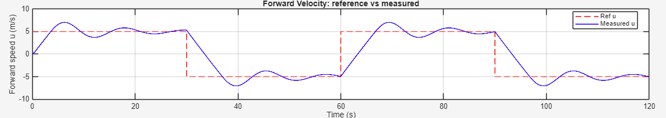
Forward Velocity Hold Plot

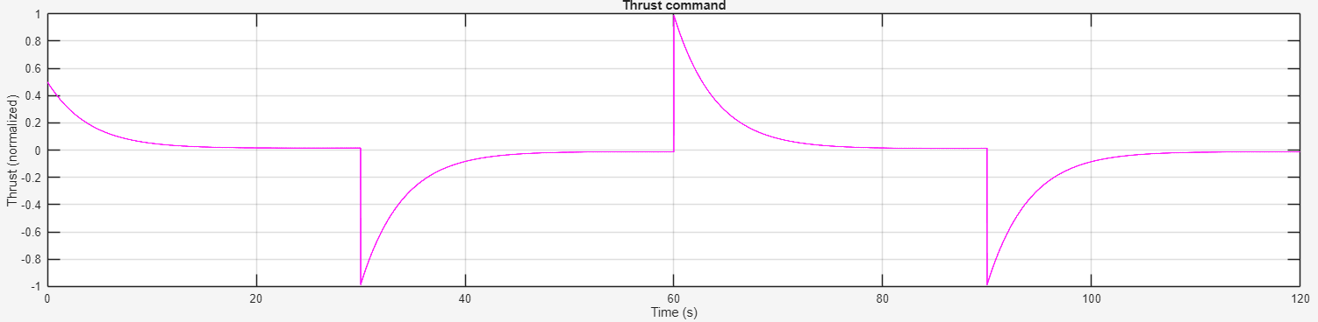
Thrust Command input that drives velocities [Y: Thrust, X: time]

“Optimizations: To stabilize the thrust signal, the integral component was reduced to near-zero $\left(K_{i}≈0\right)$. This Proportional-dominant approach proved sufficient to "hold" the velocity within a tight tolerance, preventing the engine actuators from overreacting to transient wind gusts.”
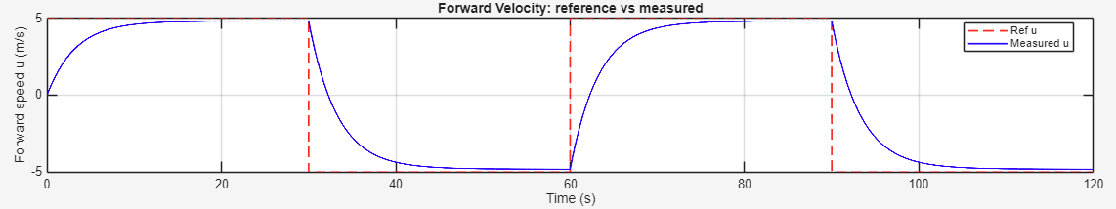
Optimized Holding of forward speed w.r.t thrust

The Role of Kalman Gain $\left(K\right)$
The Kalman Gain $\left(K\right)$ serves as the weighting factor that minimizes the mean squared error $\left(MSE\right)$ of the state estimate. It provides an optimal balance between the predicted state and new measurements:
- High Gain $\left(K→1\right)$: Indicates a high level of trust in the incoming sensor data, typically used when the model uncertainty is high.
- Low Gain $\left(K→0\right)$: Indicates that the internal model prediction is more reliable than the noisy or quantized measurement.

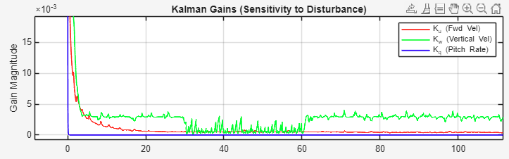
Kalman gains spikes when gust is there
To detect anomalies, the system compares the Theoretical Covariance $\left(S\right)$ with the Empirical Covariance $Σ_{\left(emp\right)}$. The empirical covariance quantifies how variables change together based on observed samples:

$Σ_{emp}=\frac{1}{N-1}\sum_{i=1}^{N}{\left(X_{i}-X\right){\left(X_{i}-X\right)}^{T}}$, [X = mean ($\bar{x)}$]

The diagonal elements represent the variance of individual states, while off-diagonal elements indicate cross-coupling. A significant discrepancy between $Σ_{\left(emp\right)} and S$ triggers the Adaptive R-scaling. During a vertical gust, the residual variance spikes; the filter detects this "physically unexpected" variance and increases the $R$ matrix value in the vertical channel, forcing the filter to trust its internal physics until the disturbance subsides.

The fidelity of the estimator is evaluated using the Mean Squared Error (MSE):
$$MSE=\frac{1}{N}\sum_{i=1}^{N}{{\left(Y_{i}-\hat{Y_{i}}\right)}^{2}}$$
The trace of the state error covariance matrix $\left(P\right)$ represents the total MSE of the state estimate $\hat{x}$ relative to the true state $X$. This paper’s objective is to minimize this trace to ensure the highest possible reconstruction accuracy.

Results and Discussion
- Gust Detection and Filter Adaptation

Simulation results confirm that AKF successfully identifies stochastic disturbances. When gusts are injected into the forward $\left(u\right)$ and vertical $\left(w\right)$ channels, the Kalman Gain deviates from its steady state. With tuned parameters filter adaptation becomes visible.

$$Q_{kf}=\text{diag}\left(\left[{10}^{-10},{10}^{-10},{10}^{-11},{10}^{-13},{10}^{-13}\right]\right)$$
$$(R_{kf}=\text{diag}\left(\left[{0.1}^{2},{0.1}^{2},{0.1}^{2},{0.01}^{2},1^{2}\right]\right))$$

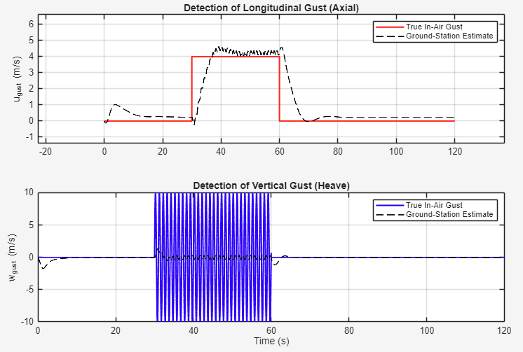
Gust Estimate

In the altitude channel, the KF estimate tracks the transmitted signal with high precision. However, under extreme gust conditions, the thrust controller reaches saturation, meaning the autopilot cannot generate sufficient counterforce to maintain the 5 m/s velocity reference. While the system remains stable, this saturation highlights the need for expanded control authority (increasing thrust limits) to reject high-magnitude disturbances.

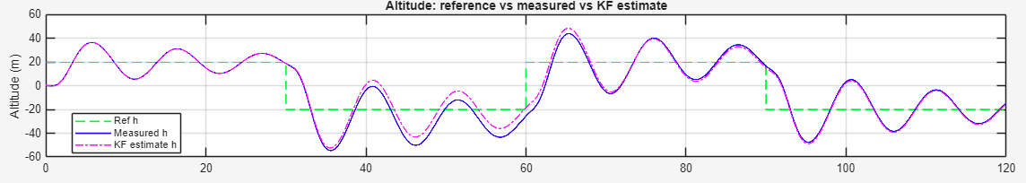
Altitude Holding when gust is introduced
- Residual Analysis

At a specific time step, the residual vector ỹ was calculated as:

ỹ = [-0.0104, -0.0036, -0.0068, 0.0015, 0.1947]

A positive residual $\left(e.g.,+0.1947 in altitude\right)$ indicates the sensor measurement is higher than the model prediction. These residuals are processed by the ground station to infer "hidden" forces. When the aircraft drops unexpectedly, the ground model recognizes that the internal physics should have maintained level flight; the resulting residual allows the system to estimate the magnitude of the external gust $\left(w_{g}\right)$.

Manual vs. Autopilot Mode Comparison

- Autopilot Mode: Holds state values using the integrated PID/LQE architecture. Tuning the Cholesky factor $\left(L\right)$ in the noise generation phase results in smoother state transitions.

- Manual Mode: Injects direct control inputs to observe the aircraft’s natural response to gusts without corrective feedback.

As shown in the velocity-hold figures, the autopilot successfully rejects the sine-wave gust components in $u$ and $w$. By utilizing the Kalman estimate for feedback, we eliminate the "actuator chatter" typically caused by raw quantized data, ensuring that the elevator and thrust commands are responding to true aircraft motion rather than measurement noise.

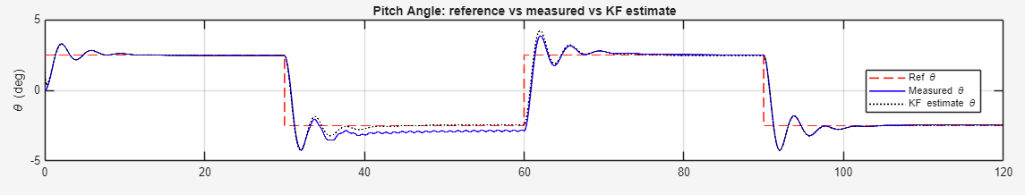
Estimating gust using Kalman filter [Theta $(θ)$ hold] and signal recovery

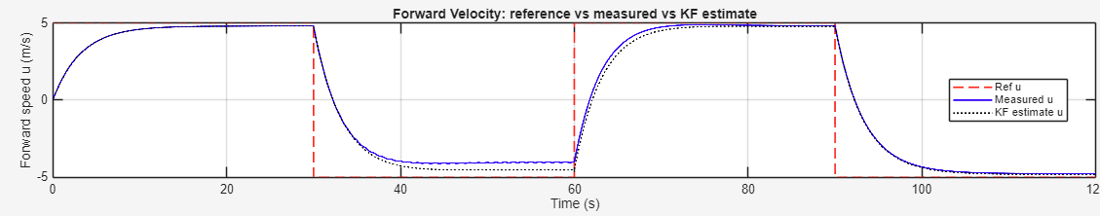
Estimating gust using Kalman filter [forward velocity $(u)$ hold] and signal recovery

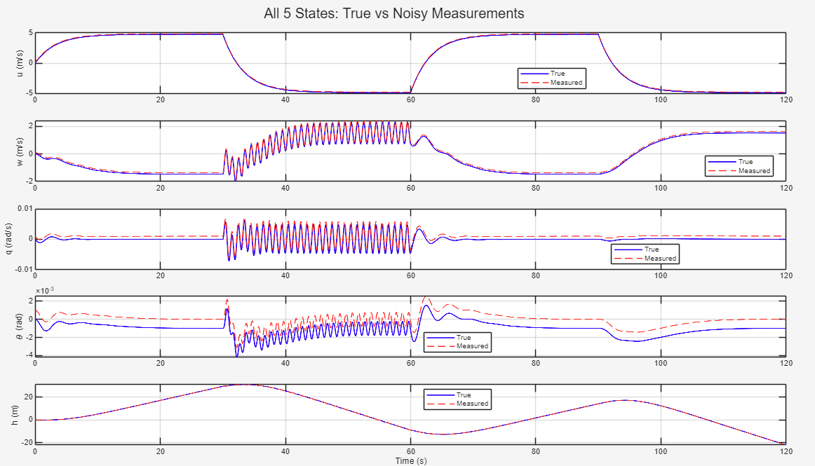
Detection of gust with Kalman filter

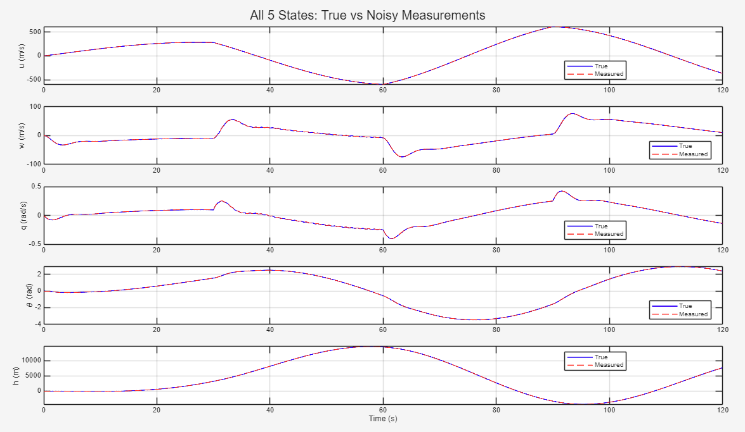
Detection of gusts without Kalman filter

REFRENCES:
- https://dspace.mit.edu/bitstream/handle/1721.1/10202/38272927-MIT.pdf?sequence=2&isAllowed=y
- https://ocw.mit.edu/courses/16-333-aircraft-stability-and-control-fall-2004/fb8395efd40e5f4a79b98fda10c85de3_l15_filter_examp.pdf
- https://www.researchgate.net/publication/271374403_Missile_longitudinal_autopilot_design_using_the_state-dependent_Riccati_equation_method
- https://ocw.mit.edu/courses/16-333-aircraft-stability-and-control-fall-2004/76c576f96472bf3052a038afba82feea_lecture_13.pdf
- https://ocw.mit.edu/courses/16-333-aircraft-stability-and-control-fall-2004/28b7f94207968c91ade88155ea9c5b00_lecture_6.pdf
- https://ocw.mit.edu/courses/16-333-aircraft-stability-and-control-fall-2004/pages/lecture-notes/
- https://arxiv.org/pdf/1702.00884
- https://en.wikipedia.org/wiki/State_observer
- https://www.researchgate.net/publication/375094324_Comparison_of_Adaptive_Kalman_Filters_in_Aircraft_State_Estimation
- https://planets.utsc.utoronto.ca/~pawel/Etkin-Dynamics_of_Flight.Stability,Ctrl-1995.pdf
- https://www.researchgate.net/publication/333203891_MODELING_AND_SIMULATION_OF_LONGITUDINAL_AUTOPILOT_FOR_GENERAL_AVIATION_AIRCRAFT

