**MOODBOARD**

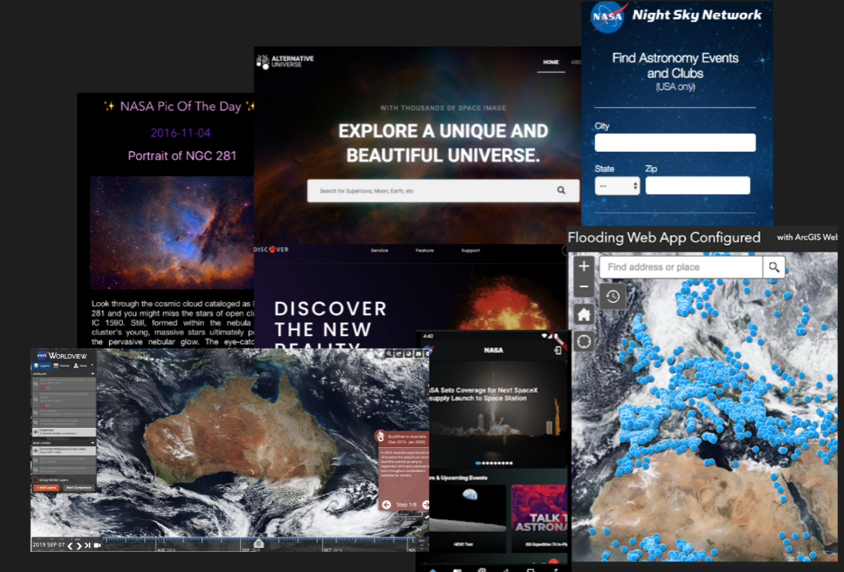

**FIRST SKETCH**

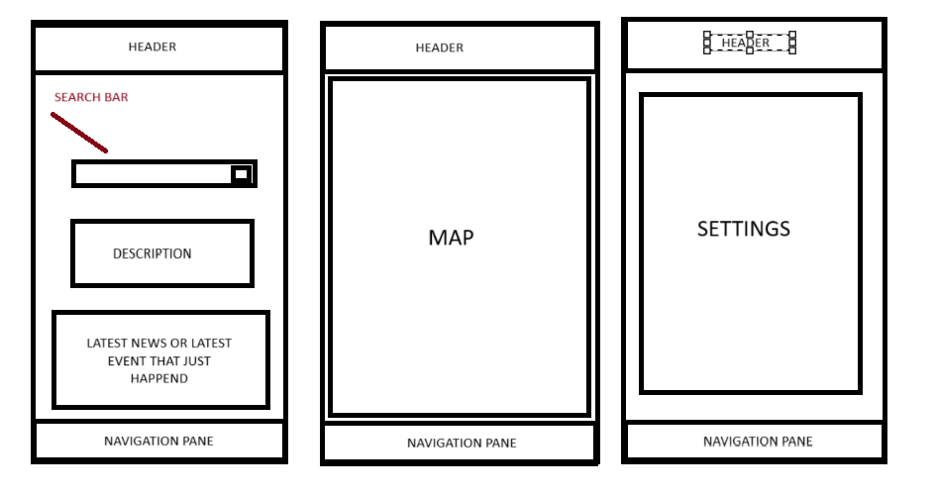

**FINAL WIREFRAME**

**­­][**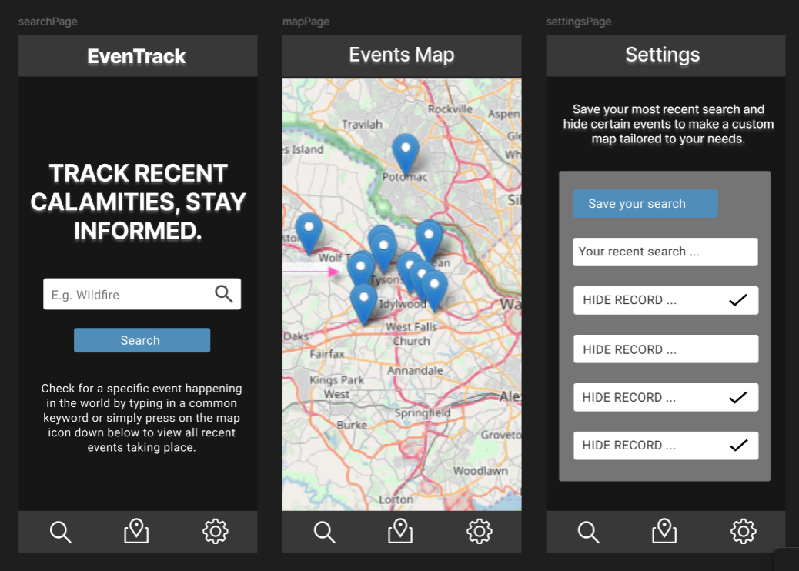

**TESTING DOCUMENTATION**

|  |  |  |  |
| --- | --- | --- | --- |
| **Function** | **Testing Phase** | **Status** | **Improvement** |
| apiResponse() | Checking whether the API returns data in json format and it’s updated through:  **tps://eonet.gsfc.nasa.gov/api/v3/events?limit=5**  Attempting to log the data and display it in the console to access the events array.  //console.log(json["events"][0]) | Successful API call made | N/A |
| function fetchData(userInputvalue) | Tested with each category listed on documentation, for example:  [**https://eonet.gsfc.nasa.gov/api/v3/events?category=drought**](https://eonet.gsfc.nasa.gov/api/v3/events?category=drought)    The return is empty. To make the most of out the implementation the code was later converted to only accept the 4 working events. | Most of the API events listed within documentation lack data. Only 4 events successfully return data. | Possibly searching for an API with accurate and regularly updated data. |
| function createMarker(jsonObj) | The code was displayed and first tested through the console to view the event coordinates fetch from EONET API.  //console.log(teswtingVariable[0]+""+testingVariable[1]) | The marker points successfully added to the map. | Future improvement focuses on naming the variables in a clearer way, for identification purposes. As well as adding a popup window for every marker to showcase the exact event and link to source. |
| function searchButton() | Input that varies from the listed keywords was also tested and no markers were created, as expected.  The user input was displayed in console to ensure it’s working.  //console.log(userInput)  Through the if statement two console logs showcased whether the input was accurately recognised.  //console.log("defined")  //console.log("undefined") | Once the button is clicked, the markers are added to the map | The code could be adjusted in a way to throw an error or alert the user to stop using unknown keywords or inform them about a typo they have made. |
| function saveToLocalStorage() | The code was tested through console.log to check whether the data is being stored.  console.log("Saved to Local text"); | The data is correctly stored in local format. | N/A |
| function getLocalStorage() | The button created in order to save the data locally was used to test whether the data was being returned, later displayed within the tab. | Data is being pulled from local storage and displayed only after reloading the page again. | N/A |