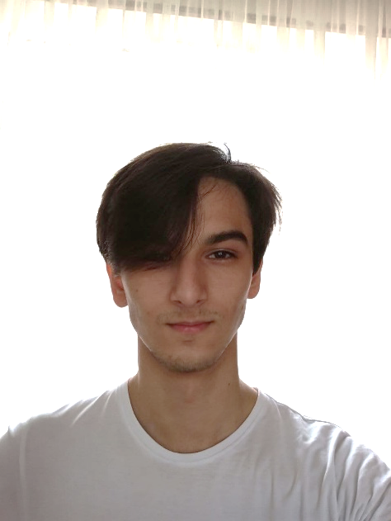**ARIFKHANOV AZAMATKHAN**

Date of Birth: 01.10.200  
Registration place: Russia, Moscow, 143002

Denis Davidov’s st., 9, 510

Citizen of Uzbekistan  
Phone: +79777755758  
aaarifkhanov@edu.hse.ru

**EDUCATION**

**B.A, Software Engineering, Higher School of Economics, 2023**

Term Papers:

* Second year, Research Project "Deep learning neural networks to control off-design contingencies", Thesis Advisor: Vasiliy Gromov, Prof.
* First year, Software Project: “3D Multiplayer Arcade with developed physics”, Thesis Advisor: Maksimenkova Olga, PHD.

**Lyceum, Academic Lyceum under Westminster International University in Tashkent, 2019**

**RESEARCH EXPERIENCE**

**Deep Learning Neural Networks to Control Off-Design Contingencies, Higher School of Economics, 2020-2021.**

A system of neural network technologies for processing the current state of the reactor at a nuclear power plant and predicting the future course of events. Goal: to reduce the error rate when predicting out-of-project accidents without relying on real statistical data.

**SERVICE**

Dormitory Student Union member. Responsible for University Buses Movement.

**EMPLOYMENT HISTORY**

**Team-Lead, Internews Europe – Good Communications PR Agency LLC Project,**

**4180-1 CA-DG-EC**

**07.20 – 01.21**

* Worked as International Project Tech-Leader, Theme “Strengthening resilience to radicalization and disinformation in Central Asia”
* Managed Work of Team according to their parts
* Created Game-Application using Unity, C#

**Intern, «Cбер» – team Sber AI.**

**01.07.21 – 21.07.21**

* Preparation of baseline solution for the hackathon together with the Ministry of Emergency
* Dataset preparation
* Preparation of manual

**RELEVANT SKILLS**

Programming ability in C#, C++, Java – University Course Level (Both Theory and Practice base)

Python. SQL, Git knowledge, Whole MS Office.

Extensive knowledge of Linear Algebra, Calculus, Discrete Mathematics, Probability Theory, Mathematical Statistics.

Data Analisys (Tinkoff course)

Fluent in Russian and English.