## **Intelligent Face Mask**

1. **Sensors:** Digital Microphone (MP34DT05), Temperature (HTS221), and Humidity (HTS221).
2. **Why we want to use them:**

First the digital microphone helps us to detect the whether the wearer cough or sneeze and runny nose with the sound, these three kinds of behaviors actually should have their own sound patterns, we could analyze it and find these 3 behaviors in the visualized data chart.

Secondly, we get our temperature data to see whether the wearer has any pattern of sickness or Abnormal body temperature (flu, allergies or covid symptoms).

Also, for humidity, we could detect whether wearer cough or sneeze since they will produce moisture that adheres to the mask.

1. **Data Processing and verification:**

In the chart above, I tried cough for a while and the PDM sensor successfully detect my sound and record it with the line chart, which shows the unique pattern of cough.

In addition, I also tried to sneeze and record the data, which is different from the chart above, so I do think these 3 patterns exist and easily to detect.

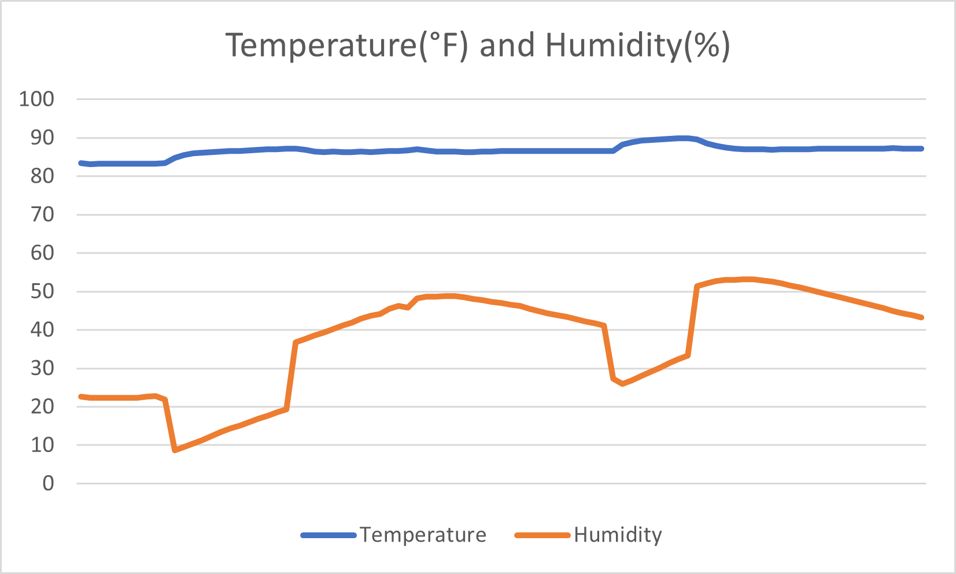

Here is the combined chart of Temperature and Humidity, I use the sensor to cough, and it will generate a curve in humidity data like the middle part of graph. And the temperature changes a little bit since I did not put it in the mask to experiment, so the temperature basically is still the temperature in the air, I will do further experiments if I have the chance.

1. **Discussion**

In sum, I think this small and light system with just 3 sensors could efficiently detect the cough, sneeze, and runny nose, which will help users to waive weight burdens of those detecting device and enable them to wear it every day without charging.

## **Activity Tracker:**

1. **Sensors:** Gesture (APDS9960), IMU(LSM9DS1)
2. **Why we want to use them:**

The gesture sensor enables us to know how the wearer move in up, down, left, or right. This is crucial since we can know whether wearer is in walking or running, and if the gesture changes quickly, we know the wearer are more likely to run instead of walk. We could even count the steps as the number of changes in the dataset.

What is more, with accelerometer sensor in IMU, we can calculate the rate of wearer doing their fitness and conclude whether the wearer is sitting, walking, or jumping.

1. **Data Processing and verification:**

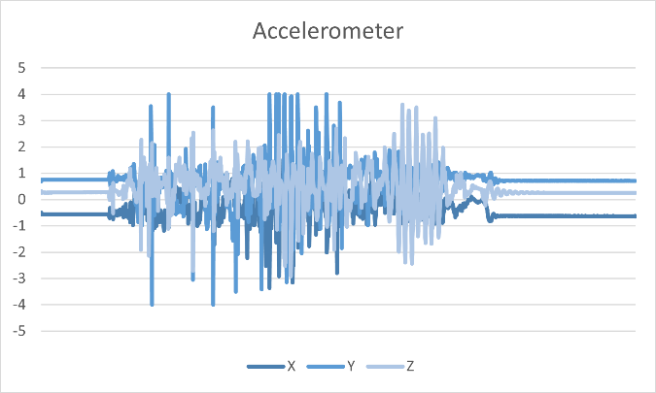

Here we have the acceleration/force of the wearer with x, y, z dimensions. As I try to jump first, the value become high and quickly return to 0 in the first half. And in the second half, I try to run for a while and the accelerations remain in a high value and keep it until I stop. Therefore, we could use this sensor to detect whether wearer is sitting without acceleration, jumping or running.

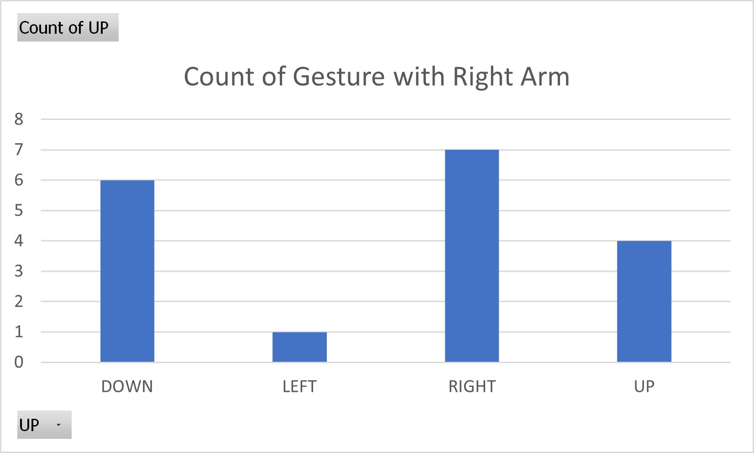

For Gesture sensor, I put the board on my right arm and simulate the movement of running, the gesture should be displayed alternately up and down, but this board cannot be fixed on my arm, so there is some data about right side, maybe we could fix it in the future. Overall, it still shows valid data in a small timestep, and the number of downs is the number of times I waved my arm (tracking steps), so it should be work in an activity tracking system.

1. **Discussion**

In conclusion, these 2 sensors are the most powerful sensors in this board, and I think they could effectively detect whether running, jumping, or sitting. These 2 sensors even help us to calculate the steps in an undirected way.