TITLE: “A Bite of Future”

- Target Group: 4-7 y.o.

- Activity Duration: 40 min

- Key Learning Goal:

- Understand that food is important: Students will learn why we need food to grow and be healthy, and that everyone needs to have enough to eat.
- Explore where food comes from: Students will discover that food comes from farms, gardens, and even labs, and there are different ways to grow and make it.
- Think about new kinds of food: Students will think about new foods and ways of growing food that might be used in the future to feed everyone.
- Learn about being creative with food: Students will use their imaginations to design fun and healthy future meals.
- Work together: Students will work in teams to share ideas and create their own future food plans.



Learning Outcomes:

Students will be able to:
- Understand that AI and robots help grow, pick, and package food.
- Recognize simple tasks that machines can do with AI guidance (e.g., watering, sorting, picking).
- Express their ideas about future food technology creatively.
- Cooperate and take on different roles in a group activity.

Knowledge & Understanding
Students will develop an early understanding of:
- Where food comes from and how it is produced today.
- How artificial intelligence helps make decisions on farms.
- That technology is already used to grow, pick, and prepare food (e.g., smart greenhouses, robots).
- The concept of “smart machines” or “robot helpers” in daily life.

Skills & Abilities:
- Role-playing and dramatic play skills.
- Communication and listening in group activities.
- Simple decision-making and cause-and-effect thinking (e.g., “If the plant is droopy → water it”).
- Drawing and storytelling to express creative ideas.

Attitudes & Values:
Students will be encouraged to:
- Show curiosity about how food is made.
- Appreciate teamwork and shared responsibility.
- Value technology as a helpful tool when used wisely.
- Feel confident in expressing future-oriented, imaginative thinking.

European Dimension / Erasmus+ Connection

- Promotes early STEM and digital education in line with European education priorities.
- Encourages awareness of sustainability, food security, and innovation across Europe.
- Supports key competences: cultural awareness, learning to learn, and digital literacy.
- Introduces children to technology’s role in global challenges, such as sustainable food production.
Resources and Tools
- Printed or digital version of “Farmer Ella and the Robot Helpers” story
- Role-play props: fruit/vegetable images, watering can, baskets
- Robot and AI name tags or stickers
- Drawing paper, crayons/markers
- Weather and crop condition cards (sun, rain, ripe fruit, etc.)
- (Optional) Digital whiteboard or slideshow
- AI image generation tools (used by teacher beforehand)

Working methods

- Storytelling to introduce and contextualize the topic
- Role-play for experiential learning and social interaction
- Creative drawing for personal expression and reflection
- Circle time for sharing and guided discussion
- Teacher facilitation with child-led participation
- Learning through play, emphasizing exploration and imagination

Introduction and Motivation | Research and Learning | Creative Application | Reflection and Evaluation
10 min  - The teacher will read or tell the story of Farmer Ella and the Robot Helpers  - The teacher will explain AI simply: “a smart computer brain”  - The teacher will ask: Who helps grow and make your food?  - Students will be divided in teams (3-4 students/team) | 20 min  - The students will act as robots (Picksy, Sprinkles, Packy) and plants  - One student (or the teacher) will take the role of the AI ("Brainy") and will give the other students instructions  - The teacher will use picture clues: weather, plant needs, ripe fruits | 15 min  - The students will design and draw their own food robot  - The teacher will add a simple sentence: “My robot helps by…”  - The teacher will create a classroom robot gallery display | 10 min  The teacher will organise:  - Group circle time: What did you learn?  - Emoji voting: Did you enjoy the activity?  - The teacher will ask the students to finish the sentence: “AI helps make food by…”  - The teacher will engage in classroom observation: The teacher will watch for understanding of roles and AI commands. The teacher will take note of teamwork, listening, and logical thinking. This informal teacher observation will always be situationally specific.

Introduction and Motivation

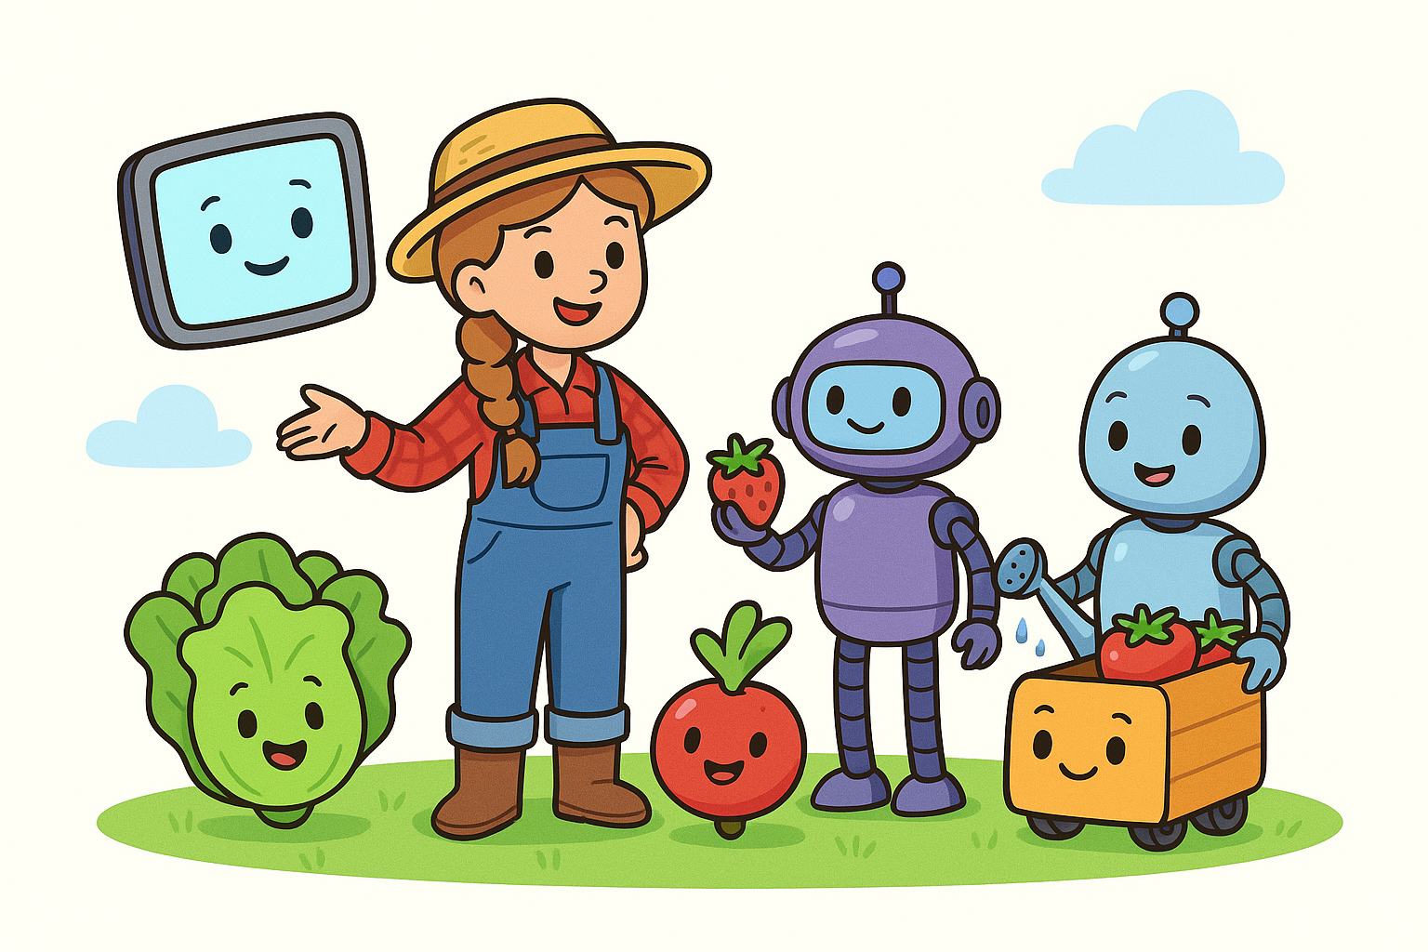The teacher will begin with a story:

"Farmer Ella and the Helpful Robots"
This is a story about how robots and computers (AI) help make the food we eat every day.

Once upon a time, there was a clever farmer named Ella.
She lived on a big, sunny farm where she grew carrots, apples, and lettuce. But Ella didn’t do it all by herself—she had robot friends and a super smart computer helper!

One robot, named Picksy, had long arms and wheels.
Picksy zoomed through the apple orchard.
“Beep! Beep! Ripe apple spotted!”
With a gentle grip, Picksy picked red apples and placed them into baskets. He could even work at night with his little headlight!

Another robot, called Sprinkles, helped water the vegetables.
But Sprinkles didn’t just spray water everywhere!
A smart computer with AI told Sprinkles,
“The lettuce is thirsty today, but the carrots are just fine!”
So Sprinkles only watered what needed it. That way, they didn’t waste water and kept the plants happy!

Inside the barn was the brain of it all: a smart AI computer named Brainy.
Brainy didn’t have arms or legs, but she was super helpful!
She checked the weather, planned when to plant seeds, and even told Farmer Ella:
“Tomorrow will be sunny—great for planting potatoes!”

In the factory nearby, robots helped pack the food.
Zoom! Lettuce went into clean plastic boxes.
Whirr! Carrots got sorted by size.
Click! Labels printed with names and dates.
The AI checked everything to make sure the food was clean, fresh, and safe to eat.

The next day, children at school opened their lunchboxes.
Inside were crunchy apples, carrot sticks, and fresh lettuce in their sandwiches.
They didn’t know it, but the food came from Farmer Ella’s smart farm—where robots and AI helped every step of the way!

At bedtime, Farmer Ella smiled.
“Thank you, robots,” she said.
“Together, we grow good food for everyone!”
And the robots beeped softly:
“You’re welcome, Ella!”
The teacher will ask these questions:
- Do you eat apples? Lettuce? Strawberries?
- Who do you think helps pick and pack all that food?
- What do you think robots can do on a farm?
- Have you ever talked to a smart computer before?
Transition to activity:
“Now YOU get to pretend to be the robots and computers that help make food!”

Research and Learning

Set the Scene: The teacher will explain the scenario to the students:
“You’re at Farmer Ella’s Smart Farm! There are:”
- Plants (some students will pretend to be lettuce, strawberries, etc.)
- Robots (some students will be robots) “Picksy” (robot picker) acts on the command. “Sprinkles” (robot watering) follows AI instructions. “Packy” (packing robot) gently packs play food into baskets or boxes.
- AI (a student or the teacher will be “Brainy,” the AI computer that gives instructions)
“Brainy” the AI says things like:
  - “Only water the plants that are droopy.”
  - “Pick the strawberries that are red.”
  - “Don’t water today, it’s raining!”
*This role can rotate regularly to give many students a chance to be the AI.
The teacher will provide props or printouts (e.g. paper fruits, watering cans, gloves, baskets).

Extension:
The teacher will use picture cards/ videos/ images showing:
- Sunny weather
- Rain
- Ripe fruit
- Droopy plants
The teacher will ask “Brainy” to decide what to do based on these clues. This will build logic & connection to real AI thinking!

Creative Application

Drawing Time: “Design Your Own Food Robot”
Each child creates their own food robot helper on paper.
Prompts:
- What is your robot’s name?
- What job does it do?
- How does it help with food?
Add sentence starters:
- “My robot helps by…”
- “AI tells my robot when to…”
Optional: Create a wall display titled “Our Food Robots”

Reflection and Evaluation

Class Reflection Circle
Ask:
- What was it like to be the AI or robot?
- What do you think AI helps with in real life?
- What job would YOU give a food robot?
Use emojis or happy/sad faces to vote:
- “Did you enjoy being a robot or an AI today?”
- “Would you like to have robots help with food at home or school?”

5. Teacher Observation & Light Assessment

While children role-play and draw, observe:
- Can they name what robots do on a farm?
- Do they understand that AI gives instructions?
- Are they working together, listening, and following instructions?
Optional exit activity:
Each child finishes the sentence:
“AI helps make food by…”

Colouring Page:

