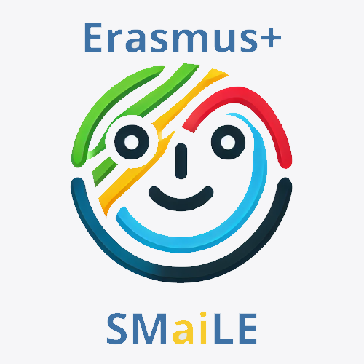
TITLE: “AI and Carbon Footprint“

- Target Group: 13-16 y.o.
- Activity Duration: 3 Weeks – 55 min/each session
- Key Learning Goal:

Raise awareness among students of the ecological impact of artificial intelligence, and help them critically explore how AI can both contribute to and help reduce carbon emissions.
Learning Outcomes:
By the end of the workshop, students will be able to:

Scientific Understanding
- Explain what a carbon footprint is and what “CO₂ equivalents” mean.
- Understand the energy and water consumption involved in AI operations.
Digital Awareness
- Evaluate the environmental impact of their digital habits.
- Compare the energy cost of different digital actions (email, streaming, search, AI training).
Critical Thinking
- Debate the ethical use of AI regarding the environment.
- Propose creative solutions using AI to reduce our ecological footprint.
Collaboration & Communication
- Work in teams to solve challenges.
- Participate in role-playing to simulate energy use of AI.
Present sustainable AI-based ideas to the group.

European Dimension / Erasmus+ Connection
This workshop encourages European students to think critically about the digital transition and sustainability – two key concerns of the EU. It highlights:
- Digital and Ecological Citizenship
Understanding the link between tech usage and environmental impact builds responsible digital citizens.
- Transnational Challenges, Shared Solutions
Students compare data center emissions in different countries and are encouraged to share solutions relevant in their local context and across borders.
- Innovation for Sustainability
The activities emphasize how digital innovation (AI in particular) can help us meet EU Green Deal objectives, encouraging youth involvement in building a greener future.
- Key Competence Development
  - Digital Competence
  - Scientific Literacy
  - Critical Thinking
  - nvironmental Awareness
  - Collaboration Skills
Working methods
- Inquiry learning
- Pair/team work
- Problem solving
- Using ICT tools in teaching

Introduction and Motivation | Research and Learning | Creative Application | Reflection and Evaluation
20 min  Video: https://www.youtube.com/watch?v=-sNKfRq1oKg  Discussion: Does using AI pollute more than we think? | 35 + 55 min  Activity 1. – Presentation + Worksheet  Activity 2. – Role-Playing Game – “If I Were an AI”  Students will work in teams (4 students) | 40 min  Designing a common mind map.  Students will work in a team (4-6 students)  Activity 1. Workshop “Can AI Help Reduce Our Carbon Footprint?”  Activity 2. Team presentation + Discussion | 15 min  Class Discussion:  What surprised you? What will you do differently now?  Digital Reflection:  Padlet or Google Form asking:  - What did I learn?  - What action will I take?

Introduction and Motivation
The teacher will start with an introduction:
Welcome to our exciting workshop about AI influence to a Carbon Footprint.
During the next 3 weeks we will implement different kinds of activities and explore the connection between artificial intelligence and its impact on the environment — especially how much energy AI uses and what that means for our planet.
Let’s start by watching a short video to learn more!
At the beginning we will watch the video: https://www.youtube.com/watch?v=-sNKfRq1oKg
What do you think about carbon impact of AI:
„Does using AI pollute more than we think? „ (short discussion)
As a conclusion we can expect students to realise that AI has a big influence on carbon footprint.
Why is it like that - together, we’ll research and discover how big an influence AI makes.

Research and Learning
Activity 1. – Presentation + Worksheet
The teacher will present the content of the Presentation: „AI and our planet!“ (Att. 2.1)
Students will be introduced to:
  - What is AI
  - How much energy and water it consumes
  - The real impact of data centers
  - Eco-gestures for digital responsibility
After presentation students will solve the task on the Worksheet (Att. 2. 2)
Activity 2. – Role-Playing Game – “If I Were an AI”
Objective: Experience firsthand how much physical resources, like electricity and water, “virtual” actions consume.
Before the workshop, the teacher will have to cut the cards for students. (Att. 2.3 – document for one team)
Students will work in a team (4 students) – randomly and use ChatBot (ChatGPT, MS Copilot...)
Teacher will explain to students the activities (Att. 2.4) A single question asked in a ChatBot consumes as much energy as a light bulb shining for 2 minutes, approximately 0.3 Wh per question. If the response also includes an image, it’s equivalent to drinking a glass of water.
For every question and follow-up question, attach a light bulb.

Activities:
- Role Assignment (Att. 2.3 and 2.4)
  - 2 students (using ChatBot and writing requests + times 10 min).
Student guidelines: During this activity try to find out:
How much CO₂ do humans and animals (e.g. cows) release?
What are the worst activities in terms of carbon footprint?
How much CO₂ do we release while watching TV for 1h?
How much CO₂ does a plane release for 1h?
How much CO₂ does a car release for 1km?

  - 2 students = the servers (place water/light cards)
Students will calculate how much water/electricity they spent during the activity.

- Resource Count
After each “AI prompt”, students place a light bulb card and a water card (representing resource usage).
At the end, they count total resource consumption. They can write it on the blackboard or Padlet, etc.
- Environmental Comparison
Students compare the result to:
  - Students convert the results in km of driving car
  - Students convert the results in min of a shower

Discussion results – Are students surprised with the results?

Creative Application
Designing a common mind map using Coggle, Canva or Miro...
Students will work in teams (4-6 students). They can stay in the same team as in the previous activity.

Activity 1. Workshop – “Can AI Help Reduce Our Carbon Footprint?”
Objective: Explore how AI can be a solution, not just a problem. Encourage creative thinking around AI’s potential.
At the beginning of the activity through short discussion we repeat the main facts and figures which we discussed in previous activities.
During the activity students will use tablets or laptops and ChatGPT or some other chatbot.
- Mini Game – “Guess the Impact”
Every student will research and match digital activities like watching HD video, sending an email, training an AI model, listening to music, playing video games etc. with their CO₂ emission estimates.
Students will share results with the other members of the team.
- Mission Sheet (Group Work):
Each team invents 2 AI-based solutions to reduce environmental impact in daily life. The teacher will guide students to avoid the same solutions.
Example prompts:
Smart AI to optimize home energy use
AI to reduce food waste in school cafeterias
AI ride-sharing algorithm to reduce traffic

All teams are using the same working area in the Collaborative tool for mind maps and create parts connected to their result.

Activity 2. Team presentation + Discussion
  - Presentations
Every team will present results to the other teams.

  - Discussion about the results of each team.

Reflection and Evaluation
Objective: Reflect on what was learned, assess participation and understanding, and encourage eco-responsible habits.
Activity 1. Digital Reflection
Padlet or Google Form asking:
What surprised me?
What did I learn?
What will I do differently now?
What action will I take?

Activity 2. Final Student Workshop Evaluation (Att. 4.1)
Teacher will prepare Google Forms or papers with evaluation question for each student:

