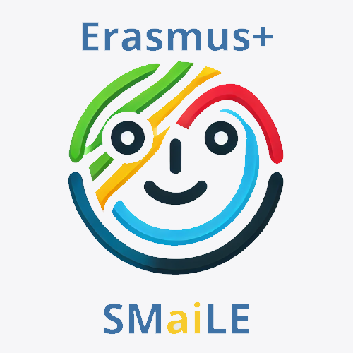
TITLE: “AI and the Environment“

- Target Group: 4 - 7 y.o.

- Activity Duration: 3 Weeks – (30–40 minute sessions recommended)

- Key Learning Goal:

Introduce children to the idea that technology and AI can affect the environment and show that small actions can help protect the planet.

Learning Outcomes:By the end of the workshop, children will be able to:
Scientific Understanding
- Recognise that using electricity (for AI, computers, or devices) affects the planet.
- Understand that “energy” comes from resources like water, sun, and wind.
Digital Awareness
- Identify simple daily actions that save energy (e.g., turning off devices, unplugging chargers).
Critical Thinking
- Suggest small ways technology can help the planet (e.g., robots that help recycle, AI for planting trees).
Collaboration & Communication
- Work in pairs or small groups to complete games and creative tasks.
- Share ideas with classmates through drawing, storytelling, or short role-plays.

European Dimension / Erasmus+ Connection | This workshop encourages European students to think critically about the digital transition and sustainability – two key concerns of the EU. It highlights:  - Digital and Ecological Citizenship: Introduces young children to being responsible with digital tools and energy usage.  - Transnational Challenges, Shared Solutions: Children can compare energy-saving actions at home, school, and in other countries.  - Innovation for Sustainability: Encourages creative thinking about how technology can help the planet.  - Innovation for Sustainability  The activities emphasize how digital innovation (AI in particular) can help us meet EU Green Deal objectives, encouraging youth involvement in building a greener future.  - Key Competence Development  - Digital Competence  - Scientific Literacy  - Critical Thinking  - Environmental Awareness  - Collaboration Skills
Resources and tools | - Books / Stories (PDF links provided):  - Energy Makes Things Happen – PDF  - Planet Power – PDF  - Energy Island – PDF  - The Boy Who Harnessed the Wind – PDF  - City Green – PDF  - The Water Princess – PDF  - Leonora Bolt: Secret Inventor – PDF  - Platforms for Creative Play:  - Minecraft: Education Edition (simple guided eco-city building)  - Eco-friendly AI apps for children (planting, recycling, or simple problem-solving)

Introduction and Motivation | Research and Learning | Creative Application | Reflection and Evaluation
30–40 minutes  Discovering Energy & AI  • Storytime introducing energy and how technology uses it.  • Simple discussion about where energy comes from.  • Children draw or talk about things that use energy. | 40 min  Learning Through Play  • “Energy Collector Game” – children collect stickers to learn that some actions use more energy.  • Team counting and comparing results.  • Discussion on saving energy. | 60 min  Creative Thinking  • Build or draw an “eco-city” showing how AI can help nature.  • Group sharing and storytelling. | 10–15 minutes  Reflection:  Children share what surprised them, what they learned about helping the planet, and one small action they can take to save energy.  • Reflect on what they learned and eco-friendly actions they can take.

Introduction and Motivation

Week 1: Introduction & Motivation
Teacher Activity:
- Welcome children: “Today we are going to learn about robots, computers, and how they use energy!”
- Read a short storybook from the list, e.g., Energy Makes Things Happen or Planet Power.
- Ask simple questions:
  - “What uses energy at home?”
  - “Can technology help plants, animals, or people?”
Child Activity:
- Draw or point to pictures of things that use energy.
- Share one thing they learned with a partner or group.

Research and Learning

Week 2: Learning Through Play

Duration: 30–40 minutes
Activity 1: Energy Collector Game
Goal: Understand that some actions use more energy than others.
Materials:
- 6–8 illustrated cards showing simple AI or technology tasks:
  - Robot vacuum
  - Watching a short video
  - Playing music from a speaker
  - Using a voice assistant
  - Turning on a tablet
- Stickers representing “energy points”
Instructions:
- Divide children into 2–3 teams.
- Place cards face down. Teams take turns picking a card.
- Each card shows energy points; children collect stickers.
- At the end, each team counts their stickers and compares total energy used.
Discussion:
- Which activities used the most energy?
- Why might that be?
- How can we save energy at home or school?

Creative Application

Week 3: Creative Application & Reflection
Duration: 30–40 minutes
Activity 2: Helping the Planet with AI (Creative Play)
Goal: Show that technology can help the environment.
Materials:
- Paper, crayons, Lego, or Minecraft: Education Edition
- Tablets/laptops for optional AI-assisted drawing
Instructions:
- Ask children: “How can robots or computers help nature?”
- Work in small groups to draw or build an “eco-city” featuring:
  - Green spaces or parks
  - Recycling robots
  - Solar panels or wind turbines
- Encourage simple explanations, e.g., “Our robot collects rubbish to help animals.”
Sharing:
- Each group presents their eco-city to the class using drawings, models, or tablets.

Reflection and Evaluation
Objective: Reflect on what was learned, assess participation and understanding, and encourage eco-responsible habits.

Activity:
- Children share orally or draw:
  - “What surprised me?”
  - “What can I do at home to help?”
Teacher Notes:
- Reinforce simple eco-actions: turning off lights, recycling, walking instead of driving.
- Encourage positive feedback and group discussion

