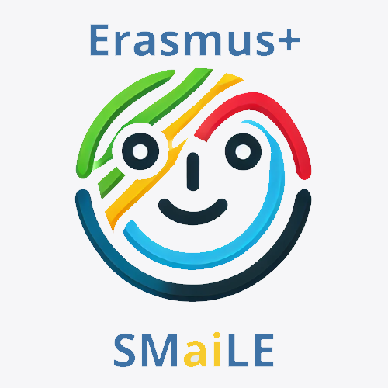
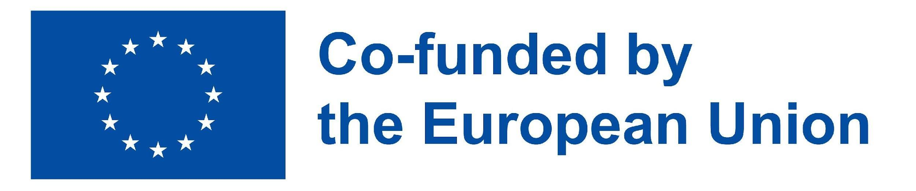

TITLE: Storytelling - Age of Discovery
Target Group: 8-12 y. o.

Activity Duration: 5 lessons (45 minutes each)

Key Learning Goal: To use storytelling to analyze how discoveries during the Age of Discovery shaped cultural heritage, transformed global interactions, and laid the groundwork for modern globalization and cross-cultural exchange.

LEARNING OUTCOMES:
Students will be able to:

KNOWLEDGE & UNDERSTANDING:
- Improve historical understanding by demonstrating knowledge of key events, figures, and motivations during the Age of Discovery

- Gather more geographical knowledge
Storytelling helps reinforce understanding of geography, as students learn about new lands discovered, routes taken, and the significance of maps from that era.

- Use diverse AI tools for education by creating examples on the topic with AI

SKILLS & ABILITIES:
- Develop research skills by conducting basic research using age-appropriate and safe sources (e.g., online articles, educational videos).

- Build up communication skills – students improve their written and oral communication skills through the creation and presentation of their work

- Enhance presentation skills as an important ability to deliver storytelling

- Strengthen critical thinking capacity to recognize bias in narratives and draw conclusions about historical events and their impact

- Reinforce content creation skills by using AI to suggest variations or unexpected perspectives and then refine students' own

- Teamwork and collaboration - students work effectively with a team

ATTITUDES & VALUES:
- Develop curiosity about history, cultures, and the world around them

- Show respect for diversity by cultivating an appreciation for diverse cultures, histories, and perspectives

- Personal development involves defining one's own beliefs, values, and perspectives influenced by past events

- Building up commitment to collaboration refers to the dedication and willingness of individuals to work together towards a common goal

- Adopting reflective practice involves continuous analysis and evaluation to foster personal growth

EUROPEAN DIMENSION / ERASMUS+ CONNECTION
This learning scenario supports the core values promoted by the Erasmus+ programme by offering students opportunities to explore Europe's historical and cultural roots while developing key competencies for the 21st century

1 Cultural Heritage and Historical Context
Students will explore the legacy of European explorers and how cultural exchange shaped both European identity and global heritage. This strengthens their understanding of Europe’s shared past, promoting a sense of belonging and intercultural awareness. (Supports cultural diversity and European identity.)
2 Social Integration
Through storytelling and group collaboration, students will learn to appreciate and respect diverse perspectives, including those of historically underrepresented groups. Activities foster empathy and inclusivity by examining both the benefits and the drawbacks of exploration. (Promotes inclusion and social cohesion.)
3. Economic Understanding & Global Awareness
Students will gain insight into how early global trade and exploration shaped modern economic systems, encouraging reflection on sustainability, fair trade, and ethical global relations. (Encourages critical thinking aligned with sustainable development goals.)
4. International Relations & Democratic Values
By analyzing the impacts of cross-cultural contact, students will understand the complexity of international cooperation and the value of peaceful global relations. (Fosters civic competence and global responsibility.)
5 Educational dimension through Digital Literacy and Language Skills
The use of AI tools, interactive maps, and digital storytelling platforms will promote creativity and technological skills. Students will learn to use digital tools critically and responsibly. (Aligns with the Erasmus+ digital transformation priority.)
6 Inclusion and Multilingualism
The activities will promote the use of different languages during research, discussion, and presentation phases, helping students strengthen their language awareness and ability to communicate across cultures. By encouraging participation from students with diverse linguistic and cultural backgrounds, the scenario fosters inclusive learning environments where every voice is valued.
(Supports multilingual competence and inclusion by ensuring all learners can engage meaningfully, regardless of language background.)
RESOURCES AND TOOLS
Resources Needed:

- WiFi connection and technology equipment (computers or tablets)
- Multimedia interactive tools (software, applications, and storytelling platforms for creating content)

Suggested Tools:
Research and AI Assistance:
- KidsChatGPT, Google Gemini, or Perplexity.ai – for guided historical research with age-appropriate supervision (Be aware that a lot of AI research tools have age restrictions.).
- Kiddle.co – a child-friendly search engine for safe internet browsing.
Mapping and Visualization:
- Google My Maps – for plotting explorers’ routes on digital maps.
- Canva for Education – to create infographics, posters, and illustrated timelines.
- Padlet – for organizing and visualizing content (e.g., food origins by continent).
Storytelling and Writing:
- My Diary App or Book Creator – for writing journal/diary entries or letters as explorers.
- StoryJumper – to turn diary stories into illustrated digital books.
- Storybird – visual storytelling using curated artwork for inspiration.
Visual Creation:
- Crayon (formerly DALL·E Mini) – AI image generation to illustrate diary entries.
- Artbreeder – for creating historical character portraits.
- AutoDraw – for quick and simple drawings to support presentations.
Presentations and Interaction:
- Genially or Google Slides – to create engaging, interactive visual storytelling presentations.
- Flip (formerly Flipgrid) – for recording and sharing oral storytelling or reflective videos.
Assessment and Feedback:
- Google Forms – for self- and peer-assessment.
- Mentimeter – to collect live feedback or reflections from students in an interactive way.

WORKING METHODS
This learning scenario uses a variety of innovative, student-centered working methods to foster engagement, collaboration, creativity, and critical thinking. The combination of traditional and digital approaches ensures inclusive and effective learning for students aged 8 to 12.
Inquiry-Based Learning
Students will be encouraged to ask questions, investigate historical events, and search for evidence using safe, age-appropriate sources and AI tools. This method promotes curiosity, independent thinking, and deeper understanding.
Project-Based Learning
Learners will work on extended tasks such as creating explorer profiles, mapping exploration routes, and writing fictional diaries. These real-world projects bring historical content to life and help students creatively apply their knowledge.

Storytelling
Storytelling is at the core of this scenario. Students will use it to connect emotionally with historical content, communicate ideas, and develop narrative skills through diaries, letters, and interactive presentations. It also fosters empathy and imagination.
Cooperative Learning
All activities are done in pairs or small groups, encouraging teamwork, peer learning, and social skills. Students will take on different roles and responsibilities, contributing to a common goal.
Problem-Solving
Through guided challenges, such as tracing explorers’ routes or analyzing the impact of discoveries on modern life, students will develop logical reasoning, decision-making, and analytical skills.
Experiential Learning
By imagining themselves as historical explorers and reflecting on their experiences through storytelling, students will engage in active, hands-on learning that makes the past more tangible and memorable.
Interdisciplinary Learning
This scenario blends history, geography, language arts, digital literacy, and citizenship education. Using AI tools enhances students’ technological competence, while the multilingual aspect develops their communication skills across disciplines.

Introduction and Motivation | Research and Learning | Creative Application | Reflection and Evaluation
15 minutes  Setting the stage for the scenario.  Providing background information and context that will engage students and prepare them for the activity.  ( Att 1.1)  - Watching the video  - Discussion question to encourage dialogue around the topic | 90 minutes  Project-based learning through assignments and research  - Group work, research of online sources, and team discussion  (Att 2.1, Att 2.2, Att 2.3, Att 2.4)  - Using digital tools | 90 minutes  Application of what has been learned through writing tasks and presentations  - Writing journals/diaries or letters  - Interactive presentations through storytelling | 30 minutes  - Self-reflection (guided questions)  (Att 3.1.)  - Peer feedback  - Teacher's feedback and evaluation – rubric  (Att 4.1.)

Introduction and Motivation
Setting the stage for the scenario.
The teacher will inform students that over the next three lessons, they will discuss and conduct research on the discoveries that dramatically changed Europe’s map of the Earth.
(Students should have some prior knowledge about the 15th and 16th centuries, or teachers can optionally use Att 1.1 (infographic) with the main discoveries of that period.)
Watch the video: The Age of Exploration ( Explainer YouTube channel, time duration 5:31)
LINK: https://www.youtube.com/watch?v=sGeXtUZQScc
For advanced classes: watch the YouTube video The Incredible Age of Discovery Explained in 10 Minutes
LINK: https://www.youtube.com/watch?v=wTjgBrlhzRs

To encourage creativity and personal connection to the subject, the teacher will ask the discussion question:
“If you had the chance to go on an adventure like an explorer in the 15th or 16th century, what new land and treasure would you want to discover, and why? “

Research and Learning

ACTIVITY 2.1
EXPLORER PROFILES
Students will work in small groups of 3 or 4 and will create detailed profiles of four famous explorers:
- Christopher Columbus,
- Vasco da Gama,
- Ferdinand Magellan,
- Amerigo Vespucci.
They will use AI tools to look up their background (3 important facts about the explorer), major voyages, and discoveries. The teacher will talk with the students about the importance of writing a quality prompt. Each group will fill out the information sheet
(Att 2.1., Att 2.2., Att 2.3., Att 2.4.)
AI Tools: text-based tools like ChatGPT or Google Gemini
The students will write down their findings, discuss, and share their findings using the strategy FISHBOWL DISCUSSION. The teacher will set the time limit. (3-5 minutes per group). A group of students will discuss a topic while others observe. After the set time, the observers can ask questions or share opinions.

ACTIVITY 2
CREATING ROUTES OF DISCOVERIES
Students will work in small groups. The teacher will prepare an A3 copy of the world map for each team. One of the explorers from the Age of Discovery will be assigned to them, and the students will collaboratively mark on a map the route of the assigned explorer's exploration, including significant places the explorer discovered.
The students will do the age-appropriate and safe sources research.
Recommended free sources:

1. CORE KNOWLEDGE FOUNDATION – “CKHG Unit 3: Age of Exploration“
https://www.coreknowledge.org/free-resource/ckhg-unit-03-age-exploration/
2. PRINTABLE MAPS (for the teacher)
https://www.printablee.com/post_black-and-white-world-map-printable_396505/
All the groups will share their findings with the others. The students will work collaboratively online to mark the route of their explorer on an interactive map by using Google My Maps or a similar tool to make their own customized map.
When all the groups have finished, they analyze and discuss. (activity 3)
AI Tools: Google My Maps

ACTIVITY 3
WHY IS CINNAMON IN MY CINNAMON ROLL, AND WHY ARE TOMATOES ON MY PIZZA?
In this activity, students will research and then compare the discoveries made by different explorers and will discuss their impact on the world.
The teacher will introduce by saying, “In the Middle Ages, people in Europe were unaware of many groceries that we consume daily, (The teacher will take a chocolate bar from a bag and continue) If you lived in the Middle Ages, you would never have tasted chocolate in your life. Do you know why? Can you name some other foods that are brought to Europe?”
The teacher will set the time (10 minutes), and the students will do the research using ChatGPT or Google Gemini. The students will use the AI-powered sorting tool Padlet to organize their findings. The teacher will prepare a Padlet with the names of the continents. Students will write what food was brought to the Middle Ages from which continent.
DISCUSSION: How do the findings change European cuisine?
AI Tools: The students use ChatGPT or Google Gemini. They can use Padlet for sorting to organize their findings or a visualization tool to create infographics, for example, Canva AI.

Creative Application
ACTIVITY 1:
THE DIARY OF __________________ (the name of the explorer)

Students will write diary/journal entries as if they were explorers embarking on their journeys, detailing their experiences and emotions. They will use an AI tool for writing.
The other option is to write a letter to a family member or a friend. (60 min)
After finishing their writing task, the students will use AI to generate visuals, such as illustrations, to complement their diary entries or a letter. It will add a multimedia dimension to the storytelling experience. (30 min)
AI Tools: My Diary

ACTIVITY 2:
INTERACTIVE VISUAL STORYTELLING: HAVE YOU EVER SAILED ON A CARRACK?
Students will prepare at home for an interactive storytelling of their diary entries.
Every student will prepare their entry question to engage the audience. (ex. Have you ever sailed on a carrack? * Carrack is a type of ship used for trade and exploration by many famous explorers. )
During the storytelling, they will use the generated visuals they have created in the previous task.
The teacher will set the time limit and make a teacher's evaluation rubric for storytelling. (Att 3.1.)

Reflection and Evaluation
Group Reflection and self-assessment (25 min)
Group discussion after completing activities.
- What went well and why?
- What challenges did we face and how did we address them?
- What can we improve for future projects?
Students individually fill out the self-reflection chart. (Att 3.1). It can lead to clearer goals and help them to understand their motivation and the importance of personal growth.

Teacher's evaluation and feedback
The teacher's evaluation of the activity follows. (Att 4.1.)

