**east west university**

**Lab Report - 01**

**Department:** **Computer Science and Engineering**

**Course Title:** Digital Image Processing

**Course Code:** CSE438

**Section No:** 02

**Submitted To**:

Dr. Engr. Ahmed Wasif Reza

Associate Professor, Department of Computer Science and Engineering

**Submitted By**:

Name: S M Arafat Rahman

ID: **2019-2-60-094**

**Solutions to Question - 01**

a) Read and show the image.

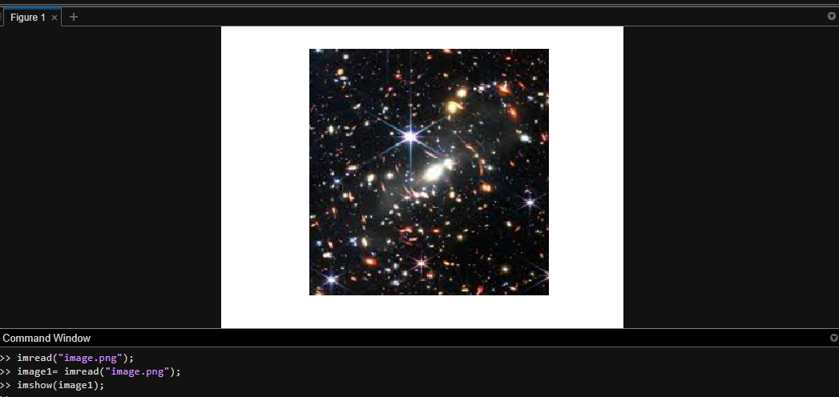

b) Show the matrix form of the image.

imread(“image.png”)

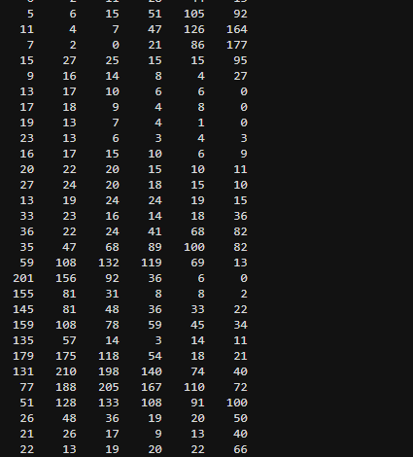

c) Show the pixel information by hovering the cursor on the image.

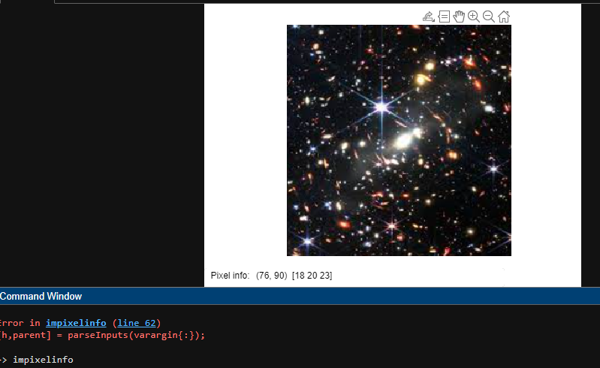

d)

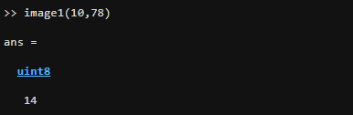

e)

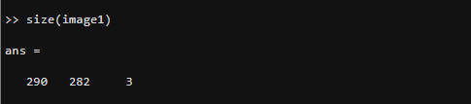

f) 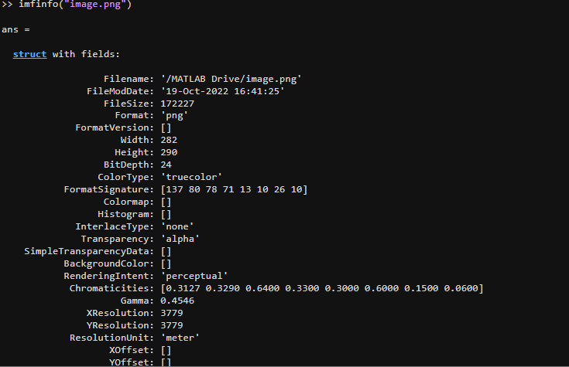

**Solutions to Question - 02**

a) Read and show all three types of images (RGB, Grayscale, and Indexed).

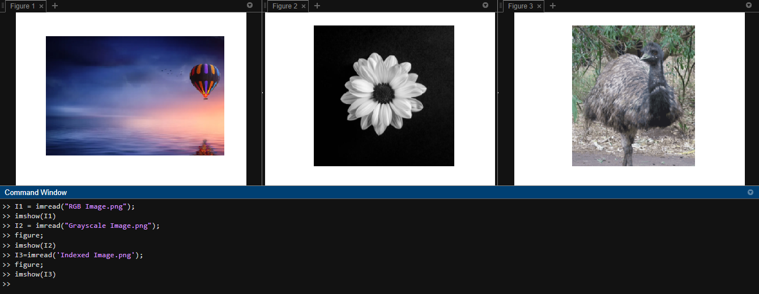

**Code:**

I1 = imread("RGB Image.png");

imshow(I1)

I2 = imread("Grayscale Image.png");

figure;

imshow(I2)

I3=imread('Indexed Image.png');

figure;

imshow(I3)

1. Turn the RGB image to a Grayscale image.

Code:

I1 = rgb2gray(I1);

imshow(I1)

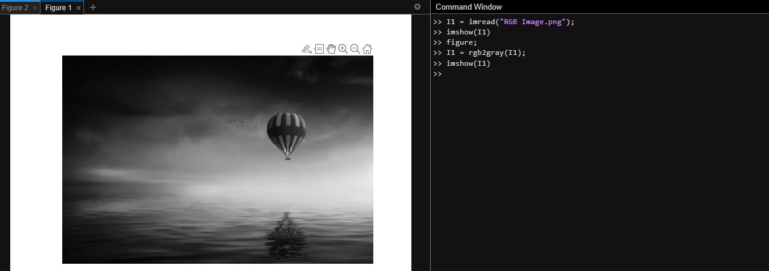

1. Turn the Indexed image to a Grayscale image.

Code:

[I4,I4map] = imread('Indexed_Image.png');

G2 = ind2gray(I4,I4map);

figure,imshow(G2)

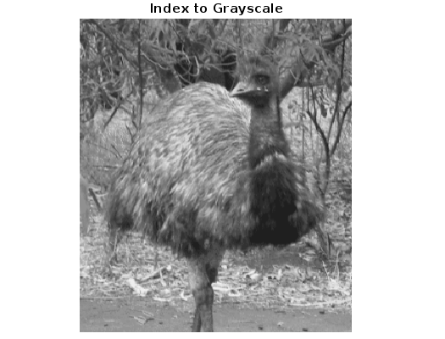

1. Turn the Indexed image to an RGB image.

rgb1 = ind2rgb(I4,I4map);

figure,imshow(rgb1

1. B_w1 = imbinarize(G2);

figure,imshow(B_w1)

1. figure,imshow(~Bw1)
2. figure,imhist(G2);
3. inv = imcomplement(rgb1);

figure,imshow(inv)

1. ww=7;

kernel = ones(ww)/ww^2;

blur1 = imfilter(rgb1,kernel);

figure,imshow(blur1)

**Solutions to Question - 03**

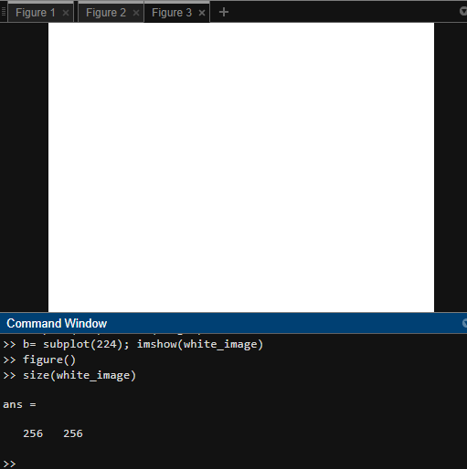

**Solutions to Question – 04**

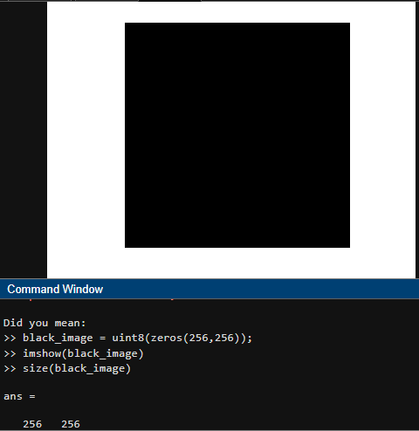

**Solutions to Question - 05**

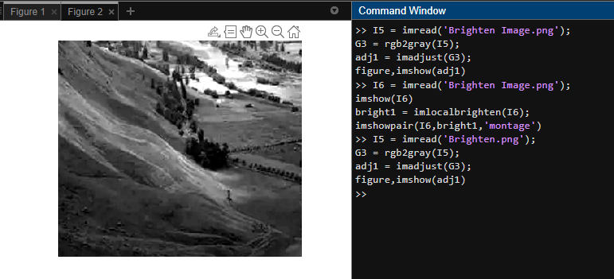

Code:

I5 = imread('Brighten.png');

G3 = rgb2gray(I5);

adj1 = imadjust(G3);

figure,imshow(adj1)

**Solutions to Question - 06**

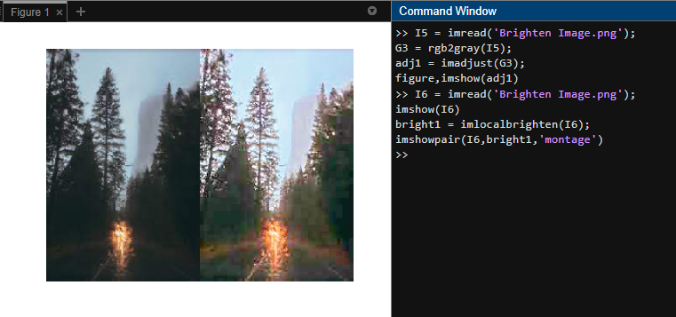

Code:

I6 = imread('Brighten Image.png');

imshow(I6)

bright1 = imlocalbrighten(I6);

imshowpair(I6,bright1,'montage')

**Solutions to Question - 07**

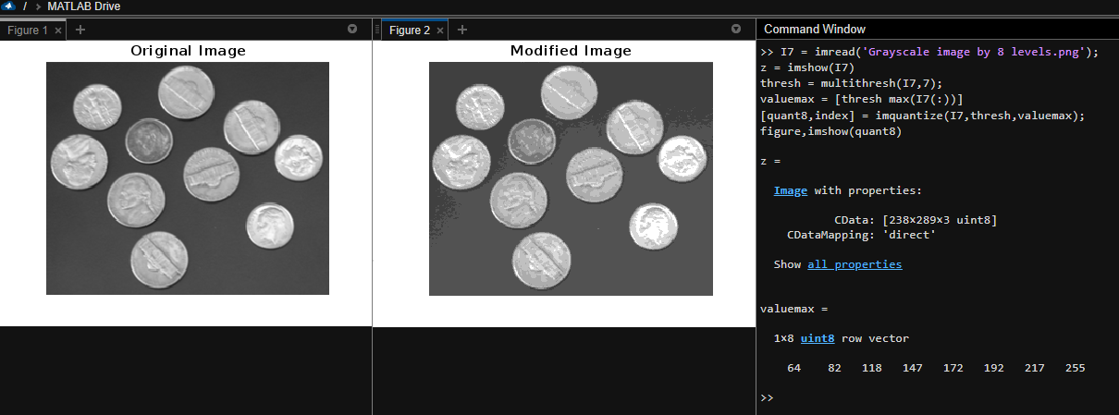

Code:

I7 = imread('Grayscale image by 8 levels.png');

z = imshow(I7)

thresh = multithresh(I7,7);

valuemax = [thresh max(I7(:))]

[quant8,index] = imquantize(I7,thresh,valuemax);

figure,imshow(quant8)