**east west university**

**Lab Report - 07**

**Department:** **Computer Science and Engineering**

**Course Title:** Digital Image Processing

**Course Code:** CSE438

**Section No:** 02

**Submitted To**:

Dr. Engr. Ahmed Wasif Reza

Associate Professor, Department of Computer Science and Engineering

**Submitted By**:

Name: S M Arafat Rahman

ID: **2019-2-60-094**

1.a)

Image =imread('Tumor.jpg');

grayIm =(Image);

I=rgb2gray(Image);

GI=imnoise(a,'gaussian');

Gg=im2double(GI);

Ord=1;

Kr=3;

Kc=3;

GF=exp(imfilter(log(Gg),ones(Kr,Kc),'replicate')).^(1/(Kr*Kc));

subplot(1,2,1),imshow(GI);title('Gaussian noise')

subplot(1,2,2),imshow(GF);title('Geometric Mean filter')

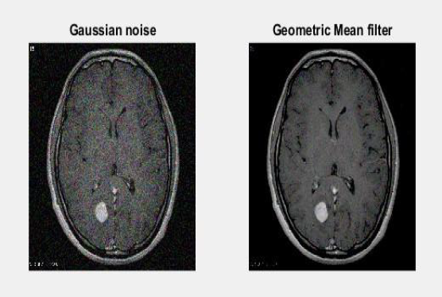

b)

Image=imread('Tumor.jpg');

grayIm =(Image);

I=rgb2gray(Image);

GI=imnoise(a,'gaussian');

Kr=3;

Kc=3;

Gg=im2double(GI);

GF=(Kr*Kc)./imfilter(1./(Gg+eps),ones(Kr,Kc),'replicate');

subplot(1,2,1),imshow(GI);title('Gaussian noise')

subplot(1,2,2),imshow(GF);title('Harmonic Mean Filter')

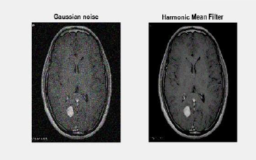

c)

Image=imread('Tumor.jpg');

grayIm =(Image);

I=rgb2gray(Image);

GI=imnoise(a,'gaussian');

Kr=3;

Kc=3;

Gg=im2double(GI);

GF=imfilter(Gg.^(Ord+1),ones(Kr,Kc),'replicate')./(imfilter(Gg.^(Ord),ones(

Kr,Kc),'repli cate')+eps);

>> subplot(1,2,1),imshow(GI);title('Gaussian noise')

subplot(1,2,2),imshow(GF);title('Contra Harmonic Mean Filter')

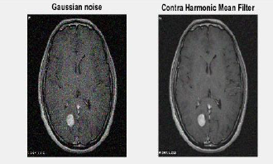

2.

a=imread('Tumor.jpg');

grayIm =(a);

I=rgb2gray(a);

GI=imnoise(a,'gaussian');

K = medfilt3(GI);

subplot(221);imshow(GI); title('Gaussian image');

subplot(222);imshow(K); title('Median filter image');

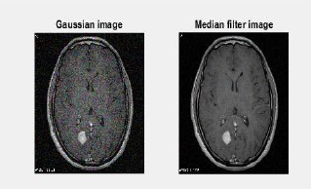

3.

By viewing and comparing the following outputs: Median filter, Maximum filter, Minimum filter, Midpoint filter, Alpha-trimmed filter, Trimmed filter Midpoint filter, in my opinion, returns the image closer to its original condition. The midpoint filter is commonly used to filter pictures with short-tail noise, such as Gaussian and uniform noise. The coordinates (x+i, y+j) are supplied over picture A, and I j) are defined over the N x N size square mask. This is the midpoint filter's definition.

4.

I = imread('Tumor.jpg');

>> level = graythresh(I)

level =

0.1725

>> BW =

imbinarize(I,level); >>

imshowpair(I,BW,'montage')

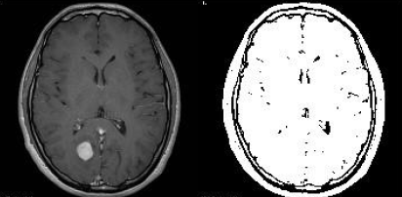

5.

Generally, segmentation algorithms are based on one of the following characteristics:

The abrupt shift in the intensity value of a pixel is referred to as discontinuity. The partition of an image's areas into separate ones based on specified criteria, such as thresholding, merging, expanding, and splitting of regions, is referred to as similarity.

There are various common picture segmentation methods. Techniques for segmentation include region-based, boundary-detection-based, pixel-based, and edge-based.