**east west university**

**Lab Report - 02**

**Department:** **Computer Science and Engineering**

**Course Title:** Digital Image Processing

**Course Code:** CSE438

**Section No:** 02

**Submitted To**:

Dr. Engr. Ahmed Wasif Reza

Associate Professor, Department of Computer Science and Engineering

**Submitted By**:

Name: S M Arafat Rahman

ID: **2019-2-60-094**

**Answer to the Question No. 01**

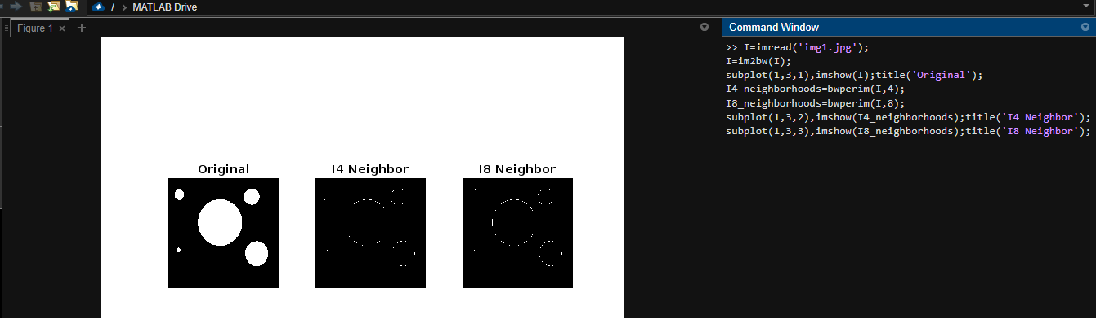

Code:

I=imread('img1.jpg');

I=im2bw(I);

subplot(1,3,1),imshow(I);title('Original');

I4_neighborhoods=bwperim(I,4);

I8_neighborhoods=bwperim(I,8);

subplot(1,3,2),imshow(I4_neighborhoods);title('I4 Neighbor');

subplot(1,3,3),imshow(I8_neighborhoods);title('I8 Neighbor');

**Answer to the Question No. 02**

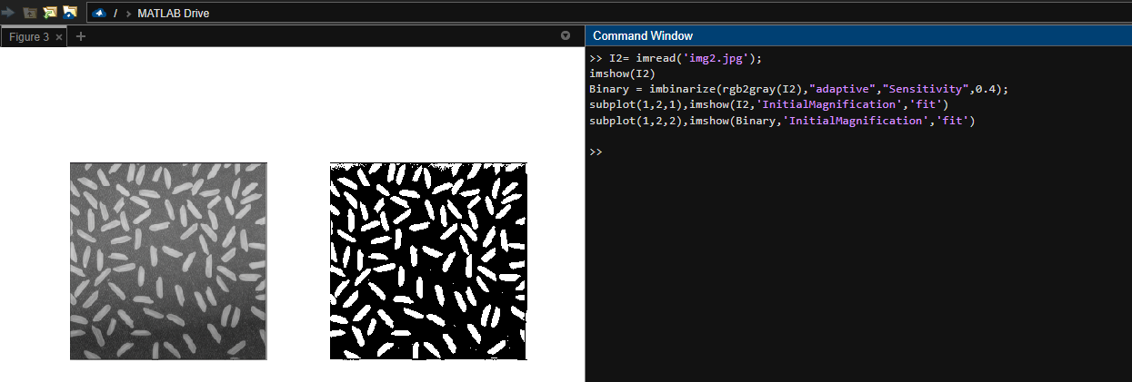

Code:

I2= imread('img2.jpg');

imshow(I2)

Binary = imbinarize(rgb2gray(I2),"adaptive","Sensitivity",0.4);

subplot(1,2,1),imshow(I2,'InitialMagnification','fit')

subplot(1,2,2),imshow(Binary,'InitialMagnification','fit')

**Answer to the Question No. 03**

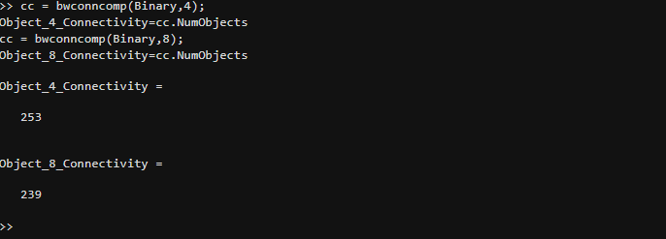

Code:

cc = bwconncomp(Binary,4);

Object_4_Connectivity=cc.NumObjects

cc = bwconncomp(Binary,8);

Object_8_Connectivity=cc.NumObjects

Output:  
Object_4_Connectivity =  
 253  
Object_8_Connectivity =  
 239

**Answer to the Question No. 04**

Code:

x=1;

y=1;

s=1024;

t=1022;

dis=((x-s).^2+(y-t).^2).^0.5

Output:

dis =  
  
 1.4453e+03

**Answer to the Question No. 05**

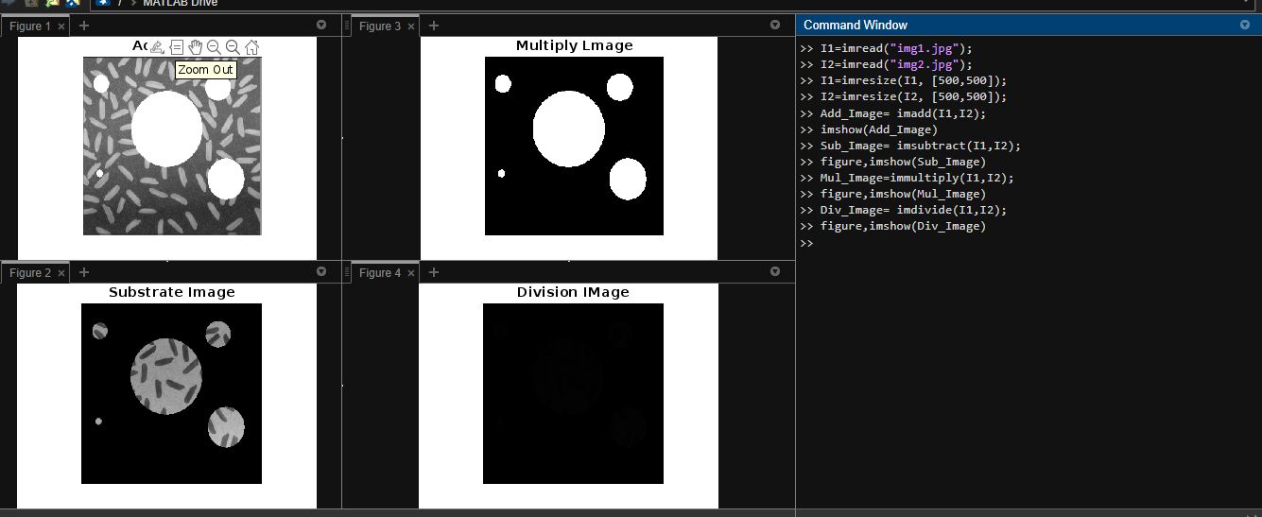

Code:

I1=imread("img1.jpg");

I2=imread("img2.jpg");

I1=imresize(I1, [500,500]);

I2=imresize(I2, [500,500]);

Add_Image= imadd(I1,I2);

1. imshow(Add_Image)

Sub_Image= imsubtract(I1,I2);

1. figure,imshow(Sub_Image)

Mul_Image=immultiply(I1,I2);

1. figure,imshow(Mul_Image)

Div_Image= imdivide(I1,I2);

1. figure,imshow(Div_Image)

**Answer to the Question No. 06**

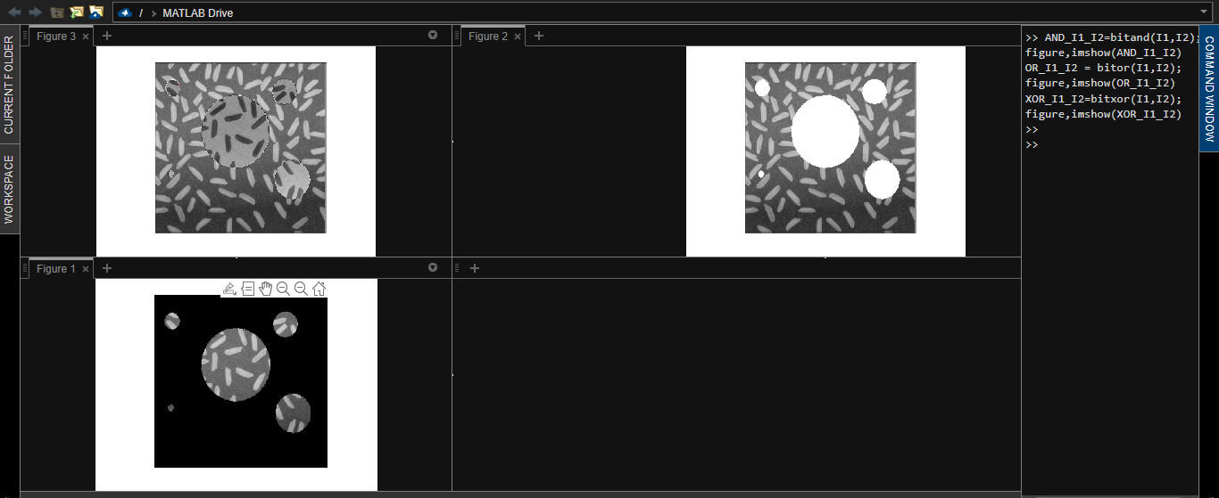

Code:

1. AND_I1_I2=bitand(I1,I2);

figure,imshow(AND_I1_I2)

1. OR_I1_I2 = bitor(I1,I2);

figure,imshow(OR_I1_I2)

1. XOR_I1_I2=bitxor(I1,I2);

figure,imshow(XOR_I1_I2)

**Answer to the Question No. 07**

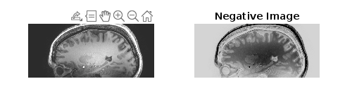

Code:

I3 = imread('img3.jpg');

Negative_Image = 255-I3;

subplot(1,2,1),imshow(I3,'InitialMagnification','fit');

subplot(1,2,2),imshow(Negative_Image,'InitialMagnification','fit');

subplot(1,2,1),imshow(I3,'InitialMagnification','fit');

title('Original');

**Answer to the Question No. 08**

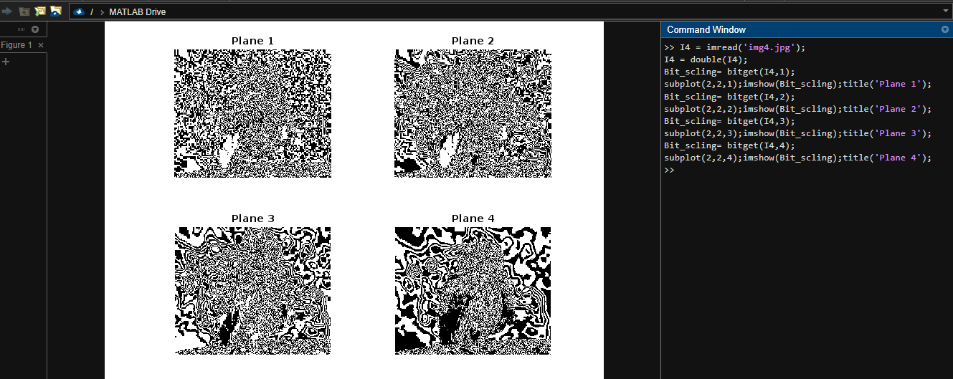

Code:

I4 = imread('img4.jpg');

I4 = double(I4);

Bit_scling= bitget(I4,1);

subplot(2,2,1);imshow(Bit_scling);title('Plane 1');

Bit_scling= bitget(I4,2);

subplot(2,2,2);imshow(Bit_scling);title('Plane 2');

Bit_scling= bitget(I4,3);

subplot(2,2,3);imshow(Bit_scling);title('Plane 3');

Bit_scling= bitget(I4,4);

subplot(2,2,4);imshow(Bit_scling);title('Plane 4');

**Answer to the Question No. 09**

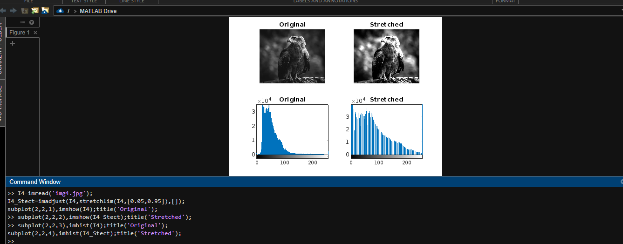

Code:

I4=imread('img4.jpg');

I4_Stect=imadjust(I4,stretchlim(I4,[0.05,0.95]),[]);

subplot(2,2,1),imshow(I4);title('Original');

subplot(2,2,2),imshow(I4_Stect);title('Stretched');

subplot(2,2,3),imhist(I4);title('Original');

subplot(2,2,4),imhist(I4_Stect);title('Stretched');

**Answer to the Question No. 10**

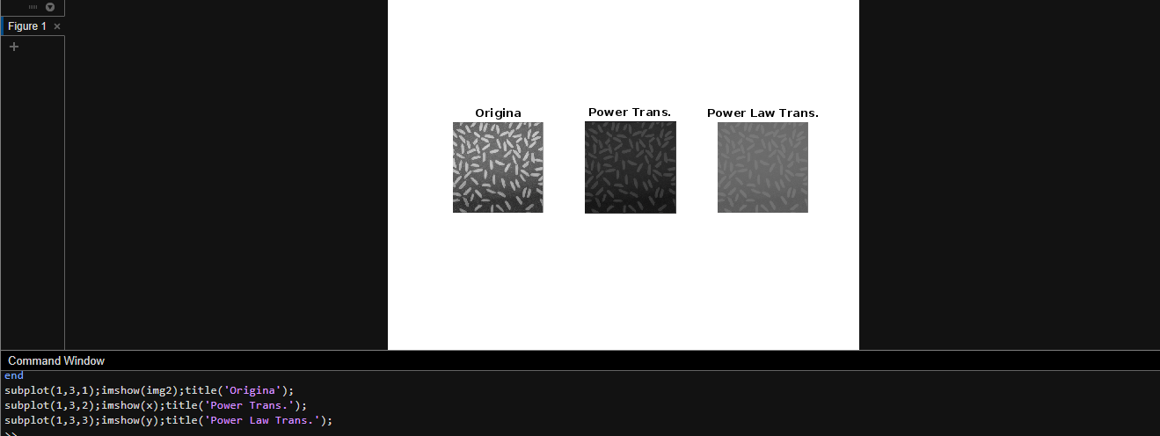

Code:

img2=imread('img2.jpg');

img2=im2double(img2);

x=img2;

y=img2;

constant=0.5;

gama=0.2;

[r,c]=size(img2);

for i=1:r

for j=1:c

x(i,j)=constant*log(1+img2(i,j));

y(i,j)=constant*img2(i,j).^0.2;

end

end

subplot(1,3,1);imshow(img2);title('Origina');

subplot(1,3,2);imshow(x);title('Power Trans.');

subplot(1,3,3);imshow(y);title('Power Law Trans.');