east west university
Lab Report- 03
Department: Computer Science and Engineering
Course Title: Digital Image Processing
Course Code: CSE438
Section No: 02

Submitted To:
Dr. Engr. Ahmed Wasif Reza
Associate Professor, Department of Computer Science and Engineering

Submitted By:
Name: S M Arafat Rahman
ID: 2019-2-60-094

1.Adjust the histogram of the following image to match the reference image using histogram matching. Show the histogram of original, reference, and output images.

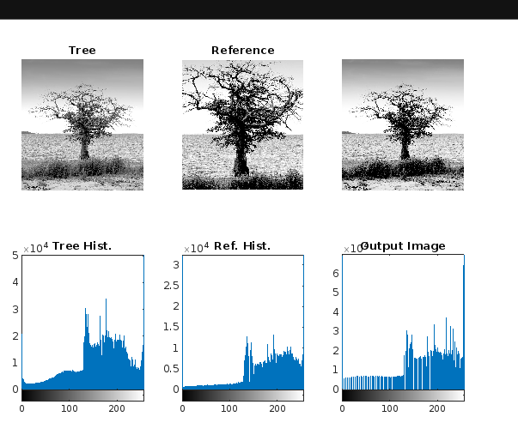
Code:
im1 = imread("tree.png");
im2 = imread("tree_reference.png");
M = zeros(256,1,'uint8');
hist1 = imhist(im1);
hist2 = imhist(im2);
cdf1 = cumsum(hist1) / numel(im1);
cdf2 = cumsum(hist2) / numel(im2);
for idx 1 : 256
for idx = 1 : 256
diff = abs (cdf1(idx) - cdf2);
[~,ind] = min(diff);
M(idx) = ind-1;
end
out = M(double(im1)+1);
subplot(2,3,1),imshow(im1);
title('Tree');
subplot(2,3,2),imshow(im2);
title('Tree_Reference');
title('Reference');
subplot(2,3,3),imshow(out);
subplot(2,3,4),imhist(im1);
title('Tree Hist.');
subplot(2,3,5),hist(im2);
subplot(2,3,5),imhist(im2);
title('Ref. Hist.');
subplot(2,3,6),imhist(out);
title('Output Image');

- Change the contrast of the image using histogram equalization. Show the histogram of both input and output images.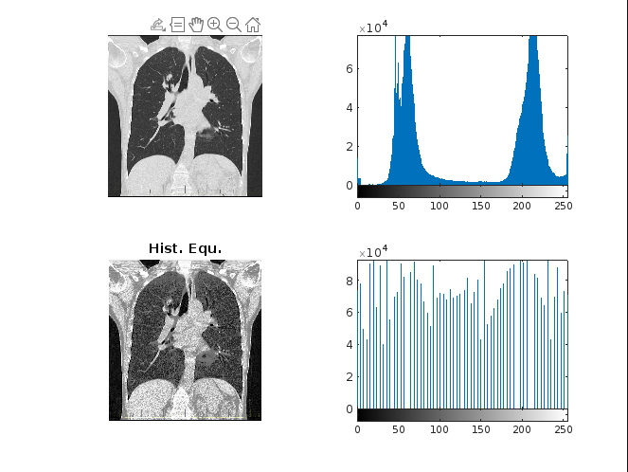

Code:
im1 = imread("CT.png");
figure;
subplot(1,2,1),imshow(im1);
subplot(1,2,2),imshow(im1);
imh = imadjust(im1,[0.3,0.6],[0.0,1.0]);
imh1 = histeq(im1);
figure;
subplot(2,2,1),imshow(imh);title('Streched');
subplot(2,2,2),imshow(imh);
subplot(2,2,2),imhist(imh);
subplot(2,2,1);imshow(im1);
subplot(2,2,2); imhist(im1);
subplot(2,2,3);imshow(im1);
subplot(2,2,3);imshow(imh1);title('Hist. Equ.');
subplot(2,2,4);imhist(imh1);

- Apply salt and pepper noise to the following image and remove the noise using min and max filtering techniques. Show input and output side by side.
Min Filter Code:
im=imread('MRI.png');
subplot(1,3,1),imshow(im);title('Input Image');
x=rand(size(im));
im(x(:)>0.95)=255;
subplot(1,3,2),imshow(im);title('Salt & Pepper Noise');
sto=[];
[a b]=size(im);
output=zeros(a,b);
for i=2:a-1
for j=2:b-1
sto=[im(i-1,j-1),im(i-1,j),im(i-1,j+1),im(i,j-1),im(i,j)...
,im(i,j+1),im(i+1,j-1),im(i+1,j),im(i+1,j+1)];
es=min(sto);
output(i,j)=es;
sto=[];
end
end
subplot(1,3,3),imshow(uint8(output));title('Filter By Min.');
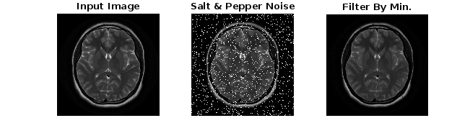
Max Filter Code:
im=imread('MRI.png');
subplot(1,3,1),imshow(im);
title('Input Image');
x=rand(size(im));
im(x(:)<0.10)=0;
subplot(1,3,2),imshow(im);
title('Salt & Pepper Noise');
sto=[];
[a b]=size(im);
output=zeros(a,b);
for i=2:a-1
for j=2:b-1
sto=[im(i-1,j-1),im(i-1,j),im(i-1,j+1),im(i,j-1),im(i,j)...
,im(i,j+1),im(i+1,j-1),im(i+1,j),im(i+1,j+1)];
es=max(sto);
output(i,j)=es;
sto=[];
end
end
subplot(1,3,3),imshow(uint8(output));
title('Filter By Max.');
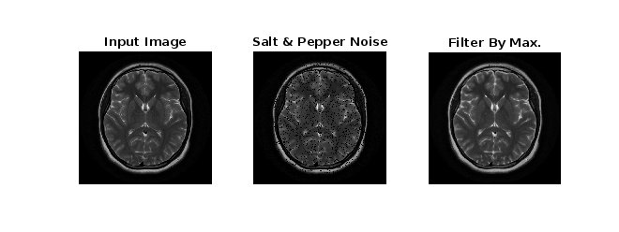
Max Filter Image

- Apply Gaussian noise to the following image and remove the noise using Gaussian filtering. Show input and output side by side.
Code:
im = imread("MRI.png");
im2 = imnoise(im,"gaussian",0.01);
subplot(1,3,1),imshow(im);
title('Input');
subplot(1,3,2),imshow(im2); title('Gaussing');
sigma = 3;
cuttoff = ceil(3*sigma);
h = fspecial("gaussian",2*cuttoff+1,sigma);
out = conv2(im,h,"same");
out1 = conv2(im2,h,"same");
w = wiener2(im2,[5,5]);
subplot(1,3,3),imshow(w);title('Output');

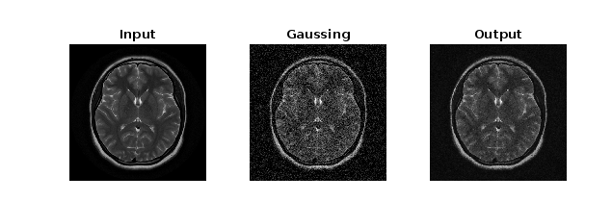
Gaussian Filtering

- Apply any noise to the following image and restore it using:
- Box filtering
Code:
I = imread('MRI_2.png');
N = imnoise(I,"salt & pepper",0.03);
mf = ones(3,3)/9;
nf = imfilter(N,mf);
subplot(2,2,1),imshow(I), title("Original");
subplot(2,2,2),imshow(N), title("Noisy");
subplot(2,2,3),imshow(I), title("After Removeing Noisy");

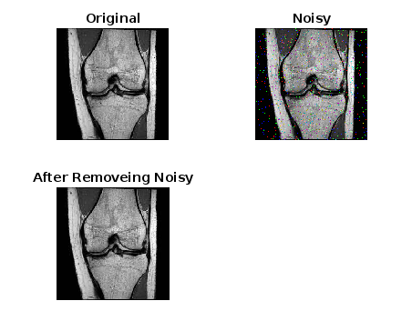
- Average filtering
Code:
x=imread('MRI_2.png');

subplot(1,2,1),imshow(x)
ag=fspecial('average',[10,10]);
g=imfilter(x,ag);

subplot(1,2,2),imshow(g)

clc
clear all
close all
x=imread('MRI_2.png');
for i=1:30
ag=fspecial('average',[i,i]);
g=imfilter(x,ag);
figure;
drawnow;
end
figure;
imshow(g);
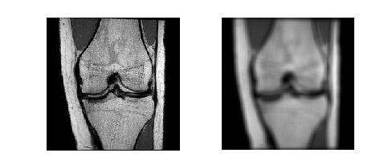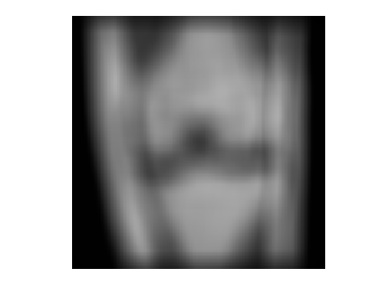

- Median filtering
Code:
a=imread('MRI_2.png');
subplot(1,3,1),imshow(a);
title('Input Image');
I=imnoise(a,'salt & pepper',0.3);
subplot(1,3,2),imshow(I);
title('Image with Slat & Pepper Noise');
I_filtered=medfilt3(I,[5,5,3]);
subplot(1,3,3),imshow(I_filtered);
title('Filtered Image');
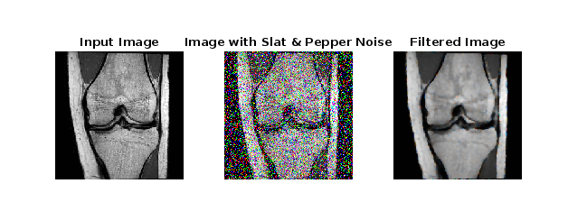
Comparison between the 3 techniques.
After finishing Three techniques of filtering Box filtering and Median filtering are better than Average filtering. And we compiled between mean and average filtering is better than mean filtering. Because the Average filter works by moving the image pixel by pixel.

