Wireframe

# Deloitte Case Study

|  |  |
| --- | --- |
| **Written By** | SM ZEYAUDDIN |

# Contents

1.Home Page.....................................................................................................03

2.Overview.......................................................................................................05

3.CPI..................................................................................................................06

3.Exchange Rate.............................................................................................07

4.Export Merchandise..................................................................................08

5.CAGR.............................................................................................................08

# Home Page

# 

Title: A prominent title reflects the purpose of your dashboard, such as "DELOITTE CASE STUDY”.

As per the requirement of the project, I have divided the analysis into five sections

1.CPI

2.Exchange Rate

3.Export Merchandise

4.CAGR

The Home page consists of two buttons

* LinkedIn
* Github

# CPI

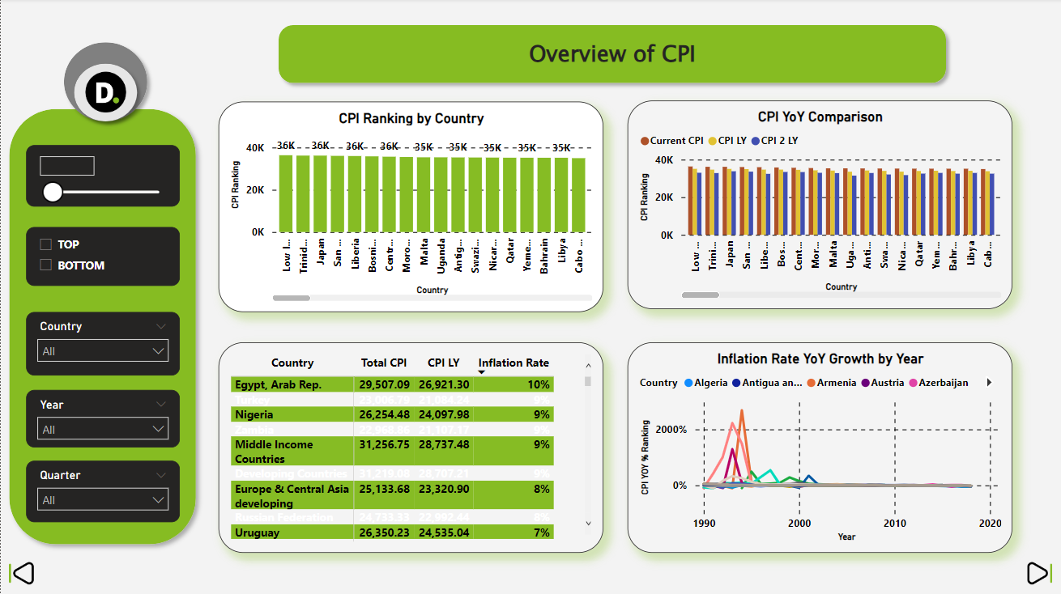

* **Slicers**: Create slicer to visually represent the part wise attrition. Display the different part such as country, Year, Quarter.
* **Clustered Column Chart**: Add stack column chart to represent CPI ranking by country and CPI YoY Comparison to allow users to filter the data shown in the bar graphs.
* **Matrix**: For representing Country, Total CPI, CPI LY, Inflation Rate.
* **Line Chart**: for representing Inflation Rate YoY Growth by Year

# Exchange Rate

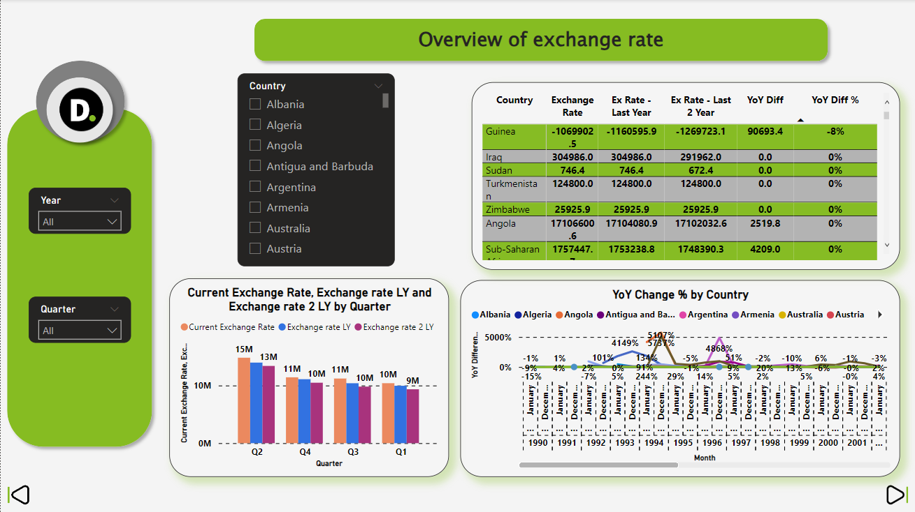

* **Slicers**: Create slicer to visually represent the part wise attrition. Display the different part such as country, Year, Quarter.
* **Stack Column Chart**: Add stack column chart to represent Current Exchange Rate, Exchange rate LY and Exchange rate 2 LY by Quarter to allow users to filter the data shown in the bar graphs.
* **Matrix**: For representing Country, Exchange Rate, Exchange Rate Last Year, Exchange Rate Last 2 Year, YoY Diff%.
* **Line Chart**: for representing YoY Change % by Country.

# Export Merchandise

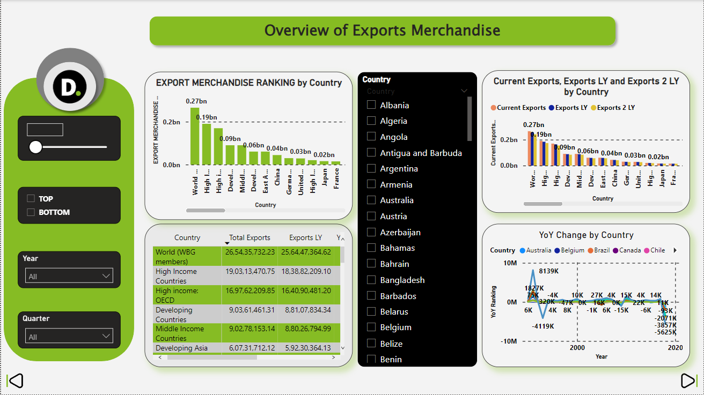

* **Slicers**: Create slicer to visually represent the part wise attrition. Display the different part such as Parameter, Value, Country, Year, Quarter.
* **Stack Column Chart**: Add stack column chart to represent Export Merchandise Ranking and Current Exports, Exports LY and Exports 2LY by country to allow users to filter the data shown in the bar graphs.
* **Matrix**: For representing Country, Total Exports, Exports LY, YOY Change, YoY Diff%.
* **Line Chart**: for representing YoY Change by Country.

# 5.CAGR

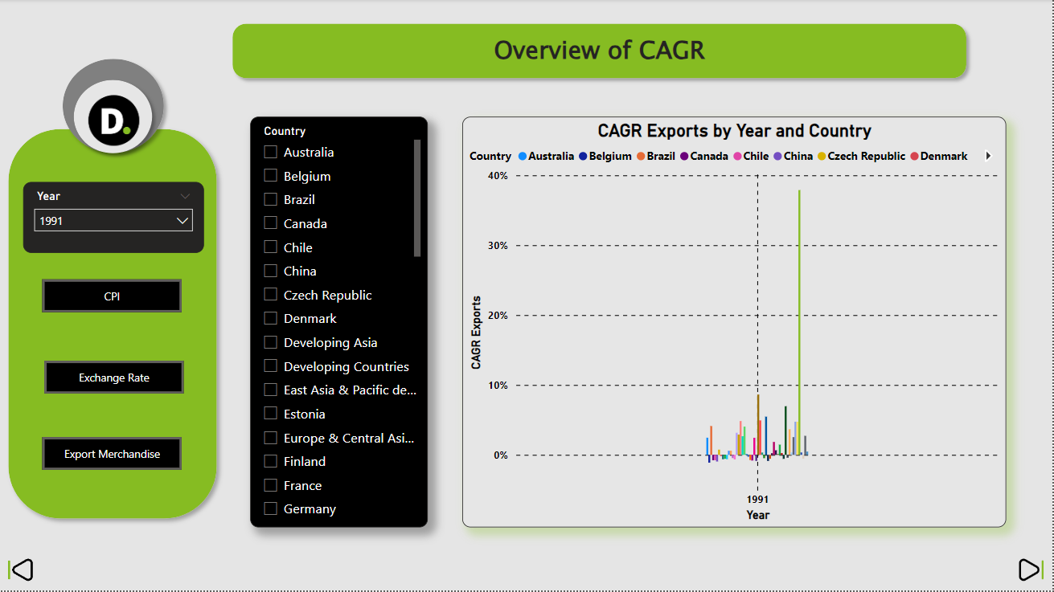

* **Slicers**: Create slicer to visually represent the part wise attrition. Display the different part such as Year, Country.
* **Buttons**: Add button to represent CPI, Exchange Rate, Export Merchandise.
* **Clustered Column Chart**: Add stack column chart to represent CAGR Exports by Year and Country to allow users to filter the data shown in the bar graphs.