Detail Project Report

# Analyzing Swiggy

|  |  |
| --- | --- |
| **Written By** | SM ZEYAUDDIN |
| **Last Revised Date** | 11.08.2023 |

**Contents**

1.Project Details.............................................................................................03

2.Problem Statement....................................................................................04

3.Data Description................................................................................. 05-06

4.Architecture................................................................................................07

5.Visuals.....................................................................................................08-10

**1.Project Details**

|  |  |
| --- | --- |
| Title | Analyzing Swiggy |
| Technologies | Business Intelligence |
| Domain | Food Industry |
| Project Difficulties Level | Advance |
| Tools Used | MS Excel, Power BI |

# 2.Problem Statement

The online food ordering market includes foods prepared by restaurants, prepared by independent people, and groceries being ordered online and then picked up or delivered.

The first online food ordering service, World Wide Waiter (now known as Waiter.com), was founded in 1995. Online food ordering is the process of ordering food from a website or other application.

The product can be either ready-to-eat food or food that has not been specially prepared for direction consumption.

# 3.Data Description

* Data was given in single excel file named as Swiggy Banglore Outlet Details.csv
* Swiggy Banglore Outlet Details.csv includes Shop_Name, Cuisine, Location, Rating, Cost_for_Two .

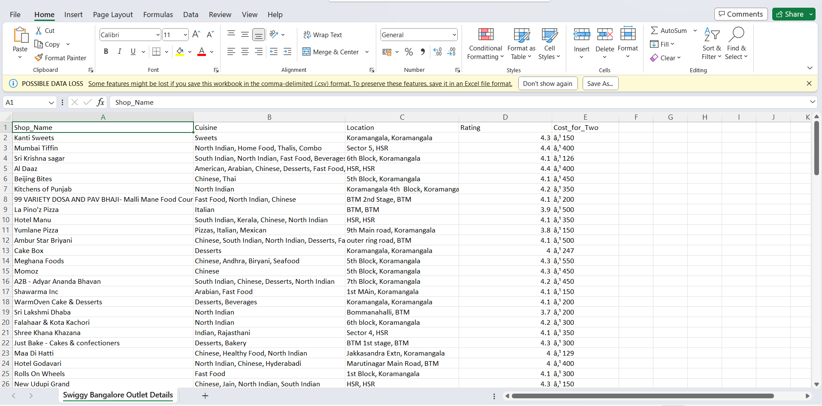

* This datasets includes total 119 rows.

**DETAIL PROJECT REPORT**

**6**

Some new column has also been added to given dataset which includes shop_pic, menu card, opening & closing time, open on , direction, phone number, cuisine_pic, price_category.

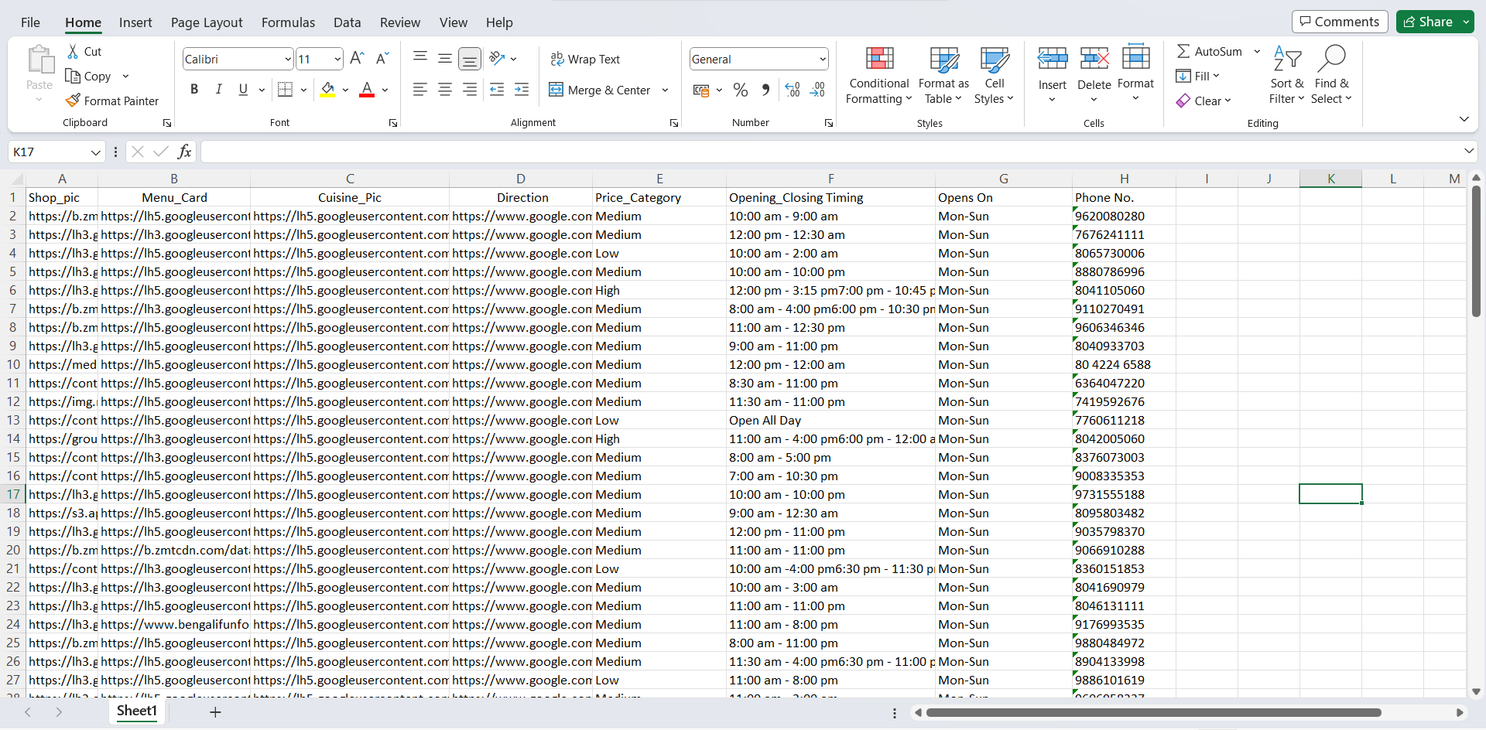

**4.Architecture**



Overall architecture of the project which was build to the dashboard.

**5.Visuals**

**HOME PAGE**

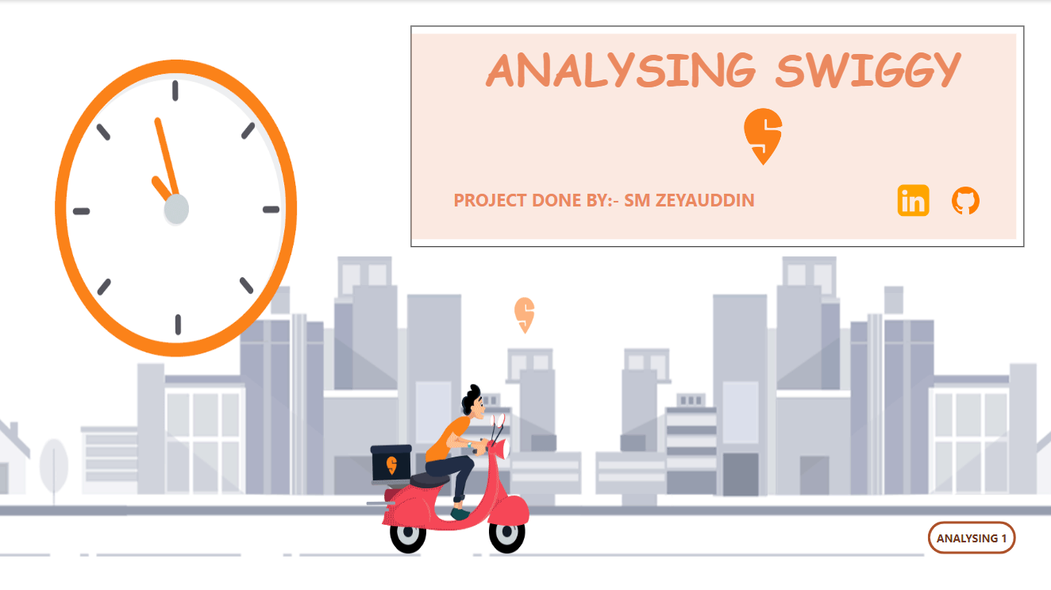

**ANALYZING 1**

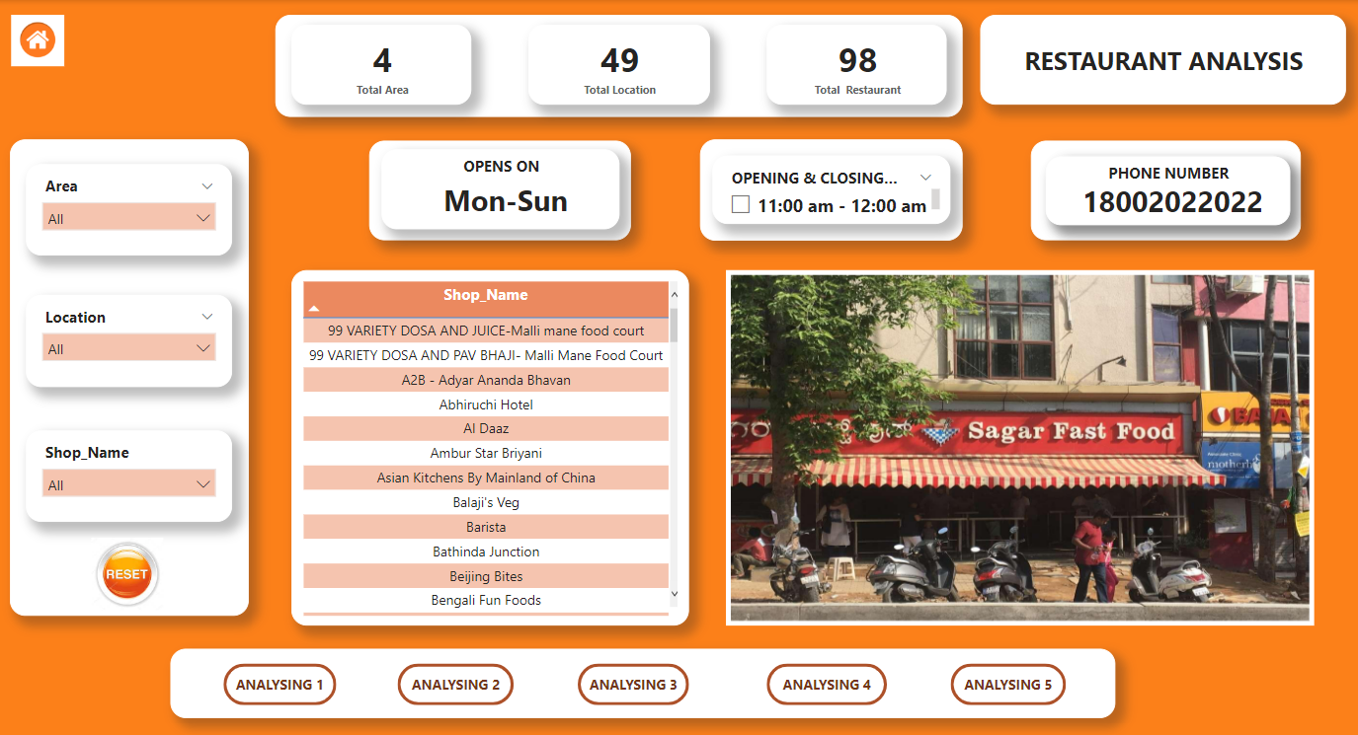

**ANALYZING 2**

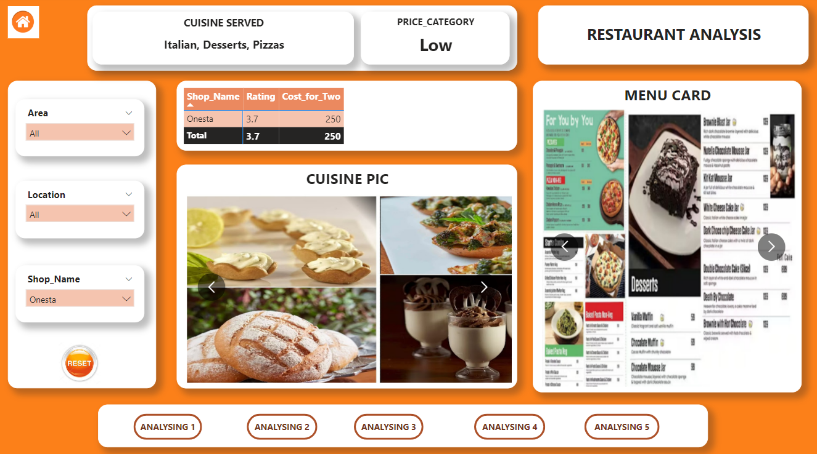

**ANALYZING 3**

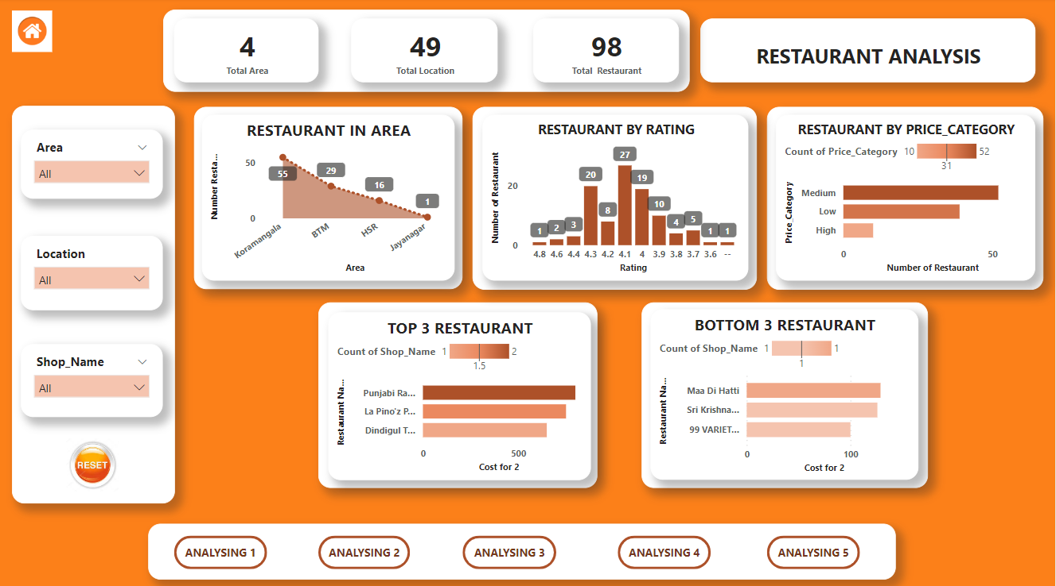

**ANALYZING 4**

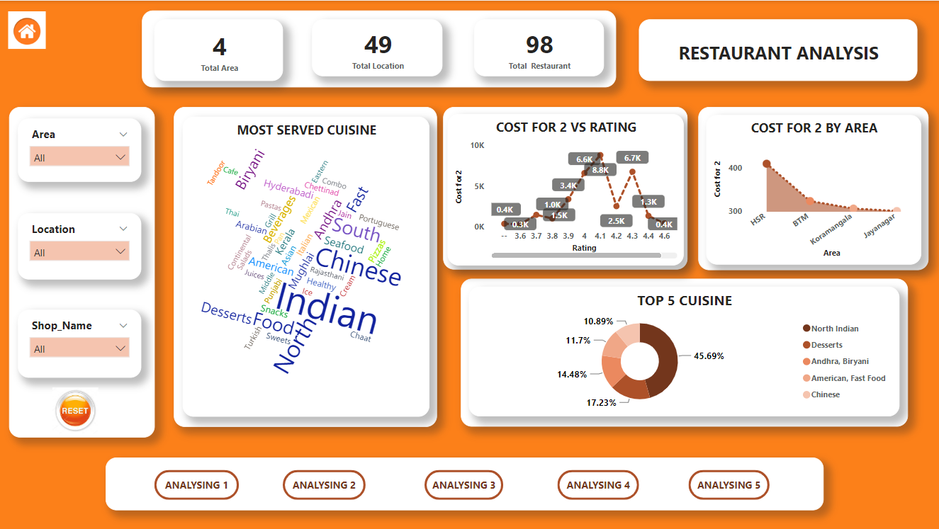

**ANALYZING 5**

