Low Level Design

# Analyzing Swiggy

SM Zeyauddin

**CONTENT**

1.Problem Statement....................................................................................03

2.Aim................................................................................................................04

3.Architecture...............................................................................................05

4. Data Description.......................................................................................06

5. Connect Data with Powerbi................................................................... 07

**Problem Statement**

The online food ordering market includes foods prepared by restaurants, prepared by independent people, and groceries being ordered online and then picked up or delivered. The first online food ordering service, World Wide Waiter (now known as Waiter.com), was founded in 1995. Online food ordering is the process of ordering food from a website or other application. The product can be either ready-to-eat food or food that has not been specially prepared for direction consumption.

# Aim

* Main aim to find out the which shop is budget-friendly and has highest rating.
* The reports also shows different types of cuisines served in different shop.

# Architecture

Power Bi is a business suite that includes several technologies that work together. To deliver

outstanding business intelligence solutions, Microsoft Power Bi technology consists of a group

of such components such as:

Power Query (for data mash-up and transformation)

* Power BI Desktop (a companion development tool)
* Power BI Mobile (for Android, iOS, Windows phones)
* Power BI Pivot (for in-memory tabular data modelling)
* Power BI View (for viewing data visualisation)
* Power BI Map (for visualizing 3D geo-spatial data)
* Power BI Q&A (for natural language Q&A)

The architecture of entire project is shown below:



* Our entire data source is our excel file. This excel file is connected to the Power Bi server. From the server, data can be shown and accessed.
* Power Bi server has various architectural components regarding to solve the query.
* The functionalities show the result according to query entered by the end user or client.
* Client entered the query to show the graph, after selecting the data in form of rows and columns it will go inside the Power Bi server. In Power Bi server, it understands the query and generates the best recommended charts based on selected data and return it into the Power Bi screen.
* Based on recommended charts, client can make the visual aspect of the same.

If client is not satisfied with the result, he/she has to select data accordingly otherwise make required changes to show the expected result.

### Shape Description automatically generated with low confidenceLOW LEVEL DESIGN

**6**

**Data Description**

* Data was given in an excel file Swiggy Banglore Outlet Details.csv
* Swiggy Banglore Outlet Details.csv includes shop_name, Cuisine, Location, Rating, Cost_for_two.

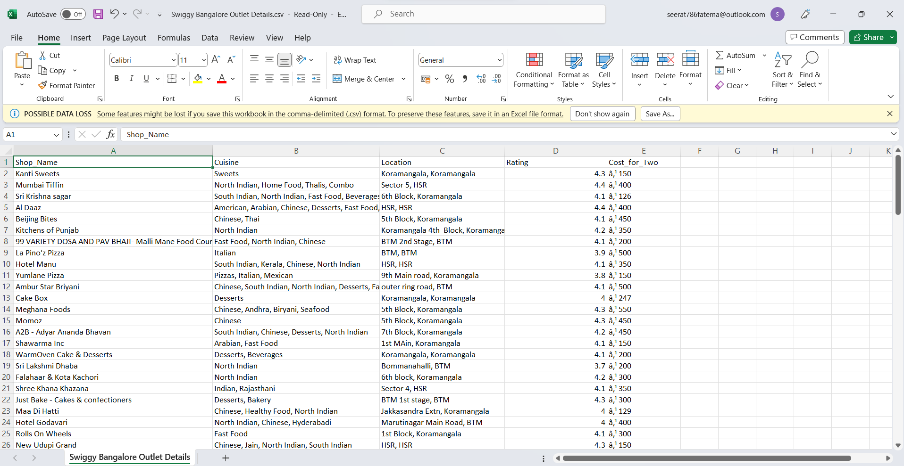

* Some new data has also been added to the existing data such as Shop_pic, Menu card, Cuisine_pic, Direction, Price_category, Opening_Closing Time,

Opens on, Phone Number.

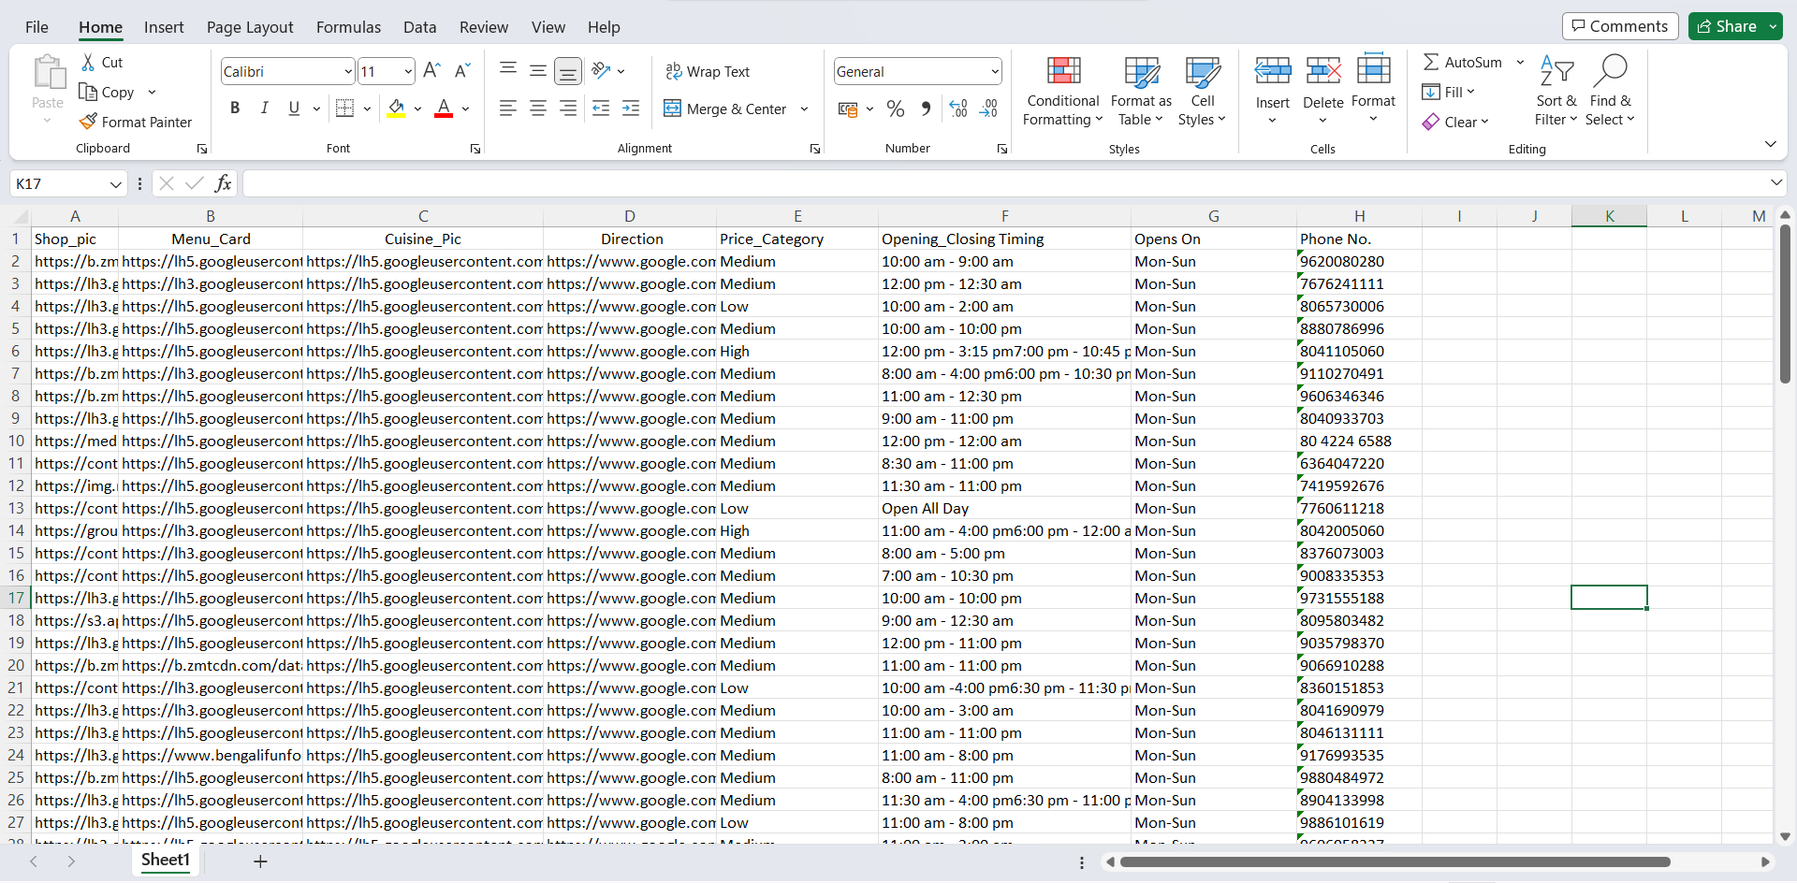

**Connect Data with Power Bi**

* Open Power Bi desktop.
* Connect it with the Excel files
* Import and load these files.
* Make sure there is good internet connection for better experience.

