Wireframe Design

# Analyzing Swiggy

|  |  |
| --- | --- |
| **Written By** | SM ZEYAUDDIN |
| **Last Revised Date** | 11.08.2023 |

**Contents**

1. Analyzing 1 03
2. Analyzing 2 06
3. Analyzing 3 08
4. Analyzing 4 11
5. Analyzing 5 14

1. **Home Page**

Title: A prominent title reflects the purpose of your dashboard, such as "Analyzing Swiggy."

Theme: Consider incorporating a theme that align with the entertainment industry.

# 

As per the requirement of the project, I have divided the analysis into five sections

* Analyzing 1
* Analyzing 2
* Analyzing 3
* Analyzing 4
* Analyzing 5

Homepage will have the button to navigate to

* Analyzing 1

Homepage also have the two more buttons to navigate to:

* My LinkedIn Profile
* My GitHub Account

1. **Analyzing 1**

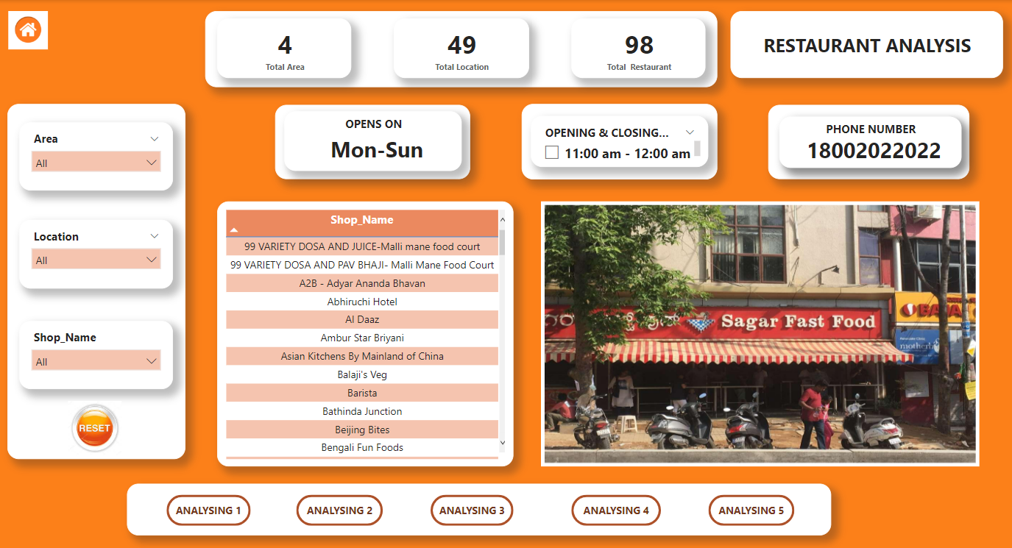

This page mainly focuses on the induvial shop, KPI list as follows

* Total Areas
* Total Locations
* Total Restaurant
* Shop opens on
* Opening & Closing Time
* Phone Number
* Shop Name
* Shop Picture
* **Slicers for Filtering**: Add slicers to allow users to filter the data. Include slicers based on relevant criteria, such as Area, Location, Shop Name. Users can interact with the slicers to dynamically update the graph based on their selections.
* **Image**: For representing the image of the entertainer.
* **Table :** To show the shop name in a single table.
* **Navigation Buttons**: Add five buttons at the bottom side of the page for easy navigation to other sections of the dashboard. Label the buttons and by clicking on each button will redirect users to the respective pages.

**SHOP NAME TABLE**

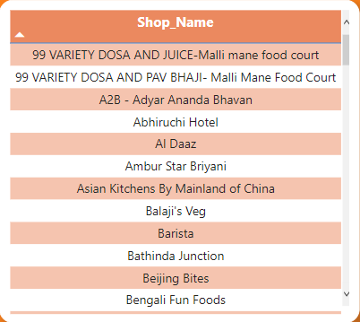

**SHOP PIC**

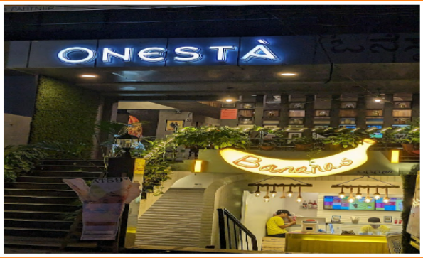

1. **Analyzing 2**

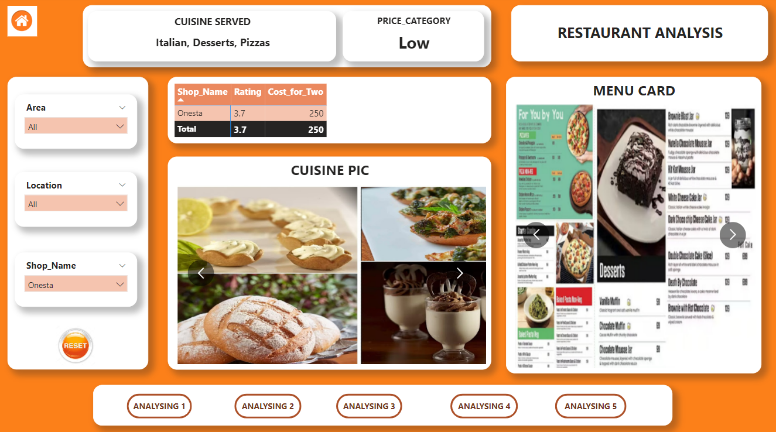

* **Slicers for Filtering**: Add slicers to allow users to filter the data. Include slicers based on relevant criteria, such as Area, Location, Shop Name. Users can interact with the slicers to dynamically update the graph based on their selections.
* **Image**: For representing the image of the entertainer.
* **Matrix :** To show the shop name in a single table.
* **Cards:** To show the Cuisine served and Price_category of the shop.
* **Navigation Buttons**: Add five buttons at the bottom side of the page for easy navigation to other sections of the dashboard. Label the buttons and by clicking on each button will redirect users to the respective pages.

**SHOP_NAME, RATING, COST_FOR_TWO**

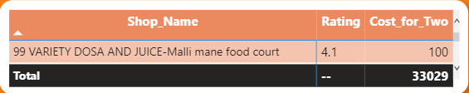

* **CUISINE_PIC**

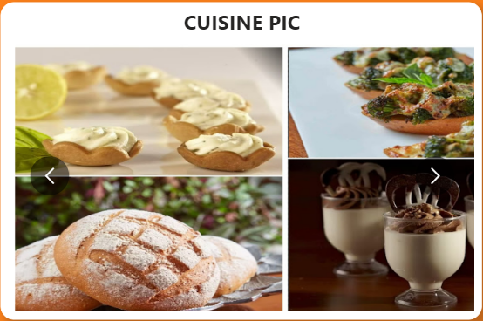

* **MENU CARD**

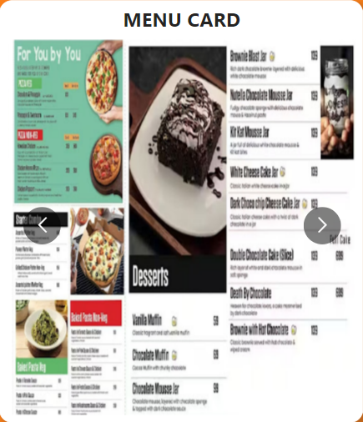

1. **Analyzing 3**

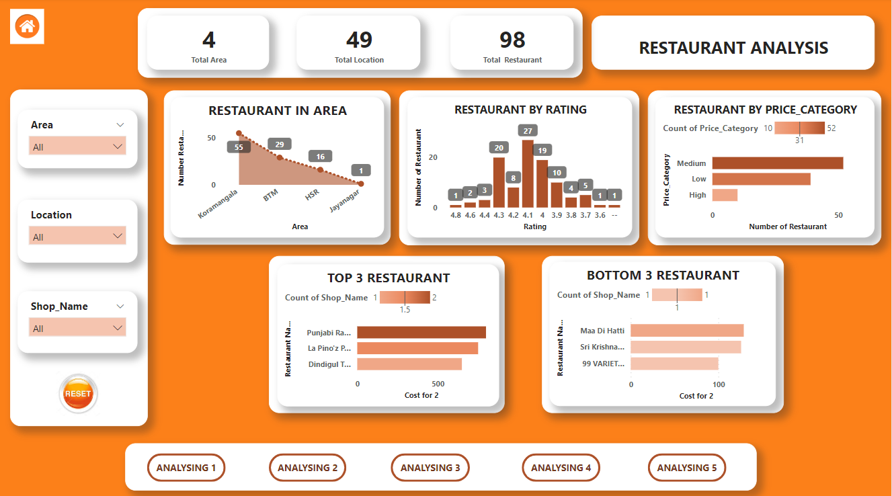

* **Slicers for Filtering**: Add slicers to allow users to filter the data. Include slicers based on relevant criteria, such as Area, Location, Shop Name. Users can interact with the slicers to dynamically update the graph based on their selections.
* **Area Chart:** For representing restaurant in area.
* **Clustered Column Chart:** For representing restaurant by rating.
* **Clustered Bar Chart:** For representing restaurant by price_category, top 3 restaurant, bottom 3 restaurant.
* **Navigation Buttons**: Add five buttons at the bottom side of the page for easy navigation to other sections of the dashboard. Label the buttons and by clicking on each button will redirect users to the respective pages.

**RESTAURANTANT IN AREA**

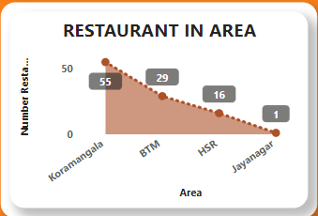

**RESTAURANT BY RATING**

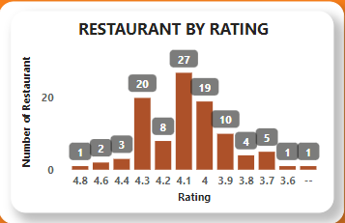

**RESTAURANT BY PRICE_CATEGORY**

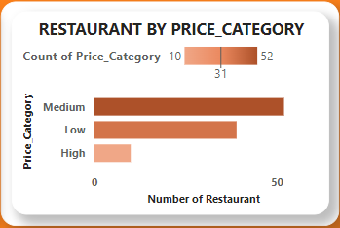

**TOP 3 RESTAURANT**

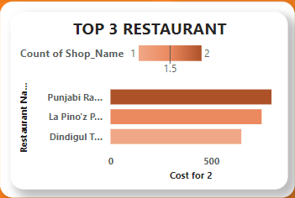

**BOTTOM 3 RESTAURANT**

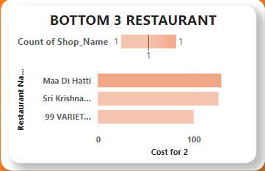

1. **Analyzing 4**

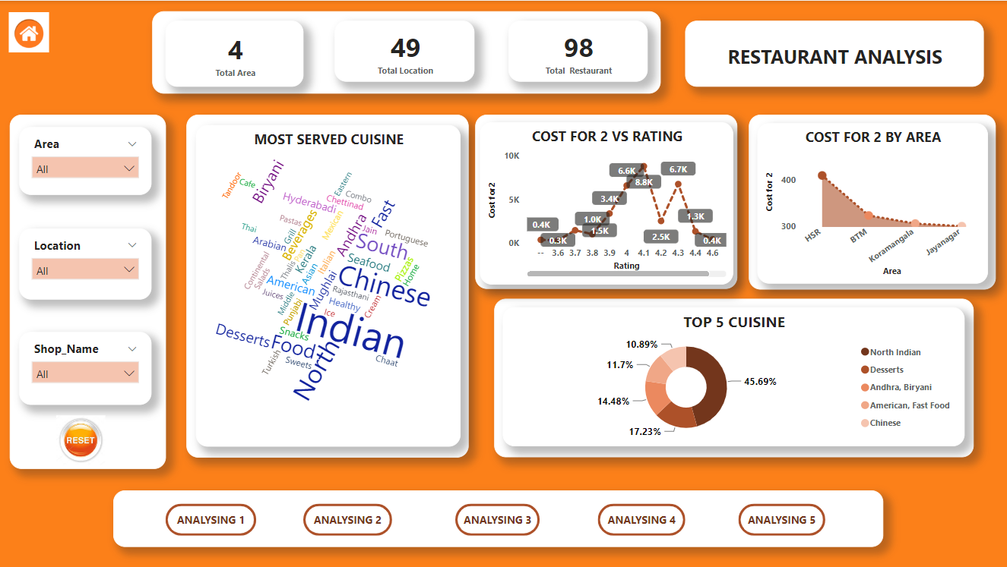

* **Slicers for Filtering**: Add slicers to allow users to filter the data. Include slicers based on relevant criteria, such as Area, Location, Shop Name. Users can interact with the slicers to dynamically update the graph based on their selections.
* **Word Cloud:** For representing most served cuisine
* **Line Chart:** For representing cost for 2 VS rating of particular restaurant.
* **Stacked Area Chart:** For representing cost for 2 by area
* **Pie Chart:** For representing top 5 cuisine from overall data
* **Navigation Buttons**: Add five buttons at the bottom side of the page for easy navigation to other sections of the dashboard. Label the buttons and by clicking on each button will redirect users to the respective pages.

**MOST SERVED CUISINE**

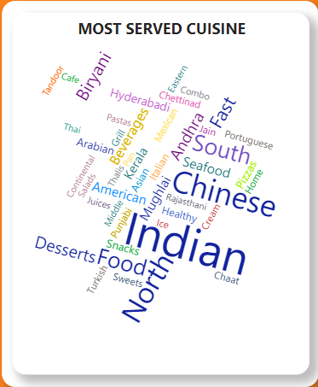

**COST FOR 2 VS RATING**

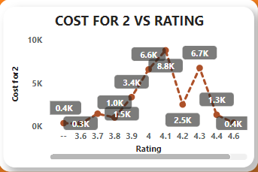

**COST FOR 2 BY AREA**

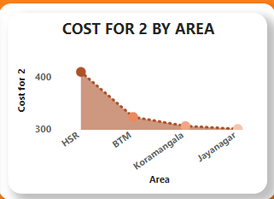

**TOP 5 CUISINE**

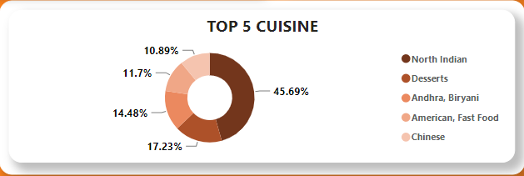

1. **Analyzing 5**

