# 实验三 白盒测试

1. **LoginServlet.doGet**
   1. **代码**

public void doGet(HttpServletRequest request, HttpServletResponse response)

throws ServletException, IOException {

1 String loginstate = request.getParameter("a");

2 if (loginstate.equals("out"))

{

3 this.Loginout(request, response);

}

4 if (loginstate.equals("login"))

{

5 this.Userlogin(request, response);

}

6 return;

}

* 1. **控制流图**

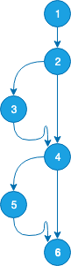

* 1. **测试用例**

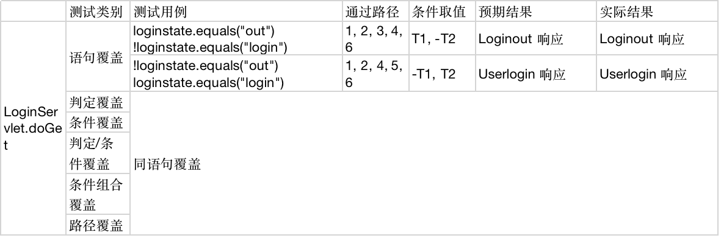

1. **LoginServlet.Userlogin**
   1. **代码**

public void Userlogin(HttpServletRequest request, HttpServletResponse response)

throws ServletException, IOException {

1 String name = request.getParameter("username");

String password = request.getParameter("password");

LoginDAO Ld = new LoginDAO();

Productuser puser = Ld.login(name, password);

2 if (puser == null) {

3 this.doError(request, response, "productuserL_tip.login.fail");

} else {

4 String superuser = puser.getSuperuser();

HttpSession mysession = request.getSession(false);

mysession.setAttribute("productuser", puser);

5 if (superuser.equals("1")) {

6 this.doBrowse(request, response, "/product/products.jsp");

7 } else if (superuser.equals("2")) {

8 this.doBrowse(request, response, "/product/products.jsp");

9 } else if (superuser.equals("3")) {

10 List allProductList = Ld.getalluser();

mysession.setAttribute("allproductlist", allProductList);

this.doBrowse(request, response, "/product/products_showusers.jsp");

11 }

12 }

}

* 1. **控制流图**

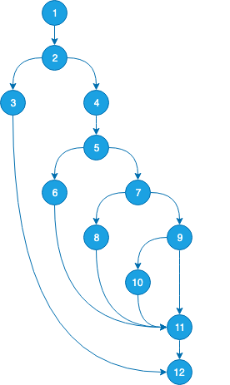

* 1. **测试用例**

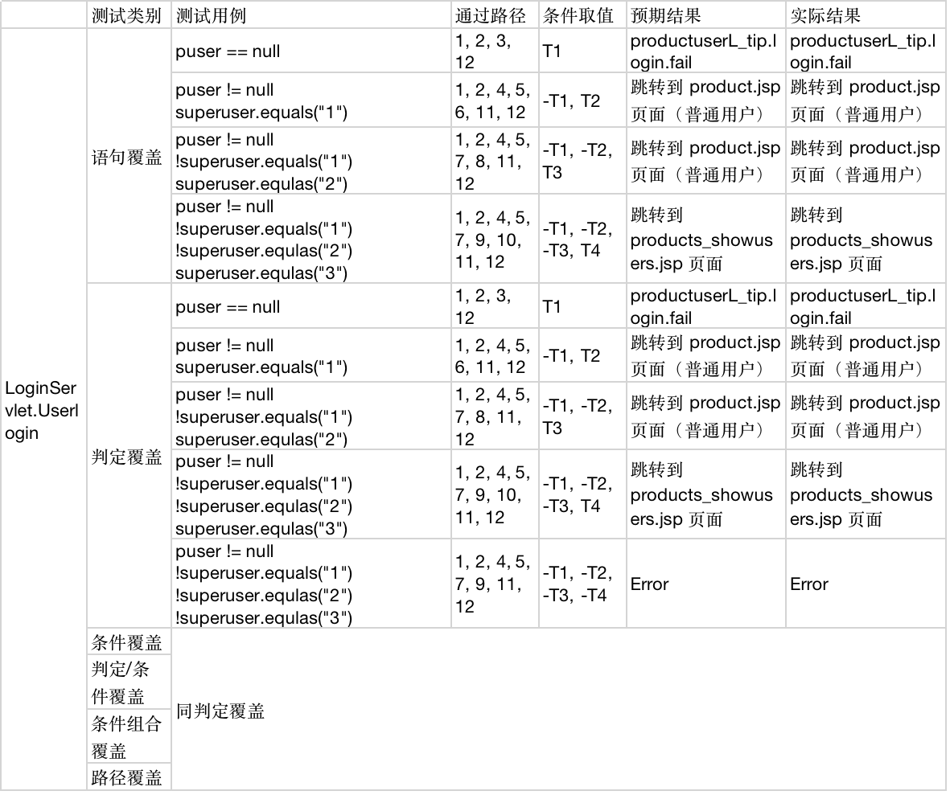

1. **MailServlet.doGet**
   1. **代码**

public void doGet(HttpServletRequest request, HttpServletResponse response)

throws ServletException, IOException {

1 String state = request.getParameter("a");

2 if (state.equals("all"))

{

3 try {

this.mailall(request, response);

} catch (SQLException e) {

// TODO Auto-generated catch block

e.printStackTrace();

}

}

4 if (state.equals("save")) {

5 String pid = request.getParameter("productId");

try {

this.savemail(request, response);

} catch (SQLException e) {

// TODO Auto-generated catch block

e.printStackTrace();

}

}

6 return;

}

* 1. **控制流图**



* 1. **测试用例**

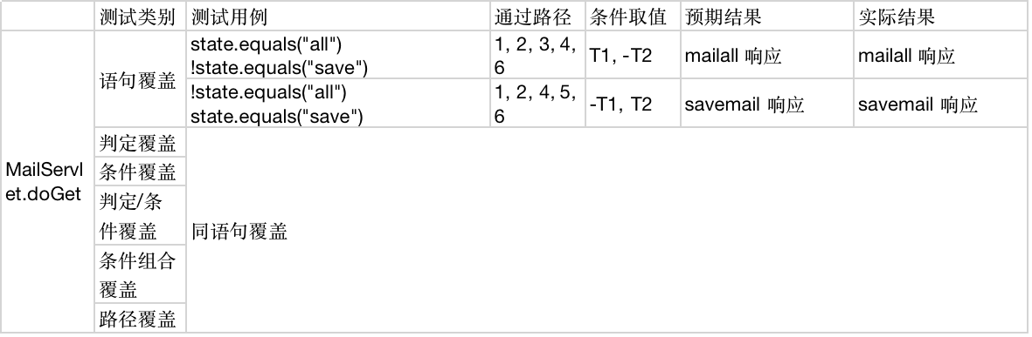

1. **MailServlet.mailall**
   1. **代码**

public void mailall(HttpServletRequest request, HttpServletResponse response)

1 throws ServletException, IOException, SQLException {

MailDAO mb = new MailDAO();

Mailtb mail;

mail = mb.findmail();

2 if (mail == null) {

3 String dthtml = "管理员还没有设置邮件"; //管理员邮箱还没设置过，请进行下面的设置操作

response.setContentType("text/html; charset=gb2312");

response.getOutputStream().print(dthtml);//返回name到 页面；

} else {

4 HttpSession mysession = request.getSession(false);

String faddress = mail.getFromaddress();

String taddress = mail.getToaddress();

String dthtml = "发件地址：" + faddress + "<br>收件地址：" + taddress + "<br>如果想修改，请进行下面的操作";

response.setContentType("text/html; charset=gb2312");

response.getOutputStream().print(dthtml);//返回name到 页面；

5 }

}

* 1. **控制流图**

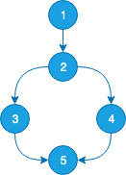

* 1. **测试用例**

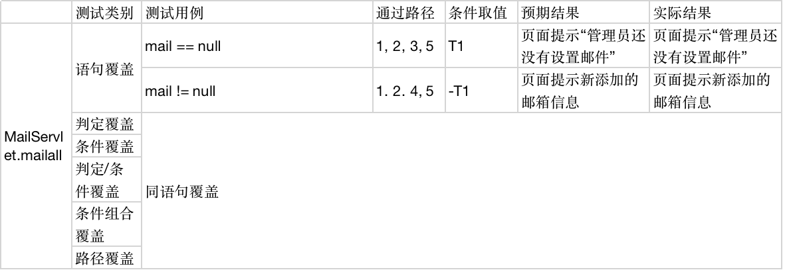

1. **ProductServlet.produceall**
   1. **代码**

public void produceall(HttpServletRequest request, HttpServletResponse response)

throws ServletException, IOException {

1 ProductDAO Pd = new ProductDAO();

List ProcuctList = Pd.getallProduct();

2 if (ProcuctList == null) {

3 this.doError(request, response, "productuserL_tip.login.fail");

} else {

4 HttpSession mysession = request.getSession(false);

Productuser pu = (Productuser) mysession.getAttribute("productuser");

mysession.setAttribute("productlist", ProcuctList);

5 if (pu == null)

{

6 this.doBrowse(request, response, "/product/products_show.jsp");

} else {

7 if (pu.getSuperuser().equals("3")) {

8 this.doBrowse(request, response, "/product/admin_products_show.jsp");

} else {

9 this.doBrowse(request, response, "/product/products_show.jsp");

10 }

11 }

12 }

}

* 1. **控制流图**

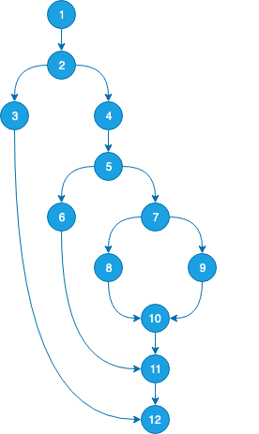

* 1. 测试用例

