US Covid-19 Cases Time Series Analysis

Stefan Maciolek

5/28/2020

#importing Covid Data from Johns Hopkins   
uscases <- read.csv(url("https://raw.githubusercontent.com/CSSEGISandData/COVID-19/master/csse_covid_19_data/csse_covid_19_time_series/time_series_covid19_confirmed_US.csv"))  
usdeaths <- read.csv(url("https://raw.githubusercontent.com/CSSEGISandData/COVID-19/master/csse_covid_19_data/csse_covid_19_time_series/time_series_covid19_deaths_US.csv"))  
uscases <- uscases[,-c(1:5,8:11)]  
usdeaths <- usdeaths[,-c(1:5,8:12)]  
n <- ncol(uscases)-2  
date <- 1:n  
date <- as.Date(date,origin = "2020-01-21")  
format(date,format = "%b %d %y")

## [1] "Jan 22 20" "Jan 23 20" "Jan 24 20" "Jan 25 20" "Jan 26 20" "Jan 27 20"  
## [7] "Jan 28 20" "Jan 29 20" "Jan 30 20" "Jan 31 20" "Feb 01 20" "Feb 02 20"  
## [13] "Feb 03 20" "Feb 04 20" "Feb 05 20" "Feb 06 20" "Feb 07 20" "Feb 08 20"  
## [19] "Feb 09 20" "Feb 10 20" "Feb 11 20" "Feb 12 20" "Feb 13 20" "Feb 14 20"  
## [25] "Feb 15 20" "Feb 16 20" "Feb 17 20" "Feb 18 20" "Feb 19 20" "Feb 20 20"  
## [31] "Feb 21 20" "Feb 22 20" "Feb 23 20" "Feb 24 20" "Feb 25 20" "Feb 26 20"  
## [37] "Feb 27 20" "Feb 28 20" "Feb 29 20" "Mar 01 20" "Mar 02 20" "Mar 03 20"  
## [43] "Mar 04 20" "Mar 05 20" "Mar 06 20" "Mar 07 20" "Mar 08 20" "Mar 09 20"  
## [49] "Mar 10 20" "Mar 11 20" "Mar 12 20" "Mar 13 20" "Mar 14 20" "Mar 15 20"  
## [55] "Mar 16 20" "Mar 17 20" "Mar 18 20" "Mar 19 20" "Mar 20 20" "Mar 21 20"  
## [61] "Mar 22 20" "Mar 23 20" "Mar 24 20" "Mar 25 20" "Mar 26 20" "Mar 27 20"  
## [67] "Mar 28 20" "Mar 29 20" "Mar 30 20" "Mar 31 20" "Apr 01 20" "Apr 02 20"  
## [73] "Apr 03 20" "Apr 04 20" "Apr 05 20" "Apr 06 20" "Apr 07 20" "Apr 08 20"  
## [79] "Apr 09 20" "Apr 10 20" "Apr 11 20" "Apr 12 20" "Apr 13 20" "Apr 14 20"  
## [85] "Apr 15 20" "Apr 16 20" "Apr 17 20" "Apr 18 20" "Apr 19 20" "Apr 20 20"  
## [91] "Apr 21 20" "Apr 22 20" "Apr 23 20" "Apr 24 20" "Apr 25 20" "Apr 26 20"  
## [97] "Apr 27 20" "Apr 28 20" "Apr 29 20" "Apr 30 20" "May 01 20" "May 02 20"  
## [103] "May 03 20" "May 04 20" "May 05 20" "May 06 20" "May 07 20" "May 08 20"  
## [109] "May 09 20" "May 10 20" "May 11 20" "May 12 20" "May 13 20" "May 14 20"  
## [115] "May 15 20" "May 16 20" "May 17 20" "May 18 20" "May 19 20" "May 20 20"  
## [121] "May 21 20" "May 22 20" "May 23 20" "May 24 20" "May 25 20" "May 26 20"  
## [127] "May 27 20"

#finding total cases and turning them into a time series object  
library(TSA)

##   
## Attaching package: 'TSA'

## The following objects are masked from 'package:stats':  
##   
## acf, arima

## The following object is masked from 'package:utils':  
##   
## tar

totcase <- colSums(uscases[,3:(n+2)])  
newcase <- rep(0,n)  
newcase[1] <- totcase[1]  
newcase[2:n] <- diff(totcase)  
newcase <- ts(data=newcase,start=c(2020,01,22),frequency = 365)

#trying various transformations  
wkday <- c("W","T","F","S","S","M","T")  
plot(date,newcase,type="o",main="Untransformed time series")

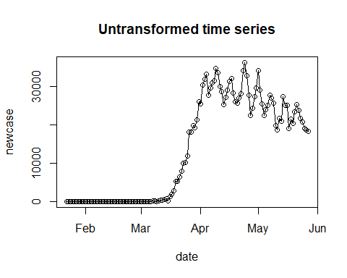

plot(date,log(newcase),type="o",main="Log time series")

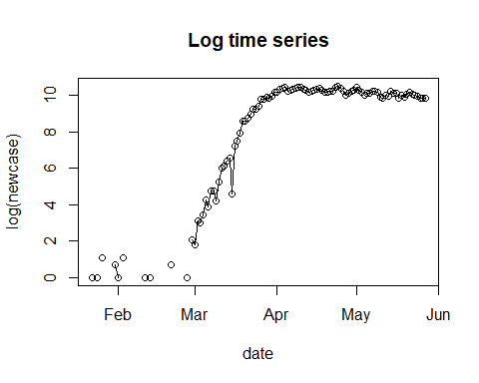

plot(date[2:n],diff(newcase),type="o",main="First difference time series",pch=wkday)

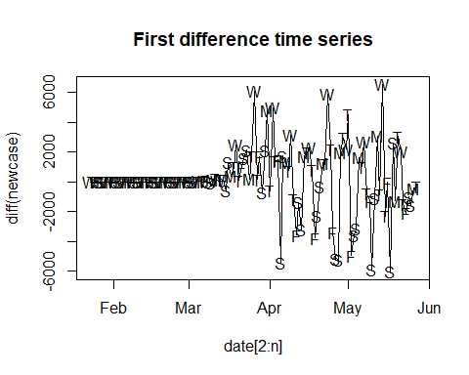

plot(date[2:n],log(diff(newcase)),type="o",main="Log of first difference time series")

## Warning in log(diff(newcase)): NaNs produced

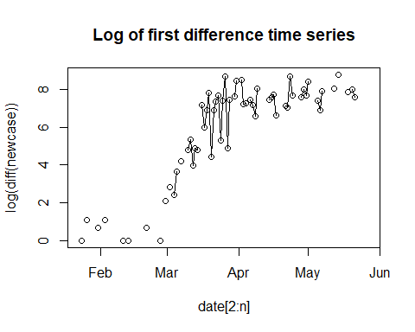

plot(date[8:n],diff(newcase,7),type="o",main="First weekly difference time series")

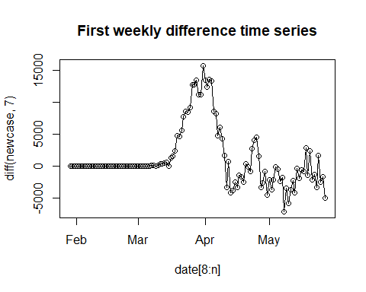

plot(date[9:n],diff(diff(newcase),7),type="o",main="First and weekly difference time series",pch=wkday)

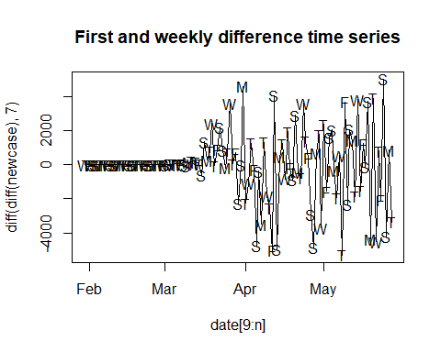

#starting with an ARIMA model with both a first and first weekly difference  
#preliminary analysis  
transcase <- diff(diff(newcase),7)  
acf(as.vector(transcase),main="ACF of transformed series",lag.max=30)

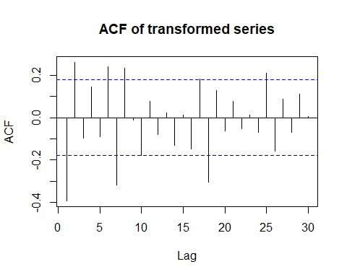

pacf(as.vector(transcase),main="PACF of transformed series",lag.max=30)

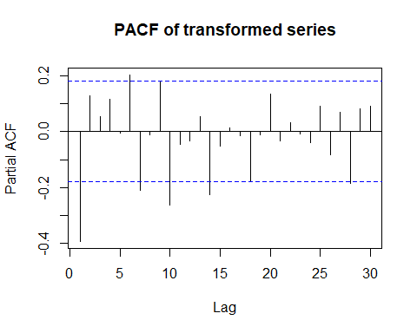

periodogram(transcase,main="Periodgram of transformed series")

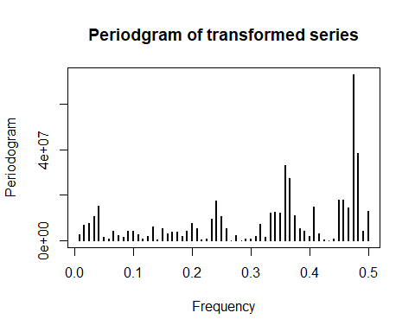

#model fitting:  
#looking at the periodograms, it appears a ARIMA(1,1,0)x(1,1,0)_7 is justified to start  
tsmodel <- function(ar,ma,ars,mas){  
 mod <- arima(newcase,order=c(ar,1,ma),seasonal=list(order=c(ars,1,mas),period=7))  
 return(mod)  
}  
tsmodel(1,0,1,0)

##   
## Call:  
## arima(x = newcase, order = c(ar, 1, ma), seasonal = list(order = c(ars, 1, mas),   
## period = 7))  
##   
## Coefficients:  
## ar1 sar1  
## -0.3344 -0.2568  
## s.e. 0.0904 0.0953  
##   
## sigma^2 estimated as 3188580: log likelihood = -1060.17, aic = 2124.34

tsmodel(2,0,1,0)

##   
## Call:  
## arima(x = newcase, order = c(ar, 1, ma), seasonal = list(order = c(ars, 1, mas),   
## period = 7))  
##   
## Coefficients:  
## ar1 ar2 sar1  
## -0.259 0.1927 -0.2972  
## s.e. 0.094 0.0912 0.0934  
##   
## sigma^2 estimated as 3067794: log likelihood = -1058, aic = 2121.99

tsmodel(2,0,2,0)

##   
## Call:  
## arima(x = newcase, order = c(ar, 1, ma), seasonal = list(order = c(ars, 1, mas),   
## period = 7))  
##   
## Coefficients:  
## ar1 ar2 sar1 sar2  
## -0.2424 0.1793 -0.3636 -0.2169  
## s.e. 0.0968 0.0934 0.0991 0.0936  
##   
## sigma^2 estimated as 2920166: log likelihood = -1055.39, aic = 2118.78

tsmodel(3,0,2,0) #not significant

##   
## Call:  
## arima(x = newcase, order = c(ar, 1, ma), seasonal = list(order = c(ars, 1, mas),   
## period = 7))  
##   
## Coefficients:  
## ar1 ar2 ar3 sar1 sar2  
## -0.2503 0.1866 0.0356 -0.3584 -0.2227  
## s.e. 0.0988 0.0953 0.0948 0.1000 0.0950  
##   
## sigma^2 estimated as 2916556: log likelihood = -1055.32, aic = 2120.64

tsmodel(2,0,3,0) #not significant

##   
## Call:  
## arima(x = newcase, order = c(ar, 1, ma), seasonal = list(order = c(ars, 1, mas),   
## period = 7))  
##   
## Coefficients:  
## ar1 ar2 sar1 sar2 sar3  
## -0.2408 0.1834 -0.3789 -0.2390 -0.0602  
## s.e. 0.0968 0.0934 0.1021 0.1003 0.0980  
##   
## sigma^2 estimated as 2908774: log likelihood = -1055.2, aic = 2120.4

tsmodel(2,1,2,0)

##   
## Call:  
## arima(x = newcase, order = c(ar, 1, ma), seasonal = list(order = c(ars, 1, mas),   
## period = 7))  
##   
## Coefficients:  
## ar1 ar2 ma1 sar1 sar2  
## 0.4163 0.3484 -0.6987 -0.3566 -0.2261  
## s.e. 0.1863 0.0882 0.1781 0.0976 0.0952  
##   
## sigma^2 estimated as 2892421: log likelihood = -1054.78, aic = 2119.55

tsmodel(2,1,2,1)

##   
## Call:  
## arima(x = newcase, order = c(ar, 1, ma), seasonal = list(order = c(ars, 1, mas),   
## period = 7))  
##   
## Coefficients:  
## ar1 ar2 ma1 sar1 sar2 sma1  
## -0.8498 -0.0243 0.6236 0.5177 0.1189 -0.9300  
## s.e. 0.2995 0.1561 0.2723 0.2988 0.1828 0.3759  
##   
## sigma^2 estimated as 2766731: log likelihood = -1053.9, aic = 2119.8

tsmodel(2,2,2,1) #not significant

##   
## Call:  
## arima(x = newcase, order = c(ar, 1, ma), seasonal = list(order = c(ars, 1, mas),   
## period = 7))  
##   
## Coefficients:  
## ar1 ar2 ma1 ma2 sar1 sar2 sma1  
## 0.1066 0.6321 -0.3125 -0.3817 0.4227 0.1037 -0.8495  
## s.e. 0.2633 0.2231 0.3131 0.2779 0.3304 0.2050 0.3139  
##   
## sigma^2 estimated as 2791097: log likelihood = -1053.48, aic = 2120.95

tsmodel(2,1,2,2) #R did not like this

##   
## Call:  
## arima(x = newcase, order = c(ar, 1, ma), seasonal = list(order = c(ars, 1, mas),   
## period = 7))  
##   
## Coefficients:

## Warning in sqrt(diag(x$var.coef)): NaNs produced

## ar1 ar2 ma1 sar1 sar2 sma1 sma2  
## -0.8647 -0.0320 0.6393 -0.1223 0.251 -0.2674 -0.426  
## s.e. 0.3931 0.1945 0.3479 NaN 0.185 NaN NaN  
##   
## sigma^2 estimated as 2821964: log likelihood = -1054.1, aic = 2122.2

#the final model is an ARIMA(2,1,2)X(2,1,1)_7

#diagnostics:  
model<-tsmodel(2,1,2,2)  
plot(date,model$residuals,main="model residuals",type="o")

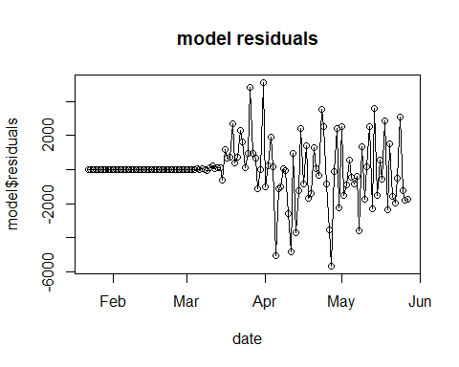

acf(as.vector(model$residuals),main="ACF of model residuals")

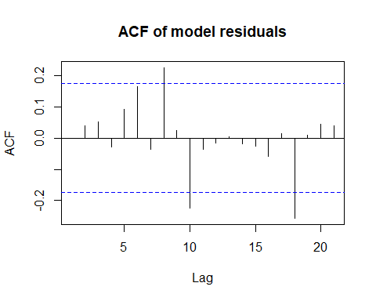

qqnorm(model$residuals,main="QQ plot of model residuals")

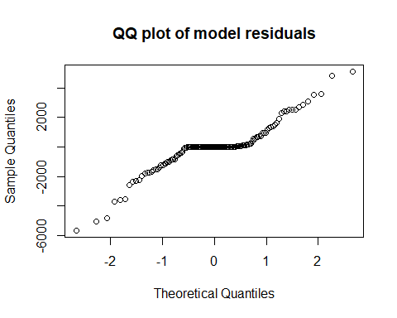

hist(model$residuals,main="histogram of model residuals")

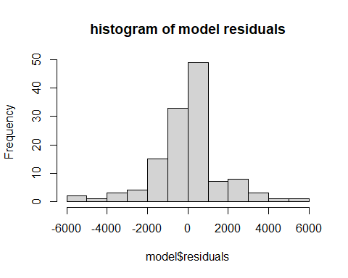

#predictions  
predictions <- predict(model,n.ahead=10)  
dateahead<- seq(from=(n+1),to=(n+10))  
dateahead <- as.Date(dateahead,origin = "2020-01-21")  
format(dateahead,format = "%b %d %y")

## [1] "May 28 20" "May 29 20" "May 30 20" "May 31 20" "Jun 01 20" "Jun 02 20"  
## [7] "Jun 03 20" "Jun 04 20" "Jun 05 20" "Jun 06 20"

plot(dateahead,predictions$pred,main="Predicted Cases",type="o",ylim=c(10000,25000),ylab="Predicted Daily New Cases",xlab="Date",col="red")  
lines(dateahead,(predictions$pred - predictions$se),type="l",col="red")  
lines(dateahead,(predictions$pred + predictions$se),type="l",col="red")

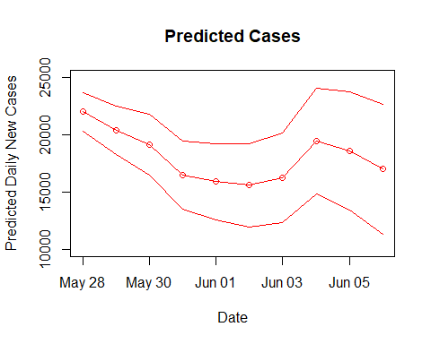

datenew <- c(date,dateahead)  
total <- c(newcase,predictions$pred)  
plot(datenew,total,col=c(rep("black",n),rep("red",10)),main="Predicted Cases",type="o",ylab="Daily New Cases",xlab="Date")  
lines(dateahead,(predictions$pred - predictions$se),type="l",col="red")  
lines(dateahead,(predictions$pred + predictions$se),type="l",col="red")

