

UNIT:ADVANCED WEB DESIGN
NAME: JOSHUA MULI-BSCCS/2024/73427
COURSE: BACHELOR OF SCIENCE IN COMPUTER SCIENCE
DEPARTMENT: INFORMATION TECHNOLOGY

LECTURER : NYORO MICHAEL

Table of Contents
Week 1:LOCAL ENVIRONMENT 6
Installation of My Mysql and its environment. 6
Figure 1: Mysql installation 6
Running of Mysql server 6
Figure 2: Running of Mysql server 7
Localhost Test Page 7
Figure 3: Localhost test page 8
Database Connection Test 9
Figure 4: Database connection test 9
WEEK 2: WIREFRAMES AND GUI DESIGN 9
The image demonstrates the initial conceptual planning for the web application framework 9
Figure 5: Hand Drawn wireframe 9
Figure 6: Mobile view mockup 10
Week 3 11
JavaScript Form Validation and Password strength Checker 11
Figure 7: Javascript Form Validation 11
Figure 8: Password strength checker 12
Database Connection Script 12
Figure 9: Database Connection Script 12
Week 4 13
Figure 10: Login Form 13
Figure 11: Folder Structure 14
Figure 12: Github updates 15
Week 5 15
Figure 13: Users table 15
Figure 14: Display all users 16
Figure 15: Movies Table 16

Week 1:LOCAL ENVIRONMENT

Installation of My Mysql and its environment.
I installed mysql-server and mysql-workbench which is an database app to display the records in tables

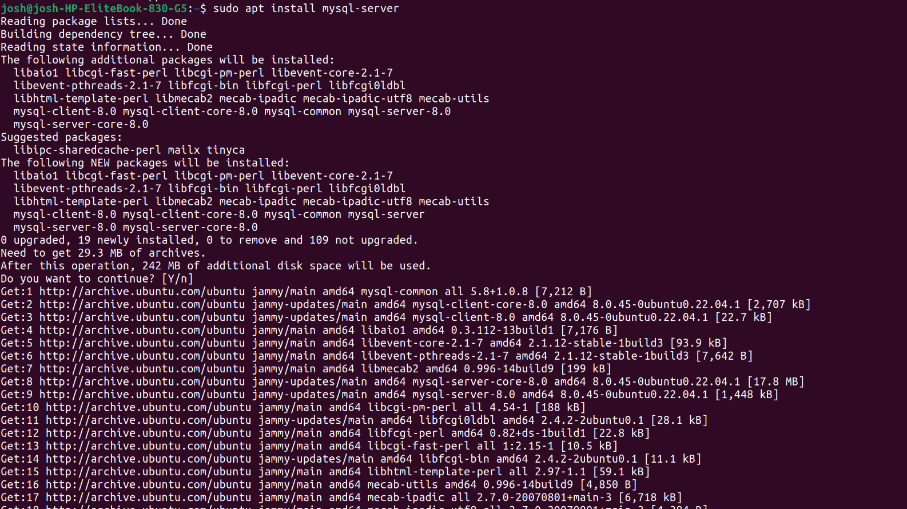Figure 1: Mysql installation

Running of Mysql server
This is where Mysql server is running after successful connection of my website to the database

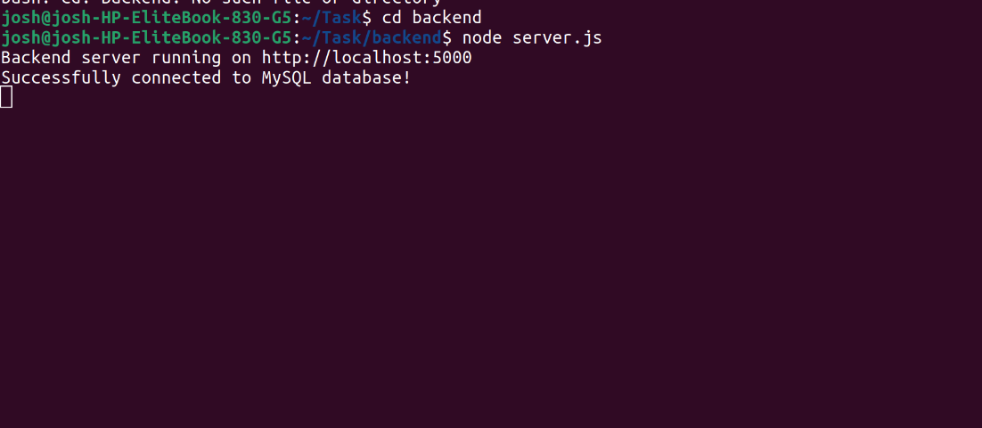Figure 2: Running of Mysql server

Localhost Test Page
The command npm run dev starts the vite development server for my web application.Vite compiles the project successfully and launches it successfully on the local host link.

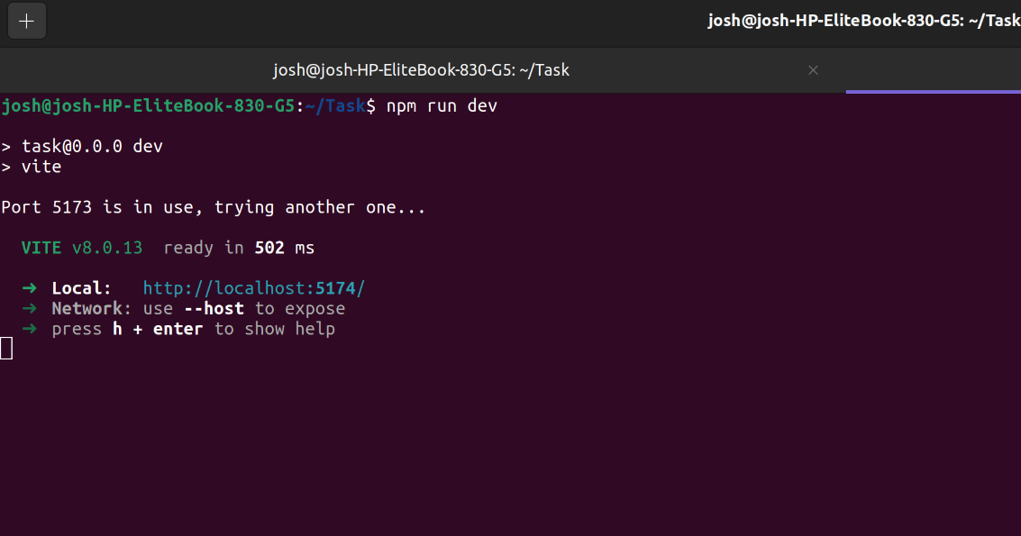Figure 3: Localhost test page
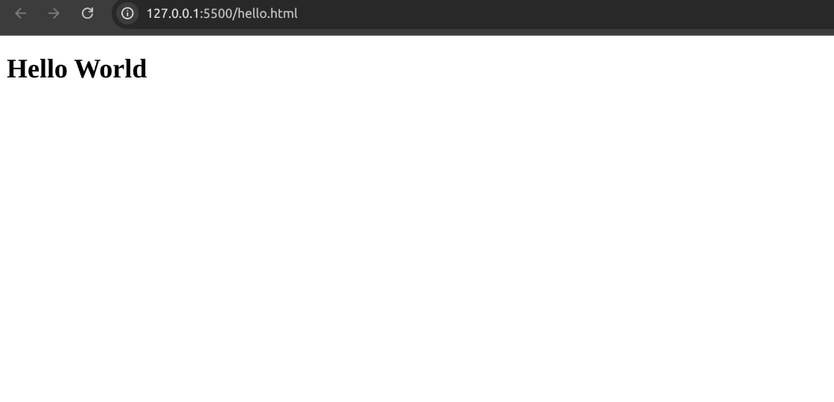
The figure above shows the hello world test page

Database Connection Test

Figure 4: Database connection test

WEEK 2: WIREFRAMES AND GUI DESIGN

The image demonstrates the initial conceptual planning for the web application framework

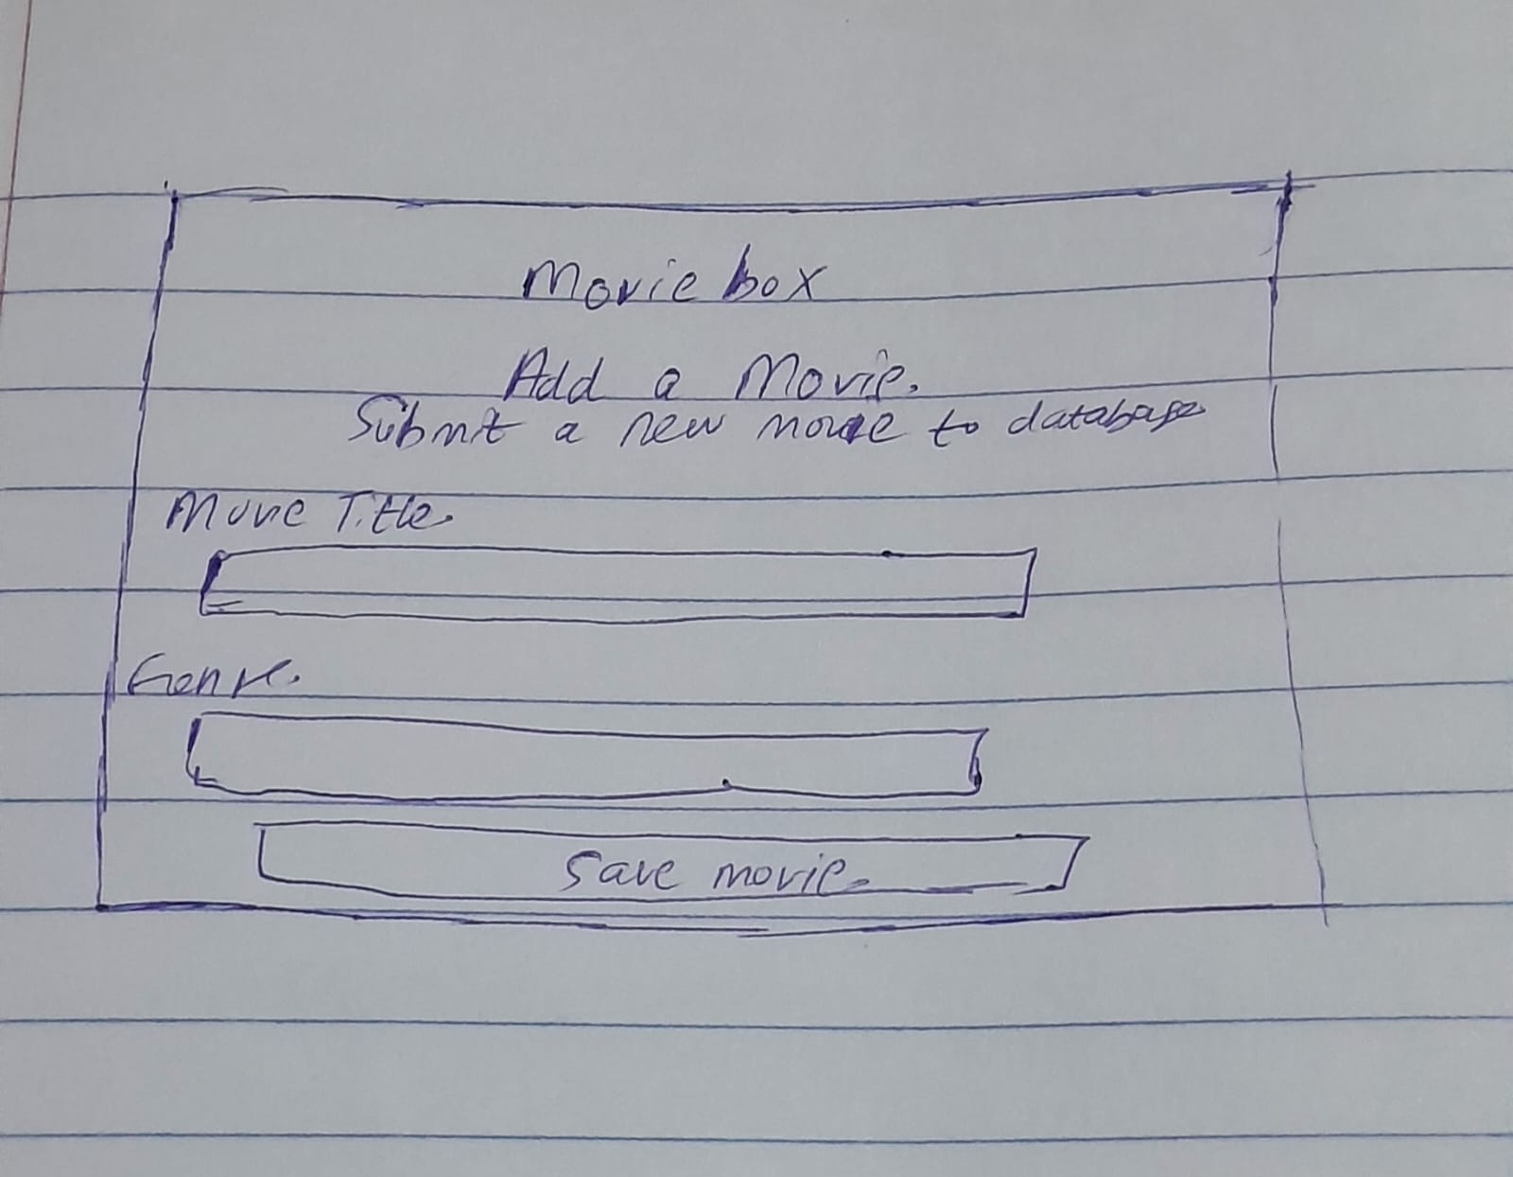Figure 5: Hand Drawn wireframe

The figure shows how my web application will appear when opened in a mobile phone

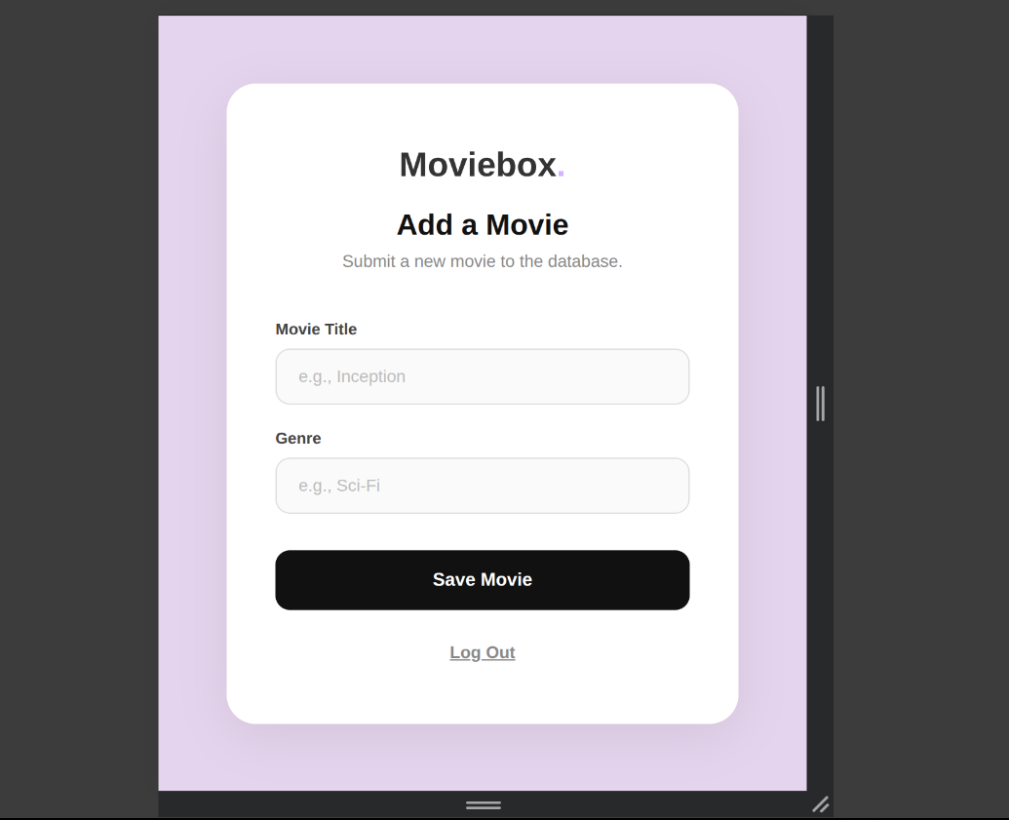Figure 6: Mobile view mockup

Week 3

JavaScript Form Validation and Password strength Checker
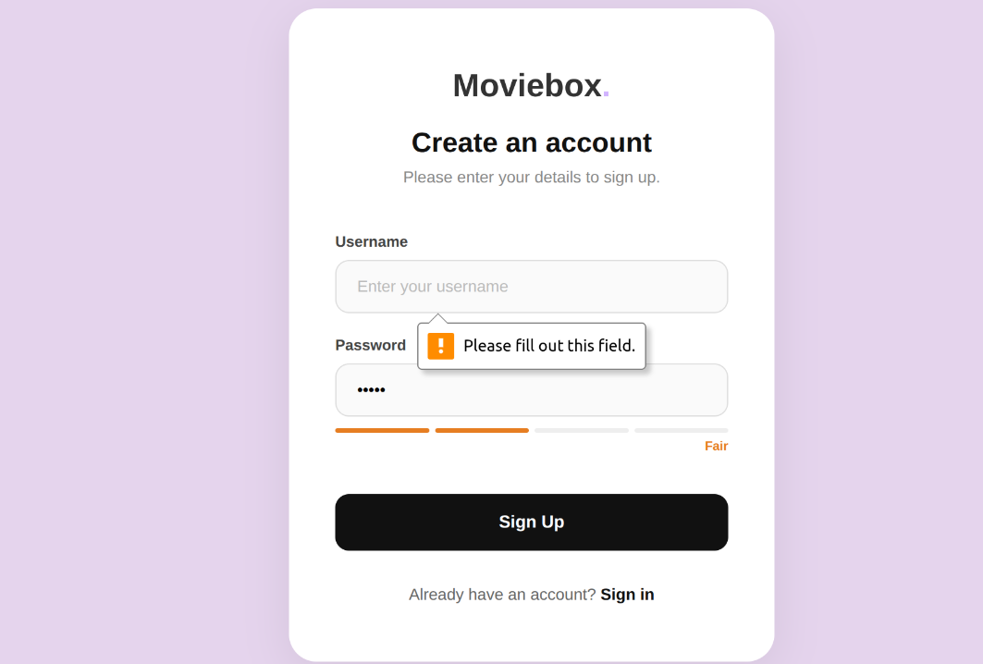
In the form above, one cannot submit data while username field is empty
The form also includes a password strength checker feature that validates strength of password.

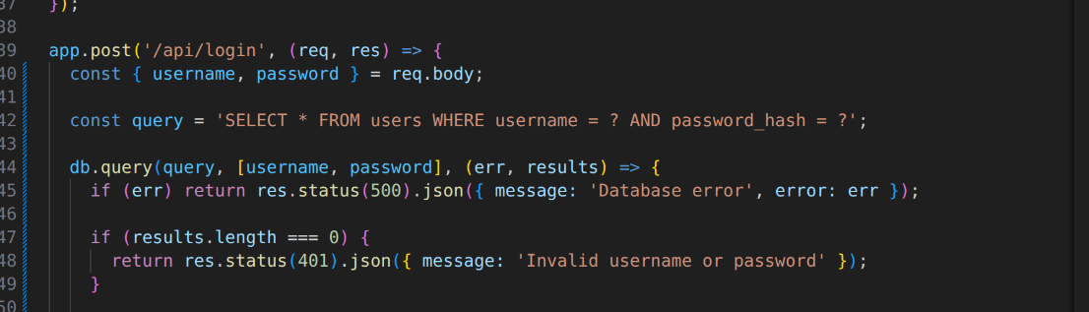Figure 7: Javascript Form Validation
Function designed to evaluate user password strength by evaluation of length, number, uppercase,symbols.

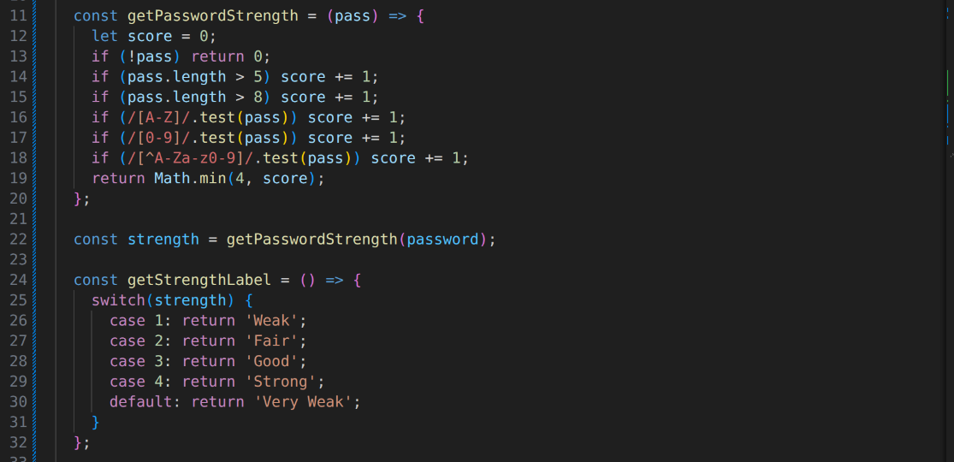Figure 8: Password strength checker

Database Connection Script
The figure shows a backend script for establishing connection of my web app to my local mysql workbench database.

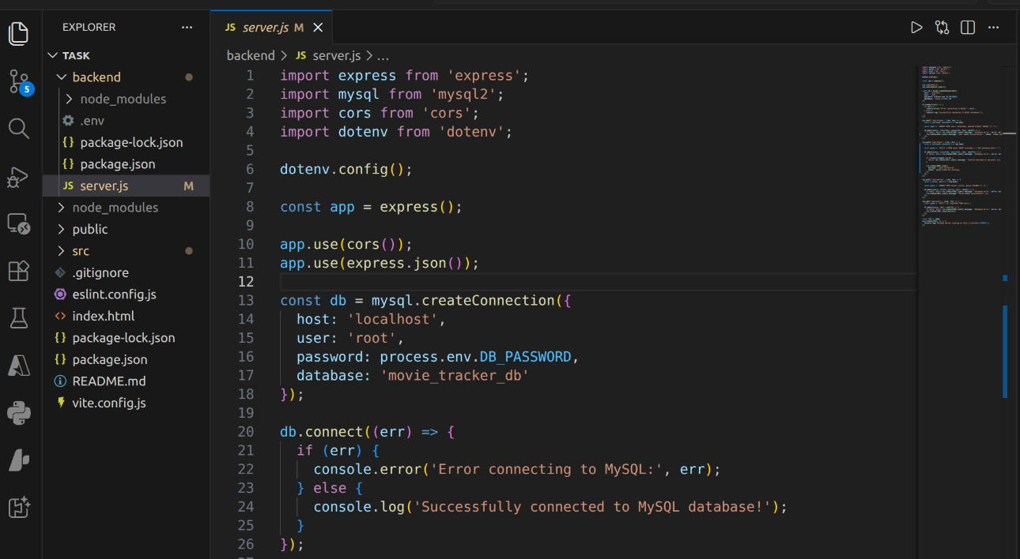Figure 9: Database Connection Script

Week 4
The figure shows a user interface designed for authentification using a password to access the web app

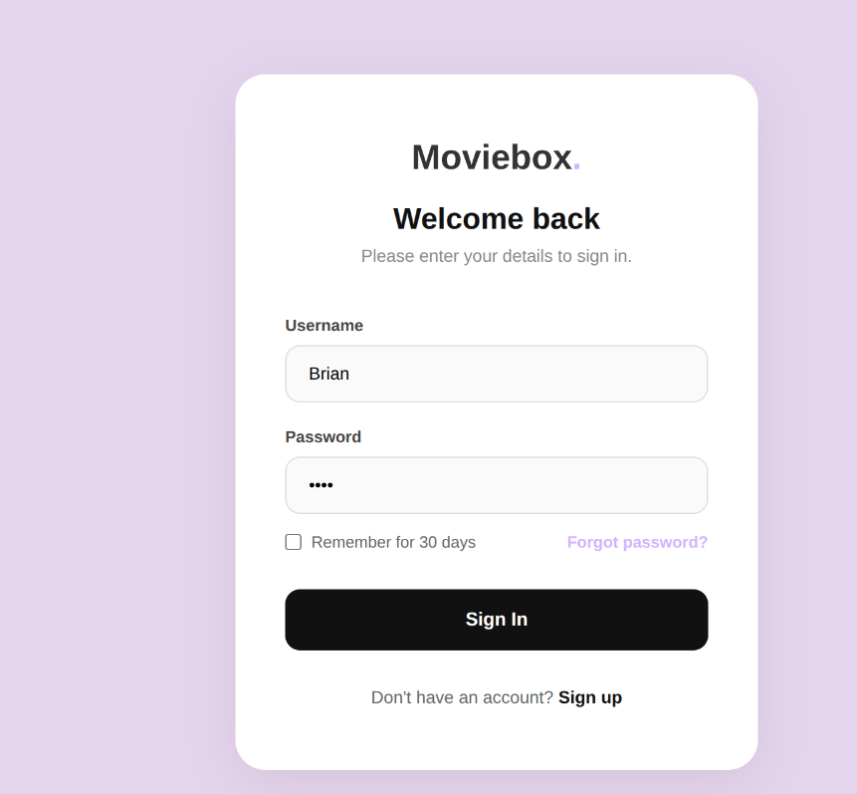Figure 10: Login Form

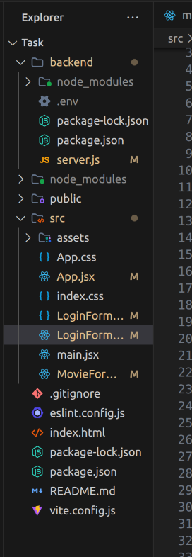Figure 11: Folder Structure

The figure shows the folder structure for my web application which contains the backend folder and frontend folder .
The figure shows an organized repository history that track addition of features.

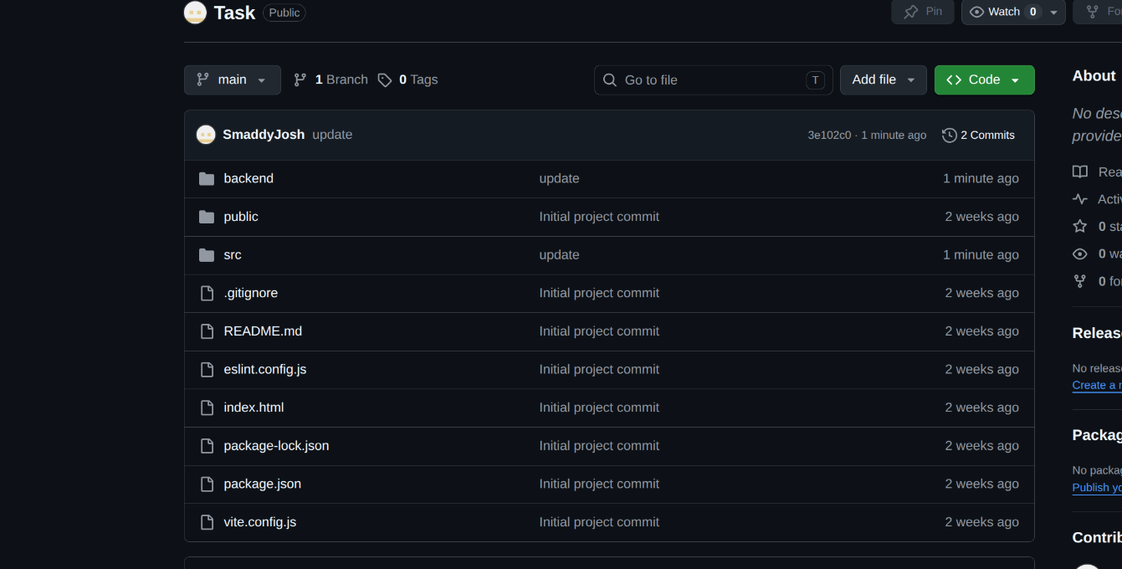Figure 12: Github updates

Week 5

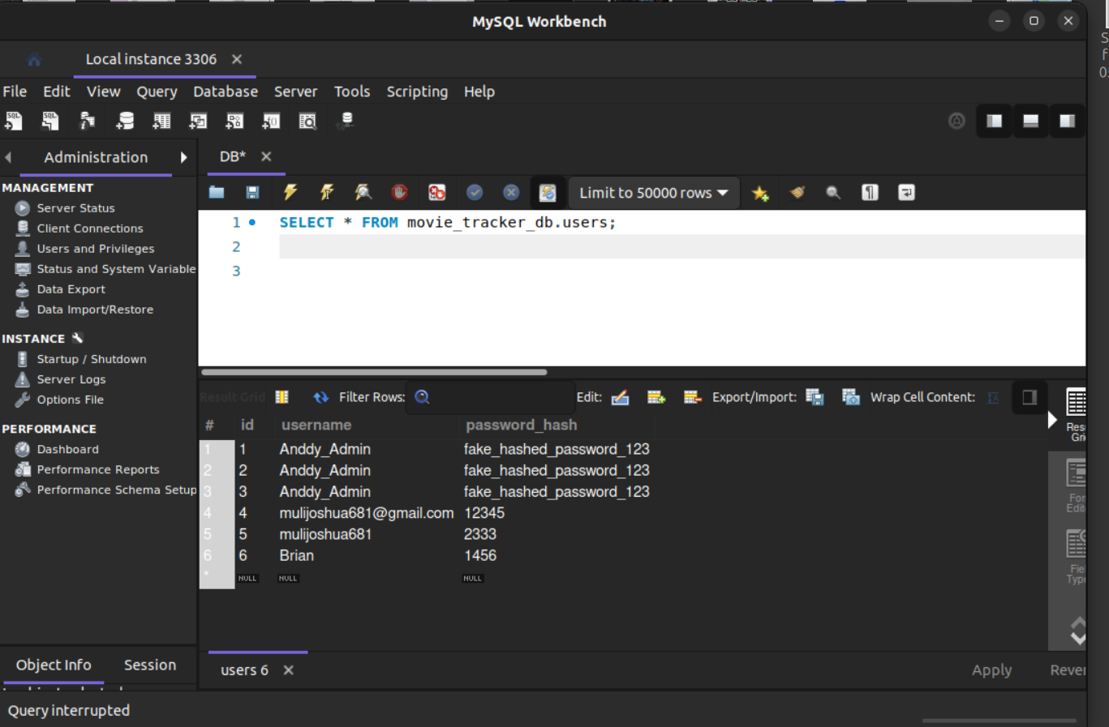Figure 13: Users table
The figure above shows user data in a database which were fen in the sign up form
The figure shows sql commands to enable displaying of all users in the database.

Figure 14: Display all users
The figure shows all movie data submitted by the user in my local mysql workbench database.

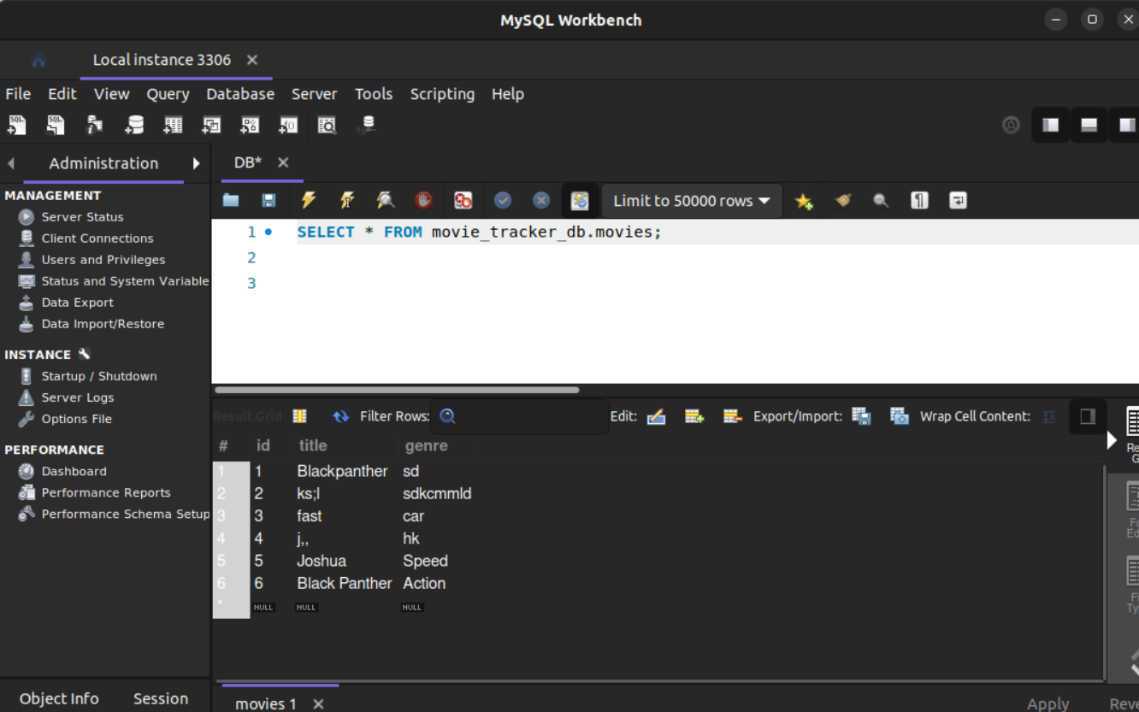Figure 15: Movies Table

Github Link-Link to project

Week 6: Movie CRUD Operations
This section contains the screenshots demonstrating the Movie Management System CRUD (Create, Read, Update, Delete) operations using React, Node.js, and MySQL.
1. Database Structure & Records
Explanation: This screenshot demonstrates the successful integration of the MySQL database. It shows the `movies` table populated with the records inserted via the web application, confirming that the backend correctly connects to and manipulates the database.
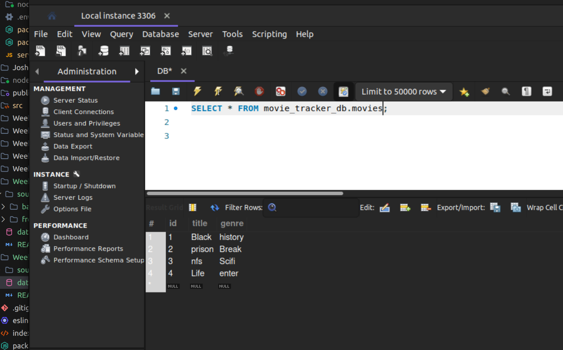
2. Create & Read Operations
Explanation: Here, the Dashboard is shown. The left side handles the Create operation (inserting a new movie), while the right side handles the Read operation (fetching all movies from the database and displaying them). The success message confirms data was successfully sent to the server.
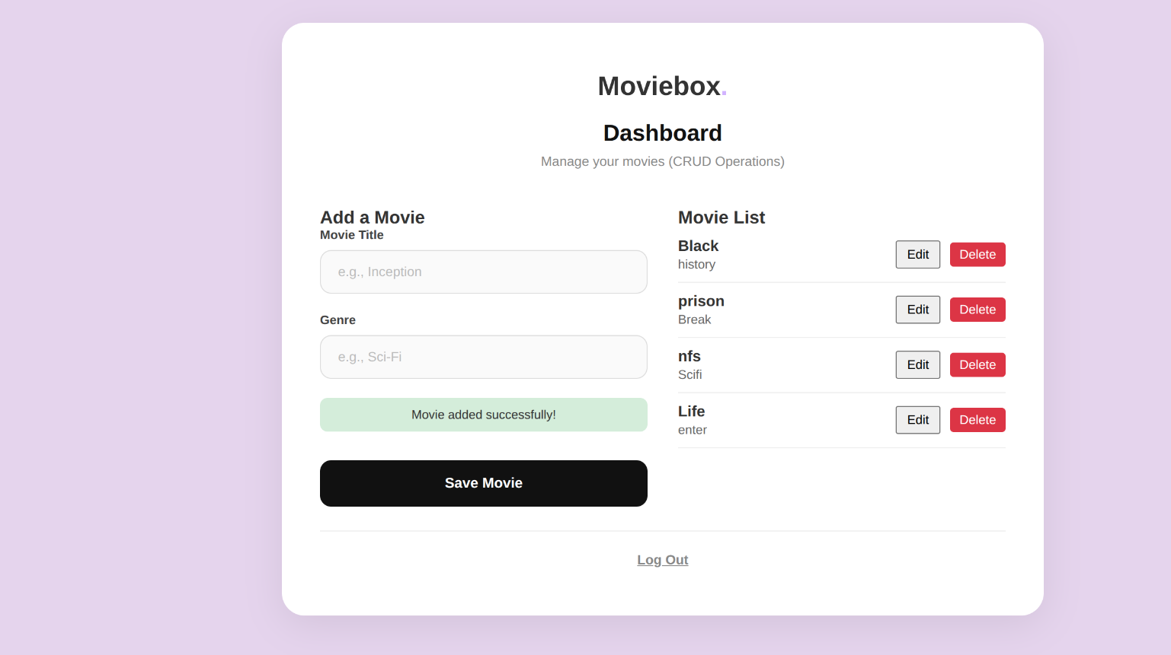
3. Update Operation
Explanation: This demonstrates the Update operation. After clicking the Edit button, the movie's data is loaded back into the form. Submitting it modifies the existing record in the database rather than creating a new one.
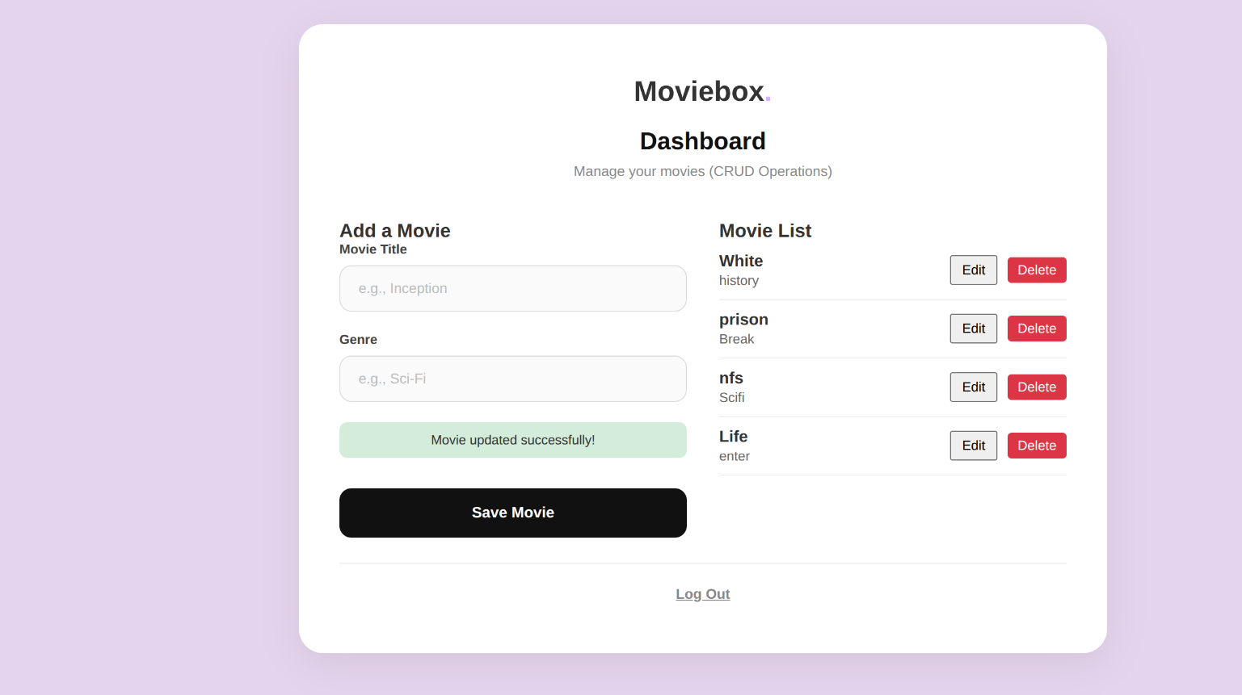
4. Delete Operation
Explanation: This shows the Delete operation. Clicking Delete prompts a confirmation dialog to prevent accidental deletion. Upon confirming, the application sends a DELETE request to the backend to remove the specific record from the database.
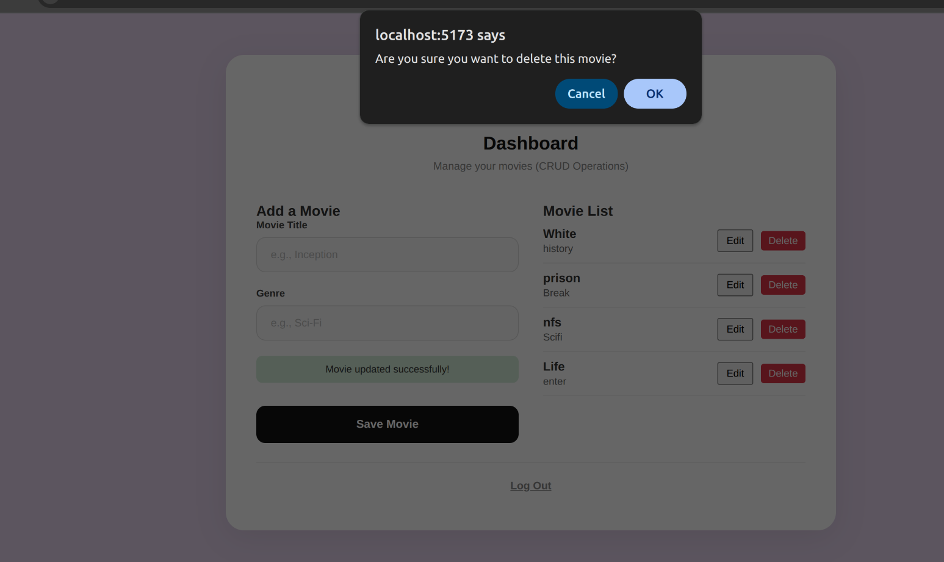

Week 7: User Authentication and Session Management
This section contains the screenshots demonstrating the Movie Management System User Authentication and Session Management operations using bcrypt and jsonwebtoken.
1. User Registration Form with Roles
Explanation: This screenshot shows the "Create an account" (Sign Up) form. It includes the required fields for Username and Password, and importantly, the "Role" dropdown (Client, Admin, Managerial) which demonstrates multi-user authentication support from the UI level.
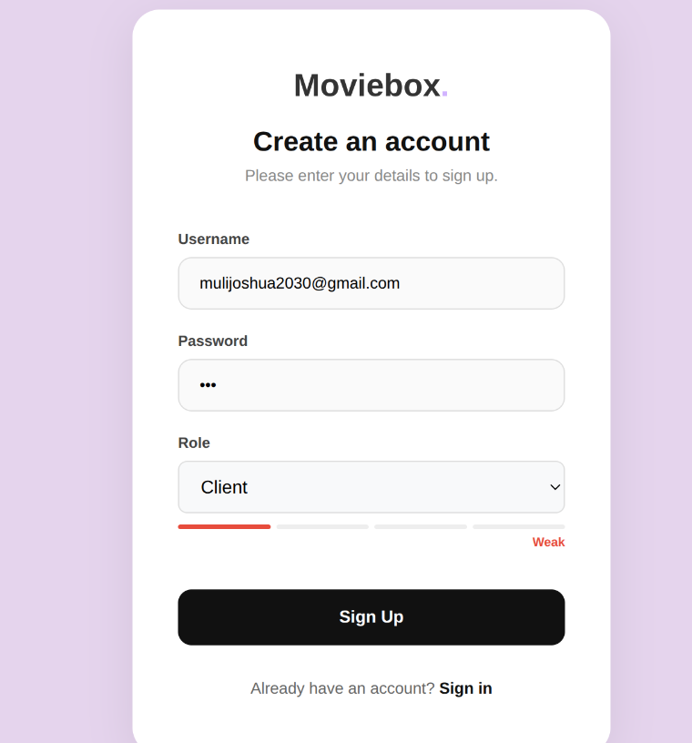
2. Database Authentication Setup
Explanation: This shows the `users` table within the database. It proves that user passwords are securely hashed using bcrypt (`password_hash` column) rather than being stored in plain text. It also verifies that the selected user roles are correctly stored in the database.
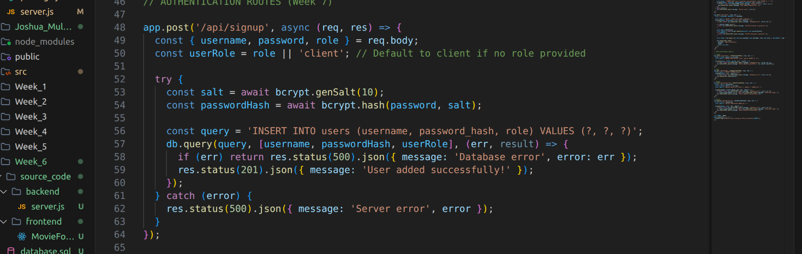
3. Secure Login & Session Management
Explanation: This screenshot of the browser Developer Tools (Local Storage) demonstrates that upon successful login, the server issues a secure JSON Web Token (JWT) that the frontend stores. This mechanism ensures secure, stateless session management.
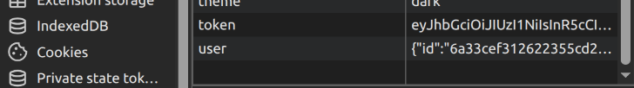
4. Protected Dashboard & Logout
Explanation: This displays the protected Movie Dashboard, confirming that only authenticated users can access this page. The presence of the "Log Out" button demonstrates that users can successfully terminate their secure session.
