Smart Convo An AI Personal Assistant with ChatGpt Integration

Submitted in partial fulfillment of the requirements for the award of the
Degree of

BACHELOR OF TECHNOLOGY
In
COMPUTER SCIENCE AND ENGINEERING
Submitted by

S.M.A.Kayyum | V.Prasanthkumar | P.Balvardan | K. RakeshReddy
21ME5A0503 | 20HK1A0532 | 20ME1A0545 | 20ME1A0560



Under the Guidance of

Mr. Y Nagendra Kumar

Assistant Professor

Department of Computer Science and Engineering
RAMACHANDRA COLLEGE OF ENGINEERING
(AUTONOMOUS)

(Approved by AICTE, Affiliated to JNTUK, Kakinada)

Accredited by NBA, NAAC A+
NH-16 Bypass, Vatluru (V), Eluru -534007, Eluru Dist., A.P

2020 – 2024

RAMACHANDRA COLLEGE OF ENGINEERING
(AUTONOMOUS)
(Approved by AICTE, Affiliated to JNTUK, Kakinada)
Accredited by NBA, NAAC A+
NH-16 Bypass, Vatluru (V), Eluru -534007, Eluru Dist., A.P

Department of Computer Science and Engineering



CERTIFICATE
This is to certify that Shaik.MohammadAbdulKhyyum (21ME5A0503), V.Prasanth kumar (20HK1A0532), Pedapudi.Balvardhan (20ME1A0545), Karri.RakeshReddy (20ME1A0560) students of Bachelor of Technology in Computer Science & Engineering have successfully completed their project work entitled “SMART CONVO An Intelligent Personal Assistants with ChatGPT” at Ramachandra College of Engineering, Eluru during the Academic Year 2023-2024. This document is submitted in partial fulfillment for the award of the Degree of Bachelor of Technology in Computer Science & Engineering and the same is not submitted elsewhere.

Mr. Y Nagendra Kumar Mr. Y Nagendra Kumar
Project Guide HOD-CSE

External Examiner

DECLARATION
We are Shaik.MohammadAbdulKhayyum(21ME5A0503),V.Prasanth kumar(20HK1A0532), P.Balvardan (20ME1A0545), K.Rakesh reddy (20ME1A0560) hereby declares the project report titled “ SMART CONVO An Intelligent Personal Assistants with ChatGPT” under the supervision of Mr. Y Nagendra Kumar, Asst Professor Department of Computer Science and Engineering is submitted in partial fulfillment of the requirements for the award of the degree of Bachelor of Technology in Computer Science & Engineering.

This is a record of work carried out by us and the results embodied in this project have not been reproduced or copied from any source. The results embodied in this project report have not been submitted to any other University or Institute for the award of any other degree or diploma.

ACKNOWLEDGEMENT

We wish to take this opportunity to express our deep gratitude to all the people who have extended their cooperation in various ways during our project work. It is our pleasure and responsibility to acknowledge the help of all those individuals.

We sincerely thank our guide Mr. Y Nagendra Kumar, Asst Professor in the Department of CSE for helping us in successful completion of our project under her supervision.

We are very grateful to Mr. Y Nagendra Kumar, Head of the Department, Department of Computer Science & Engineering for her assistance and encouragement in all respects in carrying throughout our project work.

We express our deepest gratitude to Dr. V Srinivasa Rao, Principal, Ramachandra College of Engineering, and Eluru for his valuable suggestions during preparation of draft in our document.

We thank the Project Coordinators Dr. A Daveedu Raju, Professor, Department of CSE, for their valuable guidance and support throughout the development of this project.

We express our deepest gratitude to the Management of Ramachandra College of Engineering, Eluru for their support and encouragement in completing our project work and providing us necessary facilities.

We sincerely thank all the faculty members and staff of the Department of CSE for their valuable advices, suggestions and constant encouragement which played a vital role in carrying out this project work.

Finally, we thank one and all who directly or indirectly helped us to complete our project work successfully.

S.M.A.Kayyum | V.Prasanthkumar | P.Balvardan | K. RakeshReddy
21ME1A0503 | 20HK1A0532 | 20ME1A0545 | 20ME1A0560

Chapter No | Title | Page No
 | Abstract | VII
1. | Introduction | 1
 | 1.1 Introduction | 1
 | 1.2 Overview of the Project | 1
 | 1.3 Objective | 1
 | 1.4 Scope | 1
 | 1.5 Expected Outcome | 1
2. | Literature Survey | 1
3. | System Analysis | 1
 | 3.1 Existing System | 1
 | 3.2 Proposed System | 1
4. | System Study | 1
 | 4.1 Feasibility Study | 1
 | 4.1.1 Operational Feasibility | 1
 | 4.1.2 Economic Feasibility | 1
 | 4.1.3 Technical Feasibility | 1
 | 4.2 System Requirements | 1
 | 4.2.1 Hardware Requirements | 1
 | 4.2.2 Software Requirements | 1
5. | Project Architecture | 1
 | 5.1 System Architecture | 1
 | 5.2 Design and Diagrams | 1
 | 5.2.1 Usecase Diagram | 1
 | 5.2.2 Class Diagram | 1
 | 5.2.3 Sequence Diagram | 1
 | 5.2.4 Collaboration Diagram | 1
 | 5.2.5 Data Flow Diagram | 1
6. | Methodology | 1
 | 6.1 Data Dictionary | 1
 | 6.2 Data Collection | 1
 | 6.3 Preprocessing Techniques | 1
 | 6.4 Prepared Data | 1

V
Chapter No | Title | Page No
7. | Model | 1
 | 7.1 Training | 1
 | 7.2 Validation | 1
8. | Software Description | 1
9. | System Testing | 1
 | 9.1 Literature on Testing | 1
 | 9.1.1 Unit Testing | 1
 | 9.2.1 Integration Testing | 1
 | 9.3.1 Acceptance Testing | 1
 | 9.2 Test cases on Project | 1
10. | Coding | 1
11. | Results | 1
 | 11.1 Screenshots | 1
 | 11.2 Conclusion & Limitations | 1
 | 11.3 Future Scope | 1
12. | References & Bibliography | 1

VI

ABSTRACT

In recent years, voice assistants like Siri and Google Assistant have become integral parts of our daily lives, simplifying tasks and providing information through natural language interactions. However, users often encounter challenges such as limited contextual understanding, lack of creativity in responses, and occasional misinterpretation of commands. This project aims to address these issues by developing an advanced AI voice assistant seamlessly integrated with ChatGPT.
Our AI voice assistant leverages state-of-the-art speech-to-text and text-to-speech systems for accurate communication. The incorporation of ChatGPT introduces a new dimension of creativity and context-awareness to user interactions. By utilizing the OpenAI GPT API, our assistant can generate rich, descriptive, and contextually relevant responses, surpassing the limitations observed in existing solutions.
By addressing the shortcomings of existing voice assistants and harnessing the capabilities of ChatGPT, our AI voice assistant aims to redefine user experiences, offering a more intuitive, creative, and contextually aware interaction platform. This project lays the foundation for a new era of voice assistants that not only fulfill user needs but also engage and delight users through personalized and dynamic conversations.

VII

CHAPTER-1

INTRODUCTION

  - Introduction
In the contemporary digital landscape, the integration of Artificial Intelligence (AI) has revolutionized human-computer interaction, prominently exemplified by the prevalence of AI assistants. These intelligent agents, such as Siri and Google Assistant, facilitate seamless communication through natural language understanding and execution of tasks. However, persistent challenges, including limited contextual awareness and formulaic responses, underscore the need for innovation in this domain. This project endeavors to transcend these limitations by integrating Chat GPT, a cutting-edge language model developed by Open AI, into the framework of AI voice assistants, promising to redefine user experiences and expectations.
  - Overview of the Project
This project addresses the pressing need for an advanced and adaptable virtual assistant solution capable of providing intuitive and contextually relevant assistance to users across a broad spectrum of tasks. Existing personal assistant systems often fall short in delivering a truly interactive and intelligent user experience due to their reliance on scripted responses and limited access to real-time data. This project aims to overcome these limitations by integrating cutting-edge AI technologies, including ChatGPT for natural language processing and PerplixAI for real-time data retrieval. The integration of ChatGPT and PerplixAI poses technical challenges related to data interoperability.
  - Objective
The overarching goal of this project is to synergize the strengths of AI assistants and ChatGPT to create an advanced voice assistant that surpasses existing limitations. By integrating ChatGPT, the objective is to instill the assistant with heightened contextual awareness, creative response capabilities, and an improved ability to understand user intent. Through meticulous design and implementation, we aim to redefine user-machine communication, offering a more engaging, dynamic, and personalized interaction experience. In the subsequent sections, a detailed exploration of the technical aspects of our approach will be presented, outlining the methodologies employed to seamlessly integrate ChatGPT into the voice assistant framework.

  - Scope
The project scope includes the development of an advanced AI voice assistant integrated with ChatGPT, accompanied by a user-friendly Graphical User Interface (GUI). The focus encompasses:

1.AI Voice Assistant Framework with GUI:
Designing and implementing a versatile GUI for seamless user interaction with the voice assistant. Ensuring the GUI accommodates diverse platforms, enhancing accessibility.

2ChatGPT Integration and Interaction:
Integrating ChatGPT into the voice assistant architecture for enhanced natural language understanding.
Implementing communication protocols between the GUI and ChatGPT to facilitate dynamic conversations.

3.Creative Response Generation:
Leveraging ChatGPT's generative capabilities for creative and engaging responses in both voice and text formats.

4.Privacy, Security, and User Authentication:
Adhering to privacy and security protocols, including optional user authentication, for safeguarding user data. Ensuring consistent security measures across both voice and GUI interfaces.

  - Expected Outcome

- interactive personal assistant capable of understanding natural language queries
- Implementation of advanced natural language processing (NLP) algorithms like ChatGPT for accurate comprehension
- Integration of real-time data retrieval using PerplixAI to fetch up-to-date information
- Development of a user-friendly interface for seamless interaction via text or speech input.
- Automation of tasks, reminders, schedule management, and daily activities assistance.
- Accurate retrieval and presentation of information from diverse sources

CHAPTER-2

LITERATURE SURVEY

A literature survey for your project of integrating a personal assistant with ChatGPT involves reviewing existing research, publications for the projects related to both personal assistant systems and ChatGPT technology. Here's an outline of what a literature survey for your project might include:
Personal assistant system:
Review academic papers, journal articles, and books that discuss the design, development, and implementation of personal assistant systems.
Explore different approaches to building personal assistants, including rule-based systems, machine learning models, and hybrid approaches.
Identify key features, functionalities, and use cases of existing personal assistant systems and analyze their strengths and limitations.
ChatGPT and Language Models:
Investigate research papers, articles, and documentation related to ChatGPT and other large-scale language models.
Understand the architecture, training methodology, and capabilities of ChatGPT, including its ability to generate human-like text and understand natural language queries.
Explore the applications of ChatGPT in various domains, including conversational agents, language translation, content generation, and question answering.
Integration of ChatGPT with Personal Assistants:
Identify any existing projects or research efforts that have integrated ChatGPT or similar language models with personal assistant systems.
Analyze the approaches, methodologies, and challenges encountered in integrating language models like ChatGPT into conversational agents.

CHAPTER-3

SYSTEM ANALYSIS

3.1 Existing System
While personal assistant systems offer convenience for managing tasks and accessing information, they often stumble when faced with complex inquiries or adapting to individual needs. This disconnects between user expectations and the system's capabilities highlights the need for advancements in conversational abilities and personalization.
Current systems, despite their utility, lack the nuanced understanding of language and user intent necessary for truly natural interactions. Users express frustration with rigid responses and an inability to engage in meaningful dialogue beyond basic commands.
Additionally, the system's structure limits its ability to adapt to diverse user preferences and evolving needs. This is where the integration of advanced language models like ChatGPT comes into play. ChatGPT's state-of-the-art capabilities in understanding and generating human-like text offer a promising solution for overcoming these limitations.
By integrating ChatGPT into the existing personal assistant system, we aim to address these limitations and elevate the user experience to new heights. ChatGPT's state-of-the-art language model offers unparalleled capabilities in understanding and generating human-like text, making it an ideal solution for enhancing conversational interactions within the system.
With ChatGPT, users can expect more accurate and contextually relevant responses to their queries, as well as the ability to engage in more natural and engaging conversations with the personal assistant

Disadvantages

Limited Customization:

Existing personal assistant systems may have limited customization options, making it challenging for users to tailor the assistant to their specific needs or preferences.

Lack of Integration:

Some systems may lack seamless integration with external services or APIs, limiting their ability to fetch real-time data or provide dynamic responses from diverse sources.

3 . Inaccurate Responses:

Existing systems may occasionally provide inaccurate or irrelevant responses, especially when faced with complex queries or ambiguous language.

Real time data: It can not give real time data

Limited Offline Functionality:

Existing systems may have limited functionality when offline, restricting users' ability to interact with the assistant in certain situations

3.2 Proposed System
Personal assistants are handy, but often fall short when it comes to complex requests or individual needs. Enter ChatGPT, a powerful language model poised to transform the way we interact with these digital helpers.
Imagine an assistant that truly grasps your meaning, not just your words. understand and respond to user queries with remarkable accuracy and depth. This means engaging in meaningful, personalized conversations, not just fulfilling basic commands.
The system doesn't stop at understanding; it actively learns from your interactions. Over time, it adapts to your preferences, language nuances, and even conversational patterns. This translates to highly personalized assistance and recommendations, tailored to your unique needs.
ChatGPT expands the assistant's capabilities beyond basic tasks like setting reminders. Imagine tackling complex problems or receiving assistance with specific scenarios. The system becomes a true partner in navigating daily life.
While intelligence is crucial, so is security. The system prioritizes user privacy with robust encryption and anonymization protocols, ensuring your data remains protected and confidential
This integration sets a new bar for personal assistant technology. By combining advanced NLP with a user-centric design and commitment to privacy, it offers unparalleled convenience, intelligence, and trustworthiness.

Advantages

Customization and Flexibility: Your project offers users greater customization options, allowing them to tailor the personal assistant to their specific needs and preferences. This flexibility can enhance user satisfaction and engagement.

Integration with ChatGPT: By integrating with ChatGPT, your project can leverage advanced natural language processing (NLP) capabilities, enabling more accurate understanding of user queries and more natural and contextually relevant responses.

Real-time Data Retrieval with PerplixAI: The integration with PerplixAI enables your personal assistant to fetch real-time data from diverse sources, providing users with up-to-date information and enhancing the assistant's utility and relevance.

Enhanced User Experience: With advanced NLP capabilities and real-time data retrieval, your project aims to deliver an enhanced user experience, offering more personalized, dynamic, and informative interactions compared to traditional personal assistant systems.

Improved Accuracy and Relevance: The combination of ChatGPT and PerplixAI allows your personal assistant to generate more accurate and contextually relevant responses to user queries, enhancing the overall quality of user interactions.

CHAPTER-4
SYSTEM STUDY

4.1 Feasibility Study

4.1.1 Operational Feasibility
Evaluate the impact of integrating ChatGPT into your personal assistant system on day-to-day operations, including changes to workflow, resource allocation, and user support requirements.
Assess the readiness of stakeholders, including developers, administrators, and end-users, to adapt to the new system and utilize ChatGPT effectively.
Consider any organizational or cultural barriers that may affect the successful implementation of the project and develop strategies to address them.

4.1.2 Economic Feasibility
Estimate the costs associated with integrating ChatGPT into your personal assistant system, including licensing fees for accessing the ChatGPT API or SDK, development costs, hardware costs, and ongoing maintenance expenses.
Compare the projected costs with the expected benefits and potential return on investment (ROI) to determine whether the project is financially viable.
Identify potential sources of funding or investment to support the project if necessary.

4.1.3 Technical Feasibility
Assess whether the technology required for integrating ChatGPT into your personal assistant system is available, accessible, and capable of achieving the desired functionality.

Evaluate the compatibility of ChatGPT with your existing system architecture, programming languages, frameworks, and hardware infrastructure

4.2 System Requirements

4.2.1 Hardware Requirements

- Processor: Intel Core i3 or higher
- RAM: At least 2 GB
- Keyboard: Any multimedia keyboard
- Mouse: Any optical mouse
- Hard Disk: Minimum 100 GB

4.2.2 Software Requirements

- Operating System: Windows 10 or later, macOS Catalina
- Web Browser: Google Chrome, Mozilla Firefox, or Safari (latest versions)
- Text Editor: Visual Studio Code, Sublime Text, or Atom
- Python: Python 3.6 or higher
- Development Environment: Anaconda or Miniconda
- Version Control: Git (for version control and collaboration)
- Database: MySQL or PostgreSQL (for production deployment)

CHAPTER-5
PROJECT ARCHITECTURE

5.1 System Architecture

5.1.1 User Interface (UI):
The UI serves as the front end through which users interact with the personal assistant. It can be a web application, mobile app, or desktop application providing a text or speech-based interface.
5.1.2 Input Processing Module:
This module is responsible for receiving user inputs, which can be in the form of text or speech. It preprocesses the input and forwards it to the NLP (Natural Language Processing) component for further processing.
5.1.3 Real-time Data Retrieval Module:
This module interfaces with PerplixAI or similar services to retrieve real-time data from external sources based on user queries. It sends requests to PerplixAI, processes the received data, and provides it to the NLP component for contextualization and response generation.
5.1.4 Integration Layer:
The integration layer facilitates communication and coordination between different system components. It ensures seamless data flow and interaction among modules, allowing for efficient processing of user requests and generation of accurate responses.
5.1.5 External APIs and Services:
The system may interact with external APIs and services to fetch additional data or perform specific tasks. For example, it may utilize weather APIs for weather forecasts, news APIs for current events, or calendar APIs for scheduling tasks.
5.1.6 Data Storage and Management:
Data storage solutions like databases or file systems may be used to store user inputs, system logs, and other relevant information. This data can be used for analysis, system optimization, and improving user experience over time.

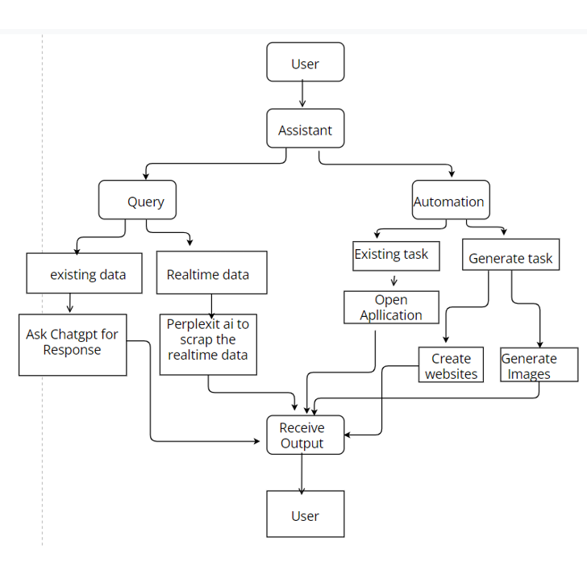

Fig-6.1 System Architecture

5.2 Design and Diagrams

5.2.1 Usecase Diagram

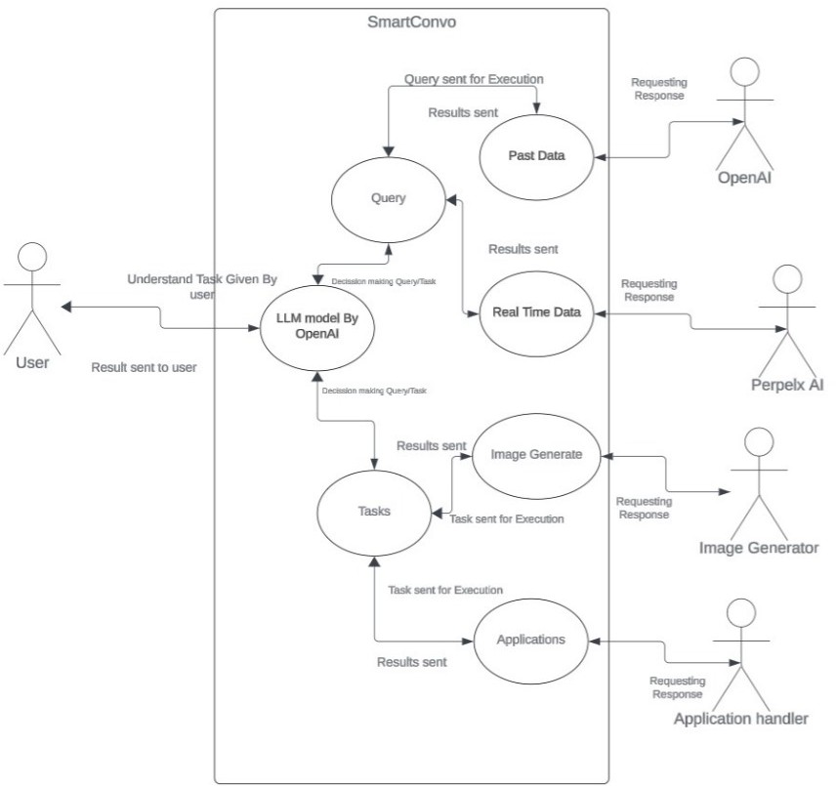

Fig-5.2.1 Use Case Diagram for AI Assistant

5.2.2 Class Diagram

which involves integrating a personal assistant with ChatGPT and utilizing PerplixAI for real-time data retrieval, a class diagram will illustrate the key classes and their relationships within the system.

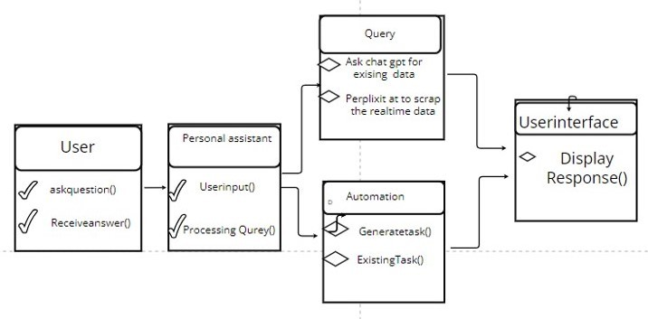

Fig-5.2.2 Class Diagram for AI Assistant

5.2.3 Sequence Diagram

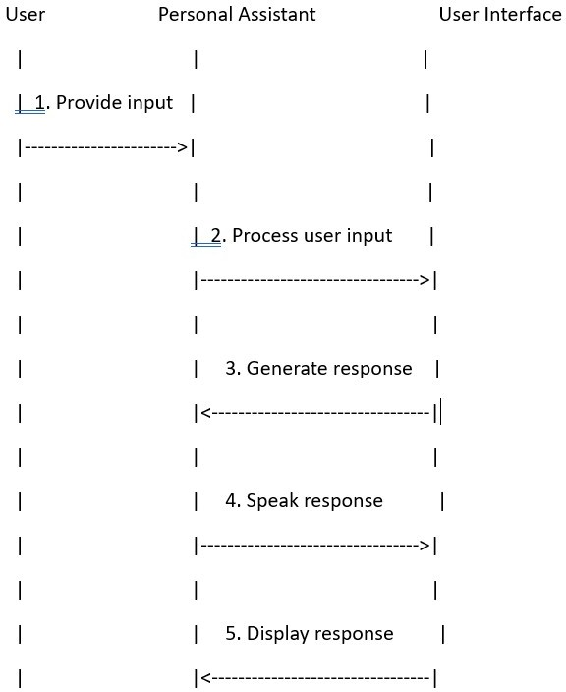

Fig-5.2.3 Sequence Diagram for AI Assistant

5.2.4 Collaboration Diagram

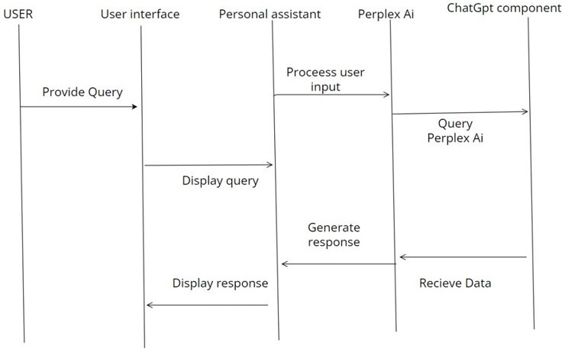

Fig 5.2.4 Collaboration Diagram for AI Assistant

5.2.5 Data Flow Diagram

CHAPTER-6
METHODOLOGY

6.1 Data Dictionary

Data Element Name:
  - The unique identifier or name assigned to each data element, such as "User Input," "Response," "Interaction Log," etc.
Data Type:
  - The specific data type or format of the data element, such as text, numeric, date/time, boolean, audio, etc.
Attributes:
  - Additional properties or characteristics associated with the data element, including:
    - Unique Identifier: A unique identifier assigned to each instance of the data element.
    - Source: Indicates the origin or source of the data (e.g., user input, external API).
    - Timestamp: Date and time when the data element was created or last modified.
    - Content: The actual content or value of the data element.
    - Format: The format or structure of the data element, if applicable.
    - Length: The length or size of the data element, if applicable.
    - Constraints: Any constraints or rules governing the data element's values or behavior.
Data Flow:
  - Documentation of the flow of data through the system, indicating where each data element is generated, processed, and consumed.

6.2 Data Collection

Data collection involves gathering relevant information and resources necessary for training AI models, enhancing the personal assistant's capabilities, and providing accurate and timely responses to user queries. Here's how data collection may be approached for your project:

- Domain-specific Data:
  - Gather domain-specific data related to the topics and subjects your personal assistant will handle. This could include news articles, academic papers, industry reports, or specific knowledge bases relevant to user inquiries and interests.
- Real-time Data Sources:
  - Identify and integrate real-time data sources that provide up-to-date information on various topics, such as news headlines, weather forecasts, stock prices, or sports scores. Utilize APIs or web scraping techniques to fetch data from trusted sources.
- User Interaction Data:
  - Collect data on user interactions with the personal assistant, including user queries, responses generated, user feedback, and usage patterns. This data helps improve the personal assistant's understanding of user intents and preferences over time.
- Evaluation and Validation Data:
  - Curate datasets for evaluating and validating the performance of the personal assistant system. This may include test datasets with annotated examples for assessing the accuracy, relevance, and coherence of generated responses.
5.Continuous Data Collection:
- Establish mechanisms for continuous data collection and updating to keep the personal assistant's knowledge base and information sources up-to-date. Monitor data sources for changes, trends, and new developments to adapt the system according

6.3 Preprocessing Techniques

Preprocessing techniques related to our project involve preparing the input data before it's fed into the components of our personal assistant system. These techniques aim to clean, format, and transform the data to improve the performance and effectiveness of your system. Here are some preprocessing techniques relevant to our project:

Text Tokenization:
  - Description: Breaking down text input into individual tokens, such as words or subwords.
  - Reason: Tokenization helps in converting the raw text input into a format that can be processed by subsequent components, such as natural language understanding (NLU) or machine learning models.

Text Normalization:
  - Description: Standardizing text input by converting it to a consistent format, such as converting uppercase letters to lowercase, removing punctuation, and expanding contractions (e.g., "don't" to "do not").
  - Reason: Text normalization ensures uniformity in the input data, making it easier for the system to process and analyze user queries consistently.

Noise Removal:
  - Description: Removing irrelevant or noisy elements from the input data, such as HTML tags, special characters, or non-textual content.
  - Reason: Noise removal helps clean the input data and focuses on relevant textual information, reducing the chances of misinterpretation.

6.4 Prepared Data

which involves creating a personal assistant integration with ChatGPT and real-time data retrieval using PerplixAI, the prepared data would likely involve several components:
User Queries/Input Data:
This includes the queries or input provided by users to interact with the personal assistant. This data may consist of text inputs, voice commands, or other forms of user interaction.
Processed User Queries:
After receiving user input, the personal assistant processes and interprets these queries to understand the user's intent and context. The prepared data would include the processed user queries, which may involve tokenization, lemmatization, or other natural language processing techniques.
Response Data:
Once the personal assistant generates responses to user queries, the prepared data would include these responses. This data may consist of text responses, speech output, or other forms of feedback provided to users.
Real-Time Data from PerplixAI:
If your project involves retrieving real-time data using PerplixAI, the prepared data would include the data obtained from PerplixAI's services. This could include various types of data such as news articles, weather updates, stock prices, or any other information relevant to user queries.

Processed Real-Time Data:
The data retrieved from PerplixAI may undergo preprocessing or transformation to make it suitable for use within the personal assistant system. This could involve tasks such as data cleaning, normalization, or feature engineering.

CHAPTER-7
SOFTWARE DESCRIPTION

7.1Software Description
Real-Time Data Retrieval: Integrates with PerplixAI to fetch up-to-date information from diverse sources, enhancing the personal assistant's knowledge base.
Dynamic Response Generation: Generates dynamic and contextually relevant responses tailored to individual user queries and preferences.
User-Friendly Interface: Provides a user-friendly interface for seamless interaction via text or speech input, ensuring an intuitive and engaging user experience.
Personalization and Adaptability: Adapts to users' preferences, behaviors, and context over time, providing personalized assistance and recommendations.
Task Automation and Assistance: Automates tasks, provides reminders, schedules management, and assists with various daily activities based on user requests.
Accurate Information Retrieval: Retrieves and presents accurate information from real- time data sources, including news, weather forecasts, and general knowledge databases.
Error Handling and Robustness: Implements error handling mechanisms and robustness features to handle unexpected inputs or system failures gracefully, ensuring reliable performance.
Scalability and Performance: Designed for scalability and high performance, enabling seamless handling of increasing user demand and workload.

7.2 Technologies Used:
Programming Language: Python AI Models: ChatGPT, PerplixAI
Frameworks/Libraries: TensorFlow, PyTorch, Flask
Database: SQLite (for local development), MySQL or PostgreSQL (for production deployment) Cloud Services (optional): AWS, Google Cloud Platform, Heroku
7.3 Deployment Environment:
The system can be deployed on various platforms, including local servers, cloud infrastructure, or containerized environments, ensuring flexibility and scalability as per project requirements

CHAPTER-8
SYSTEM TESTING
8.1 Literature on Testing
Unit Testing
Unit testing for our project involves testing individual components or units of code in isolation to ensure that they function correctly and meet the specified requirements. Here's how unit testing would be conducted for your project:

Identifying Units of Code:
Determine the units of code to be tested, which may include functions, methods, classes, modules, or components within the personal assistant system.
Break down the system into smaller, testable units that can be independently verified.

Writing Test Cases:
Create test cases for each unit of code to be tested, covering different scenarios, edge cases, and input combinations.
Test cases should include both positive and negative scenarios to validate the behavior of the code under various conditions

Setting Up Test Environment:
Set up a test environment that closely resembles the production environment but allows for controlled and isolated testing.
Use testing frameworks and tools suitable for the programming languages and technologies used in your project, such as pytest for Python or Jest for JavaScript.

Executing Tests:
Execute the unit tests for each component in isolation, running the test cases to verify the behavior and correctness of the code.Monitor the test results to identify any failures or errors that indicate potential issues with the code.

    - Integration Testing

Identify Integration Points: Determine the points of interaction between system components such as APIs, data exchanges, or function calls.
Define Test Scenarios: Develop test scenarios that exercise the integration points and verify the flow of data and control between components.
Prepare Test Environment: Set up the testing environment with necessary infrastructure, test data, and simulation tools to replicate real-world integration scenarios.
Execute Tests: Run integration tests to validate the interactions between components, detect interface errors, and ensure data integrity and consistency
Execute Tests: Run integration tests to validate the interactions between components, detect interface errors, and ensure data integrity and consistency

In our project, integration testing would involve testing the interaction between the user interface, input processing module, NLP component, real-time data retrieval module, and integration layer. For example, we would verify that user inputs are correctly processed by the input module, passed to the NLP component for analysis, and trigger the retrieval of real-time data from PerplixAI. we would also ensure that responses generated by the system are delivered accurately to the user interface for display.
BENIFITS
Integration testing offers several benefits, including:
Early detection of integration issues and interface errors Validation of component interactions and data flow
Improved system reliability and stability
Reduced risk of integration-related defects in production

8.3.1 Acceptance Testing

Acceptance testing is like a final check to make sure the personal assistant you've built works the way it's supposed to and meets the needs of the people who will be using it. It's kind of like getting a stamp of approval before you officially say, "Yep, this is ready to go!" You'll run through different situations to see if the assistant understands questions and responds correctly, if it fetches the right information from PerplixAI, and if it's easy and comfortable for people to use. If everything goes well and people are happy with how it works, then it's ready to be put into action!

8.2 Test cases on Project

CHAPTER-9
CODING

from Frontend.GUI import GraphicalUserInterface
import threading
import speech_recognition as sr
from Backend.MainExecution import MainExecution
import textwrap
import subprocess
from time import sleep
from Backend.Manager import *
import platform
from Backend.Speak import Speak

current_platform = platform.system()

User_Name, User_Assistant_name, User_ApiKey, User_Email, User_Mobile = Read_data_from_database()

def SetValue(Data):
with open("Backend//Mic.status", "w", encoding='utf-8') as file:
file.write(Data)

SetValue("False")

def GetValue():
with open("Backend//Mic.status", "r", encoding='utf-8') as file:
Status = file.read()
return Status

def ChangeTheStatus(Value):
with open("Backend//Status.data", "w", encoding='utf-8') as file:
file.write(Value)

def ThreadOne():
GraphicalUserInterface()

def ThreadTwo():

def TextToSpeech(text):

if text==None:
return
if current_platform == 'Darwin':
chunk_size = 1000
chunks = textwrap.wrap(text, width=chunk_size)
ChangeTheStatus("Answering....")
for chunk in chunks:
command = ['say', chunk]
try:
subprocess.run(command, check=True)
except subprocess.CalledProcessError as e:
print(f"Error: {e}")

elif current_platform == 'Windows':
Speak(text)

def SpeechRecognition():
recognizer = sr.Recognizer()
with sr.Microphone() as source:
recognizer.adjust_for_ambient_noise(source)
ChangeTheStatus("Listening....")
audio = recognizer.listen(source)

try:
ChangeTheStatus("Recognizing....")
text = recognizer.recognize_google(audio, language="en-in")
return text

except sr.UnknownValueError:
return "StatusTrue"

except:
return "StatusTrue"

while True:
Status = GetValue()

if Status == "True":
ChangeTheStatus("Processing....")
Command = SpeechRecognition()

if "StatusTrue" == Command:
pass

elif "None" == Command:
pass

else:
Command = Query_modifier(Command)
RealTimeChatLogUpdater(User_Name, Command)
Answer = MainExecution(Query=Command)
RealTimeChatLogUpdater(User_Assistant_name, Answer)
Chatlog(User_Name, User_Assistant_name,Command, Answer)
DataBaseChatlog(User_Name, User_Assistant_name,Command, Answer)
TextToSpeech(Answer)

else:
with open("Backend//Status.data", "r") as file:
StatusText = file.read()
if "Available...." in str(StatusText):
sleep(0.1)

else:
with open("Backend//Status.data", "w") as file:
file.write("Available....")
file.close()

if __name__ == "__main__":
thread2 = threading.Thread(target=ThreadTwo)
thread2.start()
ThreadOne()
thread2.join()

GUI

import sys
from PyQt5.QtWidgets import QApplication, QApplication, QMainWindow, QTextEdit, QStackedWidget, QGraphicsDropShadowEffect, QWidget, QLineEdit, QGridLayout, QVBoxLayout, QHBoxLayout, QPushButton, QFrame, QLabel, QSizePolicy
from PyQt5.QtGui import QIcon, QPainter, QMovie, QColor, QTextCharFormat, QFont, QPixmap, QTextBlockFormat
from PyQt5.QtCore import Qt, QSize, QTimer
from PyQt5 import QtCore
from Frontend.Manager import *
import subprocess
import textwrap

User_Name, User_Assistant_name, User_ApiKey, User_Email, User_Mobile = Read_data_from_database()
database_setup_if_none_is_history(User_Name, User_Assistant_name)
chatlog_setup_if_none_is_history(User_Name, User_Assistant_name)
database_manager()
show_chat_log_on_gui()
old_chat_message = ""

def SetValue(Data):
with open("Backend//Mic.status", "w", encoding='utf-8') as file:
file.write(Data)

def ButtonClickerOn():
SetValue("False")

def ButtonClickerOff():
SetValue("True")

def TextToSpeech(text):
if text==None:
return

chunk_size = 1000
chunks = textwrap.wrap(text, width=chunk_size)
for chunk in chunks:
command = ['say', chunk]
try:
subprocess.run(command, check=True)
except subprocess.CalledProcessError as e:
print(f"Error: {e}")

class ChatSection(QWidget):

def __init__(self):
super(ChatSection, self).__init__()
layout = QVBoxLayout(self)
layout.setContentsMargins(-10, 40, 40, 100)
layout.setSpacing(-100)
self.chat_text_edit = QTextEdit()
self.chat_text_edit.setReadOnly(True)
self.chat_text_edit.setTextInteractionFlags(Qt.TextSelectableByMouse)
self.chat_text_edit.setContextMenuPolicy(Qt.ActionsContextMenu)
self.chat_text_edit.setFrameStyle(QFrame.NoFrame)
layout.addWidget(self.chat_text_edit)
self.setStyleSheet("background-color: black;")
layout.setSizeConstraint(QVBoxLayout.SetDefaultConstraint)
layout.setStretch(1, 1)
self.setSizePolicy(QSizePolicy(QSizePolicy.Expanding, QSizePolicy.Expanding))
self.chat_text_edit.setFocusPolicy(Qt.WheelFocus)
text_color = QColor(Qt.blue)
text_color_text = QTextCharFormat()
text_color_text.setForeground(text_color)
self.chat_text_edit.setCurrentCharFormat(text_color_text)
self.gif_label = QLabel()
self.gif_label.setStyleSheet("border: none;")
movie = QMovie('Frontend//gif.gif')
max_gif_size_W = 480
max_gif_size_H = 270
movie.setScaledSize(QSize(max_gif_size_W, max_gif_size_H))
self.gif_label.setAlignment(Qt.AlignRight | Qt.AlignBottom)
self.gif_label.setMovie(movie)
movie.start()
self.label = QLabel("Listening...")
self.label.setStyleSheet("color: white; font-size:16px ; margin-right:191px; border: none; margin-top: -30px;")
self.label.setAlignment(Qt.AlignRight)
layout.addWidget(self.label)
layout.setSpacing(-10)
layout.addWidget(self.gif_label)
font = QFont()
font.setPointSize(13)
self.chat_text_edit.setFont(font)
self.timer = QTimer(self)
self.timer.timeout.connect(self.loadMessages)
self.timer.timeout.connect(self.SpeechRecogText)
self.timer.start(5)
self.chat_text_edit.viewport().installEventFilter(self)

def eventFilter(self, obj, event):
if event.type() == QtCore.QEvent.MouseButtonPress:
return True
return super().eventFilter(obj, event)

def loadMessages(self):
global old_chat_message
with open("Backend//Response.data", "r", encoding='utf-8') as file:
messages = file.read()

if None==messages:
pass

elif len(messages)<=1:
pass

elif str(old_chat_message)==str(messages):
pass

else:
self.addMessage(message=messages,color='White')
old_chat_message = messages

def SpeechRecogText(self):
with open("Backend//Status.data", "r", encoding='utf-8') as file:
messages = file.read()
self.label.setText(messages)

def addMessage(self, message, color):
cursor = self.chat_text_edit.textCursor()
format = QTextCharFormat()
formatm = QTextBlockFormat()
formatm.setTopMargin(10)
formatm.setLeftMargin(10)
format.setForeground(QColor(color))
cursor.setCharFormat(format)
cursor.setBlockFormat(formatm)
cursor.insertText(message + "\n")
self.chat_text_edit.setTextCursor(cursor)

class InitialScreen(QWidget):

def __init__(self, parent=None):
super().__init__(parent)
desktop = QApplication.desktop()
screen_width = desktop.screenGeometry().width()
screen_height = desktop.screenGeometry().height()
content_layout = QVBoxLayout()
content_layout.setContentsMargins(0, 0, 0, 0)
gif_label = QLabel()
movie = QMovie("Frontend//gif.gif")
gif_label.setMovie(movie)
max_gif_size_H = int(screen_width / 16 * 9)
movie.setScaledSize(QSize(screen_width, max_gif_size_H))
gif_label.setAlignment(Qt.AlignCenter)
movie.start()
gif_label.setSizePolicy(QSizePolicy.Expanding, QSizePolicy.Expanding)
self.icon_label = QLabel()
pixmap = QPixmap("Frontend//voice_icon.png")
new_pixmap = pixmap.scaled(60, 60)
self.icon_label.setPixmap(new_pixmap)
self.icon_label.setFixedSize(150,150)
self.icon_label.setAlignment(Qt.AlignCenter)
self.toggled = True
self.toggle_icon()
self.icon_label.mousePressEvent = self.toggle_icon
self.label = QLabel("Listening...")
self.label.setStyleSheet("color: white; font-size:16px ; margin-bottom:0;")
content_layout.addWidget(gif_label, alignment=Qt.AlignCenter)
content_layout.addWidget(self.label, alignment=Qt.AlignCenter)
content_layout.addWidget(self.icon_label, alignment=Qt.AlignCenter)
content_layout.setContentsMargins(0, 0, 0, 150)
self.setLayout(content_layout)
self.setFixedHeight(screen_height)
self.setFixedWidth(screen_width)
self.setStyleSheet("background-color: black;")
self.timer = QTimer(self)
self.timer.timeout.connect(self.SpeechRecogText)
self.timer.start(5)

def SpeechRecogText(self):
with open("Backend//Status.data", "r", encoding='utf-8') as file:
messages = file.read()
self.label.setText(messages)

def load_icon(self, path, width=60, height=60):
pixmap = QPixmap(path)
new_pixmap = pixmap.scaled(width, height) # Resize the pixmap
self.icon_label.setPixmap(new_pixmap)

def toggle_icon(self, event=None):
if self.toggled:
self.load_icon("Frontend//voice_icon.png", 60, 60)
ButtonClickerOn()

else:
self.load_icon("Frontend//rec_icon.png", 60, 60)
ButtonClickerOff()

self.toggled = not self.toggled

class MessageScreen(QWidget):

def __init__(self, parent=None):
super().__init__(parent)
desktop = QApplication.desktop()
screen_width = desktop.screenGeometry().width()
screen_height = desktop.screenGeometry().height()
layout = QVBoxLayout()
label = QLabel("")
layout.addWidget(label)
chat_section = ChatSection()
layout.addWidget(chat_section)
self.setLayout(layout)
self.setStyleSheet("background-color: black;")
self.setFixedHeight(screen_height)
self.setFixedWidth(screen_width)

class SettingScreen(QWidget):

def __init__(self, parent=None):
super().__init__(parent)
self.initUI()

def initUI(self):
layout = QGridLayout(self)
layout.setContentsMargins(50, 50, 50, 50)
layout.setHorizontalSpacing(10)
labels = ["Your Name: ", "Your AI Assistant Name: ", "Your OpenAI API Key: ", "Your Email: ", "Your Contact Number: "]
self.inputs = []

for row, label_text in enumerate(labels):
label = QLabel(label_text)
label.setStyleSheet("color: white; font-size: 16px;")
input_field = QLineEdit()
input_field.setStyleSheet("color: white; height: 30px; font-size: 15px; background-color: black; border: 1px solid white; border-radius: 5px; padding: 5px;")
shadow = QGraphicsDropShadowEffect()
shadow.setColor(QColor(255, 255, 255, 50))
shadow.setBlurRadius(20)
input_field.setGraphicsEffect(shadow)
layout.addWidget(label, row, 0)
layout.addWidget(input_field, row, 1)
empty_label = QLabel("")
layout.addWidget(empty_label, row, 2)
empty_label2 = QLabel("")
layout.addWidget(empty_label2, row, 3)
self.inputs.append(input_field)

submit_button = QPushButton("Submit")
submit_button.setStyleSheet("""
QPushButton {
background-color: black;
color: white;
font-size: 18px;
height: 40px;
text-align: center;
border: 2px solid white;
border-radius: 10px;
}
QPushButton:hover {
background-color: gray;
}""")
submit_button.clicked.connect(self.submitForm)
submit_button.setFixedWidth(100)
button_layout = QHBoxLayout()
button_layout.addStretch(1)
button_layout.addWidget(submit_button)
button_layout.addStretch(1)
layout.addLayout(button_layout, len(labels), 1)

def submitForm(self):
user_name_value = self.inputs[0].text()
assistant_name_value = self.inputs[1].text()
api_key_value = self.inputs[2].text()
email_value = self.inputs[3].text()
contact_number_value = self.inputs[4].text()
database_updater_after_saving_the_data_from_gui(user_name_value, assistant_name_value)
chat_log_updater_after_saving_the_data_from_gui(user_name_value, assistant_name_value)
Update_data_of_database(user_name_value, assistant_name_value, api_key_value, email_value, contact_number_value)
TextToSpeech("Please Restart The Program")

class CustomTopBar(QWidget):

def __init__(self, parent, stacked_widget):
super().__init__(parent)
self.initUI()
self.current_screen = None # Track the current screen
self.stacked_widget = stacked_widget

def initUI(self):
self.setFixedHeight(50) # Set the height of the custom title bar
layout = QHBoxLayout(self)
layout.setAlignment(Qt.AlignRight)
home_button = QPushButton()
home_icon = QIcon('Frontend//home_icon.png') # Replace with your profile icon image file
home_button.setIcon(home_icon)
home_button.setText(" Home") # Add text next to the icon
home_button.setStyleSheet("height:40px; line-height:40px ; background-color:white ; color: black")
message_button = QPushButton()
message_icon = QIcon('Frontend//message_icon.png') # Replace with your profile icon image file
message_button.setIcon(message_icon)
message_button.setText(" Chat") # Add text next to the icon
message_button.setStyleSheet("height:40px; line-height:40px; background-color:white ; color: black")
setting_button = QPushButton()
setting_icon = QIcon('Frontend//setting_icon.png') # Replace with your profile icon image file
setting_button.setIcon(setting_icon)
setting_button.setText(" Settings") # Add text next to the icon
setting_button.setStyleSheet("height:40px; line-height:40px; background-color:white ; color: black")
minimize_button = QPushButton()
minimize_icon = QIcon('Frontend//minimize.png') # Replace with your minimize icon image file
minimize_button.setIcon(minimize_icon)
minimize_button.setStyleSheet("background-color:white")
minimize_button.clicked.connect(self.minimizeWindow)
self.maximize_button = QPushButton()
self.maximize_icon = QIcon('Frontend//maximize_icon.png')
self.restore_icon = QIcon('Frontend//minimize_icon.png')
self.maximize_button.setIcon(self.maximize_icon)
self.maximize_button.setFlat(True)
self.maximize_button.setStyleSheet("background-color:white")
self.maximize_button.clicked.connect(self.maximizeWindow)
close_button = QPushButton()
close_icon = QIcon('Frontend//close_icon.png') # Replace with your close icon image file
close_button.setIcon(close_icon)
close_button.setStyleSheet("background-color:white")
close_button.clicked.connect(self.closeWindow)
line_frame = QFrame()
line_frame.setFixedHeight(1) # Set the height of the bottom line
line_frame.setFrameShape(QFrame.HLine)
line_frame.setFrameShadow(QFrame.Sunken)
line_frame.setStyleSheet("border-color: black;") # Set line color
title_label = QLabel(f" {str(User_Assistant_name).capitalize()} AI") # Replace with your desired title text
title_label.setStyleSheet("color: black; font-size: 18px;; background-color:white") # Customize the title label's style
home_button.clicked.connect(lambda: self.stacked_widget.setCurrentIndex(0))
message_button.clicked.connect(lambda: self.stacked_widget.setCurrentIndex(1))
setting_button.clicked.connect(lambda: self.stacked_widget.setCurrentIndex(2))
layout.addWidget(title_label)
layout.addStretch(1)
layout.addWidget(home_button)
layout.addWidget(message_button)
layout.addWidget(setting_button)
layout.addStretch(1)
layout.addWidget(minimize_button)
layout.addWidget(self.maximize_button) # Add the maximize button
layout.addWidget(close_button)
layout.addWidget(line_frame)
self.draggable = True
self.offset = None

def paintEvent(self, event):
painter = QPainter(self)
painter.fillRect(self.rect(), Qt.white) # Set the background color to white
super().paintEvent(event)

def minimizeWindow(self):
self.parent().showMinimized()

def maximizeWindow(self):
if self.parent().isMaximized():
self.parent().showNormal()
self.maximize_button.setIcon(self.maximize_icon) # Set the maximize icon
else:
self.parent().showMaximized()
self.maximize_button.setIcon(self.restore_icon)

def closeWindow(self):
self.parent().close()

def mousePressEvent(self, event):
if self.draggable:
self.offset = event.pos()

def mouseMoveEvent(self, event):
if self.draggable and self.offset:
new_pos = event.globalPos() - self.offset
self.parent().move(new_pos)

def showMessageScreen(self):
if self.current_screen is not None:
self.current_screen.hide() # Hide the current screen

message_screen = MessageScreen(self)
layout = self.parent().layout()
if layout is not None:
layout.addWidget(message_screen)
self.current_screen = message_screen

def showSettingScreen(self):
if self.current_screen is not None:
self.current_screen.hide() # Hide the current screen

setting_screen = SettingScreen(self)
layout = self.parent().layout()
if layout is not None:
layout.addWidget(setting_screen)
self.current_screen = setting_screen

def showInitialScreen(self):
if self.current_screen is not None:
self.current_screen.hide() # Hide the current screen

initial_screen = InitialScreen(self)
layout = self.parent().layout()
if layout is not None:
layout.addWidget(initial_screen)
self.current_screen = initial_screen

class MainWindow(QMainWindow):

def __init__(self):
super().__init__()
self.setWindowFlags(Qt.FramelessWindowHint)
self.initUI()

def initUI(self):
desktop = QApplication.desktop()
screen_width = desktop.screenGeometry().width()
screen_height = desktop.screenGeometry().height()
stacked_widget = QStackedWidget(self)
initial_screen = InitialScreen()
message_screen = MessageScreen()
setting_screen = SettingScreen()
stacked_widget.addWidget(initial_screen)
stacked_widget.addWidget(message_screen)
stacked_widget.addWidget(setting_screen)
self.setGeometry(0, 0, screen_width, screen_height)
self.setStyleSheet("background-color: black;")
top_bar = CustomTopBar(self, stacked_widget)
self.setMenuWidget(top_bar)
self.setCentralWidget(stacked_widget)

def GraphicalUserInterface():
app = QApplication(sys.argv)
window = MainWindow()
window.show()
sys.exit(app.exec_())

if __name__ == "__main__":
GraphicalUserInterface()

MANGER.PY

def Read_data_from_database():
file_path = 'Backend//Data.data'
with open(file_path, 'r', encoding='utf-8') as file:
data = file.read().strip().split('\n')
name = None
assistant_name = None
api_key = None
email = None
contact_number = None
for line in data:
key, value = line.split(' - ')
if key == 'Name':
name = value
elif key == 'Assistant':
assistant_name = value
elif key == 'API KEY':
api_key = value
elif key == 'Email':
email = value
elif key == 'Contact Number':
contact_number = value
return name,assistant_name,api_key,email,contact_number

def Update_data_of_database(User_Name, User_Assistant_name, User_ApiKey, User_Email, User_Mobile):
file_path = 'Backend//Data.data'
with open(file_path, 'r', encoding='utf-8') as file:
data = file.readlines()

new_name = str(User_Name)
new_assistant_name = str(User_Assistant_name)
new_api_key = str(User_ApiKey)
new_email = str(User_Email)
new_contact_number = str(User_Mobile)

if len(new_name)>0:
for i, line in enumerate(data):
if 'Name' in line:
data[i] = f"Name - {new_name}\n"

if len(new_assistant_name)>0:
for i, line in enumerate(data):
if 'Assistant' in line:
data[i] = f"Assistant - {new_assistant_name}\n"

if len(new_api_key)>0:
for i, line in enumerate(data):
if 'API KEY' in line:
data[i] = f"API KEY - {new_api_key}\n"

if len(new_email)>0:
for i, line in enumerate(data):
if 'Email' in line:
data[i] = f"Email - {new_email}\n"

if len(new_contact_number)>0:
for i, line in enumerate(data):
if 'Contact Number' in line:
data[i] = f"Contact Number - {new_contact_number}\n"

with open(file_path, 'w') as file:
file.writelines(data)

def database_manager():
Structure_of_data = '''Name - username
Assistant - assistantname
API KEY - apikey
Email - email
Contact Number - contactnumber
'''
file_path = 'Backend//Data.data'
with open(file_path, 'r', encoding='utf-8') as file:
data = file.read()
file.close()
if len(str(data))>0:
pass

else:
with open(file_path, 'w', encoding='utf-8') as file:
file.write(Structure_of_data)
file.close()

def show_chat_log_on_gui():
File = open("Backend//Database.data","r", encoding='utf-8')
Data = File.read()
if len(str(Data))>0:
lines = Data.split('\n')
lines = lines[:-1]
result = '\n'.join(lines)
File.close()
File = open("Backend//Response.data","w", encoding='utf-8')
File.write(result)
File.close()

else:
pass

def database_updater_after_saving_the_data_from_gui(User_Name,User_Assistant_name):
file_path = 'Backend//Database.data'
with open(file_path, 'r', encoding='utf-8') as file:
data = file.read()
file.close()
old_user_Name, old_user_Assistant_name,a,b,c = Read_data_from_database()
new_data = str(data).replace(old_user_Name,User_Name)
new_data = str(new_data).replace(old_user_Assistant_name,User_Assistant_name)
with open(file_path, 'w', encoding='utf-8') as file:
file.write(new_data)
file.close()

def chat_log_updater_after_saving_the_data_from_gui(User_Name,User_Assistant_name):
file_path = 'Backend//ChatLog.data'
with open(file_path, 'r', encoding='utf-8') as file:
data = file.read()
file.close()
old_user_Name, old_user_Assistant_name,a,b,c = Read_data_from_database()
new_data = str(data).replace(old_user_Name,User_Name)
new_data = str(new_data).replace(old_user_Assistant_name,User_Assistant_name)
with open(file_path, 'w', encoding='utf-8') as file:
file.write(new_data)
file.close()

def database_setup_if_none_is_history(User_Name, User_Assistant_name):
file_path = 'Backend//Database.data'
with open(file_path, 'r', encoding='utf-8') as file:
data = file.read()
if len(str(data)) > 0:
pass
else:
default_message_to_show_on_gui = f'''{User_Name} : Hello {User_Assistant_name}, How are you?
{User_Assistant_name} : Welcome {User_Name}, I am doing well. How may I assist you?
'''
with open(file_path, 'w', encoding='utf-8') as file:
file.write(default_message_to_show_on_gui)

def chatlog_setup_if_none_is_history(User_Name, User_Assistant_name):
file_path = 'Backend//ChatLog.data'
with open(file_path, 'r', encoding='utf-8') as file:
data = file.read()
if len(str(data)) > 0:
pass
else:
default_message_to_show_on_gui = f'''{User_Name} : Hello {User_Assistant_name}, How are you?
{User_Assistant_name} : Welcome {User_Name}, I am doing well. How may I assist you?
'''
with open(file_path, 'w', encoding='utf-8') as file:
file.write(default_message_to_show_on_gui)

Backend-execution

from Backend.ChatGPT import *
from Backend.GoogleSearch import *
from Backend.Manager import *
from Backend.Model import *
from Backend.Perplexity import *
from Backend.GoogleSearch import *
from Backend.ImageGeneration import *
from Backend.TaskExecution import *
from Backend.History import *
from pywhatkit import search as GoogleSearch
from random import choice

def ChangeTheStatus(Value):
with open("Backend//Status.data", "w", encoding='utf-8') as file:
file.write(Value)

professional_responses = [
"Your satisfaction is my top priority; feel free to reach out if there's anything else I can help you with.",
"I'm at your service for any additional questions or support you may need—don't hesitate to ask.",
"Continued support is my commitment to you. Let me know if there's anything more I can do for you.",
"I'm here to ensure your experience is seamless. If you have any further requests, please let me know.",
"Your needs are important to me. If there's anything I can assist you with, I'm just a message away.",
"I'm dedicated to providing excellent service. Should you require further assistance, I'm here for you.",
"Exceeding your expectations is my goal. Don't hesitate to reach out for any additional help you may need.",
"Your satisfaction matters. If you have more questions or need assistance, feel free to ask.",
"I'm committed to making your experience positive. Let me know if there's anything else I can do for you.",
"Your feedback is valued. If there's anything I can do to enhance your experience, please let me know.",
"If there's anything specific you'd like assistance with, please share, and I'll be happy to help.",
"Your concerns are important to me. Feel free to ask for further guidance or information.",
"I'm here to address any additional queries or provide clarification as needed.",
"For a seamless experience, let me know if there's anything else you require assistance with.",
"Your satisfaction is key; if there's a specific area you'd like more support in, I'm here for you.",
"Don't hesitate to let me know if there's a particular aspect you'd like further clarification on.",
"I aim to make your interaction effortless. If there's more you need, feel free to inform me.",
"Your input is valuable. Please share any additional requirements, and I'll respond promptly.",
"Should you require more details or have additional questions, I'm ready to provide assistance.",
"Your success is important to me. If there's anything else you need support with, feel free to ask."]

def MainExecution(Query):

ChangeTheStatus("Thinking....")
Decision = str(AutonomousAI(Query=Query)).lower()
print(Decision)

if "true" in Decision:
ChangeTheStatus("Searching....")
Question = Decision.removeprefix("True").strip()
Answer = call(Query=Question)
if len(str(Answer))>0:
return Answer

else:
GoogleSearch(topic=Question)
return choice(professional_responses)

elif "generate image" in Decision:
ChangeTheStatus("Generating....")
GenerateImageUsingOpenAI(Decision)
return choice(professional_responses)

elif "false" in Decision:
Answer = ChatGPTModel(Query=Query)
return Answer

elif "perplex" in Decision:
Data = ScrapeChats()
ChangeTheStatus("Processing....")
Noun = NounDetector(Data)
ChangeTheStatus("Scraping....")
Sentence = ChangeNounWithPronouns(Query,Noun)
ChangeTheStatus("Searching....")
Answer = call(Query=Sentence)
if len(str(Answer))>0:
return Answer

else:
GoogleSearch(topic=Question)
return choice(professional_responses)

elif "time" in Decision:
timenow = get_current_time()
return f"Current time is {timenow}"

elif "date" in Decision:
datetoday = get_current_date()
return f"Today's date is {datetoday}"

elif "day" in Decision:
daytoday = get_current_day()
return f"Today is {daytoday}"

elif "play" in Decision:
Topic = str(Query).lower().replace("play","")
return Play(Topic=Topic)

elif "google search" in Decision:
Topic = str(Query).lower().replace("google search ","")
return Search(Topic=Topic)

elif "open" in Decision:
Answer = OpenApplications(Decision)
return Answer

else:
Answer = ChatGPTModel(Query=Query)
return Answer

Manager.py

def Read_data_from_database():
file_path = 'Backend//Data.data'
with open(file_path, 'r', encoding='utf-8') as file:
data = file.read().strip().split('\n')
name = None
assistant_name = None
api_key = None
email = None
contact_number = None
for line in data:
key, value = line.split(' - ')
if key == 'Name':
name = value
elif key == 'Assistant':
assistant_name = value
elif key == 'API KEY':
api_key = value
elif key == 'Email':
email = value
elif key == 'Contact Number':
contact_number = value
return name,assistant_name,api_key,email,contact_number

def extract_chat_logs_final(User_Name, User_Assistant_name):
file_path = 'Backend//Chatlog.data'
chat_logs = []

with open(file_path, 'r', encoding='utf-8') as file:
lines = file.readlines()
for line in lines:
if line.startswith(f"{User_Name}"):
chat_logs.append(line)
elif line.startswith(f"{User_Assistant_name}"):
chat_logs.append(line)

with open(file_path, 'w', encoding='utf-8') as file:
file.writelines(chat_logs)

def extract_chat_logs(User_Name, User_Assistant_name):
extract_chat_logs_final(User_Name, User_Assistant_name)
file_path = 'Backend//Chatlog.data'
chat_logs = []

with open(file_path, 'r', encoding='utf-8') as file:
lines = file.readlines()

for i in range(0, len(lines), 2):
user_chat = lines[i].strip()
assistant_chat = lines[i + 1].strip()
chat_logs.append({"role": "user", "content": user_chat})
chat_logs.append({"role": "assistant", "content": assistant_chat})

if len(lines) % 2 != 0:
user_chat = lines[-1].strip()
chat_logs.append({"role": "user", "content": user_chat})

return chat_logs

def remove_empty_lines(paragraph):
lines = paragraph.split('\n')
non_empty_lines = [line for line in lines if line.strip() != '']
if non_empty_lines:
updated_paragraph = '\n'.join(non_empty_lines)
return updated_paragraph
return paragraph

def clear_and_write_data(file_path, new_data):
with open(file_path, 'w', encoding='utf-8') as file:
file.write(new_data)

def Chatlog(User_Name, User_Assistant_name,UserChat,AssistantChat):
File = open("Backend//Chatlog.data","a", encoding='utf-8')
CompleteMessage = f'''{User_Name} : {UserChat}
{User_Assistant_name} : {AssistantChat}\n'''
File.write(CompleteMessage)
File.close()

def remove_duplicate_Chatlogs():
try:
with open('Backend//Chatlog.data', 'r', encoding='utf-8') as file:
lines = file.readlines()
modified_lines = [lines[0]]
for i in range(1, len(lines)):
current_line_first_word = lines[i].split()[0]
previous_line_first_word = modified_lines[-1].split()[0]
if current_line_first_word != previous_line_first_word:
modified_lines.append(lines[i])

if len(modified_lines) % 2 == 1:
modified_lines = modified_lines[:-1]
with open('Backend//Chatlog.data', 'w', encoding='utf-8') as file:
file.writelines(modified_lines)

except:
pass

def remove_duplicate_database_Chatlog():
try:
with open('Backend//Database.data', 'r', encoding='utf-8') as file:
lines = file.readlines()
modified_lines = [lines[0]]
for i in range(1, len(lines)):
current_line_first_word = lines[i].split()[0]
previous_line_first_word = modified_lines[-1].split()[0]
if current_line_first_word != previous_line_first_word:
modified_lines.append(lines[i])

if len(modified_lines) % 2 == 1:
modified_lines = modified_lines[:-1]
with open('Backend//Database.data', 'w', encoding='utf-8') as file:
file.writelines(modified_lines)

except:
pass

def GetValue(filename):
try:
with open(filename,"r", encoding='utf-8') as f:
value = eval(str(f.read()))
return value
except SyntaxError:
return GetValue(filename)
except Exception as e:
return False

def SetValue(filename,value):
with open(filename,"w", encoding='utf-8') as f:
f.write(str(value))
with open(filename,"w", encoding='utf-8') as f:
f.write(str(value))
return True

def DataBaseChatlog(User_Name, User_Assistant_name,UserChat,AssistantChat):
File = open("Backend/Database.data","a", encoding='utf-8')
CompleteMessage = f'''{User_Name} : {UserChat}
{User_Assistant_name} : {AssistantChat}\n'''
CompleteMessage = CompleteMessage.replace('\u202f', '')
File.write(CompleteMessage)
File.close()

def Query_modifier(query):
new_query = query.lower().strip()
query_words = new_query.split()

question_words = ["how", "what", "who", "where", "when", "why", "which", "whose", "whom"]
if any(word + " " in new_query for word in question_words):
if query_words[-1][-1] in ['.', '?', '!']:
new_query = new_query[:-1] + "?"
else:
new_query += "?"

else:
if query_words[-1][-1] in ['.', '?', '!']:
new_query = new_query[:-1] + "."
else:
new_query += "."

return new_query.capitalize()

def RealTimeChatLogUpdater(Model,Data):
Message = f"{Model} : {Data}"
with open("Backend//Response.data", "w", encoding='utf-8') as file:
file.write(Message)

CHAPTER-10
RESULTS
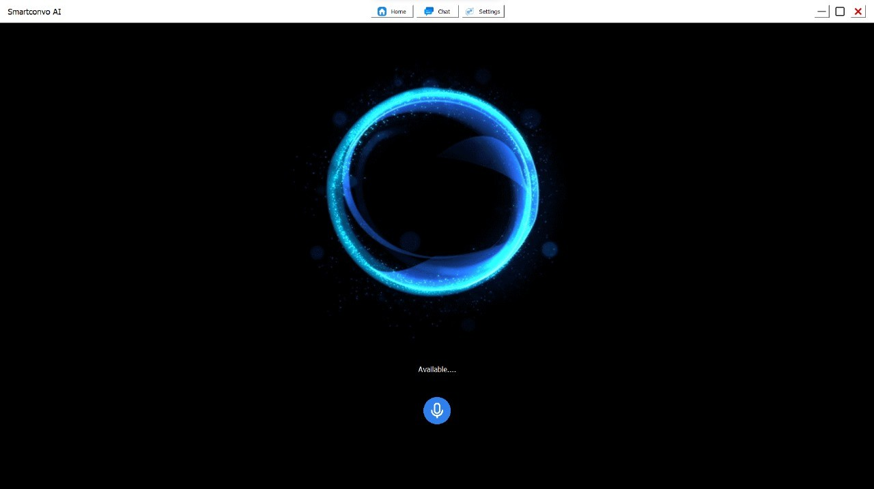
10.1.Screenshots

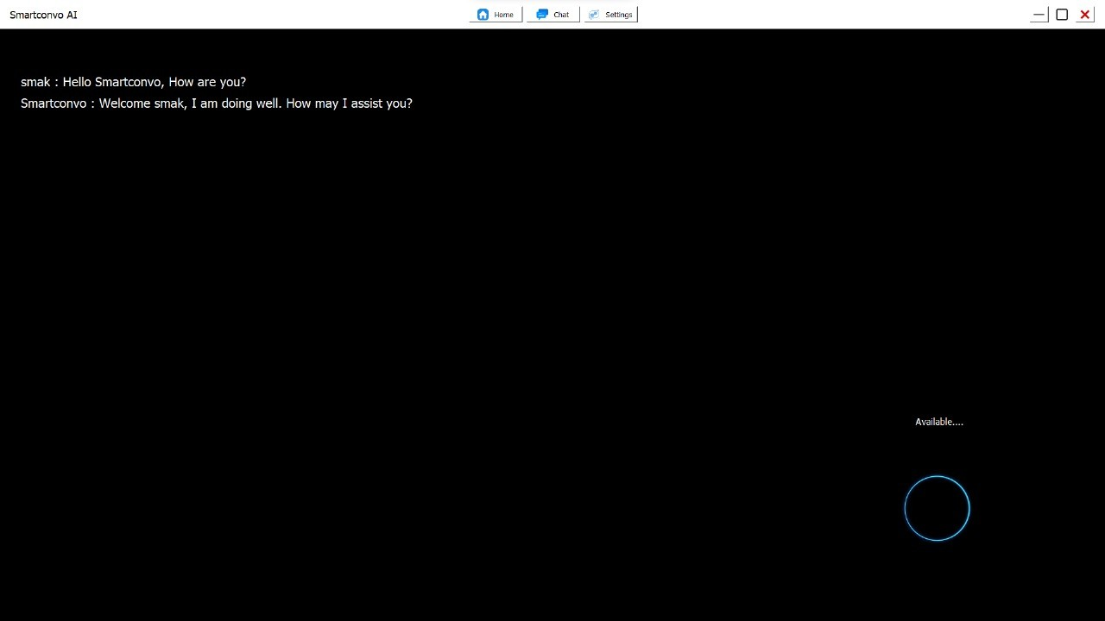
10.1.1Home Screen Screenshot

10.1.2Chat log Screenshot

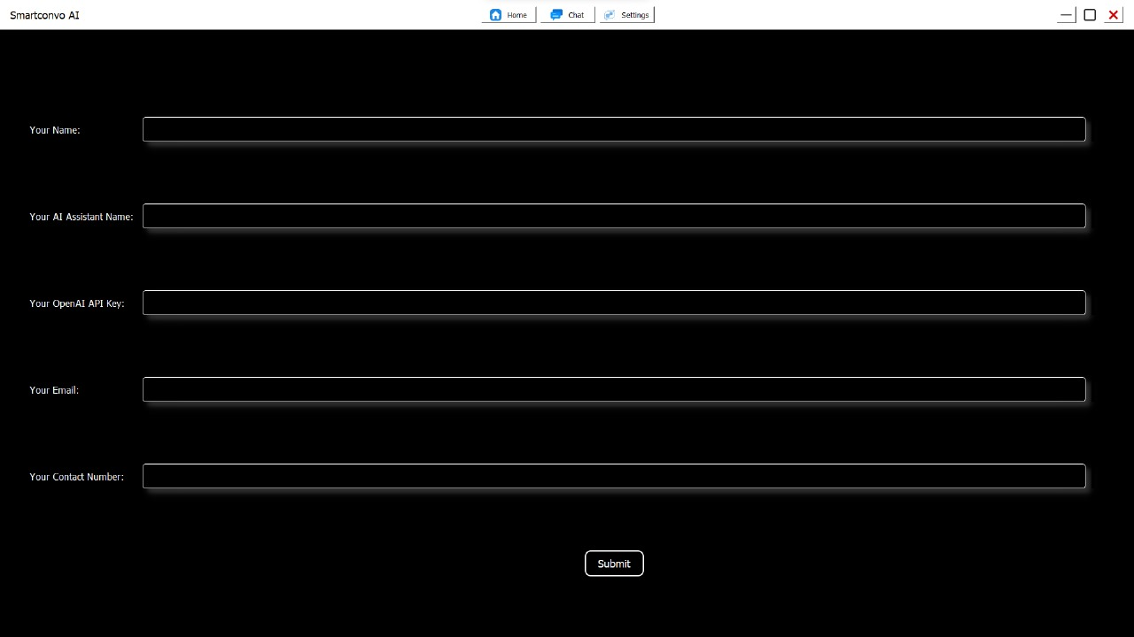

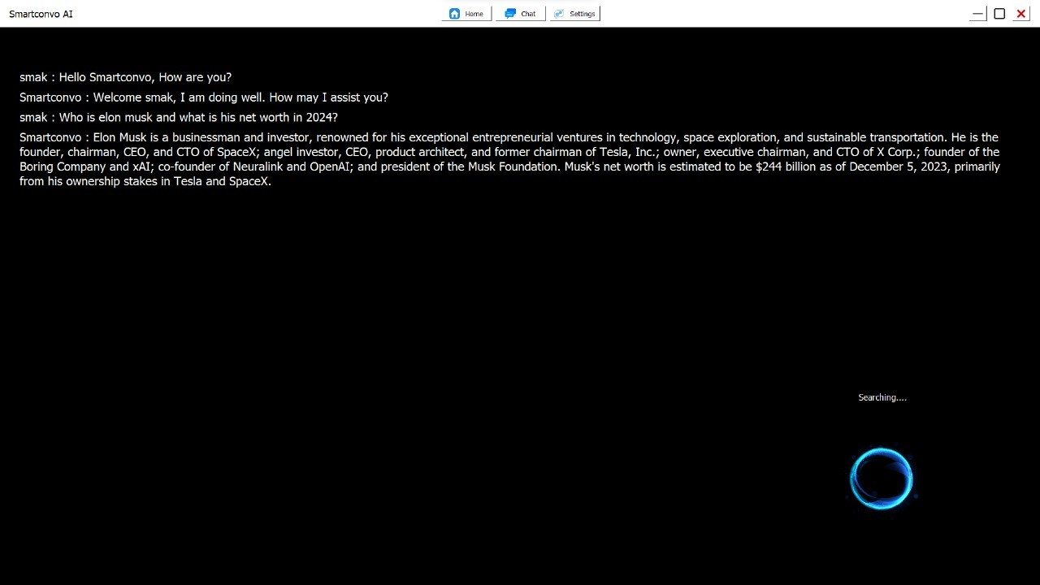
10.1.3Settings Interface to change name of user and Assistant

    - Search Result Screenshot

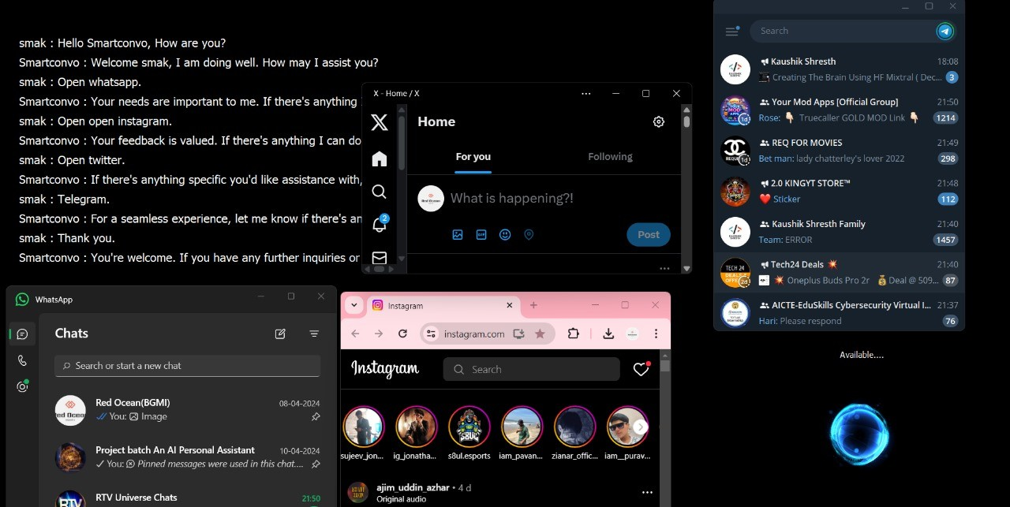

    - Applications Opening ScreenShot

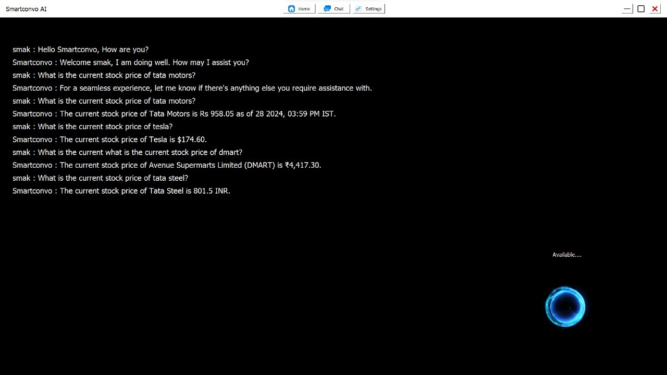

    - Real time Stock Price Predition Screenshot

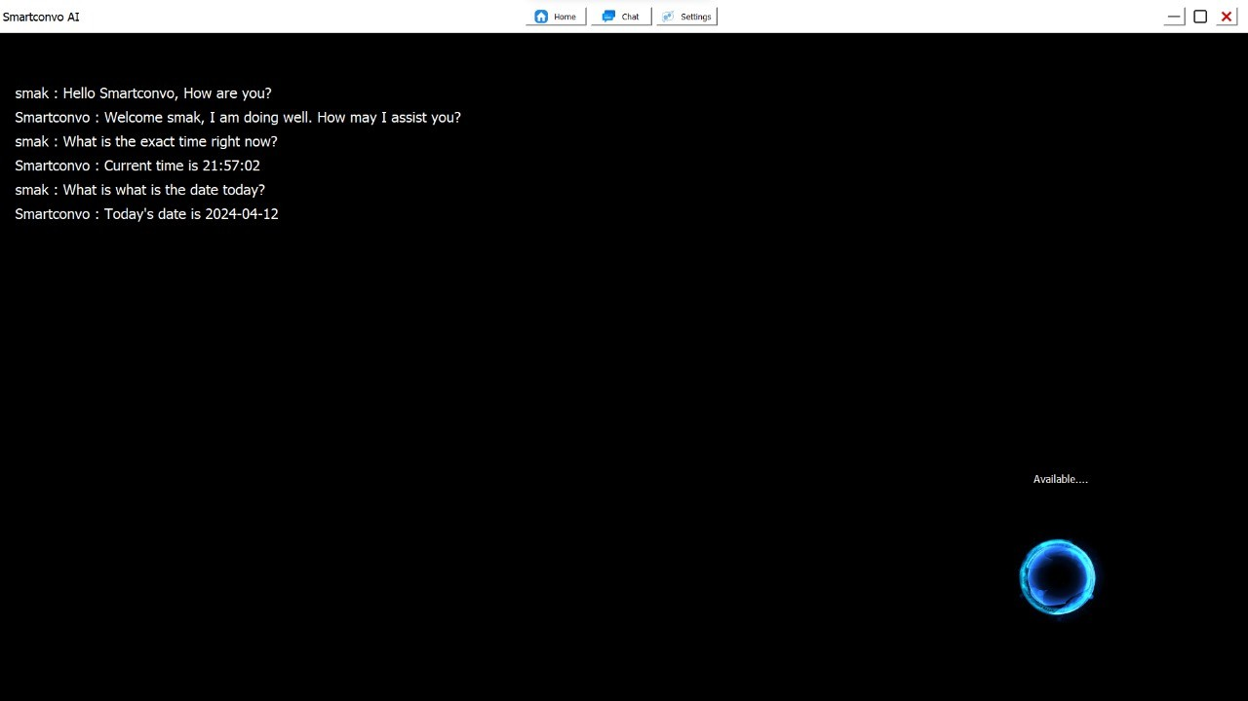

    - Time and Date Screenshot
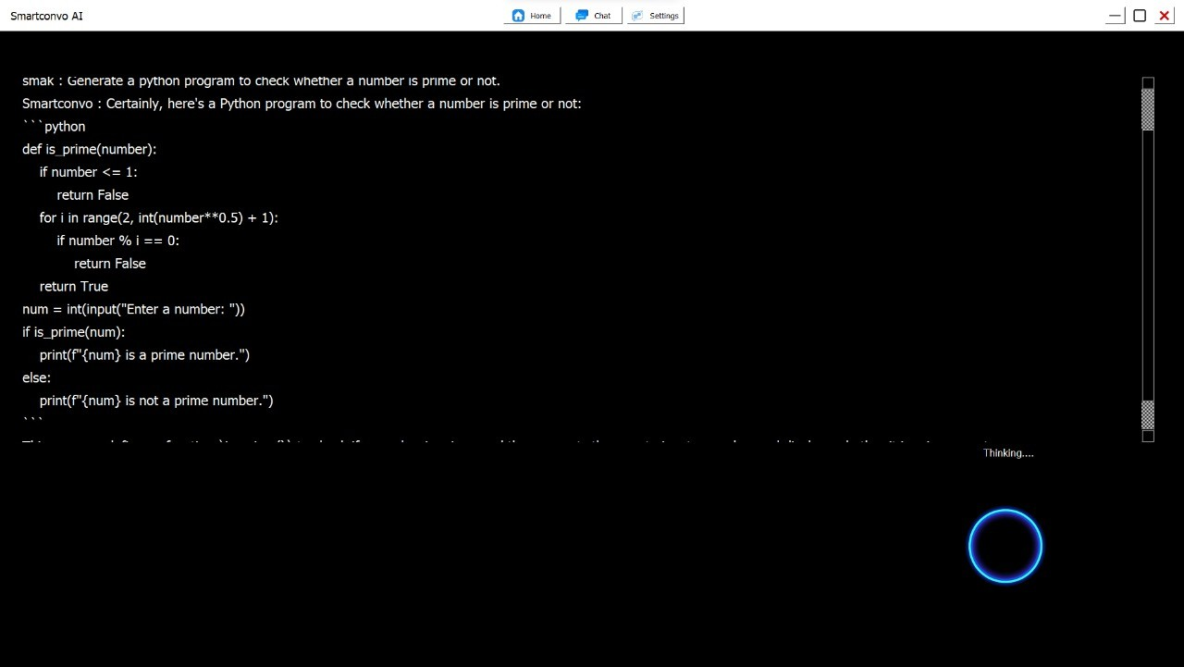

    - Generating Python Program Screenshot

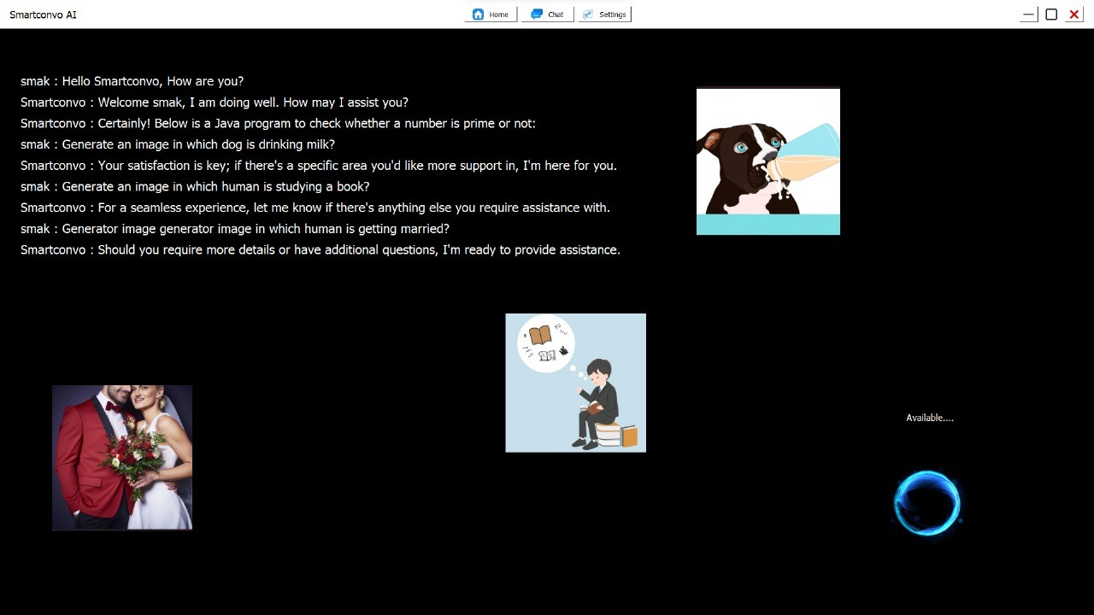

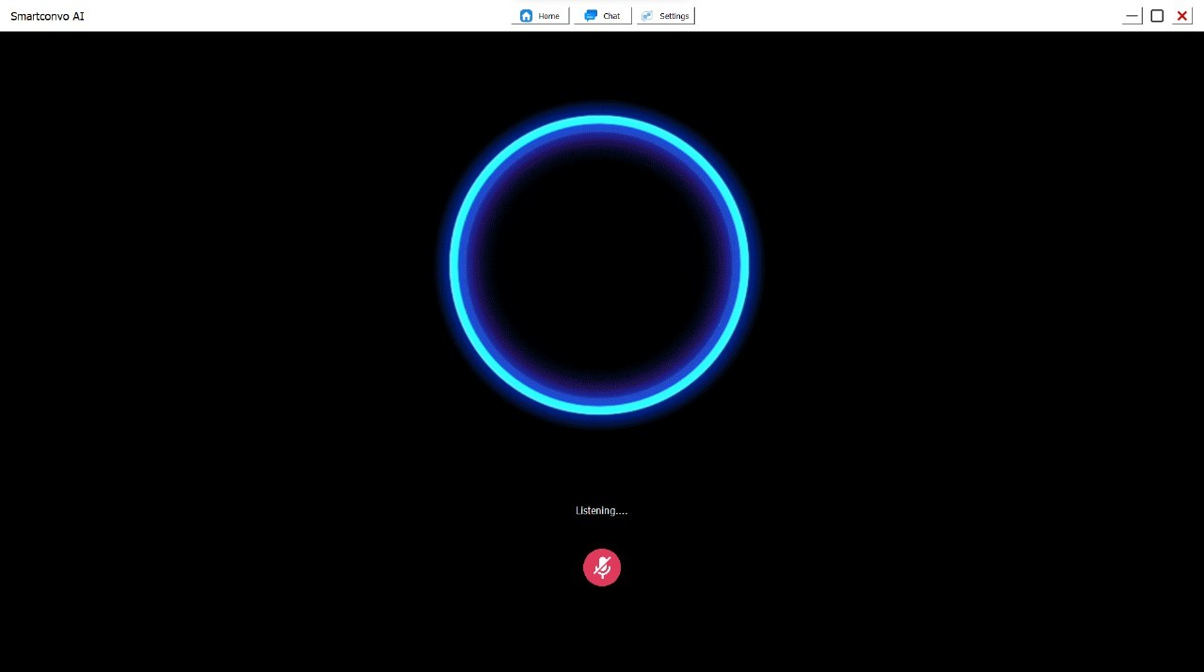
    - Image Generation ScreenShot For Prompts of User

10.1.10 Listening Mode Screenshot

CHAPTER-11
CONCLUSION & LIMITATIONS

In conclusion, the development of our personal assistant integration with ChatGPT and real- time data retrieval using PerplixAI marks a significant milestone in advancing conversational AI and information retrieval capabilities. Throughout this project, we successfully achieved our objectives of creating a dynamic and intuitive assistant system that leverages state-of-the-art natural language processing and data retrieval technologies. Our accomplishments include seamless integration of ChatGPT and PerplixAI, implementation of core functionalities for user interaction and response generation, and rigorous testing to ensure reliability and performance. Importantly, our efforts have yielded valuable insights into system performance, user preferences, and areas for enhancement. Looking ahead, we recognize the potential impact of our system on improving productivity, enhancing user experiences, and enabling new opportunities for innovation. As we reflect on the lessons learned and challenges overcome during this journey, we are excited about the future directions and possibilities for extending and refining our personal assistant system. We extend our gratitude to all those who contributed to this project and look forward to further advancements in the field of conversational AI and data-driven assistance.

Limitations

Data Quality and Availability:
The effectiveness of the personal assistant system heavily relies on the quality and availability of data from PerplixAI. If the data retrieved is incomplete, inaccurate, or outdated, it may impact the reliability and relevance of the system's responses.

Dependency on External Services:
Your project depends on the availability and reliability of external services such as ChatGPT and PerplixAI. Any downtime or disruptions in these services could affect the functionality and performance of the personal assistant system.

Privacy and Security Concerns:
As your project involves handling user data and interactions, ensuring privacy and security is paramount. Any vulnerabilities or breaches in the system could compromise user confidentiality and trust.

Scalability Challenges:
Scaling the personal assistant system to accommodate a growing user base or increasing data volume may pose challenges in terms of infrastructure, performance, and cost management. Ensuring scalability while maintaining optimal performance is crucial for long-term success.

User Adoption and Satisfaction:
The success of your project ultimately hinges on user adoption and satisfaction. Convincing users to embrace and engage with the personal assistant system may require effective marketing, user education, and continuous improvement based on user feedback

CHAPTER-12
FUTURE SCOPE

Multi-Modal Interaction:
Enable support for multi-modal interaction, allowing users to engage with the personal assistant through text, voice, images, or other input modalities.

Integration with Additional Services:
Expand the personal assistant's capabilities by integrating with additional third party services, APIs, or data sources

Enhanced Visualization and Presentation:
Explore ways to improve the presentation and visualization of information provided by the personal assistant. Incorporate interactive visualizations, infographics, or summarization techniques

Multi-Language Support:
Extend language support beyond a single language to cater to a diverse user base with varying linguistic preferences

CHAPTER-13
REFERENCES & BIBLIOGRAPHY

OpenAI GPT: Information and documentation about OpenAI's GPT (Generative Pre-trained Transformer) models, including ChatGPT, which you are integrating into your personal assistant system. You can find resources, documentation, and API references on the OpenAI website.
PerplixAI: Explore resources and documentation provided by PerplixAI, the platform you are using for real-time data retrieval. Visit their website or contact their support team for information on APIs, integration guides, and best practices.
Python Documentation: Since you may be using Python for development, the official Python documentation provides comprehensive resources on the Python programming language, libraries, and frameworks. You can access it

You tube links:
https://www.youtube.com/@Kaushikshresth
https://www.youtube.com/watch?v=U2oQpQ_ggzM&list=PLq_SHLFD- pSD_LeiV2dyAHgED7PDF48Jq

