1. 去掉搬家用户在if里面添加true条件

LauncherModel.java

**if** (**true** || ThemeScanManage.getInstance().hasMineTheme() || ThemeScanManage.getInstance().hasLiveWallpaper()) {

mIsFirstLaunch = WallpaperHelper.isFirstRunLauncher();

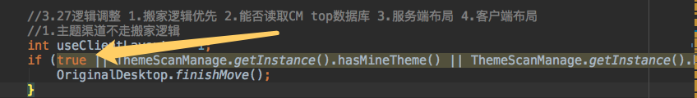

1. 去掉splash屏直接在onCreate 里面把mIsFirstLaunch=false

Launcher.java

mIsFirstLaunch = WallpaperHelper.isFirstRunLauncher();

