Program No.3
USE existing table cricket and perform aggregate functions on table whose attributes are:
F_name char(10)
S_name char(10)
Age int(2)
Runs int(5)
Query:
use IT108;
- Display maximum age from the table cricket.
Query: SELECT MAX(age) from cricket;
Output:
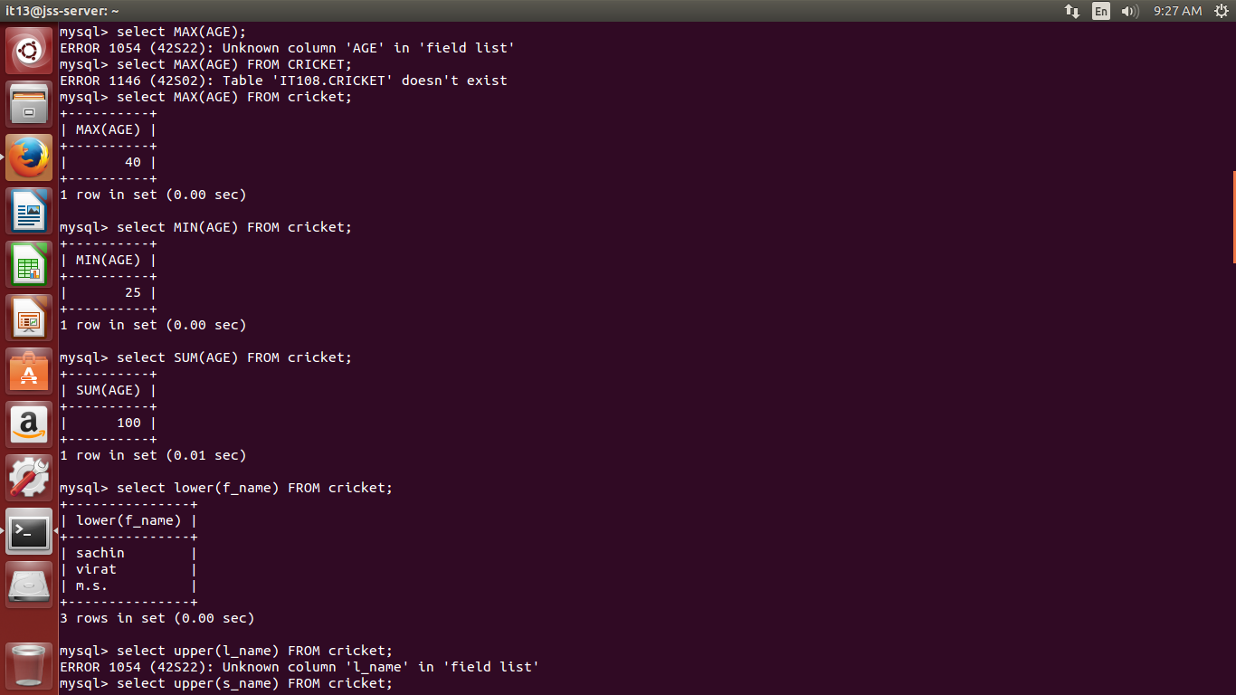
- Display minimum age from the table cricket.

3. Display total number of records from the table cricket.

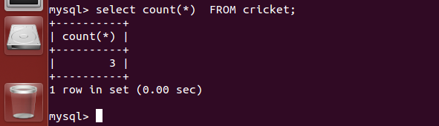

3. Display names of columns in table cricket.
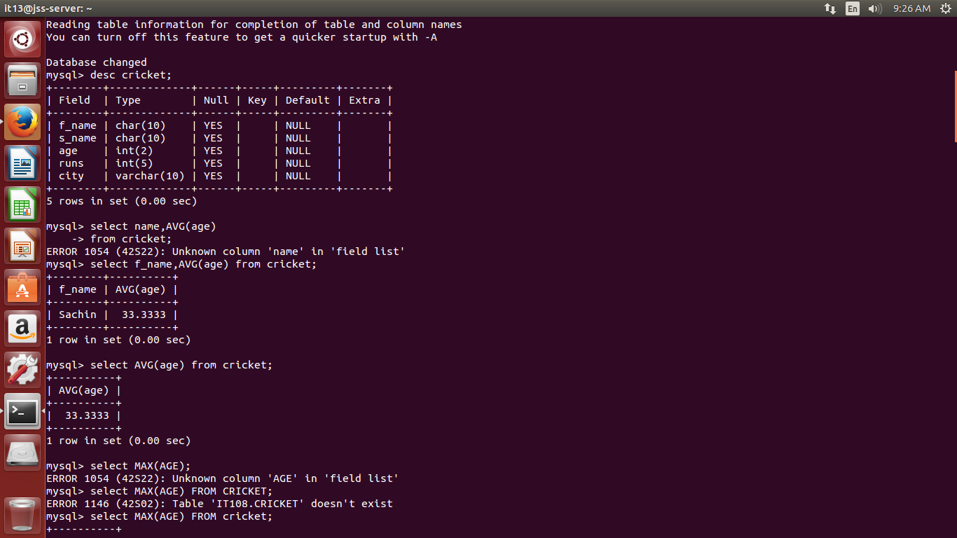

4. Display total age of all the players from the table cricket.

5. Display names of all the players in lower case .

6. Display names of all the players in UPPER case .
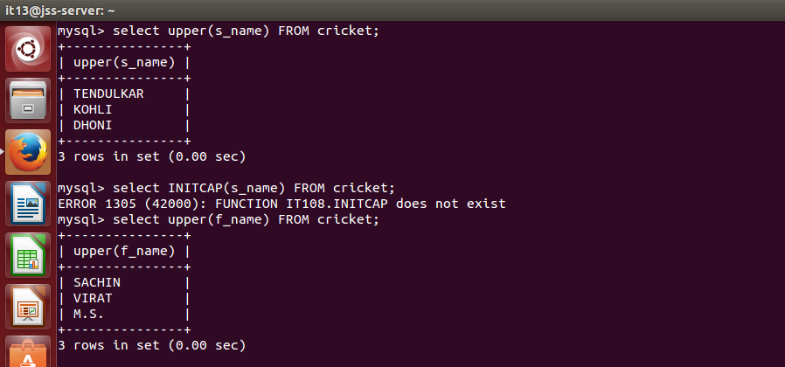

7. Display second four characters of sir name (s_name) of all the players .
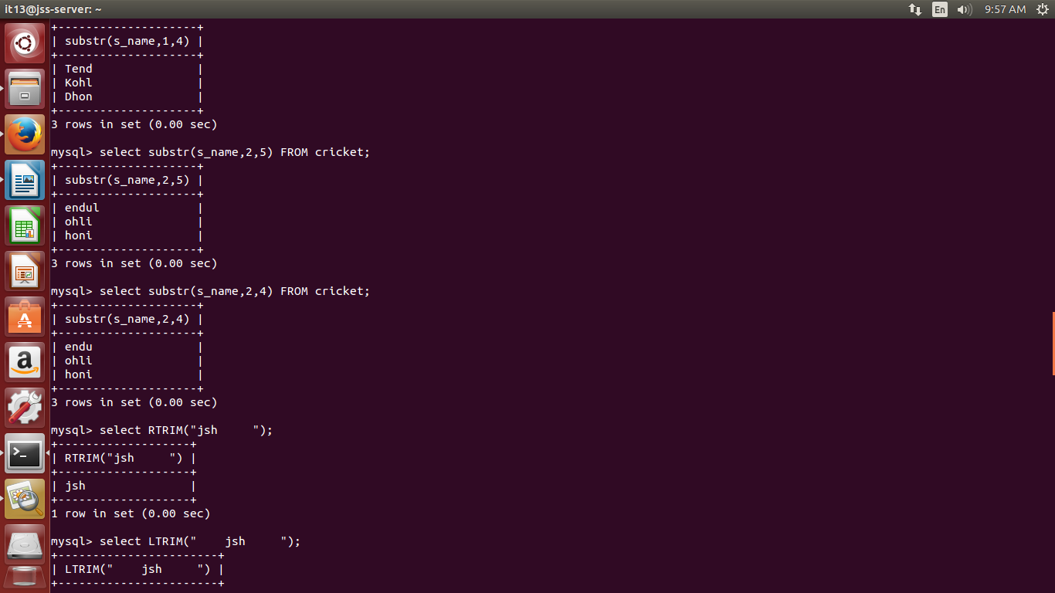

8. Remove all the white spaces from right of any string.

9. Remove all the white spaces from left of any string.
10. Join the f_name and s_name of all the players and display the result.
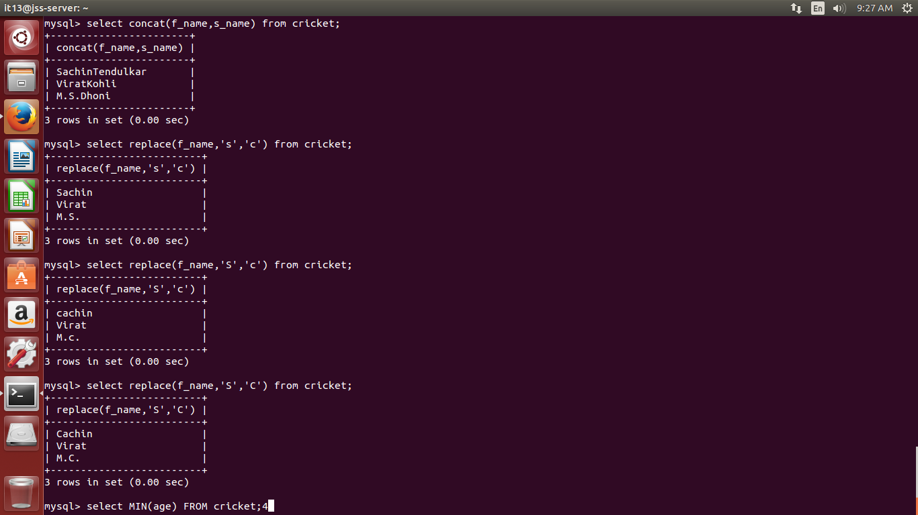

11. Replace the char “S” to “C” from column f_name in cricket table.

12. Display Average age of all the players.

