1.左边的平面图不可拼合右边的哪一个图。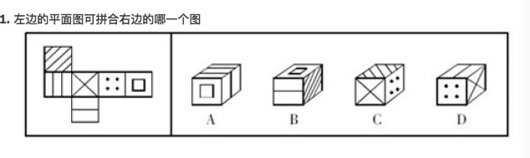

2.

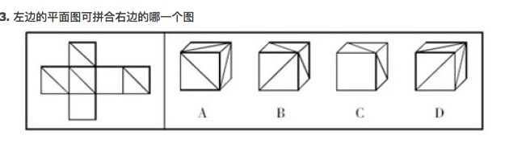

3.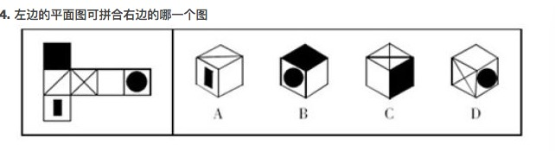

4.

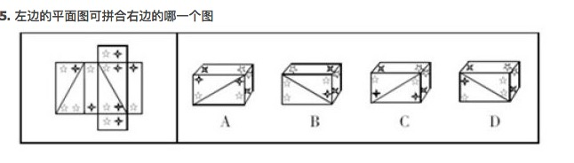

5.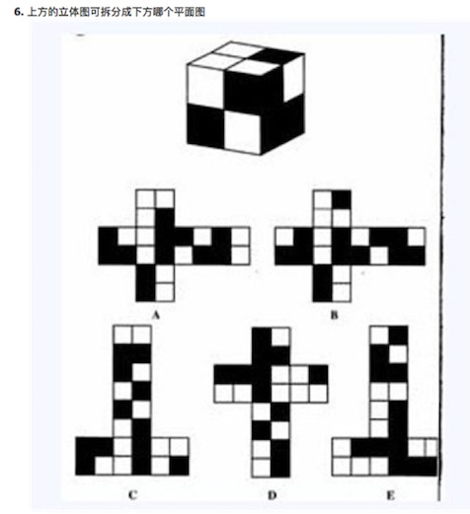

6.

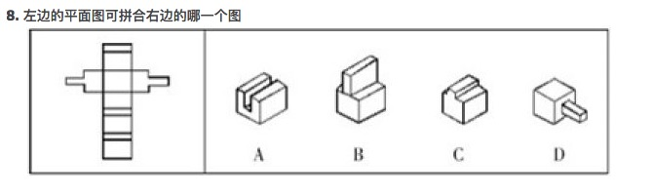

7.

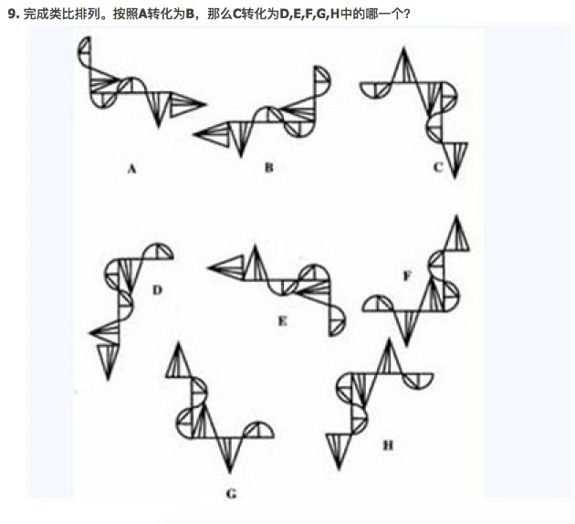

8.

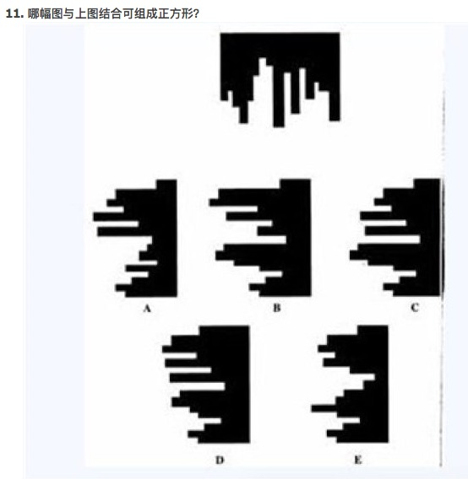

9.

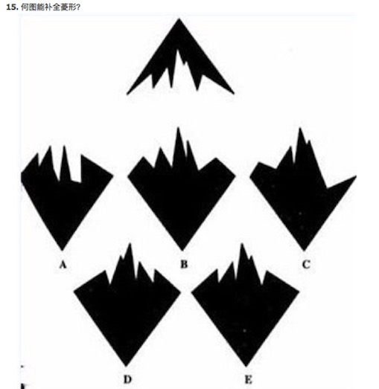

答案：

|  |  |  |  |  |  |  |  |  |  |
| --- | --- | --- | --- | --- | --- | --- | --- | --- | --- |
| 题号 | 1 | 2 | 3 | 4 | 5 | 6 | 7 | 8 | 9 |
| 答案 | B | D | C | C | B | B | H | C | E |