HL5083A
Combo OVP Switch for Dual-Port USB-C EPR

Overview

The HL5083A features two Source power switches, CC/SBU switches, VCONN power switches, CC and SBU OVP for dual Type-C ports with identical features.
Each source switch from V5V to VBUS_P0 and VBUS_P1 is implemented with high voltage back-to-back switches and each VBUS pin can withstand up to 33V. Each source switch can be enabled over its dedicated control pin in FRS mode enabled or I²C. Each source switch has an ideal diode feature, programmable current limit and supports fast role swap for USB PD3.0 application. In the source mode, each switch can handle a continuous current from V5V to each VBUS at least 3A by configuring a programmable current limit.
The device has multiple built-in protections, like programmable VBUS over voltage protection (OVP), reverse current protection (RCP), short current protection (SCP), programmable overcurrent protection (OCP), Over temperature protection (OTP).
A discharge circuit on each VBUS is integrated to meet USB PD VBUS discharging requirement. The source power switches have soft start function to minimize inrush current during startup. The device integrates high reliable CC/SBU switches to protect downstream device from abnormal high voltage. Each input CC/SBU pin can withstand up to 33V to be protected from short to VBUS. The device also integrates a dedicated VCONN power switch to deliver VCONN power to one of CC pins. This switch has a programmable current limit function. The device die size is 3.24mm x 3.04mm with 120µm x 120µm scribe line.

Features

- Dual Channel N-MOS B2B Source switches
- R_{DS_ON} with 45mΩ typ
- Programmable current limit up to 3.6A
- Short Current Protection
- Dual channel Gate driver for Sink path
- Programmable soft-start time
- High-voltage output for B2B FET
- Low-voltage output with 3.3V for eFuse
- Reverse Current Protection
- Two VCONN Switches with Current limit
- R_{DS_ON} = 0.5Ω typ
- Programmable from 0.4A to 0.8A
- Two Dual channel CC OVP Switches
- Integrated dead-battery Rd, 5.1kΩ (typ)
- R_{DS_ON} = 2Ω typ
- Programmable OVP with 5.8V or 6V
- Two Dual channel SBU OVP switches
- R_{DS_ON} = 10Ω typ at 3V bias voltage
- Fixed 4.2V OVP
- VIN_3V3 Input range: 2.7V to 3.6V
- Highly reliable AMR
- AMR of VBUS: 33V DC
- AMR of CCx_Px: 33V DC
- AMR of SBUx_Px: 33V DC
- IEC61000-4-2 Level 4 (VBUS, CC, SBU)
- Contact discharge: ±8kV
- Air discharge: ±15kV
- Support Fast Role swap in a manual mode
- Configurable two pins as voltage sense or GPIO with LDO3V3 or VDDIO pull-up I/O
- Ultrafast OVP Protection Response Time: 50ns typ
- Voltage and Current conversions (VBUS, V5V voltage and SRC Current) for the system ADC
- Integrated 3.1V system and device LDO
- 3.1V_60mA High-Voltage LDO
- Multiple Built-in protections
- Over-Voltage in Source mode
- Over current limit in Source mode
- Reverse current protection in both Sink and Source mode
- Short-circuit protection in Source mode
- OVP for CC & SBU switches
- Over temperature protection
- Die size = max 3.24mm x 3.04mm (9.85mm²)

with 120µm x 120µm scribe line

Applications
- Notebook
- Tablet PC

Simplified Application Diagram
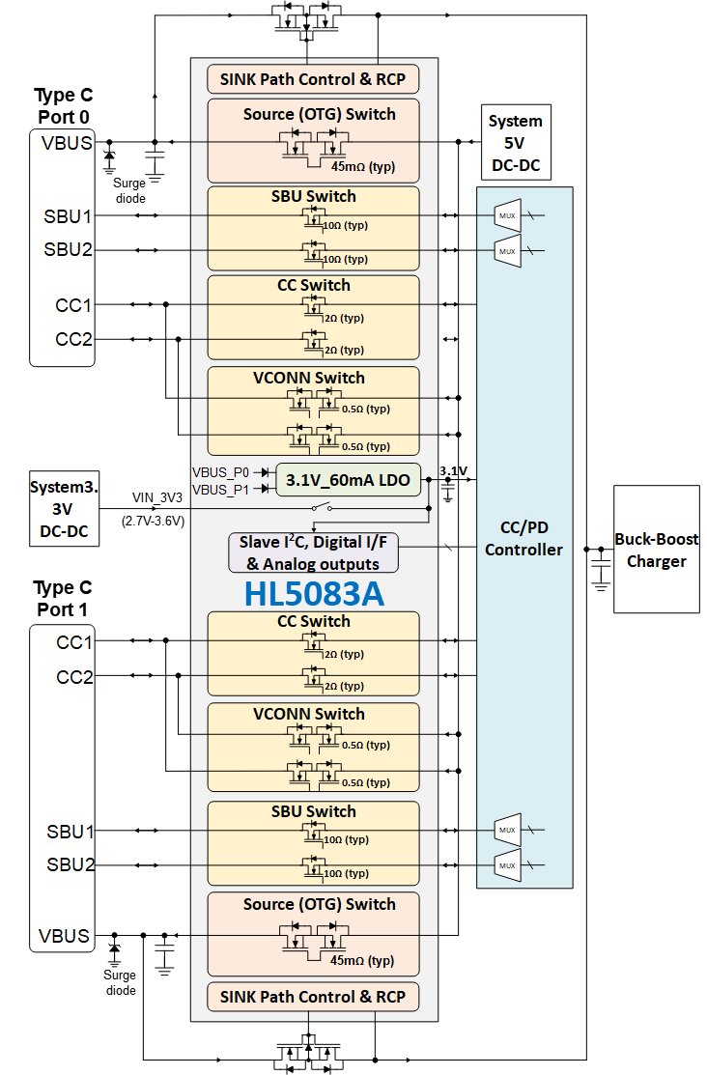

Figure 1. Simplified System Diagram

Ordering Information

Table 1 Ordering Part Number
Part Number | Package
HL5083A | 52-Pin QFN This is for internal evaluation only

Table of Contents
Overview 1
Features 1
Applications 2
Simplified Application Diagram 2
Ordering Information 3
1 Functional Block Diagram 7
2 Pin Diagram 8
2.1 Pin diagram with D die 8
2.2 Pin diagram for Halo evaluation with Halo Die only 9
2.3 Bonding wire diagram 10
2.4 Pin Description 13
3 Electrical Characteristics 16
3.1 Absolute Maximum Ratings ^{(NOTE1)} 16
3.2 ESD Ratings 16
3.3 Recommended Operating Conditions^{(NOTE1)} 17
3.4 Electrical Specification 18
4 Typical Operating Characteristics 23
5 Detailed Description 25
5.1 Power Source 25
5.2 The LDO3V3 internal regulator 25
5.3 The Internal Switch 26
5.4 Internal Power and Data Switches 26
5.5 The Operation Modes 27
5.5.1 Register Reset Mode 27
5.5.2 Dead Battery Mode 27
5.5.3 Standby (Low power) Mode 28
5.5.4 Sink Mode 28
5.5.5 Source Mode 34
5.5.6 Fast Role Swap (FRS) 38
5.6 CC, VCONN and SBU Switch 39
5.6.1 Functional diagram 39
5.6.2 CC Switch 42
5.6.3 VCONN Switch 45
5.6.4 SBU Switch 48
5.7 VBUS Discharge 50
5.8 GPIO 50
5.9 Voltage Conversion of VBUS and Source current 51
5.10 Manual enable of Source Switch 51
5.11 Thermal Shutdown 52
5.12 Summary of Protection 52
5.13 Interrupt (INTB) 54
5.14 Serial Interface Description 56
5.14.1 Bus Not Busy 56
5.14.2 Start Data Transfer 56
5.14.3 Stop Data Transfer 56
5.14.4 Data Validity 57
5.14.5 Acknowledge 57
5.14.6 I²C Write Cycle 57
5.14.7 I²C Read Cycle 58
6 I²C registers 59
6.1 Device Slave I2C_Address 59
6.2 Register reset type 59
6.3 Register type 59
6.4 I²C Register Map 60
6.5 I²C register details 61
6.5.1 0x00 Device_ID 61
6.5.2 0x01 INT_SYS_0 61
6.5.3 0x02 INT_SYS_1 62
6.5.4 0x03 INT_P0 62
6.5.5 0x04 INT_P1 63
6.5.6 0x05 INT_SYS_0_MSK 64
6.5.7 0x06 INT_SYS_1_MSK 64
6.5.8 0x07 INT_P0_MSK 65
6.5.9 0x08 INT_P1_MSK 66
6.5.10 0x09 STATUS_SYS_0 66
6.5.11 0x0A STATUS_SYS_1 67
6.5.12 0x0B STATUS_P0_0 68
6.5.13 0x0C STATUS_P0_1 68
6.5.14 0x0D STATUS_P1_0 69
6.5.15 0x0E STATUS_P1_1 69
6.5.16 0x0F SYS_CTRL_0 70
6.5.17 0x10 SYS_CTRL_1 71
6.5.1 0x11 P0_CTRL 71
6.5.2 0x12 P0_SRC_SW_CTRL 72
6.5.3 0x13 P0_FRS_CTRL 73
6.5.4 0x14 P0_VCONN_CTRL 73
6.5.5 0x15 P0_SBU1_SBU2_SW_CTRL 74
6.5.6 0x16 P1_CTRL 75
6.5.7 0x17 P1_SRC_SW_CTRL 76
6.5.8 0x18 P1_FRS_CTRL 76
6.5.9 0x19 P1_VCONN_CTRL 77
6.5.10 0x1A P1_SBU1_SBU2_SW_CTRL 77
6.5.11 0x1B GPIO_CTRL 78
6.5.12 0x1C PROTECTION_CTRL_0 79
6.5.13 0x1D PROTECTION_CTRL_1 80
7 Typical Application Diagram 82
7.1 Bill of Material (BOM) 84
8 Package and Packing Information 84
Important Notice 86
Revision History 87

Table of Figure
Figure 1. Simplified System Diagram 2
Figure 2. Functional Block Diagram 7
Figure 3. Top-View Pin Map 8
Figure 4. Pin Map for Halo’s internal evaluation 9
Figure 5. Bonding wire diagram with the Realtek die 10
Figure 6. Bonding wire diagram for Halo evaluation 11
Figure 7. Pad location 12
Figure 8. Startup of Sink Path at I_{LOAD}=100Ω & VBUS=5V 23
Figure 9. Startup of Source Path to VBUS_P0 23
Figure 10. Startup of VCONN Path to CC2_P0 23
Figure 11. Low Voltage GPIO as GPO 23
Figure 12. CC switch ON/OFF on Port 0 in VIN_3V3=3.3V 24
Figure 13. SBU switch ON/OFF on Port 0 in VIN_3V3=3.3V 24
Figure 14. Top-level connection of VIN_3V3, LDO3V3 and internal SW 26
Figure 15. Block diagram of the LDO3V3 26
Figure 16. All internal Switch paths 27
Figure 17. Diagram of Dual-function embedded GPO for Sink Mode 28
Figure 18. SNK_CTL_P0/P1 Timing diagram in the dead battery or normal condition 29
Figure 19. Diagram of Sink RCP connection 30
Figure 20. Soft and Hard RCP operation in Sink mode 31
Figure 21. SNK_CTL_P0/P1 Low Voltage Output with 3.3V in non-inverting condition 32
Figure 22. SNK_CTL_P0/P1 Output with 3.3V in Inverting condition 33
Figure 23. SRC Mode timing diagram of Enable and Disable over I²C 34
Figure 24. SRC Mode timing diagram in OCP 36
Figure 25. SRC short circuit in latch mode 37
Figure 26. Soft and Hard RCP operation in SRC mode 38
Figure 27. The FRS – Hard startup (Manual mode) 39
Figure 28. CC, VCONN and SBU functional diagram 40
Figure 29. CC Switch timing diagram in the dead battery state 43
Figure 30. Timing diagram by CC OVP in auto-recovery mode 44
Figure 31. Timing diagram by CC OVP in latch mode 45
Figure 32. VCONN Switch operation diagram over I²C 46
Figure 33. VCONN SW in OVP Operation and auto-recovery mode 47
Figure 34. VCONN SW in OCP Operation 48
Figure 35. ON/OFF of SBU SW per I²C 48
Figure 36. Timing diagram of SBU OVP in auto-recovery mode 49
Figure 37. Timing diagram of SBU OVP in latch mode 50
Figure 38. GPIO Block Diagram 51
Figure 39. Structure of Interrupt, status and mask registers 55
Figure 40. Interrupt Timing 56
Figure 41. START and STOP Condition 56
Figure 42. Bit transfer on the I²C-bus 57
Figure 43. Data Transfer on I²C Serial Bus 57
Figure 44. I²C write Cycle 58
Figure 45. I²C Read Cycle 58
Figure 46. I²C Device Slave Address 59
Figure 47. Typical Application Diagram with a Back-to-Back MOSFET 82
Figure 48. Typical Application Diagram with a stand-alone eFuse device and GPIO function enabled 83
Figure 49. Package dimension 85

Table of Table
Table 1 Ordering Part Number 3
Table 2 Pin description 13
Table 3. Behavior of SNK_CTL_P0/P1 with high and low voltage output GPO to the faults 33
Table 4. CC/SBU switch mode table 41
Table 5. Operation of VCONN switch 46
Table 6. Voltage conversion of VBUS voltage and source current 51
Table 7. Summary of behavior for all protections 52
Table 8. Slave I²C_Address 59
Table 9. Register reset condition 59
Table 10. Register reset type 59
Table 11. Register Map 60
Table 12. Bill of Material 84

Functional Block Diagram

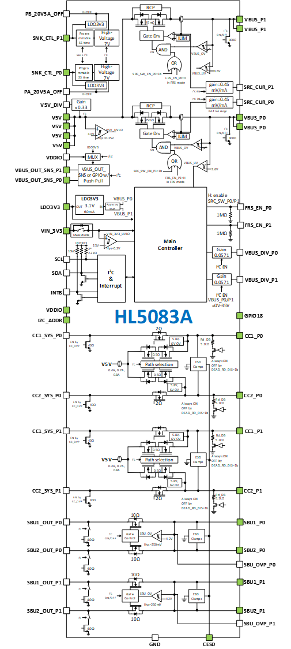
Figure 2. Functional Block Diagram

The pin pads in green are connected to the package.

Pin Diagram

Pin diagram with D die
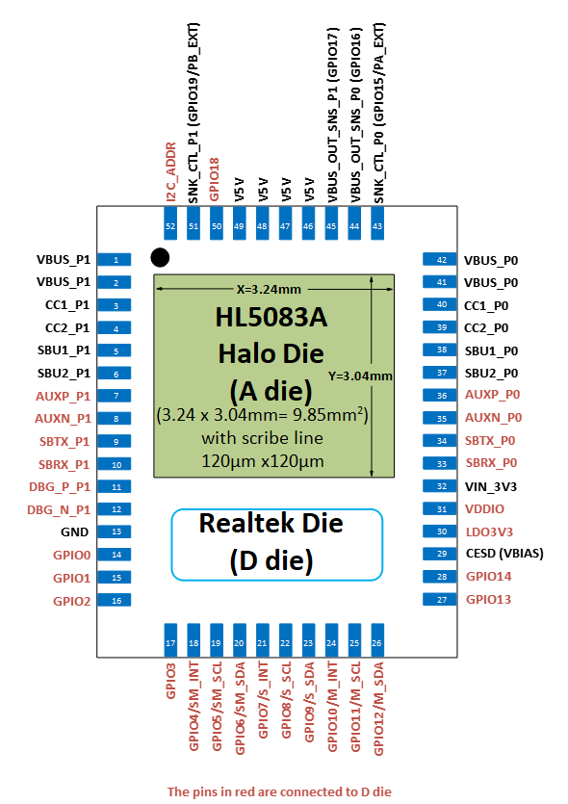

Figure 3. Top-View Pin Map

NOTE1: The connection of bonding wires for the pins in red come from Realtek die
NOTE2: I2C_ADDR and GPIO18 are just jumper bridge between Halo and Realtek die. There is no assigned function on these two pins.

Pin diagram for Halo evaluation with Halo Die only

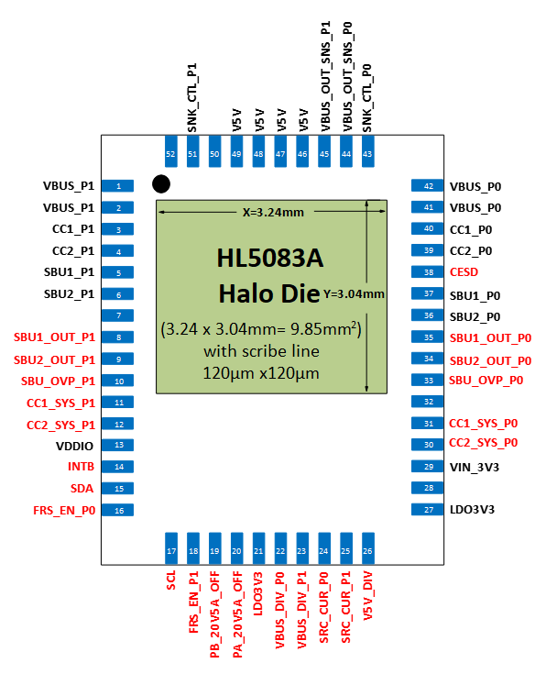

Figure 4. Pin Map for Halo’s internal evaluation

The pin names in red are for purpose of Halo bench evaluation.

Bonding wire diagram

Figure 5. Bonding wire diagram with the Realtek die
Figure 6. Bonding wire diagram for Halo evaluation

Figure 7. Pad location

Pin Description

Table 2 Pin description
AI: Analog Input, AO: Analog Output, DI: Digital Input, DO: Digital Output, DIO: Digital Input and Output
Pin Name | Pin Type | Pin Number | Description
VBUS_P0 | Power | 41, 42 | VBUS detection input. Power output in Source mode. Connect to VBUS pin in Type-C Connector Port 0. Bypass a 4.7µF/50V to GND.
VBUS_P1 | Power | 1,2 | VBUS detection input. Power output in Source mode. Connect to VBUS pin in Type-C Connector Port 1. Bypass a 4.7µF/50V to GND.
V5V | Power | 46, 47,  48, 49 | Power input for Source and VCONN mode. Connect to 5V system converter output. Bypass ceramic capacitor with 4*22µF/10V to GND.
LDO3V3 | Power | 30 | LDO output with 3.1V and min 80mA current limit. The main power source for the internal blocks and the external PD controller device. Bypass a 1µF/6.3V to GND. Input power source can be either VBUS_P0, VBUS_P1 or VIN_3V3.  It is connected to the pad named LDO_3V3.
VIN_3V3 | Power | 32 | Input to the internal switch. Connect to system power rail from 2.7V to 3.6V. Bypass a 1µF/6.3V capacitor to GND. It is connected to the pad named VIN_3V3.
SNK_CTL_P0 | AO/  DO | 43 | General Purpose Output (GPO) pin for Port 0.  It can be configured as either a high-voltage output with 7V (typ) or to the fixed output from the LDO3V3 over I²C.
SNK_CTL_P1 | AO/  DO | 51 | General Purpose Output (GPO) pin for Port 1.  It can be configured as either a high-voltage output with 7V (typ) or to the fixed output from the LDO3V3 over I²C.
VBUS_OUT_  SNS_P0 | AI/DIO | 44 | General purpose Input or output pin for port 0.  It can be configured as sense input pin for Reverse Current Protection (RCP) for This pin can also be configured as GPIO with a push-pull type over I²C.  It is connected to the pad named GPIO16 on D die.
VBUS_OUT_  SNS_P1 | AI/DIO | 45 | General purpose Input or output pin for port 1.  It can be configured as sense input pin for Reverse Current Protection (RCP) for This pin can also be configured as GPIO with a push-pull type over I²C.  It is connected to the pad named GPIO17 on D die.
VDDIO | AI | 31  Internal | A system logic supply voltage for the pin 44 & 45 when these two pins are configured as GPO. Bypass a capacitor with 0.1µF/6.3V to ground.  It is connected to the pad named VDDIO on D die.
CC1_P0 | AI, AO | 40 | CC1 pin on Type C receptacle Port 0. The CC switch between CC1_P0 and CC1_SYS_P0 stays off by default. The switch can be turned on over I²C.
CC2_P0 | AI, AO | 39 | CC2 pin on Type C receptacle Port 0. The CC switch between CC2_P0 and CC2_SYS_P0 stays off by default. The switch can be turned on over I²C.
CC1_SYS_P0 | AI, AO | Internal | CC1_P0 output pin connected to the PD controller (PDC).  It is connected to the pad named PA_CC1_IN.
CC2_SYS_P0 | AI, AO | Internal | CC2_P0 output pin connected to the PD controller (PDC).  It is connected to the pad named PA_CC2_IN.
CC1_P1 | AI, AO | 3 | CC1 pin on Type C receptacle Port 1. The CC switch between CC1_P1 and CC1_SYS_P1 stays off by default. The switch can be turned on over I²C.
CC2_P1 | AI, AO | 4 | CC2 pin on Type C receptacle Port 1. The CC switch between CC2_P1 and CC2_SYS_P1 stays off by default. The switch can be turned on over I²C.
CC1_SYS_P1 | AI, AO | Internal | CC1_P1 output pin connected to the PD controller (PDC).  It is connected to the pad named PB_CC1_IN.
CC2_SYS_P1 | AI, AO | Internal | CC2_P1 output pin connected to the PD controller (PDC).  It is connected to the pad named PB_CC2_IN.
SBU1_P0 | AI, AO | 38 | SBU1 pin on Type C receptacle Port 0. The SBU switch stays on by default.  The SW ON/OFF between SBU1_P0 and SBU1_OUT_P0 is disabled over I²C.
SBU2_P0 | AI, AO | 37 | SBU2 pin on Type C receptacle Port 0. The SBU switch stays on by default.  The SW ON/OFF between SBU2_P0 and SBU2_OUT_P0 is disabled over I²C.
SBU1_OUT_P0 | DIO | Internal | Output of SBU1_P0. Connect to the PD controller (PDC).  It is connected to the pad named PA_SBU1_IN.
SBU2_OUT_P0 | DIO | Internal | Output of SBU1_P0. Connect to the PD controller (PDC).  It is connected to the pad named PA_SBU2_IN.
SBU1_P1 | AI, AO | 5 | SBU1 pin on Type C receptacle Port 1. The SBU switch stays on by default.  The SW ON/OFF between SBU1_P1 and SBU1_OUT_P1 is disabled over I²C.
SBU2_P1 | AI, AO | 6 | SBU2 pin on Type C receptacle Port 1. The SBU switch stays on by default.  The SW ON/OFF between SBU2_P1 and SBU2_OUT_P1 is disabled over I²C.
SBU1_OUT_P1 | DIO | Internal | Output of SBU1_P1. Connect to the PD controller (PDC).  It is connected to the pad named PB_SBU1_IN.
SBU2_OUT_P1 | DIO | Internal | Output of SBU2_P1. Connect to the PD controller (PDC).  It is connected to the pad named PB_SBU2_IN.
CESD | AO | 29 | Connected to external 0.1µF/50V ceramic cap
SDA | DIO | Internal | I²C data line. An internal pull-up resistor, 2.2kΩ typ, is integrated.  It is connected to the pad named I2C_S_SDA on D die.
SCL | DI | Internal | I²C clock line. An internal pull-up resistor, 2.2kΩ typ, is integrated.  It is connected to the pad named I2C_S_SCL on D die.
INTB | DO | Internal | Active-low Interrupt output pin. An internal pull-up resistor, 10kΩ typ, is integrated. It is connected to the pad named I2C_S_INT on D die.
FRS_EN_P0 | DI | Internal | Active-high to enable the source switch between VBUS_P0 and V5V with no soft-start in the FRS mode enabled. An 1MΩ internal pull-down resistor.  This pin only works when all the FRS mode conditions are satisfied.  It is connected to the pad named PA_5V3A_ON on D die.
FRS_EN_P1 | DI | Internal | Active-high to enable the source switch between VBUS_P1 and V5V with no soft-start in the FRS mode enabled. An 1MΩ internal pull-down resistor.  This pin only works when all the FRS mode conditions are satisfied.  It is connected to the pad named PA_5V3A_ON on D die.
VBUS_  DIV_P0 | AO | Internal | An analog output from 0V to 2.0V to represent an applied voltage at VBUS_P0. The output ratio is 0.0571. A conversion is enabled over I²C.  It is connected to the pad named PA_VBUS_VSEN on D die.
VBUS_  DIV_P1 | AO | Internal | An analog output from 0V to 2.0V to represent an applied voltage at VBUS_P1. The output ratio is 0.0571. A conversion is enabled over I²C.  It is connected to the pad named PB_VBUS_VSEN on D die.
V5V_DIV | AO | Internal | An analog output from 0V to 2.0V to represent a biased voltage at V5V. The output ratio is 0.33. A conversion is enabled over I²C.  It is connected to the pad named PAPB_5V3A_VIN_VSEN on D die.
SRC_CUR_P0 | AO | Internal | Analog output from 0V to 2.0V to represent an amount of current in the source mode enabled on port 0. The transfer gain is 0.45mV/mA. A conversion for P0 is enabled over I²C. It is connected to the pad named PA_5V3A_ISEN on D die.
SRC_CUR_P1 | AO | Internal | Analog output from 0V to 2.0V to represent an amount of current in the source mode enabled on port 1. The transfer gain is 0.45mV/mA. A conversion for P1 is enabled over I²C. It is connected to the pad named PB_5V3A_ISEN on D die.
SBU_OVP_P0 | DO | Internal | A logic output signal to an OVP rising threshold detection on either SBU1 or SBU2 at Port 0. It is connected to the pad named PA_SBU_OVP on D die.
SBU_OVP_P1 | DO | Internal | A logic output signal to an OVP rising threshold detection on either SBU1 or SBU2 at Port 1. It is connected to the pad named PB_SBU_OVP on D die.
I2C_ADDR | - | 52  Internal | This is just pass-through pin to the PD controller die. It is connected to the pad named ADDR on D die.
GPIO18 | - | 50  Internal | This is just pass-through pin to the PD controller die. It is connected to the pad named GPIO18 on D die.
PA_20V5A_OFF | DI | Internal | Active-high to disable the SNK_CTL_P0 pin in both high and low voltage GPO on P0 port.
PB_20V5A_OFF | DI | Internal | Active-high to disable the SNK_CTL_P1 pin in both high and low voltage GPO on P1 port.
RPD1_P0 | DI | Internal | Configuration pin to enable an embedded dead battery R, R_{d_DB}, on CC1_P0 pin. If this pin is connected to the CC1_P0 pin, the R_{d_DB}, is enabled by default. If it is left open, the R_{d_DB}, is disabled by default.
RPD2_P0 | DI | Internal | Configuration pin to enable an embedded dead battery R, R_{d_DB}, on CC2_P0 pin. If this pin is connected to the CC2_P0 pin, the R_{d_DB}, is enabled by default. If it is left open, the R_{d_DB}, is disabled by default.
RPD1_P1 | DI | Internal | Configuration pin to enable an embedded dead battery R, R_{d_DB}, on CC1_P1 pin. If this pin is connected to the CC1_P1 pin, the R_{d_DB}, is enabled by default. If it is left open, the R_{d_DB}, is disabled by default.
RPD2_P1 | DI | Internal | Configuration pin to enable an embedded dead battery R, R_{d_DB}, on CC2_P1 pin. If this pin is connected to the CC2_P1 pin, the R_{d_DB}, is enabled by default. If it is left open, the R_{d_DB}, is disabled by default.
GND | GND | 13  and other pads | Device ground
1. Internal means that the connection between two dies is made via a bonding wire

Electrical Characteristics

Absolute Maximum Ratings ^{(NOTE1)}
Parameter | Pin | VALUE
DC Voltage range (with respect to GND unless specified) | VBUS_P0, VBUS_P1, CC1_P0, CC2_P0, CC1_P1, CC1_P1, SBU1_P0, SBU2_P0, SBU1_P1, SBU2_P1, CESD, VBUS_OUT_SNS_P0, VBUS_OUT_SNS_P1 | -0.3V ~ 33V
 | AC pulse voltage with the duration ≤10µs on VBUS_P0, VBUS_P1 | -0.3V ~ 38V
 | V5V | -0.3V ~ 5.5V
 | AC pulse voltage with the duration ≤10µs on V5V | -0.3V ~ 6.5V
 | CC1_SYS_P0, CC2_SYS_P0, CC1_SYS_P1, CC2_SYS_P1, SBU1_OUT_P0, SBU2_OUT_P0, SBU1_OUT_P1, SBU2_OUT_P1 | -0.3V ~ internally clamped  (max 3.6V)^{(NOTE3)}
 | VIN_3V3, SCL, SDA, INTB, LDO3V3, FRS_EN_P0, FRS_EN_P1, VDDIO, PA_20V5A_OFF, PB_20V5A_OFF | -0.3V ~ 5.5V
 | (SNK_CTL_P0 – VBUS_P0), (SNK_CTL_P1 – VBUS_P1) | -0.3V ~ 12V
Output DC current | V5V to VBUS_P0 | 4.6A^{(NOTE2)}
 | V5V to VBUS_P1 | 4.6A^{(NOTE2)}
 | CC1_P0 to CC1_SYS_P0, CC2_P0 to CC2_SYS_P0, CC1_P1 to CC1_SYS_P1, CC2_P1 to CC2_SYS_P1 | 200mA
 | SBU1_P0 to SBU1_OUT_P0, SBU2_P0 to SBU2_OUT_P0,  SBU1_P1 to SBU1_OUT_P1, SBU2_P1 to SBU2_OUT_P1 | 100mA
 | V5V to CC1_P0, CC2_P0, CC1_P1, CC2_P1 | 1.25A
 | LDO3V3 | 80mA
Junction temperature | T_{J} | -40°C to 150°C
Storage temperature | T_{STORAGE} | -65°C to 150°C
Pin soldering temperature | T_{s} (10s) | 260°C
NOTE1: Stress beyond those listed under absolute maximum ratings may cause permanent damage to the device.
NOTE2: It is based on the maximum value.
NOTE3: This max voltage is only effective when the device is in operation with VIN_3V3=3.3V.

ESD Ratings
Parameter | Pin | VALUE
IEC61000-4-2 Contact discharge | VBUS_P0, VBUS_P1, CC1_P0, CC2_P0, CC1_P1, CC2_P1, SBU1_P0, SBU2_P0, SBU1_P1, SBU2_P1 | ±8kV
IEC61000-4-2 Air Gap discharge | VBUS_P0, VBUS_P1, CC1_P0, CC2_P0, CC1_P1, CC2_P1, SBU1_P0, SBU2_P0, SBU1_P1, SBU2_P1 | ±15kV
IEC61000-4-5 Surge | CC1_P0, CC2_P0, CC1_P1, CC2_P1, SBU1_P0, SBU2_P0, SBU1_P1, SBU2_P1 | ±30V
HBM | All pins | ±4kV
CDM | All pins | ±500V
Latch-up |  | ±100mA

Recommended Operating Conditions ^{(NOTE1)}
Pin | Parameter | Min | Max | Unit
VBUS_P0, VBUS_P1 | Input voltage | 4.5 | 30 | V
 | Output voltage in source mode | 4.0 | 5.5 | V
V5V | Input voltage in source mode and VCONN power source | 4.5 | 5.3 | V
VIN_3V3 | Input voltage for device operation | 2.7 | 3.6 | V
CC1_P0, CC2_P0, CC1_P1, CC2_P1 | Input voltage for CC communication | 0 | 4.0 | V
CC1_P0, CC2_P0, CC1_P1, CC2_P1 | Output voltage for VCONN power | 4.5 | 5.5 | V
SBU1_P0, SBU2_P0, SBU1_P1, SBU2_P1 | Input voltage for SBU communication | 0 | 4.0 | V
FRS_EN_P0, FRS_EN_P1, SCL, SDA, INTB, | I²C, Logic input and output voltage | 0 | 3.6 | V
VDDIO | Logic output supply | 1.2 | 2.0 | V
A current in source mode | DC continuous current in Source mode from V5V to VBUS_P0 or VBUS_P1, T_{A}=-40°C to +85°C | 0 | 3 | A
A current in VCONN mode ^{(NOTE2)} | DC continuous current in VCONN mode from V5V to any of CC1_PO, CC2_P0, CC1_P1, CC2_P1,  T_{A}=-40°C to +85°C | 0 | 0.6 | A
C_{VBUS_P0_P1} | VBUS_P0 and VBUS_P1 decoupling capacitor, no derating at a biased voltage | 4.7 | 10 | µF
C_{V5V} | V5V decoupling capacitor, no derating at a biased voltage | 88 | 100 | µF
C_{VIN_3V3} | VIN_3V3 decoupling capacitor, no derating at a biased voltage | 1 |  | µF
C_{LDO3V3} | LDO3V3 decoupling capacitor, no derating at a biased voltage | 1 |  | µF
C_{VDDIO} | VDDIO decoupling capacitor, no derating at a biased voltage | 0.1 |  | µF
C_{CESD} | CESD decoupling capacitor, no derating at a biased voltage | 100 |  | nF
T_{A} | Operating free-air temperature range | -40 | 85 | °C
NOTE1: Functional operation of the device at any other conditions beyond those indicated under recommended operating conditions are not implied. Exposure to absolute maximum rated conditions for extended periods may affect device reliability. All voltage values are defined at ambient temperature range from -40°C to +85°C unless otherwise noted
NOTE2: The current limit is set to 800mA or higher over I²C.

Electrical Specification
Minimum and maximum values are at V_{VBUS_P0_P1}=5V-30V, V_{V5V}=5V, V_{VIN_3V3}=3.3V, C_{VBUS_P0}=C_{VBUS_P1}=4.7µF, C_{V5V}=4*22µF, C_{VIN_3V3}=C_{LDO3V3}=1µF, C_{VDDIO}=0.1µF, C_{CESD}=100nF, Typical values are at T_{A} = 25°C. T_{A} = -40°C ~ +85°C, unless otherwise noted.
Symbol | Parameter | Condition | Min | Typ | Max | Unit
Power Supplies
I_{Q_STBY_VIN3V3} | Quiescent Current for VIN_3V3 at Stand-by mode with I²C active | Device in the delink mode where VIN_3V3=3.3V, VBUS_P0=VBUS_P1=0V, LDO3V3=OFF, all CC1/2_P0/1 switches stay on, all the other switches stay off, I²C active, all the others are set to default, the internal switch in ideal diode mode |  | 85 | 110 | µA
I_{Q_SNK_VIN3V3} | Quiescent Current for VIN_3V3 in sink mode enabled | VBUS_P0 or P1=5V, VIN_3V3=3.3V, one SNK_CTL_P0/P1=ON with the high voltage output, LDO3V3=OFF, all the other switches stay off, except for all CC1/2_P0/1 switches, all the others are set to default |  | 185 | 220 | µA
I_{Q_SNK_VBUS} | Quiescent Current for VBUS_P0/P1 in sink mode enabled | VBUS_P0 or P1=5V, VIN_3V3=3.3V, one SNK_CTL_P0/P1=ON with the high voltage output, LDO3V3=OFF, all the other switches stay off, except for all CC1/2_P0/1 switches, all the others are set to default |  | 310 | 360 | µA
I_{Q_SRC_VIN3V3} | Quiescent Current for VIN_3V3 in source mode enabled with no load | V5V=5V, VIN_3V3=3.3V, one Source SW=ON, LDO3V3=OFF, all the other switches stay off, except for all CC1/2_P0/1 switches, all the others are set to default |  | 260 | 330 | µA
I_{Q_SRC_V5V} | Quiescent Current for V5V in source mode enabled | V5V=5V, VIN_3V3=3.3V, one Source SW=ON, LDO3V3=OFF, all the other switches stay off, except for all CC1/2_P0/1 switches, all the others are set to default |  | 220 | 280 | µA
I_{Q_VCONN_V5V} | Quiescent Current for V5V in VCONN mode enabled | V5V=5V, VIN_3V3=3.3V, one VCONN SW=ON at one Port only, LDO3V3=OFF, all the other switches stay off, except for all CC1/2_P0/1 switches, all the others are set to default |  | 50 | 65 | µA
V_{VIN_3V3_UVLO} | VIN_3V3 UVLO | Rising for VIN_3V3_POK=H | 2.35 | 2.5 | 2.65 | V
V_{VIN_3V3_UVLO_HYS} | VIN_3V3 UVLO Hysteresis | Falling |  | 200 |  | mV
3.3V LDO Regulator (LDO3V3)
V_{LDO3V3}^{(NOTE2)} | LDO3V3 output regulation voltage | VBUS_P0/P1 ≥ UVLO, I_{LOAD}=0mA-60mA | -3% | 3.1 | +3% | V
I_{LDO3V3_MAX} | LDO3V3 maximum output current | DC continuous | 60 |  |  | mA
I_{LDO3V3_LIM} | LDO3V3 Current Limit | V_{LDO3V3}=0V | 80 |  |  | mA
V_{LDO3V3_POK} | LDO3V3 POK^{(NOTE1)} | Rising for LDO3V3 POK=H | 2.35 | 2.5 | 2.65 | V
V_{LDO3V3_POK_HYS} | LDO3V3 POK Hysteresis | Falling |  | 200 |  | mV
Internal Switch (SW) between VIN_3V3 and LDO3V3
R_{DS_ON_SW} | Internal switch ON resistance between VIN_3V3 and LDO3V3 | VIN_3V3=3.3V, I_{LOAD}=50mA, including bonding wire resistance |  | 1.9 | 3 | Ω
V_{SW}__{REG} | The switch regulation from VIN_3V3 | VIN_3V3 ≥ 3.15V at 1mA & VBUS_P0/P1=0V |  | 10 |  | mV
Thermal Protection
T_{SHDN}^{(NOTE1)} | Thermal Shutdown | Rising to disable all the switches (SNK_CTL_P0/P1 output, Source, VCONN, CC & SBU SW) or & LDO3V3 regulator  (except for the internal SW between VIN_3V3 and LDO3V3) |  | 135 |  | °C
Logic Output (INTB)
V_{OL} | Output Logic Low voltage | I_{OL}=1mA |  |  | 0.4 | V
R_{PULLUP_INTB} | Internal pull-up resistance | Pull-up to LDO3V3 |  | 10 | 20 | kΩ
Logic Inputs (FRS_EN_P0, FRS_EN_P1)
V_{IH} | Logic input high threshold |  | 1.2 |  |  | V
V_{IL} | Logic input low threshold |  |  |  | 0.4 | V
I_{LK} | Leakage Current | Pull up to LDO3V3 |  | 3.3 | 5 | µA
R_{PD} | Pulldown resistance | On each pin |  | 1 |  | MΩ
High or Low Voltage Output on SNK_CTL_P0 and SNK_CTL_P1
V_{SNK_CTL_P0_P1} | High voltage output range | SNK_CTL_GDRV_P0/P1=1b (high voltage output) in SNK_CTL_EN_P0/P1=1b | 6 | 8 |  | V
I_{SNK_CTL_P0_1} | Sourcing current in high voltage output | SNK_CTL_GDRV_P0/P1=1b (high voltage output) at VBUS_P0/1=5V |  | 10 | 20 | µA
I_{SNK_CTL_P0_1} | Sourcing current in low voltage output | SNK_CTL_GDRV_P0/P1=0b (low voltage output) | 80 | 100 |  | µA
t_{SNK_CTL_RAMP} | SNK_CTL_P0/P1 Ramp Up Time in high voltage output | Programmable, Cg=4nF, VBUS_P0/P1=5V, time from 10% to 90% of SNK_CTL_P0/P1 set to SNK_CTL_GDRV_P0=1b (high voltage output), only effective for an initial startup, 1.75V/ms default |  | 1.75  1.350.93  0.5 |  | V/ms
t_{OFF_CTL_DIS} | SNK_CTL_P0/P1 OFF Time ^{(NOTE1)} | From SNK_CTL_P0/P1=OFF by SNK_CTL_EN_P0/P1=0b or VBUS_UVLO detected to turn off or  PA/PB_20V5A_OFF=L-to-H |  | 2 | 4 | µs
GPIO on VBUS_OUT_SNS_P0 and VBUS_OUT_SNS_P1
V_{OH} | High-level output voltage | I_{OH}=0.1mA | LDO3V3/ VDDIO – 0.1 |  |  | V
V_{OL} | Low-level output voltage | I_{OL}=0.1mA |  |  | 0.1 | V
I_{IH_LKG} | High-level input leakage current | LDO3V3 or VDDIO=3.3V, apply 0V to 3.3V on each pin, configured as input |  | 0 | 1 | µA
I_{IL_LKG} | Low-level input leakage current | LDO3V3 or VDDIO=3.3V, apply 0V on each pin, configured as input |  | 0 | 1 | µA
VBUS_P0 & VBUS_P1 Sink Mode
V_{VBUS_UVLO} | VBUS_P0 & VBUS_P1 UVLO | Rising | 3.4 | 3.6 | 3.8 | V
V_{VBUS_UVLO_HYS} | VBUS_P0 & VBUS_P1 UVLO Hysteresis | Falling |  | 250 |  | mV
V_{VBUS_OVP} | VBUS_P0 & VBUS_P1 OVP threshold | Rising to set a corresponding interrupt, programmable over I²C, 31.6V default | -3.5% | 6 6.8 12 13.217.5 23 31  31.6 | +  3.5% | V
V_{VBUS_OVP_HYS} | VBUS_P0 & VBUS_P1 OVP threshold Hysteresis |  | 1 | 2 | 3 | %
V_{RCP_SNK} | RCP Trigger Level of Sink Mode to turn off SNK_CTL_P0/P1 | (V_{VBUS_OUT_SNS_P0} – V_{VBUS_P0}) or  (V_{VBUS_OUT_SNS_P1} – V_{VBUS_P1}) | 4.5 | 10 | 20 | mV
V_{RCPS_SNK} | Severe RCP Trigger Level of Sink Mode to turn off SNK_CTL_P0/P1 | (V_{VBUS_OUT_SNS_P0} – V_{VBUS_P0}) or  (V_{VBUS_OUT_SNS_P1} – V_{VBUS_P1}) | 30 | 45 | 60 | mV
I_{LK_VBUS_OFF} | VBUS_P0/P1 Leakage Current in Off State | VBUS_P0/P1=5V-30V, VIN_3V3=3.3V, SNK_CTL_P0/P1=OFF, disable R_{VBUS_PD} |  | 80 | 450 | µA
R_{VBUS_PD} | VBUS_P0/P1 discharge resistance | VBUS_P0 or VBUS_P1=5V-30V, enable over I²C |  | 300 | 2500 | Ω
t_{DEB_VBUS}^{(NOTE1)} | VBUS_P0/P1 debounce Time | Re-enable the pin of SNK_CTL_P0 or SNK_CTL_P1 with a high or voltage output from OV release condition or at in initial power-up | 13 | 15 | 17 | ms
t_{RCPS_SNK}^{(NOTE1)} | SNK_CTL_P0/P1 output OFF Time from severe RCP | From Sink Severe RCP to SNK_CTL_P0/P1 output Off, VBUS_OUT_SNS_P0/P1 – (VBUS_P0 or VBUS_P1) = 55mV |  | 1.3 |  | µs
t_{RCP_SNK_DEG} | SNK_CTL_P0/P1 output OFF RCP Deglitch Time ^{(NOTE1)} | Deglitch Time from RCP to SNK_CTL_P0/P1 output OFF |  | 4 |  | ms
t_{REC_RCP_SNK} | SNK_CTL_P0/P1 output recovery time from RCP^{(NOTE1)} | RCP/RCPS (severe RCP) recovery to enable SNK_CTL_P0/P1 output, C_{LOAD}=100µF, R_{LOAD}=10Ω, V_{VBUS_P0/P1}=5V |  | 15 |  | ms
t_{OVP_RES}^{(NOTE1)} | VBUS_P0/P1 OVP response delay time in both Sink and Source mode | From V_{VBUS_P0/P1} ≥ V_{VBUS_OVP} to the peak of the external FET output, R_{LOAD}=10Ω, V_{VBUS} Rise > 2V/µs |  | 50 | 100 | ns
Source Mode (V5V to VBUS_P0 or VBUS_P1)
R_{DS_ON_SRC} | Source Switch ON resistance between V5V and VBUS_P0 or VBUS_P1 | VIN_3V3=3.3V, V5V=5V, I_{LOAD}=100mA, diode mode is disabled, including bonding wire resistance |  | 45 | 60 | mΩ
V_{V5V_UVLO} | V5V UVLO | Rising | 3.4 | 3.6 | 3.8 | V
V_{V5V_UVLO_HYS} | V5V UVLO Hysteresis |  |  | 250 |  | mV
V_{V5V}__{REG} | VBUS regulation from V5V | V5V – VBUS_P0/P1 at 10mA |  | 10 |  | mV
I_{OCP_SRC_RANGE} | Overcurrent threshold range | SRC_OC_TH_P0/P1[3:0], 200mA steps | 1000 |  | 3600 | mA
I_{OCP_SRC} | Overcurrent threshold accuracy | V5V=5V, T_{A} = 25ºC | +3.3 | 13.3 | +23.3 | %
 |  | V5V=5V, T_{A} = -40ºC ~ 85ºC | +1.0 | 13.3 | +27 | %
V_{RCP_SRC} | RCP Trigger Level in Source Mode to turn off source switch | V_{VBUS_P0/P1} - V_{V5V} | 4.5 | 10 | 20 | mV
V_{RCPS_SRC} | Severe RCP Trigger Level in Source Mode to turn off source switch | V_{VBUS_P0/P1} - V_{V5V} | 30 | 45 | 69 | mV
I_{LK_V5V_OFF} | V5V Off State Leakage Current | V5V=5V, both source switches stay off |  | 1 | 8 | µA
I_{SCP_SRC}^{(NOTE1)} | Source Switch Short Circuit Protection threshold | Programmable, 5A default | -10% | 5 6 |  | A
t_{EN_SRC_DELAY}^{(NOTE1)} | Source Switch Enable Time | V5V ≥ V_{V5V_UVLO}, time from SRC_EN_P0/P1=1b to VBUS_P0/P1 = 10% of V_{V5V} at R_{LOAD} = 100Ω |  | 15 |  | ms
t_{OCP_DEB}^{(NOTE1)} | OCP debounce time to turn off a Source Switch | Programmable, time from a programmed OCP threshold detected to turn off the source switch |  | 10 20 40 80 |  | ms
t_{R_SS_SRC}^{(NOTE1)} | Source Switch soft start Rising Time by I²C enable bit=1b | V_{VBUS_P0/P1} from 10% to 90% of V_{V5V} at R_{LOAD}=5Ω, V_{V5V}=5V, C_{VBUS_P0}=C_{VBUS_P1}=10µF |  | 1.5 | 3 | ms
t_{OFF_SRC}^{(NOTE1)} | Source Switch OFF Time | V_{V5V}=5V, from FRS_EN_P0/P1 pin =L or enable bits=0b to V_{VBUS_P0/P1} = 90% of V_{V5V} at R_{LOAD}=10Ω | 11 | 15 | 20 | µs
t_{RCPS_SRC}^{(NOTE1)} | Source Switch OFF Time from Severe RCP | From SRC Severe RCP to Switch Off, VBUS_P0/1 – V5V = 55mV |  | 3.2 |  | µs
t_{RCP_SRC_DEG}^{(NOTE1)} | Source Switch RCP Deglitch Time | Deglitch Time from RCP to Switch OFF |  | 4 |  | ms
t_{SRC_FRS}^{(NOTE1)} | Source Switch FRS Time | V_{V5V}=5V, from V_{RCPS_SRC} to 95% V_{V5V} on VBUS_P0/P1 at C_{LOAD}=10µF, R_{LOAD}=10Ω, FRS_EN_CFG_P0/P1=1b |  | 15 | 50 | µs
CC1, CC2 SWITCH (CC1/2_P0/P1 to CC1/2_SYS_P0/P1)
R_{ON_CC} | CC Switch ON resistance | VIN_3V3=3.3V, Bias voltage ≤ 3.0V & I_{LOAD}=40mA, including bonding wire resistance |  | 3.6 | 7 | Ω
V_{CC_OVP} | CC1/2_P0/1 Over Voltage protection threshold in both VCONN and non VCONN mode (CC SW enabled) | Programmable, rising to turn off both CC1 & CC2 switches at the same port in both CC SW=ON mode and VCONN SW enabled and turn on the R_{CC_DIS} | 5.845.65 | 6  5.8 | 6.21  6 | V
V_{CC_OVP_HYS} | CC1/2_P0/1 Over Voltage protection threshold hysteresis | Falling to re-enable the CC switch in auto-recovery mode enabled |  | 250 |  | mV
t_{CC_OVP}^{(NOTE1)} | CC1/2_P0/1 OVP Switch Off Time | OVP trip to turn off CC switch (> 2V/µs slope) |  | 30 | 100 | ns
t_{CC_OVP_REC}^{(NOTE1)} | OVP Falling Auto-Recovery Time | Delay time from V_{CC_OVP_HYS} detected to re-enable CC switch in being enabled |  | 1 |  | ms
BW_{CC}^{(NOTE1)} | 3dB Bandwidth | Single ended, 50Ω termination, V_{SIG} = 0.1V to 1.2V |  | 100 |  | MHz
I_{CC_LEAK} | CC pin leakage current in R_{d_DB} disabled | V_{VIN_3V3}=3.3V, V_{CC1/2_P0/1}=3.6V, CC1/2_SYS_P0/1 pin is float |  | 4 | 10 | µA
R_{d_DB} | Rd of CC1/2_P0/1 pin at dead battery condition | V_{CC1/2_P0/1} > 1.5V & V_{VIN_3V3} < V_{VIN_3V3_UVLO} | 4.1 | 5.1 | 6.1 | kΩ
R_{CC_DIS} | Discharge Resistor | On CC1/2_SYS_P0/1 pin during OVP |  | 40 |  | Ω
VCONN SWITCH (V5V to CC1/2_P0/P1)
R_{ON_VCONN} | VCONN Switch R_{DS_ON} | V_{VIN_3V3}=3.3V, I_{VCONN}=100mA, including bonding wire resistance |  | 0.55 | 0.85 | Ω
I_{OCP_VCONN} | Over-Current Clamping threshold | Programmable over I²C |  | 0.4 0.7 0.8 |  | A
I_{OCP_VCONN_ACC} | Over current limit accuracy | (V5V – CC1/2_P0/1) ≤ 1.5V | 0 | 10 | 20 | %
t_{OCP}__{VCONN_DEG} | VCONN OCP Deglitch Time | Deglitch time to OCP_VCONN_I Interrupt |  | 8 |  | ms
t_{CC_OVP_VCONN}^{(NOTE1)} | VCONN SW OFF delay time in VCONN OVP | OVP trip to turn off VCONN Switch Off (> 2V/µs slope) |  | 30 | 100 | ns
t_{CC_OVP_REC} | OVP Falling Recovery Time | From V_{CC_OVP_VCONN_HYS} detected to re-enable VCONN enabled and non-VCONN SW |  | 1 |  | ms
t_{R_VCONN}^{(NOTE1)} | VCONN turn on time | CC1/2_P0/1 from 10% to 90% of V5V |  | 1.5 |  | ms
R_{VCONN_DIS} | Discharge Resistance at CC1/2_P0/1 | In the R_{d_DB} enabled |  | 5.1 |  | kΩ
SBU1, SBU2 SWITCH (SBU1/2_P0/P1 to SBU1/2_OUT_P0/P1)
R_{ON_SBU} | Each SBU Switch ON resistance | V_{VIN_3V3}=3.3V, bias voltage ≤ 3.0V & I_{LOAD}=40mA including bonding wire resistance |  | 10 | 14 | Ω
V_{SBU_OVP} | SBU1/2_P0/1 Over Voltage Protection Threshold | Rising to turn off both SBU1 and SBU2 switch at an OVP-triggered port | 4.053 | 4.2 | 4.347 | V
V_{SBU_OVP_HYS} | SBU1/2_P0/1 Over Voltage Protection Threshold Hysteresis | Falling to re-enable the switch over t_{SBU_OVP_REC} in auto-recovery mode enabled |  | 250 |  | mV
t_{SBU_SW_ON}^{(NOTE1)} | SBU1/2_P0/1 Switch on Time | Switch turn-on time from 10% of V_{SBU1/2_P0/P1} to 90% of V_{SBU1/2_P0/P1} over I²C command or OV condition released |  | 10 |  | µs
t_{SBU_OVP}^{(NOTE1)} | SBU1/2_P0/1 OVP Switch Off delay Time | Programmable over I²C, time from OVP trip to Switch Off |  | 30 100 | 100 175 | ns
t_{SBU_OVP_REC}^{(NOTE1)} | OVP Falling auto-Recovery Time | From V_{SBU_OVP_HYS} detected to re-enable switch in being enabled |  | 1 |  | ms
BW_{SBU}^{(NOTE1)} | 3dB Bandwidth | Single ended, 50Ω termination, V_{SBUx} =1.8V | 200 | 250 |  | MHz
R_{SBU_DIS} | Discharge resistor on the SBU system side pins | On SBU1/2_SYS_P0/P1 during OVP in SBU_RD_DIS_OV_EN=1b |  | 40 |  | Ω
VBUS Voltage Conversion Analog Output (VBUS_DIV_P0, VBUS_DIV_P1)
V_{VBUS_OUT_RANGE} | Output voltage range on VBUS_DIV_P0/P1 pin | VBUS_P0/P1=0V-35V | 0 |  | 2.0 | V
CON_{Ratio_VOL} | Conversion ratio via each pin ^{(NOTE1)} | With respect to a measured voltage at VBUS_P0 and VBUS_P1 |  | 0.0571
V5V Voltage Conversion Analog Output (V5V_DIV)
V_{V5V_OUT_RANGE} | Voltage range on V5V pin | V5V=0V-6.0V | 0 |  | 2.0 | V
CON_{Ratio_VOL} | Conversion ratio ^{(NOTE1)} | With respect to a measured voltage at V5V |  | 0.33
Source Current Conversion Analog Output (SRC_CUR_P0, SRC_CUR_P1)
V_{SRC_OUT_RANGE} | Voltage range for source current from V5V to VBUS_P0/P1 on each SRC_CUR_P0/P1 pin | Source current=0A-4.5A | 0 |  | 2.0 | V
Accuracy^{(NOTE1)} |  | Source current ≤ 1A | -25 |  | +25 | %
 |  | Source current >1A | -10 |  | +10
CON_{Ratio_CUR} | Conversion ratio ^{(NOTE1)} | With respect to a measured current |  | 0.45 |  | mV/mA
I²C Specification
V_{IH_I2C} | Input High Threshold Voltage | SDA and SCL | 1.2 |  |  | V
V_{IL_I2C} | Input Low Threshold Voltage | SDA and SCL |  |  | 0.4 | V
R_{PULLUP_I2C} | Internal pull-up resistance | On SDA and SCL, pull-up to LDO3V3=3.3V |  | 2.2 |  | kΩ
V_{OL_I2C} | SDA Output Low Threshold Voltage | Sink current=5mA |  |  | 0.4 | V
f_{SCL} | Clock Frequency |  |  |  | 1000 | kHz
NOTE1: Guaranteed by Design and Characterization
NOTE2: A load current on LDO3V3 at VBUS=30V should be reduced to 50mA to avoid thermal shutdown

Typical Operating Characteristics

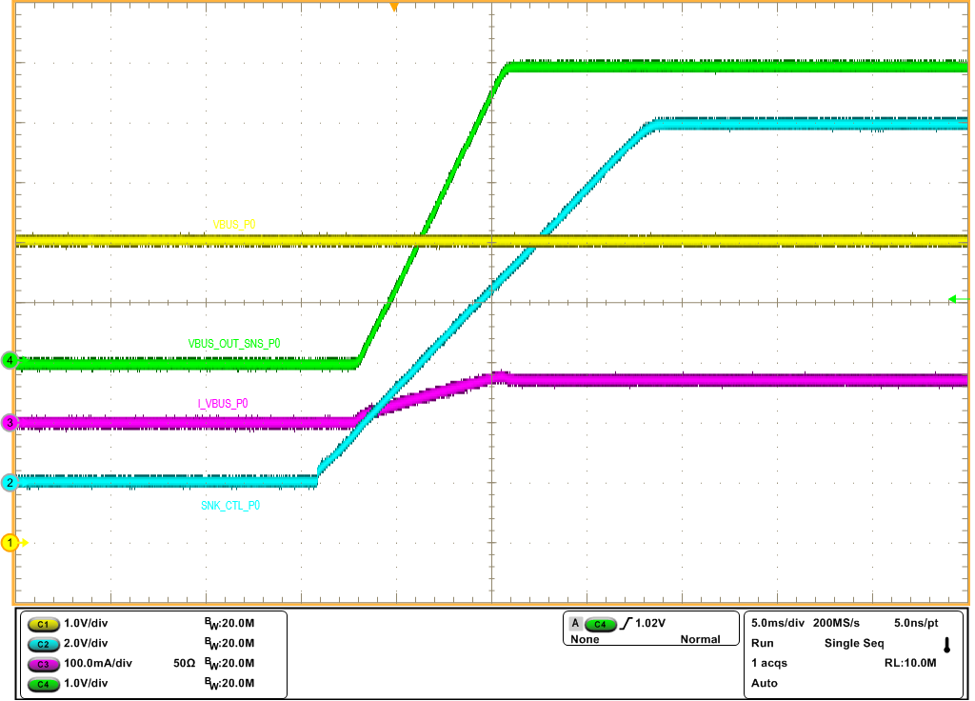  Figure 8. Startup of Sink Path at I_{LOAD}=100Ω & VBUS=5V | 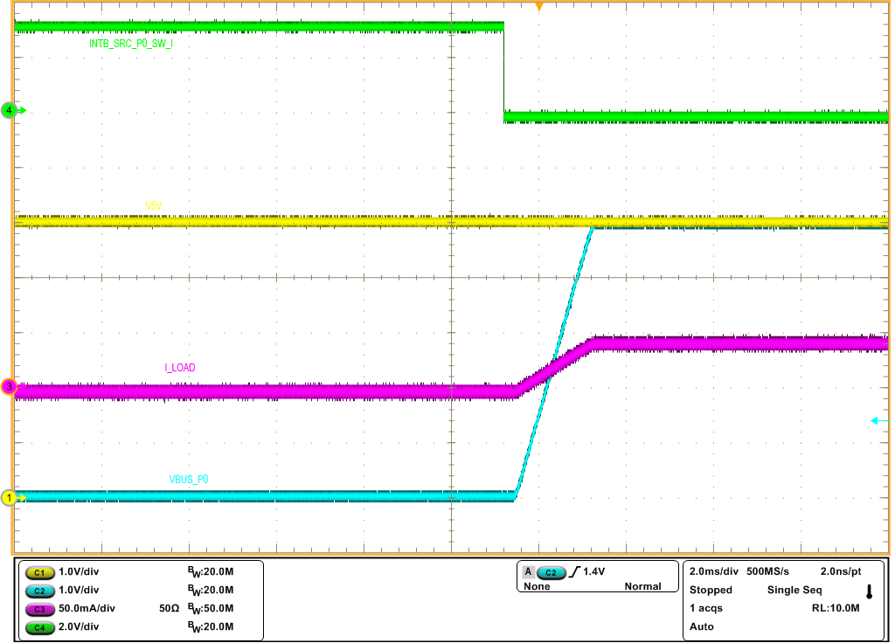  Figure 9. Startup of Source Path to VBUS_P0  at I_{LOAD}=100Ω & V5V=5V
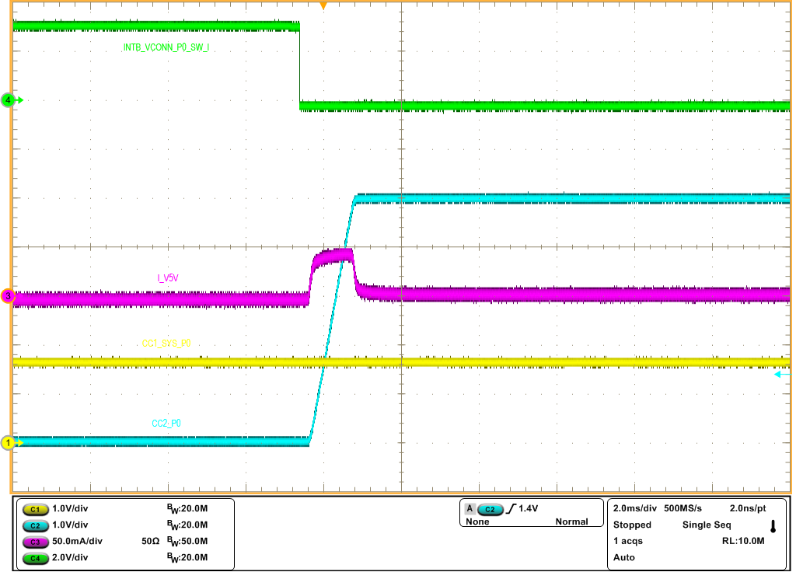  Figure 10. Startup of VCONN Path to CC2_P0  at C=10µF & V5V=5V | 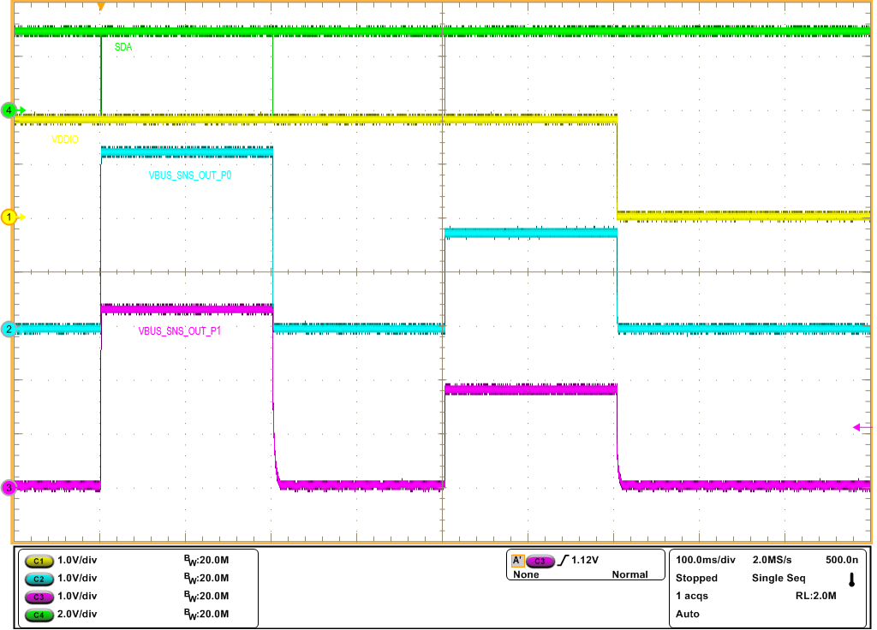  Figure 11. Low Voltage GPIO as GPO
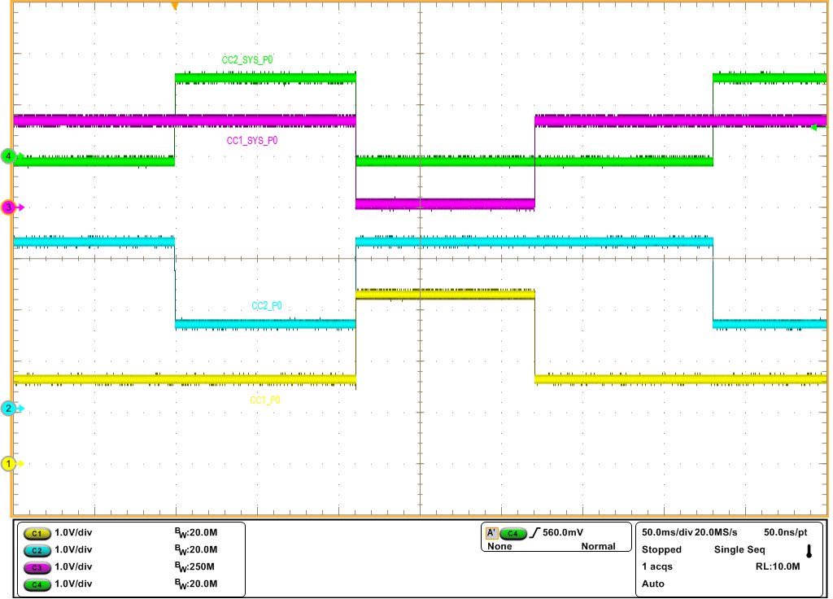  Figure 12. CC switch ON/OFF on Port 0 in VIN_3V3=3.3V | 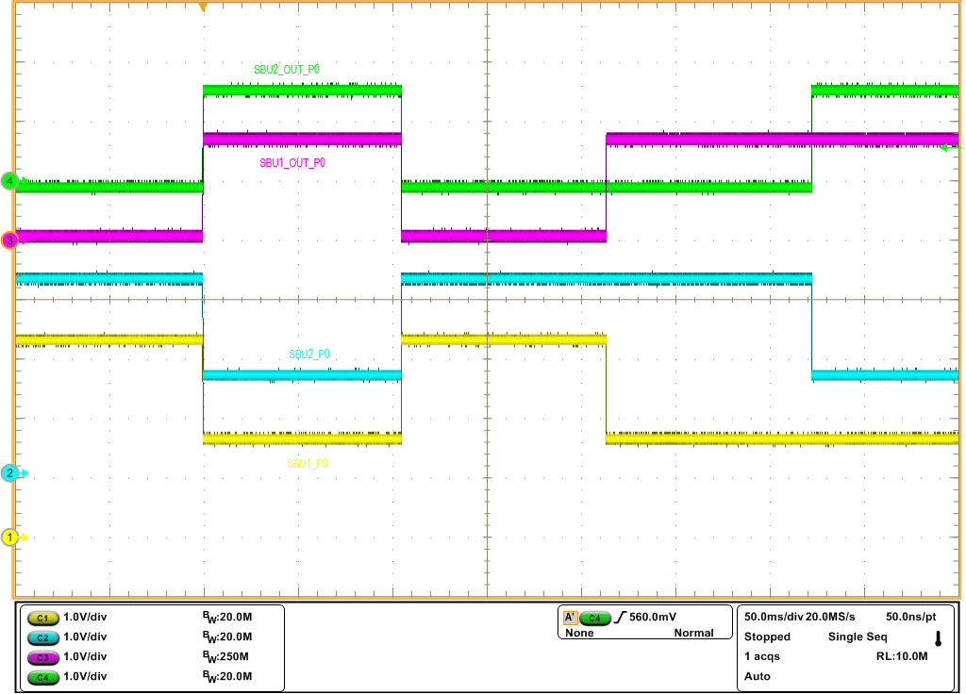  Figure 13. SBU switch ON/OFF on Port 0 in VIN_3V3=3.3V

Detailed Description

Power Source
A main power source for the device is one of the following sources.
- VIN_3V3 in normal state
- VBUS_P0
- VBUS_P1
- LDO3V3 in dead battery state

The VIN_3V3 is typically operated at 3.3V that comes from a system power supply. As long as the system stays alive, this supply voltage with g from 3.15V as low to 3.45V as high is continuously provided to the VIN_3V3. However, a power source to wake up the device from the dead battery condition where the VIN_3V3 typically stays at 0V comes from either VBUS_P0 or VBUS_P1.

Power source in the dead battery state
The dead battery state for the device is defined as the state where the VIN_3V3 is less than its UVLO while no valid supply is at both VBUS_P0 and VBUS_P1. In the dead battery state, a main power source to turn on LDO3V3 regulator is a valid supply voltage at either VBUS_P0 or VBUS_P1.
The LDO3V3 is mainly used for all the necessary internal blocks in the device until VIN_3V3 voltage becomes valid.

The Delink mode
The device features the delink mode to minimize the quiescent current in the following condition.

- All of SBU switches stay off
- All of VCONN switches stay off
- All of Source switches stay off
- All of Sink control outputs stay off
- A voltage on both VBUS_P0 and VBUS_P1 is less than the VBUS UVLO threshold
- Only CC switch(es) stays ON

In the delink mode, a time delay with 50µs (minimum) or longer should be applied for transaction of I²C read on any or all of interrupt registers (0x01 to 0x04) or write any or all of Read/Write registers for the internal I²C logic circuit to handle with an appropriate execution.
For an instance, if the PD controller wants to read four of interrupt registers in single time and sequence, the transaction should be made as below.

- The PD controller send Read I²C command to 0x01 register
- Take 50µs or longer time delay to read 0x02 after the STOP condition
- Read 0x02 register after the 50µs or longer time delay
- Continue to read the remaining two more registers with the same time delay between each READ transaction

The LDO3V3 internal regulator
The LDO3V3 regulator is used for most of internal circuitries. The output is a fixed 3.1V. The simple block diagram is presented as below.

Figure 14. Block diagram of the LDO3V3

The signals to enable and disable the LDO3V3 regulator are presented as below.

Enable signals: Any of the following signals turns on the LDO3V3
- VBUS_P0_UVLO in rising=H (VBUS_UVLO, 3.6V typ) && DIS_LDO33 bit=0b
- VBUS_P1_UVLO in rising=H (VBUS_UVLO, 3.6V typ) && DIS_LDO33 bit=0b

Disable signals: Any of the following signals turns off the LDO3V3 regulator
- VBUS_P0_UVLO in falling && VBUS_P1_UVLO in falling
- DIS_LDO33 bit=1b
- Thermal shutdown
However, the abnormal condition with VBUS OV does not turn off the LDO3V3.

The Internal Switch
The device features an internal switch (SW) between VIN_3V3 and LDO3V3 output with an embedded ideal diode.
The diagram below shows top-level connection with the system.

Figure 15. Top-level connection of VIN_3V3, LDO3V3 and internal SW

Internal Power and Data Switches
The device features all types of internal switches to provide power delivery and data transaction between two Type-C ports and system. However, the device does not integrate a power switch for SINK path but provide two control pins with a high (7V typ) or low (LDO3V3) voltage to control two external sink paths. The system is recommended to control an appropriate internal switch(es) over I²C or the dedicated control pins.

Power Delivery | Data Transaction over CC1/2 | Data Transaction over SBU1/2
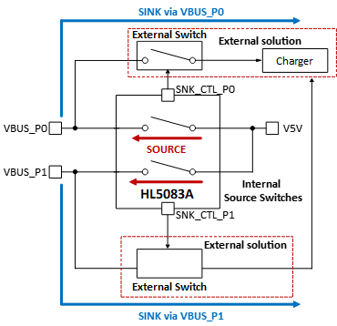  SINK Path:  Control by SNK_CTL_P0/P1 over I²C  SOURCE SW:  1. SRC_SW_EN_P0/P1 bit=1b  in normal mode  2. Control of FRS_EN_P0/P1 pin  in FRS mode | 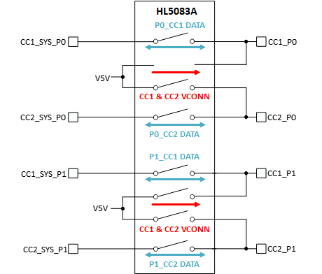  All CC SW:  1. All the CC switches remain OFF in normal state with VIN_3V3_POK=H & the corresponding I²C control bit with 0b  2. Can enable CC switches over I²C | 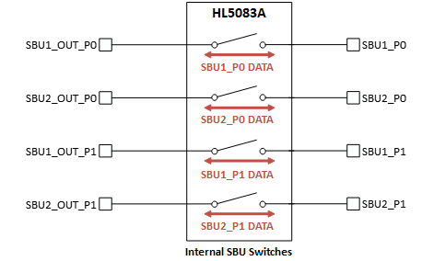  All SBU SW:  1. Default ON  2. Control of corresponding bit over I²C in no abnormal condition

Figure 16. All internal Switch paths

The Operation Modes
The device features various operation modes to support applications.

Register Reset Mode
When the device does not have any valid power source on all of the VIN_3V3, VBUS_P0 and VBUS_P1, the device is put into the reset mode. In the reset mode, the device has the following conditions due to no power source.

- No I²C
- All registers reset to their POR value
- All internal switches stay off (open)
- All internal functions not effective

Dead Battery Mode
The definition of the dead battery mode is the condition where the VIN_3V3 supply voltage stays at its UVLO regardless of VBUS_P0/P1 presence. If a valid supply voltage is presented at either VBUS_P0 or VBUS_P1, the internal regulator of LDO3V3 is turned on with an embedded soft start. Once the LDO3V3 POK internal signal is set to high in the valid supply voltage at VBUS_P0 or VBUS_P1, the following functions are effective.

- I²C interface
- All CC switches at both ports (Port 0 and Port 1) are disabled by default
- VBUS OVP detection
- CC OVP detection

Standby (Low power) Mode
The device stays at the standby mode where all the functions in the devices are possible with VIN_3V3_POK=H.
All the functions are possible over I²C or/and the designated external control pins. In this mode, the device minimizes a quiescent current as much as possible while keeping four CC switches ON. In this standby mode with all the default conditions, two of sink control pins (SNK_CTL_P0 & SNK_CTL_P1) stay at high-z state if the function itself stays disabled by SNK_CTL_P0/P1_EN=0b. An appropriate state shall be made on a device with either a pull-down or pull-up resistor. In this standby (Low power) mode, the following state is defined.

- No valid VBUS supply is applied at both VBUS_P0 and VBUS_P1
- No any internal (Source, VCONN, SBU) switches are enabled
- FRS_EN_P0 & FRS_EN_P1 stay low
- Internal charge-pump stays ON
- All CC SWs stay ON over I²C

The device exits the low power mode when any of above conditions is not qualified.

Sink Mode
The device features a dual-function embedded output pin for each sink path, Port 0 and Port 1. This dual-function with a high voltage output is only possible with a valid VBUS supply voltage on each port.
Each function can be configured over I²C. The simple block diagram is presented as below.

Figure 17. Diagram of Dual-function embedded GPO for Sink Mode

Sink Mode with a high voltage output for driving MOSFET Gate
The device pulls the INTB pin low to alert the system to indicate a valid or invalid VBUS voltage is detected at either VBUS_P0 or VBUS_P1 in the standby or dead battery mode.

- VBUS_P0 or VBUS_P1 ≥ VBUS UVLO over the debounce time
- VBUS_P0 or VBUS_P1 ≤ VBUS UVLO_HYS

Since then, the system can set all corresponding control bits to enable SINK path through an external FET switch.
Both control pins (SNK_CTL_P0/P1) can be enabled at the same time.

For P0 port sink path
- SNK_CTL_GDRV_P0=1b && SNK_CTL_EN_P0=1b for a back-to-back MOSFET

For P1 port sink path
- SNK_CTL_GDRV_P1=1b && SNK_CTL_EN_P1=1b for a back-to-back MOSFET

Where && means for AND Gating.

Figure 18. SNK_CTL_P0/P1 Timing diagram in the dead battery or normal condition

Note 1: The t_{SNK_CTL_RAMP} with programmable four timers, 1.75V/ms (default), 1.35V/ms, 0.93V/ms, 0.5V/ms, is for SNK_CTL_P0/P1 high voltage output at an initial start-up.

In the SINK mode, three protections are provided as below.

- VBUS Over Voltage Protection (OVP)
The OVP threshold level at VBUS_P0/P1 is programmable over I²C. An appropriate OVP threshold shall be set before the SINK path is made. In the OVP event during the SINK mode, the device pulls the corresponding SNK_CTL_P0/P1 pin down to turn an external SINK path off quickly.
A corresponding interrupt signal is consequently set in the register to alert the system by pulling the INTB pin low as long as the corresponding mask bit is not masked. If the corresponding mask bit is masked, the corresponding bit is still set to 1b but the INTB pin is not pulled low.
Once the voltage at VBUS_P0/P1 drops below V_{VBUS_OV} hysteresis and no other protection remains, the corresponding SNK_CTL_P0/P1 pin resumes operation after the VBUS debounce time, t_{DEB_VBUS} 15ms typ, is expired.

- VBUS Under Voltage Lockout (UVLO)
When the UVLO falling threshold is detected at VBUS_P0/P1, the corresponding SNK_CTL_P0/P1 pin is accordingly turned off with no delay time to disconnect the external SINK path.
If each SNK_CTL_P0 or P1 pin is configured as a low voltage output (3.3V output), the pin stays at its programmed setting even in VBUS < UVLO falling threshold.

- Reverse Current Protection (RCP) with VBUS_OUT_SNS_P0/P1 pins
An RCP circuit in sink mode monitors a voltage difference between (VBUS_OUT_SNS_P0 to VBUS_P0) or (VBUS_OUT_SNS_P0 - VBUS_P1) by default, VBUS_SNS_P0_P1_PROP_CFG=0b.
An individual sense pin for each port RCP should be made appropriately.

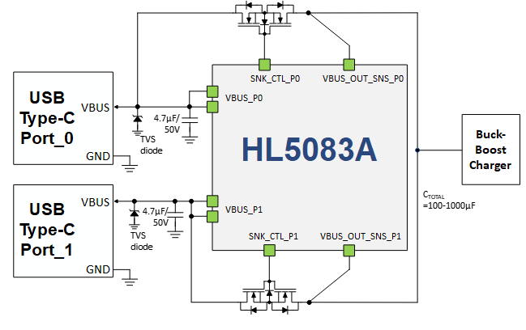
Figure 19. Diagram of Sink RCP connection

In the sink mode enabled, the device monitors a voltage difference between the pins (VBUS_P0/P1 and VBUS_OUT_SNS_P0/P1). When the voltage difference at VBUS_OUT_SNS_P0/P1 is higher by an RCP threshold, V_{RCP_SNK}, 10mV typ, the corresponding SNK_CTL_P0/P1 output will be turned off after the deglitch time, t_{RCP_SNK_DEG}, 4ms. However, if the voltage difference reaches at the severe RCP threshold, V_{RCPS_SNK}, 45mV typ, the corresponding SNK_CTL_P0/P1 output is turned off immediately without any deglitch time. If the RCP condition is detected before turning on the switch, the switch stays off while issuing the corresponding interrupt bit.

Figure 20. Soft and Hard RCP operation in Sink mode

However, the device in the SINK mode does not support the following protections.

- SCP (Short Current Protection)
- OCO (Over Current Protection)
- RCP if VBUS_OUT_SNS_P0/P1 pins are not configured as sensing function

Sink Mode with a low voltage output for a stand-alone eFuse device
When the VBUS supply voltage is stabilized, the system can set all corresponding control bits to turn on a stand-alone OVP device with the following command.

If each SNK_CTL_P0/P1 output is configured as low voltage output in (VIN_3V3 > UVLO || LDO3V3_POK=H), this LDO3V3 DC output can be generated in either non-inverting or inverting way.

- Non-Inverting output with high by
- SNK_CTL_EN_P0/P1=1b (enable) &&
- SNK_CTL_GDRV_P0/P1=0b (3.3V output mode) &&
- SNK_CTL_3V3_OUT_MODE_P0/P1=1b (3.3V output) &&
- SNK_CTL_3V3_CFG_P0/P1=0b (non-inverting)

- Inverting output with low by
- SNK_CTL_EN_P0/P1=1b (enable) &&
- SNK_CTL_GDRV_P0/P1=0b (3.3V output mode) &&
- SNK_CTL_3V3_OUT_MODE_P0/P1=1b (3.3V output) &&
- SNK_CTL_3V3_CFG_P0/P1=1b (inverting)

Where && means for AND Gating.
Figure 21. SNK_CTL_P0/P1 Low Voltage Output with 3.3V in non-inverting condition

Figure 22. SNK_CTL_P0/P1 Output with 3.3V in Inverting condition

Note: A high or low on SNK_CTL_P0/P1 pin can also be controlled by SNK_CTL_3V3_CFG_P0/P1 bit while setting SNK_CTL_EN_P0/P1 bit to 1b (enabled).

Summary of behavior for SNK_CTL_P0/P1 to all of the faults
The table below summarize the behavior of the SNK_CTL_P0/P1 pin to all of the possible fault events in both high and low voltage output.

Table 3. Behavior of SNK_CTL_P0/P1 with high and low voltage output GPO to the faults
Condition of Pin Output | Fault or event | Output Expected Behavior
High voltage output (7V typ) | - VBUS OV  - VBUS UVLO  - RCP  - Severe RCP  - Thermal shutdown  - FRS_EN=H in FRS mode enabled  - PA/PB_20V5A_OFF=H | Output pulled down to 0V
Low voltage output (3.3V typ) | - VBUS OV  - VBUS UVLO  - RCP  - Severe RCP  - Thermal shutdown | Output stays at its programmed state
 | - FRS_EN=H in FRS mode enabled | Output goes back to its original state  (e.g.: High-to-low for active-high)
 | - PA/PB_20V5A_OFF=H | Output goes back to its original state  (e.g.: High-to-low for active-high)

Source Mode
A corresponding source switch is enabled in one of the conditions.

- (FRS_P0_EN=H in FRS mode enabled || SRC_SW_EN_P0=1b) in V5V ≥ V_{V5V_UVLO}, 3.6V typ && No fault:
The source switch from V5V to VBUS_P0 turns on

- (FRS_P1_EN=H in FRS mode enabled || SRC_SW_EN_P1=1b) in V5V ≥ V_{V5V_UVLO}, 3.6V typ && No fault:
The source switch from V5V to VBUS_P1 turns on

Where && means for AND Gating and || for OR gating.
The source switch is turned on with no soft start by FRS_EN_P0/P1=H in the FRS mode enabled.

Figure 23. SRC Mode timing diagram of Enable and Disable over I²C

In this source mode, each switch has an adjustable over current limit from 1A to 3.6A in 200mA steps, reverse current blocking protection (direction from VBUS_P0/P1 to V5V) and short circuit protection. An appropriate VBUS OVP threshold over I²C should be made before enabling the SOURCE mode.

In the SOURCE mode, the multiple protections are executed as below.

- VBUS Over Voltage Protection (OVP)
The OVP threshold level at VBUS_P0/P1 is programmable over I²C. An appropriate OVP threshold shall be set before the SRC path is made. In the OVP event during the Source mode, the device turns off the corresponding internal switch.
A corresponding interrupt signal is consequently set in the register to alert the system by pulling the INTB pin low as long as the corresponding mask bit is not masked. If the corresponding mask bit is masked, the corresponding bit is still set to 1b but the INTB pin is not pulled low.
Once the voltage at VBUS_P0/P1 drops below V_{VBUS_OV} hysteresis and no other protection remains, the corresponding internal source switch resumes operation after the SRC debounce time, t_{EN_SRC_DELAY} 15ms typ, is expired.

- V5V Under Voltage Lockout (UVLO)
When the UVLO falling threshold is detected at V5V, the source switch is consequently turned off with no delay time.

- Adjustable Over Current Limit Protection (OCP)
The source mode supports over current limit function. The threshold of the current limit, I_{OCP_SRC}, is programmable from 1A to 3.6A in 200mA steps. The device status is changed to OCP detected once the programmed OCP threshold is detected. If the current stays longer than a programmed OCP debounce time, t_{OCP_DEB}, 10ms, 20ms, 40ms or 80ms, the source switch will be turned off by changing the device status to switch off and then stays off. To re-enable the source switch, a corresponding I²C enable bit should be toggled from 0b to 1b again.
The device operates only in the following behavior in the OCP event.
The device keeps the source current to a programmed threshold, SRC_OC_TH_P0/P1 [3:0].

Figure 24. SRC Mode timing diagram in OCP

- Short Circuit Protection (SCP)
The device features a programmable I_{SCP_SRC} threshold, 5A (default) or 6A over I²C. When a source current exceeds a programmed I_{SCP_SRC}, the device immediately turns off the corresponding source switch to protect device and system. In this short circuit event, the device behaves in latch mode (remains off continuously). In the latch mode, the corresponding source switch remains off. To re-enable the switch, each I²C enable bit (SRC_SW_EN_P0/P1 bit) or dedicated control pin (FRS_EN_P0/P1) in the FRS mode enabled should be toggled from 0b (Low) to 1b (High).

Figure 25. SRC short circuit in latch mode

- Reverse Current Protection (RCP)
The RCP circuit is to prevent any reverse power from VBUS_P0/P1 to V5V. When the VBUS_P0/P1 voltage is higher than the V5V voltage by RCP threshold, V_{RCP_SRC}, 10mV typ, the source switch will be turned off after t_{RCP_SRC_DEG}, 4ms, deglitch time. However, if the VBUS_P0/P1 is higher than V5V by the severe RCP threshold, V_{RCPS_SRC}, 45mV typ, the source switch is turned off immediately without any deglitch time. If the RCP condition is detected before turning on the switch, the switch stays off while issuing the corresponding interrupt bit.

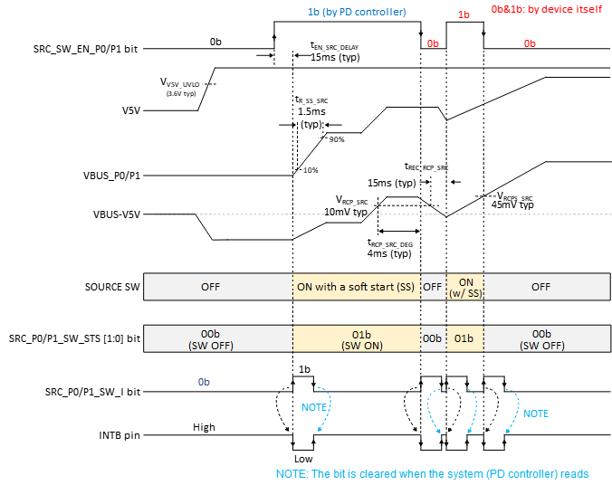

Figure 26. Soft and Hard RCP operation in SRC mode

- Ideal Diode Feature
The device integrates dynamic gate drive control acting like “Ideal Diode” mode in the source mode. The device regulates VBUS_P0/P1 voltage 10mV below V5V to protect any reverse current when VBUS_P0/P1 rises with slower than 30mV/µs defined in USB PD spec. This ideal diode mode can be enabled through the control bit, DIODE_MODE_EN_P0/P1, over I²C. It is enabled by default.

Fast Role Swap (FRS)
The device features fast role swap function with hard (manual) startup.

- Hard startup (Manual mode)
If FRS_EN_P0/P1 pin is pulled high in the FR mode enabled by FRS_EN_CFG_P0/P1=1b, the corresponding source switch is immediately turned on with no soft startup to provide V5V supply to VBUS_P0/P1 when all the FRS mode conditions are satisfied. The corresponding source switch is quickly turned on without soft start time right after VBUS_P0/P1 is discharged down to V_{RCPS_SRC} threshold. Therefore, the corresponding sink path control pin (SNK_CTL_P0 or SNK_CTL_P1) is turned off. After the device enters FRS mode successfully, the FRS_EN_CFG_P0/P1 bit will be automatically reset to 0b. To keep the source switch on, each corresponding enable bit (SRC_SW_EN_P0/P1) should be set to 1b. Then, the FRS_EN=H can be pulled down to low. To turn off the enabled source switch, the PD controller should drive the FRS_EN_P0/P1 pin low while the enable bit is set to 0b or reset the enable bit to 0b while the FRS_EN pin stays low.

Figure 27. The FRS – Hard startup (Manual mode)

CC, VCONN and SBU Switch

Functional diagram
The device integrates VCONN switch to pass VCONN power through the CC pins. The device also features a programmable VCONN current limit from 400mA to 800mA. The current limit function can be also disabled over I²C.

Figure 28. CC, VCONN and SBU functional diagram

The table below summarizes the CC and SBU status depending on VIN_3V3 and fault conditions.

Table 4. CC/SBU switch mode table
VIN_3V3 | Conditions | Switch & Pulldown resistors On/Off mode^{(NOTE7)}
 |  | Port 0 |  |  |  |  | Port 1
 |  | CC1/2 SWs | SBU1/2  SWs | R_{CC_DIS}  at CC1/2_SYS  (typ 40Ω) | R_{d_DB} for CC1/2  (typ 5.1kΩ) | R_{SBU_DIS} for SBU1/2  (typ 40Ω) | CC1/2 SWs | SBU1/2  SWs | R_{CC_DIS}  at CC1/2_SYS  (typ 40Ω) | R_{d_DB} for CC1/2  (typ 5.1kΩ) | R_{SBU_DIS} for SBU1/2  (typ 40Ω)
VIN_3V3  ≥ V_{3V3_UVLO}  (Battery healthy condition) or LDO3V3  ≥ V_{LDO3V3_POK}  (Either VBUS plugged) | No Faults | OFF  (NOTE1) | ON  (NOTE2) | OFF | ON  (NOTE8) | OFF | OFF  (NOTE1) | ON  (NOTE2) | OFF | ON  (NOTE8) | OFF
 | V_{CC1_P0} ≥  V_{CC1_OVP_P0} | CC1&2_P0 OFF | ON  (NOTE2) | CC1&2_  SYS_P0 ON (NOTE3) | CC1&2_  P0 ON  (NOTE4) | OFF | OFF  (NOTE1) | ON  (NOTE2) | OFF | ON  (NOTE8) | OFF
 | V_{CC2_P0} ≥  V_{CC2_OVP_P0} | CC1&2_P0 OFF | ON  (NOTE2) | CC1&2_  SYS_P0 ON  (NOTE3) | CC1&2_  P0 ON  (NOTE4) | OFF | OFF  (NOTE1) | ON  (NOTE2) | OFF | ON  (NOTE8) | OFF
 | V_{SBU1_P0} ≥ V_{SBU1_OVP_P0} | OFF  (NOTE1) | SBU1&2_P0 OFF | OFF | OFF | SBU1&2_P0 ON  (NOTE5) | OFF  (NOTE1) | ON  (NOTE2) | OFF | ON  (NOTE8) | OFF
 | V_{SBU2_P0} ≥ V_{SBU2_OVP_P0} | OFF  (NOTE1) | SBU1&2_P0 OFF | OFF | OFF | SBU1&2_P0 ON  (NOTE5) | OFF  (NOTE1) | ON  (NOTE2) | OFF | ON  (NOTE8) | OFF
 | V_{CC1_P0} ≥  V_{CC1_OVP_VCONN_P0} | CC2 & CC1-to-VCONN_P0 OFF  (NOTE6) | ON  (NOTE2) | CC1/2_  SYS_P0 ON | CC1&2_  P0 ON  (NOTE4) | OFF | OFF  (NOTE1) | ON  (NOTE2) | OFF | ON  (NOTE8) | OFF
 | V_{CC2_P0} ≥  V_{CC2_OVP_VCONN_P0} | CC1 & CC2-to-VCONN_P0 OFF  (NOTE6) | ON  (NOTE2) | CC1/2_  SYS_P0 ON | CC1&2_  P0 ON  (NOTE4) | OFF | OFF  (NOTE1) | ON  (NOTE2) | OFF | ON  (NOTE8) | OFF
 | V_{CC1_P1} ≥  V_{CC1_OVP_P1} | OFF  (NOTE1) | ON  (NOTE2) | OFF | ON(NOTE8) | OFF | CC1&2_P1 OFF | ON  (NOTE2) | CC1&2_  SYS_P1 ON (NOTE3) | CC1&2_  P1 ON  (NOTE4) | OFF
 | V_{CC2_P1} ≥  V_{CC2_OVP_P1} | OFF  (NOTE1) | ON  (NOTE2) | OFF | ON(NOTE8) | OFF | CC1&2_P1 OFF | ON  (NOTE2) | CC1&2_  SYS_P1 ON (NOTE3) | CC1&2_  P1 ON  (NOTE4) | OFF
 | V_{SBU2_P1} ≥ V_{SBU2_OVP_P1} | OFF  (NOTE1) | ON  (NOTE2) | OFF | ON(NOTE8) | OFF | ON | SBU1&2_P1 OFF | OFF | OFF | SBU1&2_P1 ON  (NOTE5)
 | V_{SBU2_P1} ≥ V_{SBU2_OVP_P1} | OFF  (NOTE1) | ON  (NOTE2) | OFF | ON(NOTE8) | OFF | ON | SBU1&2_P0 OFF | OFF | OFF | SBU1&2_P0 ON  (NOTE5)
 | V_{CC1_P1} ≥  V_{CC1_OVP_VCONN_P1} | OFF  (NOTE1) | ON  (NOTE2) | OFF | ON  (NOTE8) | OFF | CC2 & CC1-to-VCONN_P1 OFF  (NOTE6) | ON  (NOTE2) | CC1/2_  SYS_P1 ON | CC1&2_  P1 ON  (NOTE4) | OFF
 | V_{CC2_P1} ≥  V_{CC2_OVP_VCONN_P1} | OFF  (NOTE1) | ON  (NOTE2) | OFF | ON(NOTE8) | OFF | CC1 & CC2-to-VCONN_P1 OFF  (NOTE6) | ON  (NOTE2) | CC1/2_  SYS_P1 ON | CC1&2_  P1 ON  (NOTE4) | OFF
 | T_{J} > T_{J_SD} | OFF | OFF | OFF | ON(NOTE8) | OFF | OFF | OFF | OFF | OFF | OFF
VIN_3V3 < V_{3V3_UVLO} &&  LDO3V3 < V_{LDO3V3_POK}  (Dead battery and no VBUS condition) | V_{CC1/2_P0/1} ≥ 1.5V | ON  (NOTE1) | OFF | OFF | ON  (NOTE8) | OFF | ON  (NOTE1) | OFF | OFF | ON(NOTE8) | OFF
NOTE 1: All the CC SWs are default OFF. Each CC SW can be enabled over I²C command once the LDO3V3_POK is internally set high.
NOTE 2: All the SBU switches are default ON
NOTE 3: ON at only OVP-happened port is automatically enabled by V_{CC1/2_OVP_P0/P1} threshold detection
NOTE 4: It turns ON per I²C command by setting DEAD_RD_DIS_P0/P1 to 0b at 0x10 [5:4]. This bit control is fully dependent on the PD controller.
NOTE 5: ON at both SBU switches at the same port is manually enabled over I²C by SBU_RD_DIS_OV_EN=1b
NOTE 6: The corresponding enabled VCONN and the other CC switch are disabled (turn off)
NOTE 7: All the OVP functions on each CC, SBU and VCONN are always alive as long as the device is in normal operation. Any of OVP event turns off a corresponding switch first.
NOTE 8: The dead battery Rd_DB (5.1kΩ) is default ON. If necessary, it should be disabled over I²C command, DEAD_RD_DIS_P0/P1=1b at 0x10 [5:4].

CC Switch
From USB Type C spec, VBUS is provided after detecting R_{d_DB}, 5.1kΩ typ, on CC pin. The device integrates the dead battery R_{d_DB} on CC1_P0/P1 and CC2_P0/P1, which are always enabled in both dead battery and non-dead battery state. This R_{d_DB} allows the USB PD adapter to detect the R_{d_DB}, then to provide 5V on VBUS under dead battery condition. If necessary, this R_{d_DB} should be disabled manually by setting the bit, DEAD_RD_DIS_P0/P1, to 1b at 0x10 [5:4].
All CC switches in the device stays off by default. It can be turned on over I²C.

Figure 29. CC Switch timing diagram in the dead battery state

The device integrates CC OVP switches to protect PD controller in the system from over voltage conditions like surge or short to VBUS in the Type C connector.
When the device detects a programmed over-voltage threshold, V_{CC_OVP}, 6.0V or 5.8V typ, on either of CC1_P0/P1 or CC2_P0/P1, both CC switches at the same port are quickly turned off while enabling the embedded discharge resistor, R_{CC_DIS}, 40Ω typ at CC1/2_SYS_P0/P1 pins. However, both CC1/2 switches at the other port remain on as long as its corresponding I²C bit set to 1b.
The device features two different behaviors on the OVP event.
The 1st behavior is auto-recovery by default. In the auto-recovery mode, the disabled both CC switches are turned back on in t_{CC_OVP_REC},1ms, after CC1_P0/P1 or CC2_P0/P1 voltage are lower than its OVP hysteresis threshold.

Figure 30. Timing diagram by CC OVP in auto-recovery mode

The 2nd behavior is latch mode. In the latch mode, the disabled both CC switches by OVP remain off until CC12_ENABLE_P0/P1 bit is set to 1b from 0b by PD controller.

Figure 31. Timing diagram by CC OVP in latch mode

VCONN Switch
The VCONN switch is controlled by VCN_SW_EN_P0/P1 [1:0] bits over I²C along with CC1/2_DISABLE_P0/P1 bits at 0x1D [5:2]. To enable a VCONN SW, a voltage at V5V should be higher its UVLO threshold. To enable an appropriate VCONN SW while all the CC SWs stay ON, the following sequence is recommended.

For example, the recommended sequences to enable VCONN SW to CC2_P0 are:
- Set CC2_DISABLE_P0 at 0x1D [3] to 1b to break CC2_P0 switch first
- Keep the CC1_P0 switch ON by 0x1D [2] =1b
- Set VCN_SW_EN_P0 at 0x14 [4:3] to 11b to turn on VCONN switch

To re-turn on the CC2_P0 switch back to CC2_SYS_P0, the following sequence is recommended.
- Reset VCN_SW_EN_P0 at 0x14 [4:3] to from 11b to 00b or 01b break off the VCONN switch first
- Reset CC2_ENABLE_P0 at 0x1D [3] to from 0b to 1b to turn back on CC2_P0 switch to CC2_SYS_P0
Table 5. Operation of VCONN switch
VCN_SW_EN_P0/P1 [1:0] | Operation of VCONN switch | Status of the other CC SW
00b-01b | VCONN Switch stays OFF | All other CC SW stay ON
10b | Enable switch from V5V to CC1_P0/P1 | CC2 SW at P0/P1 stay ON
11b | Enable switch from V5V to CC2_P0/P1 | CC1 SW at P0/P1 stay ON

Figure 32. VCONN Switch operation diagram over I²C

If a voltage at any CC1/2_P0/P1 goes over the programmed OVP threshold, 5.8V or 6.0V, the corresponding VCONN switch will be turned off immediately. In addition, the other enabled CC switch at the same port will be turned off as well. Both VCONN and CC switches are turned back on in t_{CC_OVP_REC},1ms, after the voltage falls below the falling hysteresis, 250mV in VCONN auto-recovery mode.
However, any enabled SBU1 and SBU2 switches at the same port and CC switches at the other port will remain on.

Figure 33. VCONN SW in OVP Operation and auto-recovery mode

The device provides current limit features which is programmable with 400mA, 700mA, 800mA or no limit through VCN_OC_P0/P1 [1:0] bits. Once a load current is higher than a programmed threshold, the device limits the load current by increasing the switch resistance in VCN_OC_CFG_P0/P1=0b. If the bit is set to 1b, the VCONN switch will be turned off after the t_{OCP_VCONN_DEG}, (typ 8ms) time by setting the bit of VCN_SW_EN_P0/P1 [1:0] to 00b-01b for turn-off. There is no auto-recovery function for VCONN OCP event. The interrupt will be generated consequently in the condition the mask bit is not set. The power dissipation will be significantly increased during this regulation; therefore, the host should decide to turn off VCONN switch or increase OC threshold to minimize power dissipation.

Current limit | No current limit

Figure 34. VCONN SW in OCP Operation

SBU Switch
The device integrates SBU OVP function to protect SBU-connected pins in the system from over voltage conditions like surge or short to VBUS in the Type C connector.
All the SBU switches stay ON by default. Each SBU switch at Port 0 and Port 1 can be enabled over I²C, SBU1/2_EN_P0/P1 bit=1b.

Figure 35. ON/OFF SBU SW per I²C

When the device detects over-voltage threshold, V_{SBU_OVP}, typ 4.2V, on either SBU1_P0/P1 or SBU2_P0/P1, both SBU1/2 switches at the OVP-happened port are quickly turned off. However, the enabled SBU1/2 and CC switches at the other port remain on. To discharge SBU output pins (SBU1/2_OUT_P0/P1) in the OVP event, the embedded discharge resistor, R_{SBU_DIS} (40Ω typ), can be automatically enabled in SBU_RD_DIS_OV_EB bit set to 1b.
In the OVP event, the device features programmable switch-off delay time, 30ns or 100ns, over I²C.
The device features two different behaviors on the OVP event.
The 1st behavior is auto-recovery by default. In the auto-recovery mode, the disabled both SBU switches are turned back on in t_{SBU_OVP_REC},1ms, after SBU1_P0/P1 or SBU2_P0/P1 voltage are lower than its OVP hysteresis threshold.

Figure 36. Timing diagram of SBU OVP in auto-recovery mode

The 2nd behavior is latch mode. In the latch mode, the disabled both SBU switches by OVP remain off until SBU12_EN_P0/P1 bit is toggled to 1b by PD controller.

Figure 37. Timing diagram of SBU OVP in latch mode

VBUS Discharge
The device has a built-in discharge resistor, R_{VBUS_PD}=300Ω (typ), on each VBUS_P0/P1 to discharge residual voltage charged VBUS_P0/P1 capacitor. ON/OFF is manually controlled by the corresponding bit, VBUS_P0/P1_DIS_EN, for each VBUS_P0 and VBUS_P1 pin.

GPIO
The device features 2 GPIO pins with push-pull type over I²C. Both VBUS_OUT_SNS_P0/P1 pins can be configured as voltage sense input or general GPIO with VDDIO or LDO3V3 pull-up I/O level.
The simple block diagram is presented as below.

Figure 38. GPIO Block Diagram

Voltage Conversion of VBUS and Source current
The device features three voltage conversions for a voltage at both VBUS_P0 and VBUS_P1 and a source current for both source switches.

Table 6. Voltage conversion of VBUS voltage and source current
Dedicated pin | Conversion range | Conversion ratio | Max output at each pin | Note
VBUS_DIV_P0 | 0V to 35V | 0.0571 | 2.0V | Enable conversion over I²C, CONV_VBUS_EN_P0 bit  0b: Disable  1b: Enable conversion
VBUS_DIV_P1 | 0V to 35V | 0.0571 | 2.0V | Enable conversion over I²C, CONV_VBUS_EN_P1 bit  0b: Disable  1b: Enable conversion
V5V_DIV | 0V to 6V | 0.33 | 2.0V | Enable conversion over I²C, CONV_V5V_EN bit  0b: Disable  1b: Enable conversion
SRC_CUR_P1 | 0A to 4.5A | 0.45mV/mA | 2.0V | Enable conversion over I²C, CONV_SRC_CUR_P1 bit  0b: Disable  1b: Enable conversion
SRC_CUR_P0 | 0A to 4.5A | 0.45mV/mA | 2.0V | Enable conversion over I²C, CONV_SRC_CUR_P0 bit  0b: Disable  1b: Enable conversion

Manual enable of Source Switch
Each source switch can be re-enabled by toggling each corresponding I²C bit (SRC_SW_EN_P0/P1) even in the abnormal event as below.
- Thermal shutdown
- Short Circuit Protection (SCP)
- Over-Current Protection (OCP)

In the thermal shutdown, the Sink path also stays off due to the latch operation. To re-enable the sink path, all corresponding control bits should be set appropriately. Refer to the table 6 for the details.

Thermal Shutdown
When the device’s temperature exceeds the thermal shutdown threshold, T_{SHDN} (130°C typ), the Over Temperature Protection (OTP) is activated. In the OTP condition, all internal switches (Source, VCONN, CC, SBU) and sink path control pins (SNK_CTL_P0/P1) configured as the high voltage output are turned off, and the interrupt will be sent by setting THSD_I bit=1b. All the disabled switches stay off until a corresponding enable bit for each switch is toggled again. The LDO3V3 stays on even in the OTP condition.

Summary of Protection
The device provides a full of protections to protect any downstream devices and device itself.
The table below summaries an expected behavior for each protection.

Table 7. Summary of behavior for all protections
Fault (or abnormal) Event | Expected behavior | Auto-recovery or Latch | Note
Device Level
Thermal shutdown | - Turn off all of internal and external switches except for the internal switch between VIN_3V3 and LDO3V3 & LDO3V3  - Does not turn off SNK_CTL_P0/P1 output configured as low voltage output GPO | - Latch (Stays off)  - Once a die temp goes below its hysteresis, a corresponding interrupt is generated | No I²C control bit to select auto-recovery or latch
Sink Mode over SNK_CTL_P0/P1 GPIO Pins
VBUS_P0_UVLO  or  VBUS_P1_UVLO | - Only turn off SNK_CTL_P0/P1 pin configured as the high voltage output  - SNK_CTL_P0/P1 configured as the low voltage output stays at its programmed value | - Auto-recovery for the high voltage output GPO  - Turn_ON: 15ms delay (15ms debounce time after VBUS goes over UVLO while all corresponding bits set correctly)  - Turn-OFF on falling UVLO: No delay | No I²C control bit to select auto-recovery or latch
 |  |  | No I²C control bit to select auto-recovery or latch
VBUS_P0_OV  or  VBUS_P1_OV | - Only turn off SNK_CTL_P0/P1 pin configured as the high voltage output  - SNK_CTL_P0/P1 configured as the low voltage output stays at its programmed value | - Auto-recovery for the high voltage output GPO  - Turn-ON: 15ms debounce after OV condition is cleared  - Turn-OFF on falling UVLO: No delay | No I²C control bit to select auto-recovery or latch
 |  |  | No I²C control bit to select auto-recovery or latch
Soft RCP (10mV typ) for VBUS_P0 or VBUS_P1 | - Turn off SNK_CTL_P0 output configured as the high voltage output in 4ms debounce time  - SNK_CTL_P0/P1 configured as the low voltage output stays at its programmed value | - Auto-recovery for the high voltage output GPO  - PIN_OFF: Turn OFF in 4ms debounce time  - PIN_ON: Turn ON in 15ms debounce time after the soft RCP condition is released | - Should configure VBUS_OUT_SNS_P0 & VBUS_OUT_SNS_P1 as sensing pin  - If not, no RCP is executed  - No I²C control bit to select auto-recovery or latch
Severe RCP (45mV typ) for VBUS_P0 or VBUS_P1 | - Turn off SNK_CTL_P0 output configured as the high voltage output with no delay  - SNK_CTL_P0/P1 configured as the low voltage output stays at its programmed value | - Auto-recovery for the high voltage output GPO  - PIN_OFF: No delay  - PIN_ON: Once severe RCP condition is released, follows the soft RCP behavior
Source Mode through an internal Switch for each port
V5V UVLO | Turn off Source Switch | - Auto-recovery  - SW_ON: 15ms delay (15ms debounce time after V5V goes over UVLO while all corresponding bits set correctly)  - SW_OFF on falling UVLO: No delay | No I²C control bit to select auto-recovery or latch
VBUS_P0_OV or VBUS_P1_OV | Turn off Source Switch | Latch | No I²C control bit to select auto-recovery or latch
Over-Current-Limit (OCP) | Keep Source Switch ON and limit the load current at a programmed OCP threshold | - Latch  - SW_OFF: The SW turns off after one of 4 programmable debounce timers  - Then, remains OFF until I²C bit is toggled | - 4 debounce timers  (10ms, 20ms, 40ms, 80ms)  - No I²C control bit to select auto-recovery or latch
Short-Circuit Protection (SCP) | Turn off Source Switch | - Latch  - SW_OFF: No delay  - Remains OFF until I2C bit is toggled | No I²C control bit to select auto-recovery or latch
Soft RCP (10mV typ) for VBUS_P0 | Turn off Source Switch in 4ms debounce time | - Auto-recovery  - 15ms debounce time after the soft RCP condition is released | - No I²C control bit to select auto-recovery or latch
Severe RCP (45mV typ) for VBUS_P0 | Turn off Source Switch with no delay | - Auto-recovery  - Once severe RCP condition is released, follows the soft RCP behavior | - No I²C control bit to select auto-recovery or latch
Soft RCP (10mV typ) for VBUS_P1 | Turn off Source Switch in 4ms debounce time | - Auto-recovery  - 15ms debounce time after the soft RCP condition is released | - No I²C control bit to select auto-recovery or latch
Severe RCP (45mV typ) for VBUS_P1 | Turn off Source Switch with no delay | - Auto-recovery  - Once severe RCP condition is released, follows the soft RCP behavior | - No I²C control bit to select auto-recovery or latch
CC Switches
Over-Voltage (OV) | Turn off both CC1/2 switches at the OV-happened port only. Refer to Table 3 for details | - 1-bit programmable for auto-recovery or Latch (default)  - Auto-recovery with 1ms debounce time  - Latch (remains OFF until I²C bit is toggled) | 1-bit I²C control bit for both CC1 and CC2 SW at each port
SBU Switches
Over-Voltage (OV) | Turn off both SBU1/2 switches at the OV-happened port only. Refer to Table 3 for details | - 1-bit programmable for auto-recovery or Latch (default)  - Auto-recovery with 1ms debounce time  - Latch (remains OFF until I²C bit is toggled) | 1-bit I²C control bit for both SBU1 and SBU2 SW at each port
VCONN Switches
Over-Voltage (OV) | Turn off both VCONN and CC switches at the OV-happened port only. Refer to Table 3 for details | - Same 1-bit programmable as CC_OVP  - Auto-recovery with 1ms debounce time  - turn off both VCONN and CC SW, Latch (remains OFF until I²C bit is toggled) | Same I²C control bit for CC OVP to select auto-recovery or latch
Over-Current-Limit (OCP) | Keep VCONN Switch ON or OFF | - Keep the SW ON at a programmed current limit (Generate INT in 8ms debounce time)  - SW_OFF (Default): Keep the SW ON for 8ms debounce time and then turn off both VCONN and CC SW  (Remains OFF & Generate INT in 8ms debounce time)

Interrupt (INTB)
The INTB is active low open drain output, an internal pull up resistor, 10kΩ, is connected to LDO3V3. Any unmasked interrupt event will pull the INTB pin low. The INTB pin will not be pulled back to high until INT registers are cleared. New event(s) that occur during an interrupt event register handling will be held until INT registers are cleared, ensuring that host does not miss any of them. All interrupt events are not masked by default.

Figure 39. Structure of Interrupt, status and mask registers

Figure 40. Interrupt Timing

Serial Interface Description
The device supports I²C bus protocol. A device that sends data onto the bus is defined as a transmitter and a device receiving data as a receiver. The device that controls the bus is called a mater, whereas the devices controlled by the master are known as slaves. A master device must generate the serial clock (SCL), control bus access and generate START and STOP conditions to control the bus. The device operates as a slave on the I²C bus. Within the bus specifications, a standard mode (100kHz maximum clock rate) and fast mode plus (1MHz maximum clock rate) are defined. The device works in both modes. Connections to the bus are made through two open-drain IO lines, SDA and SCL.
The following bus protocol has been defined in the below.
- Data transfer may be initiated only when the bus is not busy
- During data transfer, the data line must remain stable whenever the clock line is HIGH. Changes in the data line while the clock line is HIGH are interpreted as control signals.
Accordingly, the following bus conditions have been defined

Bus Not Busy
Both data and clock lines remain HIGH.

Start Data Transfer
A change in the state of the data line from HIGH to LOW, while the clock is HIGH, defines a START condition.

Stop Data Transfer
A change in the state of the data line from LOW to HIGH, while the clock is HIGH, defines a STOP condition.
Figure 41. START and STOP Condition

Data Validity
The state of the data line represents valid data when, after a START condition, the data line is stable for the duration of the HIGH period of the clock signal. The data one the line must be changed during the LOW period of the clock signal. There is one clock pulse per bit of data. Each data transfer is initiated with a START condition and terminated with a STOP condition. The number of data bytes transferred between START and STOP conditions are not limited and are determined by the master device. The information is transferred byte-wise, and each receiver acknowledges with a ninth bit.
Figure 42. Bit transfer on the I²C-bus

Acknowledge
Each receiving device, when I2C address, is obliged to generate an acknowledge after the reception of each byte. The master device must generate an extra clock pulse that is associated with this acknowledge bit.
A device that acknowledges must pull down the SDA line during the acknowledge clock pulse in such a way that the SDA lie is stable LOW during the high period of the acknowledge-related clock pulse. Setup and hold times must also be considered.
There are five conditions that lead to the generation of a NACK.
1. No receiver is present on the bus with the transmitted I2C address so there is no device to respond with an acknowledge.
2. The receiver is unable to receive or transmit because it is performing some real-time function and is not ready to start communication with the master
3. During the transfer, the receiver gets data or commands that it does not understand
4. During the transfer, the receiver cannot receive any more bytes.
5. A master-receiver must signal the end of the transfer to the slave transmitter.
Figure 43. Data Transfer on I²C Serial Bus

Device has a 7-bit slave I2C address and the slave I2C address byte is the first byte received following START condition from the master device.

I²C Write Cycle
For I²C write cycle, data is transferred from a master to a slave. The first byte transmitted in the 7-bit slave plus one bit of 0b for write. Next follows a number of data bytes. The slave returns an acknowledge bit after each received byte. Data is transferred with the most significant bit (MSB) first. The figure below shows the sequence of the I²C write cycle.

Figure 44. I²C write Cycle

I²C Write Cycle Steps:
- Master generates a START condition
- Master sends 7-bits slave I2C_ADDRess and 1-bit data direction 0b for write
- Slave sends an acknowledge if the slave I2C_ADDRess is matched
- Master sends 8-bit register I2C_ADDRess
- Slave sends an acknowledge
- Master sends 8-bit data for that I2C_ADDRessed register
- Slave sends an acknowledge
- If master sends more data bytes, the register I2C_ADDRess will be incremented by one after each acknowledge.
- Mast generates a STOP condition to finish the write cycle

I²C Read Cycle
For I²C read cycle, data is transferred from a slave to a master. But to start the read cycle, master needs to write the register I2C address first to define which register data to read. The figure below shows the steps of the I²C read cycle.
Figure 45. I²C Read Cycle

I²C Read Cycle Steps:
- Master generates a START condition
- Master sends 7-bits slave I2C_ADDRess and 1-bit data direction 0b for write
- Slave sends an acknowledge if the slave I2C address is matched
- Master sends 8-bit register I2C address
- Slave sends an acknowledge
- Master generates repeated a START condition
- Master sends 7-bits slave I2C address and 1-bit data direction 1b for read
- Slave sends an acknowledge if the slave I2C address is matched
- Slave sends the data byte of that I2C address register
- If master sends an acknowledge, the register I2C address will be incremented by one after each acknowledge and the slave will continue to send the data for the updated I2C address register
- If master sends no acknowledge, the slave will stop sending the data
- Master generates a STOP condition to finish the read cycle

I²C registers

Device Slave I2C_Address
The device has a slave I²C address as below.

MSB LSB
1 | 0 | 0 | 0 | 0 | 0 | 0 | R/W
Figure 46. I²C Device Slave Address

Table 8. Slave I²C_Address
7-bit I²C Address | 8-bit I²C Address in write
100 0000 (0x40) | 1000 0000 (0x80)

Register reset type
There are four different reset types in the device. Each register with specified reset condition is reset to its own default value.

Table 9. Register reset condition
Type | Reset Condition
POR | VIN_3V3 < UVLO && LDO3V3_POK=L

Register type
The table below gives type of registers used in the register specification.

Table 10. Register reset type
Type | Function
R | Read only
R/C | Read and Clear
R/W | Read and Write
RWSC | Read and write, then self-reset after taking effect

I²C Register Map
Table 11. Register Map
I2C_  ADDR (hex) | Name | Type | POR(hex) | Bit 7 | Bit 6 | Bit 5 | Bit 4 | Bit 3 | Bit 2 | Bit 1 | Bit 0
00 | DEVICE_ID | R | 82 | DEV_ID [3] | DEV_ID [2] | DEV_ID [1] | DEV_ID [0] | DEV_REV [3] | DEV_REV [2] | DEV_REV [1] | DEV_REV [0]
01 | INT_SYS_0 | R/C | 00 | VCONN_P1_OC_I | VCONN_P0_OC_I | SRC_P1_OC_I | SRC_P0_OC_I | SRC_  P1_SCP_I | SRC_  P0_SCP_I | VBUS_  SNS_P1_I | VBUS_  SNS_P0_I
02 | INT_SYS_1 | R/C | 00 | RSVD | SBU12_P1_OV_  CLEAR_  I | CC12_P1_OV_  CLEAR_  I | SBU12_P0_OV_  CLEAR_  I | CC12_P0_OV_  CLEAR_  I | LDO3V3_I | VIN_3V3_I | THSD_I
03 | INT_P0 | R/C | 00 | SNK_P0_  RCP_I | SRC_P0_  RCP_I | SBU12_P0_OV_I | CC12_P0_OV_I | DEV_P0_  STS_I | VBUS_P0_  POK_I | VCONN_  P0_SW_I | SRC_P0_  SW_I
04 | INT_P1 | R/C | 00 | SNK_P1_  RCP_I | SRC_P1_  RCP_I | SBU12_P1_OV_I | CC12_P1_OV_I | DEV_P1_  STS_I | VBUS_P1_  POK_I | VCONN_  P1_SW_I | SRC_P1_  SW_I
05 | INT_SYS_0_MSK | R/W | 00 | VCONN_P1_OC_M | VCONN_P0_OC_M | SRC_P1_OC_M | SRC_P0_OC_M | SRC_  P1_SCP_M | SRC_  P0_SCP_M | VBUS_SNS_P1_M | VBUS_SNS_P0_M
06 | INT_SYS_1_MSK | R/W | 00 | RSVD | SBU12_P1_OV_  CLEAR_  M | CC12_P1_OV_  CLEAR_  M | SBU12_P0_OV_  CLEAR_  M | CC12_P0_OV_  CLEAR_  M | LDO3V3_M | VIN_3V3_M | THSD_M
07 | INT_P0_  MSK | R/W | 00 | SNK_P0_  RCP_M | SRC_P0_  RCP_M | SBU12_P0_OV_M | CC12_P0_OV_M | DEV_P0_  STS_M | VBUS_P0_  POK_M | VCONN_  P0_SW_M | SRC_P0_  SW_M
08 | INT_P1_  MSK | R/W | 00 | SNK_P1_  RCP_M | SRC_P1_  RCP_M | SBU12_P1_OV_M | CC12_P1_OV_M | DEV_P1_  STS_M | VBUS_P1_  POK_M | VCONN_  P1_SW_M | SRC_P1_  SW_M
09 | STATUS_  SYS_0 | R | - | RSVD | RSVD | RSVD | RSVD | RSVD | RSVD | VBUS_SNS_P1_STS | VBUS_SNS_P0_STS
0A | STATUS_  SYS_1 | R | - | RSVD | SBU12_P1_OV_  CLEAR_  STS | CC12_P1_OV_  CLEAR_  STS | SBU12_P0_OV_  CLEAR_  STS | CC12_P0_OV_  CLEAR_  STS | LDO3V3_  STS | VIN_3V3_STS | THSD_  STS
0B | STATUS_  P0_0 | R | - | DEV_P0_  STS [1] | DEV_P0_  STS [0] | VBUS_P0_  POK_STS [1] | VBUS_P0_  POK_STS [0] | VCONN_  P0_SW_  STS [1] | VCONN_  P0_SW_  STS [0] | SRC_P0_  SW_STS [1] | SRC_P0_  SW_STS [0]
0C | STATUS_  P0_1 | R | - | RSVD | SRC_P0_  SCP_STS | SNK_P0_  RCP_STS | SRC_P0_  RCP_STS | SBU12_P0_OV_STS [1] | SBU12_P0_OV_STS [0] | CC12_P0_OV_STS [1] | CC12_P0_OV_STS [0]
0D | STATUS_  P1_0 | R | - | DEV_P1_  STS [1] | DEV_P1_  STS [0] | VBUS_P1_  POK_STS [1] | VBUS_P1_  POK_STS [0] | VCONN_  P1_SW_  STS [1] | VCONN_  P1_SW_  STS [0] | SRC_P1_  SW_STS [1] | SRC_P1_  SW_STS [0]
0E | STATUS_  P1_1 | R | - | RSVD | SRC_P1_  SCP_STS | SNK_P1_  RCP_STS | SRC_P1_  RCP_STS | SBU12_P1_OV_STS [1] | SBU12_P1_OV_STS [0] | CC12_P1_OV_STS [1] | CC12_P1_OV_STS [0]
0F | SYS_CTRL_0 | R/W | 00 | CH_PUMP_DIS | CONV_  V5V_EN | SBU_RD_  DIS_OV_  EN | RESERVED | CONV_  VBUS_P1_  EN | CONV_  VBUS_P0_  EN | CONV_  SRC_CUR_P1 | CONV_  SRC_CUR_P0
10 | SYS_CTRL_1 | R/W | 00 | RSVD | RSVD | DEAD_RD_DIS_P1 | DEAD_RD_DIS_P0 | DIS_VIN33 | DIS_LDO | OCP_DEB_TIME [1] | OCP_DEB_TIME [0]
11 | P0_CTRL | R/W | E0 | VBUS_  OVP_TH_P0 [2] | VBUS_  OVP_TH_P0 [1] | VBUS_  OVP_TH_P0 [0] | VBUS_  DIS_EN_  P0 | RSVD | RSVD | SNK_CTL_  GDRV_P0 | SNK_CTL_  EN_P0
12 | P0_SRC_  SW_CTRL | R/W | 4D | SRC_SW_EN_P0 | DIODE_  MODE_  EN_P0 | SRC_  SRCP [1] | SRC_  SRCP [0] | SRC_OC_TH_P0 [3] | SRC_OC_TH_P0 [2] | SRC_OC_TH_P0 [1] | SRC_OC_TH_P0 [0]
13 | P0_FRS_  CTRL | R/W | 00 | RSVD | RSVD | RSVD | RSVD | FRS_  EN_CFG_P0 | RESERVED | RESERVED | RESERVED
14 | P0_VCONN_CTRL | R/W | 01 | RSVD | RSVD | RSVD | VCN_  SW_EN_  P0 [1] | VCN_  SW_EN_  P0 [0] | VCN_OC_P0 [1] | VCN_OC_P0 [0] | VCN_OC_CFG_P0
15 | P0_SBU1_SBU2_SW_CTRL | R/W | 03 | RSVD | RSVD | RSVD | RSVD | RSVD | RSVD | SBU2_EN_  P0 | SBU1_EN_P0
16 | P1_CTRL | R/W | E0 | VBUS_  OVP_TH_P1 [2] | VBUS_  OVP_TH_P1 [1] | VBUS_  OVP_TH_P1 [0] | VBUS_  DIS_EN_  P1 | RESERVED | RESERVED | SNK_CTL_  GDRV_P1 | SNK_CTL_  EN_P1
17 | P1_SRC_  SW_CTRL | R/W | 4D | SRC_SW_EN_P1 | DIODE_  MODE_  EN_P1 | DISABLE_ALL_RCP | SNK_RCP_7mV | SRC_OC_TH_P1 [3] | SRC_OC_TH_P1 [2] | SRC_OC_TH_P1 [1] | SRC_OC_TH_P1 [0]
18 | P1_FRS_  CTRL | R/W | 00 | RSVD | RSVD | RSVD | RSVD | FRS_  EN_CFG_P1 | RSVD | RSVD | RSVD
19 | P1_VCONN_CTRL | R/W | 01 | RSVD | RSVD | RSVD | VCN_  SW_EN_  P1 [1] | VCN_  SW_EN_  P1 [0] | VCN_OC_P1 [1] | VCN_OC_P1 [0] | VCN_OC_CFG_P1
1A | P1_SBU1_SBU2_SW_CTRL | R/W | 03 | RSVD | RSVD | RSVD | RSVD | RSVD | RSVD | SBU2_EN_  P1 | SBU1_EN_P1
1B | GPIO_  CTRL | R/W | 00 | GPIO_PU_IO_CONF | VBUS_  SNS_OUT_MODE_  P1 [1] | VBUS_  SNS_OUT_MODE_  P1 [0] | VBUS_  SNS_OUT_MODE_  P0 [1] | VBUS_  SNS_OUT_MODE_  P0 [0] | VBUS_  SNS_PIN_DIR_P1 | VBUS_  SNS_PIN_DIR_P0 | VBUS_  SNS_P0_  P1_PROP_CFG
1C | PROTECTION_CTRL_0 | R/W | 1E | CC_OVP_REDUCE_0P2 | SBU12_  OVP_  DELAY_  TIME_  P1 | SBU12_  OVP_  DELAY_  TIME_  P0 | CC12_  VCONN_  OVP_  LATCH_  _EN_P1 | CC12_  VCONN_  OVP_  LATCH_  _EN_P0 | SBU12_  OVP_  LATCH_  _EN_P1 | SBU12_  OVP_  LATCH_  _EN_P0 | I_SCP_  SRC
1D | PROTECTION_CTRL_1 | R/W | 00 | RSVD | RSVD | CC2_  ENABLE_P1 | CC1_  ENABLE_P1 | CC2_  ENABLE_P0 | CC1_  ENABLE_P0 | GATE_SS_TMR_P0_P1 [1] | GATE_SS_TMR_P0_P1 [0]

I²C register details
The following tables define the operation of each register bit.

0x00 Device_ID
0x00 – Device_ID |  |  |  | Reset Type: POR | Reset Value (hex): 82
Bit | Name | Type | Reset | Description
7:4 | DEV_ID [3:0] | R | 1000 | 1000: device ID
3:0 | DEV_REV [3:0] | R | 0002 | Device Revision  0x0: 1st sample  0x1: 2nd sample  ….  0xn: (n+1)^{rd} sample

0x01 INT_SYS_0
0x01 – INT_SYS_0 |  |  |  | Reset Type: POR | Reset Value (hex): 00
Bit | Name | Type | Reset | Description
7 | VCONN_P1_OC_I | R/C | 0 | VCONN_P1_SW interrupt for OC event  0b: VCONN_P1_SW for OC not detected  1b: VCONN_P1_SW for OC detected
6 | VCONN_P0_OC_I | R/C | 0 | VCONN_P0_SW interrupt for OC event  0b: VCONN_P0_SW for OC not detected  1b: VCONN_P0_SW for OC detected
5 | SRC_P1_OC_I | R/C | 0 | SRC_P1_SW interrupt for OC event  0b: SRC_P1_SW for OC not detected  1b: SRC_P1_SW for OC detected
4 | SRC_P0_OC_I | R/C | 0 | SRC_P0_SW interrupt for OC event  0b: SRC_P0_SW for OC not detected  1b: SRC_P0_SW for OC detected
3 | SRC_P1_SCP_I | R/C | 0 | SRC_P1_SCP_STS status change interrupt  0b: SRC_P1_SCP_STS bit has not been changed  1b: SRC_P1_SCP_STS bit has been changed
2 | SRC_P0_SCP_I | R/C | 0 | SRC_P0_SCP_STS status change interrupt  0b: SRC_P0_SCP_STS bit has not been changed  1b: SRC_P0_SCP_STS bit has been changed
1 | VBUS_SNS_P1_I | R/C | 0 | VBUS_SNS_P1_STS status change interrupt  0b: VBUS_SNS_P1_STS bit has not been changed  1b: VBUS_SNS_P1_STS bit has been changed
0 | VBUS_SNS_P0_I | R/C | 0 | VBUS_SNS_P0_STS status change interrupt  0b: VBUS_SNS_P0_STS bit has not been changed  1b: VBUS_SNS_P0_STS bit has been changed

0x02 INT_SYS_1
0x02 – INT_SYS_1 |  |  |  | Reset Type: POR | Reset Value (hex): 00
Bit | Name | Type | Reset | Description
7 | RESERVED | R/C | 0 | RESERVED
6 | SBU12_P1_OV_CLEAR_I | R/C | 0 | SBU12 OV release status on Port 1  0b: SBU12_P1_OV_CLEAR_STS bit has not been changed  1b: SBU12_P1_OV_CLEAR_STS bit has been changed
5 | CC12_P1_OV_CLEAR_I | R/C | 0 | CC12 OV release status on Port 1  0b: CC12_P1_OV_CLEAR_STS bit has not been changed  1b: CC12_P1_OV_CLEAR_STS bit has been changed
4 | SBU12_P0_OV_CLEAR_I | R/C | 0 | SBU12 OV release status on Port 0  0b: SBU12_P0_OV_CLEAR_STS bit has not been changed  1b: SBU12_P0_OV_CLEAR_STS bit has been changed
3 | CC12_P0_OV_CLEAR_I | R/C | 0 | CC12 OV release status on Port 0  0b: CC12_P0_OV_CLEAR_STS bit has not been changed  1b: CC12_P0_OV_CLEAR_STS bit has been changed
2 | LDO3V3_I | R/C | 0 | LDO3V3 status change interrupt  0b: LDO3V3_STS bit has not been changed  1b: LDO3V3_STS bit has been changed
1 | VIN_3V3_I | R/C | 0 | VIN_3V3 status change interrupt  0b: VIN_3V3_STS bit has not been changed  1b: VIN_3V3_STS bit has been changed
0 | THSD_I | R/C | 0 | THSD_STS bit status change interrupt  0b: THSD_STS bit has not been changed  1b: THSD_STS bit has been changed

0x03 INT_P0
0x03 – INT_P0 |  |  |  | Reset Type: POR | Reset Value (hex): 00
Bit | Name | Type | Reset | Description
7 | SNK_P0_RCP_I | R/C | 0 | SNK_P0_RCP_STS status change interrupt  0b: SNK_P0_RCP_STS bit has not been changed  1b: SNK_P0_RCP_STS bit has been changed
6 | SRC_P0_RCP_I | R/C | 0 | SRC_P0_RCP_STS status change interrupt  0b: SRC_P0_RCP_STS bit has not been changed  1b: SRC_P0_RCP_STS bit has been changed
5 | SBU12_P0_OV_I | R/C | 0 | SBU12_P0_OV_STS [1:0] status change interrupt  0b: SBU12_P0_OV_STS bit has not been changed  1b: SBU12_P0_OV_STS bit has been changed.  The SBU_OVP_P0 logic output signal is also pulled high.
4 | CC12_P0_OV_I | R/C | 0 | CC12_P0_OV_STS [1:0] status change interrupt  0b: CC12_P0_OV_STS bit has not been changed  1b: CC12_P0_OV_STS bit has been changed
3 | DEV_P0_STS_I | R/C | 0 | DEV_P0_STS [1:0] status change interrupt  0b: DEV_P0_STS bit has not been changed  1b: DEV_P0_STS bit has been changed
2 | VBUS_P0_POK_I | R/C | 0 | VBUS_P0_POK_STS [1:0] status change interrupt  0b: VBUS_P0_POK_STS bit has not been changed  1b: VBUS_P0_POK_STS bit has been changed
1 | VCONN_P0_SW_I | R/C | 0 | VCONN_P0_SW_STS [1:0] status change interrupt  0b: VCONN_P0_SW_STS bit has not been changed  1b: VCONN_P0_SW_STS bit has been changed
0 | SRC_P0_SW_I | R/C | 0 | SRC_P0_SW_STS [1:0] status change interrupt  0b: SRC_P0_SW_STS bit has not been changed  1b: SRC_P0_SW_STS bit has been changed

0x04 INT_P1
0x04 – INT_P1 |  |  |  | Reset Type: POR | Reset Value (hex): 00
Bit | Name | Type | Reset | Description
7 | SNK_P1_RCP_I | R/C | 0 | SNK_P1_RCP_STS status change interrupt  0b: SRC_P1_RCP_STS bit has not been changed  1b: SRC_P1_RCP_STS bit has been changed
6 | SRC_P1_RCP_I | R/C | 0 | SRC_P1_RCP_STS status change interrupt  0b: SRC_P1_RCP_STS bit has not been changed  1b: SRC_P1_RCP_STS bit has been changed
5 | SBU12_P1_OV_I | R/C | 0 | SBU12_P1_OV_STS [1:0] status change interrupt  0b: SBU12_P1_OV_STS bit has not been changed  1b: SBU12_P1_OV_STS bit has been changed  The SBU_OVP_P1 logic output signal is also pulled high
4 | CC12_P1_OV_I | R/C | 0 | CC12_P1_OV_STS [1:0] status change interrupt  0b: CC12_P1_OV_STS bit has not been changed  1b: CC12_P1_OV_STS bit has been changed
3 | DEV_P1_STS_I | R/C | 0 | DEV_P1_STS [1:0] status change interrupt  0b: DEV_P1_STS bit has not been changed  1b: DEV_P1_STS bit has been changed
2 | VBUS_P1_POK_I | R/C | 0 | VBUS_P1_POK_STS [1:0] status change interrupt  0b: VBUS_P1_POK_STS bit has not been changed  1b: VBUS_P1_POK_STS bit has been changed
1 | VCONN_P1_SW_I | R/C | 0 | VCONN_P1_SW_STS [1:0] status change interrupt  0b: VCONN_P1_SW_STS bit has not been changed  1b: VCONN_P1_SW_STS bit has been changed
0 | SRC_P1_SW_I | R/C | 0 | SRC_P1_SW_STS [1:0] status change interrupt  0b: SRC_P1_SW_STS bit has not been changed  1b: SRC_P1_SW_STS bit has been changed

0x05 INT_SYS_0_MSK
0x05 – INT_SYS_0_MSK |  |  |  | Reset Type: POR | Reset Value (hex): 00
Bit | Name | Type | Reset | Description
7 | VCONN_P1_OC_M | R/W | 0 | Mask bit for VCONN_P1_OC_I  0b: Unmasked  1b: Masked
6 | VCONN_P0_OC_M | R/W | 0 | Mask bit for VCONN_P0_OC_I  0b: Unmasked  1b: Masked
5 | SRC_P1_OC_M | R/W | 0 | Mask bit for SRC_P1_OC_I  0b: Unmasked  1b: Masked
4 | SRC_P0_OC_M | R/W | 0 | Mask bit for SRC_P0_OC_I  0b: Unmasked  1b: Masked
3 | SRC_P1_SCP_M | R/W | 0 | Mask bit for SRC_P1_SCP_I  0b: Unmasked  1b: Masked
2 | SRC_P0_SCP_M | R/W | 0 | Mask bit for SRC_P0_SCP_I  0b: Unmasked  1b: Masked
1 | VBUS_SNS_P1_M | R/W | 0 | Mask bit for VBUS_SNS_P1_I  0b: Unmasked  1b: Masked
0 | VBUS_SNS_P0_M | R/W | 0 | Mask bit for VBUS_SNS_P0_I  0b: Unmasked  1b: Masked

0x06 INT_SYS_1_MSK
0x06 – INT_SYS_1_MSK |  |  |  | Reset Type: POR | Reset Value (hex): 00
Bit | Name | Type | Reset | Description
7 | RESERVED | R/W | 0 | RESERVED
6 | SBU12_P1_OV_CLEAR_M | R/W | 0 | Mask bit for SBU12_P1_OV_CLEAR _I  0b: Unmasked  1b: Masked
5 | CC12_P1_OV_CLEAR_M | R/W | 0 | Mask bit for CC12_P1_OV_CLEAR_I  0b: Unmasked  1b: Masked
4 | SBU12_P0_OV_CLEAR_M | R/W | 0 | Mask bit for SBU12_P0_OV_CLEAR _I  0b: Unmasked  1b: Masked
3 | CC12_P0_OV_CLEAR_M | R/W | 0 | Mask bit for CC12_P0_OV_CLEAR_I  0b: Unmasked  1b: Masked
2 | LDO3V3_M | R/W | 0 | Mask bit for LDO3V3_I  0b: Unmasked  1b: Masked
1 | VIN_3V3_M | R/W | 0 | Mask bit for VIN_3V3_I  0b: Unmasked  1b: Masked
0 | THSD_M | R/W | 0 | Mask bit for THSD_I  0b: Unmasked  1b: Masked

0x07 INT_P0_MSK
0x07 – INT_P0_MSK |  |  |  | Reset Type: POR | Reset Value (hex): 00
Bit | Name | Type | Reset | Description
7 | SNK_P0_RCP_M | R/W | 0 | Mask bit for SNC_P0_RCP_I  0b: Unmasked  1b: Masked
6 | SRC_P0_RCP_M | R/W | 0 | Mask bit for SRC_P0_RCP_I  0b: Unmasked  1b: Masked
5 | SBU12_P0_OV_M | R/W | 0 | Mask bit for SBU12_P0_OV_I  0b: Unmasked  1b: Masked
4 | CC12_P0_OV_M | R/W | 0 | Mask bit for CC12_P0_OV_I  0b: Unmasked  1b: Masked
3 | DEV_P0_STS_M | R/W | 0 | Mask bit for DEV_P0_STS_I  0b: Unmasked  1b: Masked
2 | VBUS_P0_POK_M | R/W | 0 | Mask bit for VBUS_P0_POK _I  0b: Unmasked  1b: Masked
1 | VCONN_P0_SW_M | R/W | 0 | Mask bit for VCONN_P0_SW _I  0b: Unmasked  1b: Masked
0 | SRC_P0_SW_M | R/W | 0 | Mask bit for SRC_P0_SW _I  0b: Unmasked  1b: Masked

0x08 INT_P1_MSK
0x08 – INT_P1_MSK |  |  |  | Reset Type: POR | Reset Value (hex): 00
Bit | Name | Type | Reset | Description
7 | SNK_P1_RCP_M | R/W | 0 | Mask bit for SNK_P1_RCP_I  0b: Unmasked  1b: Masked
6 | SRC_P1_RCP_M | R/W | 0 | Mask bit for SRC_P1_RCP_I  0b: Unmasked  1b: Masked
5 | SBU12_P1_OV_M | R/W | 0 | Mask bit for SBU12_P1_OV_I  0b: Unmasked  1b: Masked
4 | CC12_P1_OV_M | R/W | 0 | Mask bit for CC12_P1_OV_I  0b: Unmasked  1b: Masked
3 | DEV_P1_STS_M | R/W | 0 | Mask bit for DEV_P1_STS_I  0b: Unmasked  1b: Masked
2 | VBUS_P1_POK_M | R/W | 0 | Mask bit for VBUS_P1_POK _I  0b: Unmasked  1b: Masked
1 | VCONN_P1_SW_M | R/W | 0 | Mask bit for VCONN_P1_SW _I  0b: Unmasked  1b: Masked
0 | SRC_P1_SW_M | R/W | 0 | Mask bit for SRC_P1_SW _I  0b: Unmasked  1b: Masked

0x09 STATUS_SYS_0
0x09 – STATUS_SYS_0^{(NOTE)} |  |  |  | Reset Type: POR | Reset Value (hex):
Bit | Name | Type | Reset | Description
7 | RESERVED | R | - | RESERVED
6 | RESERVED | R | - | RESERVED
5 | RESERVED | R | - | RESERVED
4 | RESERVED | R | - | RESERVED
3 | RESERVED | R | - | RESERVED
2 | RESERVED | R | - | RESERVED
1 | VBUS_SNS_P1_STS | R | - | Reflect the incoming logic level on VBUS_OUT_SNS_P1 pin when it is configured as GPIO input  0b: Logic low  1b: Logic high
0 | VBUS_SNS_P0_STS | R | - | Reflect the incoming logic level on VBUS_OUT_SNS_P0 pin when it is configured as GPIO input  0b: Logic low  1b: Logic high

0x0A STATUS_SYS_1
0x0A – STATUS_SYS_1^{(NOTE)} |  |  |  | Reset Type: POR | Reset Value (hex):
Bit | Name | Type | Reset | Description
7 | RESERVED | R | - | RESERVED
6 | SBU12_P1_OV_CLEAR_STS | R | - | The falling OV release threshold status on either SBU1_P1 or SBU2_P1 on Port 1  0b: Not detected  1b: The falling OV threshold detected, and the switch still stays off
5 | CC12_P1_OV_CLEAR_STS | R | - | The falling OV release threshold status on either CC1_P1 or CC2_P1 on Port 1  0b: Not detected  1b: The falling OV threshold detected, and the switch still stays off
4 | SBU12_P0_OV_CLEAR_STS | R | - | The falling OV release threshold status on either SBU1_P0 or SBU2_P0 on Port 0  0b: Not detected  1b: The falling OV threshold detected, and the switch still stays off
3 | CC12_P0_OV_CLEAR_STS | R | - | The falling OV release threshold status on either CC1_P0 or CC2_P0 on Port 0  0b: Not detected  1b: The falling OV threshold detected, and the switch still stays off
2 | LDO3V3_STS | R | - | LDO3V3 status change  0b: OFF (Internal block off)  1b: ON (Internal block on)
1 | VIN_3V3_STS | R | - | VIN_3V3 status change  0b: VIN_3V3 < VIN_3V3_UVLO (POK=L)  1b: VIN_3V3 ≥ VIN_3V3_UVLO (POK=H)
0 | THSD_STS | R | - | Thermal shutdown status  0b: Device is not in thermal shutdown status  1b: Device is in thermal shutdown status

0x0B STATUS_P0_0
0x0B – STATUS_P0_0^{(NOTE)} |  |  |  | Reset Type: POR | Reset Value (hex):
Bit | Name | Type | Reset | Description
7 | DEV_P0_STS [1] | R | - | Device status on P0 port  00b: Standby Status (No Sink and Source Mode)  01b: SINK Status (SNK_CTL_P0 pin=H)  10b-11b: SOURCE Status  ([FRS_EN_P0 = H || SRC_SW_EN_P0=1b] && V5V_POK=H)
6 | DEV_P0_STS [0] | R | -
5 | VBUS_P0_POK_STS [1] | R | - | VBUS_P0 Power status on P0 port  00b-01b: VBUS_P0 < UVLO  10b: UVLO (over t_{DEB_VBUS}, 15ms typ) ≤ VBUS_P0 < OV threshold  11b: VBUS_P0 ≥ OV threshold in either Sink or Source mode
4 | VBUS_P0_POK_STS [0] | R | -
3 | VCONN_P0_SW_STS [1] | R | - | VCONN SW between V5V and CC1_P0 or CC2_P0 status on P0 port  00b: Switch OFF  01b: Switch fully ON to CC1_P0  10b: Switch fully ON to CC2_P0  11b: Switch is in over current limit mode over the debounce time, t_{OCP_VCONN_DEG}, (typ 8ms)
2 | VCONN_P0_SW_STS [0] | R | -
1 | SRC_P0_SW_STS [1] | R | - | Source SW between V5V and VBUS_P0 status  00b: Switch OFF  01b: Switch fully ON  10b-11b: Switch is in over current limit condition over a programmed OCP debounce time, t_{OCP_DEB}
0 | SRC_P0_SW_STS [0] | R | -

0x0C STATUS_P0_1
0x0C – STATUS_P0_1^{(NOTE)} |  |  |  | Reset Type: POR | Reset Value (hex):
Bit | Name | Type | Reset | Description
7 | RESERVED | R | - | RESERVED
6 | SRC_P0_SCP_STS | R | - | Short current Protection (SCP) on Port 0 in source mode  0b: Not detected  1b: Detected
5 | SNK_P0_RCP_STS | R | - | Reverse Current Protection (RCP) status on Port 0 in sink mode  0b: Not detected  1b: Detected
4 | SRC_P0_RCP_STS | R | - | Reverse Current Protection (RCP) on Port 0 in source mode  0b: Not detected  1b: Detected
3 | SBU12_P0_OV_STS [1] | R | - | OV status on SBU1_P0 & SBU2_P0 on Port 0  00b: No OV event  01b: OV event on SBU1_P0  10b-11b: OV event on SBU2_P0
2 | SBU12_P0_OV_STS [0] | R | -
1 | CC12_P0_OV_STS [1] | R | - | OV status on CC1_P0 & CC2_P0 in both CC SW and VCONN SW ON mode on Port 0  00b: No OV event  01b: OV event on CC1_P0  10b-11b: OV event on CC2_P0
0 | CC12_P0_OV_STS [0] | R | -

0x0D STATUS_P1_0
0x0D – STATUS_P1_0^{(NOTE)} |  |  |  | Reset Type: POR | Reset Value (hex): 00
Bit | Name | Type | Reset | Description
7 | DEV_P1_STS [1] | R | - | Device status on P1 port  00b: Standby Status (No Sink and Source Mode)  01b: SINK Status (SNK_CTL_P1 pin = H)  10b-11b: SOURCE Status  ([FRS_EN_P1 = H || SRC_SW_EN_P1=1b] && V5V_POK=H)
6 | DEV_P1_STS [0] | R | -
5 | VBUS_P1_POK_STS [1] | R | - | VBUS_P1 Power status on Port 1  00b-01b: VBUS_P1 < UVLO  10b: UVLO (over t_{DEB_VBUS}, 15ms typ) ≤ VBUS_P1 < OV threshold  11b: VBUS_P1 ≥ OV threshold in either Sink or Source mode
4 | VBUS_P1_POK_STS [0] | R | -
3 | VCONN_P1_SW_STS [1] | R | - | VCONN SW between V5V and CC1_P1 or CC2_P1 status on Port 1  00b: Switch OFF  01b: Switch fully ON to CC1_P1  10b: Switch fully ON to CC2_P1  11b: Switch is in over current limit mode over the debounce time, t_{OCP_VCONN_DEG}, (typ 8ms)
2 | VCONN_P1_SW_STS [0] | R | -
1 | SRC_P1_SW_STS [1] | R | - | Source SW between V5V and VBUS_P1 status  00b: Switch OFF  01b: Switch fully ON  10b-11b: Switch is in over current limit condition over a programmed OCP debounce time, t_{OCP_DEB}
0 | SRC_P1_SW_STS [0] | R | -

0x0E STATUS_P1_1
0x0E – STATUS_P1_1^{(NOTE)} |  |  |  | Reset Type: POR | Reset Value (hex):
Bit | Name | Type | Reset | Description
7 | RESERVED | R | - | RESERVED
6 | SRC_P1_SCP_STS | R | - | Short current Protection (SCP) on Port 1 in source mode  0b: Not detected  1b: Detected
5 | SNK_P1_RCP_STS | R | - | Reverse current protection status on Port 1 in sink mode  0b: Not detected  1b: Detected
4 | SRC_P1_RCP_STS | R | - | Reverse current protection status on Port 1 in source mode  0b: Not detected  1b: Detected
3 | SBU12_P1_OV_STS [1] | R | - | OV status on SBU1_P1 & SBU2_P1 on Port 1  00b: No OV event  01b: OV event on SBU1_P1  10b-11b: OV event on SBU2_P1
2 | SBU12_P1_OV_STS [0] | R | -
1 | CC12_P1_OV_STS [1] | R | - | OV status on CC1_P1 & CC2_P1 in both CC SW and VCONN SW ON mode on Port 1  00b: No OV event  01b: OV event on CC1_P1  10b-11b: OV event on CC2_P1
0 | CC12_P1_OV_STS [0] | R | -
NOTE: These status registers reflect a real time status.

0x0F SYS_CTRL_0
0x0F – SYS_CTRL_0 |  |  |  | Reset Type: POR | Reset Value (hex): 00
Bit | Name | Type | Reset | Description
7 | CH_PUMP_DIS | R/W | 0 | Disable an internal charge pump in standby mode (low power mode). Do not set to 1b in normal operation.  0b: Enable  1b: Disable
6 | CONV_V5V_EN | R/W | 0 | Enable conversion of V5V voltage  0b: No conversion  1b: Enable conversion by * 2/6 (=0.33)
5 | SBU_RD_DIS_OV_EN | R/W | 0 | Enable the discharge resistor, R_{SBU_DIS}, typ 40Ω, in OV event on all the system-connected pins. The is enabled at all the pins at the same time in the OV event.  0b: Disable  1b: Enable
4 | RESERVED | R/W | 0 | RESERVED
3 | CONV_VBUS_EN_P1 | R/W | 0 | Enable conversion of VBUS_P1 voltage  0b: No conversion  1b: Enable conversion by * 2/35 (=0.0571)
2 | CONV_VBUS_EN_P0 | R/W | 0 | Enable conversion of VBUS_P0 voltage  0b: No conversion  1b: Enable conversion by * 2/35 (=0.0571)
1 | CONV_SRC_CUR_P1 | R/W | 0 | Enable conversion of source current for P1 source  0b: No conversion  1b: Enable conversion by * 0.45mV/mA
0 | CONV_SRC_CUR_P0 | R/W | 0 | Enable conversion of source current for P0 source  0b: No conversion  1b: Enable conversion by * 0.45mV/mA

0x10 SYS_CTRL_1
0x10 – SYS_CTRL_1 |  |  |  | Reset Type: POR | Reset Value (hex): 00
Bit | Name | Type | Reset | Description
7 | RESEVED | R/W | 0 | RESERVED
6 | RESEVED | R/W | 0 | RESERVED
5 | DEAD_RD_DIS_P1 | R/W | 0 | Disable dead Rd_DB (5.1kΩ) on all of CC pins on Port 1  0b: Enable  1b: Disable
4 | DEAD_RD_DIS_P0 | R/W | 0 | Disable dead Rd_DB (5.1kΩ) on all of CC pins on Port 0  0b: Enable  1b: Disable
3 | DIS_VIN33 | R/W | 0 | Disable the internal switch between VIN_3V3 and LDO3V3  0b: Enable  1b: Disable
2 | DIS_LDO33 | R/W | 0 | Disable the LDO3V3  0b: Enable  1b: Disable
1 | OCP_DEB_TIME [1] | R/W | 0 | Program an OCP debounce time for source switch  00b: 10ms  01b: 20ms  10b: 40ms  11b: 80ms
0 | OCP_DEB_TIME [0] | R/W | 0

0x11 P0_CTRL
0x11 – P0_CTRL |  |  |  | Reset Type: POR | Reset Value (hex): E0
Bit | Name | Type | Reset | Description
7 | VBUS_OVP_TH_P0 [2] | R/W | 1 | VBUS_P0 Overvoltage protection threshold configuration. 31.6V default  000b: 6.0V  001b: 6.8V  010b: 12V  011b: 13.2V  100b: 17.5V  101b: 23V  110b: 31V  111b: 31.6V
6 | VBUS_OVP_TH_P0 [1] | R/W | 1
5 | VBUS_OVP_TH_P0 [0] | R/W | 1
4 | VBUS_DIS_EN_P0 | R/W | 0 | Enable 300Ω typ discharge R at VBUS_P0  0b: Disable  1b: Enable
3 | SNK_CTL_3V3_CFG_P0 | R/W | 0 | Configure SNK_CTL_P0=3.3V in either non-inverting or inverting scheme. This bit is not effective in the gate out configured as gate driving function.  0b: Non-inverting output  3.3V output in SNK_CTL_EN_P0=1b && SNK_CTL_GDRV_P0=0b && SNK_CTL_3V3_OUT_MODE_P0=1b  1b: Inverting output  3.3V output in SNK_CTL_GDRV_P0=0b && SNK_CTL_3V3_OUT_MODE_P0=1b
2 | SNK_CTL_3V3_OUT_MODE_P0 | R/W | 0 | Configuration as 3.3V output in SNK_CTL_GDRV_P0=0b && SNK_CTL_EN_P0=1b  0b: High-Z output  1b: 3.3V output (logic high)
1 | SNK_CTL_GDRV_P0 | R/W | 0 | Configuration of SNK_CTL_P0 pin output in either gate driving or 3.3V DC output  (Only effective in SNK_CTL_EN_P0=1b)  0b: 3.3V DC output  (For a stand-alone eFuse IC)  1b: Gate driving output. A voltage on SNK_CTL_P0 pin is referenced to VBUS_P0 voltage (For an external back-to-back FET component)
0 | SNK_CTL_EN_P0 | R/W | 0 | Enable SNK_CTL_P0 function. It is effective for both Gate-driving output and 3.3V DC output.  0b: Disabled (OR gating with PA_20V5A_OFF signal with active-high)  1b: Enable

0x12 P0_SRC_SW_CTRL
0x12 – P0_SRC_SW_CTRL |  |  |  | Reset Type: POR | Reset Value (hex): 4D
Bit | Name | Type | Reset | Description
7 | SRC_SW_EN_P0 | R/W | 0 | Enable the source switch between V5V and VBUS_P0  0b: Disable (Fault signals such as thermal shutdown, short circuit force reset the bit to 0b from 1b internally)  1b: Enable with a soft start  (OR-gating with FRS_EN_P0 pin=H). In latch mode enabled, this bit or the FRS_EN_P0 pin should be toggled to re-enable the source switch.
6 | DIODE_MODE_EN_P0 | R/W | 1 | Enable Diode Mode on P0  0b: Disable  1b: Enable ideal diode mode (Regulate VBUS_P0 to 10mV lower than V5V at a light load only)
5 | SRC_SRCP [1] | R/W | 0 | Configure threshold for Source Severe RCP  00b: 45mV  01b: 98mV  10b: 145mV  11b: 183mV
4 | SRC_SRCP [0] | R/W | 0
3 | SRC_OC_TH_P0 [3] | R/W | 1 | P0 port Source Overcurrent Limit threshold configuration in the Source mode. Programmable from 1A to 3.6A in 200mA steps.  3600mA is default  0000b: 1000mA  0001b: 1200mA  ………  0011b: 1600mA  ………  1011b: 3200mA  1100b: 3400mA  1101b: 3600mA  1110b – 1111b: Disabled
2 | SRC_OC_TH_P0 [2] | R/W | 1
1 | SRC_OC_TH_P0 [1] | R/W | 0
0 | SRC_OC_TH_P0 [0] | R/W | 1

0x13 P0_FRS_CTRL
0x13 – P0_FRS_CTRL |  |  |  | Reset Type: POR | Reset Value (hex): 00
Bit | Name | Type | Reset | Description
7 | RESERVED | R/W | 0 | RESERVED
6 | RESERVED | R/W | 0 | RESERVED
5 | RESERVED | R/W | 0 | RESERVED
4 | RESERVED | R/W | 0 | RESERVED
3 | FRS_EN_CFG_P0 | RWSC | 0 | Enable Fast Role Swap Mode for P0 port  (Automatically reset to 0b once FRS_EN_P0 is pulled high and V_{RCPS_SRC} threshold is detected)  0b: Disabled  1b: Enabled
2 | RESERVED | R/W | 0 | RESERVED
1 | RESERVED | R/W | 0 | RESERVED
0 | RESERVED | R/W | 0 | RESERVED

0x14 P0_VCONN_CTRL
0x14 – P0_VCONN_CTRL |  |  |  | Reset Type: POR | Reset Value (hex): 01
Bit | Name | Type | Reset | Description
7 | RESERVED | R/W | 0 | RESERVED
6 | RESERVED | R/W | 0 | RESERVED
5 | RESERVED | R/W | 0 | RESERVED
4 | VCN_SW_EN_P0 [1] | R/W | 0 | VCONN Switch enable configuration on Port 0  00b-01b: P0 VCONN Switch is disabled  10b: P0 VCONN Switch is enabled to CC1_P0  CC1_P0 SW should be disabled in advance  11b: P0 VCONN Switch is enabled to CC2_P0  CC2_P0 SW should be disabled in advance
3 | VCN_SW_EN_P0 [0] | R/W | 0
2 | VCN_OC_P0 [1] | R/W | 0 | VCONN Switch Over current limit configuration on Port 0  00b: 400mA  01b: 700mA  10b: 800mA  11b: Disabled (No current limit)
1 | VCN_OC_P0 [0] | R/W | 0
0 | VCN_OC_CFG_P0 | R/W | 1 | VCONN overcurrent behavior on Port 0  0b: Keep Current regulation  1b: Turn off the switch after t_{OCP_VCONN_DEG} (typ 8ms).  No auto-recovery. The VCN_SW_EN_P0 [1:0] bits are automatically reset to 2’b00.

0x15 P0_SBU1_SBU2_SW_CTRL
0x15 – P0_SBU12_SW_CTRL |  |  |  | Reset Type: POR | Reset Value (hex): 03
Bit | Name | Type | Reset | Description
7 | RESERVED | R/W | 0 | RESERVED
6 | RESERVED | R/W | 0 | RESERVED
5 | RESERVED | R/W | 0 | RESERVED
4 | RESERVED | R/W | 0 | RESERVED
3 | RESERVED | R/W | 0 | RESERVED
2 | RESERVED | R/W | 0 | RESERVED
1 | SBU2_EN_P0 | R/W | 1 | Enable SBU2_P0 switch to SBU2_OUT_P0 on Port 0  0b: Disable (Automatically reset this bit to 0b from 1b by SBU Over Voltage event when SBU12_OVP_LATCH_EN_P0 bit is set to 0b)  1b: Enable
0 | SBU1_EN_P0 | R/W | 1 | Enable SBU1_P0 switch to SBU1_OUT_P0 on Port 0  0b: Disable (Automatically reset this bit to 0b from 1b by SBU Over Voltage event when SBU12_OVP_LATCH_EN_P0 bit is set to 0b)  1b: Enable

0x16 P1_CTRL
0x16 – P1_CTRL |  |  |  | Reset Type: POR | Reset Value (hex): E0
Bit | Name | Type | Reset | Description
7 | VBUS_OVP_TH_P1 [2] | R/W | 1 | VBUS_P1 Overvoltage protection threshold configuration on Port 1. 31.6V default  000b: 6.0V  001b: 6.8V  010b: 12V  011b: 13.2V  100b: 17.5V  101b: 23V  110b: 31V  111b: 31.6V
6 | VBUS_OVP_TH_P1 [1] | R/W | 1
5 | VBUS_OVP_TH_P1 [0] | R/W | 1
4 | VBUS_DIS_EN_P1 | R/W | 0 | Enable 300Ω typ discharge R at VBUS_P1  0b: Disable  1b: Enable
3 | SNK_CTL_3V3_CFG_P1 | R/W | 0 | Configure SNK_CTL_P1=3.3V in either non-inverting or inverting scheme. This bit is not effective in the gate out configured as gate driving function.  0b: Non-inverting output. 3.3V output in SNK_CTL_EN_P1=1b && SNK_CTL_GDRV_P1=0b && SNK_CTL_3V3_OUT_MODE_P1=1b  1b: Inverting output. 3.3V output in SNK_CTL_GDRV_P1=0b && SNK_CTL_3V3_OUT_MODE_P1=1b
2 | SNK_CTL_3V3_OUT_MODE_P1 | R/W | 0 | Configuration as 3.3V output in SNK_CTL_GDRV_P1=0b && SNK_CTL_EN_P1=1b  0b: High-Z output  1b: 3.3V output (logic high)
1 | SNK_CTL_GDRV_P1 | R/W | 0 | Configuration of SNK_CTL_P1 pin output in either gate driving or 3.3V DC output  (Only effective in SNK_CTL_EN_P1=1b)  0b: 3.3V DC output  (For a stand-alone eFuse IC)  1b: Gate driving output. A voltage on SNK_CTL_P1 pin is referenced to VBUS_P1 voltage (For an external back-to-back FET component)
0 | SNK_CTL_EN_P1 | R/W | 0 | Enable SNK_CTL_P1 function. It is effective for both Gate-driving output and 3.3V DC output.  0b: Disabled (OR gating with PB_20V5A_OFF signal with active-high)  1b: Enable

0x17 P1_SRC_SW_CTRL
0x17 – P1_SRC_SW_CTRL |  |  |  | Reset Type: POR | Reset Value (hex): 4D
Bit | Name | Type | Reset | Description
7 | SRC_SW_EN_P1 | R/W | 0 | Enable the source switch between V5V and VBUS_P1  0b: Disable  1b: Enable with a soft start  (OR-gating with FRS_EN_P1 pin=H). In latch mode enabled, this bit or the FRS_EN_P1 pin should be toggled to re-enable the source switch.
6 | DIODE_MODE_EN_P1 | R/W | 1 | Enable Diode Mode on P1  0b: Disable  1b: Enable ideal diode mode (Regulation VBUS_P1 to 10mV lower than V5V at a light load only)
5 | DISABLE_ALL_RCP | R/W | 0 | Disable all of RCP for Sink and Source (NOTE)  0b: Keep enable (do not disable)  1b: Disable all RCP & SRCP
4 | SNK_RCP_7MV | R/W | 0 | Add 7mV more on the Sink RCP typical threshold when VBUS > 18V  0b: Use default value (10mV)  1b: Add 7mV on the top of the typical value
3 | SRC_OC_TH_P1 [3] | R/W | 1 | P1 port Source Overcurrent Limit threshold configuration in the Source mode. Programmable from 1A to 3.6A in 200mA steps.  3600mA is default  0000b: 1000mA  0001b: 1200mA  ………  0011b: 1600mA  ………  1011b: 3200mA  1100b: 3400mA  1101b: 3600mA  1110b-1111b: Disabled
2 | SRC_OC_TH_P1 [2] | R/W | 1
1 | SRC_OC_TH_P1 [1] | R/W | 0
0 | SRC_OC_TH_P1 [0] | R/W | 1
NOTE: Recommend not to disable all RCP function for both Sink and Source in applications

0x18 P1_FRS_CTRL
0x18 – P0_FRS_CTRL |  |  |  | Reset Type: POR | Reset Value (hex): 00
Bit | Name | Type | Reset | Description
7 | RESERVED | R/W | 0 | RESERVED
6 | RESERVED | R/W | 0 | RESERVED
5 | RESERVED | R/W | 0 | RESERVED
4 | RESERVED | R/W | 0 | RESERVED
3 | FRS_EN_CFG_P1 | RWSC | 0 | Enable Fast Role Swap Mode for P1 port  (Automatically reset to 0b once FRS_EN_P1 is pulled high and V_{RCPS_SRC} threshold is detected)  0b: Disabled  1b: Enabled
2 | RESERVED | R/W | 0 | RESERVED
1 | RESERVED | R/W | 0 | RESERVED
0 | RESERVED | R/W | 0 | RESERVED

0x19 P1_VCONN_CTRL
0x19 – P1_VCONN_CTRL |  |  |  | Reset Type: POR | Reset Value (hex): 01
Bit | Name | Type | Reset | Description
7 | RESERVED | R/W | 0 | RESERVED
6 | RESERVED | R/W | 0 | RESERVED
5 | RESERVED | R/W | 0 | RESERVED
4 | VCN_SW_EN_P1 [1] | R/W | 0 | VCONN Switch enable configuration on Port 1  00b-01b: P0 VCONN Switch is disabled  10b: P1 VCONN Switch is enabled to CC1_P1.  CC1_P1 SW should be disabled in advance.  11b: P1 VCONN Switch is enabled to CC2_P1.  CC2_P1 SW should be disabled in advance.
3 | VCN_SW_EN_P1 [0] | R/W | 0
2 | VCN_OC_P1 [1] | R/W | 0 | VCONN Switch Over current limit configuration on Port 1  00b: 400mA  01b: 700mA  10b: 800mA  11b: Disabled (No current limit)
1 | VCN_OC_P1 [0] | R/W | 0
0 | VCN_OC_CFG_P1 | R/W | 1 | VCONN overcurrent behavior on Port 1  0b: Keep Current regulation  1b: Turn off the switch after t_{OCP_VCONN_DEG} (typ 8ms).  No auto-recovery. The VCN_SW_EN_P1 [1:0] bits are reset to 2’b00.

0x1A P1_SBU1_SBU2_SW_CTRL
0x1A – P1_SBU12_SW_CTRL |  |  |  | Reset Type: POR | Reset Value (hex): 03
Bit | Name | Type | Reset | Description
7 | RESERVED | R/W | 0 | RESERVED
6 | RESERVED | R/W | 0 | RESERVED
5 | RESERVED | R/W | 0 | RESERVED
4 | RESERVED | R/W | 0 | RESERVED
3 | RESERVED | R/W | 0 | RESERVED
2 | RESERVED | R/W | 0 | RESERVED
1 | SBU2_EN_P1 | R/W | 1 | Enable SBU2_P1 switch to SBU2_OUT_P1  0b: Disable (Automatically reset this bit to 0b from 1b by SBU Over Voltage event when SBU12_OVP_LATCH_EN_P1 bit is set to 0b)  1b: Enable
0 | SBU1_EN_P1 | R/W | 1 | Enable SBU1_P1 switch to SBU1_OUT_P1  0b: Disable (Automatically reset this bit to 0b from 1b by SBU Over Voltage event when SBU12_OVP_LATCH_EN_P1 bit is set to 0b)  1b: Enable

0x1B GPIO_CTRL
0x1B – GPIO_CTRL |  |  |  | Reset Type: POR | Reset Value (hex): 00
Bit | Name | Type | Reset | Description
7 | GPIO_PU_IO_CONF | R/W | 0 | Configure the internal pull-up output supply for two pins (VBUS_OUT_SNS_P0 & P1) in output mode  0b: LDO3V3  1b: VDDIO
6 | VBUS_SNS_OUT_MODE_P1 [1] | R/W | 0 | Configure output logic level on VBUS_OUT_SNS_P1 pin configured as an output mode. This is only effective in VBUS_SNS_P0_P1_PROP_CFG=1b.  00b: Logic low (the pin is pulled low)  01b: High-Z output (the pin stays high at high-Z)  10b-11b: Logic high (the pin is pulled high)
5 | VBUS_SNS_OUT_MODE_P1 [0] | R/W | 0
4 | VBUS_SNS_OUT_MODE_P0 [1] | R/W | 0 | Configure output going logic level on VBUS_OUT_SNS_P0 pin configured as an output mode. This is only effective in VBUS_SNS_P0_P1_PROP_CFG=1b.  00b: Logic low (the pin is pulled low)  01b: High-Z output (the pin stays high at high-Z)  10b-11b: Logic high (the pin is pulled high)
3 | VBUS_SNS_OUT_MODE_P0 [0] | R/W | 0
2 | VBUS_SNS_PIN_DIR_P1 | R/W | 0 | Configuration of VBUS_OUT_SNS_P1 Pin direction. This is only effective in VBUS_SNS_P0_P1_PROP_CFG=1b.  0b: Configured as Input  1b: Configured as Output
1 | VBUS_SNS_PIN_DIR_P0 | R/W | 0 | Configuration of VBUS_OUT_SNS_P0 Pin direction. This is only effective in VBUS_SNS_P0_P1_PROP_CFG=1b.  0b: Configured as Input  1b: Configured as Output
0 | VBUS_SNS_P0_P1_PROP  _CFG | R/W | 0 | Configure property of both VBUS_OUT_SNS_P0 and VBUS_OUT_SNS_P1 pins in either voltage sense pin or GPIO with a programmed Configure pull-up I/O  0b: Configuration as voltage sense pin for SINK RCP function  1b: Configuration as GPIO

0x1C PROTECTION_CTRL_0
0x1C – PROTECTION_CTRL_0 |  |  |  | Reset Type: POR | Reset Value (hex): 1E
Bit | Name | Type | Reset | Description
7 | CC_OVP_REDUCE_0P2 | R/W | 0 | Select an OVP threshold on all of the CC1/2_P0/P1  0b: 6V  1b: 5.8V
6 | SBU12_OVP_DELAY_TIME_P1 | R/W | 0 | Configure switch-off delay time in SBU OV event on Port 1. This is effective on both SBU switches on Port 1.  0b: 30ns  1b: 100ns
5 | SBU12_OVP_DELAY_TIME_P0 | R/W | 0 | Configure switch-off delay time in SBU OV event on Port 0. This is effective on both SBU switches on Port 0.  0b: 30ns  1b: 100ns
4 | CC12_VCONN_OVP_LATCH_EN_P1 | R/W | 1 | Configure auto-recovery or latch mode on CC1 & CC2 s & VCONN witch on P1 port in CC OVP condition  0b: Auto-recovery (once an OV condition is released, both CC switches turn on)  1b: Manual-recovery (once an OV condition is released, both CC/VCONN switches still stay off).  To re-enable both CC1_P1 and CC2_P1 switch, set CC1_ENABLE_P1 and CC2_ENABLE_P1 bit to 1b from 0bb again.
3 | CC12_VCONN_OVP_LATCH_EN_P0 | R/W | 1 | Configure auto-recovery or latch mode on CC1 & CC2 & VCONN switch on P0 port in CC OVP condition  0b: Auto-recovery (once an OV condition is released, both CC switches turn on)  1b:Manual-recovery (once an OV condition is released, both CC/VCONN switches still stay off).  To re-enable both CC1_P0 and CC2_P0 switch, set CC1_WNABLE_P0 and CC2_ENABLE_P0 bit to 1b from 0b again.
2 | SBU12_OVP_LATCH_EN_P1 | R/W | 1 | Configure auto-recovery or latch mode on SBU1 & SBU2 switch on P1 port in SBU OVP condition  0b: Auto-recovery (once an OV condition is released, both SBU switches turn on)  1b: Manual-recovery (once an OV condition is released, both SBU switches still stay off). To re-enable both SBU1_P1 and SBU_P1 switch, set both SBU1_EN_P1 and SBU2_EN_P1 bit to 1b from 0b again.
1 | SBU12_OVP_LATCH_EN_P0 | R/W | 1 | Configure auto-recovery or latch mode on SBU1 & SBU2 switch on P0 port in SBU OVP condition  0b: Auto-recovery (once an OV condition is released, both SBU switches turn on)  1b: Both SBU switches stay off. To re-enable both SBU1_P0 and SBU_P0 switch, set both SBU1_EN_P0 and SBU2_EN_P0 bit to 1b from 0b again.
0 | I_SCP_SRC | R/W | 0 | Program a short circuit threshold on both source switches  0b: 5A  1b: 6A

0x1D PROTECTION_CTRL_1
0x1D – PROTECTION_CTRL_1 |  |  |  | Reset Type: POR | Reset Value (hex): 00
Bit | Name | Type | Reset | Description
7 | RESERVED | R/W | 0 | RESERVED
6 | RESERVED | R/W | 0 | RESERVED
5 | CC2_ENABLE_P1 | R/W | 0 | Enable CC2 switch on Port 1  0b: Disable CC2_P1 switch  (Automatically set this bit to 1b by CC Over Voltage event when CC12_VCONN_OVP_LATCH_DIS_P1 bit is set to 1b)  1b: Enable CC2_P1 switch
4 | CC1_ENABLE_P1 | R/W | 0 | Enable CC1 switch on Port 1  0b: Disable CC1_P1 switch  (Automatically set this bit to 1b by CC Over Voltage event when CC12_VCONN_OVP_LATCH_DIS_P1 bit is set to 1b)  1b: Enable CC1_P1 switch
3 | CC2_ENABLE_P0 | R/W | 0 | Enable CC2 switch on Port 0  0b: Disable CC2_P0 switch  (Automatically set this bit to 1b by CC Over Voltage event when CC12_VCONN_OVP_LATCH_DIS_P0 bit is set to 1b)  1b: Enable CC2_P0 switch
2 | CC1_ENABLE_P0 | R/W | 0 | Enable CC1 switch on Port 0  0b: DisableCC1_P0 switch  (Automatically set this bit to 1b by CC Over Voltage event when CC12_VCONN_OVP_LATCH_DIS_P0 bit is set to 1b)  1b: Enable CC1_P0 switch
1 | GATE_SS_ TMR_P0_P1 [1] | R/W | 0 | Configure a soft-start time on both Gate output pins (SNK_CTL_P0 & SNK_CTL_P1) in the configuration of a high voltage output with 7V typ.  00b: 1.75V/ms  01b: 1.35V/ms  10b: 0.93V/ms  11b: 0.5V/ms
0 | GATE_SS_ TMR_P0_P1 [0] | R/W | 0

Typical Application Diagram
1. The schematic below shows the top-level connection with a back-to-back MOSFET for each sink path

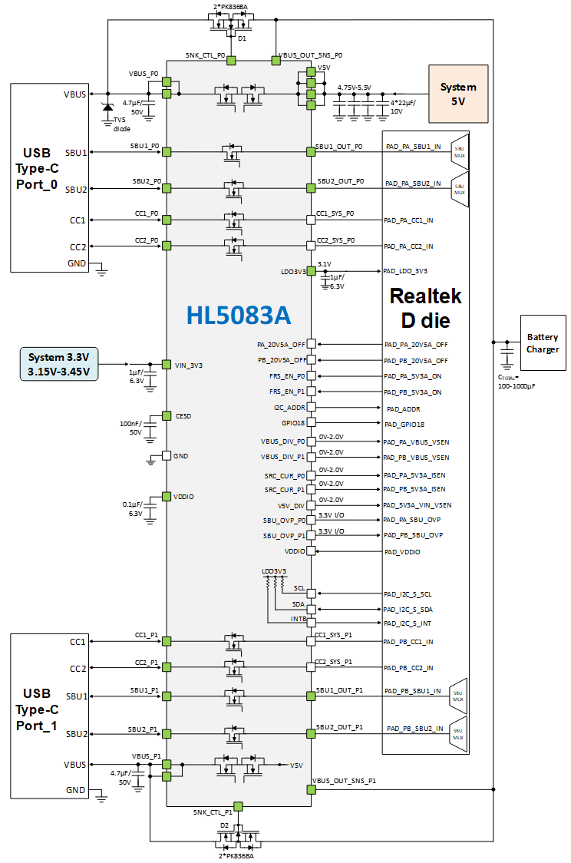

Figure 47. Typical Application Diagram with a Back-to-Back MOSFET

2. The schematic below shows the top-level connection with a stand-alone eFuse device with GPIO function enabled

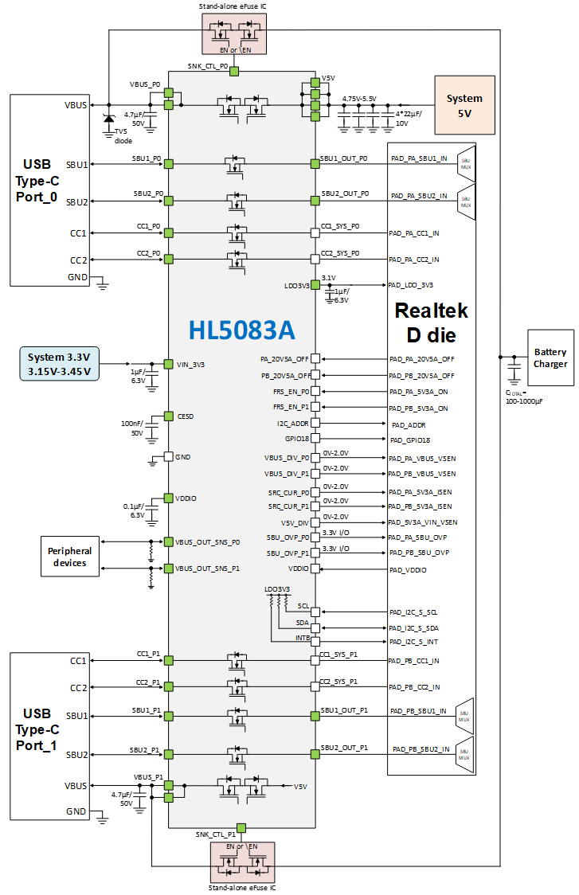

Figure 48. Typical Application Diagram with a stand-alone eFuse device and GPIO function enabled

Bill of Material (BOM)

Table 12. Bill of Material
Name | Value | Size  (L x W x H mm) | Maker, Part Name | Note
C_{VBUS_P0} | 4.7µF/50V | 3.2 x 1.6 x 1.8 | Murata, GRM31CR71H475KA12
C_{VBUS_P1} | 4.7µF/50V | 3.2 x 1.6 x 1.8 | Murata, GRM31CR71H475KA12
C_{V5V} | 88µF/10V | 3.2 x 1.6 x 1.8 | Murata, GRM31CR71A226KE15 | Use 4 pcs of 22µF/10V
C_{VIN_3V3} | 1µF/6.3V | 1 x 0.5 x 0.5 | Murata, GRM152R60J105ME15
C_{LDO3V3} | 1µF/6.3V | 1 x 0.5 x 0.5 | Murata, GRM152R60J105ME15
C_{VDDIO} | 0.1µF/6.3V | 1 x 0.5 x 0.5 | Murata, GRM155R70J104KA01
C_{CESD} | 100nF/50V | 1 x 0.5 x 0.5 | Murata, GRM155R61H104KE19
D1, D2 |  | 2.6 x 1.8 x 1.15 | SD103AWS 120mA/40V | Schottky diode
NFET |  |  | PK836BA | 2 * NFET for each VBUS sink path

Package and Packing Information

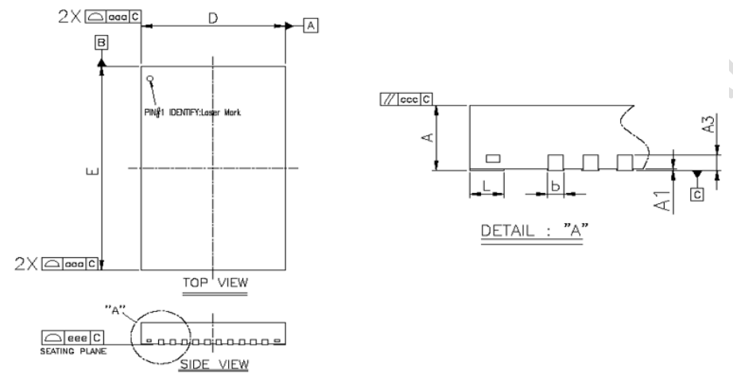

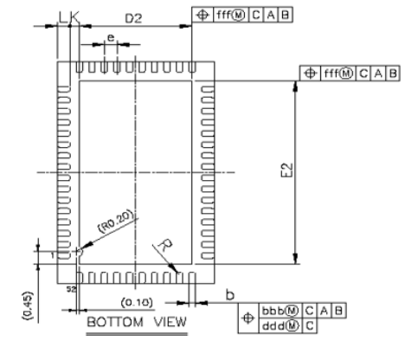

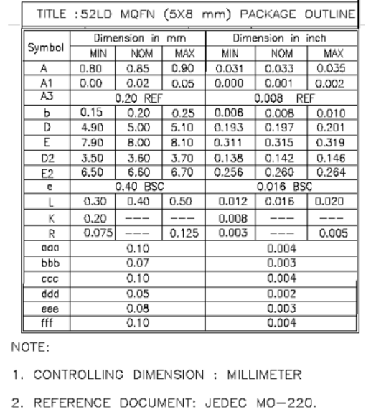

Figure 49. Package dimension

Important Notice

Halo Microelectronics Co., Ltd. reserves the right to modify, improve, and terminate its products, services, documentations, etc. without advance notice. Customers are encouraged to contact Halo Microelectronics Co., Ltd. sales representatives to get the latest product information.

Without proper legal authorization, Halo Microelectronics Co., Ltd. products shall not be used for medical or military applications. Halo Microelectronics Co., Ltd. does not assume any liability of personal or property damages of any kind due to such applications.

All text, images, trademarks of this document, and any intellectual property contained in the product and in this document belong to Halo Microelectronics Co., Ltd. No part of this document may be used, copied, modified, distributed, or published without legal authorization from Halo Microelectronics Co., Ltd.

Revision History

Revision No. | Description | Revision Date
1.0 | Official Release | October 2025

