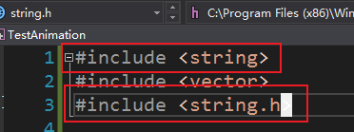

有什么区别

What is the difference between a definition and a declaration?

单例模式泛型

#pragma once  
  
template <typename T>  
class DTSingleton  
{  
public:  
    static T \* Instance()  
    {  
        if (!pT)  
        {  
            pT = new T;  
        }  
        return pT;  
    }  
  
    static void Destroy()  
    {  
        if (!pT)  
        {  
            delete pT;  
        }  
        pT = nullptr;  
    }  
protected:  
        DTSingleton() {}  
        DTSingleton(const DTSingleton& rhs);  
        DTSingleton& operator=(const DTSingleton& rhs);  
protected:  
        static T \* pT;  
private:  
};  
  
template <typename T>  
T \* DTSingleton<T>::pT = nullptr;

实现四元数lerp功能.