

**Jump Robot**

**Thank you for purchasing the asset , if you have any question please contact me at** [**madfireongames@gmail.com**](mailto:madfireongames@gmail.com)

**Scripts**

1. GameManager:- This script controls the game , its saves and loads data from the device eg:- Best Score , musics status ,etc.

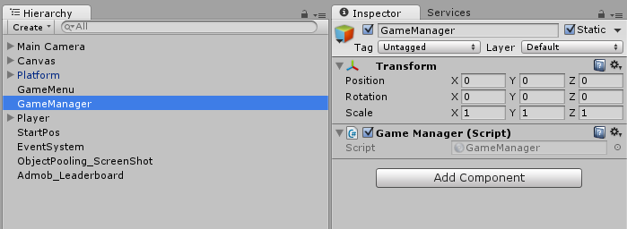

1. GameMenu:- This script controls the game menu , is assigns the functions to the buttons and updates the text like score , best score , etc;

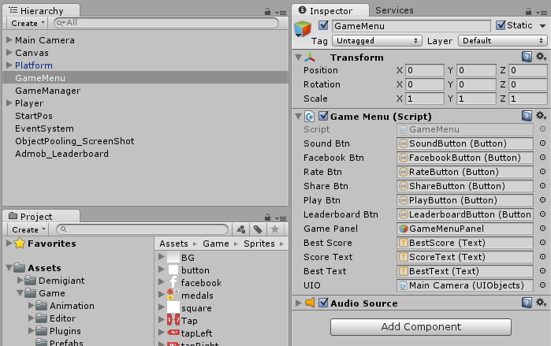

1. ObjectPooling:- This script created the required clone of objects which are used again and again and it the make them active when required , helps in game optimization.

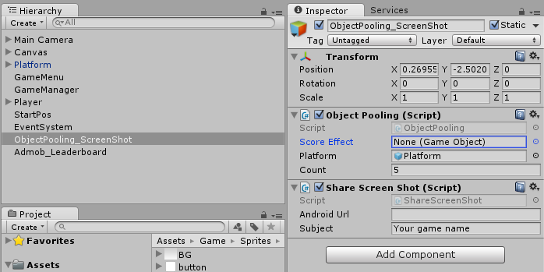

1. ScreenShot:- This script helps player to take the screen shot of their game and share it on the social platforms like facebook , whatsapp , etc.



1. UIObject:- This script keep tack of all the elements in the scene like sprites , text , sound , font etc .

