How To Reskin?

Go to Tools -> Click on GameDesign.

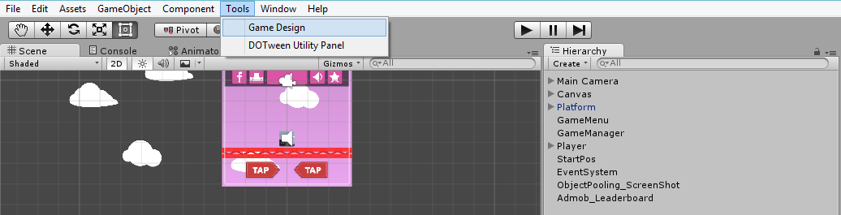

GameDesign window will open.

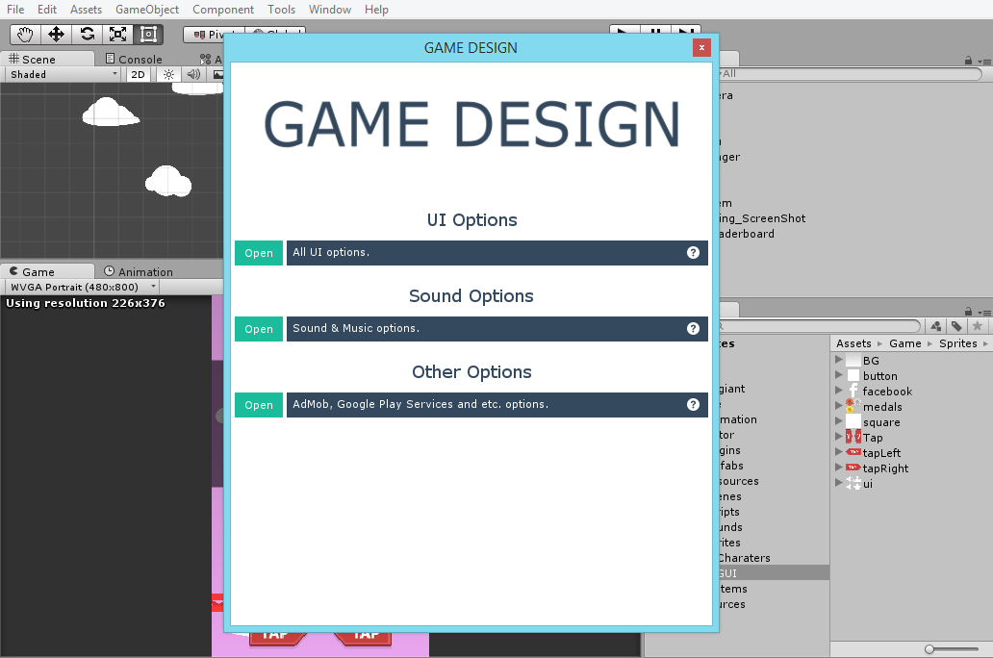

Open any section and you will find fields to change.

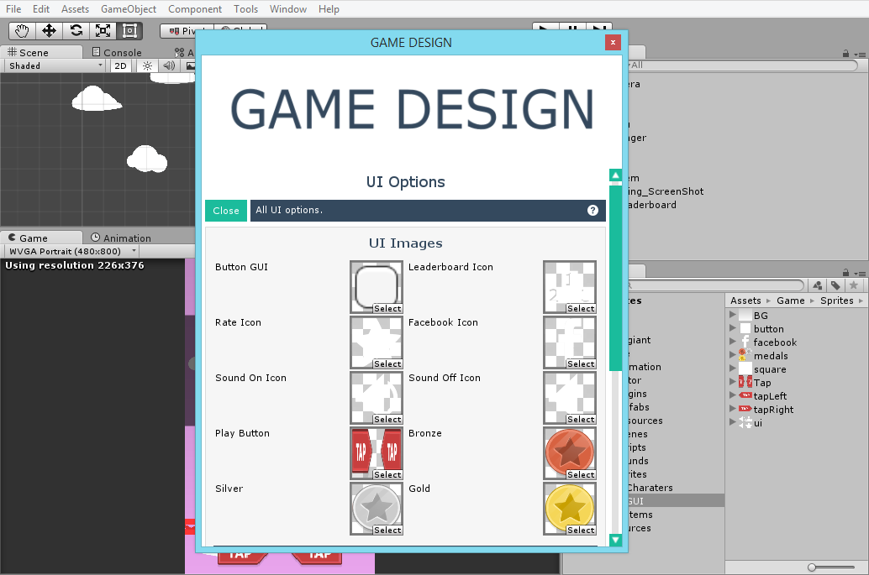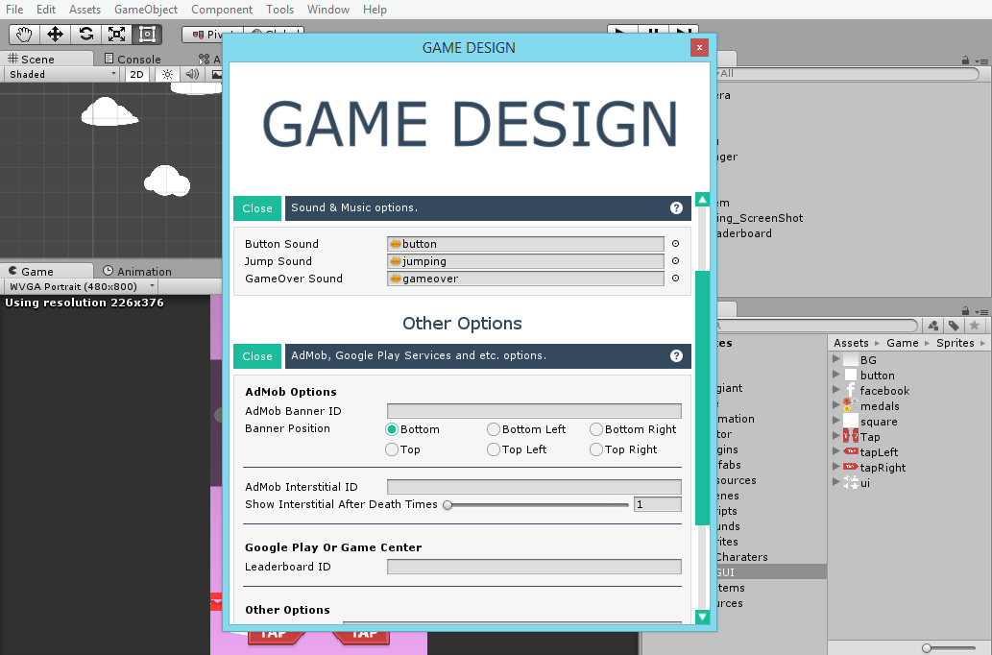

You can change button scripts , texts , fonts , sounds , ads ids , rate and facebook urls , etc. The only thing which you cannot change from here is the sprites of Player , enemies and platform , you will have to do it manually.